**Distance vehicle repairing system**

**TECHNICAL REPORT**



**SUBMITTED BY**

Muhammad amjad mehmoo (2018-ag-8215)

Nafeesa Hassan (2018-ag-8317)

Maryaam (2018-ag-8999)

**ADVISED BY**

Sir Milhan Afzaal

**A TECHNICAL REPORT SUBMITTED IN PARTIAL FULFILLMENT OF REQUIREMENT FOR THE DEGREE OF**

*Bachelors of Sciences*

*IN*

*Computer Science*

**DEPARTMENT OF COMPUTER SCIENCE**

**FACULTY OF SCIENCES**

**UNIVERSITY OF AGRICULTURE FAISALABAD**

**DECLARATION**

I hereby declare that the contents of the report **Distance vehicle repairing system** are a project of my own research and no part has been copied from any published source (except the references). I further declare that this work has not been submitted for award of any other diploma/degree. The university may take action if the information provided is found false at any stage. In case of any default the scholar will be proceeded against as per UAF policy.

_________________

Muhammad amjad mehmood

_________________

Nafeesa Hassan

_________________

Maryam

**CERTIFICATE**

To,

The Controller of Examinations,

University of Agriculture,

Faisalabad.

The supervisory committee certifies that **Muhammad amjad mehmood (2018-ag-8215), Nafeesa Hassan (2018-ag-8317) and Maryam (2018-ag-8317)** have successfully completed their project in partial fulfillment of requirement for the degree of BS. Software Engineeringunder our guidance and supervision.

_____________________________________

Dr. Milhal Afzal

Supervisor

**ACKNOWLEDGEMENT**

I thank all who in one way or another contributed in the completion of this report. First, I thank ALLAH ALMIGHTY, most magnificent and most merciful, for all his blessings. I am so grateful to the Department of Computer Science for making it possible for me to study here. My special and heartfelt thanks to my supervisor, **Sir Milhan Afzal** who encouraged and directed us. His challenges brought this work towards a completion. It is with his supervision that this work came into existence. For any faults I take full responsibility. I am also deeply thankful to my informants. I want to acknowledge and appreciate their help and transparency during my research. I am also so thankful to my fellow students whose challenges and productive critics have provided new ideas to the work. Furthermore, I also thank my family who encouraged me and prayed for me throughout the time of my research. May the Almighty God richly bless all of you

**ABSTRACT**

Distance vehicle repairing web application is developed using state of the art technology, Mern Stack, a strong, powerful stack, used all over the world .

Mostly in Pakistan, travelers face too much difficulty when they meet any fault with their vehicle on the way. In this situation they need a vehicle mechanic to remove faults from their vehicle, but unfortunately they don’t know where this mechanic workshop is located, this web application will make them able to contact vehicle repairing workshops from remote locations.

This **Distance vehicle repairing** web application, will provide facility to tourism, traveling, transport systems of the country. This project is easily feasible in the current available technology stack, this product is under the country's cyber laws and does not violate any moral values.

This application is designed on **Figma**, developed using **reactjs** for front end, **nodeJs**  back end and **mongodb**.This project is developed using the rapid application development model which provides flexibility to the developers to build and run the increments rapidly. Users can see their output very soon if the project is being developed using this development process model.

Finally, this project is completed with all its predefined requirements and provides facilities to students an

**Table of Contents**

Chapter 1 - INTRODUCTION 1

1.1 Background: 1

1.2 Description: 1

1.3 Problem Statement: 2

1.4 Scope: 2

1.5 Objectives: 2

1.6 Feasibility: 3

1.7 Requirements: 4

1.7.1 Functional Requirements 4

1.7.2 Non- Functional Requirements 5

1.7.3 Hardware Requirements 5

1.7.4 Software Requirements 5

1.8 Stakeholders: 5

Chapter 2 – MATERIALS & METHODS 9

2.1 Process Model: 9

2.2 Tools & Technologies 9

2.3 Design: 9

2.3.1 Use Case Diagrams: 10

2.3.3 Sequence Diagram: 16

2.3.4 Class Diagram: 19

2.3.5 Data Flow Diagram: 20

2.3.6 ER Diagram: 24

2.3.7 Database Model: 24

2.3.8 Architecture: 25

Chapter 3 - RESULTS & DISCUSSION 27

3.1 Testing: 27

3.2 Test Cases: 27

3.3 Conclusion: 29

Chapter 4 - USER MANUAL 30

References 31

**List of Figures**

Figure *‎*1.1 Stakeholders 8

Figure *‎*2.1 Agile Activities 9

Figure 2.*‎*2 Use Case Diagram 12

Figure 2.3 Sequence Diagram 19

Figure 2.4 Class Diagram 20

Figure *‎*2.5 Context Diagram 22

Figure *‎*2.6 Level 0 DFD 22

Figure 2.7 Level 1 DFD 23

Figure *‎*2.8 Entity Relationship Diagram 24

Figure 2.9 Database Model 25

Figure *‎*2.10 Applications's Architecture 26

Figure *‎*4.1 Signing in 30

**List of Tables**

Table 2. 1: Add User 15

Table 3. 1: User login Test Case 29

# Chapter 1 - INTRODUCTION

## 1.1 Background:

In the current era, in the world, especially in Pakistan, the traffic system is in its worst condition. Too many vehicles of different types are on the roads but beside roads there are no standard vehicle maintenance facilities. if they exist they are too far from locations where the vehicle ran out of functions .

By seeing these issues, the idea of **distance vehicle repairing web application** comes into being. Generally when we go on traveling, movement of goods from one location to another location, we use different types of vehicle. It may be a motor car, motor bike, heavy trollar for shifting of goods, or tractor for farming purposes, they all can be in technical fault situations at any time.

Our Application will provide facility to these people who are stuck at a barren place due to technical fault with their vehicle. Now they can find online repair workshops, can see their workshops on google maps and contact them by sending fault type to these workshops by using this **distance vehicle repairing** web application.

This application will bring revolution in our transport system, will make the traveling easy and fast, will promote tourism and will save important money and will help country’s economy

.

## 1.2 Description:

This **distance vehicle repairing** application will bring ease of traveling and tourism. This application's goals are to show vehicle repair workshops to the user and users can contact these workshops by online means using the internet, and to digitize these workshops to be available to everyone who needs them.

This application will be completed now-a-days with the most advanced technology stack known as mern stack(m for mongo, e for expressjs, n for node js, r for reactjs). Business needs of this project are that before this application, due to any fault, when any one's vehicle runs out of function, they bring their vehicle to the repair workshop by loading on another vehicle which costs a lot. Now by using this application workshops repairer will come to that vehicle which has run of function at a barren place, so cost reduces. The problem of this project was to attain that technology stack that is compulsory for completion of this project.

The main drawback of this application is that network availability is compulsory to run this application but in Pakistan at remote locations network availability is a big challenge.

People are interested in this application because this application addresses their problem in traveling, make their traveling safe.

As now-a-days governments make technology friendly laws, so there is no chances to face legal problems.

We are a team of three people with command on technology required for this project. We are using the RAD model for development of this project.

Requirements to run this application are a mobile device or computer with minimum 2bg RAM, ro normal processor and connected with internet

## 1.3 Problem Statement:

Roads maintenance system and vehicle maintenance system are in the worst situation in Pakistan, due to which our vehicle faces faults while driving from one location to another.

This application can be run only by the people who know the english language and have device and network available

## 1.4 Scope:

**Distance Vehicle Repairing,** will be used by travelers, tourist,goods shifting vehicle and by farming purposes vehicles,

Shop owners will register their shops to this platform and then these shops will show to the customer, customers will see these registered workshops to their network connected devices and will see how many kilometers this repair workshop is far from.and can send their vehicle fault type to the workshops and order to workshops to come the place where this vehicle stands faulted.

Mern Stack technology is used for this project's completion. The RAD(Rapid Application Development) model is used in this application which is very fast.

This application will address the vehicle repairing problem, now there is no need to bring heavy machinery to the workshop, rather workshop personnel will come to vehicle location hence time and money save.

As this application is connected to the internet so, every one who needs to use this application must have a mobile or computer device and network connection

## 1.5 Objectives:

The objective of this project is to bring ease in traveling and tourism, and to bring workshops to one click away. There is no need to search manually and no need to ask unknown that where is our issue related repairing workshop located as you are at barren place and do not know area geography. This application will save travelers maney and time and shop owner revenue will also increased

## 1.6 Feasibility:

A feasibility study is performed by a company when they want to know whether a project is possible given certain circumstances. Feasibility studies are undertaken under many circumstances – to find out whether a company has enough money for a project, to find out whether the product being created will sell, or to see if there are enough human resources for the project. A good feasibility study will show the strengths and deficits before the project is planned or budgeted for. By doing the research beforehand, companies can save money and resources in the long run by avoiding projects that are not feasible. There are many different types of feasibility studies; here is a list of some of the most common:

**1.6.1 Technical Feasibility** – All the technological requirements for this project are easily available in the market. This can be done using various tools and technologies.

**1.6.2 Schedule Feasibility** – The given time span is far enough for current requirements of this project. This project can easily be done within time.

**1.6.3 Economic Feasibility** – This project is very economical and can be performed using various free tools, technologies. This product will cost nothing from the users except internet resources and a normal mobile phone or computer device.

**1.6.4 Cultural Feasibility** – Now in the modern era, everything is being digitized and human acceptable. This product will easily be digestible by every part of the world. Now this is a trend in bloom in the whole world to find online applications like this to be a part of Global World.

**1.6.5 Legal/Ethical Feasibility** – Nowadays, every country is promoting digital products and making laws to bring ease to the public and stop harmful or unethical cyber services. This product is totally ethical and acceptable in every country of the world.

**1.6.6 Resource Feasibility** – All the required resources for this product to be built are easily accessible like mobile devices, laptop, internet, required knowledge and helping resources.

**1.6.7 Operational Feasibility** – This product will provide a central place to repair workshops and customers to get connected. This problem will successfully be resolved by this product.

## Requirements:

Both functional and nonfunctional requirements are detailed below.

### 1.7.1 Functional Requirements

Functional requirements of the project are described below.

**FR01:** Provide email and password to log in

| FR01-01 | System shall get Email and Password from customer |
| --- | --- |
| FR01-02 | System should authenticate Email and password |
| FR01-03 | System shall let the customer to log in if information is valid |
| FR01-04 | If information is not valid then the system will display a message to create an account. |
| FR01-04 | There is feature to login with facebook or google |

**FR02:** Registor customer account

| FR02-01 | System shall get Name, Email, Phone number,photo,Password from customer |
| --- | --- |
| FR02-02 | System shall send a confirmation email to the user to continue. |
| FR02-03 | If email is not verified by the user, the system shall not allow the user to log in. |

**FR03:** Enter Details

| FR03-01 | System shall get basic information from the customer to continue. |
| --- | --- |
| FR03-02 | If the user does not provide details, he shall not be allowed to move further until he fills all the required fields. |

**FR04:** Workshops login

| FR04-01 | System shall get Email and Password from WorkShop Owner |
| --- | --- |
| FR04-02 | System should authenticate Email and password |
| FR04-03 | If information is not valid then the system will display a message to create an account. |

**FR05:** Register workshop account

| FR05-01 | System shall get workshop Name, Email, Phone number, exact address workshop type ,photo,Password, confirm password from shopowner |
| --- | --- |

**FR06:** Display shops

| FR06-01 | System shall display all the shops to the customer. |
| --- | --- |

### 1.7.2 Non- Functional Requirements

**NFR01:** System shall remain available 24/7 to its customer.

**NFR02:** System shall have two types of users i.e.,shop owner, customer.

**NFR03:** System shall display a warning message if any required data is not provided by the user.

### 1.7.3 Hardware Requirements

Minimum mobile device, tablets, or computer

RAM: 2GB or more

### 1.7.4 Software Requirements

Operating System: all existed operating systems

## Stakeholders:

This project is dependent on basically two stakeholders, workshop owner and customer. Shop Owner will register workshop to the platform and customer will get facility to from this workshop

# Chapter 2 – MATERIALS & METHODS

## 2.1 Process Model:

Campus Recruitment System is developed using Agile methodology. The Agile model is the Rapid Application Development model. It is a type of incremental model. In the Agile model the components or functions are developed in parallel as if they were mini projects. The developments are time boxed, delivered and then assembled into a working prototype. This can quickly give the customer something to see and use and to provide feedback regarding the delivery and their requirements.



*Figure 2.1 Agile Activities*

## 2.2 Tools & Technologies

This project is developed using now-a-days most demanded technology stack, **The MERN (M for mongodb, E for expressJs, R for reactjs, N for Nodejs ) STACK** which consists of both front end and back end . **ReactJs** is a javaScript lightweight framework developed and used by facebook. **Nodejs** provides a runtime environment for javascript code.**ExpressJs** is nodejs framework and used as back end . **MongoDb** is no sql database.

## 2.3 Design:

### 2.3.1 Use Case Diagram:

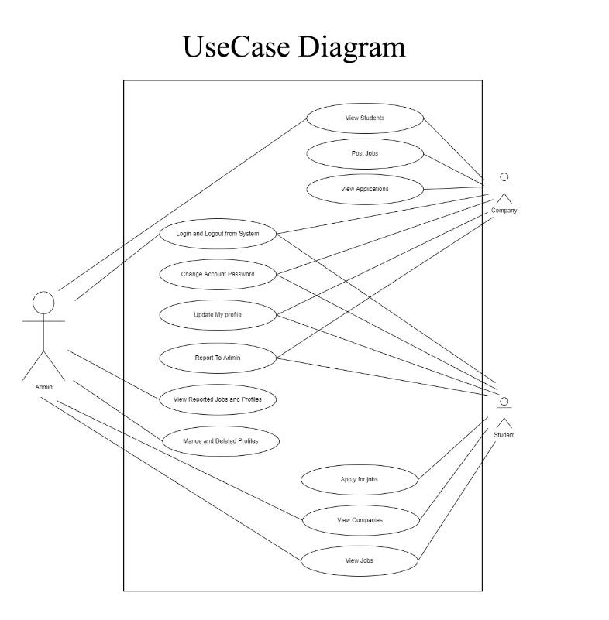

*Figure 2.2 Use Case Diagram*

### 2.3.4 Class Diagram:

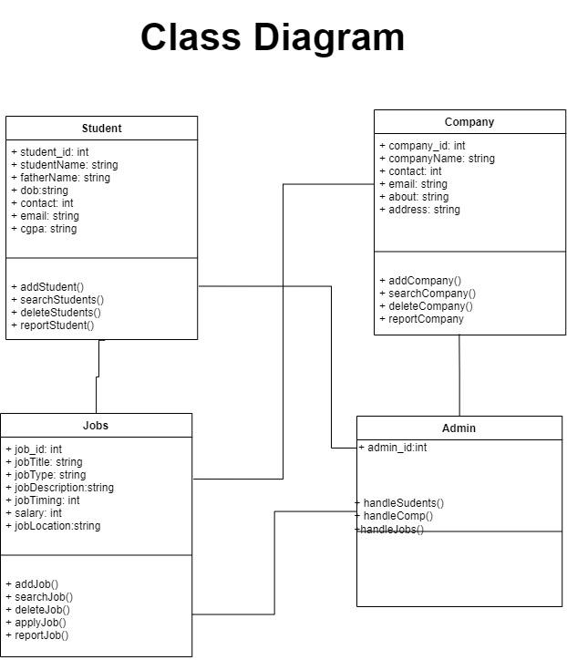

*Figure 2.4 Class Diagram*

### 2.3.5 Data Flow Diagram:

A data flow diagram (DFD) maps out the flow of information for any process or system. It uses defined symbols like rectangles, circles and arrows, plus short text labels, to show data inputs, outputs, storage points and the routes between each destination. A Data Flow Diagram (DFD) is traditional visual representation of the information flows within a system. A neat and clear DFD can depict a good amount of the system requirements graphically. It can be manual, automated, or combination of both.

It shows how information enters and leaves the system, what changes the information and where information is stored. The purpose of a DFD is to show the scope and boundaries of a system as a whole. It may be used as a communications tool between a systems analyst and any person who plays a part in the system that acts as the starting point for redesigning a system. [3]

It is usually beginning with a context diagram as the level 0 of DFD diagram, a simple representation of the whole system. To elaborate further from that, we drill down to a level 1 diagram with lower level functions decomposed from the major functions of the system. This could continue to evolve to become a level 2 diagram when further analysis is required. Progression to level 3, 4 and so on is possible but anything beyond level 3 is not very common. Please bear in mind that the level of details for decomposing particular function really depending on the complexity that function. For further reading use the link given below:

<https://www.visual-paradigm.com/guide/data-flow-diagram/what-is-data-flow-diagram/>

#### DFD Diagram Notations

#### External Entity

An external entity can represent a human, system or subsystem. It is where certain data comes from or goes to. It is external to the system we study, in terms of the business process. For this reason, people used to draw external entities on the edge of a diagram.

cust

#### Process

A process is a business activity or function where the manipulation and transformation of data takes place. A process can be decomposed to finer level of details, for representing how data is being processed within the process.   
process

#### Data Store

A data store represents the storage of persistent data required and/or produced by the process. Here are some examples of data stores: membership forms, database table, etc.   
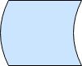

#### Data Flow

A data flow represents the flow of information, with its direction represented by an arrow head that shows at the end(s) of flow connector.

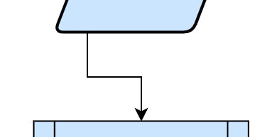

**Context Diagram:**

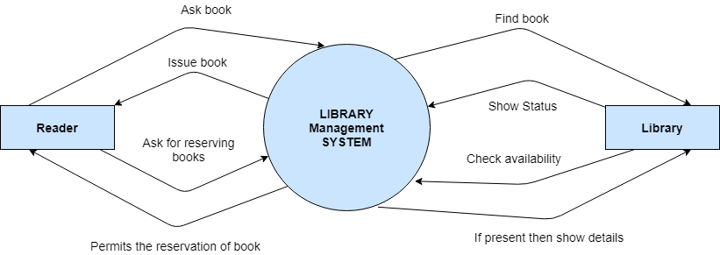

*Figure 2.5 Context Diagram*

**Level 0:**

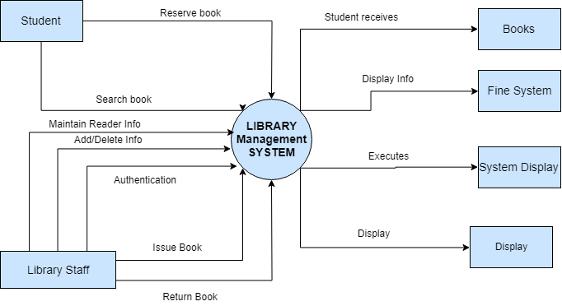

*Figure 2.6 Level 0 DFD*

**Level 1:**

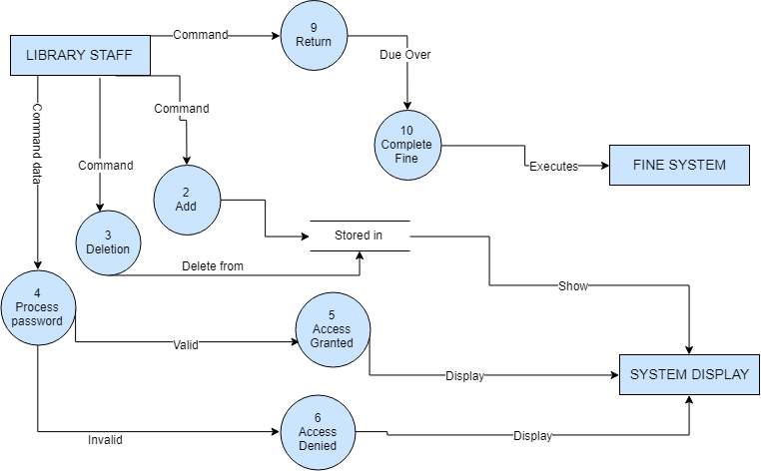

*Figure 2.7 Level 1 DFD*

**Also include Data Dictionary in this section.**

### 2.3.6 ER Diagram:

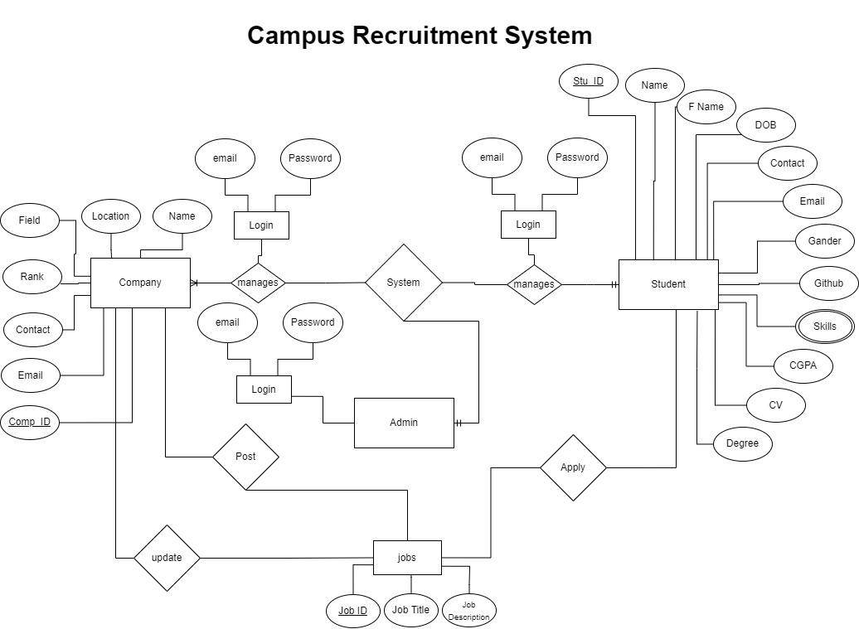

*Figure 2.8 Entity Relationship Diagram*

### 

### 2.3.7 Database Model:

Firebase is a no SQL database used for this project. It is more easy to handle and fast to use. It stores data in JavaScript Object Notation. Structure of database is shown below.

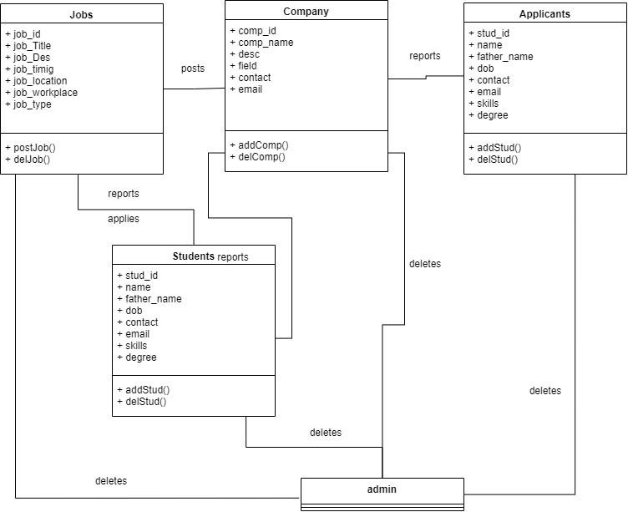

*Figure 2.9 Database Model*

### 2.3.8 Architecture:

**3-Tier:**

This project is developed on 3-Tier architecture. First layer is presentation layer, second layer is all about logical portion and third layer is data storage layer. Their explanation is given below.

**Presentation Tier-** Front end of the Application is built using react native. React native uses Jsx format to build front end. Its logic is quite similar to that of HTML but Jsx is the extension of Javascript. React native provide within file styling format to give styling to the front end.

**Application Tier-** Core logic of the application is written in Javascript and Node js which is a strong framework of javascript. It makes the application to work smoothly and data to flow through the application properly.

**Data Tier-** This layer is all about data and database. It has firebase as its database which allows node js to send and get requests of data to the database Cloud Firestore. It also authenticates user before login.

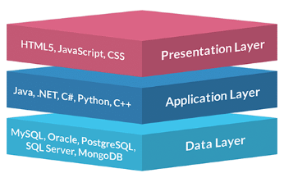

*Figure 2.10 Application Architecture*

# Chapter 3 - RESULTS & DISCUSSION

In this chapter discuss overall performance or all functional and non-functional requirements you listed in chapter no. 1 as this section will verify the performance measures proposed for this project. For this software testing plays a vital role.

## 3.1 Testing:

Software testing is a process, to evaluate the functionality of a software application with an intent to find whether the developed software met the specified requirements or not and to identify the defects to ensure that the product is defect free in order to produce the quality product. In this regard, Test case writing is a major activity and considered as one of the most important parts of software testing. It is used by the testing team, development team as well as the management. If there is no documentation for an application, we can use test case as a baseline document. Below are some suggestions for writing good test cases:

## 3.2 Test Cases:

**Test Case: User Login:**

***Table 3. 1: User login Test Case***

| Test Case ID: | TC-1 |
| --- | --- |
| Test Case Title: | To verify the Login functionality of the application |
| Test Case Priority: | High |
| Requirement: | User Login |
| Test Description: | This test will verify the user login process. |
| Test Date: | 06/02/2022 |
| Pre-Conditions: | 1. Run the application.  2. Click Sign in button. |
| Dependencies: | Internet Availability |
| Test Steps: | 1. Enter Valid user name and password and click Login  2. Click Sign Out  3. Without entering user name click sign in  4. Without entering password click sign in  5. Enter wrong password or user name and click sign in |
| Test Data | Email id and password of user |
| Expected Results: | 1. System should open home page.  2. Login page should be displayed.  3. An error message should be shown to enter user name  4. An error message should be shown to enter password  5. Error message should be shown to enter correct password and user id |
| Actual Results: | As above |
| Post Conditions: | System shows Dash board page of signed in user. In case of unauthorized sign in attempt system shows the message “Invalid username/password”. |
| Status: (Pass/Fail) | Pass |
| Other Comments: | None |

**Test Case: User Data Sending:**

***Table 3.2: User Data Sending Test Case***

| Test Case ID: | TC-2 |
| --- | --- |
| Test Case Title: | To verify the functionality of sending user’s data to the data base |
| Test Case Priority: | High |
| Requirement: | User Data Sending |
| Test Description: | This test will verify that the user can send data to the database right after signing up.. |
| Test Date: | 06/02/2022 |
| Pre-Conditions: | 1. Run the application.  2. Sign Up successfully. |
| Dependencies: | Internet Availability |
| Test Steps: | 1. Enter all the required data.  2. Click next button  3. Without entering data, click next button  4. Without entering a few fields, click next button. |
| Test Data | Email id and password of user |
| Expected Results: | 1. System should enable next button.  2. Home page should be displayed.  3. An error message should be shown to fill the fields and then disable next button.  4. System should disable next button and show error message. |
| Actual Results: | As above |
| Post Conditions: | System shows Dash board page of signed in user. |
| Status: (Pass/Fail) | Pass |
| Other Comments: | None |

**Test Case: Job Apply:**

***Table 3.3: User Job Apply Test Case***

| Test Case ID: | TC-3 |
| --- | --- |
| Test Case Title: | To verify the functionality of Applying for a job |
| Test Case Priority: | High |
| Requirement: | Job Apply |
| Test Description: | This test will verify that the user can apply on available jobs. |
| Test Date: | 06/02/2022 |
| Pre-Conditions: | 1. Run the application.  2. Sign in successfully. |
| Dependencies: | Internet Availability |
| Test Steps: | 1. Click on an available job.  2. Click on apply job. |
| Test Data | Email id and password of user |
| Expected Results: | 1. System should open detailed page to show more about that job.  2. A success massage should be displayed to user.  3. That particular job should be displayed in applied job tab in user’s dashboard. |
| Actual Results: | As above |
| Post Conditions: | System shows all the available jobs and applied jobs to the user in his dashboard. |
| Status: (Pass/Fail) | Pass |
| Other Comments: | None |

**Test Case: Marking as Spam:**

***Table 3.4: Marking as spam Test Case***

| Test Case ID: | TC-4 |
| --- | --- |
| Test Case Title: | To verify the functionality reporting a job as spam. |
| Test Case Priority: | High |
| Requirement: | Marking as spam |
| Test Description: | This test will verify that the user can mark a job as spam. |
| Test Date: | 06/02/2022 |
| Pre-Conditions: | 1. Run the application.  2. Sign in successfully.  3. Open a job details page. |
| Dependencies: | Internet Availability |
| Test Steps: | 1. Click on the report button. |
| Test Data | Email id and password of user |
| Expected Results: | 1. System should display a massage and send that job to the admin’s dashboard. |
| Actual Results: | As above |
| Post Conditions: | System should display that job in admin’s panel.. |
| Status: (Pass/Fail) | Pass |

**Test Case: Report a Student:**

***Table 3.5: Report Student Test Case***

| Test Case ID: | TC-5 |
| --- | --- |
| Test Case Title: | To verify the functionality of reporting a student. |
| Test Case Priority: | High |
| Requirement: | Report a student. |
| Test Description: | This test will verify that the user can mark a student as spam. |
| Test Date: | 06/02/2022 |
| Pre-Conditions: | 1. Run the application.  2. Sign in successfully.  3. Open a applicants page. |
| Dependencies: | Internet Availability |
| Test Steps: | 1. Click on the report button. |
| Test Data | Email id and password of user |
| Expected Results: | 1. System should display a massage and send that job to the admin’s dashboard. |
| Actual Results: | As above |
| Post Conditions: | System should display that student in admin’s panel.. |
| Status: (Pass/Fail) | Pass |
| Other Comments: | None |

**Test Case: Data Delete:**

***Table 3.6: Data delete Test Case***

| Test Case ID: | TC-6 |
| --- | --- |
| Test Case Title: | To verify the functionality deleting job and students. |
| Test Case Priority: | High |
| Requirement: | Delete data |
| Test Description: | This test will verify that the admin can delete data from database using dashboard. |
| Test Date: | 06/02/2022 |
| Pre-Conditions: | 1. Run the application.  2. Sign in successfully.  3. Open a dashboard.  4. Delete a reported job.  5. Delete a reported student. |
| Dependencies: | Internet Availability |
| Test Steps: | 1. Click on delete button. |
| Test Data | Email id and password of user |
| Expected Results: | 1. System should display a massage that data has deleted. |
| Actual Results: | As above |
| Post Conditions: | System should display that student in admin’s panel.. |
| Status: (Pass/Fail) | Pass |
| Other Comments: | None |

## 3.3 Conclusion:

This project is completely tested against all the possible conditions. None of the test failed during testing. The overall performance of this application is tremendous. The project works smooth and fast. This is designed in such a way that even a person who have very less interaction will mobile or internet, can use and understand this application easily. Every end point is well defined will clear and understandable display messages against every action.

# Chapter 4 - USER MANUAL

User manual of Campus Recruitment System is attached below.

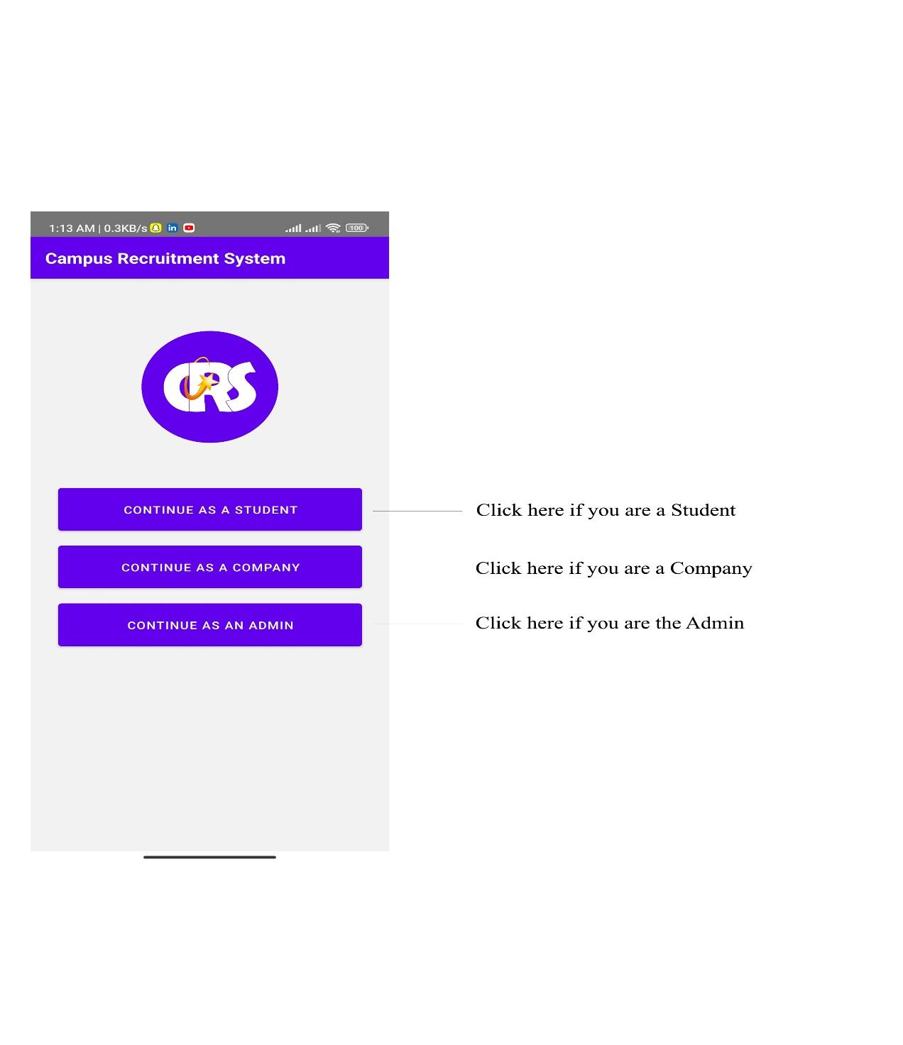

*Figure 3.1 Welcome Screen*

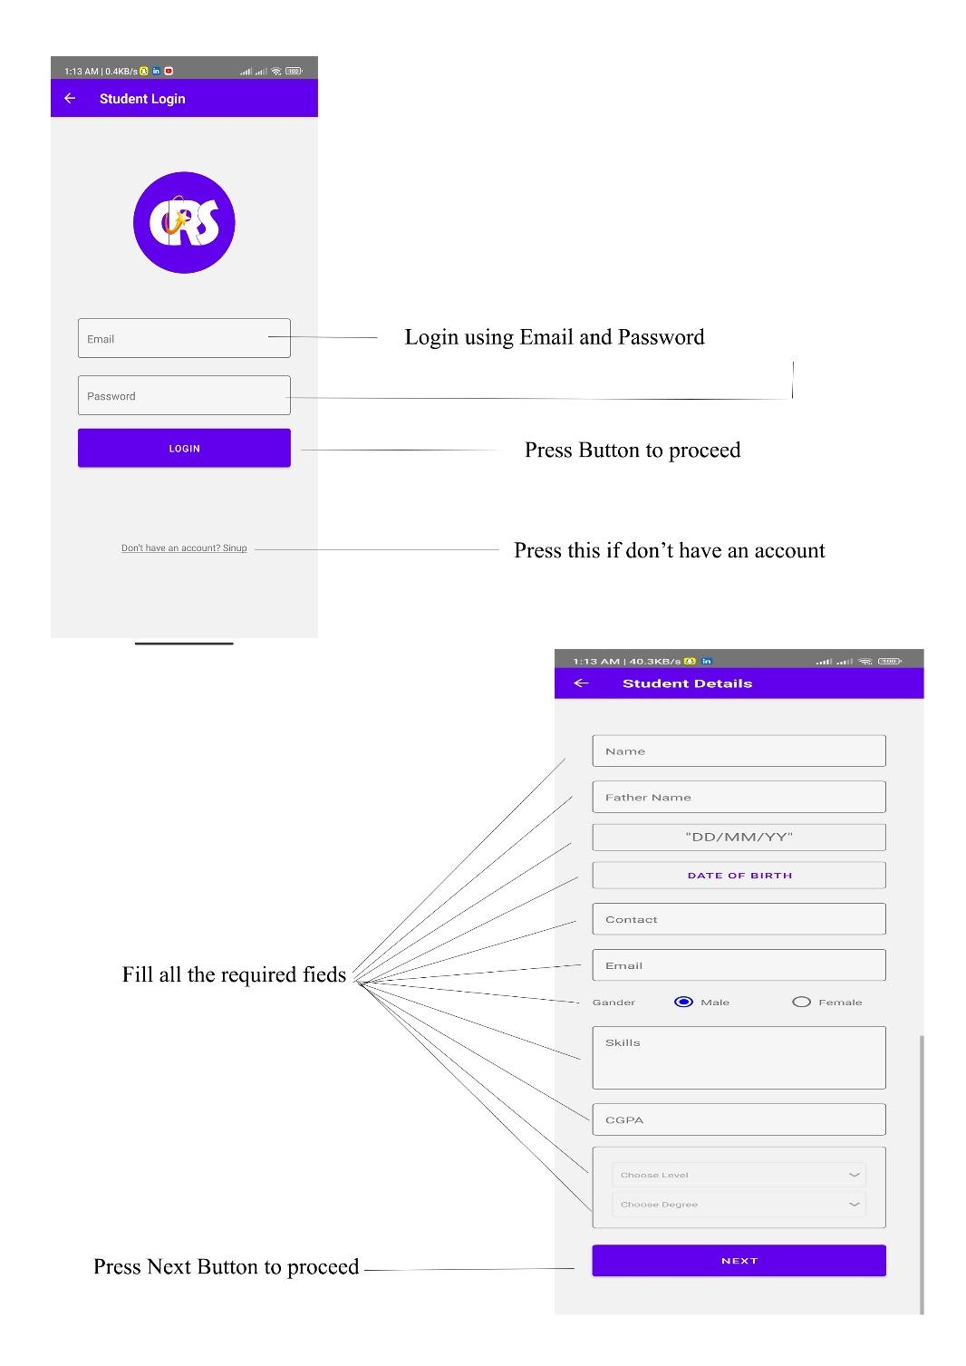

*Figure 3.2 Login and fill details as student*

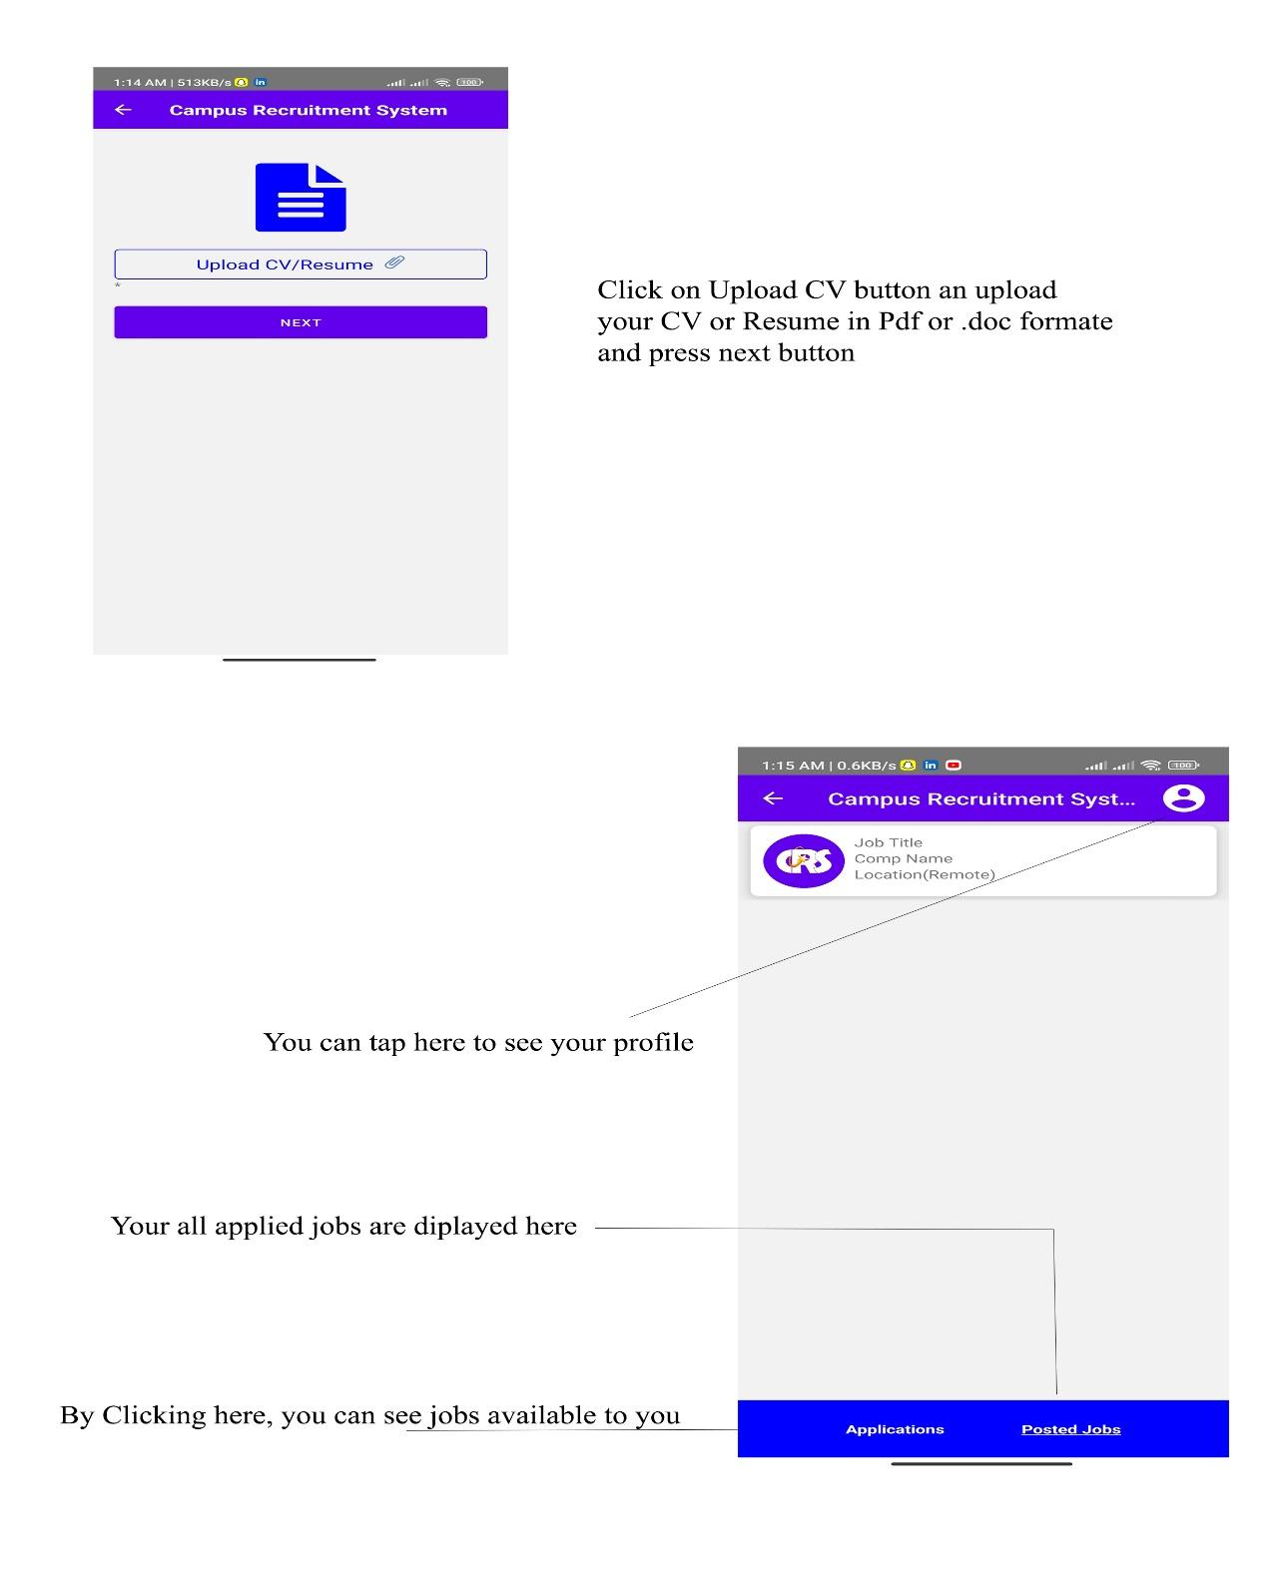

*Figure 3.3 Upload resume and home Screen*

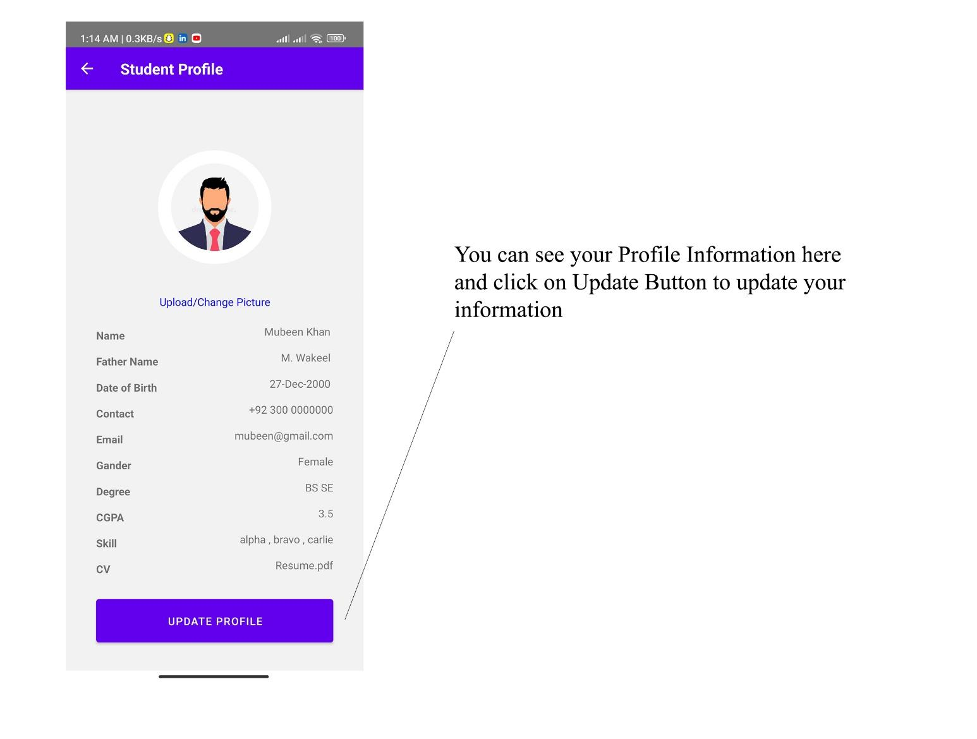

*Figure 3.4 Student Profile*

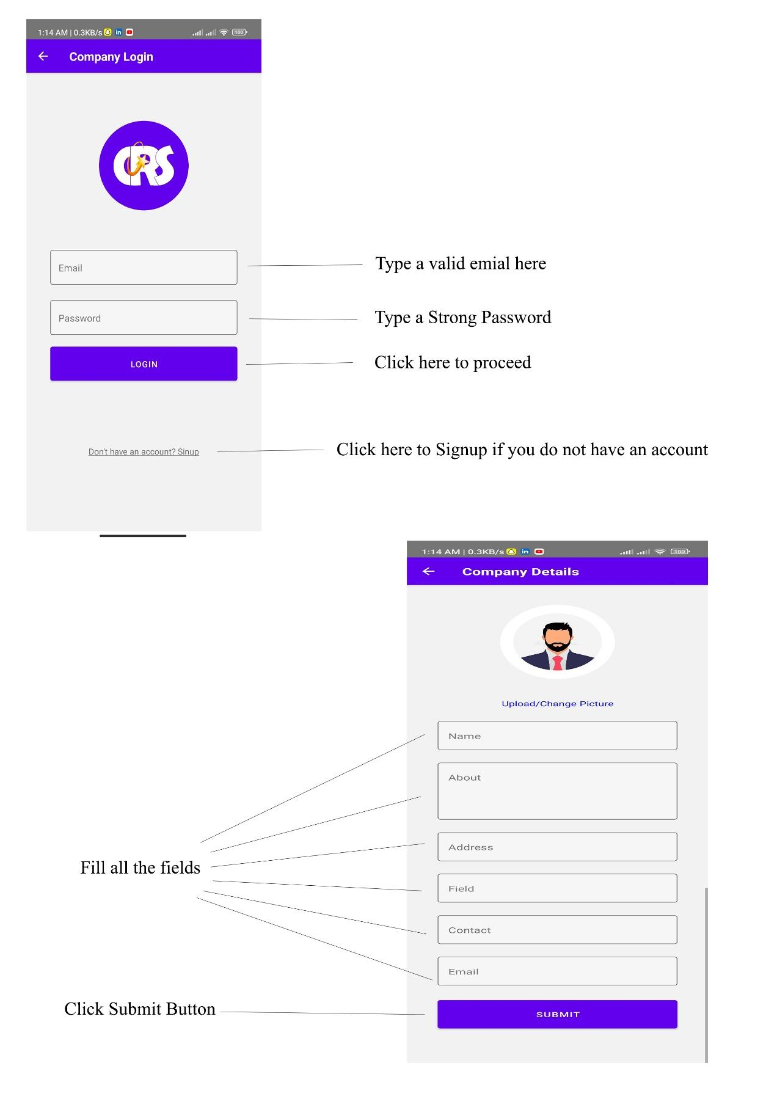

*Figure 3.5 Login as Company and fill details*

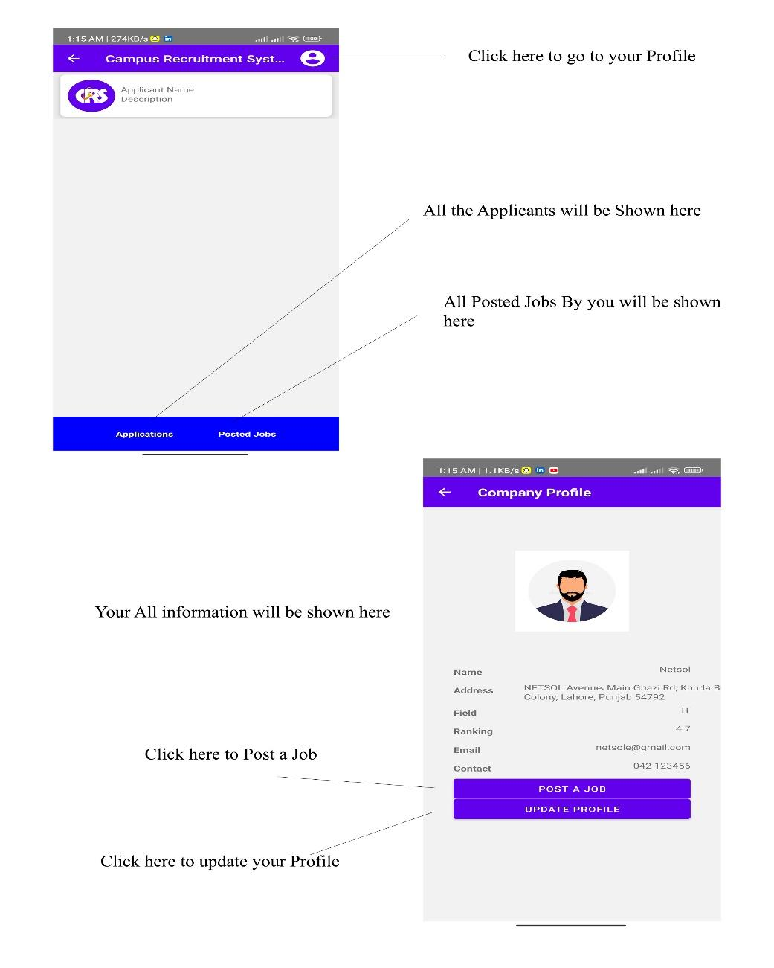

*Figure 3.6 Home Screen and Profile Screen of Company*

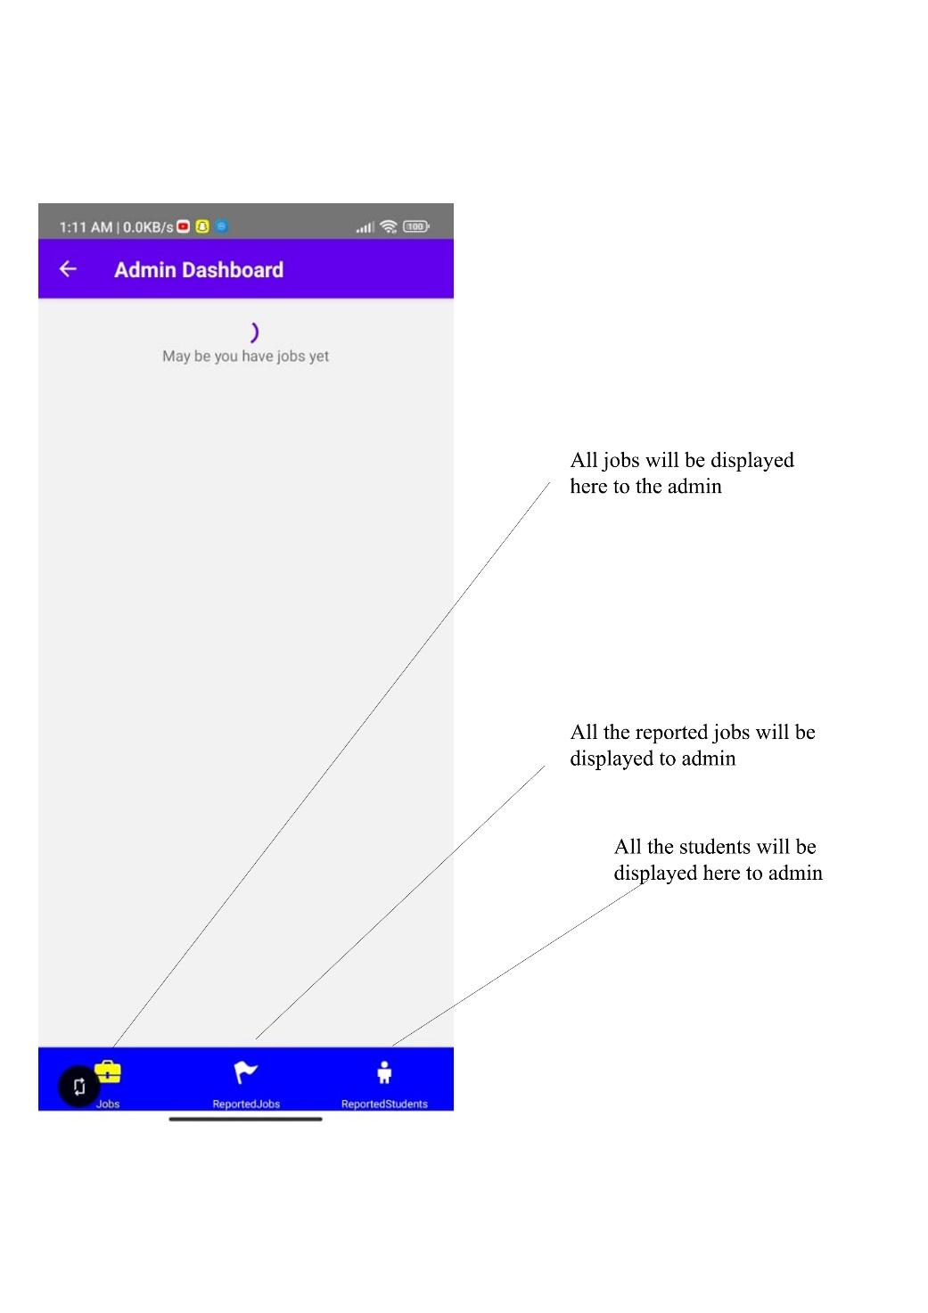

*Figure 3.7 Admin Home Screen*

**End**