WEB GIS LABORATORY 4

Getting Started with GeoDjango
Django - PostgreSQL/PostGIS - Admin - Leaflet
MS Remote Sensing and GIS
Institute of Geographical Information Systems
School of Civil and Environmental Engineering
National University of Sciences and Technology, Islamabad
Completed: 26 October 2026
Project: C:\webgis-lab\lab4
Source data: Lab 3 districts.geojson (160 districts)
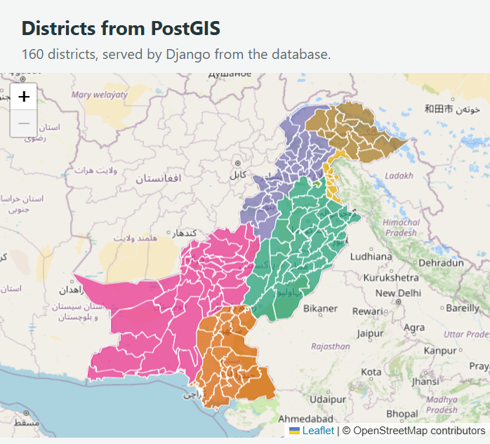
Figure 1. GeoDjango application running locally and drawing the database-backed district layer.
  - Purpose. Move the Lab 3 district data from a static GeoJSON file into PostGIS, expose it through Django, explore it in the GIS admin, and answer a spatial point-in-polygon query.

Figure 1A. Captured Python/Django versions and local server response.
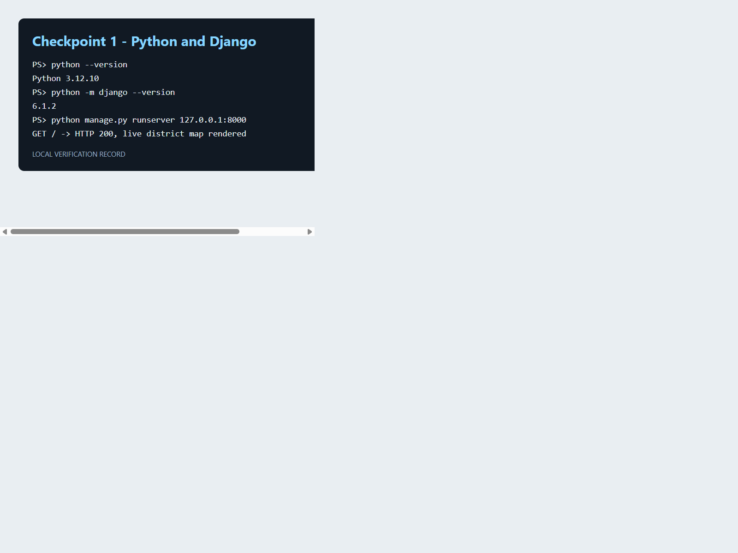
Python 3.12.10 and Django 6.1.2 were installed in the lab4 virtual environment. The local server returned HTTP 200 and rendered the working district application.

Checkpoint 1 - Python and first Django run

Completion summary
Checkpoint | Outcome
1. Django project | Complete ? Django 6.1.2 runs in a Python 3.12.10 virtual environment.
2. PostGIS database | Complete ? PostgreSQL 18.0, database webgis, PostGIS 3.6.2.
3. GeoDjango connection | Complete ? GIS libraries load; migrations applied to PostgreSQL.
4. Geometry model | Complete ? MultiPolygon, SRID 4326, GiST spatial index.
5. Load districts | Complete ? 160 features loaded; ORM checks match the handout.
6. Django admin | Complete ? province filter, GIS map, edit, and history verified.
7. Leaflet and API | Complete ? 160 database features served as GeoJSON and mapped.
8. Spatial extension | Complete ? click query returns the containing district; area comparison run.

Environment and recorded versions
Component | Recorded version / configuration
Python | 3.12.10 (virtual environment in lab4\venv)
Django | 6.1.2
PostgreSQL | 18.0 (Windows x86_64)
PostGIS | 3.6.2
GDAL | 3.10.3 (GeoDjango / QGIS 3.40.6 libraries)
GEOS | 3.13.1 in GeoDjango; PostGIS reports GEOS 3.14.1dev
PROJ | 8.2.1 as reported by postgis_full_version()

Data and implementation
- Source: copied the existing Lab 3 districts.geojson into lab4/data/; the Lab 3 project was left unchanged.
- The source has mixed Polygon and MultiPolygon features. The importer wraps single Polygon shapes as MultiPolygon before saving them in the SRID 4326 geometry column.
- PostgreSQL table districts_district stores all 160 records. The spatial geometry index is created with USING GIST.
- GET /api/districts/ serves a 1,026,495-byte GeoJSON response with 160 features; adding ?province=Sindh returns 29 features.
- GET /api/where/?lat=33.6423&lng=72.9906 returns Islamabad. The map calls this endpoint when clicked.
- Connection settings read WEBGIS_DB_* environment variables. No database password is embedded in the source or this report.

Evidence note
The map and admin figures are screenshots of the live local browser session. For database and command-line checkpoints, figures are report-ready captures of the successful local command/query output; psql was used for SQL verification instead of the pgAdmin graphical window. The API size was measured from the real browser response used to draw the map.

Checkpoint 2 - PostgreSQL and PostGIS
Created the webgis database, enabled the PostGIS extension, and read postgis_full_version(). The local PostgreSQL server was already installed and running; no installation errors occurred.
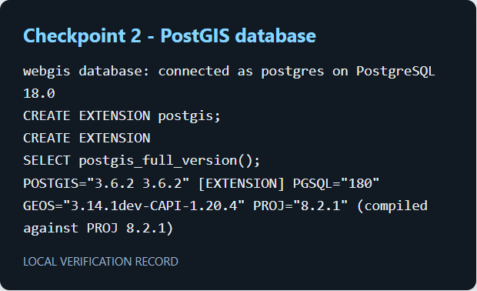
Figure 2. Database and PostGIS version verification.

Checkpoint 3 - Connect GeoDjango to PostGIS
Configured the Django PostGIS backend and the machine's QGIS GDAL/GEOS/PROJ libraries. Django check and migrations succeeded; PostgreSQL contains Django tables, districts_district, and spatial_ref_sys.
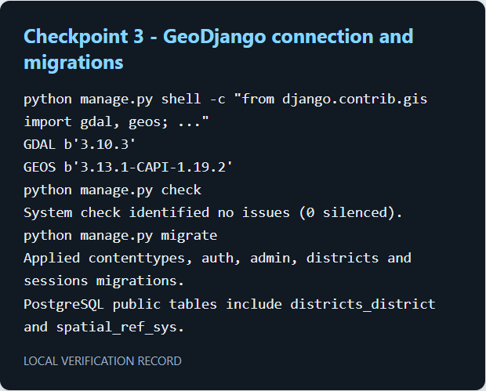
Figure 3. GIS library versions, Django check, migration, and database-table evidence.

Checkpoint 4 - District model and geometry schema
The model uses MultiPolygonField(srid=4326). The generated SQL constrains the geometry to MULTIPOLYGON,4326 and creates a GiST index for spatial queries.
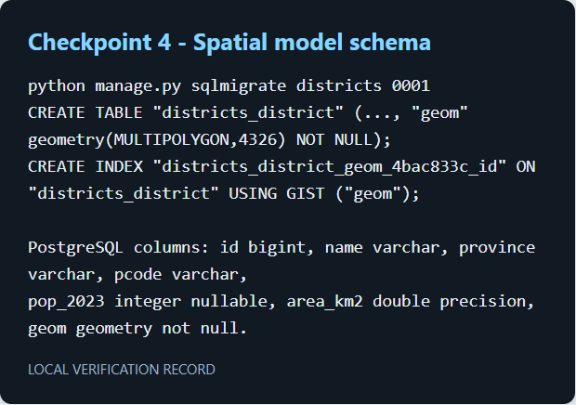
Figure 4. sqlmigrate output and the resulting table-column summary.

Checkpoint 5 - Load the Lab 3 data
The importer reported 160 features and saved 160 districts. ORM results: Sindh 29, missing census values 25, Lahore population 13,004,135, and Lahore geometry MultiPolygon with 238 coordinates.
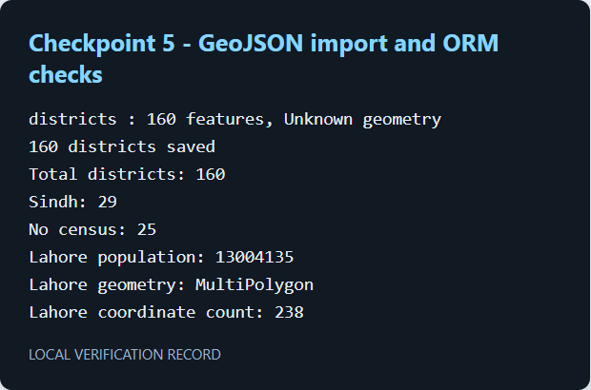
Figure 5. Import and ORM verification output.

Checkpoint 6 - Django GIS admin
Registered District with GISModelAdmin, a province filter, search by district or P-code, and the population/area columns. The Sindh filter returned 29 records. Lahore's geometry is displayed in the admin map.
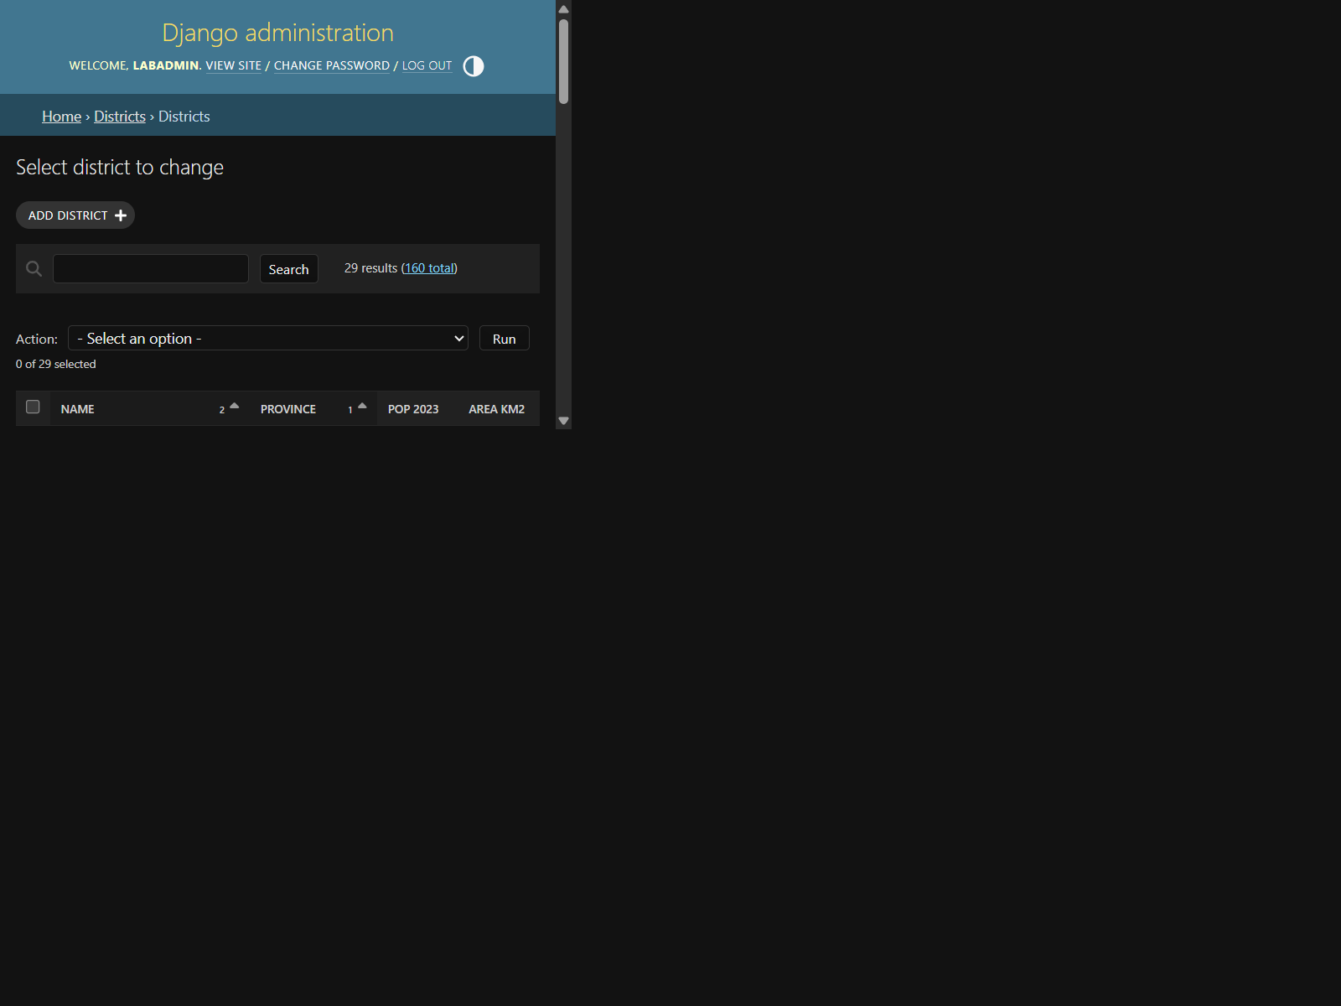
Figure 6. Django admin district list filtered to Sindh (29 results).

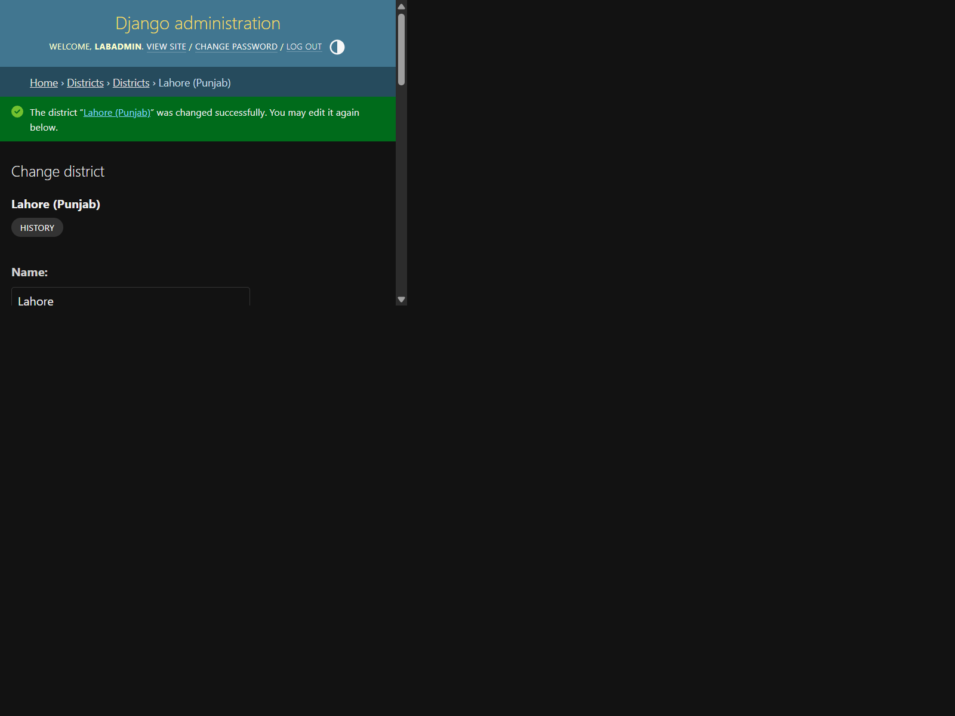
Figure 7. Lahore's district edit form in the GIS admin.
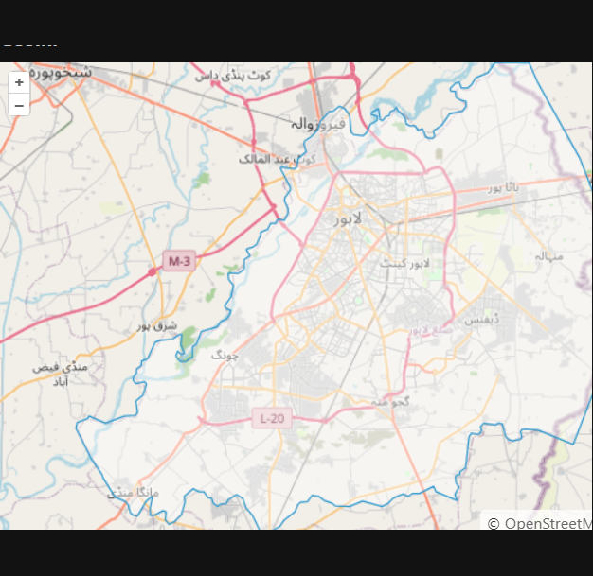
Figure 8. Lahore geometry shown on the admin map.

To verify that admin edits reach PostGIS, changed Lahore's population from 13,004,135 to 13,004,136, confirmed that value in SQL, and restored the original 13,004,135. Django's history page records both edits.
Figure 9. Successful admin save for the temporary population edit.
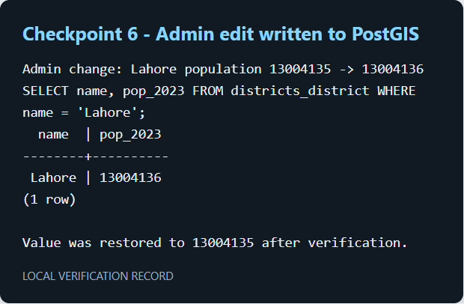
Figure 10. SQL query result in PostGIS while the temporary value was set.

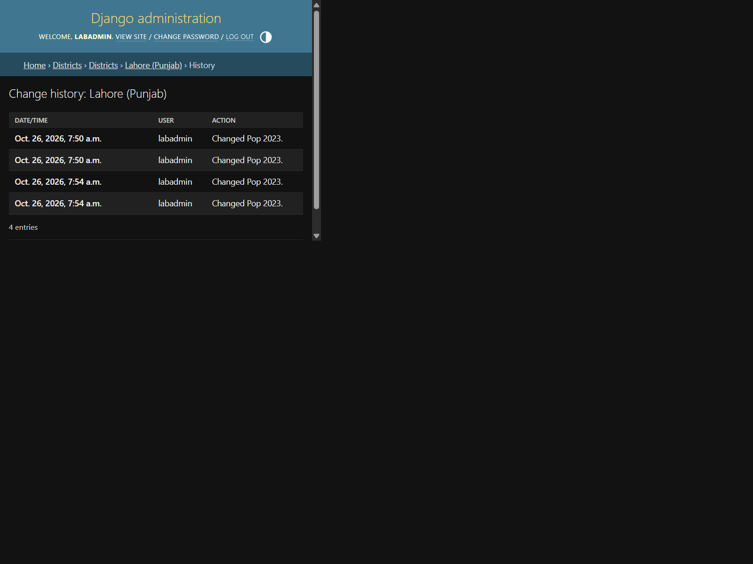
Figure 11. Django admin change history for Lahore.

Checkpoint 7 - Leaflet map fed by Django
Leaflet fetches /api/districts/ from Django rather than reading a static GeoJSON file. The live page shows 160 districts; hovering displays a district tooltip. The browser request returned HTTP 200, content type application/geo+json, and 1,026,495 bytes.
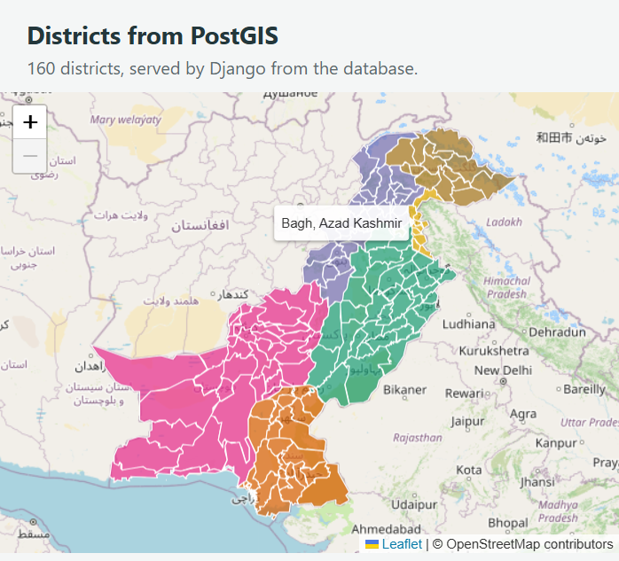
Figure 12. Live Leaflet map with a district tooltip and click popup.
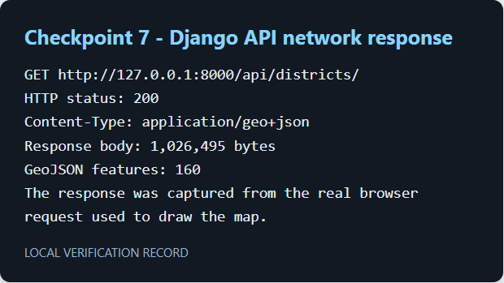
Figure 13. Measured response status, media type, payload size, and feature count from the actual map request.

Checkpoint 8 - PostGIS spatial question (extension)
The browser sends named lat and lng parameters; Django creates Point(lng, lat, srid=4326) and filters with geom__contains, which runs a PostGIS ST_Contains query. The example coordinate (72.9906, 33.6423) falls in Islamabad. A separate SQL query compares stored area, geodesic area, and Web Mercator area.

Area comparison (km2)
District | Stored | Geodesic | Web Mercator
Gilgit | 4,016 | 4,015 | 6,133
Gwadar | 11,574 | 11,574 | 14,244
Lahore | 1,730 | 1,730 | 2,385
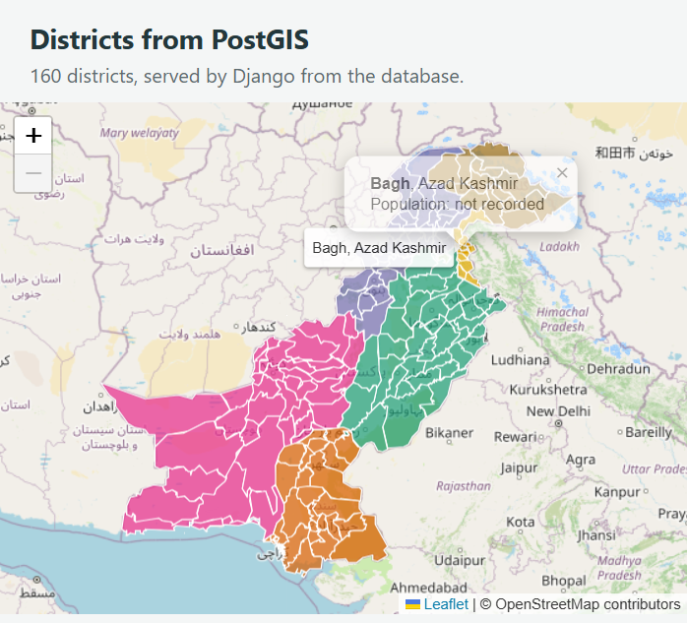
Figure 14. Map click calls the PostGIS-backed point-in-polygon endpoint and displays the result.
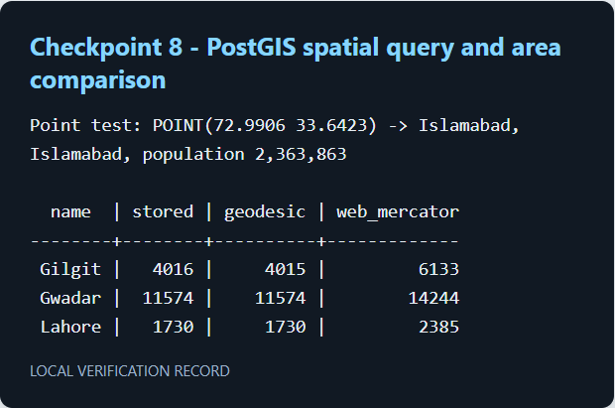
Figure 15. Point test and Part 8 area-comparison output.

Handout questions - answers

1. What can Django/PostGIS do instead of sending every visitor the whole file?
It can filter the response on the server (for example, return only Sindh's 29 districts) and answer spatial questions such as which district contains a clicked coordinate. The API returns GeoJSON generated from database rows.

2. Why use an environment variable for the database password?
Settings are source-controlled and may be shared. Reading the password from WEBGIS_DB_PASSWORD keeps credentials out of committed code and lets each machine configure its own connection.

3. What does the GiST index do, and which query uses it?
The GiST index is a spatial index that narrows candidate geometries before exact spatial tests. The point-in-polygon geom__contains query (PostGIS ST_Contains) benefits from it.

4. Why wrap Polygon geometries as MultiPolygon?
The model column accepts only MultiPolygon geometries. A plain Polygon would violate the column's geometry-type constraint and PostgreSQL would reject the insert; wrapping a Polygon as a one-part MultiPolygon preserves its shape.

5. Who should have an admin login?
Only trusted data maintainers who need to edit the authoritative district records. Public users should use the read-only map/API rather than an account that can change or delete records.

6. Where are the two coordinate orders used?
Leaflet reports events as latitude then longitude. The URL keeps these in named lat and lng parameters; Django passes them to Point(lng, lat), the longitude-first order required by GIS geometry and GeoJSON.

Errors and recovery
No installation errors occurred. One initial test fixture used an invalid two-point LinearRing; it was corrected to a closed polygon ring and all five tests then passed. The final dataset and Lahore population were verified after the admin edit was reverted.

Run the project again
cd C:\webgis-lab\lab4
venv\Scripts\Activate.ps1
python manage.py runserver 127.0.0.1:8000
Admin: http://127.0.0.1:8000/admin/ - Map: http://127.0.0.1:8000/ - API: http://127.0.0.1:8000/api/districts/
Local admin account: labadmin. Its generated password is provided separately and is not saved in this report or source files.

