PowerShell Runbook to list out Azure Resources Settings

Amjad Nagori

Table of Contents

Variables Description 3

Pre-Requisites 3

Create Azure Runbook 5

# Variables Description

**Variables:**

1. storageaccount: Destination Storage account name in which output file should be uploaded.
2. storageaccountrg: Resource Group name for above storage account.
3. container: Destination container.

**Example:**

$storageaccount = "storage1248765"

$storageaccountrg = "test-rg"

$container = "az-resource-settings"

# Pre-Requisites

1. Azure Automation Account should be created with Run as Account.

Follow below document and refer screenshot if Automation account is not already created.

<https://docs.microsoft.com/en-us/azure/automation/automation-create-standalone-account>

<https://docs.microsoft.com/en-us/azure/automation/create-run-as-account>

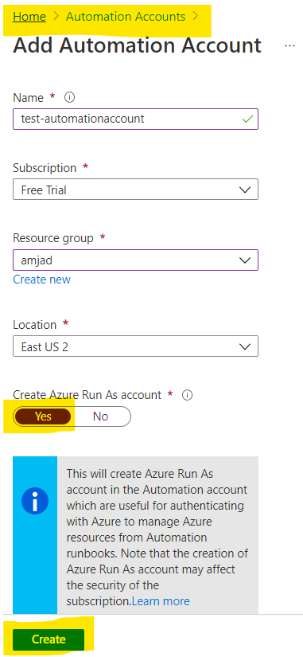

1. Go to Azure Portal and search for Automation Account.

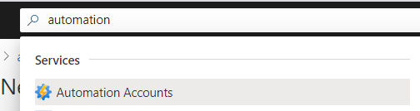

1. Open your Automation Account and go to Module Gallery.

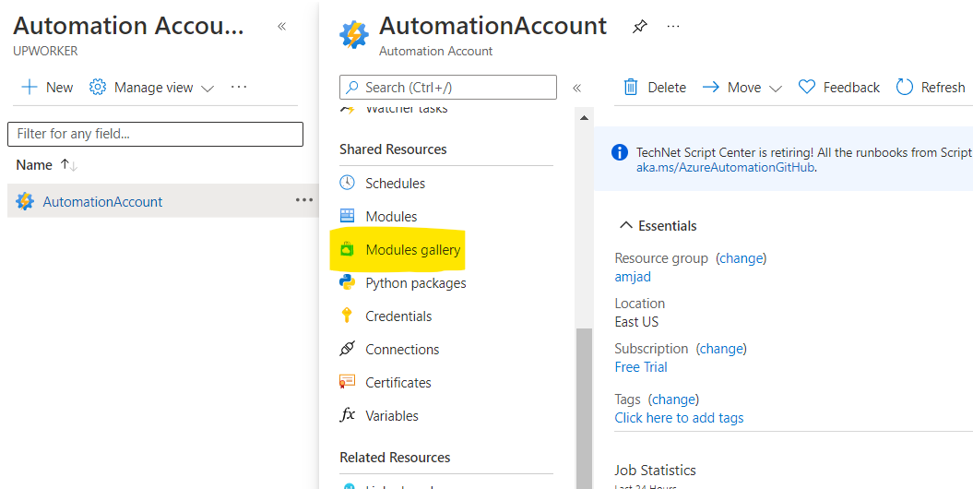

1. Search for Az and select Az.Accounts > Import it.

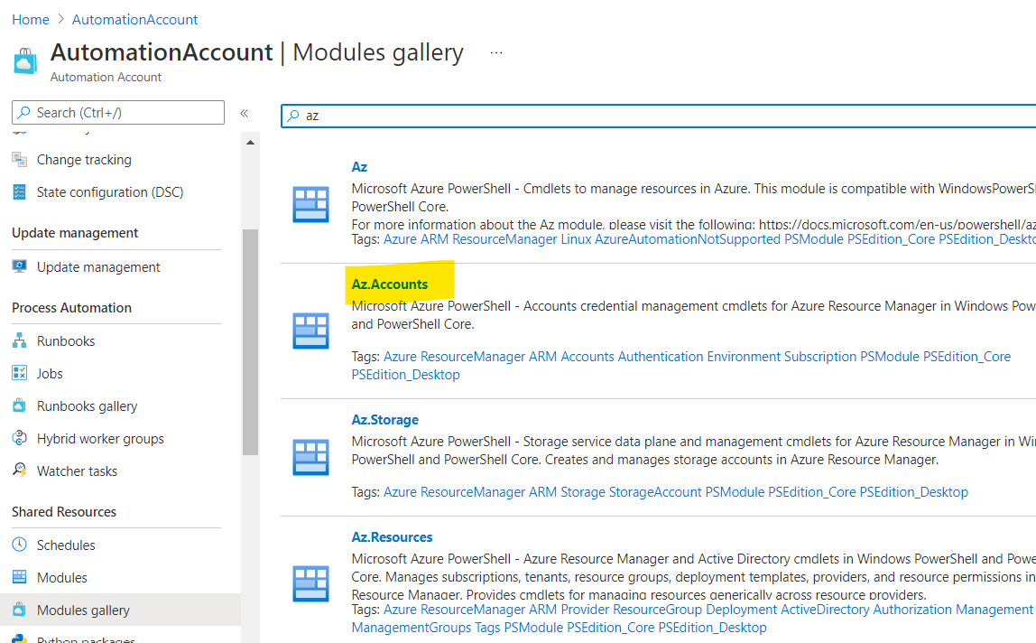

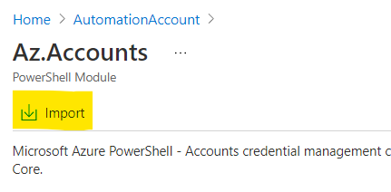

1. Wait for few minutes to complete the import.
2. Repeat steps 2 to 5 for below modules too.
3. Az.Comput
4. Az.Network
5. Az.Resource
6. Az.Storage
7. Az.KeyVault
8. Az.Sql
9. Az.Websites
10. Az.CosmosDB
11. Once import is completed then validate all the installed modules should be available in Modules tab.

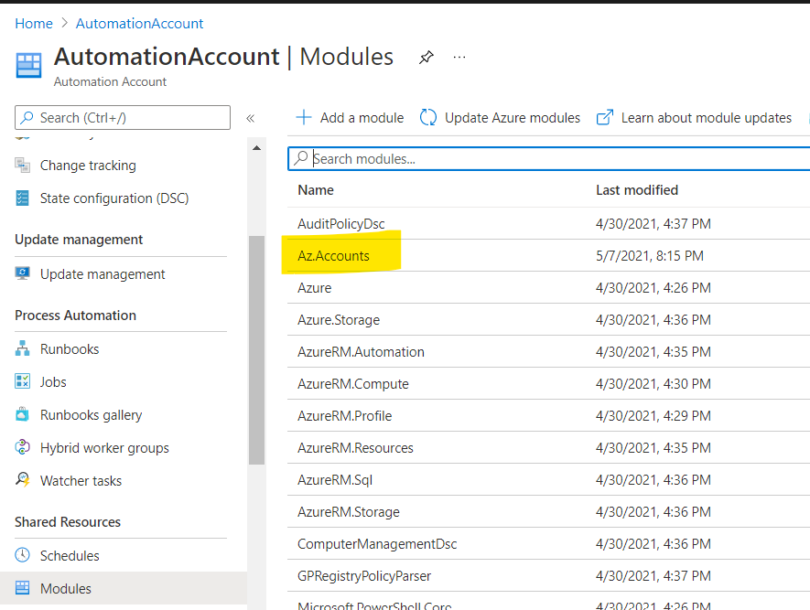

# Create Azure Runbook

1. Go to Automation Account and select Runbooks > click on Create a runbook and provide below details.

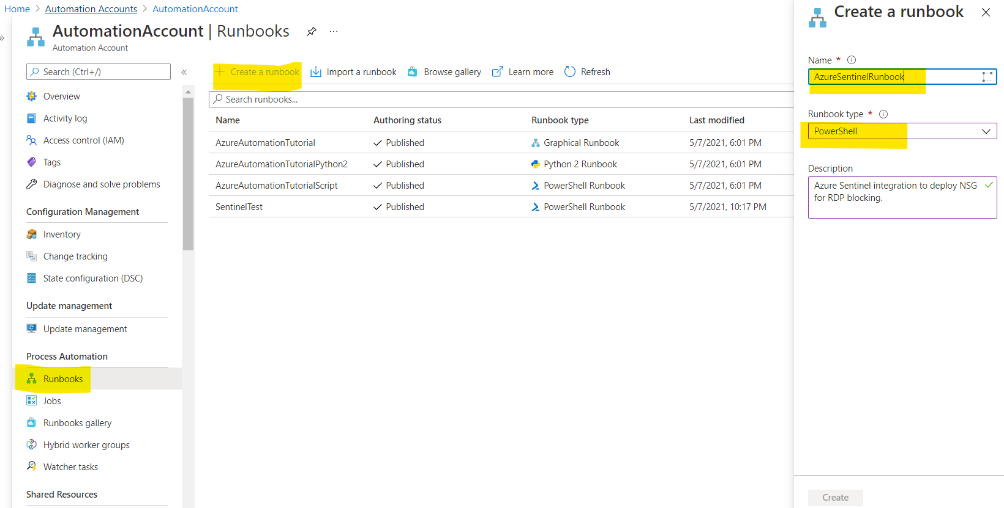

**Name:** Runbook name (you can choose whatever you want)

**Runbook type:** PowerShell

**Description:** Whatever you want.

1. Once Runbook created, it will redirect you to the Edit windows.
2. Copy and paste code from PowerShell file into it.
3. Change Storage Account parameters in below section of script.

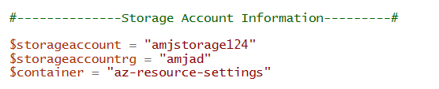

1. Click on Save and then Publish.

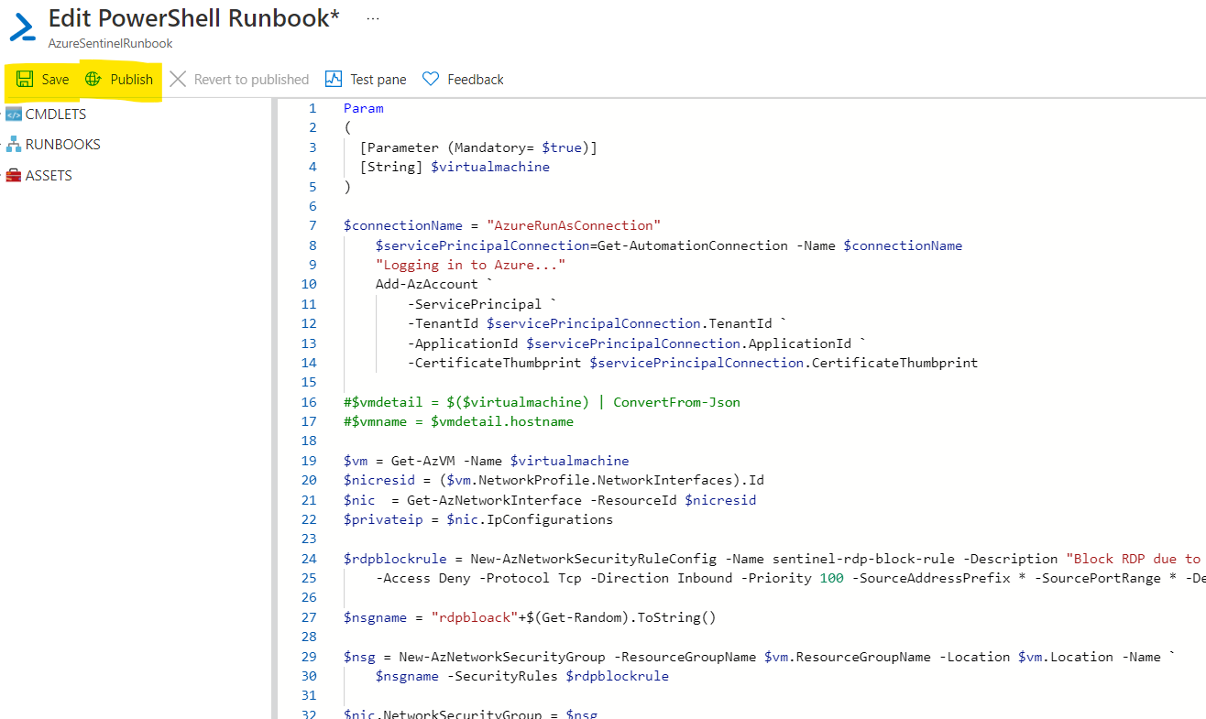

1. Repeat the same above steps for all other PowerShell file and create individual runbook for the same.