|  |  |
| --- | --- |
|  | **BAHRIA UNIVERSITY,**  **(Karachi Campus)**  *Department of Computer Science*  **ASSIGNMENT#02 – Spring 2023** |

COURSE TITLE: **Software Applications for Mobile Devices** COURSE CODE: **SEN-448**

Class: **BSE – 6(A, B)** Shift: **Morning**

Course Instructor: **Engr. M. Adnan Ur Rehman** Date: **14-Apr-2023**

Due Date: **21-Apr-2023** Max. Points: **20 Points**

**Instructions:**

* This is a group assignment. Maximum three number of members are allowed per group. All members of a group MUST submit the same copy through LMS. Submission is permitted on ***LMS***.
* You must upload only compressed (.zip) version of app\src\main folder.
* Be aware of PLAGIARISM.

|  |  |
| --- | --- |
| **Enrolment#** | **Student Name** |
| 02-131202-041 | Muhammad Amjad |

**TASK-1:** **[CLO3, PLO4, C3, 20 points]**

Create an android application which can demonstrate all the events of activity life cycle. Your application must show event logs on main screen for all possible callbacks.

***Hint:***

Your UI may looks like as follows:

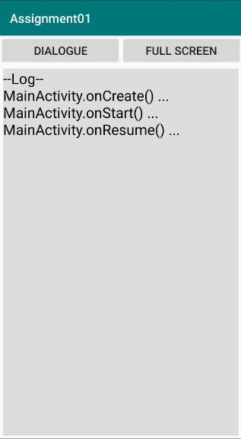 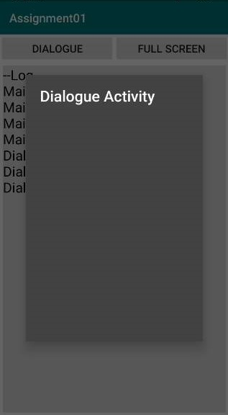 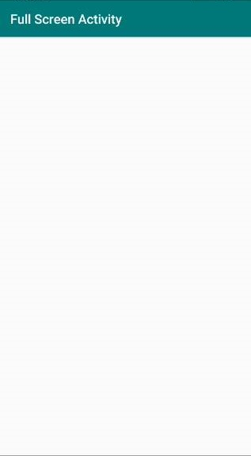

**Outputs:**

**Note: I have used ScrolledView where the log is displaying.**

**All layouts which I design is displayed below:**

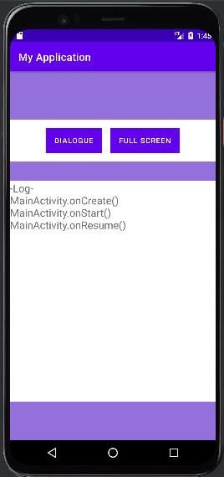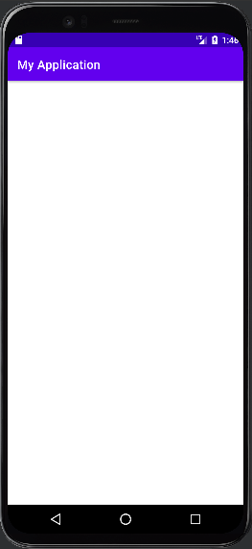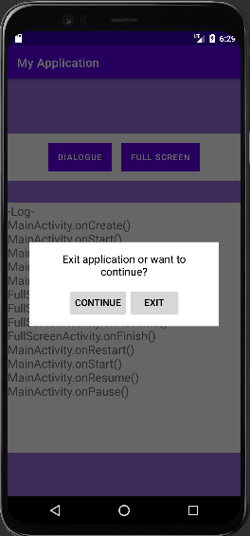

**MainActivity() FullScreenActivity() DialogActivity()**

**Opening FullScreenActivity and press back button:**

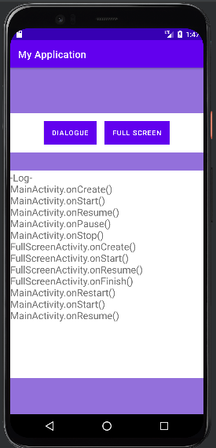

**Opening DialogBoxActivity and press back button:**

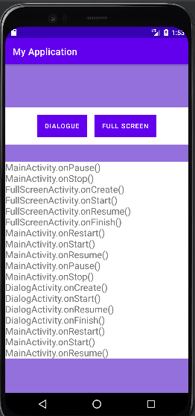

**Opening DialogBoxActivity and press continue button:**

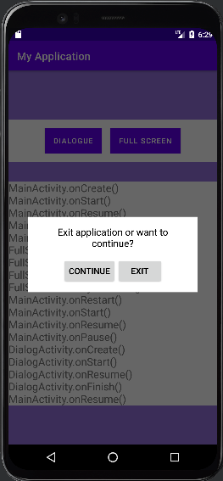 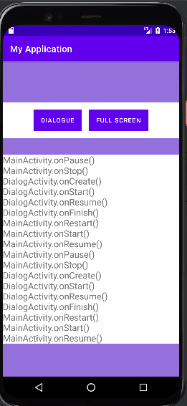

**Opening DialogBox and Press Exit Button:**

Application will be exit

