LAB # 01
Task # 01: Make a 5 page website, including home page, linked altogether having header and footer section mandatorily. Web pages should cover all the html tags overall eg : make a gallery page with the help of table tag and insert images in that.
Topic for the website can be anything. No css required.
Make sure to use all tags mentioned in slides.
Solution:
- Home:
<!DOCTYPE html>
<html lang="en">
<head>
<meta charset="UTF-8">
<meta http-equiv="X-UA-Compatible" content="IE=edge">
<meta name="viewport" content="width=device-width, initial-scale=1.0">
<title>Apple | Home</title>
<link rel="stylesheet" href="style.css">
</head>
<body>
<header>
<nav class="navbar">
<ul>
<h1>Apple Store |</h3>
<li ><a href="Home.html" style="color: black;">Home</a></li>
<li><a href="Iphone.html">Iphone</a></li>
<li><a href="Laptop.html">Laptop</a></li>
<li><a href="Desktop.html">Desktop</a></li>
<li><a href="About.html">About Us</a></li>
</ul>
</nav>
</header>
<div class="container" style="text-align: center;">
<br>
<h1>Welcome to Apple Store</h1>
<br>
<img src="apple2.jpg" width="600vh" height="300vh">
<br>
<figure>Apple staff make bid for first union at a US store - BBC News</figure>
<br><br>
<hr>
<marquee><b>IPhone 14 now available in store.&nbsp;&nbsp;&nbsp;Check it now&nbsp;&nbsp;&nbsp;&nbsp;&nbsp;&nbsp;&nbsp;&nbsp;&nbsp;&nbsp;&nbsp;&nbsp;&nbsp;&nbsp;&nbsp;&nbsp;&nbsp;&nbsp;&nbsp;&nbsp;&nbsp;&nbsp;&nbsp;&nbsp;&nbsp;&nbsp;&nbsp;&nbsp;&nbsp;&nbsp;&nbsp;&nbsp;&nbsp;&nbsp;&nbsp;&nbsp;&nbsp;&nbsp;&nbsp;&nbsp;&nbsp;&nbsp;&nbsp;&nbsp;&nbsp;&nbsp;&nbsp;&nbsp;&nbsp;&nbsp;&nbsp;&nbsp;&nbsp;&nbsp;&nbsp;&nbsp;&nbsp;&nbsp;&nbsp;&nbsp;&nbsp;&nbsp;&nbsp;&nbsp;&nbsp;&nbsp;&nbsp;&nbsp;&nbsp;&nbsp;&nbsp;&nbsp;&nbsp;&nbsp;&nbsp;&nbsp;&nbsp;&nbsp;&nbsp;&nbsp;Laptop and Desktop prices has changed.Check it now</b></marquee>
<hr>
<br>
<p>Lorem ipsum dolor sit amet consectetur, adipisicing elit. Ut at harum debitis non quos perspiciatis iusto cumque quisquam perferendis aspernatur temporibus in, magni dolor, officiis incidunt eveniet nemo accusamus dolore inventore, commodi facilis soluta mollitia. Mollitia ut odio dolorem obcaecati quos laboriosam minus iusto nihil suscipit earum? Illo, possimus itaque!</p><br>
<img src="apple.png" width="600vh" height="300vh"><br>
<p>Lorem ipsum dolor sit amet consectetur, adipisicing elit. Mollitia dolorem amet accusantium blanditiis repellat ad quibusdam accusamus quos obcaecati ut.</p><br>
</div>
</body>
<footer >
<div class="container" style="background-color:black ;height: 20vh; color: white;text-align: center;">
<br><br>
<h3>About Company</h3>
<p>Lorem ipsum dolor sit amet consectetur adipisicing elit. Placeat sunt, minus sapiente repellendus dicta dolore ipsa corporis nobis nostrum, odio praesentium explicabo, ex dolor cupiditate maxime? Explicabo repellat blanditiis atque!</p>
</div>
</footer>
</html>
- Iphone:
<!DOCTYPE html>
<html lang="en">
<head>
<meta charset="UTF-8">
<meta http-equiv="X-UA-Compatible" content="IE=edge">
<meta name="viewport" content="width=device-width, initial-scale=1.0">
<title>Apple | Home</title>
<link rel="stylesheet" href="style.css">
</head>
<body>
<header>
<nav class="navbar">
<ul>
<h1>Apple Store |</h3>
<li ><a href="Home.html">Home</a></li>
<li><a href="Iphone.html" style="color: black;">Iphone</a></li>
<li><a href="Laptop.html">Laptop</a></li>
<li><a href="Desktop.html">Desktop</a></li>
<li><a href="About.html">About Us</a></li>
</ul>
</nav>
</header>
<div class="container" style="text-align: center; align-items: center;">
<br>
<h1>Available Iphone</h1>
<br>
<table style="margin-left: auto;margin-right:auto;">
<tr>
<td>
<br>
<img src="iphone7.png" alt="" width="200vh" height="250vh"><br><br>
<h3>Iphone 7</h3><br>
<figure>Price:121324</figure><br>
</td>
<td>
<br>
<img src="iphone8.png" alt="" width="200vh" height="250vh"><br><br>
<h3>Iphone 8</h3><br>
<figure>Price:121324</figure><br>
</td>
<td>
<br>
<img src="iphoneX.png" alt="" width="200vh" height="250vh"><br><br>
<h3>Iphone X</h3><br>
<figure>Price:121324</figure><br>
</td>
<td>
<br>
<img src="iphone11.png" alt="" width="200vh" height="250vh"><br><br>
<h3>Iphone 11</h3><br>
<figure>Price:121324</figure><br>
</td>
<td>
<br>
<img src="iphone11p.png" alt="" width="200vh" height="250vh"><br><br>
<h3>Iphone 11 Pro Max</h3><br>
<figure>Price:121324</figure><br>
</td>
</tr>
<tr>
<td>
<br>
<img src="iphone12.png" alt="" width="200vh" height="250vh"><br><br>
<h3>Iphone 12</h3><br>
<figure>Price:121324</figure><br>
</td>
<td>
<br>
<img src="iphone13.png" alt="" width="200vh" height="250vh"><br><br>
<h3>Iphone 13</h3><br>
<figure>Price:121324</figure><br>
</td>
<td>
<br>
<img src="iphone13p.png" alt="" width="200vh" height="250vh"><br><br>
<h3>Iphone 13 Pro</h3><br>
<figure>Price:121324</figure><br>
</td>
<td>
<br>
<img src="iphone14.png" alt="" width="200vh" height="250vh"><br><br>
<h3>Iphone 14</h3><br>
<figure>Price:121324</figure><br>
</td>
<td>
<br>
<img src="iphone14p.png" alt="" width="200vh" height="250vh"><br><br>
<h3>Iphone 14 Pro</h3><br>
<figure>Price:121324</figure><br>
</td>
</tr>
</table>
<br>
<h2>Sale Upto 20% on each item</h1>
<br>
</div>
</body>
<footer style="padding-bottom:-10px;margin-bottom: -10px;">
<div class="container" style="background-color:black ;height: 20vh; color: white;text-align: center;">
<br><br>
<h3>About Company</h3>
<p>Lorem ipsum dolor sit amet consectetur adipisicing elit. Placeat sunt, minus sapiente repellendus dicta dolore ipsa corporis nobis nostrum, odio praesentium explicabo, ex dolor cupiditate maxime? Explicabo repellat blanditiis atque!</p>
</div>
</footer>
</html>
- Laptop:
<!DOCTYPE html>
<html lang="en">
<head>
<meta charset="UTF-8">
<meta http-equiv="X-UA-Compatible" content="IE=edge">
<meta name="viewport" content="width=device-width, initial-scale=1.0">
<title>Apple | Home</title>
<link rel="stylesheet" href="style.css">
</head>
<body>
<header>
<nav class="navbar">
<ul>
<h1>Apple Store |</h3>
<li ><a href="Home.html">Home</a></li>
<li><a href="Iphone.html">Iphone</a></li>
<li><a href="Laptop.html" style="color: black;">Laptop</a></li>
<li><a href="Desktop.html">Desktop</a></li>
<li><a href="About.html">About Us</a></li>
</ul>
</nav>
</header>
<br>
<div class="container" style="text-align: center;">
<br>
<h1>Available Laptop</h1>
<br>
<table style="margin-left: auto;margin-right:auto;">
<tr>
<td>
<img src="air13.png" alt="" width="300vh" height="200vh"><br><br>
<h3>Apple Air 13</h3><br>
<figure>Price:121324</figure><br>
</td>
<td>
<img src="air13.png" alt="" width="300vh" height="200vh"><br><br>
<h3>Apple Air 14</h3><br>
<figure>Price:121324</figure><br>
</td>
<td>
<img src="air13.png" alt="" width="300vh" height="200vh"><br><br>
<h3>Apple Air 15</h3><br>
<figure>Price:121324</figure><br>
</td>
</tr>
<tr>
<td>
<img src="air13.png" alt="" width="300vh" height="200vh"><br><br>
<h3>Apple Air 16</h3><br>
<figure>Price:121324</figure><br>
</td>
<td>
<img src="air13.png" alt="" width="300vh" height="200vh"><br><br>
<h3>Apple Air 17</h3><br>
<figure>Price:121324</figure><br>
</td>
<td>
<img src="air13.png" alt="" width="300vh" height="200vh"><br><br>
<h3>Apple Air 18</h3><br>
<figure>Price:121324</figure><br>
</td>
</tr>
</table>
</div>
</body>
<footer >
<div class="container" style="background-color:black ;height: 20vh; color: white;text-align: center;">
<br><br>
<h3>About Company</h3>
<p>Lorem ipsum dolor sit amet consectetur adipisicing elit. Placeat sunt, minus sapiente repellendus dicta dolore ipsa corporis nobis nostrum, odio praesentium explicabo, ex dolor cupiditate maxime? Explicabo repellat blanditiis atque!</p>
</div>
</footer>
</html>
- Desktop:
<!DOCTYPE html>
<html lang="en">
<head>
<meta charset="UTF-8">
<meta http-equiv="X-UA-Compatible" content="IE=edge">
<meta name="viewport" content="width=device-width, initial-scale=1.0">
<title>Apple | Home</title>
<link rel="stylesheet" href="style.css">
</head>
<body>
<header>
<nav class="navbar">
<ul>
<h1>Apple Store |</h3>
<li ><a href="Home.html" >Home</a></li>
<li><a href="Iphone.html">Iphone</a></li>
<li><a href="Laptop.html">Laptop</a></li>
<li><a href="Desktop.html" style="color: black;">Desktop</a></li>
<li><a href="About.html" >About Us</a></li>
</ul>
</nav>
</header>
<div class="container" style="text-align: center;">
<br>
<h1>Available Desktop</h1>
<br>
<table style="margin-left: auto;margin-right:auto;">
<tr>
<td>
<img src="m1.png" alt="" width="300vh" height="200vh"><br><br>
<h3>Apple M1</h3><br>
<figure>Price:121324</figure><br>
</td>
<td>
<img src="m1.png" alt="" width="300vh" height="200vh"><br><br>
<h3>Apple M2</h3><br>
<figure>Price:121324</figure><br>
</td>
<td>
<img src="m1.png" alt="" width="300vh" height="200vh"><br><br>
<h3>Apple M3</h3><br>
<figure>Price:121324</figure><br>
</td>
</tr>
<tr>
<td>
<img src="m1.png" alt="" width="300vh" height="200vh"><br><br>
<h3>Apple M4</h3><br>
<figure>Price:121324</figure><br>
</td>
<td>
<img src="m1.png" alt="" width="300vh" height="200vh"><br><br>
<h3>Apple M5</h3><br>
<figure>Price:121324</figure><br>
</td>
<td>
<img src="m1.png" alt="" width="300vh" height="200vh"><br><br>
<h3>Apple M6</h3><br>
<figure>Price:121324</figure><br>
</td>
</tr>
</table>
</div>
</body>
<footer >
<div class="container" style="background-color:black ;height: 20vh; color: white;text-align: center;">
<br><br>
<h3>About Company</h3>
<p>Lorem ipsum dolor sit amet consectetur adipisicing elit. Placeat sunt, minus sapiente repellendus dicta dolore ipsa corporis nobis nostrum, odio praesentium explicabo, ex dolor cupiditate maxime? Explicabo repellat blanditiis atque!</p>
</div>
</footer>
</html>
- About Us:
<!DOCTYPE html>
<html lang="en">
<head>
<meta charset="UTF-8">
<meta http-equiv="X-UA-Compatible" content="IE=edge">
<meta name="viewport" content="width=device-width, initial-scale=1.0">
<title>Apple | Home</title>
<link rel="stylesheet" href="style.css">
</head>
<body>
<header>
<nav class="navbar">
<ul>
<h1>Apple Store |</h3>
<li ><a href="Home.html">Home</a></li>
<li><a href="Iphone.html">Iphone</a></li>
<li><a href="Laptop.html">Laptop</a></li>
<li><a href="Desktop.html">Desktop</a></li>
<li><a href="About.html" style="color: black;">About Us</a></li>
</ul>
</nav>
</header>
<div class="container" >
<br>
<h1 style="text-align: center;">About Us</h1>
<br>
<p style="text-align: center;">
<img src="apple2.jpg" width="600vh" height="300vh" >
<br>
Lorem ipsum dolor sit amet consectetur, adipisicing elit. Minus sit ducimus obcaecati quibusdam vitae. Fugit, dignissimos voluptatem? Assumenda in velit quo unde. Architecto debitis minus dignissimos eos adipisci quisquam est impedit amet quo eligendi aspernatur quis blanditiis, a perferendis itaque pariatur voluptatem culpa repudiandae officiis vitae reprehenderit similique harum error?</p>
<br>
<table style="margin-left: auto;margin-right:auto;">
<tr>
<th>
Phone No.
</th>
<td>123982</td>
</tr>
<tr>
<th>Telephone No.</th>
<td>091230913</td>
</tr>
</table>
<br>
</div>
</body>
<footer >
<div class="container" style="background-color:black ;height: 20vh; color: white;text-align: center;">
<br>
<h3>About Company</h3>
<p>Lorem ipsum dolor sit amet consectetur adipisicing elit. Placeat sunt, minus sapiente repellendus dicta dolore ipsa corporis nobis nostrum, odio praesentium explicabo, ex dolor cupiditate maxime? Explicabo repellat blanditiis atque!</p>
</div>
</footer>
</html>

Output:
- Home:
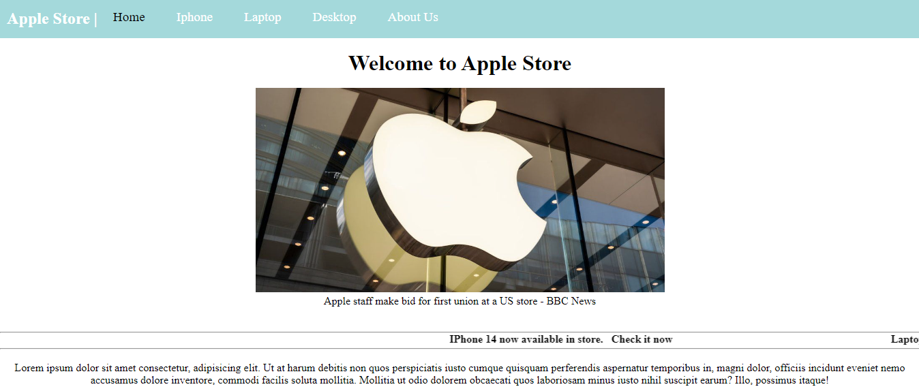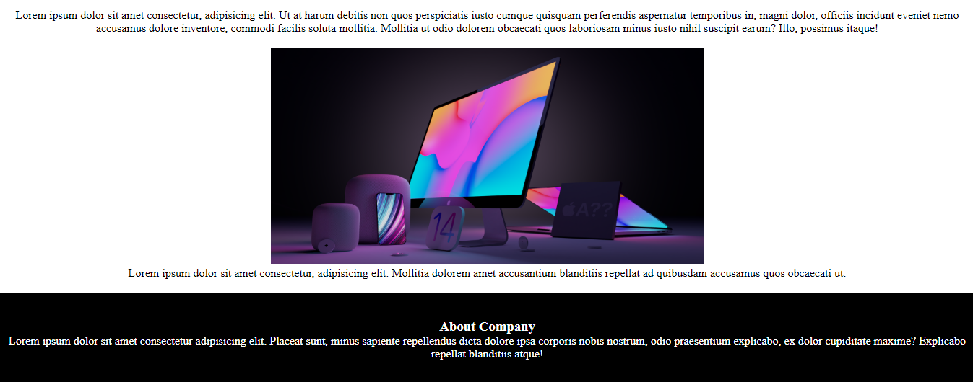

- Iphone:
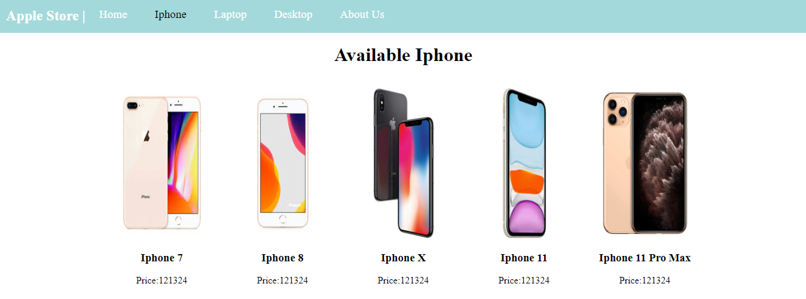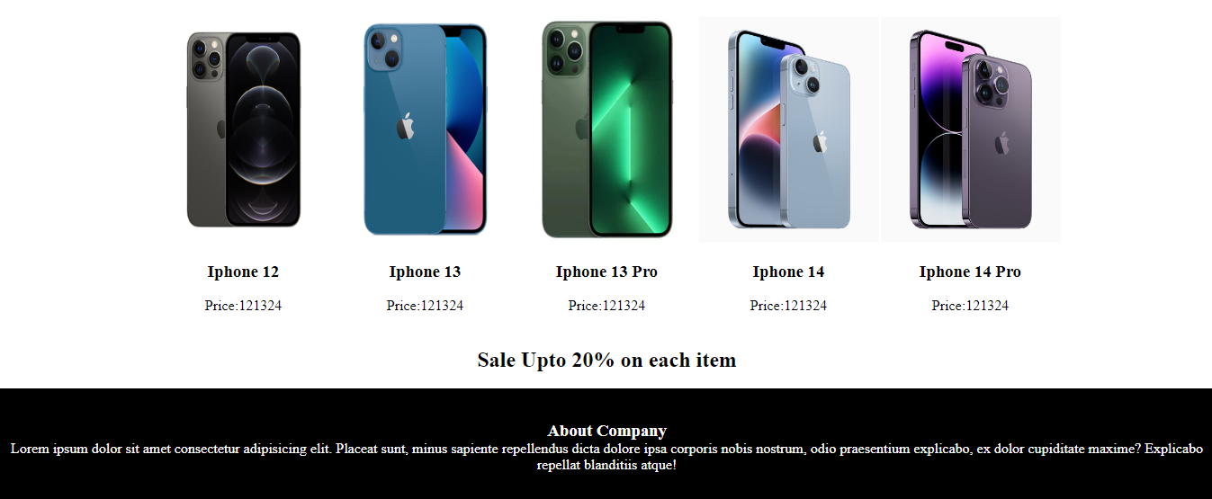

- Laptop:
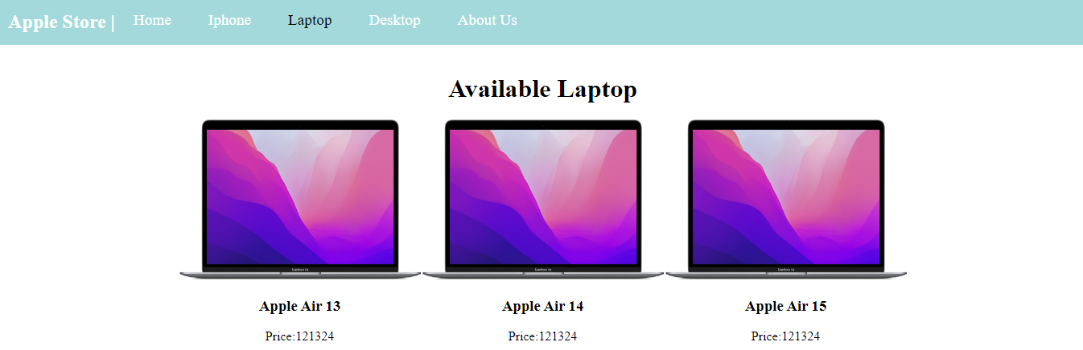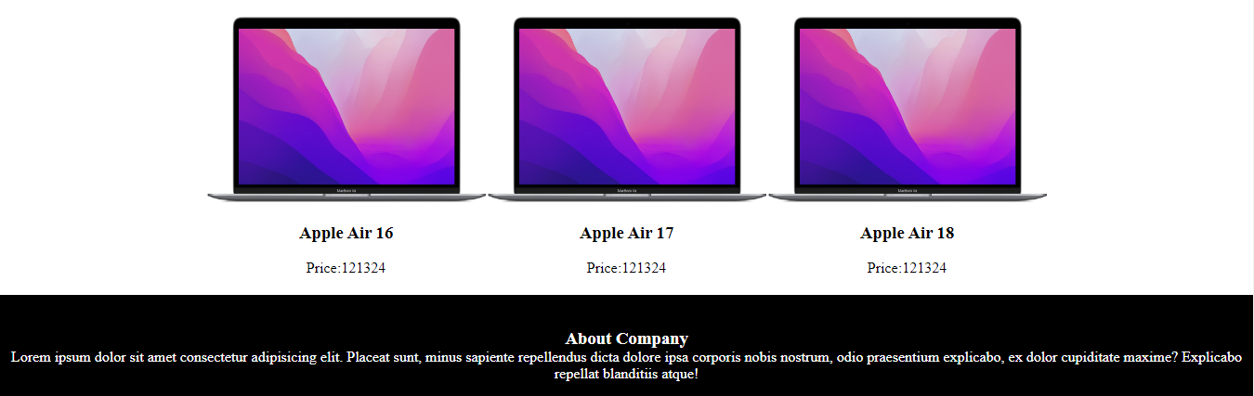

- Desktop:
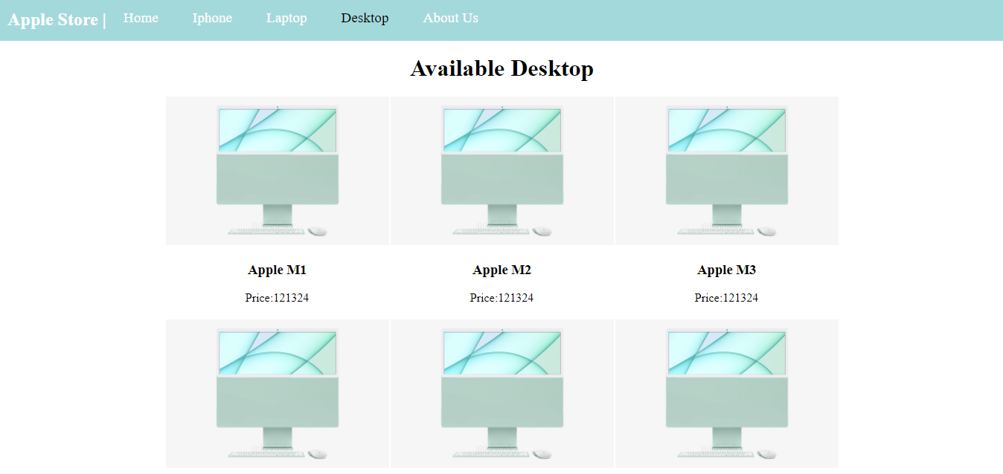
- About Us:
