Computer Science Department  
College of Engineering and Information Technology  
Programming principles II 10671102   
Mini-Project  
Inheritance and Polymorphism

Concepts

• Inheritance  
• Polymorphism

Overview

This project introduces polymorphism and provides additional practice translating UML diagrams into code.

Description

In this project, you will implement the inheritance hierarchy provided below. Notice, that the Employee class has annualPay and monthlyPay methods. The annualPay method is also present in the Manager, Staff, FullTime, and PartTime classes, while the monthlyPay is present in the SalariedEmployee and HourlyEmployee classes. This will give us our first look at polymorphic behavior.

Employee Class Hierarchy

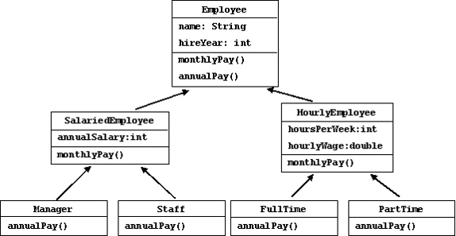

Implement the seven classes shown above. The pay calculations should be implemented as follows:

Monthly pay:

• Employee: simply return zero  
• SalariedEmployee: annualSalary / 12  
• HourlyEmployee: HoursPerWeek X 4 X hourlyWage

Annual pay:

• Employee: simply return zero  
• Manager: annual salary + 10% bonus  
• Staff: annual salary + 2% bonus per year of service up to 5 years  
• FullTime: 50 weeks of wages + 2 weeks wages as bonus  
• PartTime: 50 weeks of wages (no bonus)

Execution

In the main method reads this data file (EmployeeData.txt) containing employee information, instantiates the appropriate objects, and adds them to Vector that holds Employee objects. Using a for loop, you will need to add the code to the toString() method that iterates through the vector and returns each employee's name, monthly pay, and annual pay and print its returned value. You should call the Employee object's monthlyPay and annualPay methods to get these values. You will also need to implement all of the subclasses.

Your output should look something like this:

Johnson Monthly Pay: 5416.67 Annual Pay: 71500.00  
Thomas Monthly Pay: 8083.33 Annual Pay: 106700.00  
Olson Monthly Pay: 4333.33 Annual Pay: 55120.00  
Lewis Monthly Pay: 1250.00 Annual Pay: 15625.00  
Campion Monthly Pay: 3000.00 Annual Pay: 39000.00  
Davis Monthly Pay: 8750.00 Annual Pay: 115500.00  
Wiley Monthly Pay: 585.00 Annual Pay: 7312.50  
Parsons Monthly Pay: 3600.00 Annual Pay: 46800.00  
  
  
  
(EmployeeData.txt)  
  
Staff Johnson 1994 65000  
Manager Thomas 2003 97000  
Staff Olson 2004 52000  
Parttime Lewis 2006 25 12.50  
Fulltime Campion 2005 40 18.75  
Manager Davis 1996 105000  
Parttime Wiley 2007 15 9.75  
Fulltime Parsons 2002 40 22.50