**A Mobile App Architecture for Real-time Mobile Stock Trend Analysis System**

Alghamdi Amjad Ahmed (M2016721)

amjad.alghamdi@yahoo.com

school of computer science,kookmin university

Korea,Seoul

**ABSTRACT:** The stock exchange is important element in development of economy of any country.It is differs from other markets that it does not contain real assets, but securities or financial assets.There are many information to show it in stock exchange and rules to follow.The development of stock trend information system is normally difficult with lack of technical and financial resources.Consequently, the investor may be exposed to a significant loss if try to sells or buys securities based on inaccurate or unrelated data. **[1]**

This paper proposes a stock analysis mobile app architecture which use the resources of the existing stock information system.The stockholder interacts with data store via this for information about stock.This app reused the database and the web resources.The information fetch from the database and fetched data is presented via user friendly designed screens.The app enables delivery of information to stockholder on their mobile devices which is accessible worldwide and anytime. This keeps them informed and updated every time.

**Keywords**: Capital market,Mobile App, Information system,SOA, Stock Analysis, Stock Manager, Web Services, 3-Tier Architecture.

**1**. **Introduction**

The internet’s arrival and its subsequent popularity in world have made online trading possible in world. Which is about the online purchase and sales of shares, one of the extremely popular means of trading. Both beginner and experienced traders and investors are milking this opportunity by trading online in futures and options, stocks and currencies worldwide. Such opportunities are in the form of reduced brokerage and commissions, better broking services etc.**[2]**

The use of advanced technology have positively improving the standard of living and also improving the country's economy.Such as online trading, in equity markets it increased trade volumes and number of investors trading in stock markets. Generally an online trading system allows the investor to trade through an internet site where the major financial products and services like equities, mutual funds, life insurance, general insurance, loans, share trading, commodities trading, portfolio management and financial planning etc. are directly available for the customer. **[3]**

There is also stock option trading. An option is a financial agreement, with a predetermined maturity period and price, for the purchase or sales of the underlying products. Stock options enable the protection of dealers and control of their stocks, in addition to generation of higher earnings.

For carrying out online trading,normally you have to open an online demat and trading account with broker, followed with online trading software. For this purpose, need a Depository Participant (DP), the selection هs done through extensive research on different determinants.This takes longer than necessary and it is an inefficient way. And this caused the monopoly and reduce the activity in trading, which affects the efficiency of stock trading markets.

In order to overcome these obstacles, we must establish a fully automated online system that reaches by everyone and from anywhere ‘SCREEN BASED TRADING SYSTEM’. **[4][5]**

**2. Why Mobile App for Stock Analysis System?**

Whenever any stockholder want to get information about any stock’s current price or previous price or comparison of price for required period of time. Stock holder require to search on many website, and to gather lot of information from different websites or Stock company.This app provides tis in personalized nature, personalized nature of this information eliminates the hassle of searching long list for finding individual information. Figure 1 demonstrates how mobile app can help by delivering all the related,required information to our mobile in a gracious manner.

**3. Present System Analysis and Model Study**

**3.1 Definition**

System Analysis is the detailed study of the various operations performed by the system and their relationships within and outside the system. Analysis is the process of breaking something into its parts so that the whole may be understood.System analysis is identify the problem and determine the variables related to it, analysis of different factors and determine the best solution. During this alternate system solutions are studied and recommendations are made about committing the resources used to design the system.(Ref Uni. Akyureyri).**[6][9]**

**3.2 Proposed System and Technical Study**

Stock Analysis is aimed at developing a web-based system. In this system the person can make analysis of Stock online and do many things. The details of all the things are made available to them through the web.

**Advantage:**

▪ This app provides list of all available Stock in market.

▪ This app provides all the users to save their favorite stock in separate list.

▪ The app provides facility to user to see the live/current price of Stock.

* The app provides facility to user to analyze price of Stock based on its value in past days.

▪ The system UI is user friendly.

**3.3 Feasibility Study**

A feasibility analysis usually involves a thorough assessment of the operational (need), financial and technical aspects of a proposal. Feasibility study is the test of the system proposal made to identify whether the user needs may be satisfied using the current software and hardware technologies, whether the system will be cost effective from a business point of view and whether it can be developed with the given budgetary constraints. A feasibility study should be relatively cheap and done at the earliest possible time. Depending on the study, the decision is made whether to go ahead with a more detailed analysis. **[7]**

When a new project is proposed, it normally goes through feasibility assessment. Feasibility study is carried out to determine whether the proposed system is possible to develop with available resources and what should be the cost consideration. Facts considered in the feasibility analysis were.

* Technical Feasibility
* Economic Feasibility
* Behavioral Feasibility

**3.3.1 Technical Feasibility**

Technical Feasibility deals with the hardware as well as software requirements. Technology is not a constraint to type system development. We have to find out whether the necessary technology, the proposed equipment have the capacity to hold the data, which is used in the project, should be checked to carry out this technical feasibility.

The technical feasibility issues usually raised during the feasibility stage of investigation includes these .

**3.3.2 Economical Feasibility**

This feasibility study present tangible and intangible benefits from the prefect by comparing the development and operational cost. The technique of cost benefit analysis is often used as a basis for assessing economic feasibility. This system needs some more initial investment than the existing system, but it can be justifiable that it will improve quality of service.

Thus feasibility study should center along the following points:

* Improvement resulting over the existing method in terms of accuracy, timeliness.

* Cost comparison.

.

* Estimate on the life expectancy of the hardware
* Overall objective

Our project is economically feasible. It does not require much cost to be involved in the overall process. The overall objectives are in easing out the requirement processes.

**3.3.3 Behavioral/ Operational Feasibility**

This analysis involves how it will work when it is installed and the assessment of political and managerial environment in which it is implemented. People are inherently resistant to change and computers have been known to facilitate change. The new proposed system is very much useful to the useful to the users and therefore it will accept broad audience from around the world.

**3.4 Waterfall Model**

The waterfall model is a sequential design process usually used in software development processes is illustrated in below figure.The progress of the work is in the form of fixed pieces flowing from top to bottom (eg waterfall) through the stages: Requirement, design, implementation, Verification,and maintenance.**[8]**

* **Requirement**
* **Design**
* **Implementation**
* **Verification**
* **Maintenance**



* **Requirement:-**

In the requirement phase the need to create the application is specified. What is the need of the system is defined. What information to be feeder to create the application will come under the requirement phase?

* **Design:**

After the requirement phase the next phase is the Design phase where the application is designed according to the forms and other modules created. This phase is much important phase because it will structure the layout of your application.

* **Implementation:**

Implementation is the process of having a system personnel phase check out and put new equipment into use, train users, install new application and construct any file of data need to use it.

* **Verification:**

After the whole application is being the developed the main phase is the verification phase where the whole application tested and verified to check the whole application.

* **Maintenance:**

After the successful verification of the application the main phase is the maintenance phase where the application needs to be maintained for its successful operation in future.

**4. Architecture of a ‘Stock Analysis System’ Mobile App**

When we want to design a completely new application is designed, a lot of effort goes into its development and testing to come up with a stable product. Reuse of existing open source resources offers various benefits in terms of reducing time, cost and effort involved in developing an application. Reuse is the practice of incorporating an asset in more than one system. Most of listed Stock institutions already have their web based information systems in place which means they have web server/application server on which the web site is hosted and a database containing all stock-related data (including past Data).If we reuse existing infrastructure and software, existing processes do not get much impacted and we mainly focus on stabilizing the new features. Also, by using service oriented architecture, if we built self-contained web services for different components of required information system, they can be reused by different consumer applications across multiple platforms by putting in very little extra effort.

Keeping in mind the benefits of ‘Service Oriented Architecture, and ‘Reusability’, this paper proposes extensible 3-tier architecture to develop mobile applications for student information system. Figure 2 represents the proposed architecture. We describe the components of the architecture in detail.



Figure 2. Three tier architecture of Stock analysis mobile app

**Database Tier**

Database tier is divided into two data stores. One is the existing database of stock market from which stock related information is fetched. This project retrieve data from this database without any modification that can be used by web based information system.

**Web/Application Tier**

develop web services in this tier. Web services for this mobile app separate into two services. First service that fetch the stock information from database based on stock’s unique id.This service not provide create,update or delete operation and provide only read operation on existing database. This service data to presentation layer in XML/ JSON format.Second Web service provide analysis operation on app that fetch the selected stock’s information using XML/JSON.

**Presentation Tier**

In presentation tier create user interface screens on device.This layer works as consumer of web services that have been created at middle layer.It requests stock’s information by calling web services that interact with database and provide data to this layer in XML/JSON format.

**5. App Structure**

Separate user interface screen has been provided for each component of app.

**5.1 Navigation Drawer**

The navigation drawer is a UI panel that shows your app's main navigation menu. It is hidden when not in use, but appears when the user swipes a finger from the left edge of the screen or, when at the top level of the app, the user touches the drawer icon in the app bar. We had put a stock market related image at top of navigation bar to make it more attractive.

We had put a stock market related image at top of navigation bar to make it more attractive. Right now we had kept two Main item 1.) My Stock 2.) News and, one Sub Item 1.)About (to write information or contact detail/social links of app provider) furthermore, we can add more options in navigation drawer when we want more functionality to integrate in out app.

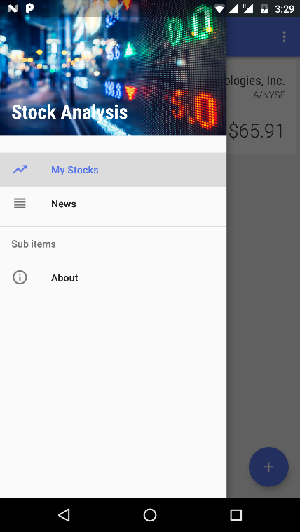

Fig. 3 Navigation Drawer

**5.2 Main Activity/My Stocks Page**

When we open our Stock Analysis app first/main page it shows is My Stock page .this page is taken as mainactivity page of out page and same it is named it shows main content of our app which is list of selected/interested stock

of user which are chosen/selected by user for analysis. Each stock item in this activity is shown by use of cardview which is become popular now days. We had putted Stock name, Exchange name, Stock value, Day Hi/Low on each card. User can add/delete stock item in this list whenever he wants. Simple long press on any stock card will show you option to delete that item. User can refresh the data of the page by pull down.

We had put a floating button on bottom side of app. Which navigates us to the next page of the app which is stock selector page. Which provide us interface to add more stock in our interested stock list.

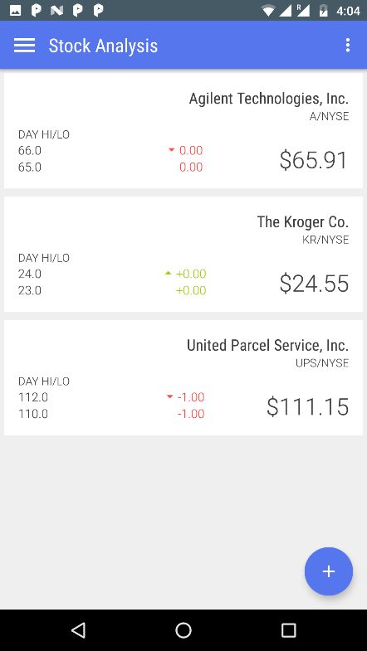

Fig. 4 My Stocks

**5.3 Stock Detail Page**

By Clicking on any particular stock item (Card) from the list of interested stock items , the app will navigate user to the stock detail page. This page will show you perhaps most of the data related to that stock as shown in below figure. It will show Sock name on the top in bold letter, and below that it will show, Exchange Name, Stock Price ,Change in Price, Change in price in %, Opening Price, Previous Close, Day High, Day Low, Year High ,Year Low, Market Capitalization, Earnings Per Share etc. As per our research regard stock market investor, points listed above are mostly sufficient to provide them analysis of any stock.

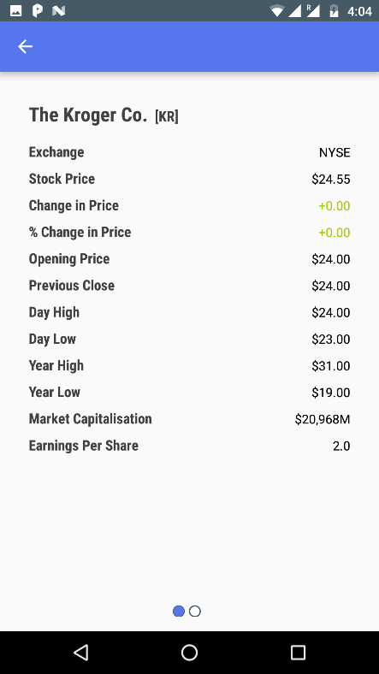

Fig. 4 Stock Details

On Swipe of this page we had put graph to analyse stock value on timebases.

**5.4 Stock Selector Page (Add Stocks Page)**

By clicking on floating button on My Stock page it will navigate user to Add stock page in this page as per shown in image below it consist of one edit text on top of page. By Entering one or more letter of the any stock item name here. This page will show list of all the available stock item related to this edit text letter. In below image i had write letter “u” . now the real work of app start. If your internet/data connection is on (which is compulsory at this activity). The app will fetch all related stock item from market and will represent to user in vertical list with Stock name ,Symbol and Exchange name.

Now to select any one(or more) interested stock from this list. User have to long click on that particular item.

By Clicking thus , the app will open/show a “+” button on top left corner of page. When user will click on this “+”

Button , selected item will be added to interested stock list of user. Toast has been provided here to notify user about Stock item had been added.

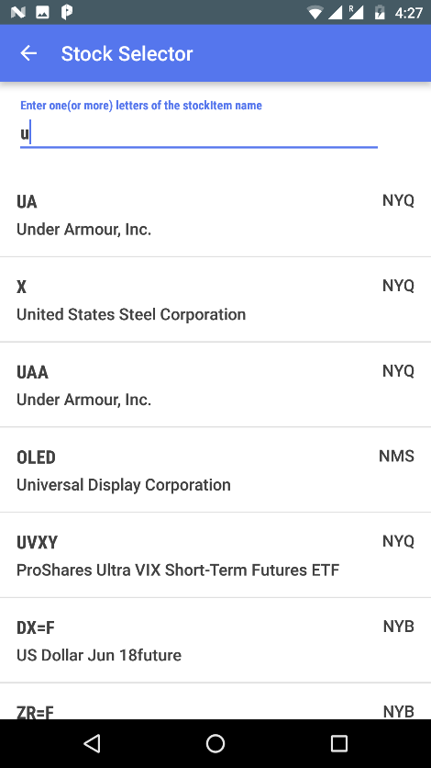

Fig 5 Stock Selector

**5. Discovery Processes**

After analysis of current market scenario, a group of stockholder (from different area and different financial backgrounds) were selected. Similarly, Stock market system person from various departments were identified. Experienced admin staff was chosen. Lastly, the third party vendor who manages the database was also invited. As interactor of a product must take part in the innovation process, these people were brought together to form a focus group for discussions. Many brainstorming sessions were held to finalize the features. Storyboard was created to illustrate the interaction between user interfaces and components. Existing Database and Web server was reused and web services were implemented for app specific components.

**6. Conclusion**

With the availability of information and high efficiency on mobile devices Many of stockholders are turning to obtain applications that give them the accuracy in the information they need.

Here, the service provider has to choose between build a new technical architecture to provide information or choose to reuse existing infrastructure” database, web-servers” using SOA (service oriented architecture).

In this project reuse the existing infrastructure to provide information based on application to investors

The architecture is stable and met to develop to meet the diverse needs of shareholders and investors.

**7-References**

**[1]-Miladinovic, R. (2006). Development of the stock exchange information system. Yugoslav Journal of Operations Research, 16(2), pp.265-284.**

**[2]-Benzinga. (2018). What is an Online Broker? - Benzinga. [online] Available at: https://www.benzinga.com/investing/what-is-an-online-broker/ [Accessed 1 May 2018].**

**[3]-Vrontis, D. and Thrassou, A. (2013). Innovative Business Practices. Newcastle upon Tyne: Cambridge Scholars Publishing, pp.115-117.**

**[4]-Shodhganga.inflibnet.ac.in. (2018). [online] Available at: http://shodhganga.inflibnet.ac.in/bitstream/10603/113149/12/12_chapter%203.pdf [Accessed 1 May 2018].**

**[5]-Anon, (2018). [online] Available at: https://www.samco.in/knowledge-center/articles/how-do-i-trade-online/ [Accessed 1 May 2018].**

**[6]-Essays, UK. (November 2013). The Drawbacks Of Existing System Information Technology Essay. Retrieved from https://www.ukessays.com/essays/information-technology/the-drawbacks-of-existing-system-information-technology-essay.php?vref=1**

**[7]-Osarome.blogspot.kr. (2018). 1. TECHNICAL FEASIBILITY 2. OPERATIONAL FEASIBILITY 3. ECONOMIC FEASIBILITY. [online] Available**

**[8]-Repository.um.edu.my. (2018). Chapter 3: Methodology. [online] Available at: http://repository.um.edu.my/115/7/Chapter3.pdf [Accessed May 2018].**

**[9]-En.wikibooks.org. (2018). Systems Analysis and Design/Introduction - Wikibooks, open books for an open world. [online] Available at: https://en.wikibooks.org/wiki/Systems_Analysis_and_Design/Introduction [Accessed May 2018].**