**Prompt 2: Current Technology Usage**

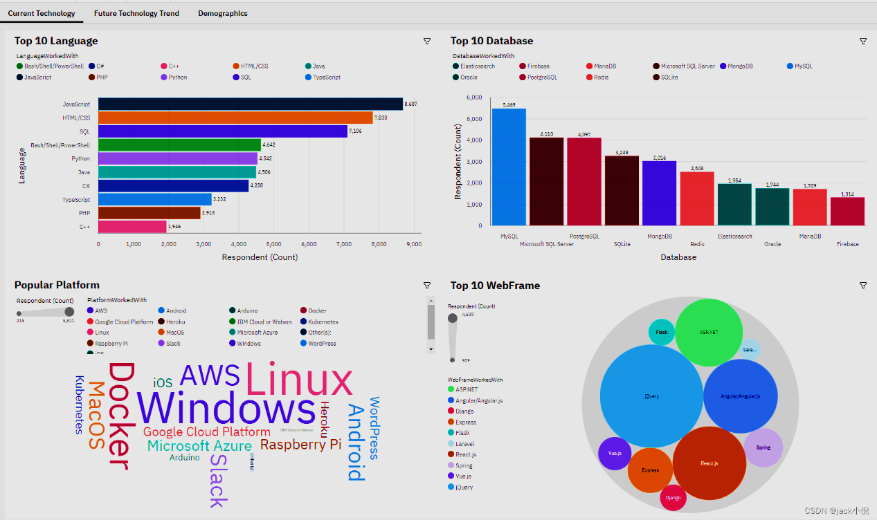

## Prompt 3: Future Technology Trend

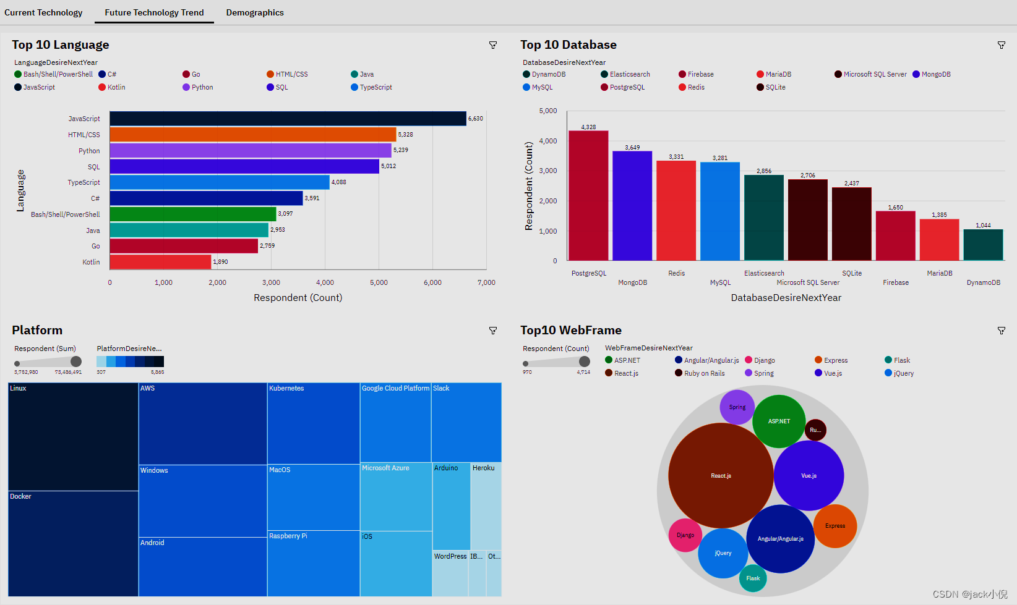

## Prompt 4: Demographics

