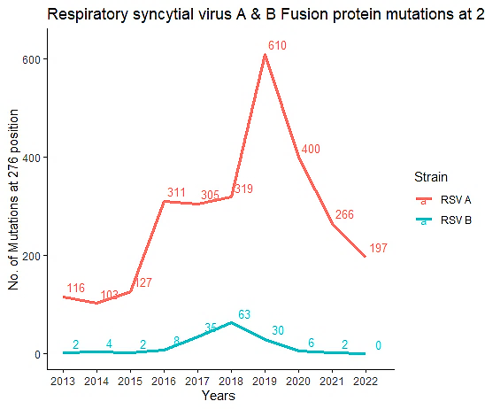

Supp. Figure 2A. Number of mutations at 276 position
Note: This line graph contains the information about the number of mutations recorded at position 276 in the RSV fusion protein during each year. The reference genomes for RSV A is M74568 and for RSV B is AY353550.

