Supp. Figure 2B. Comparison of HRA mutations
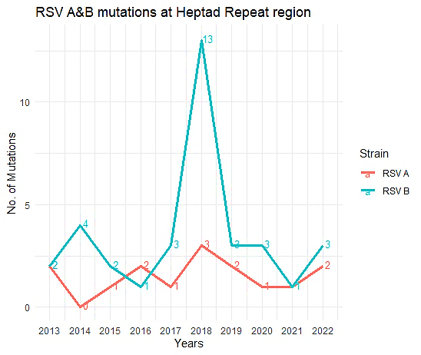
Note: The line graph compares the number of all the mutations recorded at HRA region in both strains of RSV. X-axis contains the number of mutations while Y-axis contains years. The highest mutations at HRA region were recorded in RSV B in 2018.

