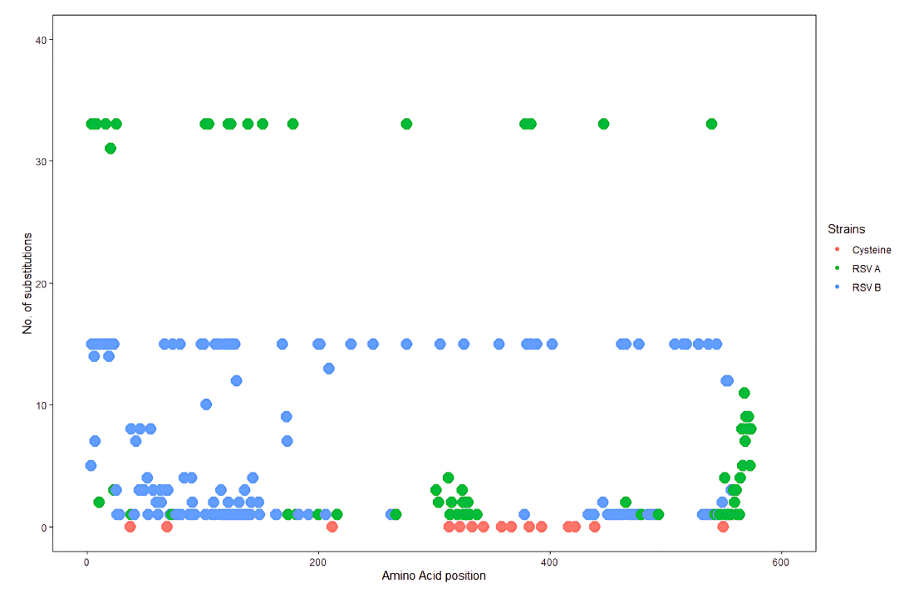
Supp. Figure 3. Amino acid substitutions in the CDS
Note: RSV A is mutations are indicated with green color dots while blue color dots for RSV B. Pink color dots indicate all the conserved cysteine residues. This graph demonstrates that the substitutions appeared in clusters in the middle and at the end of F gene CDS in RSV A while in RSV B, most of mutations appeared in the initial 200 amino acids.

