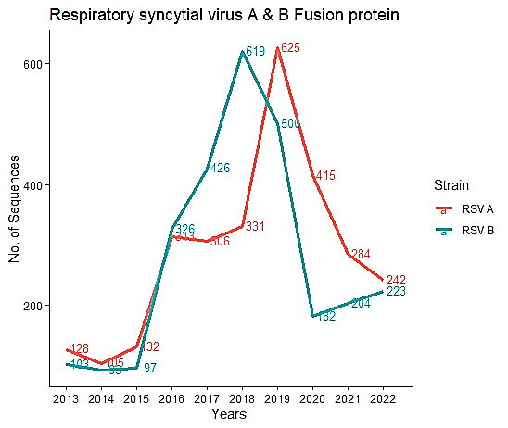
Supp. Figure 1. Number of sequences per year
Note: This line graph indicates the number of sequences recorded during each year of the study program for both strains of RSV. The pink color line indicates RSV A, while the blue color line indicates RSV B. The number of sequences presented here in the figure represents the complete coding regions of fusion protein after deduplication and cleansing process of datasets, hence may vary from raw datasets from NCBI and GISAID

