Project: Proposal

Course: COP-2939

Prof. Banisakher

Alexander Crawford

Date: 01/22/2021

For my final project I have chosen to create a game for both iOS, and Android operating systems. While innovation and new ideas are great, rarely are new ideas successful. therefore I chose to take a simple, yet effectively lucrative video game that generated $50-thousand-dollars a day for months before the creator decided to take the game off the app store due to their guilt and criticism of the design being both addictive and design being too similar to the widely popular Mario Bros franchise (Business Insider, 2014.) This game is widely known as Flappy Bird. Flappy Bird was initially created with a few simple lines of code written with Python. While playing this game the user taps on the screen to have the bird fly upward, all while trying to avoid objects coming towards the user from both the ground and sky.

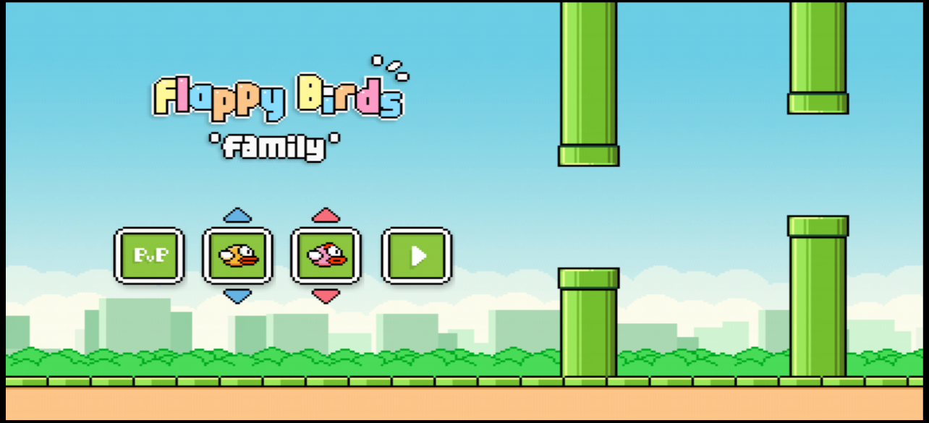

The reason I chose this game concept for my project is that its educational, information of creating this game has been ready available and open source for editing and implementation. I also chose flappy bird as it has proven to be an extremely lucrative and may help myself learn to create something as successful.

The Who:

All those who with an interest in retro style graphics and those who enjoy a simple yet addictive game to pass the time. Being that that player-vs-player game modes will be accessible as well as a high score board being added to the game in the future, this game will also attract players with a competitive mind set to reach the top of the scoreboard.

The How:

I plan to use Eclipse, and maybe Notepad++ for my development environment to create my project that will be running on the Python coding language. I choose to use a similar art style as shown above, personally I have always enjoyed the 8-bit retro art style in video games and feel coming up with sprites and graphic should be generally easy for the project. I would like to keep most focus on operability and use simple yet attractive designs.

Limitations / Risks anticipated:

Being this will be my first video game project limitations will involve lack of knowledge on the subject can prove to be troublesome, but luckily in our day and age the internet is the holy grail of knowledge and should not be hugely crippling to finish the project. Some other limitations will include work with available time, while working a full time schedule and perhaps the project could incur some costs for listing on platforms? If so the other options for porting the video game may be best set to being an online web browser game. Upon research there are 3rd party development software like Mu and Pygame Zero for python game developers that may help reduce the time required to finish development and debugging.

Also, When considering the amount of code needed to create the game many developers have been able to recreate the game with as few as 18 lines of really ugly code. (Yannick, kotaku.com, 2015.)  Although, I can expect the amount to be higher in the range of 100 – 300 lines of code at a minimum.

Delivery / installation plan:

Implementation and delivery of the project will include the steps starting with creating original art and design. Next, will include writing lines of code and linking images to objects for testing and debugging. Once initial testing and debugging is finished the final steps to complteting the game will be to learn how games are added to the app store for download. Future steps would include adding extra features to the game, like pvp(player-vs-player), high scores and possibly payment options for various skins, backgrounds and maybe new game modes / options. Once these steps are achieved the game should be set for users to start playing their new favorite game!

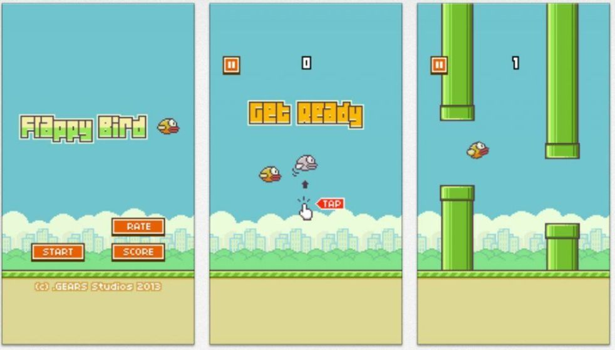

Sources:

<https://kotaku.com/it-only-takes-17-lines-of-code-to-clone-flappy-bird-1678240994>

https://www.businessinsider.com/dong-nguyen-says-why-flappy-bird-shut-down-2014-2