**INSY 4305**

**HOMEWORK 2**

1. Write a WriteFiles program that writes the files actors.txt, shows.txt, and networks.txt using the data from homework 1. You should have methods writeActors, writeShows, and writeNetworks.
2. Develop the following graphical user interface. Using this GUI the user will enter in either actors, shows or networks to be added to the appropriate arraylists.

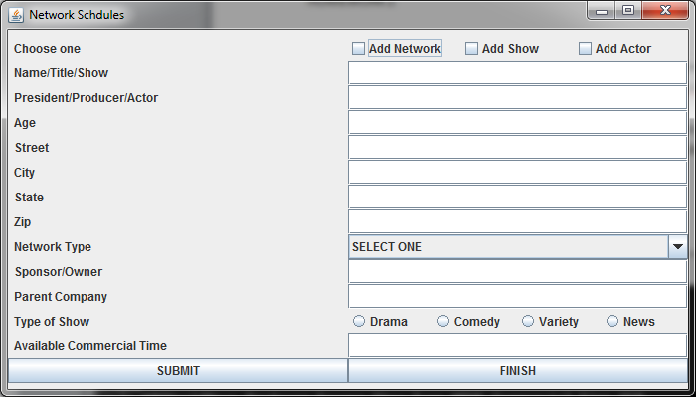

If the Add Network box is checked, the GUI looks as

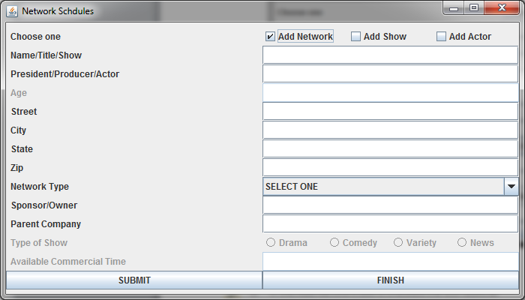

If the Add Show box is checked, the GUI looks as

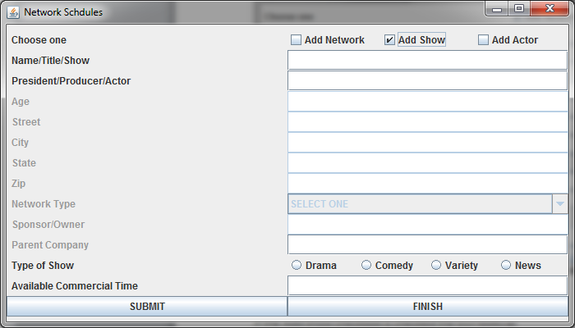

If the Add Actor box is checked, the GUI looks as

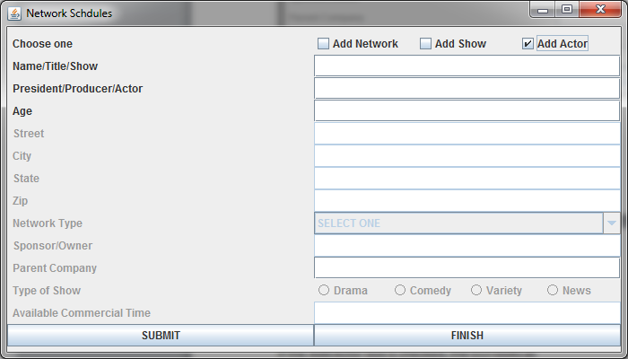

Notice that each selection grays-out the labels/fields not required.

1. Upon start of your program, the actors, shows, and networks files will be read in to your program and used to populate the appropriate arraylists. The GUI will be shown and the user will interact with the GUI. Everytime the SUBMIT button is clicked, the data in the fields will be used to create the selected object and add it to the arraylist
2. When the user is finished and selects the FINISH button, all arraylists are written to their appropriate text file.