Instructions

1) Click start... button.
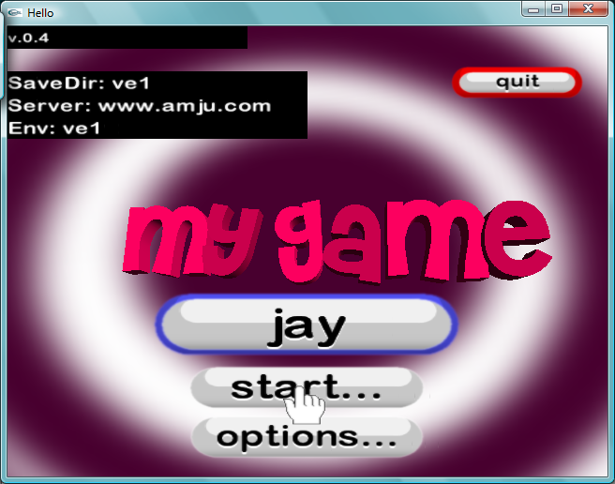
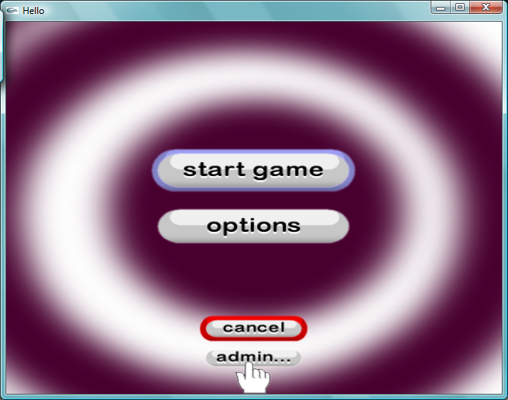
2) Click the small admin... button at the bottom of the screen.
- Now click on edit mode .
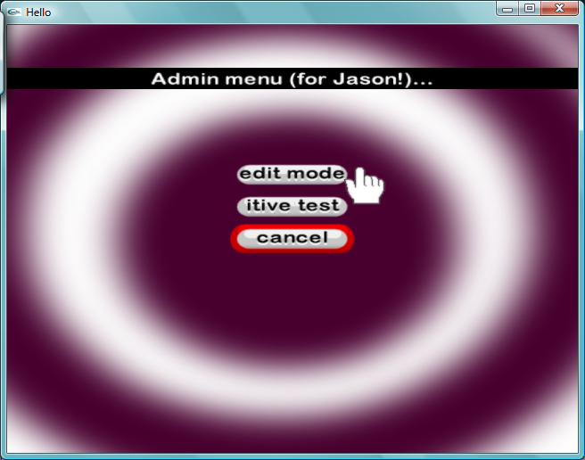
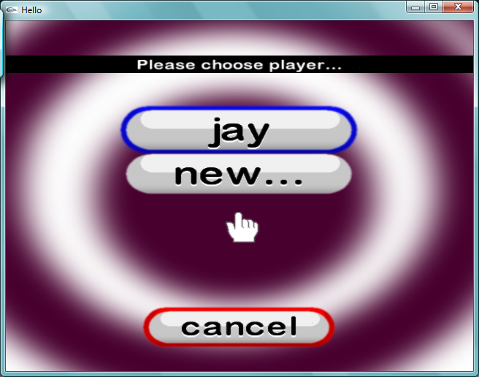

- Login as you normally would.

5) Right click to create a menu. Click on New Game Object... then click on Furniture .
At any time (except when a menu is open) to change the camera's view, hold down C and left or right drag to zoom in and out or rotate.
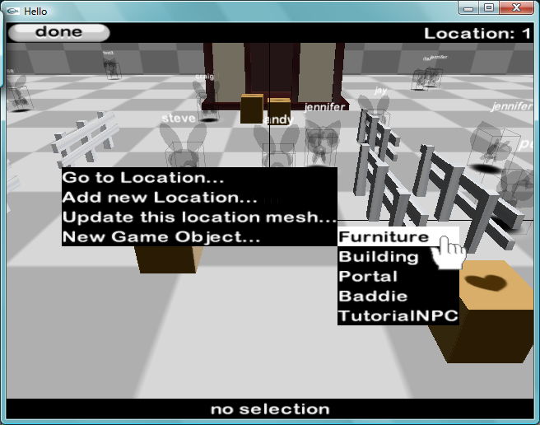
- A blue box will appear.
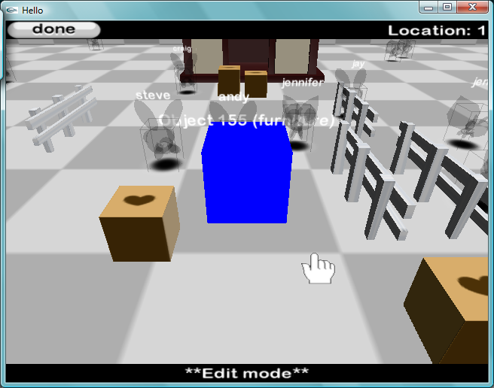
7) Click the blue box to select it. It will then turn red. Left drag on the box to move the box.
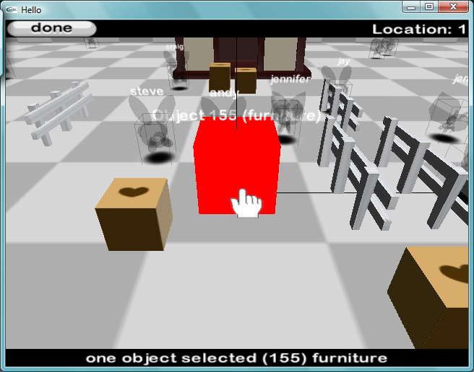
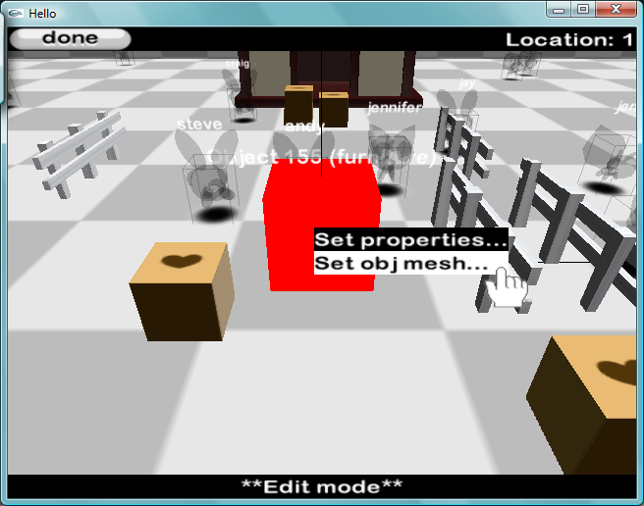
- Right click on the box to open this menu. Click on Set obj mesh... .

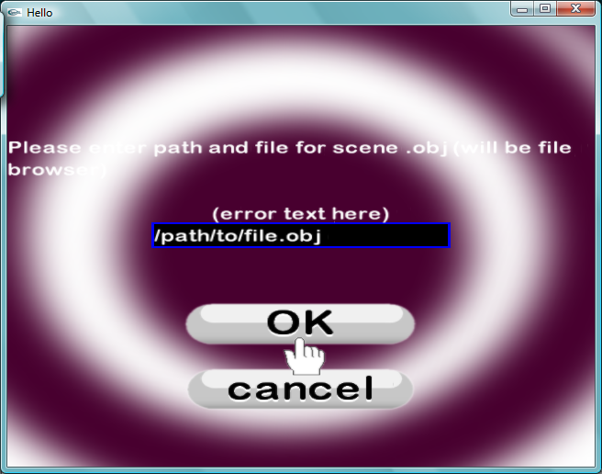
9) Type the full path and filename of the obj file (file browser coming “soon”). Then click OK .

