- Executive Summary
After comparing the two neural networks: Artificial Neural Network and Convolutional Neural Network I have learned how to teach a computer to look at a picture of clothes and guess what type it is, whether it be a shirt, shoe, or bag. ANN learned from flattened image data.

- The ANN model learned from flattened image data.
- The CNN model used image features (edges, shapes, textures).
- Both models were trained and tested in PyTorch.
- ANN achieved 88.44% accuracy, while CNN achieved 92.11%, which is an indicator that CNNs are better only with pictures since it is dedicated to images and understands them. In other words, CNN can “see” the patterns in the image.

2. Technical Implementation
2.1 Dataset and Pre-Processing
Dataset and Pre-processing The dataset for the problem comes from Fashion-MNIST, which includes 70 000 grayscale images. For the experiment, we used 60 000 for training and 10 000 for testing.
The images are 28 × 28 pixels and belonging to 10 image classes are as follows: t-shirt, trousers, pullover, dress, coat, sandals, shirt, sneaker, bag, and boot.
We scale images to have pixel values between 0 and 1, and we split the data into training, validation, and testing.

Dataset | Samples | Purpose
Training | 60 000 | model learning
Validation | 12 000 | tuning the model
Test | 10 000 | final accuracy check

2.2 Model Designs
We made two models and compared them:
A. ANN – Artificial Neural Network
It is like a simple network of connected dots.
It looks at all image pixels at once after flattening them.

- ANN = looks at all pixels directly.
- CNN = looks at small image parts first, then the whole.
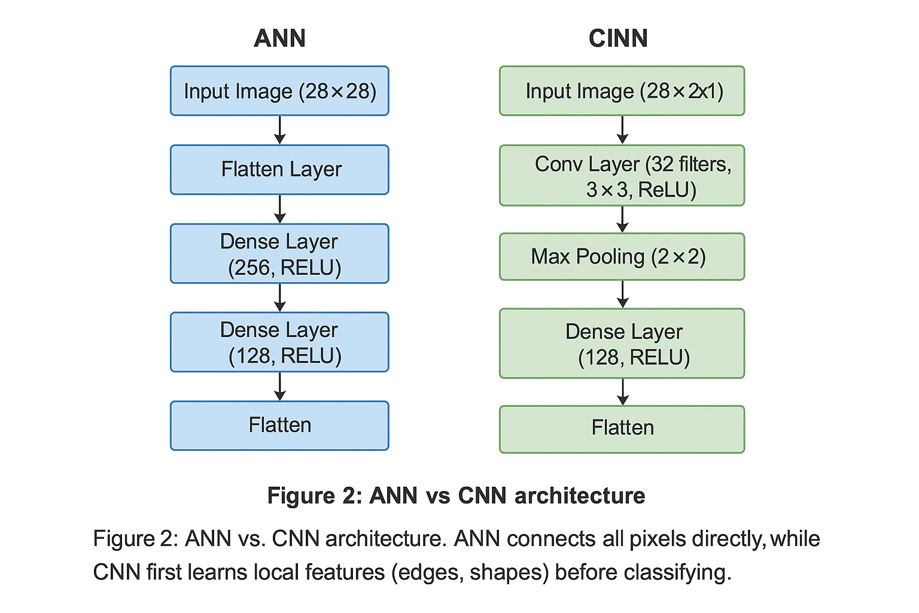
2.3 Training Setup
Both networks were trained for 10 epochs with the Adam optimizer and Cross-Entropy Loss.
A batch size of 64 images was used, and a learning rate of 0.001 helped the model learn steadily.
Setting | Value
Optimizer | Adam
Loss Function | Cross Entropy Loss
Learning Rate | 0.001
Batch Size | 64
Epochs | 10
Hardware | CPU / GPU

OUTPUT :
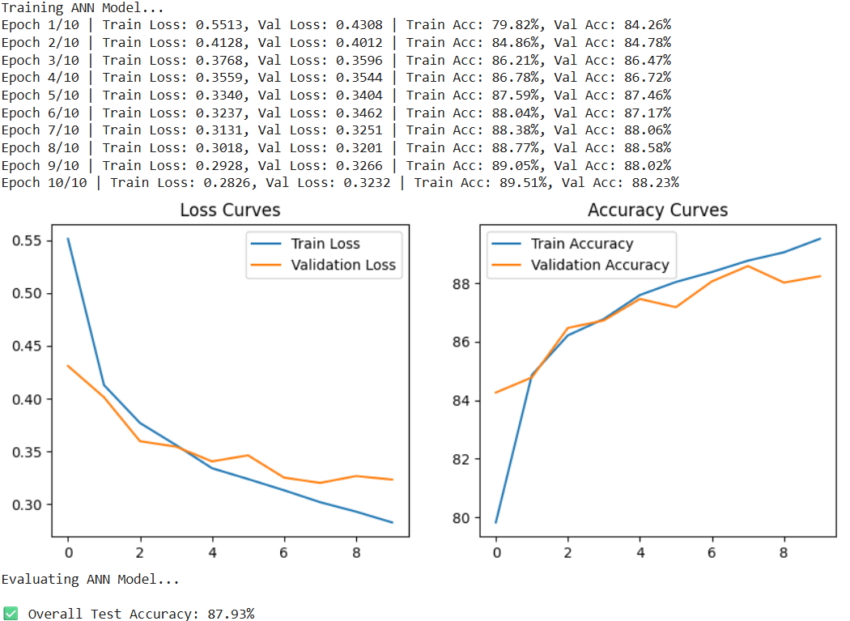

2.4 Results and Evaluation
Model | Test Accuracy | Validation Accuracy | Notes
ANN | 88.44 % | 87.2 % | Slower and less accurate
CNN | 92.11 % | 91.6 % | Learns image patterns better
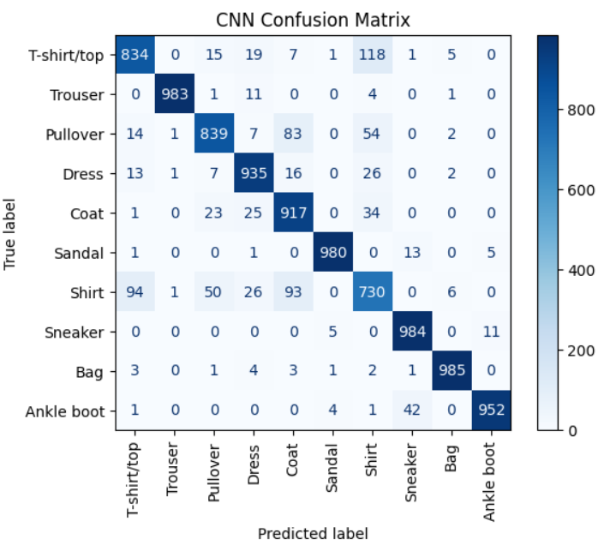

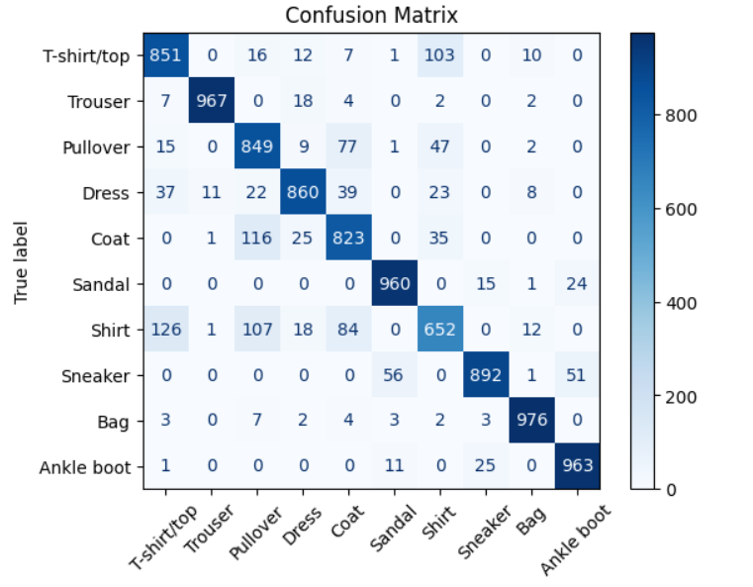

What we learned:
- Both models confused shirts and coats because they look similar.
- CNN made fewer mistakes and converged faster.

2.5 Comparison of Models
Feature | ANN | CNN
Accuracy | 88.44 % | 92.11 %
Speed | Medium | Fast
Feature Extraction | Weak | Strong
Overfitting | Slight | Minimal
Visual Understanding | Low | High
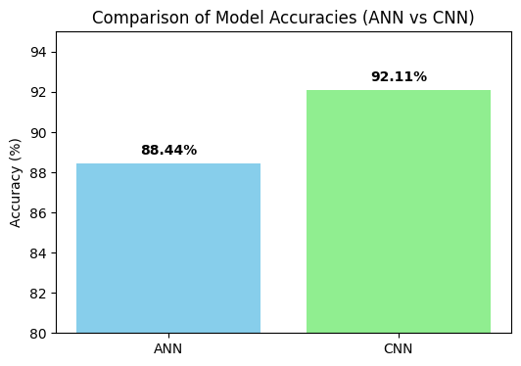

In simple words:
The CNN works better because it can “see” image details before making a guess, while ANN just looks at numbers.

2.6 Possible Improvements
To make the model even better, we can:
- Use data augmentation (flip or rotate images).
- Add dropout layers to avoid overfitting.
- Use learning-rate scheduling to train smoothly.
Try transfer learning using pre-trained CNNs, such as VGG or ResNet.
Figure 6: Example of augmented images (optional - show flipped or rotated images)

3. Conclusion
The project showed clearly that CNNs outperform ANNs in the classification of images. The CNN understood the shapes and patterns of the images better; hence, it gave higher accuracy and faster learning.

This experiment taught that choosing the right architecture is very important in Artificial Intelligence.

In short: ANN = good learner, CNN = smarter vision learner.

5. Appendix (Optional)

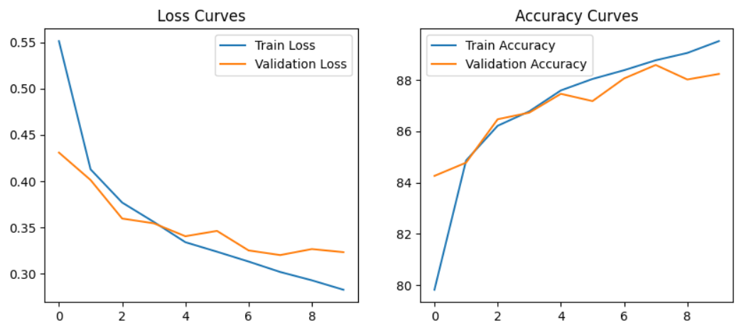
Appendix A: Training and validation curve
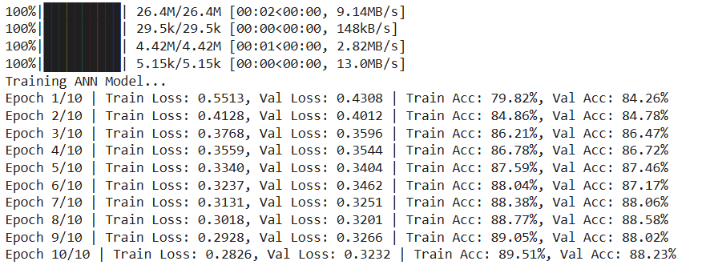

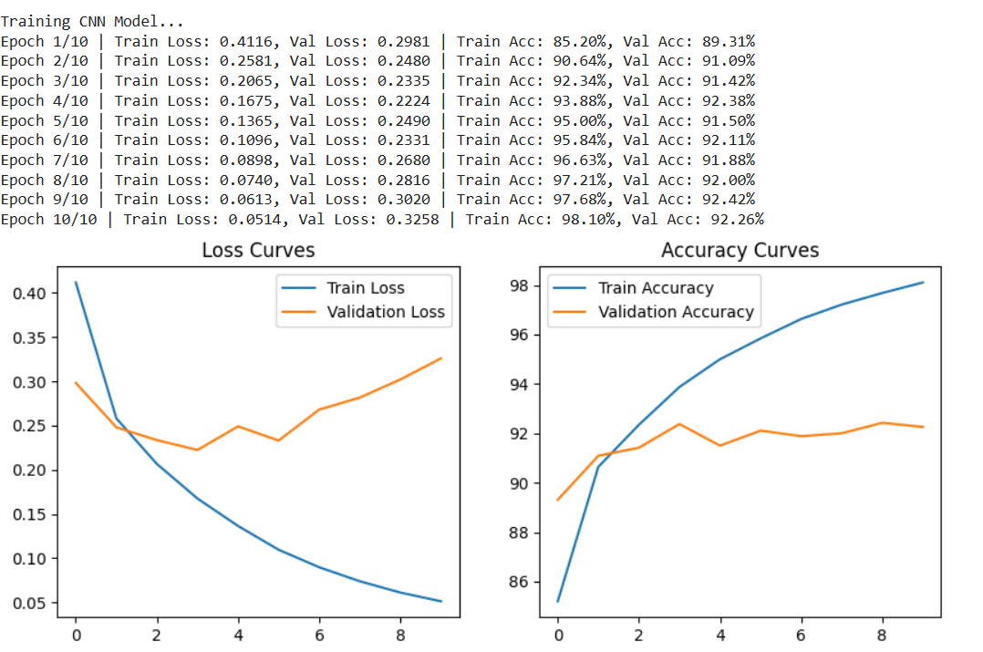
Appendix C: test accuracy from terminal.

