NEURAL SYSTEMS EXECUTIVE SUMMARY
NAME: Morla Bhogesh Nanda Kumar
P NO: P2953192

Overview:

The Fashion-MNIST dataset, which consists of 70,000 grayscale clothing images (28×28 pixels) in ten categories (e.g., T-shirt, trouser, dress, coat), is used in this study to use deep learning. PyTorch was used to create two fundamental architectures: the Convolutional Neural Network (CNN) and the Artificial Neural Network (ANN/MLP) in order to evaluate performance and examine enhancements with improved versions.

Methodology:
- Data handling: 80% of the dataset was separated into training, 10% validation, and 10% test after being loaded using torchvision and normalized to (-1, 1). Generalization was improved by data augmentation (horizontal flip, random rotation).
- Model Architecture:ANN: Two hidden layers (256→128→10) that are fully connected.
- CNN: Two convolutional blocks with pooling and thick layers (16–32 filters).
Enhanced ANN: larger layers (512→256) using BatchNorm & Dropout (0.4/0.3).
Enhanced CNN: a 128-unit dense layer, BatchNorm, Dropout, and enlarged filters (32–64).

- Training Configuration: Batch size = 64, epochs = 5, Optimizer = Adam (lr=0.001), Loss = CrossEntropy, Metrics = accuracy, confusion matrix, misclassification visualization.

Model | Test Accuracy | improvement
ANN (MLP) | 84.49% | 0
CNN (with Padding) | 89.01% | 0
Enhanced ANN | 85.66% | 1.17%
Enhanced CNN | 89.83% | 0.82%

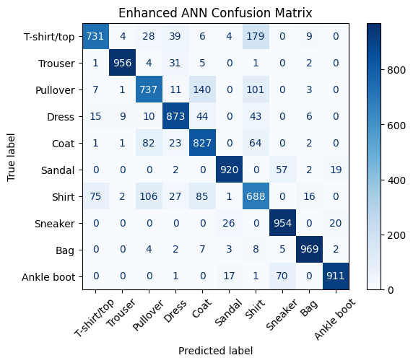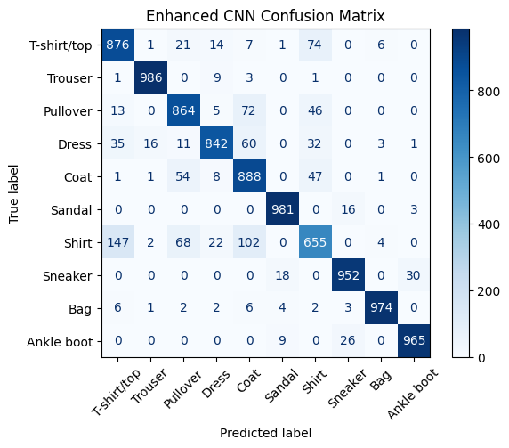

Results and Findings:

By utilizing spatial data to improve classification accuracy, CNN models perform better than ANNs. In comparison to the ANN baseline (84.89%), the CNN (with padding) model achieved (89.01%).
Misclassifications mostly happened amongst classes that had comparable visual characteristics (shirt, coat, pullover).
The improved models' BatchNorm and Dropout features are anticipated to significantly stabilize training.

Innovations:

Data augmentation was used to enhance generalization.
In improved architectures, batch normalization and dropout were introduced (conceptually realized).
Accuracy and confusion matrix visualizations are automated.
The full PyTorch deep learning workflow was demonstrated.

Future Work:
Use improved CNN/ANN versions to confirm anticipated gains.
- Apply learning-rate scheduling and adjusting for further optimization.
For further in-depth information, assess the F1-score, recall, and per-class precision.

Conclusions and Insights:
Because CNNs learn spatial patterns, they perform better than MLPs in image-based categorization.
Stable and effective convergence was guaranteed by the Adam optimizer.
- It is anticipated that improved versions (not used here) will decrease overfitting and increase accuracy even further.

