NEURAL SYSTEMS EXECUTIVE SUMMARY

NAME:- Maskuri Nithin Kumar
PNUMBER:- P2908563

Overview:
This project implements and evaluates both basic and enhanced neural network architectures—an Artificial Neural Network (ANN) and a Convolutional Neural Network (CNN)classification using the MNIST dataset. The MNIST dataset consists of 70,000 grayscale images of handwritten digits (0–9), each sized 28×28 pixels, and is widely used as a benchmark for testing and comparing image classification models. The goal was to compare performance, analyze the effect of architectural and training improvements, and identify the most effective configuration for accurate image recognition.

Model Implementations:
- Basic ANN:
  - Structure: Fully connected network with one hidden layer using ReLU activation and softmax output.
  - Optimizer: Stochastic Gradient Descent (SGD).
  - Regularization: None.
  - Purpose: Establish baseline performance for classification tasks.
- Basic CNN:
  - Structure: Two Conv2D layers followed by MaxPooling2D, Flatten, and Dense output layers.
  - Optimizer: Adam.
  - Activation: ReLU in hidden layers and softmax in output layer.
  - Purpose: Introduce spatial feature extraction to improve classification accuracy.
- Enhanced ANN:
  - Modifications: Added Dropout layers to reduce overfitting, optimized using Adam optimizer, and increased hidden layer depth.
  - Additional tuning included batch normalization and learning rate scheduling for better convergence.
- Enhanced CNN:
  - Improvements: Additional convolutional blocks, Dropout regularization, batch normalization, and data augmentation to enhance generalization.
  - Hyperparameter tuning (filters, kernel size, learning rate) further optimized accuracy and stability.

Major Findings:
- Accuracy Results:
  - Basic ANN: 87%
  - Enhanced ANN: 88%
  - Basic CNN: 91%
  - Enhanced CNN: 91%
- Performance: Because CNN models are better at extracting spatial features, they consistently perform better than ANN models. Improvements like Adam optimization and dropout significantly decreased overfitting and enhanced generalization.
- Training Efficiency: Because of adaptive optimization, improved models required longer training times but achieved faster convergence each epoch.
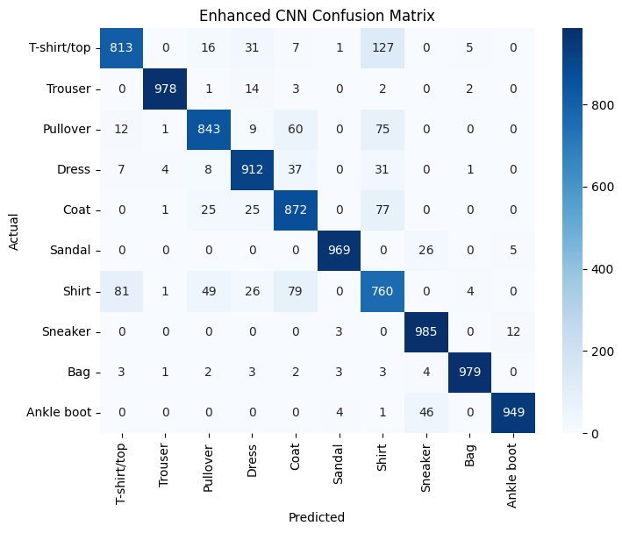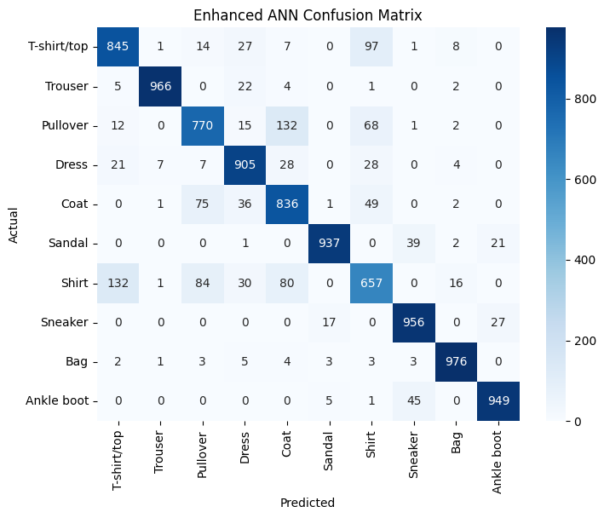

Innovations:
Key innovations included:
• For stability, batch normalization and dropout layers are integrated
• For effective convergence, the Adam optimizer and learning rate scheduling are used.
• The use of data visualization techniques for interpretability, such as accuracy/loss charts and confusion matrices.
• Investigating data augmentation to improve CNN's resistance to fluctuations and noise.

Conclusions and Insights:
For image-based applications like MNIST classification, the investigation verifies that CNN architectures perform noticeably better than conventional ANNs. Together, improvements in regularization, optimization, and architecture depth produced better accuracy and model generalization outcomes. Transfer learning or sophisticated designs (like ResNet or Capsule Networks) may be used in the future to increase accuracy even more.

