FASHION-MNIST CLASSIFICATION
Executive Summary
This report outlines and presents a comparison of two deep learning classifiers, Artificial neural Network (ANN) and Convolutional Neural Network (CNN), to classify grayscale images based on Fashion-MNIST dataset in ten different clothing classes, T-shirt, trouser, pullover, dress, coat, sandal, shirt, sneaker, bag, and ankle boot. The overarching goal of the project was to come up with the correct models that would identify fashion items through supervised learning methods.
It had 70,000 images (60,000 used as training and 10,000 used as testing), which were normalized to [ -1, 1] and divided into training, validation and test. The ANN was implemented in the form of fully connected layers of ReLU-activation and dropout to reduce overfitting, whereas the CNN had convolutional and pooling layers to achieve the extraction of spatial and texture-based features successfully. The two models were both trained on Adam optimizer and CrossEntropyLoss, with a learning rate of 0.001 and 10 epochs.
The project is aimed at categorising the Fashion-MNIST images in accordance with ten types of clothing by using Artificial Neural Network (ANN) and Convolutional Neural Network (CNN) models. The data was processed and normalised, and split into training, validation and test sets. Both models have been trained and tested according to a number of performance metrics. The outcomes indicate that the CNN (91.43) was more accurate than the ANN (88.01) because it was able to extract spatial features more effectively. The paper finishes with recommendations on how to improve model performance and generalisation.
The evaluation of the performance was made with accuracy, loss curves, confusion matrices and classification report. The ANN had an 88.01% accuracy, and the CNN had a better accuracy of 91.43, which indicates that it is very strong in visual pattern recognition. Nevertheless, there was slight confusion between difficult to distinguish classes between shirts, coats, and pullovers in both models.
The report concludes that CNNs are better compared to ANNs in image classification problems because they have hierarchical features extraction abilities. There are suggestions of future improvements such as data augmentation, dropout scheduling, and learning rate scheduling to increase the accuracy and model generalization further.

Table of Contents
1. Introduction 4
2. Data Handling 4
2.1 Dataset Overview 4
2.2 Data Loading, Normalisation and Splitting 4
2.3 Data Visualization 5
3. Network Topology 7
3.1 Artificial Neural Network (ANN) Architecture 7
3.2 Convolutional Neural Network (CNN) Architecture 8
4. Training Setup 10
4.1 Optimizer and Loss Function 10
4.2 Hyperparameters 11
4.3 Training and Validation Strategy 11
5. Evaluation and Results 11
6. Critical Analysis 16
7. Reflection and Improvements 16
References 18
Appendix 19
Python Code Implementation 19

1. Introduction
The current project is based on the task of classifying the images of the Fashion-MNIST dataset into ten different clothing categories, such as shirts, coats and sneakers. This is aimed at creating, training, and testing two deep learning networks: one Artificial Neural Network (ANN) and another Convolutional Neural Network (CNN), both implemented in PyTorch. The comparison will be conducted to examine their performance, accuracy, and ability to recognise visually similar fashion items.

2. Data Handling

2.1 Dataset Overview
Fashion-MNIST dataset has 70,000 28x28 grey scale images of 60,000 training and 10,000 test samples. The images are categorised into ten types of clothes, e.g. T-shirt, trousers, pullover, dress, coat, sandal, shirt, sneaker, bag or ankle boot, which makes them effective in multi-classification tasks.

2.2 Data Loading, Normalisation and Splitting
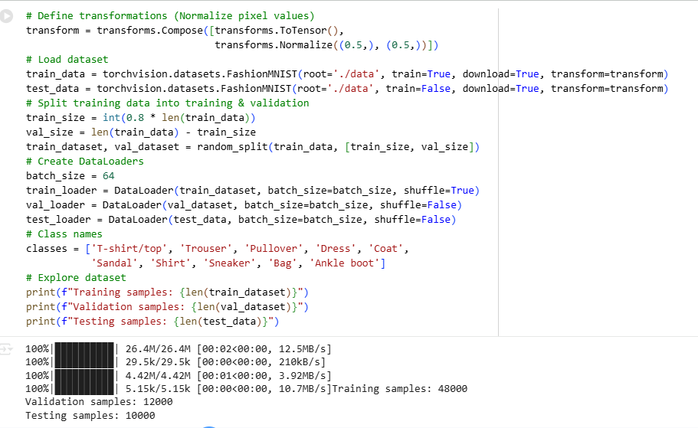
Figure 1: Loading data, normalisation and splitting
(Source: Google Colab)
The Fashion-MNIST dataset was downloaded and loaded with the help of the torchvision.datasets.FashionMNIST, which is the default powerful downloader of the pictures. Transforms.Normalise (0.5,), 0.5,)) were used to normalise the pixel values between (-1, 1) when turning them into tensors. The dataset was split into 80 per cent training, 20 per cent validation and 10000 individual test samples to maintain an equal balance between the training and testing of the model.

2.3 Data Visualization
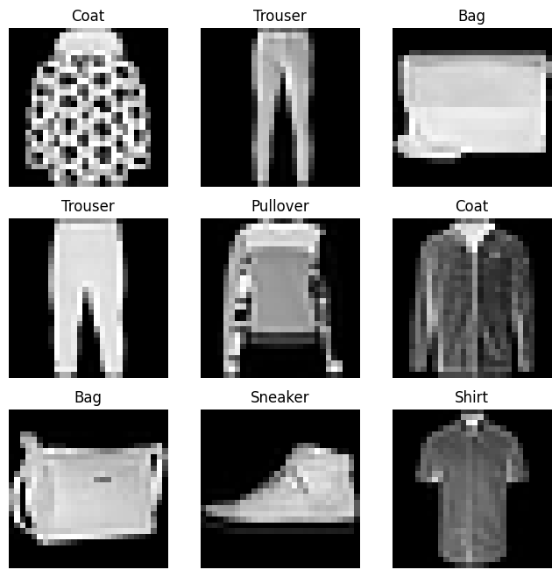
Figure 2: Sample image visualisations
(Source: Google Colab)
Nine images of the training dataset were plotted in a 3x3 grid with Matplotlib and shown in grayscale with the labels representing the classes to ensure appropriate data loading was appropriate and that the labels were assigned properly.
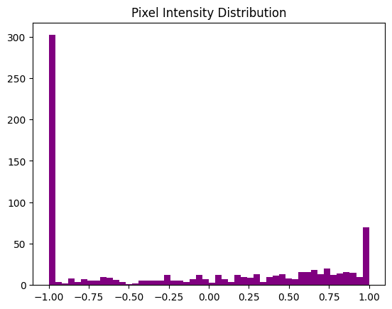
Figure 3: Pixel intensity distribution
(Source: Google Colab)
The histogram presents the maximum pixel value as mostly near -1.0 (dark areas) and the minimum pixel value as mostly near 1.0 (bright areas), with a low number of mid-range values that are evenly distributed in the middle range.
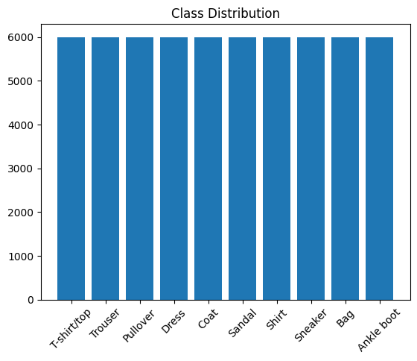
Figure 4: Class Distribution
(Source: Google Colab)
The plot of the distribution of the classes indicates that the sample sizes of all ten categories of Fashion-MNIST are equal, which proves the existence of a balanced dataset. This makes training of the models just and not uniform to favour a particular line of clothing.

3. Network Topology

3.1 Artificial Neural Network (ANN) Architecture
Layer Type | Details / Parameters | Activation Function | Additional Notes
Input Layer | Flatten 28×28 pixels (784 inputs) | — | Converts 2D to 1D vector
Hidden Layer 1 | Fully Connected (784 → 256) | ReLU | Dense feature extraction
Dropout | 0.2 probability | — | Prevents overfitting
Hidden Layer 2 | Fully Connected (256 → 128) | ReLU | Learns deeper patterns
Output Layer | Fully Connected (128 → 10) | Softmax (via loss) | Classifies into 10 classes
Table 1: Artificial Neural Network (ANN) Architecture Overview
(Source: Self-created)
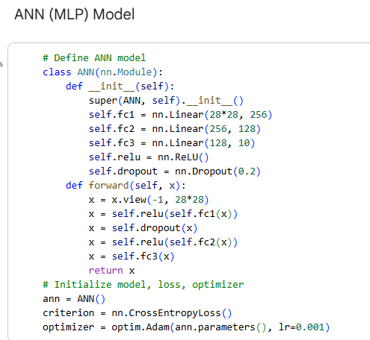
Figure 5: ANN Model Architecture
(Source: Google Colab)
Optimizer: Adam (learning rate = 0.001)
Loss Function: CrossEntropyLoss
Epochs: 10
Regularization: Dropout (0.2)

3.2 Convolutional Neural Network (CNN) Architecture
Layer Type | Details / Parameters | Activation Function | Additional Notes
Convolutional 1 | 1 input channel → 32 filters (3×3) | ReLU | Padding = 1
Max Pooling 1 | 2×2 kernel | — | Reduces spatial dimensions
Convolutional 2 | 32 → 64 filters (3×3) | ReLU | Padding = 1
Max Pooling 2 | 2×2 kernel | — | Further reduces dimensions
Fully Connected | 64×7×7 → 128 neurons | ReLU | Dense layer for feature mapping
Dropout | 0.25 probability | — | Regularization layer
Output Layer | 128 → 10 neurons | Softmax (via loss) | Predicts 10 clothing categories
Table 2: Convolutional Neural Network (ANN) Architecture Overview
(Source: Self-created
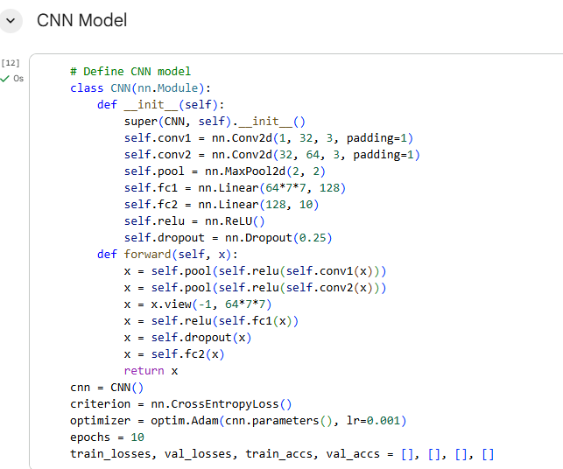
Figure 6: CNN Model Architecture
(Source: Google Colab)
Optimizer: Adam (learning rate = 0.001)
Loss Function: CrossEntropyLoss
Epochs: 10
Regularization: Dropout (0.25)

4. Training Setup

4.1 Optimizer and Loss Function
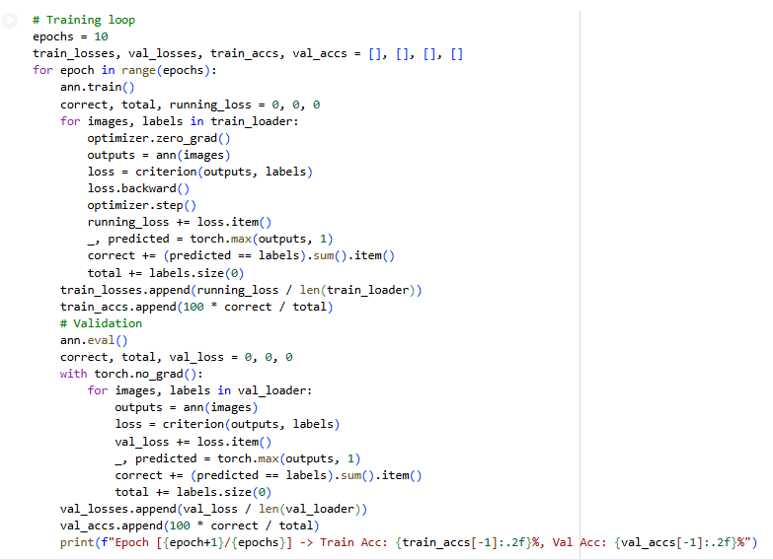
Figure 7: ANN Model Training
(Source: Google Colab)
Both models have been trained with the Adam optimiser, which is based on an adaptive learning ability since it integrates the advantages of momentum and RMSProp that resulting in swifter and sounder convergence.
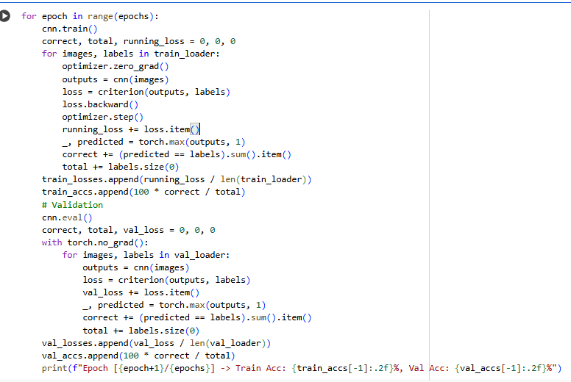
Figure 8: CNN Model Training
(Source: Google Colab)
The CrossEntropyLoss function was selected as it is effective due to its multi-classification issues, as it compares the differences between the actual outcomes and the estimated outcomes via the prediction of probabilities.

4.2 Hyperparameters
The most important hyperparameters were the learning rate of 0.001, the batch size of 64, and 10 training epochs (Bbouzidi et al. 2024). Such settings had a moderate compromise between computational efficiency and model performance.

4.3 Training and Validation Strategy
The ANN and CNN models recorded training and validation loss and accuracy at any time during the training process (Xhaferra et al. 2022). This constant checking also provided the correct convergence, aided in identifying overfitting or underfitting trends, and allowed testing the performance on unknown validation data prior to final testing on the independent test set.

5. Evaluation and Results
ANN Model Results
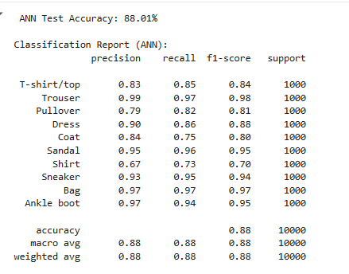
Figure 9: ANN Model Results
(Source: Google Colab)
The ANN model had an overall accuracy of 88.01% which is decent. Nevertheless, it had difficulties with similar classes such as shirt and coat, as its precision and recall were lower than discrete categories such as trousers and bag.
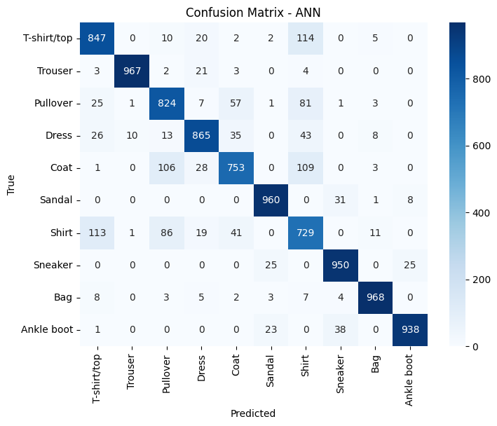
Figure 10: ANN Model Confusion Matrix
(Source: Google Colab)
The confusion matrix reveals a high degree of diagonal dominance, which implies that most of the classes are highly accurate. There are, however, significant instances of misclassifications between T-shirt/top and Shirt (114 cases) and Coat and Pullover (106 cases), as these clothes are visually similar to each other.
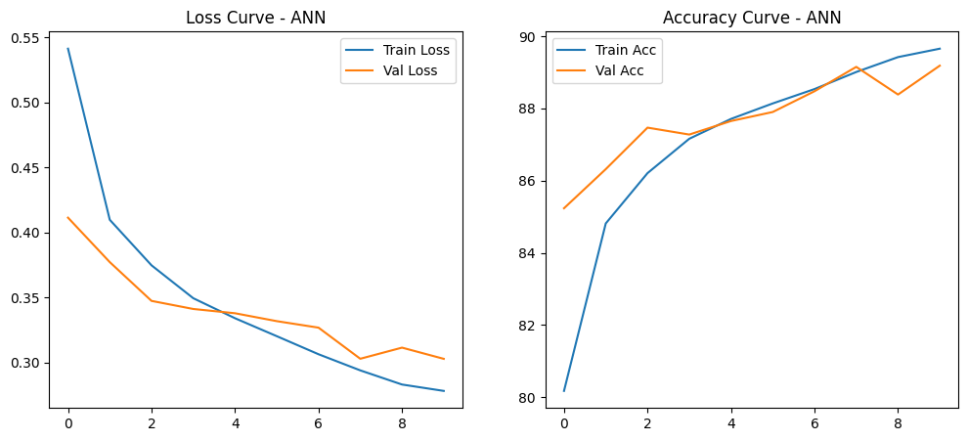
Figure 11: ANN Model Training Curve
(Source: Google Colab)
The training and validation curves of the ANN indicate that the losses declined, and the accuracies were stabilised at about 89%. This represents efficient learning and limited overfitting, which assures proper generalization of the models with varying epochs.
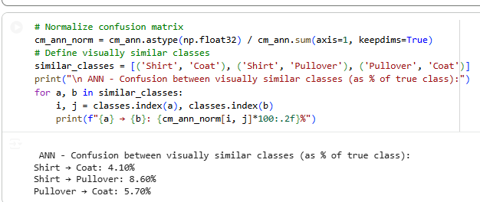
Figure 12: ANN Model Confusion
(Source: Google Colab)
The ANN model demonstrates significant confusion in classes that are similar to each other, and this is also observed with Shirt to Pullover (8.6% ) and Pullover to Coat (5.7% ), with the model having a difficult time separating similar textures and styles of clothing.
CNN Model Results
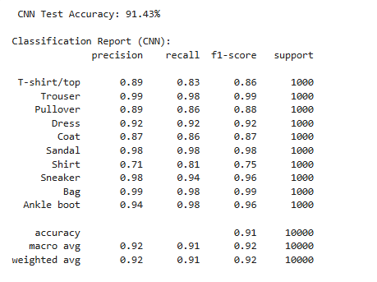
Figure 12: CNN Model Results
(Source: Google Colab)
The CNN had an accuracy of 91.43, thus scoring better than the ANN. It demonstrated a high degree of accuracy on the majority of classes, but still there was a little confusion with shirt, coat and pullover, indicating difficulties in separating visually similar fashion products.
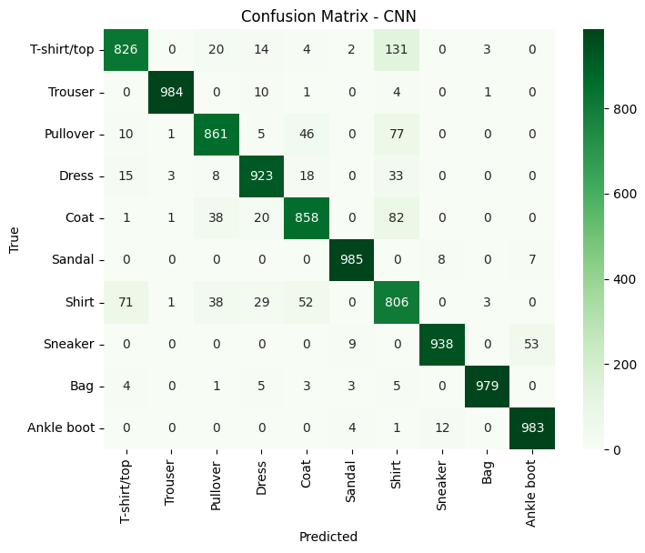
Figure 13: CNN Model Confusion Matrix
(Source: Google Colab)
The CNN confusion matrix indicates that it has a high level of accuracy in a majority of the categories with little misclassification. There is moderate confusion between T-shirt/top and Shirt (131) and Pullover and Coat (38) as visual similarity problems exist in some clothing types.
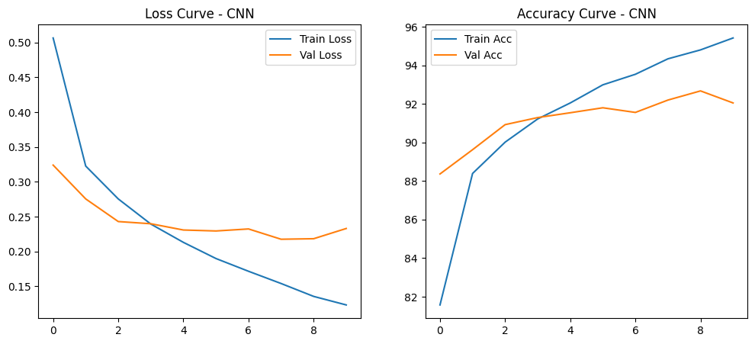
Figure 14: CNN Model Training Curve
(Source: Google Colab)
The training and validation curves of the CNN exhibit a steady improvement as the losses reduce and the accuracies reach a stabilisation in the range of more than 92%. This means that learning is efficient, convergence is high and that overfitting is low during the training process.
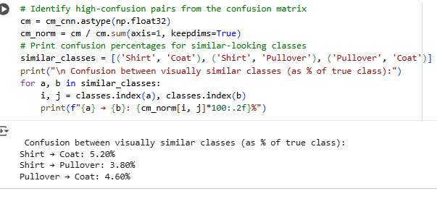
Figure 15: CNN Model Confusion
(Source: Google Colab)
CNN had less confusion than the ANN, with lower misclassification rates of Shirt → Coat (5.2%), Shirt → Pullover (3.8%), and Pullover → Coat (4.6%), which meant that better visual features were extracted.

6. Critical Analysis
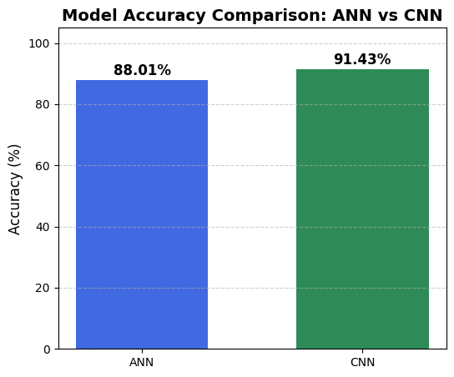
Figure 16: Model Comparison
(Source: Google Colab)
The CNN was more effective than the ANN, with its options of pointing at the spatial hierarchy and local image features, achieved with the help of convolutional layers. Although the overall performance was strong, both models were confused with similar-looking classes, like shirt, coat, and pullover, where both texture and shape have similarities (Nocentini et al. 2022). The ANN displayed a satisfactorily high performance with separate categories such as trousers and bags, whereas the CNN showed better generalisation and strength. The CNN was relatively more expensive in terms of computation and time spent training, though, than the more basic ANN.

7. Reflection and Improvements
Enhancements in the future may be directed towards bettering model generalisation and stability. Random rotations, flips, and brightness can be used to augment the data by causing diversity in the dataset. Other techniques to avoid overfitting and stabilise training are dropout tuning and batch normalisation. A learning rate scheduler can also be introduced in order to make the convergence and optimisation smoother (Sumera et al. 2022). Also, investigating more complex CNN structures, including more convolutional and pooling blocks, may aid the model to be more selective on smaller spatial structures, enhancing the classification rate in best-case scenarios where visually similar objects are matched during the classification process.

References
Bbouzidi, S., Hcini, G., Jdey, I. and Drira, F., 2024. Convolutional neural networks and vision transformers for fashion mnist classification: A literature review. arXiv preprint arXiv:2406.03478.
Nocentini, O., Kim, J., Bashir, M.Z. and Cavallo, F., 2022. Image classification using multiple convolutional neural networks on the fashion-MNIST dataset. Sensors, 22(23), p.9544.
Sumera, S.R., Anjum, N. and Vaidehi, K., 2022. Implementation of CNN and ANN for Fashion-MNIST-Dataset using Different Optimizers. Indian Journal of Science and Technology, 15(47), pp.2639-2645.
Xhaferra, E., Cina, E. and Toti, L., 2022, October. Classification of standard fashion MNIST dataset using deep learning based CNN algorithms. In 2022 international symposium on multidisciplinary studies and innovative technologies (ISMSIT) (pp. 494-498). IEEE.

Appendix

Python Code Implementation

“ “ “ “
## Load Dataset, Explore & Visualize
"""

# Import required libraries
import torch
import torchvision
import torchvision.transforms as transforms
import matplotlib.pyplot as plt
import numpy as np
from torch.utils.data import DataLoader, random_split
import torch.nn as nn
import torch.optim as optim
from sklearn.metrics import accuracy_score, classification_report, confusion_matrix
import seaborn as sns

# Define transformations (Normalize pixel values)
transform = transforms.Compose([transforms.ToTensor(),
transforms.Normalize((0.5,), (0.5,))])
# Load dataset
train_data = torchvision.datasets.FashionMNIST(root='./data', train=True, download=True, transform=transform)
test_data = torchvision.datasets.FashionMNIST(root='./data', train=False, download=True, transform=transform)
# Split training data into training & validation
train_size = int(0.8 * len(train_data))
val_size = len(train_data) - train_size
train_dataset, val_dataset = random_split(train_data, [train_size, val_size])
# Create DataLoaders
batch_size = 64
train_loader = DataLoader(train_dataset, batch_size=batch_size, shuffle=True)
val_loader = DataLoader(val_dataset, batch_size=batch_size, shuffle=False)
test_loader = DataLoader(test_data, batch_size=batch_size, shuffle=False)
# Class names
classes = ['T-shirt/top', 'Trouser', 'Pullover', 'Dress', 'Coat',
'Sandal', 'Shirt', 'Sneaker', 'Bag', 'Ankle boot']
# Explore dataset
print(f"Training samples: {len(train_dataset)}")
print(f"Validation samples: {len(val_dataset)}")
print(f"Testing samples: {len(test_data)}")

"""## Exploring the data"""

# Sample Image Visualizations
images, labels = next(iter(train_loader))
plt.figure(figsize=(8, 8))
for i in range(9):
plt.subplot(3, 3, i+1)
plt.imshow(images[i].squeeze(), cmap='gray')
plt.title(classes[labels[i]])
plt.axis('off')
plt.show()

# Pixel intensity distribution
plt.hist(images[0].view(-1).numpy(), bins=50, color='purple')
plt.title("Pixel Intensity Distribution")
plt.show()

# Class distribution
labels_all = [label for _, label in train_data]
plt.hist(labels_all, bins=np.arange(11)-0.5, rwidth=0.8)
plt.xticks(range(10), classes, rotation=45)
plt.title("Class Distribution")
plt.show()

"""## Machine learning Model

### ANN (MLP) Model
"""

# Define ANN model
class ANN(nn.Module):
def __init__(self):
super(ANN, self).__init__()
self.fc1 = nn.Linear(28*28, 256)
self.fc2 = nn.Linear(256, 128)
self.fc3 = nn.Linear(128, 10)
self.relu = nn.ReLU()
self.dropout = nn.Dropout(0.2)
def forward(self, x):
x = x.view(-1, 28*28)
x = self.relu(self.fc1(x))
x = self.dropout(x)
x = self.relu(self.fc2(x))
x = self.fc3(x)
return x
# Initialize model, loss, optimizer
ann = ANN()
criterion = nn.CrossEntropyLoss()
optimizer = optim.Adam(ann.parameters(), lr=0.001)

# Training loop
epochs = 10
train_losses, val_losses, train_accs, val_accs = [], [], [], []
for epoch in range(epochs):
ann.train()
correct, total, running_loss = 0, 0, 0
for images, labels in train_loader:
optimizer.zero_grad()
outputs = ann(images)
loss = criterion(outputs, labels)
loss.backward()
optimizer.step()
running_loss += loss.item()
_, predicted = torch.max(outputs, 1)
correct += (predicted == labels).sum().item()
total += labels.size(0)
train_losses.append(running_loss / len(train_loader))
train_accs.append(100 * correct / total)
# Validation
ann.eval()
correct, total, val_loss = 0, 0, 0
with torch.no_grad():
for images, labels in val_loader:
outputs = ann(images)
loss = criterion(outputs, labels)
val_loss += loss.item()
_, predicted = torch.max(outputs, 1)
correct += (predicted == labels).sum().item()
total += labels.size(0)
val_losses.append(val_loss / len(val_loader))
val_accs.append(100 * correct / total)
print(f"Epoch [{epoch+1}/{epochs}] -> Train Acc: {train_accs[-1]:.2f}%, Val Acc: {val_accs[-1]:.2f}%")

# Plot accuracy & loss
plt.figure(figsize=(12,5))
plt.subplot(1,2,1)
plt.plot(train_losses, label='Train Loss')
plt.plot(val_losses, label='Val Loss')
plt.title("Loss Curve - ANN")
plt.legend()
plt.subplot(1,2,2)
plt.plot(train_accs, label='Train Acc')
plt.plot(val_accs, label='Val Acc')
plt.title("Accuracy Curve - ANN")
plt.legend()
plt.show()

# Evaluate on test set
ann.eval()
y_true_ann, y_pred_ann = [], []
with torch.no_grad():
for images, labels in test_loader:
outputs = ann(images)
_, predicted = torch.max(outputs, 1)
y_true_ann.extend(labels.tolist())
y_pred_ann.extend(predicted.tolist())
# Accuracy score
acc_ann = accuracy_score(y_true_ann, y_pred_ann)
print(f"\n ANN Test Accuracy: {acc_ann * 100:.2f}%")
# Classification report
print("\nClassification Report (ANN):")
print(classification_report(y_true_ann, y_pred_ann, target_names=classes))
# Confusion matrix
cm_ann = confusion_matrix(y_true_ann, y_pred_ann)
plt.figure(figsize=(8,6))
sns.heatmap(cm_ann, annot=True, fmt='d', cmap='Blues', xticklabels=classes, yticklabels=classes)
plt.title("Confusion Matrix - ANN")
plt.xlabel("Predicted")
plt.ylabel("True")
plt.show()

# Normalize confusion matrix
cm_ann_norm = cm_ann.astype(np.float32) / cm_ann.sum(axis=1, keepdims=True)
# Define visually similar classes
similar_classes = [('Shirt', 'Coat'), ('Shirt', 'Pullover'), ('Pullover', 'Coat')]
print("\n ANN - Confusion between visually similar classes (as % of true class):")
for a, b in similar_classes:
i, j = classes.index(a), classes.index(b)
print(f"{a} → {b}: {cm_ann_norm[i, j]*100:.2f}%")

"""### CNN Model"""

# Define CNN model
class CNN(nn.Module):
def __init__(self):
super(CNN, self).__init__()
self.conv1 = nn.Conv2d(1, 32, 3, padding=1)
self.conv2 = nn.Conv2d(32, 64, 3, padding=1)
self.pool = nn.MaxPool2d(2, 2)
self.fc1 = nn.Linear(64*7*7, 128)
self.fc2 = nn.Linear(128, 10)
self.relu = nn.ReLU()
self.dropout = nn.Dropout(0.25)
def forward(self, x):
x = self.pool(self.relu(self.conv1(x)))
x = self.pool(self.relu(self.conv2(x)))
x = x.view(-1, 64*7*7)
x = self.relu(self.fc1(x))
x = self.dropout(x)
x = self.fc2(x)
return x
cnn = CNN()
criterion = nn.CrossEntropyLoss()
optimizer = optim.Adam(cnn.parameters(), lr=0.001)
epochs = 10
train_losses, val_losses, train_accs, val_accs = [], [], [], []

# Training
for epoch in range(epochs):
cnn.train()
correct, total, running_loss = 0, 0, 0
for images, labels in train_loader:
optimizer.zero_grad()
outputs = cnn(images)
loss = criterion(outputs, labels)
loss.backward()
optimizer.step()
running_loss += loss.item()
_, predicted = torch.max(outputs, 1)
correct += (predicted == labels).sum().item()
total += labels.size(0)
train_losses.append(running_loss / len(train_loader))
train_accs.append(100 * correct / total)
# Validation
cnn.eval()
correct, total, val_loss = 0, 0, 0
with torch.no_grad():
for images, labels in val_loader:
outputs = cnn(images)
loss = criterion(outputs, labels)
val_loss += loss.item()
_, predicted = torch.max(outputs, 1)
correct += (predicted == labels).sum().item()
total += labels.size(0)
val_losses.append(val_loss / len(val_loader))
val_accs.append(100 * correct / total)
print(f"Epoch [{epoch+1}/{epochs}] -> Train Acc: {train_accs[-1]:.2f}%, Val Acc: {val_accs[-1]:.2f}%")

# Plot accuracy & loss
plt.figure(figsize=(12,5))
plt.subplot(1,2,1)
plt.plot(train_losses, label='Train Loss')
plt.plot(val_losses, label='Val Loss')
plt.title("Loss Curve - CNN")
plt.legend()
plt.subplot(1,2,2)
plt.plot(train_accs, label='Train Acc')
plt.plot(val_accs, label='Val Acc')
plt.title("Accuracy Curve - CNN")
plt.legend()
plt.show()

# Evaluate on test set
cnn.eval()
y_true, y_pred = [], []
with torch.no_grad():
for images, labels in test_loader:
outputs = cnn(images)
_, predicted = torch.max(outputs, 1)
y_true.extend(labels.tolist())
y_pred.extend(predicted.tolist())
# Accuracy score
acc_cnn = accuracy_score(y_true, y_pred)
print(f"\n CNN Test Accuracy: {acc_cnn * 100:.2f}%")
# Classification report
print("\nClassification Report (CNN):")
print(classification_report(y_true, y_pred, target_names=classes))
# Confusion matrix
cm_cnn = confusion_matrix(y_true, y_pred)
plt.figure(figsize=(8,6))
sns.heatmap(cm_cnn, annot=True, fmt='d', cmap='Greens',
xticklabels=classes, yticklabels=classes)
plt.title("Confusion Matrix - CNN")
plt.xlabel("Predicted")
plt.ylabel("True")
plt.show()

# Identify high-confusion pairs from the confusion matrix
cm = cm_cnn.astype(np.float32)
cm_norm = cm / cm.sum(axis=1, keepdims=True)
# Print confusion percentages for similar-looking classes
similar_classes = [('Shirt', 'Coat'), ('Shirt', 'Pullover'), ('Pullover', 'Coat')]
print("\n Confusion between visually similar classes (as % of true class):")
for a, b in similar_classes:
i, j = classes.index(a), classes.index(b)
print(f"{a} → {b}: {cm_norm[i, j]*100:.2f}%")

"""## Model comparison"""

# Model names and accuracies (in %)
models = ['ANN', 'CNN']
accuracies = [acc_ann * 100, acc_cnn * 100] # convert to percentage
# Create bar plot
plt.figure(figsize=(6,5))
bars = plt.bar(models, accuracies, color=['royalblue', 'seagreen'], width=0.6)
# Add text labels (accuracy values) on top of bars
for bar, acc in zip(bars, accuracies):
plt.text(bar.get_x() + bar.get_width()/2, bar.get_height() + 0.5,
f"{acc:.2f}%", ha='center', va='bottom', fontsize=12, fontweight='bold')
# Customize plot
plt.title("Model Accuracy Comparison: ANN vs CNN", fontsize=14, fontweight='bold')
plt.ylabel("Accuracy (%)", fontsize=12)
plt.ylim(0, 105)
plt.grid(axis='y', linestyle='--', alpha=0.6)
plt.show()
””””

