Anna Kurchenko

1.

Column = 530.00

Row = 396.00

2.

Looking at the grayscale image, do you notice anything wrong with it?

Do you notice any watermarks, writing, or copyright information on the image?

I notice there is an RIT logo with the GCCIS college name on it

3.

What does this image look like:

This image looks like you flattened the black and gray image to only 2 tones of black and white

And then inverted the colors

What is the data type of b_low_values?

logical, mask only containing 1s and 0s

4.

a. Does the green channel best mimic the grayscale value?

Yes, its almost identical

b. Which channel has the WORST quality? What is wrong with it?

What do you notice in this channel?

What kinds of artifacts did you notice in this channel?

Blue is the worst channel, it completely distorts the skin tone and makes it blend in with the t-shirt and hair

In this image the text on his t-shirt is hard to recognize, and the glasses pop on his face more and almost obstruct his face.

I notice in this channel the color values are almost flipped and the lights are almost as visible as the darks.

5.

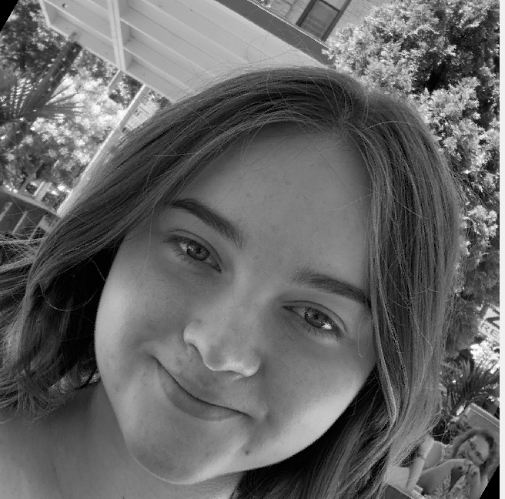

6. a

code used:

m_in_rgb = im2double(imread('HW_01_Anna_Kurchenko_DIR/Kitchen_Kolors_4670_ss.jpg'));

[im_red, im_grn, im_blu] = imsplit(im_in_rgb);

im_red_bin = im_red >= 0.5;

im_grn_bin = im_grn >= 0.5;

im_blu_bin = im_blu >= 0.5;

im_red_bin = double(im_red_bin);

im_grn_bin = double(im_grn_bin);

im_blu_bin = double(im_blu_bin);

im_new_part_a = cat(3, im_red_bin, im_grn_bin, im_blu_bin);

figure;

imshow(im_new_part_a);

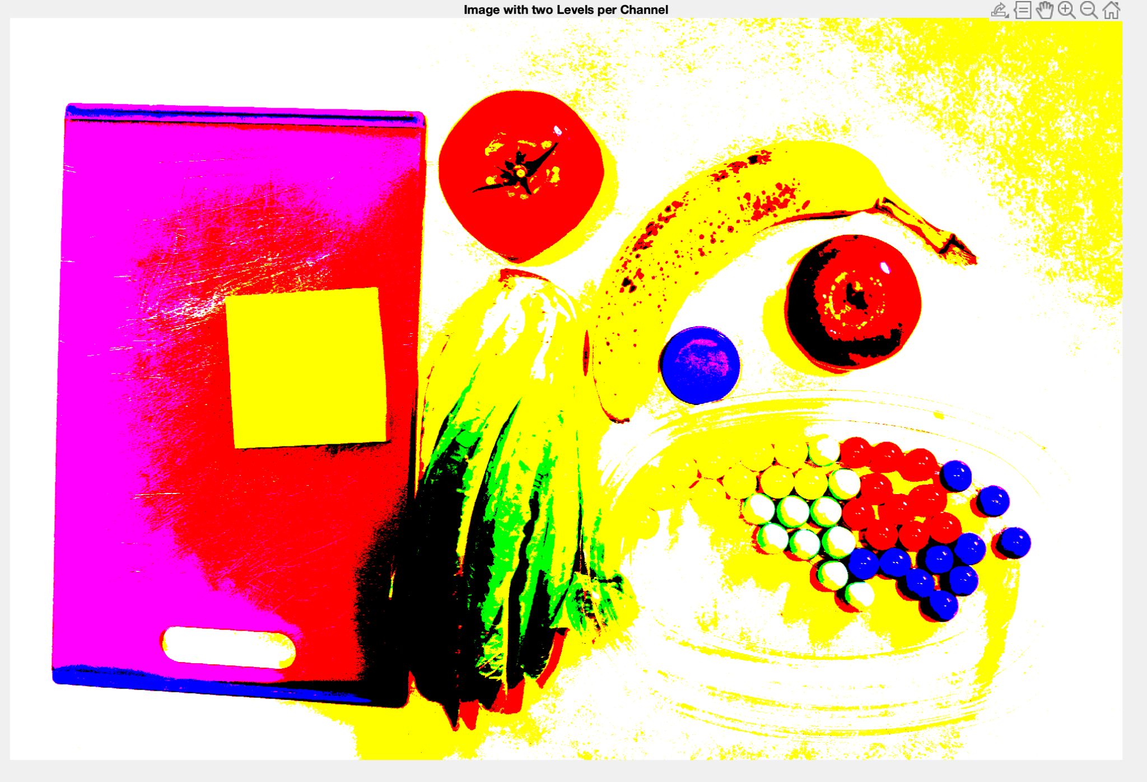

b.

code used:

im_quantized = round(im_in_rgb * 4) / 4.0;

figure;

imshow(im_quantized);

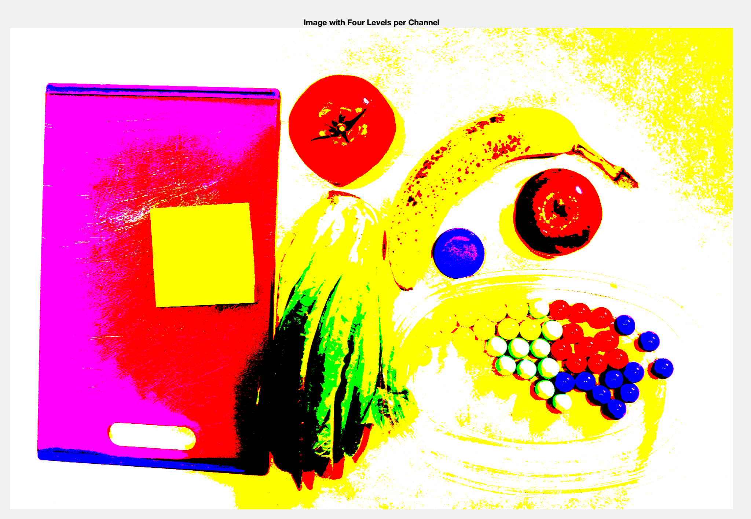

This image does look better than the previous image.

c.

This is code used:

num_levels = 6;

im_quantized = round(im_in_rgb * (num_levels - 1)) / (num_levels - 1);

figure;

imshow(im_quantized);

This image is not really better than from part b. , its kind of the same

d.

Total Colors=6^3=216

The number of actual unique colors was only 105.

7.

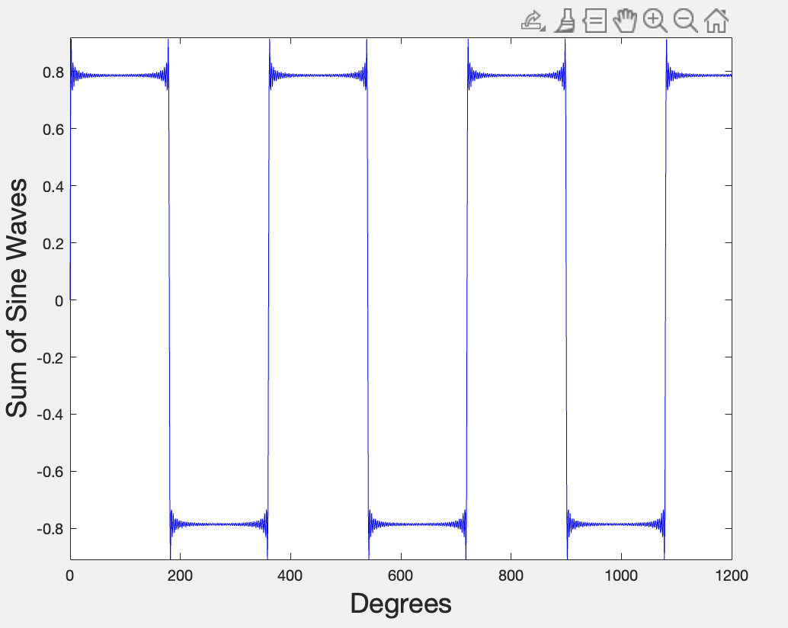

8.

I think it was really interesting to manipulate images in this homework like we did. I especially liked working with the Kitchen_kolors image, I found it visually interesting. I learned that splitting up an image in more than four levels of color channel does not really change anything, but the jump from 2 channels to 4 is really noticeable. I also learned about color quantization, which besides sounding cool, is a cool operation as well.

I was surprised mostly by how easily it is to manipulate images, at least in MATLAB, by only adjusting the color channels. Also it was cool to line up all of my image manipulations next to each other and compare what operations caused what differences, and how

they each altered my perception of the image.