# Emergency Responder Radio System

**Coverage Report Test Results**

|  |  |
| --- | --- |
| **Date Prepared:** | Apr 5, 2021 |
| **Test File:** | Seattle University CSI_20210405_101140 |
| **Test Location:** | Seattle University CSI |
|  | 901 12th Ave  Seattle, WA 98122 |
| **Technician:** | Aaron Keyte |
| **FCC#:** | PG00066071 |

## Building: Seattle University CSI

**Result:** Pass

Test Report Summary

| **Channel/ Ch Group** | **Freq (MHz)** | **Technology** | **Band** | **Result** | **Area Points**  **passed (%)** | **Critical Points passed (%)** |
| --- | --- | --- | --- | --- | --- | --- |
| 1 | 853.17500 | Custom Channel Power | Seattle Simulcast - PCC | Pass | 114/114 (100%) | 31/31 (100%) |

|  |  |  |  |
| --- | --- | --- | --- |
| **Test Details** | | | |
| **Number of Floors Tested:** | 6 | **Result Calculation:** | By area per floor |
| **Number of Areas Tested:** | 114 | **Area Pass Criteria:** | 95% |
| **Number of Critical Points Tested:** | 31 | **Critical Points Pass Criteria:** | 99% |
|  |  | **Apply Adjacent Area Rule:** | No |

|  |  |  |  |  |
| --- | --- | --- | --- | --- |
| **Equipment Configuration** | | | | |
| **Vendor** | **Application** | **Device** | **Calibration Expires** | **Antenna info** |
| PCTEL | SeeHawk Touch  rel 3.0.0.2 | SeeGull IBflex Device rel 3.5.0.0  SN: 081911044 | 11-13-2021 |  |

**Threshold Settings**

| **Measurement** | **DL Area Point** | **UL Area Point** | **DL Critical Point** | **UL Critical Point** | **Use for grading** |
| --- | --- | --- | --- | --- | --- |
| General Power (RSSI) | -95.0 dBm | -95.0 dBm | -95.0 dBm | -95.0 dBm | Yes |
| DAQ | 3.0 |  |  |  | No |

**Floors Result**

| **Floor Plan** | **1 853.17500** |
| --- | --- |
| Seattle U CSE - L6 | **Pass** |
| Seattle U CSE - L5 | **Pass** |
| Seattle U CSE - L4 | **Pass** |
| Seattle U CSE - L3 | **Pass** |
| Seattle U CSE - L2 | **Pass** |
| Seattle U CSE - L1 | **Pass** |

**Floor: Seattle U CSE - L6**

**Channel: 1**

**Result: Pass**

| **Freq (MHz)** | **Tech** | **Band** | **Ant Gain** | **Cable Loss** |  |  |  |  | **Area Points passed (%)** | **Critical Points passed (%)** |
| --- | --- | --- | --- | --- | --- | --- | --- | --- | --- | --- |
| 853.17500 | Custom Channel Power | Seattle Simulcast - PCC | 0.00 | 0.00 |  |  |  |  | 14/14 (100%) | 3/3 (100%) |

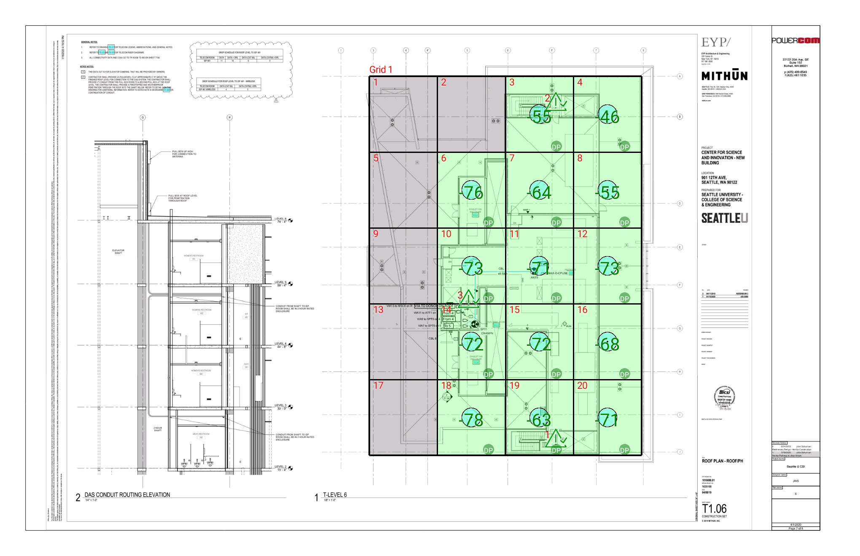

| **Grid** | **# of Areas** | **Area Size (sq. ft)** | **Area Width**  **(ft)** | **Area Height**  **(ft)** | **Comments** |
| --- | --- | --- | --- | --- | --- |
| 1 | 20 | 612.63 | 20.53 | 29.85 |  |

**Floor: Seattle U CSE - L6**

**Channel: 1**

| **Critical Point** | **DL**  **Power**  **(dBm)** | **DL**  **DAQ** | **UL**  **DAQ** | **Result** | **Comment** |
| --- | --- | --- | --- | --- | --- |
| 1 | -78.19 | 5 | 5 | **Pass** | Stairwell |
| 2 | -77.27 | 5 | 5 | **Pass** | Stairwell |
| 3 | -72.20 | 5 | 5 | **Pass** | Elevator lobby |

| **Grid** | **Area** | **DL**  **Power**  **(dBm)** | **DL**  **DAQ** | **UL**  **DAQ** | **Result** | **Comment** |
| --- | --- | --- | --- | --- | --- | --- |
| 1 | 1 | NT | NT | NT | **NT** |  |
| 1 | 2 | NT | NT | NT | **NT** |  |
| 1 | 3 | -54.78 | 5 | 5 | **Pass** |  |
| 1 | 4 | -45.69 | 5 | 5 | **Pass** |  |
| 1 | 5 | NT | NT | NT | **NT** |  |
| 1 | 6 | -75.55 | 5 | 5 | **Pass** |  |
| 1 | 7 | -63.93 | 5 | 5 | **Pass** |  |
| 1 | 8 | -54.06 | 5 | 5 | **Pass** |  |
| 1 | 9 | NT | NT | NT | **NT** |  |
| 1 | 10 | -72.79 | 5 | 5 | **Pass** |  |
| 1 | 11 | -70.93 | 5 | 5 | **Pass** |  |
| 1 | 12 | -72.56 | 5 | 5 | **Pass** |  |
| 1 | 13 | NT | NT | NT | **NT** |  |
| 1 | 14 | -71.49 | 5 | 5 | **Pass** |  |
| 1 | 15 | -71.07 | 5 | 5 | **Pass** |  |
| 1 | 16 | -67.80 | 5 | 5 | **Pass** |  |
| 1 | 17 | NT | NT | NT | **NT** |  |
| 1 | 18 | -77.06 | 5 | 5 | **Pass** |  |
| 1 | 19 | -62.20 | 5 | 5 | **Pass** |  |
| 1 | 20 | -70.77 | 5 | 5 | **Pass** |  |

**Floor: Seattle U CSE - L5**

**Channel: 1**

**Result: Pass**

| **Freq (MHz)** | **Tech** | **Band** | **Ant Gain** | **Cable Loss** |  |  |  |  | **Area Points passed (%)** | **Critical Points passed (%)** |
| --- | --- | --- | --- | --- | --- | --- | --- | --- | --- | --- |
| 853.17500 | Custom Channel Power | Seattle Simulcast - PCC | 0.00 | 0.00 |  |  |  |  | 20/20 (100%) | 4/4 (100%) |

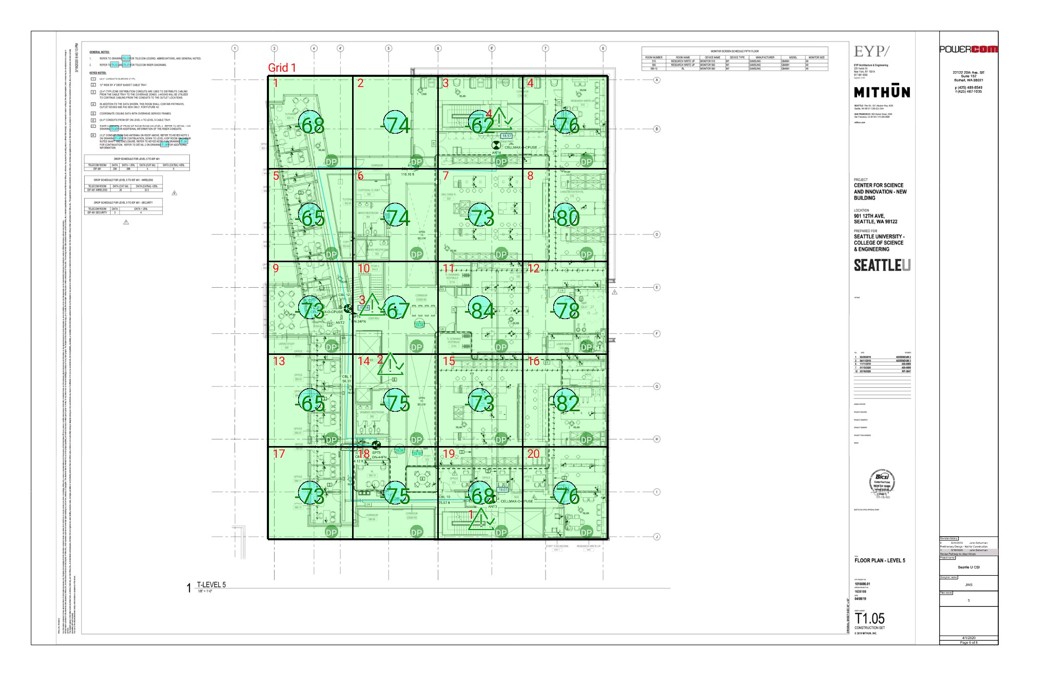

| **Grid** | **# of Areas** | **Area Size (sq. ft)** | **Area Width**  **(ft)** | **Area Height**  **(ft)** | **Comments** |
| --- | --- | --- | --- | --- | --- |
| 1 | 20 | 631.34 | 21.04 | 30.01 |  |

**Floor: Seattle U CSE - L5**

**Channel: 1**

| **Critical Point** | **DL**  **Power**  **(dBm)** | **DL**  **DAQ** | **UL**  **DAQ** | **Result** | **Comment** |
| --- | --- | --- | --- | --- | --- |
| 1 | -80.22 | 5 | 5 | **Pass** | Stairwell |
| 2 | -73.28 | 5 | 5 | **Pass** | Elevator lobby |
| 3 | -58.56 | 5 | 5 | **Pass** | Stairwell |
| 4 | -89.59 | 5 | 5 | **Pass** | Stairwell |

| **Grid** | **Area** | **DL**  **Power**  **(dBm)** | **DL**  **DAQ** | **UL**  **DAQ** | **Result** | **Comment** |
| --- | --- | --- | --- | --- | --- | --- |
| 1 | 1 | -67.50 | 5 | 5 | **Pass** |  |
| 1 | 2 | -73.78 | 5 | 5 | **Pass** |  |
| 1 | 3 | -61.27 | 5 | 5 | **Pass** |  |
| 1 | 4 | -75.55 | 5 | 5 | **Pass** |  |
| 1 | 5 | -64.84 | 5 | 5 | **Pass** |  |
| 1 | 6 | -73.59 | 5 | 5 | **Pass** |  |
| 1 | 7 | -72.31 | 5 | 5 | **Pass** |  |
| 1 | 8 | -79.33 | 5 | 5 | **Pass** |  |
| 1 | 9 | -72.70 | 5 | 5 | **Pass** |  |
| 1 | 10 | -66.51 | 5 | 5 | **Pass** |  |
| 1 | 11 | -83.87 | 5 | 5 | **Pass** |  |
| 1 | 12 | -77.37 | 5 | 5 | **Pass** |  |
| 1 | 13 | -64.96 | 5 | 5 | **Pass** |  |
| 1 | 14 | -74.42 | 5 | 5 | **Pass** |  |
| 1 | 15 | -72.94 | 5 | 5 | **Pass** |  |
| 1 | 16 | -81.19 | 5 | 5 | **Pass** |  |
| 1 | 17 | -72.92 | 5 | 5 | **Pass** |  |
| 1 | 18 | -74.56 | 5 | 5 | **Pass** |  |
| 1 | 19 | -67.16 | 5 | 5 | **Pass** |  |
| 1 | 20 | -75.47 | 5 | 5 | **Pass** |  |

**Floor: Seattle U CSE - L4**

**Channel: 1**

**Result: Pass**

| **Freq (MHz)** | **Tech** | **Band** | **Ant Gain** | **Cable Loss** |  |  |  |  | **Area Points passed (%)** | **Critical Points passed (%)** |
| --- | --- | --- | --- | --- | --- | --- | --- | --- | --- | --- |
| 853.17500 | Custom Channel Power | Seattle Simulcast - PCC | 0.00 | 0.00 |  |  |  |  | 20/20 (100%) | 4/4 (100%) |

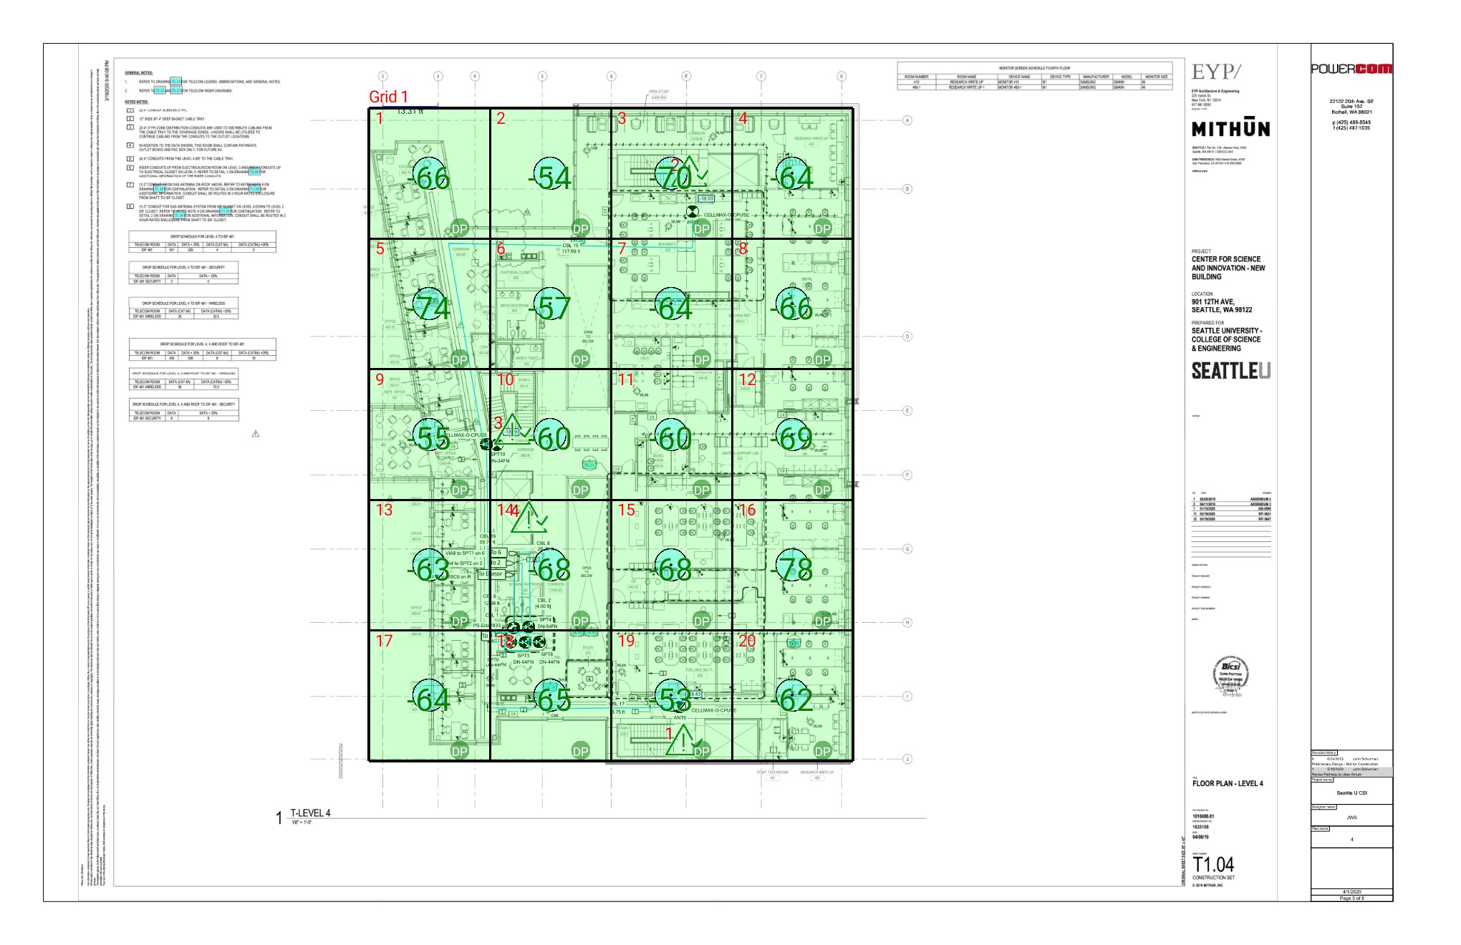

| **Grid** | **# of Areas** | **Area Size (sq. ft)** | **Area Width**  **(ft)** | **Area Height**  **(ft)** | **Comments** |
| --- | --- | --- | --- | --- | --- |
| 1 | 20 | 649.68 | 21.48 | 30.25 |  |

**Floor: Seattle U CSE - L4**

**Channel: 1**

| **Critical Point** | **DL**  **Power**  **(dBm)** | **DL**  **DAQ** | **UL**  **DAQ** | **Result** | **Comment** |
| --- | --- | --- | --- | --- | --- |
| 1 | -52.99 | 5 | 5 | **Pass** | Stairwell |
| 2 | -77.68 | 5 | 5 | **Pass** | Stairwell |
| 3 | -53.08 | 5 | 5 | **Pass** | Stairwell |
| 4 | -66.66 | 5 | 5 | **Pass** | Elevator lobby |

| **Grid** | **Area** | **DL**  **Power**  **(dBm)** | **DL**  **DAQ** | **UL**  **DAQ** | **Result** | **Comment** |
| --- | --- | --- | --- | --- | --- | --- |
| 1 | 1 | -65.55 | 5 | 5 | **Pass** |  |
| 1 | 2 | -53.83 | 5 | 5 | **Pass** |  |
| 1 | 3 | -69.13 | 5 | 5 | **Pass** |  |
| 1 | 4 | -63.61 | 5 | 5 | **Pass** |  |
| 1 | 5 | -73.81 | 5 | 5 | **Pass** |  |
| 1 | 6 | -56.56 | 5 | 5 | **Pass** |  |
| 1 | 7 | -63.29 | 5 | 5 | **Pass** |  |
| 1 | 8 | -65.59 | 5 | 5 | **Pass** |  |
| 1 | 9 | -54.65 | 5 | 5 | **Pass** |  |
| 1 | 10 | -59.25 | 5 | 5 | **Pass** |  |
| 1 | 11 | -59.06 | 5 | 5 | **Pass** |  |
| 1 | 12 | -68.61 | 5 | 5 | **Pass** |  |
| 1 | 13 | -62.07 | 5 | 5 | **Pass** |  |
| 1 | 14 | -67.80 | 5 | 5 | **Pass** |  |
| 1 | 15 | -67.92 | 5 | 5 | **Pass** |  |
| 1 | 16 | -77.83 | 5 | 5 | **Pass** |  |
| 1 | 17 | -63.36 | 5 | 5 | **Pass** |  |
| 1 | 18 | -64.36 | 5 | 5 | **Pass** |  |
| 1 | 19 | -52.26 | 5 | 5 | **Pass** |  |
| 1 | 20 | -61.79 | 5 | 5 | **Pass** |  |

**Floor: Seattle U CSE - L3**

**Channel: 1**

**Result: Pass**

| **Freq (MHz)** | **Tech** | **Band** | **Ant Gain** | **Cable Loss** |  |  |  |  | **Area Points passed (%)** | **Critical Points passed (%)** |
| --- | --- | --- | --- | --- | --- | --- | --- | --- | --- | --- |
| 853.17500 | Custom Channel Power | Seattle Simulcast - PCC | 0.00 | 0.00 |  |  |  |  | 20/20 (100%) | 4/4 (100%) |

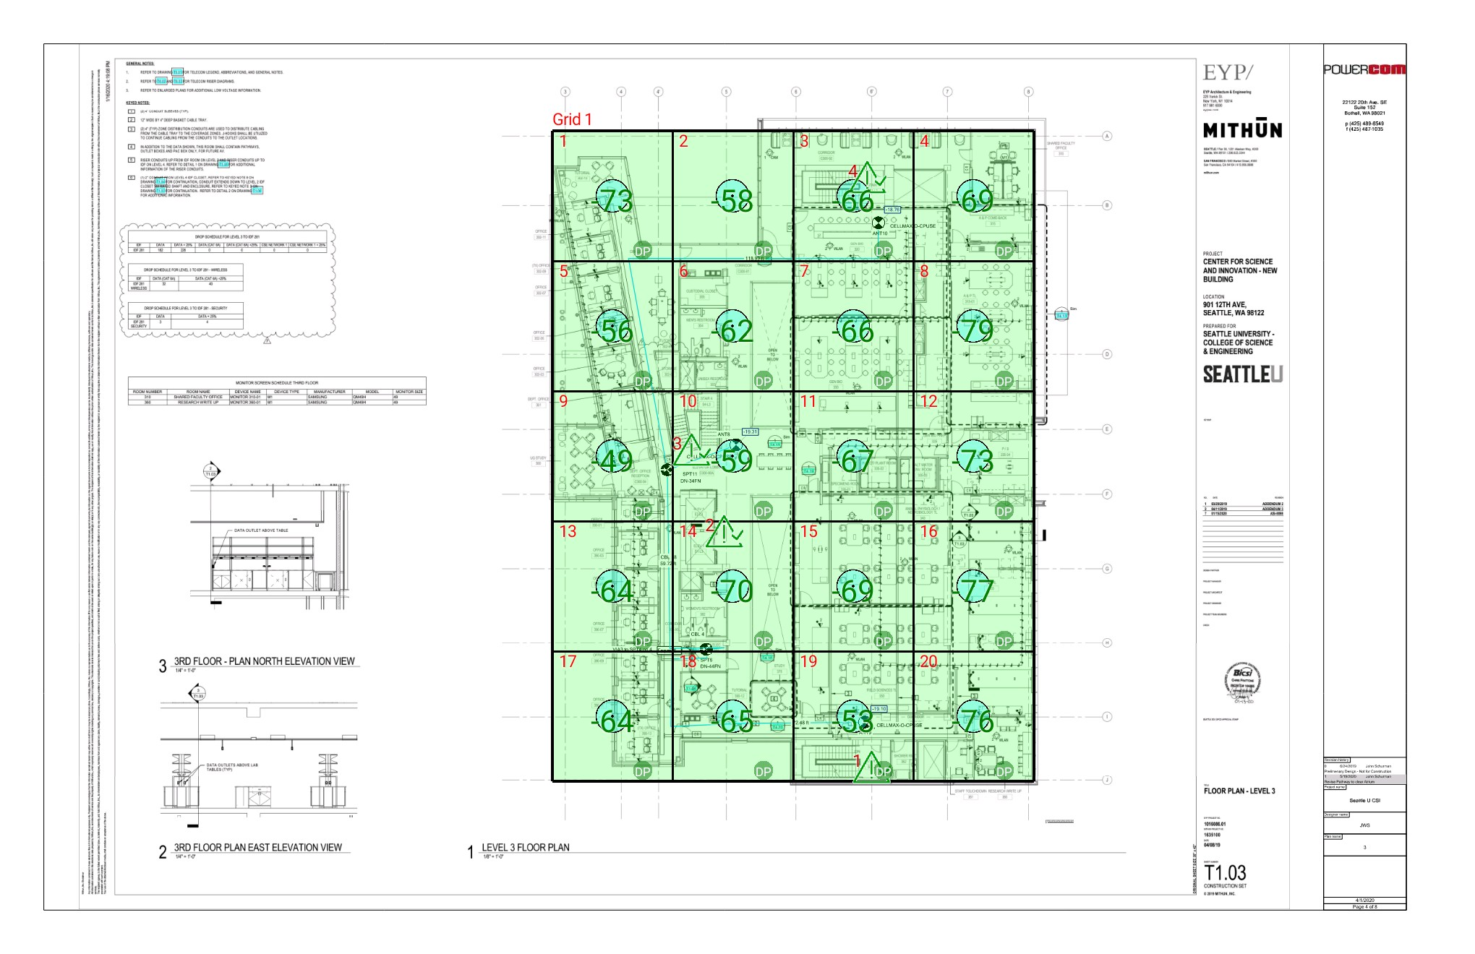

| **Grid** | **# of Areas** | **Area Size (sq. ft)** | **Area Width**  **(ft)** | **Area Height**  **(ft)** | **Comments** |
| --- | --- | --- | --- | --- | --- |
| 1 | 20 | 631.58 | 21.16 | 29.85 |  |

**Floor: Seattle U CSE - L3**

**Channel: 1**

| **Critical Point** | **DL**  **Power**  **(dBm)** | **DL**  **DAQ** | **UL**  **DAQ** | **Result** | **Comment** |
| --- | --- | --- | --- | --- | --- |
| 1 | -66.71 | 5 | 5 | **Pass** | Stairwell |
| 2 | -66.88 | 5 | 5 | **Pass** | Elevator lobby |
| 3 | -54.59 | 5 | 5 | **Pass** | Stairwell |
| 4 | -73.61 | 5 | 5 | **Pass** | Stairwell |

| **Grid** | **Area** | **DL**  **Power**  **(dBm)** | **DL**  **DAQ** | **UL**  **DAQ** | **Result** | **Comment** |
| --- | --- | --- | --- | --- | --- | --- |
| 1 | 1 | -72.15 | 5 | 5 | **Pass** |  |
| 1 | 2 | -57.62 | 5 | 5 | **Pass** |  |
| 1 | 3 | -65.19 | 5 | 5 | **Pass** |  |
| 1 | 4 | -68.61 | 5 | 5 | **Pass** |  |
| 1 | 5 | -55.90 | 5 | 5 | **Pass** |  |
| 1 | 6 | -61.25 | 5 | 5 | **Pass** |  |
| 1 | 7 | -65.16 | 5 | 5 | **Pass** |  |
| 1 | 8 | -78.43 | 5 | 5 | **Pass** |  |
| 1 | 9 | -48.58 | 5 | 5 | **Pass** |  |
| 1 | 10 | -58.96 | 5 | 5 | **Pass** |  |
| 1 | 11 | -66.46 | 5 | 5 | **Pass** |  |
| 1 | 12 | -72.29 | 5 | 5 | **Pass** |  |
| 1 | 13 | -63.02 | 5 | 5 | **Pass** |  |
| 1 | 14 | -69.12 | 5 | 5 | **Pass** |  |
| 1 | 15 | -68.19 | 5 | 5 | **Pass** |  |
| 1 | 16 | -76.35 | 5 | 5 | **Pass** |  |
| 1 | 17 | -63.05 | 5 | 5 | **Pass** |  |
| 1 | 18 | -64.01 | 5 | 5 | **Pass** |  |
| 1 | 19 | -52.46 | 5 | 5 | **Pass** |  |
| 1 | 20 | -75.30 | 5 | 5 | **Pass** |  |

**Floor: Seattle U CSE - L2**

**Channel: 1**

**Result: Pass**

| **Freq (MHz)** | **Tech** | **Band** | **Ant Gain** | **Cable Loss** |  |  |  |  | **Area Points passed (%)** | **Critical Points passed (%)** |
| --- | --- | --- | --- | --- | --- | --- | --- | --- | --- | --- |
| 853.17500 | Custom Channel Power | Seattle Simulcast - PCC | 0.00 | 0.00 |  |  |  |  | 20/20 (100%) | 5/5 (100%) |

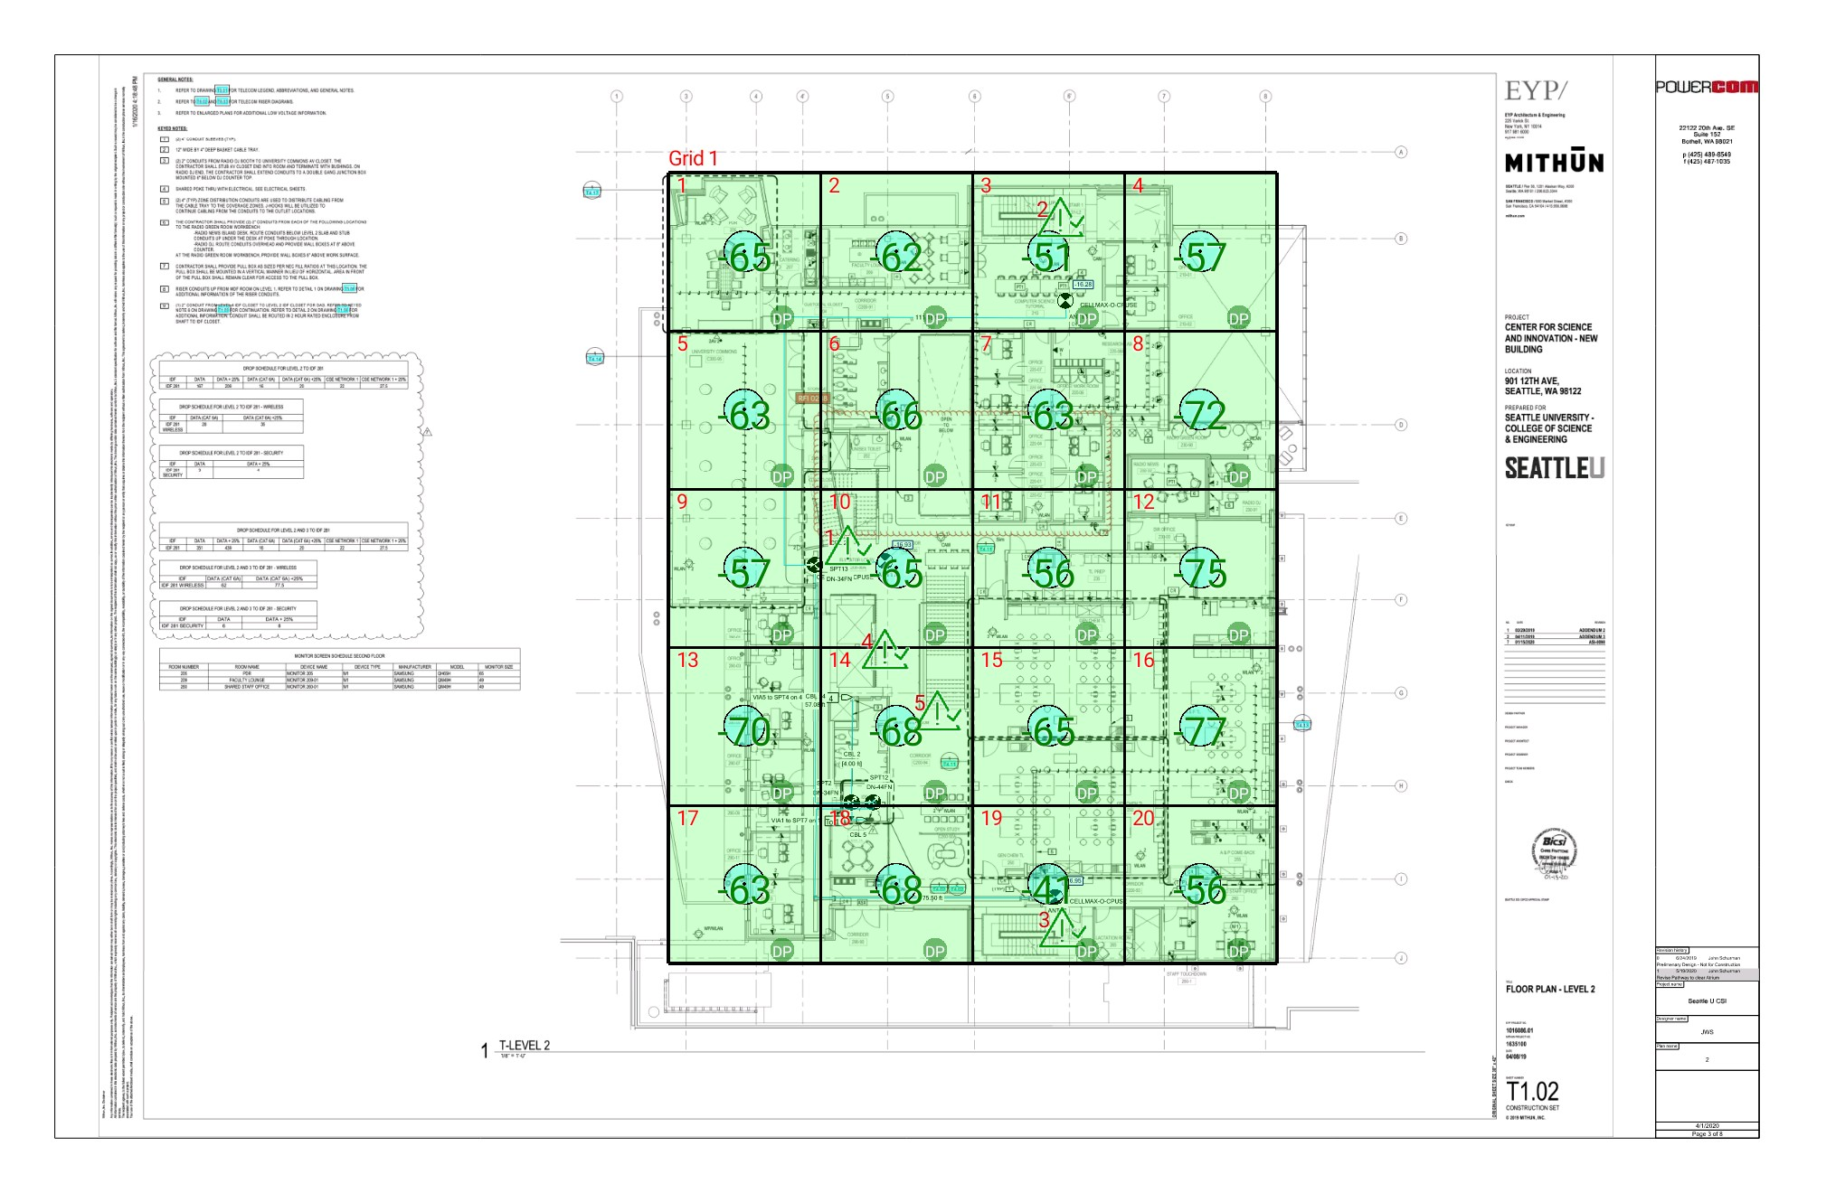

| **Grid** | **# of Areas** | **Area Size (sq. ft)** | **Area Width**  **(ft)** | **Area Height**  **(ft)** | **Comments** |
| --- | --- | --- | --- | --- | --- |
| 1 | 20 | 620.52 | 21.38 | 29.02 |  |

**Floor: Seattle U CSE - L2**

**Channel: 1**

| **Critical Point** | **DL**  **Power**  **(dBm)** | **DL**  **DAQ** | **UL**  **DAQ** | **Result** | **Comment** |
| --- | --- | --- | --- | --- | --- |
| 1 | -55.89 | 5 | 5 | **Pass** | Stairwell |
| 2 | -64.66 | 5 | 5 | **Pass** | Stairwell |
| 3 | -62.03 | 5 | 5 | **Pass** | Stairwell |
| 4 | -70.02 | 5 | 5 | **Pass** | Elevator lobby |
| 5 | -69.89 | 5 | 5 | **Pass** | Stairwell |

| **Grid** | **Area** | **DL**  **Power**  **(dBm)** | **DL**  **DAQ** | **UL**  **DAQ** | **Result** | **Comment** |
| --- | --- | --- | --- | --- | --- | --- |
| 1 | 1 | -64.42 | 5 | 5 | **Pass** |  |
| 1 | 2 | -61.56 | 5 | 5 | **Pass** |  |
| 1 | 3 | -50.31 | 5 | 5 | **Pass** |  |
| 1 | 4 | -56.80 | 5 | 5 | **Pass** |  |
| 1 | 5 | -62.72 | 5 | 5 | **Pass** |  |
| 1 | 6 | -65.12 | 5 | 5 | **Pass** |  |
| 1 | 7 | -62.03 | 5 | 5 | **Pass** |  |
| 1 | 8 | -71.58 | 5 | 5 | **Pass** |  |
| 1 | 9 | -56.27 | 5 | 5 | **Pass** |  |
| 1 | 10 | -64.83 | 5 | 5 | **Pass** |  |
| 1 | 11 | -55.41 | 5 | 5 | **Pass** |  |
| 1 | 12 | -74.32 | 5 | 5 | **Pass** |  |
| 1 | 13 | -69.20 | 5 | 5 | **Pass** |  |
| 1 | 14 | -67.87 | 5 | 5 | **Pass** |  |
| 1 | 15 | -64.88 | 5 | 5 | **Pass** |  |
| 1 | 16 | -76.31 | 5 | 5 | **Pass** |  |
| 1 | 17 | -62.04 | 5 | 5 | **Pass** |  |
| 1 | 18 | -67.14 | 5 | 5 | **Pass** |  |
| 1 | 19 | -40.98 | 5 | 5 | **Pass** |  |
| 1 | 20 | -55.08 | 5 | 5 | **Pass** |  |

**Floor: Seattle U CSE - L1**

**Channel: 1**

**Result: Pass**

| **Freq (MHz)** | **Tech** | **Band** | **Ant Gain** | **Cable Loss** |  |  |  |  | **Area Points passed (%)** | **Critical Points passed (%)** |
| --- | --- | --- | --- | --- | --- | --- | --- | --- | --- | --- |
| 853.17500 | Custom Channel Power | Seattle Simulcast - PCC | 0.00 | 0.00 |  |  |  |  | 20/20 (100%) | 11/11 (100%) |

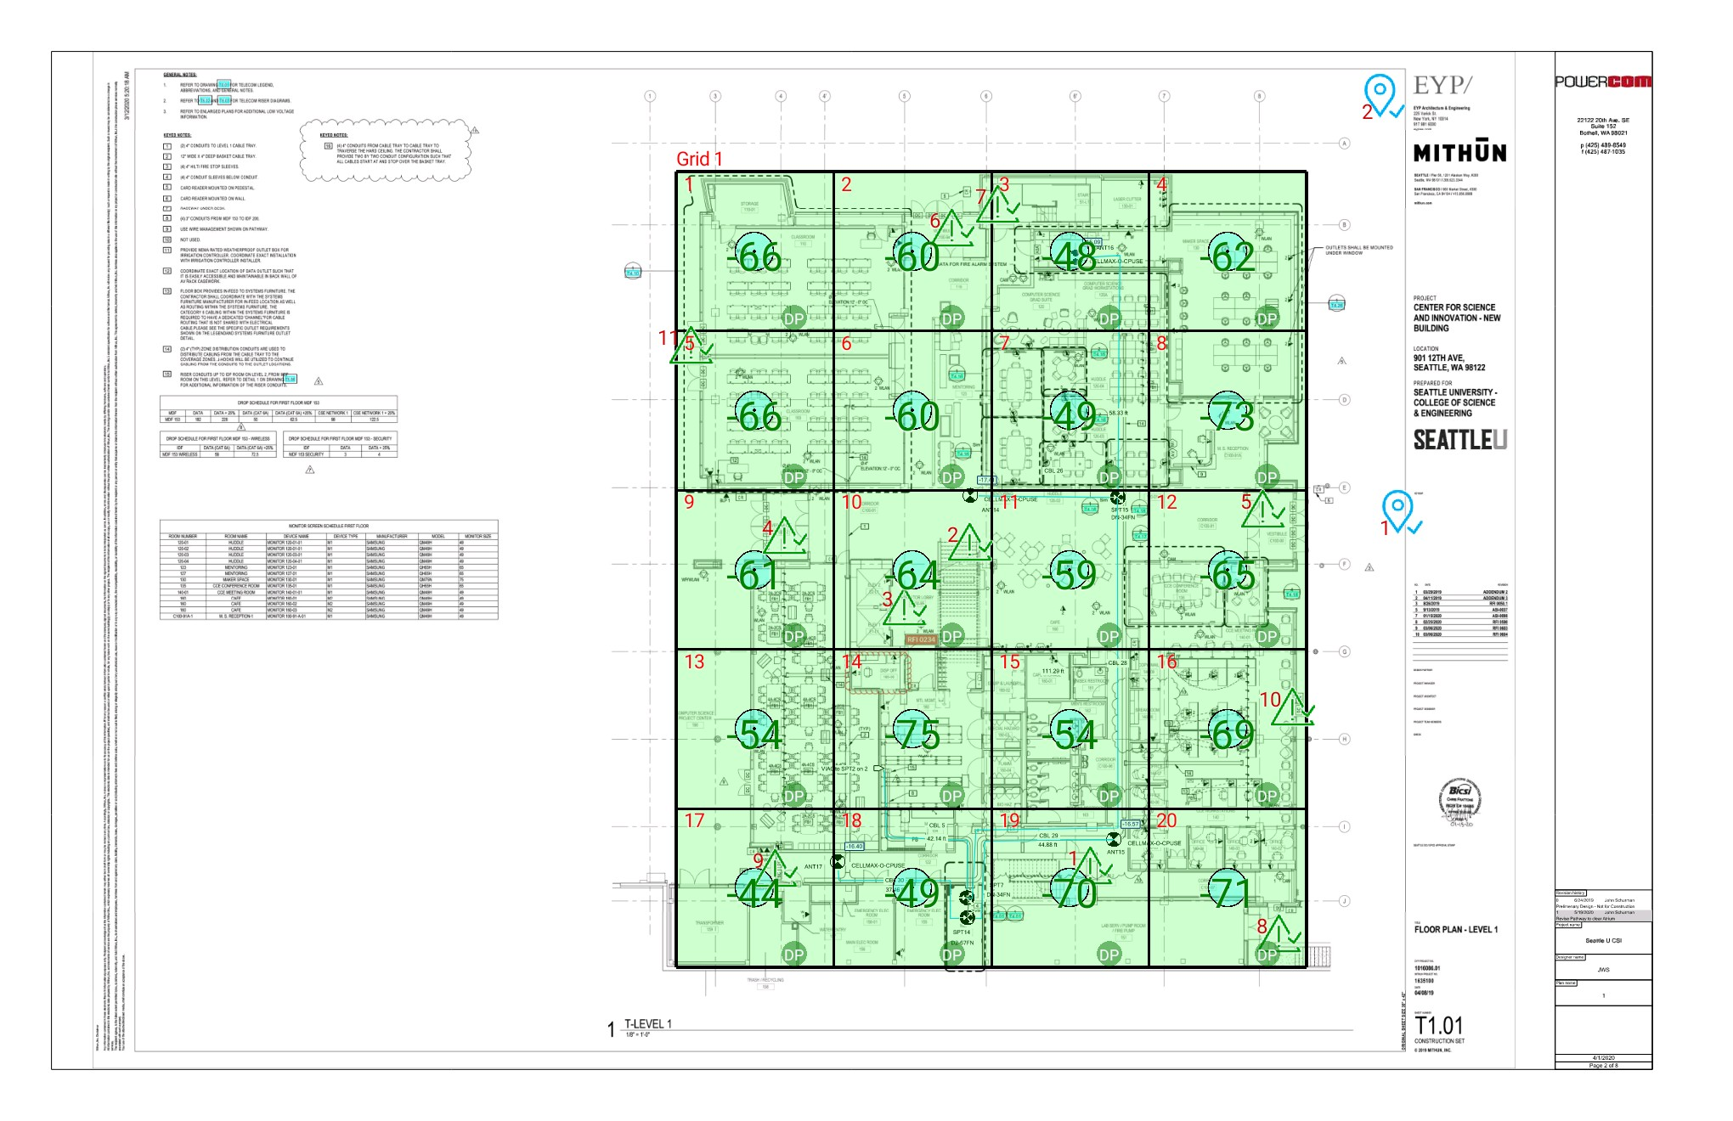

| **Grid** | **# of Areas** | **Area Size (sq. ft)** | **Area Width**  **(ft)** | **Area Height**  **(ft)** | **Comments** |
| --- | --- | --- | --- | --- | --- |
| 1 | 20 | 732.62 | 23.58 | 31.08 |  |

**Floor: Seattle U CSE - L1**

**Channel: 1**

| **Reference Point Report** | | | |
| --- | --- | --- | --- |
| **Reference Point** | **Power (dBm)** | **Selected** | **Comment** |
| 1 | -53.25 |  | Outdoor |
| 2 | -64.78 |  | Outdoor |

| **Critical Point** | **DL**  **Power**  **(dBm)** | **DL**  **DAQ** | **UL**  **DAQ** | **Result** | **Comment** |
| --- | --- | --- | --- | --- | --- |
| 1 | -71.72 | 5 | 5 | **Pass** | Outdoor |
| 2 | -62.82 | 5 | 5 | **Pass** | Outdoor |
| 3 | -71.00 | 5 | 5 | **Pass** | Elevator lobby |
| 4 | -60.78 | 5 | 5 | **Pass** | Entrance |
| 5 | -71.23 | 5 | 5 | **Pass** | Entrance |
| 6 | -60.91 | 5 | 5 | **Pass** | Entrance |
| 7 | -67.13 | 5 | 5 | **Pass** | Outdoor |
| 8 | -71.28 | 5 | 5 | **Pass** | Entrance |
| 9 | -46.85 | 5 | 5 | **Pass** | Entrance |
| 10 | -54.39 | 5 | 5 | **Pass** | Entrance |
| 11 | -64.76 | 5 | 5 | **Pass** | Entrance |

| **Grid** | **Area** | **DL**  **Power**  **(dBm)** | **DL**  **DAQ** | **UL**  **DAQ** | **Result** | **Comment** |
| --- | --- | --- | --- | --- | --- | --- |
| 1 | 1 | -65.17 | 5 | 5 | **Pass** |  |
| 1 | 2 | -59.66 | 5 | 5 | **Pass** |  |
| 1 | 3 | -47.04 | 5 | 5 | **Pass** |  |
| 1 | 4 | -61.68 | 5 | 5 | **Pass** |  |
| 1 | 5 | -65.10 | 5 | 5 | **Pass** |  |
| 1 | 6 | -59.22 | 5 | 5 | **Pass** |  |
| 1 | 7 | -48.53 | 5 | 5 | **Pass** |  |
| 1 | 8 | -72.41 | 5 | 5 | **Pass** |  |
| 1 | 9 | -60.62 | 5 | 5 | **Pass** |  |
| 1 | 10 | -63.93 | 5 | 5 | **Pass** |  |
| 1 | 11 | -58.65 | 5 | 5 | **Pass** |  |
| 1 | 12 | -64.61 | 5 | 5 | **Pass** |  |
| 1 | 13 | -53.63 | 5 | 5 | **Pass** |  |
| 1 | 14 | -74.76 | 5 | 5 | **Pass** |  |
| 1 | 15 | -53.82 | 5 | 5 | **Pass** |  |
| 1 | 16 | -68.51 | 5 | 5 | **Pass** |  |
| 1 | 17 | -43.59 | 5 | 5 | **Pass** |  |
| 1 | 18 | -48.83 | 5 | 5 | **Pass** |  |
| 1 | 19 | -69.84 | 5 | 5 | **Pass** |  |
| 1 | 20 | -70.78 | 5 | 5 | **Pass** |  |