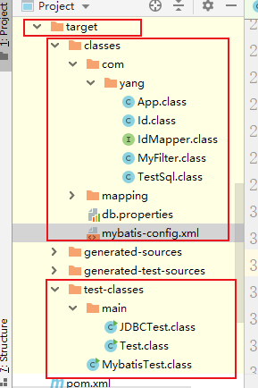

String t = App.  
 **class**.  
 getClassLoader().  
 getResource(**"mybatis-config.xml"**).  
 getPath();  
String t2 = App.  
 **class**.  
 getClassLoader().  
 getResource(**""**).  
 getPath();  
*// 制定类加载路径*String t1 = App.**class**.getResource(**""**).getPath();  
System.***out***.println(t);  
System.***out***.println(t2);  
System.***out***.println(t1);

结果：

/G:/java/workspace/service/target/classes/mybatis-config.xml

/G:/java/workspace/service/target/test-classes/

/G:/java/workspace/service/target/classes/com/yang/