**Topology**

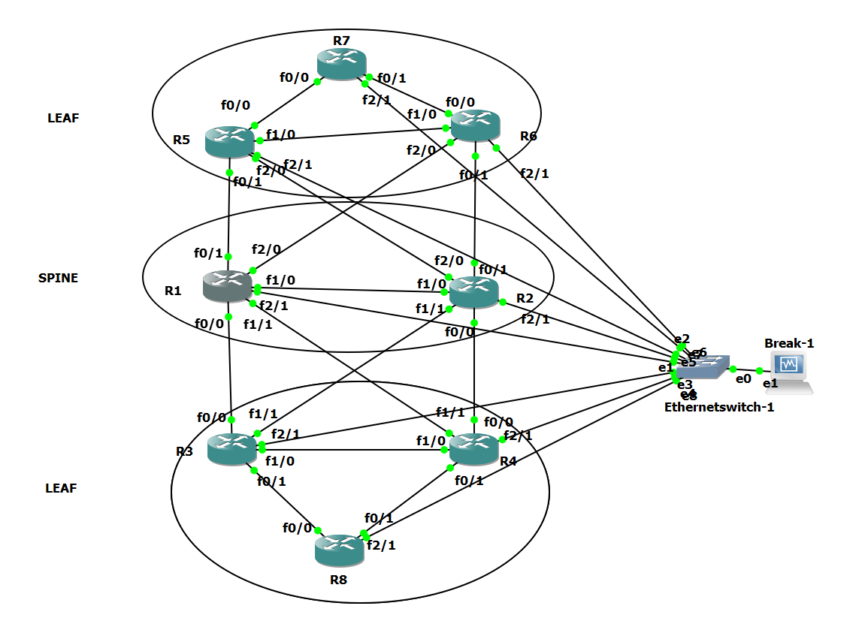

**IP-Addressing**

Used a /24 network

Mgmt ip – 192.168.10.0/24

Interface – 10.1.xX.x /24

Where x is lower router number ad=nd X is higher.

10.1. (lower_number)(higher_number).router_Number

So when R1 - connected to R5

R1

interface

ip add 10.1.15.1

R5

interface

ip add 10.1.15.5

This way from traceroute we can easily decipher our path based on the digit in the last octet that represents Router number

Give Linux VM IP-address in same subnet as management IP subnet with Router



ip addr add 192.168.10.10/24 dev enp0s8

**About Script**

The script provides you options

Enter option

1 - Drain R1

2 - Drain R2

3 - Drain R3

4 - Drain R4

5 - Drain R5

6 - Drain R6

7 - Undrain

8 - Exit

**Physical Connections**

All Routers connect int f2/1 connect to switch.

Assumptions

All areas are under Area 0.

Traceroute from R8 to R7 at opposite ends to show the best effect of Drain.

Enabling SSH on all the routers to enable us SSH from VM

conf t

username lab privilege 15 password lab123

ip domain-name lab

crypto key generate rsa

1024

ip ssh version 2

!

line vty 0 15

login local

transport input all

!

Apply config from excel sheet.

All config mentioned in click and apply. If you wish to reconstruct in GNS3, you have to just make sure the interfaces are correct.

Default route from R8-R7(10.1.67.7)

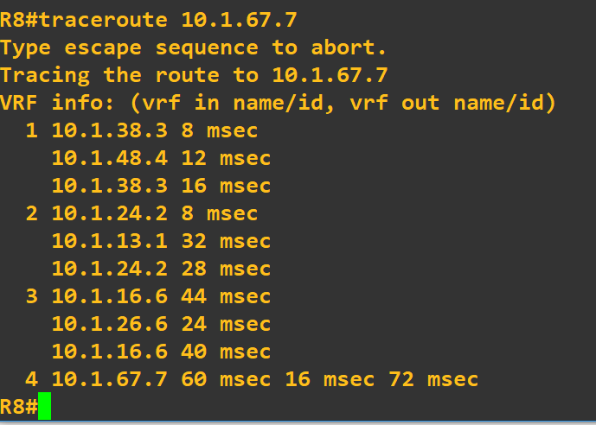

Default route from R8-R7(10.1.57.7)

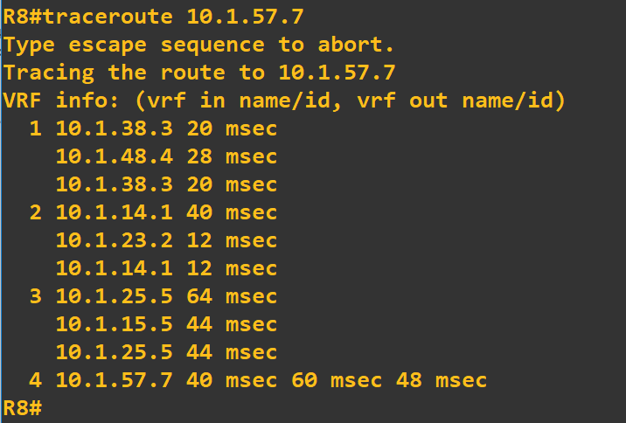

Testing the left arm – we suspend routers on right arm

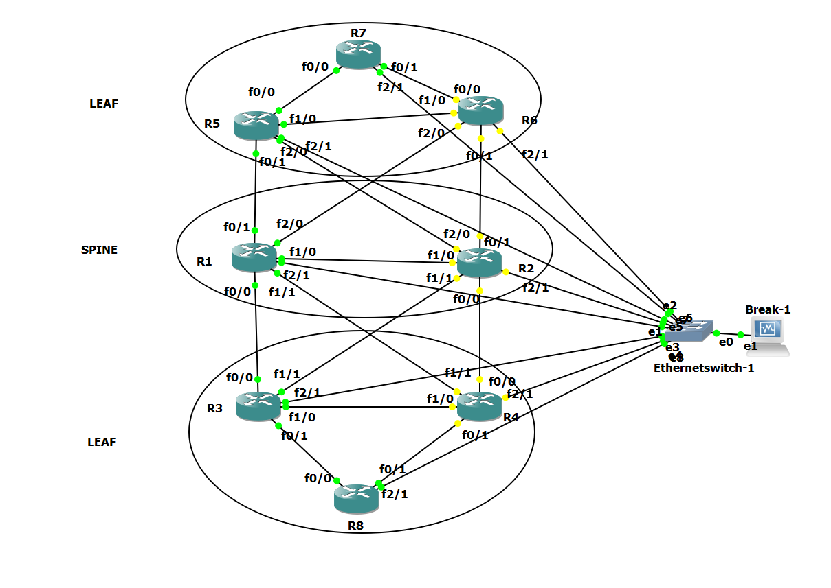

Ping from R7 to R8

Follows path R7-R5-R1-R3-R8 – Left Arm

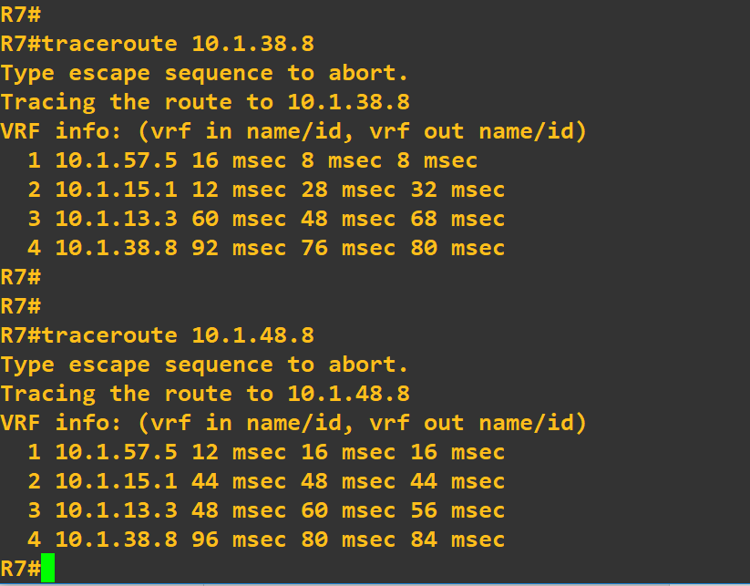

Ping from R8 to R7

Follows path R8-R3-R1-R5-R7 – Left Arm

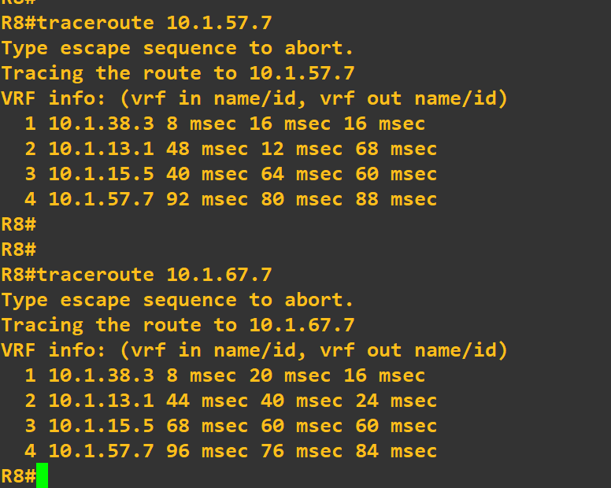

Testing the right arm– we suspend routers on left arm

Ping from R7 to R8

Follows path R7 - R6 – R2- R4 - R8

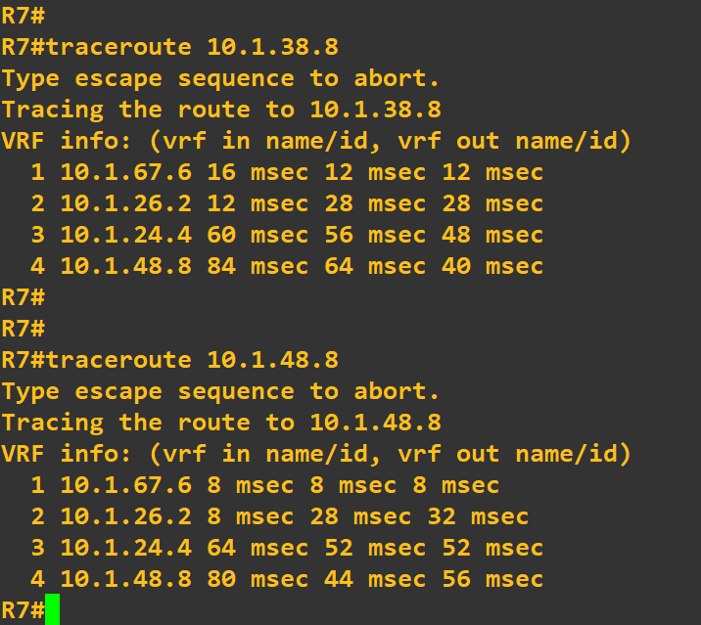

Ping from R8 to R7

Follows path R8 - R4 - R2 – R6 - R7

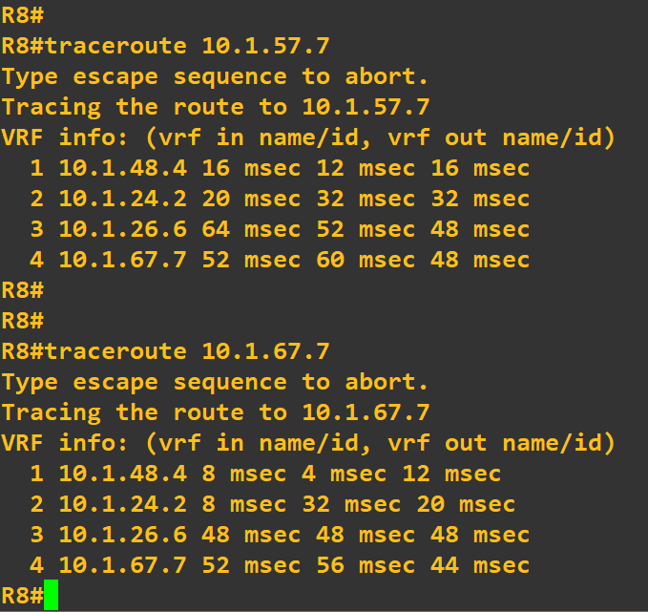

Before Drain R1

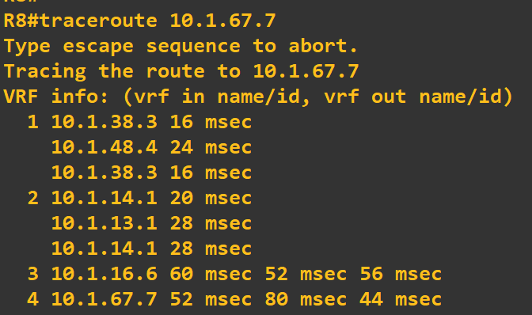

after Drain R1

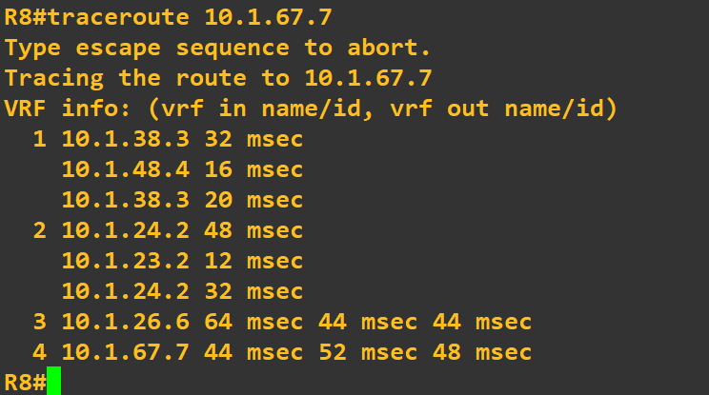

Path to R1 avoided

Befor e draining R2

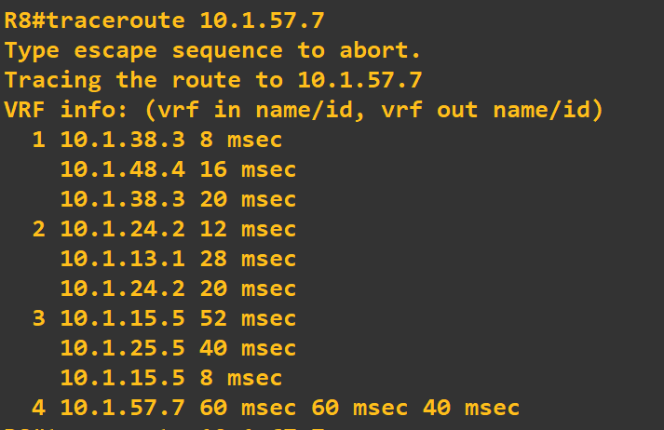

After Draining R2

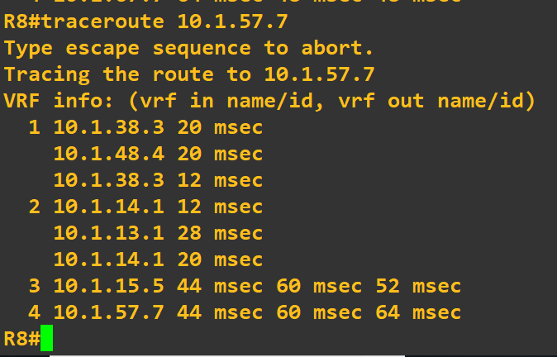

Main Page

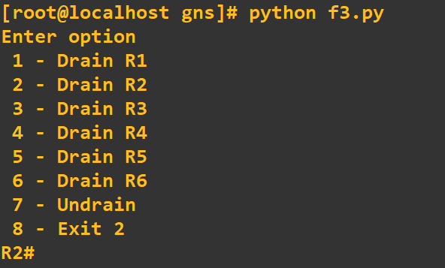

Before Draining R4

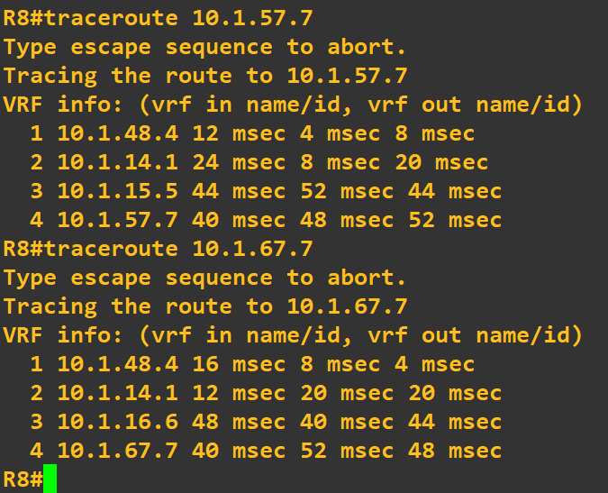

After Draining R4

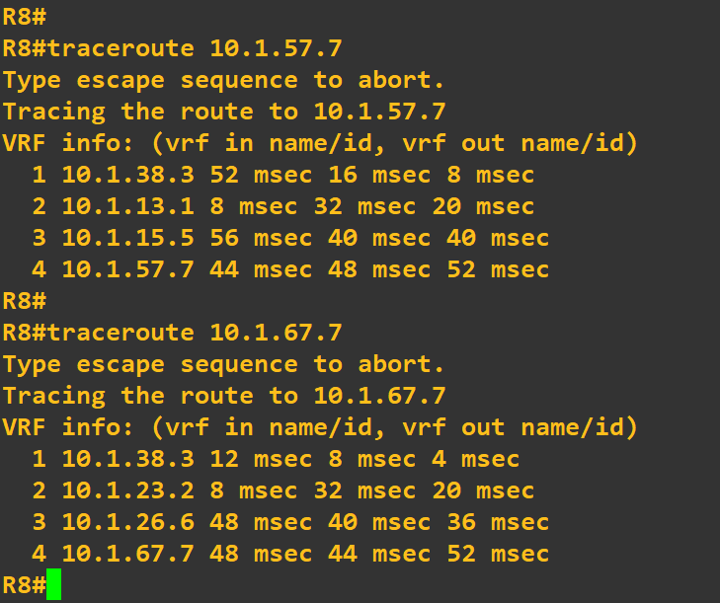

Before affecting R5

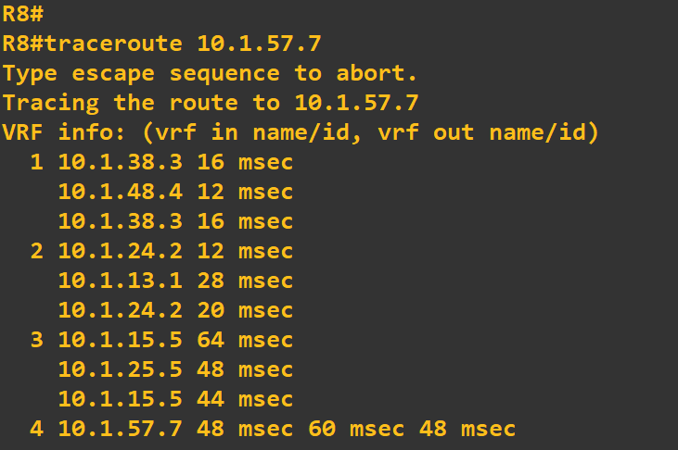

After Draining R5

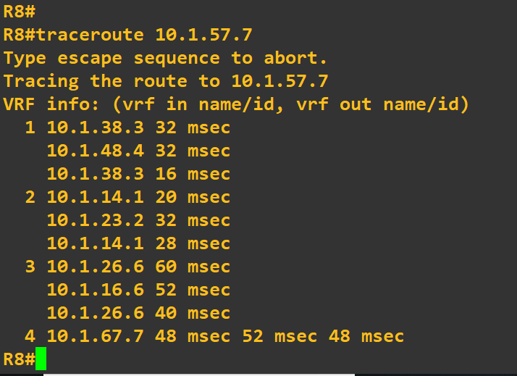

Before draining R6

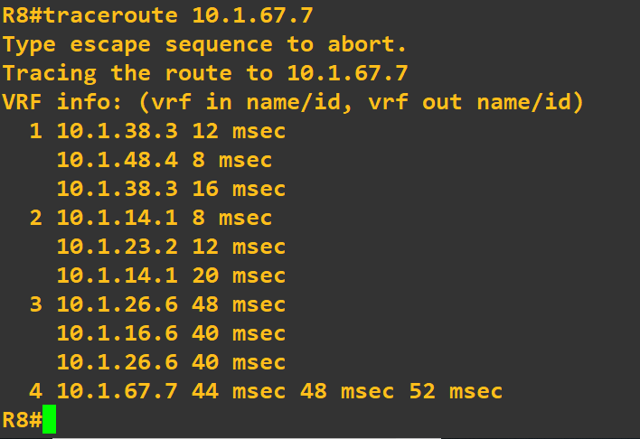

After Draining R6 – R6 is left out from Hops in 3.

