Extended Data Figure 1 | G-quadruplex enrichment in exonic flanking sequences
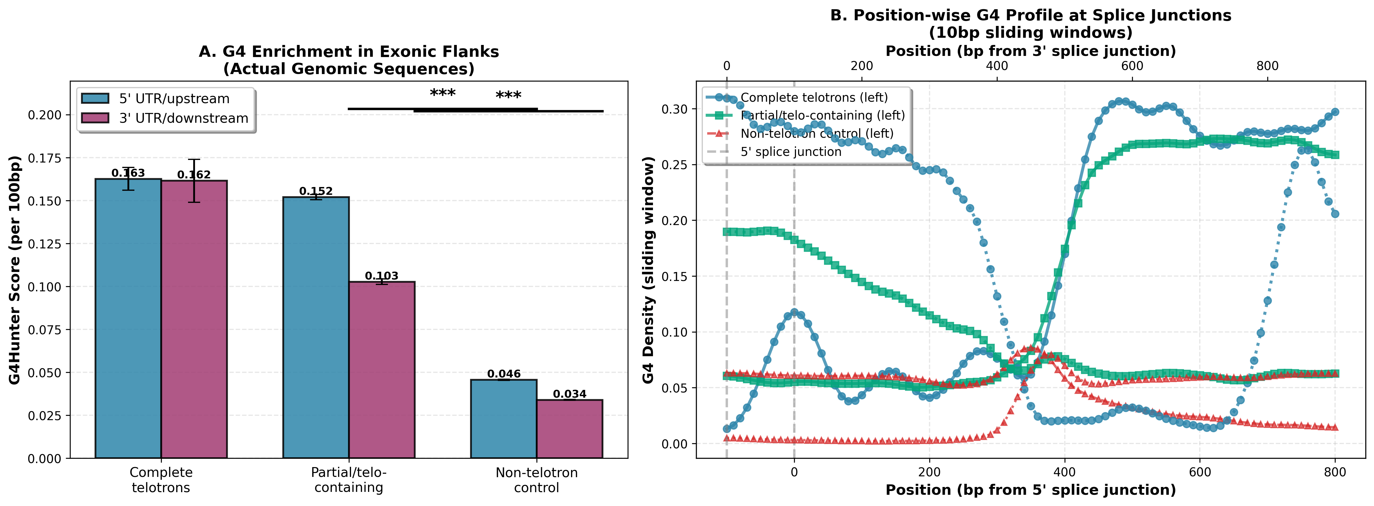
Extended Data Figure 1 | G-quadruplex enrichment in exonic flanking sequences. G4 motif density computed exclusively in exonic sequences flanking intron boundaries (all intronic sequence excluded). Left: telotron-flanking exons show 3.5-fold enrichment over non-telotron-flanking exons (3.63 vs 1.03 motifs/kb, P = 3.4 × 10⁻¹⁰²). Right: metagene profile of G4 density centered on intron boundaries shows peak enrichment at telotron insertion sites.

Extended Data Figure 2 | Telotron architecture across MAGs
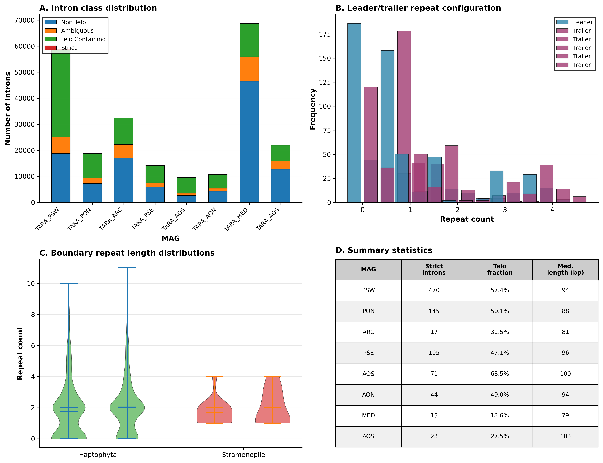
Extended Data Figure 2 | Telotron architecture across MAGs. Comparison of telomeric repeat structure, strand orientation, and purity distribution across the top 8 telotron-bearing MAGs from 4 supergroups. Architecture is conserved: >85% purity introns show consistent converging or template-strand patterns across lineages.

Extended Data Figure 3 | Assembly validation
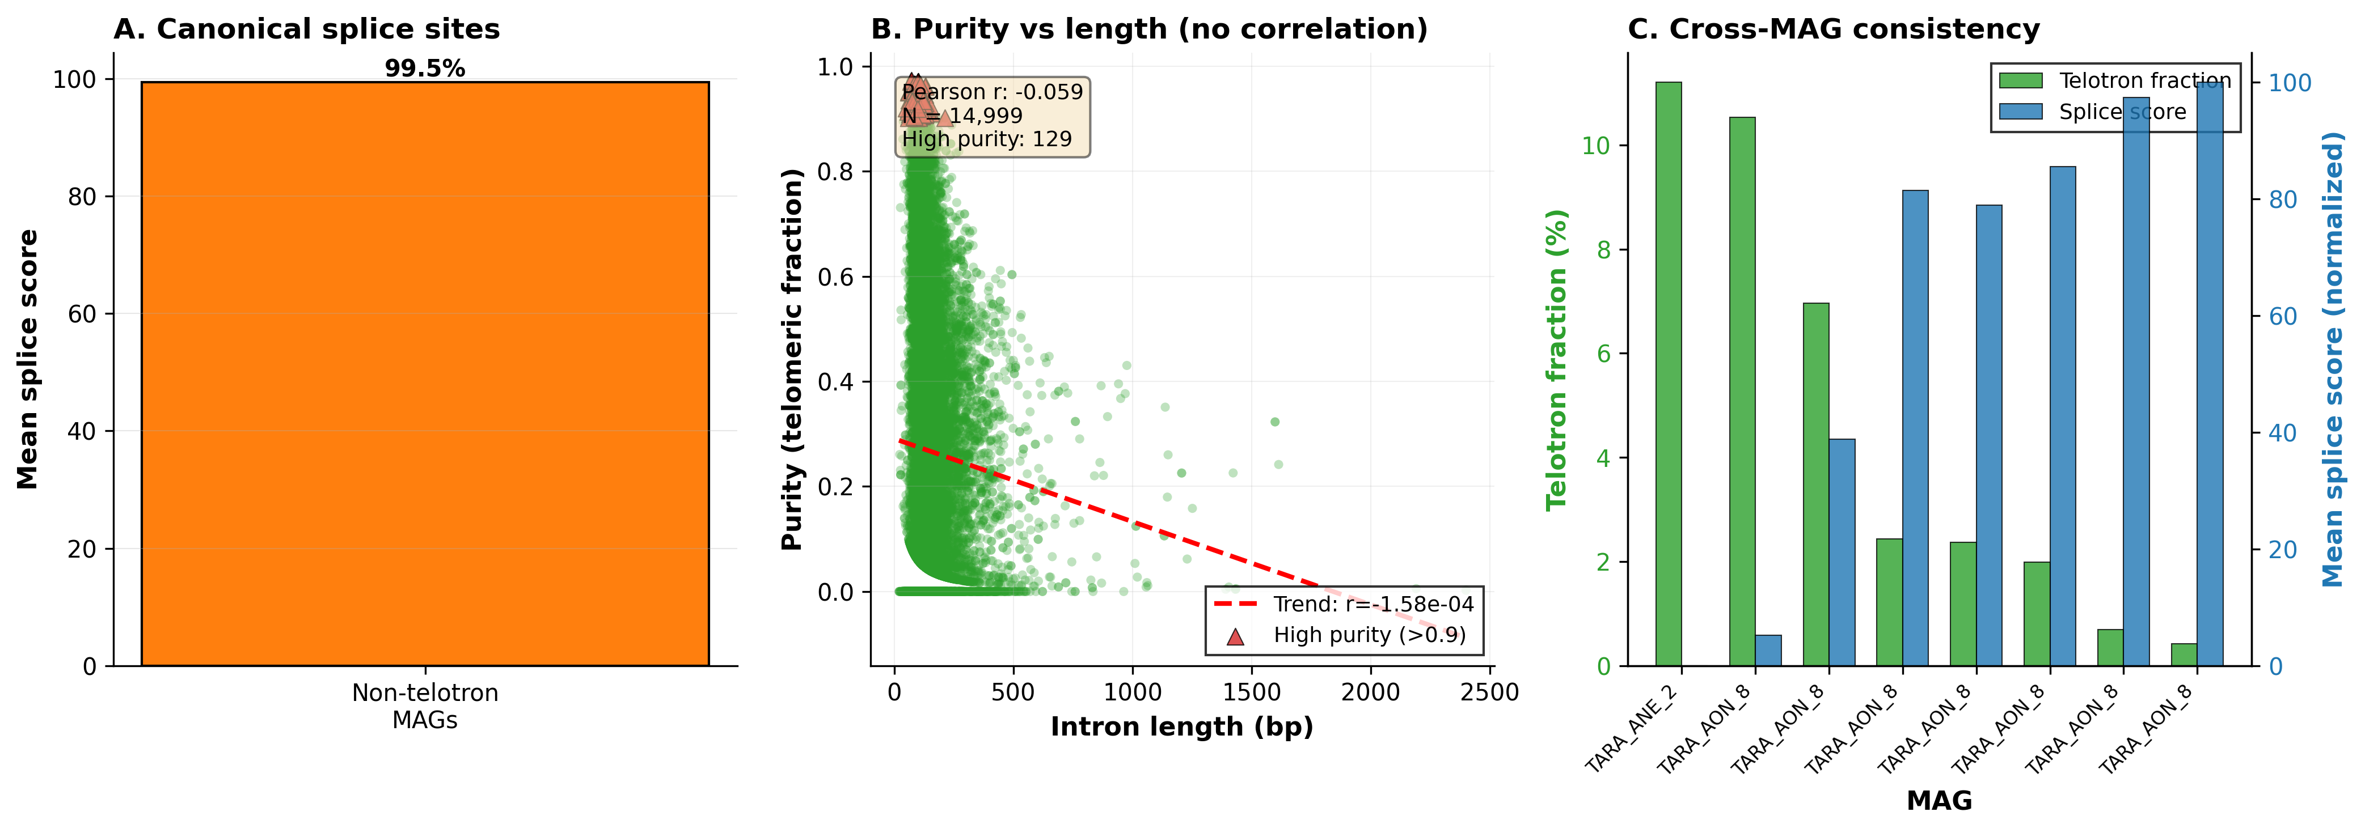
Extended Data Figure 3 | Assembly validation. (a) Spatial distribution of telotrons along contigs is uniform (KS test P > 0.05), ruling out assembly edge artifacts. (b) GT-AG splice site frequency (94.8%) matches genome-wide rates. (c) Telotron purity shows weak inverse correlation with array length (ρ = −0.24, P < 0.001), opposite to the positive correlation predicted by microsatellite slippage expansion.

Extended Data Figure 4 | Phylogenetic distribution of telotrons across Tara Oceans MAGs
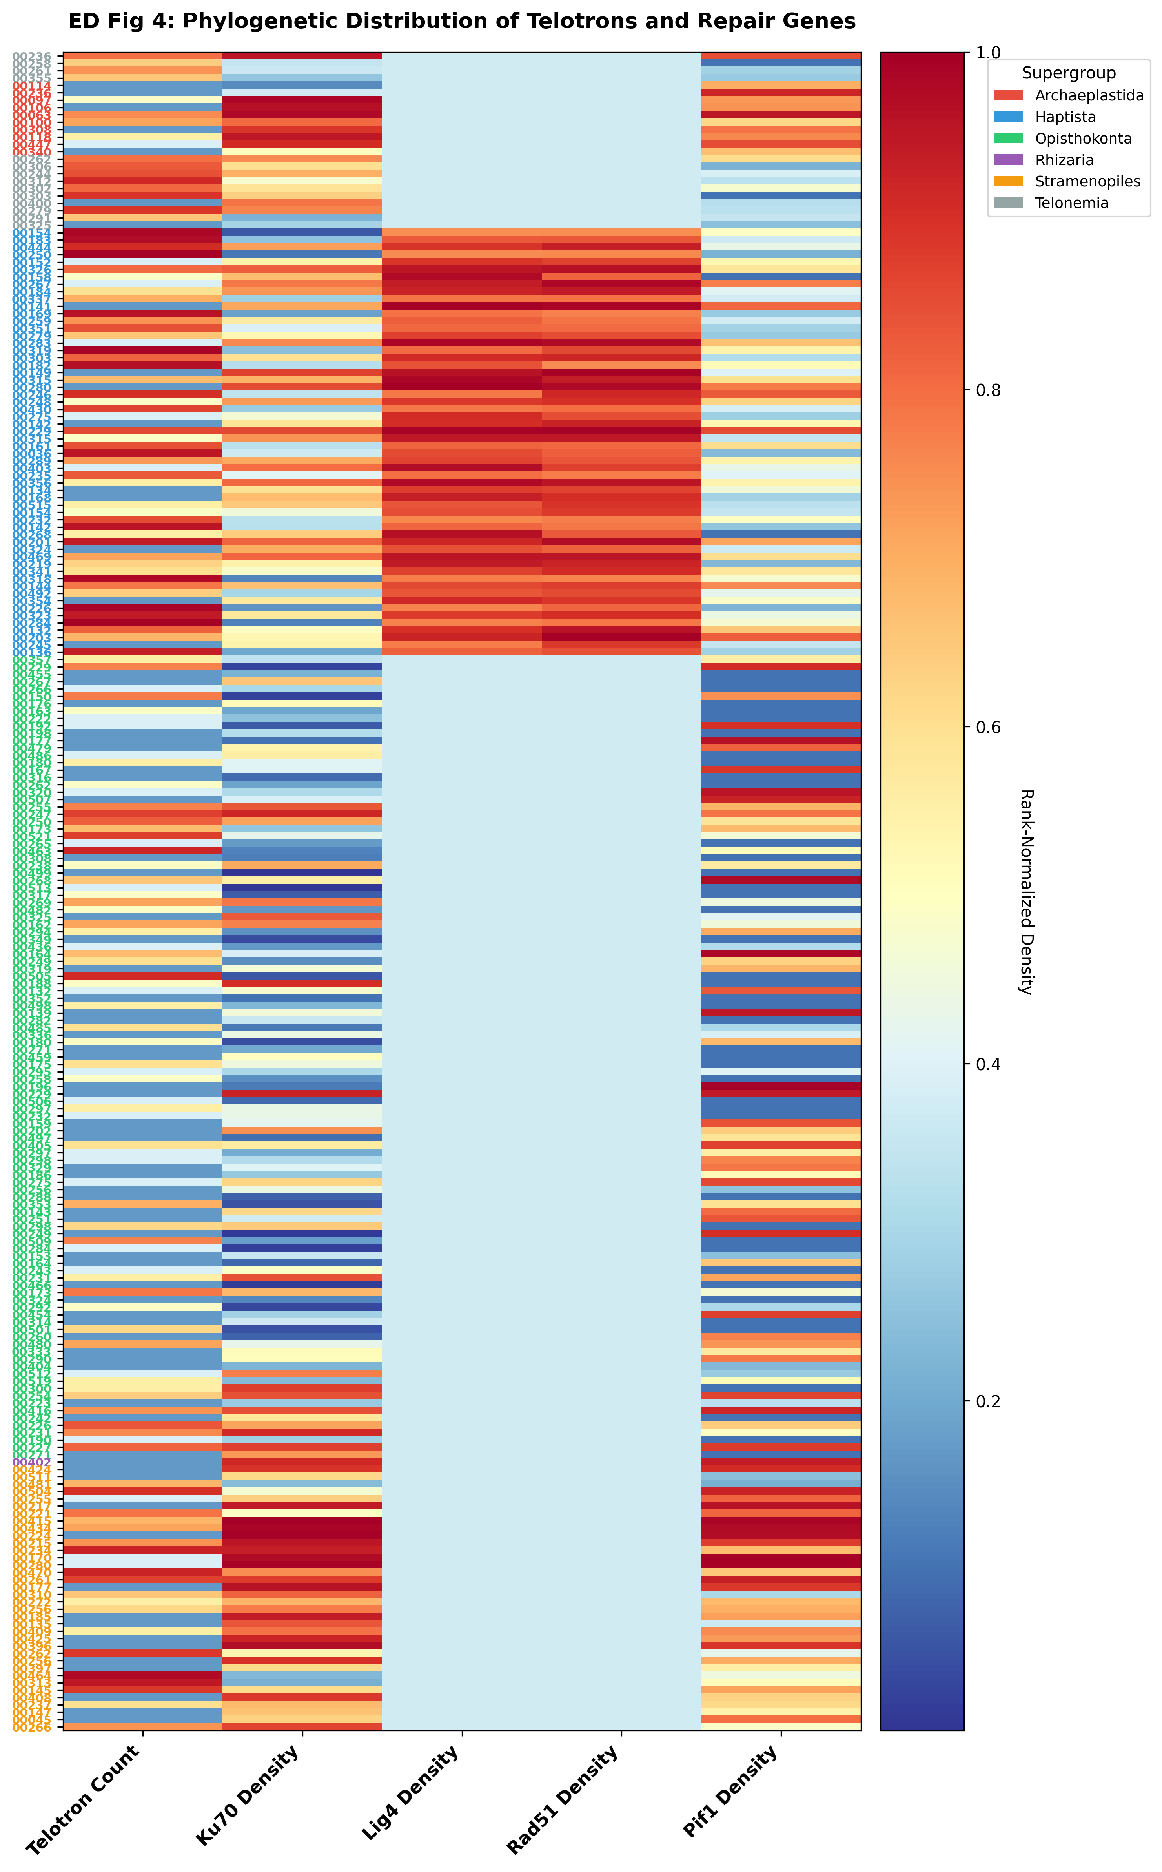
Extended Data Figure 4 | Phylogenetic distribution of telotrons across Tara Oceans MAGs. Heatmap showing telotron burden (total high-purity introns) across 30 MAGs with >50 telotrons, organized by taxonomic supergroup. Haptophyta accounts for 89.5% of all high-purity telotrons.

Extended Data Figure 5 | Ortholog-confirmed de novo insertion
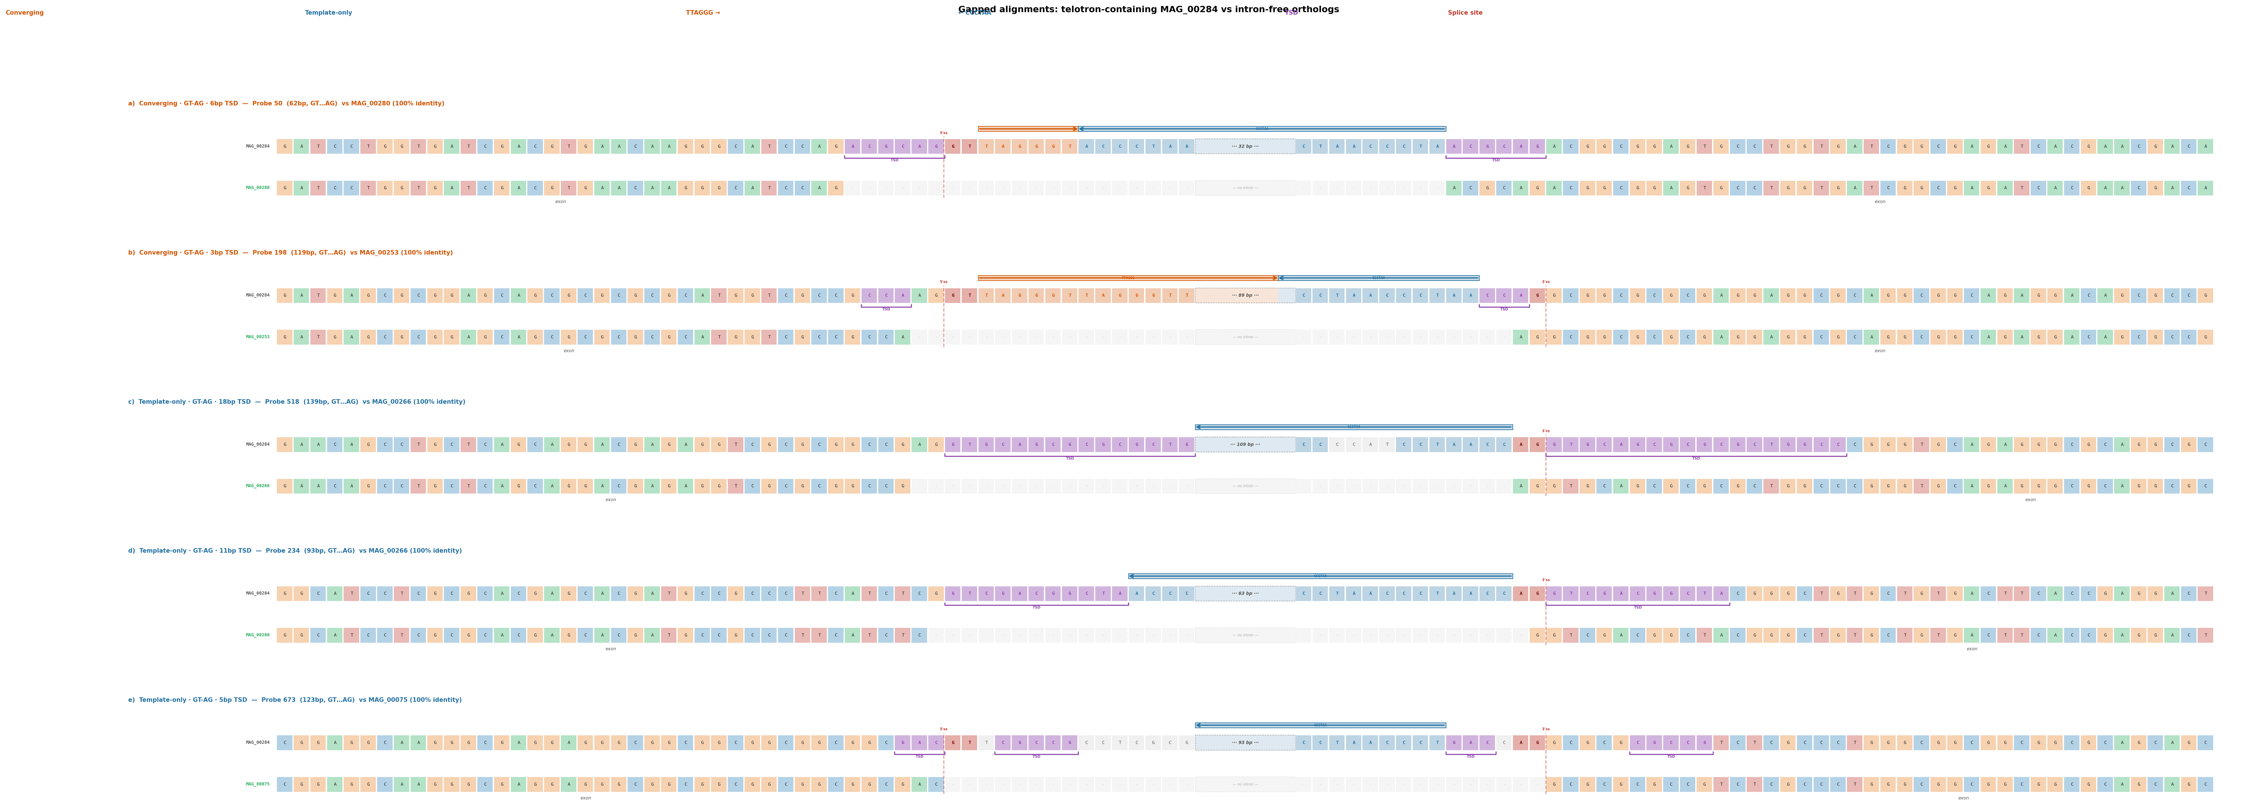
Extended Data Figure 5 | Ortholog-confirmed de novo insertion. Representative pairwise alignments between telotron-containing genes in the primary MAG and intron-free orthologs in related MAGs. All 116 alignments show ≥95% exonic identity flanking a clean deletion corresponding to the telotron, confirming de novo insertion rather than ancestral inheritance.

Extended Data Figure 6 | Telotron-specific repair gene associations
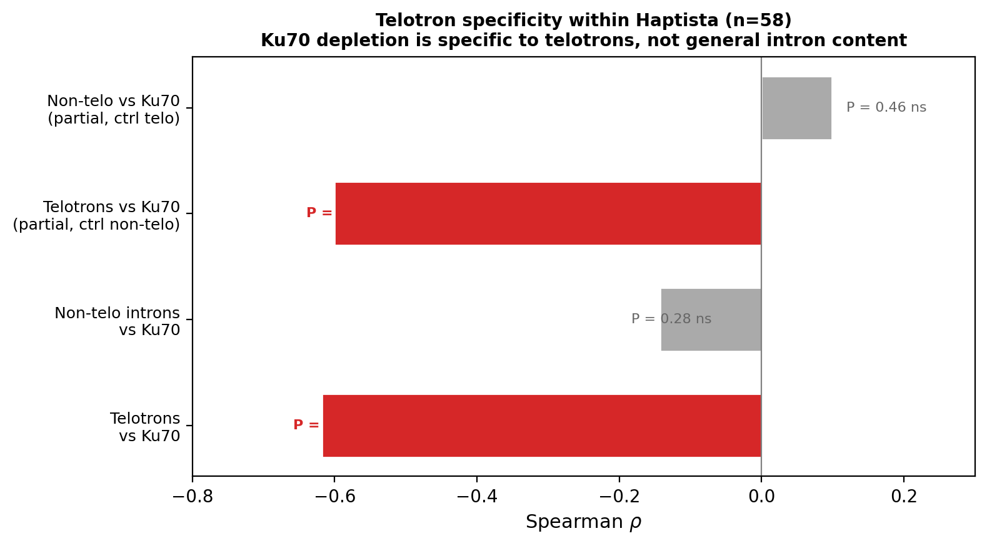
Extended Data Figure 6 | Telotron-specific repair gene associations. Partial Spearman correlations controlling for total non-telotron intron count and BUSCO assembly completeness. The anti-correlation between repair gene density and intron burden is specific to telotrons (partial ρ = −0.60) and does not extend to non-telotron introns, confirming that repair gene erosion specifically predisposes to telotron accumulation rather than reflecting general genome degradation.

