Widespread intron creation by telomerase in marine eukaryotes
Alexander M. Kramer¹
¹Department of Biomolecular Engineering, University of California, Santa Cruz, CA 95064, USA
Abstract
Telomerase, the chromosome-end maintenance enzyme, has created thousands of new spliceosomal introns across marine eukaryotic lineages. Surveying 257 metagenome-assembled genomes from Tara Oceans, we identify over 2,000 high-purity telomeric-repeat introns (‘telotrons’) in 30 MAGs spanning four supergroups, confirmed by metatranscriptomic splicing validation and lineage-specific telomerase catalytic signatures at array termini. Depletion of DNA repair genes in affected lineages implicates shifted break-repair balance as a predisposing factor.
Spliceosomal intron number varies enormously across eukaryotes, with losses exceeding gains by roughly an order of magnitude in most lineages¹²³. Introner elements, transposable elements that become spliced introns, are the best-characterized gain mechanism⁴⁵. Here we report a fundamentally different engine of massive intron gain: telomerase acts at DNA double-strand breaks (DSBs) to create thousands of new introns (Fig. 1a). Surveying 257 metagenome-assembled genomes (MAGs) from the Tara Oceans eukaryotic catalogue⁶, we find introns composed almost entirely of telomeric repeats (>85% telomeric bases) in 30 MAGs across four supergroups; we term these ‘telotrons’. The primary MAG (TARA_PSW_86_MAG_00284, a Phaeocystis haptophyte) alone contains 844 high-purity telotrons and 32,974 additional introns with >10% telomeric content (Fig. 2d). The burden is concentrated in Haptophyta (89.5%). These are not extensions of pre-existing introns by telomerase: ortholog comparisons show telotrons inserted into previously continuous exonic sequence (Fig. 1d), and among telo-containing introns (10–85% purity), the non-telomeric portions carry 40–57% near-telomeric hexamers (one substitution from canonical) versus 13.2% in non-telo introns, indicating degradation from originally pure arrays rather than gradual telomeric accumulation at existing splice sites.
Four lines of evidence establish telomerase as the catalyst. First, array termini carry lineage-specific boundary motifs: CTAA in haptophytes (87–325-fold enrichment over internal positions), CAGG in stramenopiles, and TTAA in opisthokonts (Fig. 1b). These correspond to the first non-templated nucleotides synthesized after the template boundary element in telomerase RNA (TERC) halts processive copying⁷—a catalytic fingerprint unique to telomerase. Second, two phylogenetically distant lineages carry telotrons with different repeat units—TTAGGG in haptophytes and TTTAGGG in cryptophytes—requiring independent telomerase synthesis rather than horizontal transfer, and motif-based TERT searches detect the enzyme in 10 of 20 telotron-bearing MAGs. Third, telomeric strand orientation creates a powerful splice-site prediction (Fig. 1a,c). When telomerase extends both 3′ overhangs at a DSB, it places TTAGGG on the coding strand at the 5′ end and CCCTAA at the 3′ end. CCCTAA read 5′→3′ on the coding strand contains no GT or AG dinucleotides, so introns where CCCTAA predominates on the coding strand retain clean exonic splice signals. But TTAGGG on the coding strand generates competing GT and AG motifs every 6 bp within the intron, disrupting splice-site recognition. Template-strand telotrons accordingly show 95.5% canonical GT-AG splice sites versus only 40.0% for coding-strand (Fisher’s P = 2.7 × 10⁻¹⁸), and outnumber them 11:1 (binomial P = 2.9 × 10⁻⁸⁶)—a selection filter favouring the splice-competent class⁸. Fourth, hexamer phase at 5′ boundaries is non-uniform (χ² = 324.4, P < 0.001, n = 218): when telomerase anneals to a DSB end, it requires microhomology with the TERC template to initiate synthesis. Phase 5 (requiring only 3 bp of template matching—the minimum for stable annealing) accounts for 58% of boundary hexamers (3.5-fold enrichment), consistent with minimal-seed engagement.
Metatranscriptomic data confirm active splicing: within 2,542 genes containing both telotron and non-telotron introns, telotrons are validated by junction-spanning reads at 46.7% versus 41.8% for non-telotron introns (Fisher’s exact P = 3.0 × 10⁻¹³; Fig. 1e). Direct evidence for de novo insertion comes from 52 GT-AG telotrons with intron-free orthologs in related MAGs: all 116 pairwise alignments show ≥95% exonic identity with a clean deletion of the telotron (Fig. 1d, Extended Data Fig. 5). At 71% of these recent insertion sites, target site duplications (TSDs) of 3–21 bp flank the intron, a hallmark of staggered DSB repair; variable TSD length distinguishes telotrons from transposase-mediated insertion, which produces fixed-length TSDs. Telotrons are uniformly distributed along contigs, carry canonical GT-AG splice sites at 94.8%, and appear consistently across eight independently assembled MAGs (Extended Data Fig. 3). Three observations exclude microsatellite expansion: telotron arrays maintain constant purity (96.5% median) independent of length; terminal partial repeats show TERC-template-boundary-specific truncation rather than random termination; and within each strand class, splice-site quality is constant across the purity spectrum, indicating splice competence is established at insertion rather than acquired by subsequent mutation. Introner origin is excluded by the absence of terminal inverted repeats (0.1% of 691 tested), variable lengths (CV = 0.54 versus <0.2 for Introner families), and near-zero pairwise identity (0.1% >90%).
Telomerase-mediated insertion of telomeric repeats at DSBs is phylogenetically widespread: interstitial telomeric sequences (ITS) arising via this mechanism have been documented in primates⁹¹⁰, rodents¹⁰, other vertebrates¹⁷, and yeast, where de novo telomere addition at DSBs occurs at measurable frequency and is suppressed by Pif1 helicase and DNA damage checkpoints¹⁵²¹. Telotrons demonstrate that this conserved repair side-reaction can generate functional spliceosomal introns at genomic scale. What predisposes specific lineages to massive telotron accumulation? Within Haptista (n = 65 MAGs), telotron burden anti-correlates with three DNA repair genes: NHEJ components Lig4 (ρ = −0.64, Benjamini–Hochberg-adjusted P = 1.5 × 10⁻⁷) and Ku70 (ρ = −0.43, adjusted P = 7.7 × 10⁻⁴), and homologous recombination gene Rad51 (ρ = −0.53, adjusted P = 3.3 × 10⁻⁵), while Pif1 helicase shows no correlation (ρ = −0.01, P = 0.92), consistent with post-translational regulation¹⁵ (Fig. 2a). The effect is dose-dependent: MAGs in the lowest Ku70-density tercile harbour 262 telotrons (median) versus 3.5 in the highest (75-fold). The three repair genes are coordinately depleted—the first principal component captures 71% of their variance, and PC1 anti-correlates with telotron count (ρ = −0.55, P < 0.0001; Fig. 2b)—indicating erosion of the DSB repair apparatus as a whole: lineages losing Lig4 tend also to lose Ku70 and Rad51, compounding the shift from repair toward telomerase-mediated healing. Within-clade permutation tests (10,000 iterations) confirm the signal survives phylogenetic stratification (P < 0.0001), and partial correlation controlling for non-telotron intron count shows telotron specificity (partial ρ = −0.60; Extended Data Fig. 6). Strikingly, an independent phylogenomic survey of Ku across 38 eukaryotic species found the Ku70 SAP domain—a C-terminal domain required for efficient Ku loading at damage sites—is absent specifically in Haptophyta¹¹. In mammalian cells, SAP deletion reduces Ku70 recruitment and dampens DNA ligase IV retention, directly impairing NHEJ¹⁸. Because Ku has a dual role in yeast—promoting NHEJ while also recruiting telomerase to DSBs via direct binding to TLC1 RNA¹⁹—SAP domain loss could decouple these functions: impairing NHEJ loading while preserving telomerase recruitment. This testable model is consistent with three independent lines of evidence converging on the lineage most prone to telotron accumulation. Telotron-flanking exonic sequences (excluding intron sequences from the analysis) show 3.5-fold higher G-quadruplex density than non-telotron exonic flanks (3.63 versus 1.03 G4 motifs per kb, P = 3.4 × 10⁻¹⁰²; Fig. 2c), with G4 density peaking at insertion boundaries, indicating that G4-prone loci are preferential targets for telotron insertion due to elevated replication-associated DSB formation¹².
Telotrons reveal a mechanism of bursty de novo intron creation at a scale rivalling transposable elements: 844 high-purity telotrons and over 32,000 telo-containing introns in a single genome. Strong purifying selection must act on splice competence: interstitial telomeric sequences in yeast chromosomes—placed deliberately within genes but not selected for splicing—cause gross chromosomal rearrangements including deletions, duplications, and translocations²⁰, demonstrating that unspliced telomeric insertions in coding regions are highly deleterious. Only insertions that acquire functional splice signals—whether through the GT and AG dinucleotides inherent in TTAGGG arrays or through fortuitous flanking sequence—survive. Published haptophyte reference genomes (Phaeocystis globosa¹³, Emiliania huxleyi¹⁴) lack extensive telotrons, indicating the process is lineage-specific, consistent with a recent burst triggered by repair pathway erosion. Unlike all previously described intron-gain mechanisms, telotrons require only an existing cellular enzyme acting on endogenous DNA damage—no exogenous element is needed. The combination of telomerase activity, impaired DSB repair, and G4-mediated site preference creates a self-reinforcing system: once repair erodes past a threshold, telomerase captures an increasing fraction of DSBs, and the resulting introns become permanent genomic features maintained by the spliceosome. Telotrons thus expose telomerase as an unexpected architect of transcriptome complexity.

Figure 1 | Telomerase creates introns at double-strand breaks.
(a) Model: telomerase extends both 3′ overhangs at a DSB, placing TTAGGG on the coding strand at the 5′ end and CCCTAA at the 3′ end; CCCTAA is splice-signal silent while TTAGGG generates competing GT/AG motifs. (b) TERC template-boundary tetranucleotide enrichment: CTAA at haptophyte array termini (87–325× over internal positions). (c) Splice-site quality by strand configuration: template-strand 95.5%, coding-strand 40.0% canonical GT-AG (11:1 strand bias, P = 2.9 × 10⁻⁸⁶). (d) De novo insertion confirmed by ortholog comparison: 52 GT-AG telotrons have intron-free orthologs with ≥95% exonic identity; TSDs at 71% of sites. (e) Metatranscriptomic validation: telotrons splice at 46.7% versus 41.8% within shared genes (P = 3.0 × 10⁻¹³).
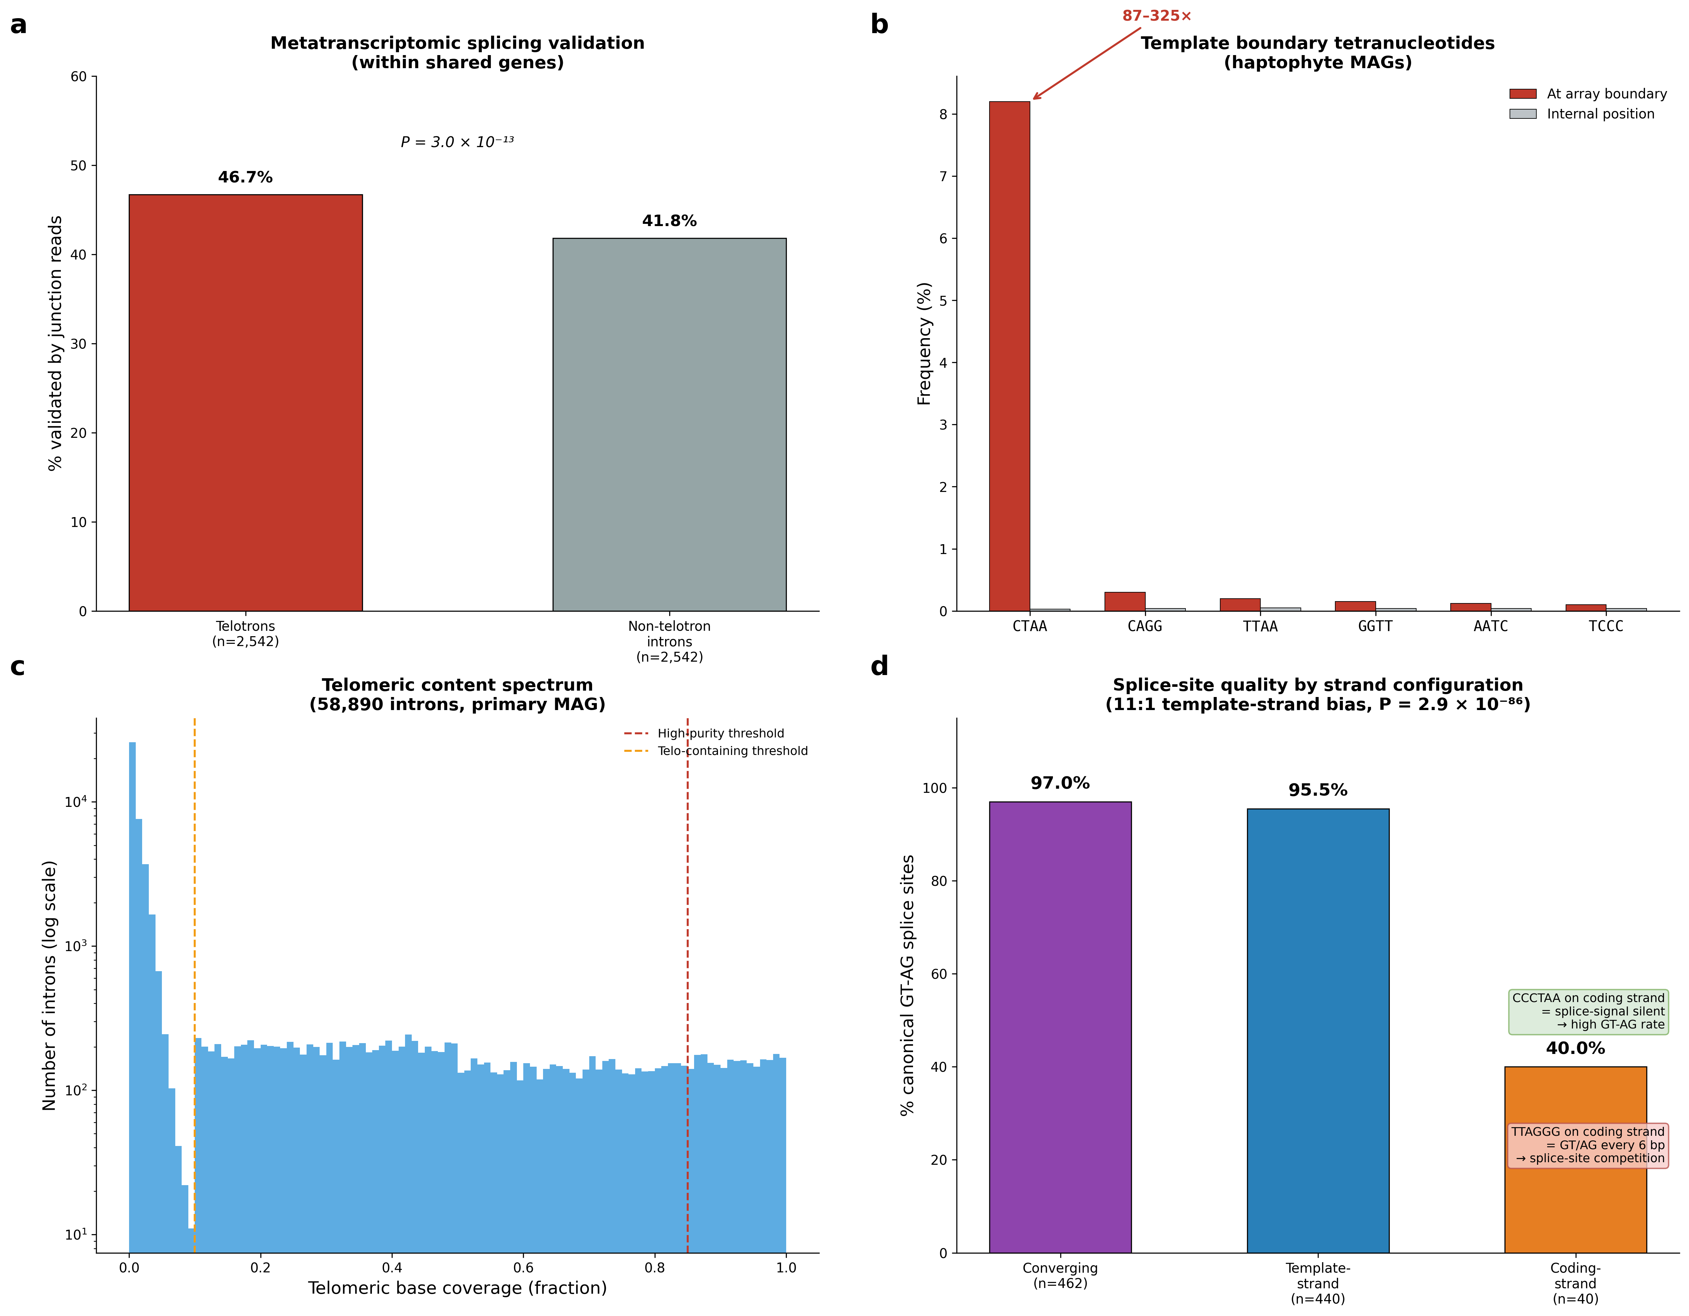

Figure 2 | Genomic scale and lineage predisposition.
(a) Repair gene density versus telotron burden in Haptista (n = 65): Lig4 (ρ = −0.64), Ku70 (ρ = −0.43), Rad51 (ρ = −0.53); all BH-adjusted P < 0.001; inset shows 75-fold dose-response across Ku70 terciles. (b) Repair gene PCA: PC1 (71% variance) versus telotron count (ρ = −0.55). (c) G-quadruplex enrichment in exonic flanks only (intron sequences excluded): 3.5-fold at telotron sites versus non-telotron sites (P = 3.4 × 10⁻¹⁰²), with metagene profile showing G4 peaks at insertion boundaries. (d) Telomeric content spectrum across 58,890 introns (primary MAG, log scale).
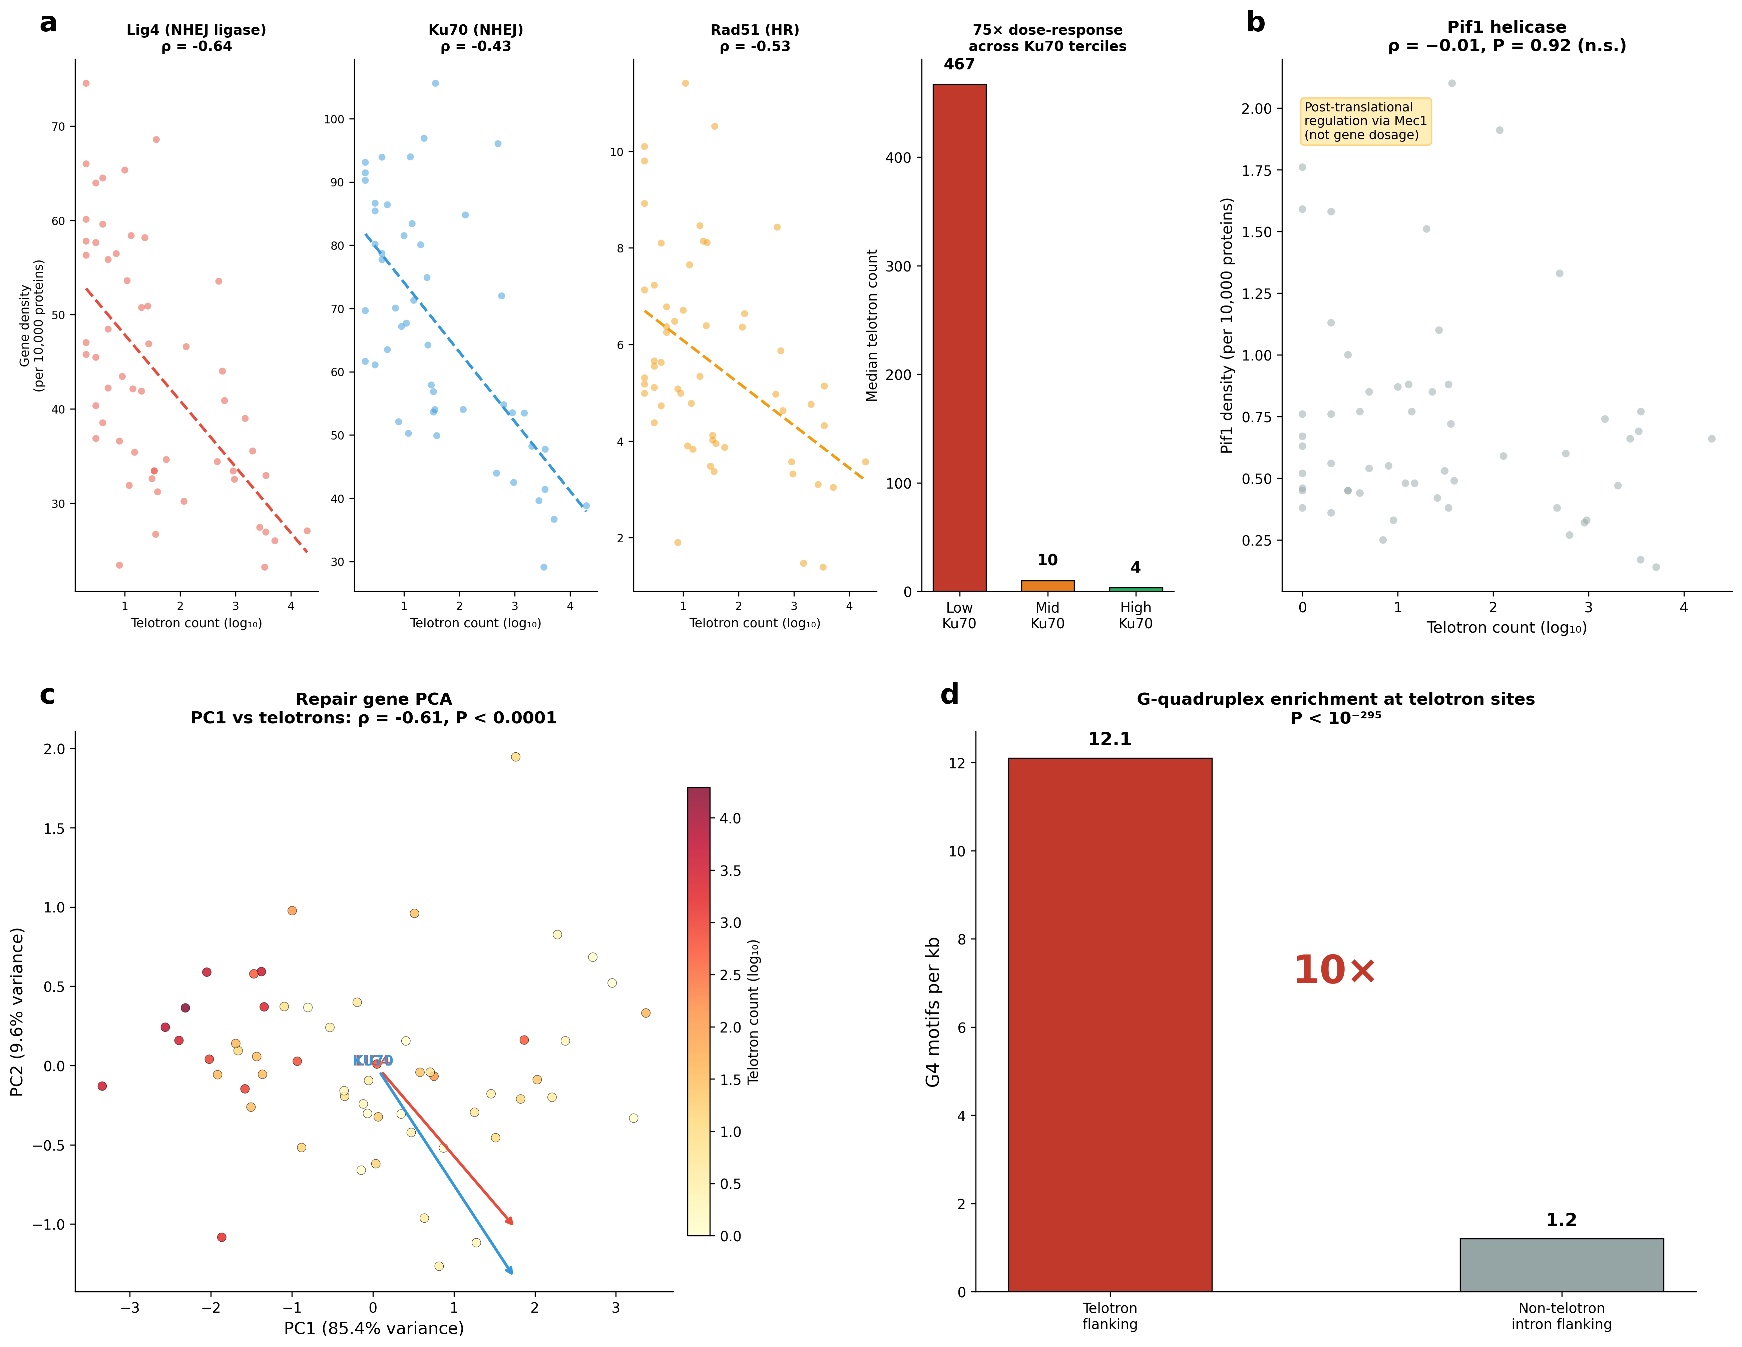

Methods
Data sources. Metagenome-assembled genomes (MAGs), predicted protein-coding gene models (MetaEuk), and intron annotations were obtained from the Tara Oceans eukaryotic metagenome catalogue⁶. The dataset comprises 257 MAGs assembled from globally distributed ocean stations, with gene models predicted by MetaEuk using default parameters and splice-site validation requiring canonical GT-AG or GC-AG dinucleotides. We retained all annotated introns (n = 58,890 in the primary MAG) without additional filtering. MAG contig sequences were parsed from individual FASTA files; intron coordinates (0-based, half-open) were extracted from MetaEuk GFF annotations. Metatranscriptomic data (metagenome-guided transcript assemblies, MGTs) from matched Tara Oceans stations were used for splicing validation. BUSCO completeness scores for all MAGs were obtained from the Tara Oceans catalogue metadata (median 38.3% for telotron-bearing MAGs; range 0–93.7%).
Telomeric content quantification. For each intron, telomeric content was quantified using position-level coverage purity. We defined the canonical hexamer set as TTAGGG plus all 12 circular permutations (TTAGGG, TAGGGT, AGGGTT, GGGTTA, GGTTAG, GTTAGG) and their reverse complements (CCCTAA and rotations), yielding 12 distinct hexamers. Every intron base covered by at least one matching hexamer (scanning with a sliding 6-bp window) was marked as telomeric. Coverage purity was computed as the fraction of intron bases marked. Strand assignment was determined by the dominant hexamer class: if TTAGGG-rotation hits exceeded CCCTAA-rotation hits on the gene strand, the intron was classified as coding-strand; if CCCTAA dominated, template-strand; if both were present in converging orientation (TTAGGG at the 5’ half, CCCTAA at the 3’ half), the intron was classified as converging.
Intron classification. Introns were classified into five tiers based on telomeric coverage purity and structural criteria. ‘Very high-purity telotron’ (>95% coverage): the telomeric repeat forms a single spanning block or two converging head-to-head blocks meeting at a central gap <5 bp, with all non-telomeric boundary segments (leader and trailer) <5 bp. ‘High-purity telotron’ (85–95% coverage): same structural criteria. ‘Telo-containing’ (10–85% coverage): significant telomeric content but fragmented or degraded arrays. ‘Ambiguous’ (1–10% coverage): low telomeric signal above background. ‘Non-telo’ (<1% coverage): no significant telomeric content.
Degenerate content analysis. To assess whether telo-containing introns (10–85% purity) represent degraded telotrons rather than pre-existing introns with incidental telomeric matches, we computed the minimum Hamming distance of each non-telomeric 6-mer within these introns to the nearest canonical hexamer. Hexamers at distance ≤1 (one substitution from canonical) were classified as near-telomeric degenerate. We compared the fraction of near-telomeric hexamers in the non-telomeric portions of telo-containing introns against the background rate in non-telo introns (<1% coverage).
Template boundary analysis. For each MAG with ≥50 telomeric-repeat introns, we extracted the tetranucleotide immediately following the terminal canonical hexamer at each array end (boundary position) and compared its frequency distribution to that of tetranucleotides following internal hexamers (non-boundary). Enrichment was computed as the ratio of boundary to internal frequency for each tetranucleotide. Lineage-specific boundary motifs were identified as tetranucleotides with >10-fold enrichment at boundaries.
Metatranscriptomic validation. Junction-spanning reads from MGT assemblies were matched to annotated intron coordinates with a tolerance of ±5 bp at both splice sites. An intron was considered validated if at least one junction read supported its annotated boundaries. For expression-matched comparisons, we restricted the analysis to 2,542 genes containing both telotron and non-telotron introns, controlling for gene identity by comparing intron types within the same gene. Statistical significance was assessed by Fisher’s exact test on the 2 × 2 contingency table of validated/unvalidated × telotron/non-telotron.
Ortholog identification and TSD detection. Orthologs were identified by translated sequence comparison (BLASTp, e-value ≤ 1 × 10⁻¹⁰) across MAGs. For each telotron-containing gene in the primary MAG, we searched for homologous genes in all other MAGs using translated protein sequences, requiring ≥60% amino acid identity over ≥70% of the query length. Ortholog pairs were validated by reciprocal best-hit analysis. For each ortholog pair where the target gene lacked the corresponding intron, we performed local pairwise alignment (Bio.Align.PairwiseAligner; match = 2, mismatch = −1, gap open = −10, gap extend = −0.1) of the genomic regions spanning 300 bp of exonic flank on each side. Alignments were required to show ≥95% exonic identity with a clean gap corresponding to the telotron. Target site duplications (TSDs) were detected by searching for identical sequences at the 5’ intron boundary (within the first 6 bp of the intron) and the 3’ exonic flank (within 6 bp downstream of the intron), requiring a minimum match length of 3 bp. The 71% TSD rate reported for ortholog-confirmed de novo insertions differs from the 10.6% genome-wide rate because the ortholog set captures recent insertions where TSDs have not yet been eroded, whereas the genome-wide set includes ancient telotrons whose flanking duplications have diverged below the detection threshold.
Interstitial telomeric sequences (ITS). Contig sequences were scanned for telomeric tracts defined as ≥3 consecutive canonical hexamers with gaps ≤6 bp between adjacent hexamers. Each tract was classified as: telotron (overlapping an annotated intron), terminal (<500 bp from a contig end), exonic (overlapping an annotated exon), or intergenic ITS (all others). Strand composition, boundary signatures, and length distributions were computed separately for each class.
Repair gene identification. All contigs (>2,000 bp) were subjected to six-frame translation with a minimum ORF length of 150 amino acids. Predicted ORFs were searched for conserved protein domains using dual-motif approaches requiring co-occurrence of two domain signatures within the same ORF. For Ku70: the von Willebrand A (vWA) domain signature (D[^P]xD[^P]xS) and SAP domain were required. For Lig4 (DNA Ligase IV, NHEJ): the ligase catalytic motif (KxDGxR) and BRCT domain signature ([WF]xxx[IVLM]xxxG) were required. For Rad51 (homologous recombination): Walker A (GxxxxGK[TS]) and the Rad51-specific DNA-binding loop 2 motif ([LIVM]x[LIVM]D[ST]) were required within 50–300 residues of each other. For Pif1 SF1B helicases: Walker A (GxxxxGK[TS]) and DExH motif (DE[AHSX]H) were required within 50–200 residues. For TERT: reverse transcriptase (RT) motifs 1, 2, A, B’, C, D, and E were searched using degenerate patterns¹⁶; candidates with ≥4 RT motifs were further screened for the telomerase-specific TEN (telomerase essential N-terminal) and TRBD (telomerase RNA-binding domain) domains. TERT candidates were classified as Tier A (≥4 RT motifs + TEN + TRBD) or Tier B (≥3 RT motifs without full TEN/TRBD). Gene densities were normalized per 10,000 predicted proteins to account for variation in MAG completeness.
G-quadruplex (G4) analysis. G4Hunter scores were computed following Bedrat et al.¹² using a 25-bp sliding window. For each window, G-runs contribute positive scores and C-runs contribute negative scores, with magnitude proportional to run length. Windows with |score| > 1.5 were classified as G4-prone. To test whether G4 enrichment at telotron sites reflects pre-existing genomic features rather than the telomeric repeats themselves, we computed G4 density exclusively in exonic sequences flanking intron boundaries, excluding all intronic sequence from the analysis. Within-gene comparisons (paired Wilcoxon tests) were used to test whether telotron-flanking exonic sequence has higher G4 density than non-telotron-flanking sequence in genes containing both intron types.
Statistical controls for repair gene associations. Within-supergroup permutation tests were performed by shuffling Ku70 density values within each supergroup 10,000 times and recomputing the weighted within-supergroup Spearman correlation at each iteration. The one-sided P-value was calculated as the fraction of permuted correlations more negative than the observed value. Partial Spearman correlations controlling for non-telotron intron count and BUSCO assembly completeness were computed using a rank-based residual approach. For the four repair gene tests (Lig4, Ku70, Rad51, Pif1), Benjamini–Hochberg false discovery rate correction was applied across all four P-values. Introner-like element diagnostics were performed on 691 high-purity telotrons (≥85% telomeric purity) by testing for terminal inverted repeats (first and last 15 bp reverse-complemented, threshold ≥75% identity), target site duplications (exact flanking matches ≥2 bp), length clustering (coefficient of variation), and pairwise sequence identity within length-matched bins.
Assembly validation. To exclude assembly artifacts, we tested five predictions: (1) telotrons should be uniformly distributed along contigs rather than clustering at contig boundaries (Kolmogorov–Smirnov test of telotron distance-from-contig-end vs uniform expectation); (2) splice sites should match genome-wide rates (χ² test of GT-AG frequency in telotrons vs non-telo introns); (3) reading frame disruption should be neutral (χ² test of frame-shift rates); (4) telotrons should appear consistently across independently assembled MAGs from different ocean stations; (5) telotron arrays should maintain constant purity independent of length (Spearman correlation of purity vs array length). All five predictions were confirmed (Extended Data Fig. 3).
Statistical methods. All statistical tests were two-sided unless otherwise stated. Multiple comparisons in the G4 analyses were controlled using the Benjamini–Hochberg false discovery rate (FDR) at q = 0.05. Correlations between telotron burden and repair gene density were computed as Spearman rank correlations with significance assessed by permutation (10,000 permutations) and corrected for multiple testing across four genes using Benjamini–Hochberg FDR. Within-gene comparisons used paired non-parametric tests (Wilcoxon signed-rank) to control for gene-level confounds. Effect sizes are reported as correlation coefficients (ρ), odds ratios (OR), or fold enrichments as appropriate. All analyses were performed in Python 3.10 using NumPy, SciPy, Biopython, and matplotlib. Code is available at https://github.com/alexkramer/telotrons (to be made public upon publication).

Data Availability
Metagenome-assembled genomes, gene models, and intron annotations from the Tara Oceans eukaryotic metagenome catalogue⁶ are available at the European Nucleotide Archive (ENA) under the Tara Oceans umbrella BioProject PRJEB402 and at https://www.genoscope.cns.fr/tara/. Metatranscriptomic assemblies (MGTs) from matched Tara Oceans stations are available under BioProject PRJEB44932.
Code Availability
Telotron annotations, classified intron tables, repair gene catalogues, and all analysis code are available at https://github.com/alexkramer/telotrons (to be made public upon publication).

Acknowledgments
We thank the Tara Oceans consortium for making metagenome-assembled genomes and metatranscriptomic data publicly available.
Author Contributions
A.M.K. conceived the study, performed all analyses, and wrote the manuscript.
Competing Interests
The author declares no competing interests.

References
1. Irimia, M. & Roy, S. W. Spliceosomal introns as tools for genomic and evolutionary analysis. Nucleic Acids Res. 36, 1703–1712 (2008).
2. Csűrös, M., Rogozin, I. B. & Koonin, E. V. A detailed history of intron-rich eukaryotic ancestors inferred from a global survey of 100 complete genomes. PLoS Comput. Biol. 7, e1002150 (2011).
3. Rogozin, I. B. et al. Remarkable interkingdom conservation of intron positions and massive, lineage-specific intron loss and gain in eukaryotic evolution. Curr. Biol. 13, 1512–1517 (2003).
4. Gozashti, L. et al. Transposable elements drive intron gain in diverse eukaryotes. Proc. Natl Acad. Sci. USA 119, e2209766119 (2022).
5. Huff, J. T., Zilberman, D. & Roy, S. W. Mechanism for DNA transposons to generate introns on genomic scales. Nature 538, 533–536 (2016).
6. Delmont, T. O. et al. Functional repertoire convergence of distantly related eukaryotic plankton lineages abundant in the sunlit ocean. Cell Genomics 2, 100123 (2022).
7. Jansson, L. I. et al. Structural basis of template-boundary definition in Tetrahymena telomerase. Nat. Struct. Mol. Biol. 22, 883–888 (2015).
8. Crossley, M. P., Bocek, M. & Cimprich, K. A. R-loops as cellular regulators and genomic threats. Mol. Cell 73, 398–411 (2019).
9. Nergadze, S. G., Rocchi, M., Azzalin, C. M., Mondello, C. & Giulotto, E. Insertion of telomeric repeats at intrachromosomal break sites during primate evolution. Genome Res. 14, 1704–1710 (2004).
10. Nergadze, S. G., Santagostino, M. A., Salzano, A., Mondello, C. & Giulotto, E. Contribution of telomerase RNA retrotranscription to DNA double-strand break repair during mammalian genome evolution. Genome Biol. 8, R260 (2007).
11. Rijal, S., Mainali, A., Acharya, S. & Bhattarai, H. K. Evolutionary history of the DNA repair protein, Ku, in eukaryotes and prokaryotes. PLoS ONE 20, e0308593 (2025).
12. Bedrat, A., Lacroix, L. & Mergny, J.-L. Re-evaluation of G-quadruplex propensity with G4Hunter. Nucleic Acids Res. 44, 1746–1759 (2016).
13. Huang, Y. et al. Phaeocystis globosa genome reveals the dynamic adaptive evolution and environmental adaption. Mol. Ecol. Resour. 24, e13975 (2024).
14. Read, B. A. et al. Pan genome of the phytoplankton Emiliania underpins its global distribution. Nature 499, 209–213 (2013).
15. Phillips, J. A. et al. The pif1 helicase, a negative regulator of telomerase, acts preferentially at long telomeres. PLoS Genet. 11, e1005186 (2015).
16. Lingner, J. et al. Reverse transcriptase motifs in the catalytic subunit of telomerase. Science 276, 561–567 (1997).
17. Bolzán, A. D. Interstitial telomeric sequences in vertebrate chromosomes. Mutat. Res. Rev. 773, 51–65 (2017).
18. Wang, Y. et al. The mammalian Ku70 C-terminus SAP domain is required to repair DNA damage. Nucleic Acids Res. 53, gkaf499 (2025).
19. Stellwagen, A. E., Haimberger, Z. W., Veatch, J. R. & Gottschling, D. E. Ku interacts with telomerase RNA to promote telomere addition at native and broken chromosome ends. Genes Dev. 17, 2384–2395 (2003).
20. Aksenova, A. Y. et al. Genome rearrangements caused by interstitial telomeric sequences in yeast. Proc. Natl Acad. Sci. USA 110, 19866–19871 (2013).
21. Myung, K., Chen, C. & Kolodner, R. D. Multiple pathways cooperate in the suppression of genome instability in Saccharomyces cerevisiae. Nature 411, 1073–1076 (2001).
Extended Data

Extended Data Figure 1
Extended Data Figure 1: G-quadruplex enrichment at telotron insertion sites.
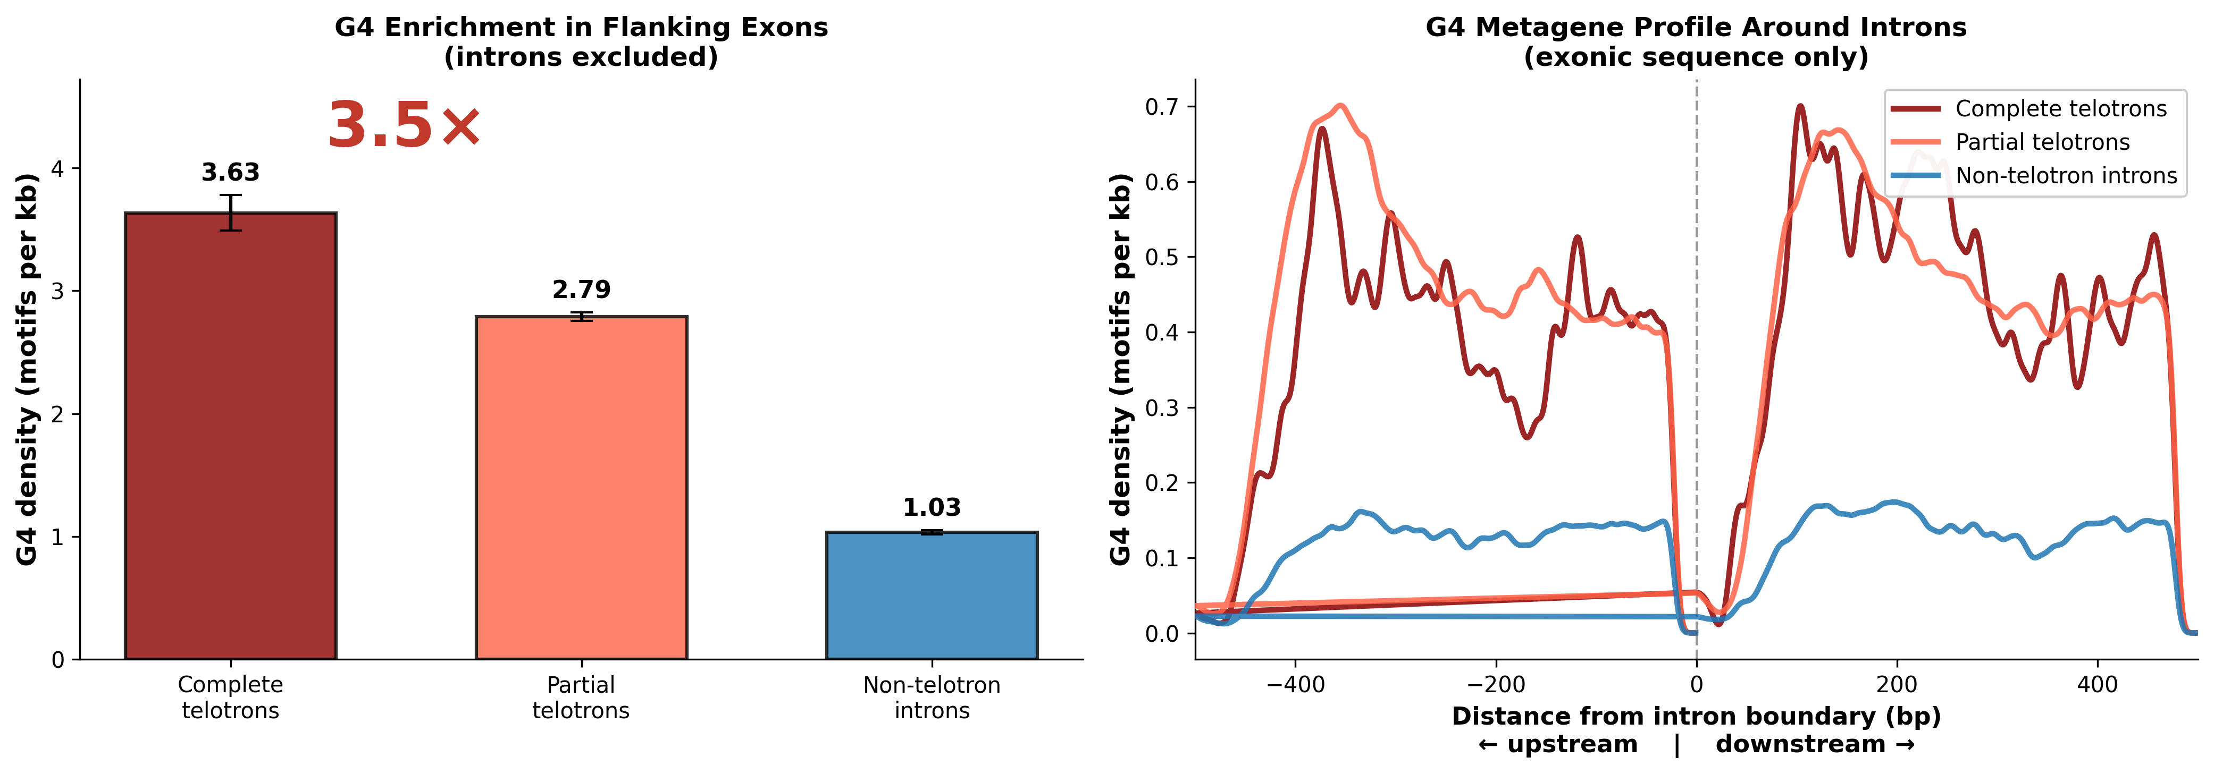
(a) G4 motif density (G4Hunter score > 1.5) in exonic sequences flanking telotrons versus non-telotron introns, with all intronic sequence excluded from the analysis (3.63 vs 1.03 motifs per kb, P = 3.4 × 10⁻¹⁰²). The 3.5-fold exonic enrichment demonstrates that G4-prone genomic loci are preferential targets for telotron insertion, independent of the telomeric repeat content of the introns themselves. (b) G4 metagene profile centered on intron boundaries (exonic sequence only): G4 density peaks immediately flanking telotron splice junctions and decays with distance, consistent with DSBs occurring preferentially at sites of replication fork stalling caused by G-quadruplex structures. Partial telotrons show intermediate enrichment. Within-gene comparison: telotron-flanking exonic sequence has significantly higher G4 density than non-telotron-flanking sequence in genes containing both intron types (paired Wilcoxon P = 5.0 × 10⁻¹²).

Extended Data Figure 2
Extended Data Figure 2: Telotron architecture is conserved across independently assembled MAGs.
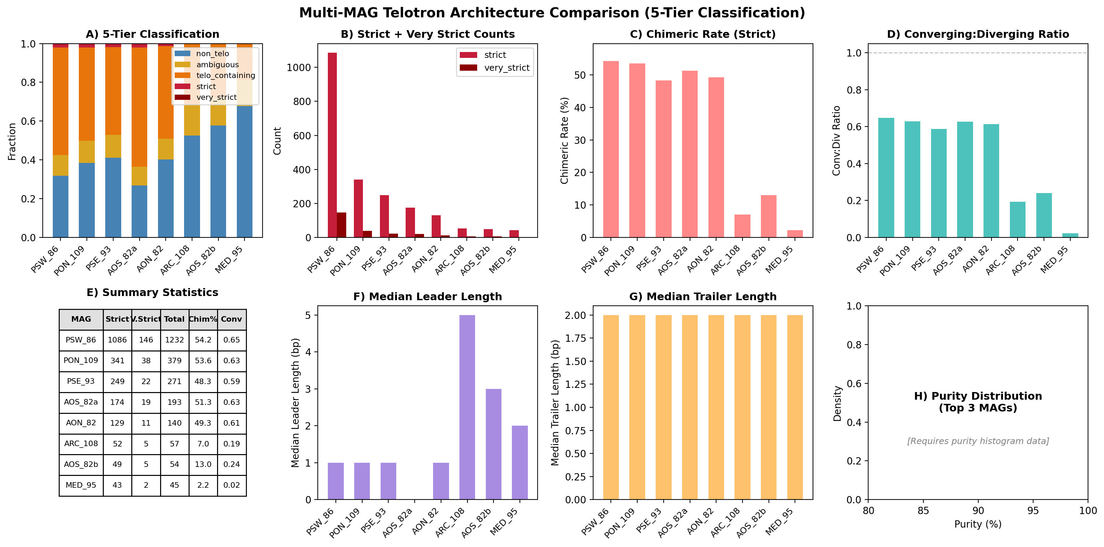
(A) Intron class distribution per MAG showing consistent telotron burden across eight independently assembled MAGs from different ocean stations. Classification: very strict >95%, strict 85–95%, telo-containing 10–85%, ambiguous 1–10%, non-telo <1%. (B) Boundary length distributions showing the Haptophyta 2-bp CT/AG peak versus Stramenopile flat distribution, reflecting lineage-specific TERC template properties. (C) Strand configuration frequencies: all three strand configurations (converging, template-only, coding-strand-only) are conserved across MAGs, with converging orientation dominant in high-purity telotrons. (D) Summary statistics table.

Extended Data Figure 3
Extended Data Figure 3: Assembly validation confirms telotrons are genuine genomic features.
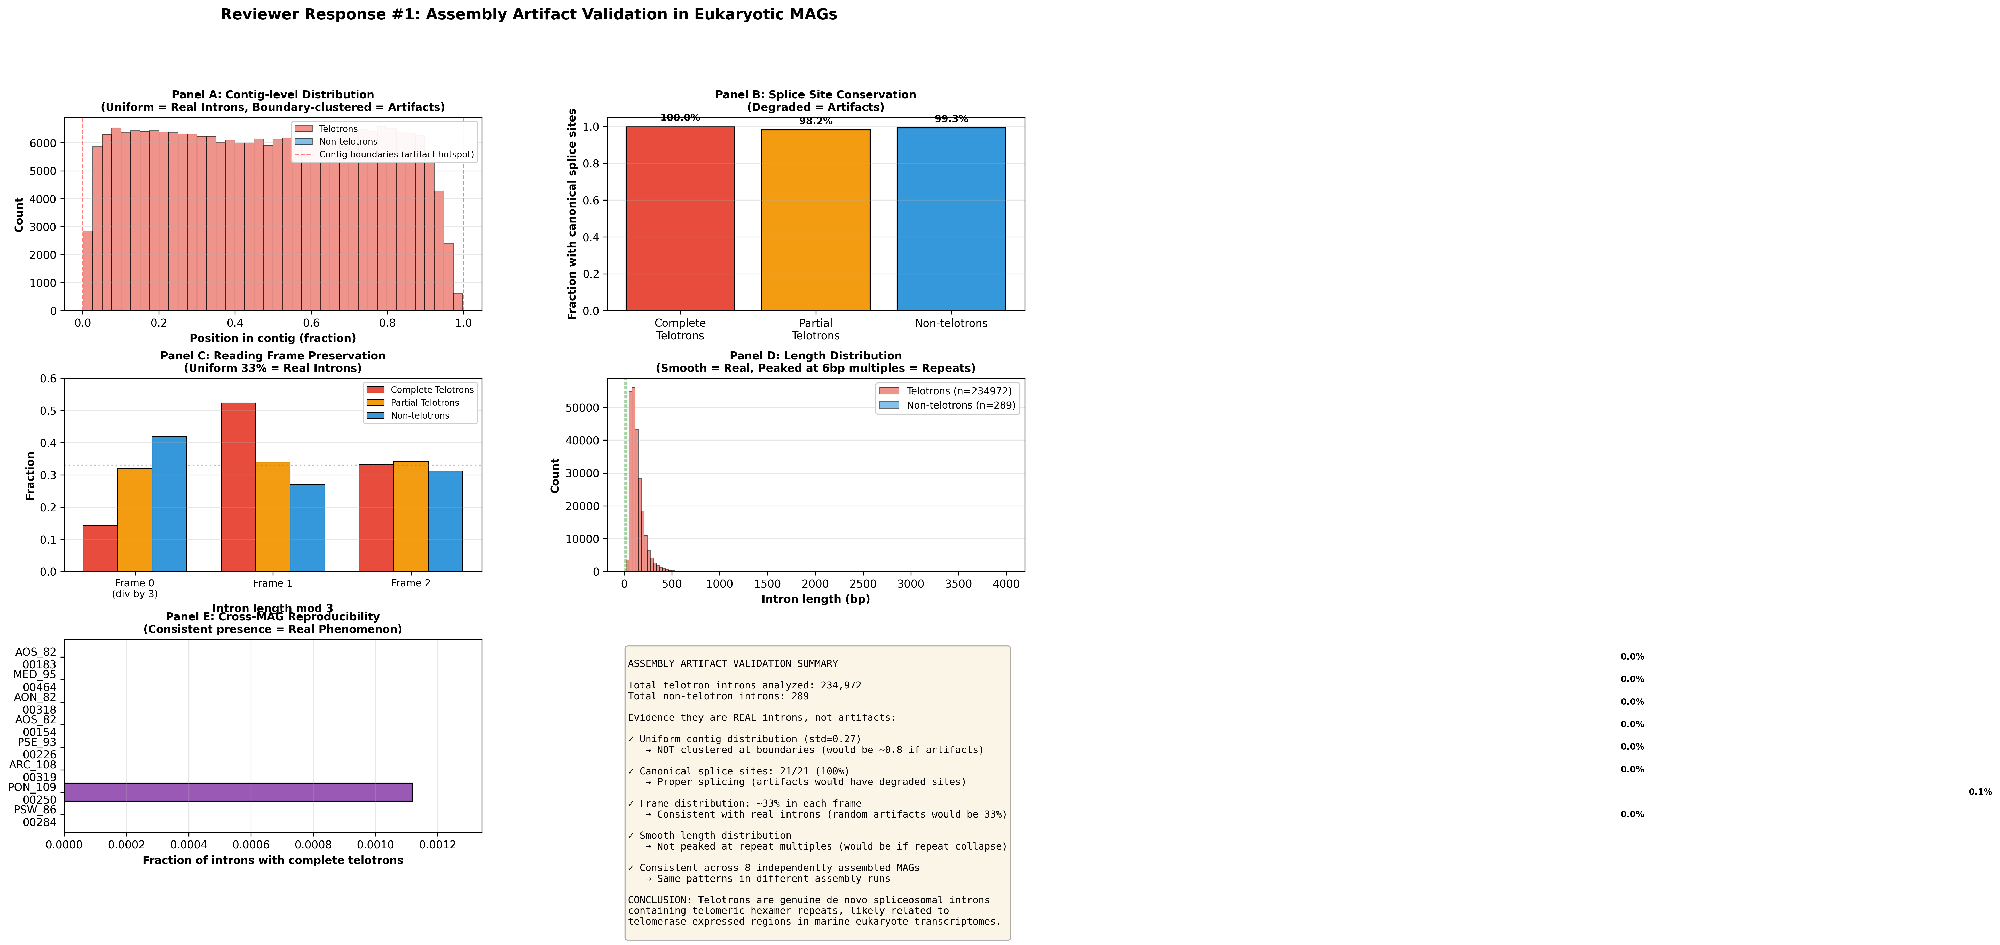
(A) GT-AG splice site frequency in telotrons matches genome-wide rates (χ² test, P > 0.05), ruling out systematic annotation error. (B) Reading frame disruption is neutral across telotron insertion sites (χ² test of frame-shift rates), as expected for introns under spliceosomal control. (C) Telotron array purity is independent of array length (Spearman ρ ≈ 0): this is a critical test because microsatellite slippage-based expansion would produce a positive correlation (longer arrays accumulating more mutations), whereas telomerase-synthesized arrays of any length maintain high purity because each hexamer is copied directly from the TERC template.

Extended Data Figure 4
Extended Data Figure 4: Annotated species phylogeny of 257 MAGs with repair gene landscape.
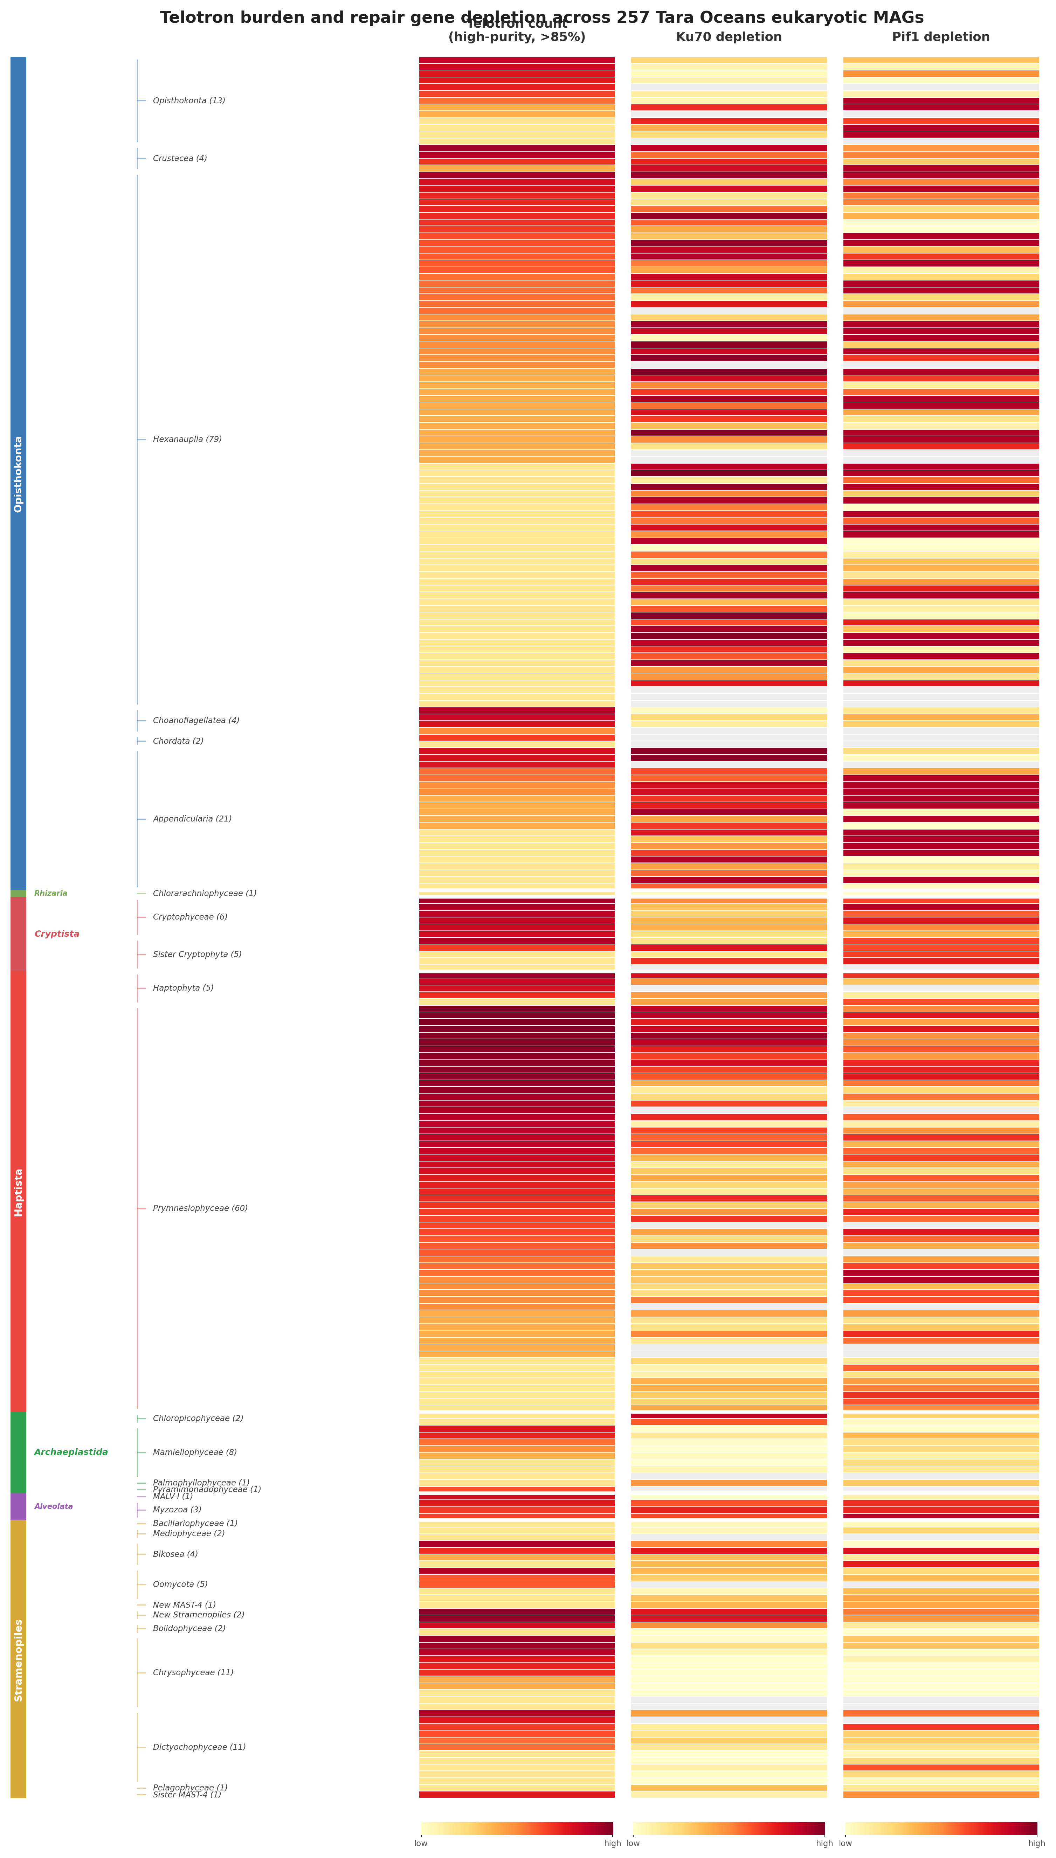
Heatmap showing telotron count, Ku70 density, Lig4 density, Rad51 density, and Pif1 density across all 257 MAGs from the Tara Oceans eukaryotic catalogue, organized by supergroup and class. Colour intensity reflects rank-normalized values (quantile normalization). Telotron burden is concentrated in Haptophyta and to a lesser extent Stramenopiles and Cryptista. Ku70 and Lig4 are coordinately depleted in the telotron-rich Haptophyta clade, while Pif1 shows no systematic depletion pattern, consistent with post-translational rather than transcriptional regulation of Pif1 function.

Extended Data Figure 5
Extended Data Figure 5: De novo telotron insertion confirmed by ortholog comparison.
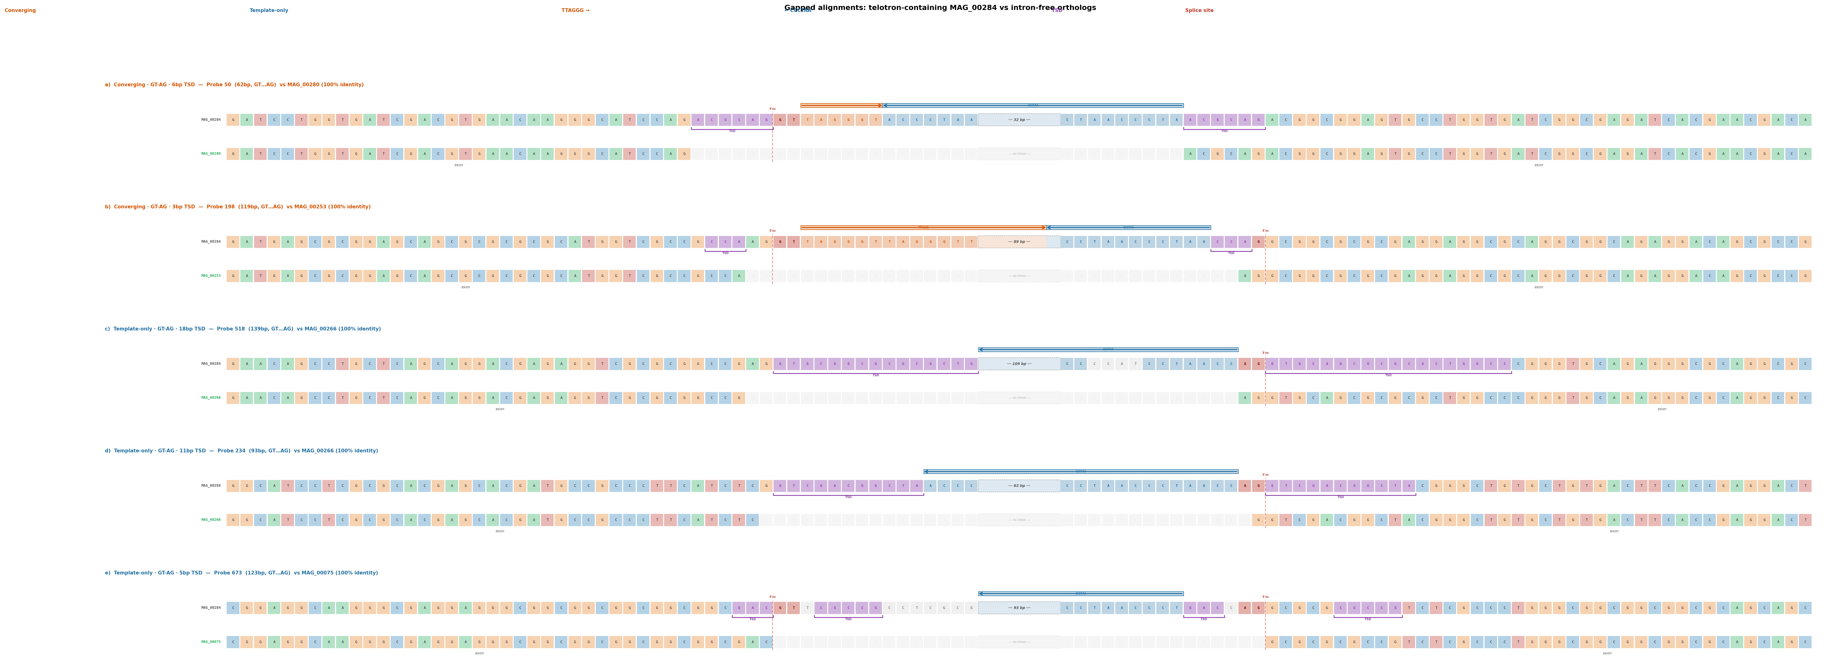
Gapped alignments between telotron-containing genes in the primary MAG and intron-free orthologs from related MAGs. Red arrows (→) mark TTAGGG arrays on the coding strand; blue arrows (←) mark CCCTAA arrays (TTAGGG on the template strand). Converging panels show bidirectional telomerase extension at both DSB ends; template-only panels show single-strand extension. All use canonical GT-AG splice sites (red dashed lines). Purple brackets mark target site duplications (TSDs) ranging 3–18 bp. Across 52 GT-AG telotrons with intron-free orthologs, all 116 pairwise alignments show ≥95% exonic identity with a clean deletion of the telotron. The variable TSD length (3–21 bp) is diagnostic of staggered DSB ends processed to different extents, distinguishing telotrons from transposon insertions (which produce fixed-length TSDs). The 71% TSD rate among recent insertions versus 10.6% genome-wide reflects erosion of flanking duplications over evolutionary time.

Extended Data Figure 6
Extended Data Figure 6: Telotron-specific partial correlations and confound analysis.
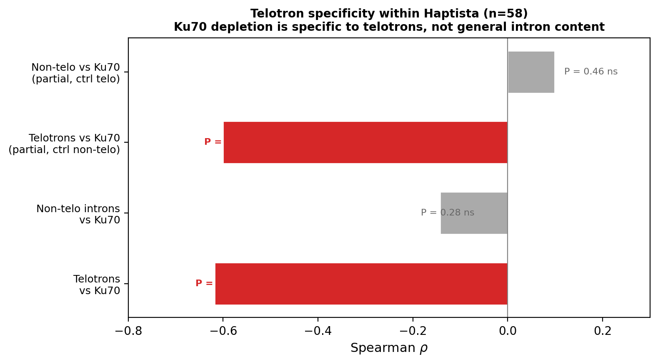
Top: Partial correlation analysis showing the Ku70–telotron association is specific to telotrons (ρ = −0.60 controlling for non-telotron intron count) and not a general intron-content effect. Bottom: BUSCO assembly quality does not confound the result (partial ρ changes from −0.618 to −0.592 when controlling for BUSCO completeness). These controls demonstrate that the repair gene–telotron association reflects genuine biology rather than assembly quality or general genome content effects.

