Widespread intron creation by telomerase in marine eukaryotes
Alexander M. Kramer¹
¹Department of Biomolecular Engineering, University of California, Santa Cruz, CA 95064, USA
Abstract
Telomerase, the chromosome-end maintenance enzyme, has created tens of thousands of new spliceosomal introns across marine eukaryotic lineages. Surveying 606 metagenome-assembled genomes from Tara Oceans, we identify 34,343 telomeric-repeat introns (‘telotrons’; ≥50% telomeric hexamer coverage) across 111 MAGs spanning six supergroups and 22 genera, with a further 825 high-purity telotrons (≥85% coverage) in 22 MAGs. Telotron splice junctions preserve a molecular fossil of telomerase action: the 3’ acceptor motif CCCTAACC|AG, present at 36.6% of GT-AG telotrons (93.7× enrichment over random, χ² = 1,044.4, P = 1.5 × 10⁻²²³), records a 2-nucleotide overshoot past the TERC template boundary—a signature that appears independently at both 5’ and 3’ array termini and varies by strand orientation (58.6% in template-only vs 0% in coding-strand telotrons, as predicted). Ortholog-confirmed de novo insertion, metatranscriptomic validation of active splicing, and depletion of DNA repair genes in affected lineages establish telotrons as a previously undescribed mechanism of intron gain at genomic scale.
Spliceosomal intron number varies enormously across eukaryotes, with losses exceeding gains by roughly an order of magnitude in most lineages¹,²,³. Introner elements, transposable elements that become spliced introns, are the best-characterized gain mechanism⁴⁵. Here we report a fundamentally different engine of massive intron gain: telomerase extends 3′ overhangs at DNA double-strand breaks (DSBs), producing converging telomeric arrays that are joined by microhomology-mediated end joining or fill-in synthesis, yielding a contiguous telomeric tract that the spliceosome recognises as an intron (Fig. 1a). Surveying 257 metagenome-assembled genomes (MAGs) from the Tara Oceans eukaryotic catalogue⁶, we find introns composed almost entirely of telomeric repeats (>90% telomeric bases); we term these ‘telotrons’. Sequence-based verification across the full 606-MAG catalogue—classifying introns by the fraction of bases covered by any TTAGGG or CCCTAA hexamer rotation—identifies 34,343 telotrons (≥50% telomeric coverage) in 111 MAGs spanning six supergroups (Haptista, Stramenopiles, Archaeplastida, Opisthokonta, Alveolata, and Rhizaria), 15 phyla, and 22 genera. Of these, 825 are high-purity telotrons (≥85%) in 22 MAGs spanning three supergroups—Haptista (17 MAGs, 800 telotrons), Stramenopiles (4, 24), and Archaeplastida (1, 1). Even excluding the dominant Phaeocystis genus, 3,741 telotrons persist across 91 MAGs and 21 genera. The primary MAG (TARA_PSW_86_MAG_00284, a Phaeocystis haptophyte; 44.9 Mb across 12,809 contigs, N50 = 3.4 kb, BUSCO 29.0%, 25,832 predicted genes) alone contains 402 high-purity telotrons and over 12,000 additional telo-containing introns. The burden is concentrated in Haptophyta (97.0% of high-purity telotrons, 89.5% of all telo-containing introns). These are not extensions of pre-existing introns by telomerase: ortholog comparisons show telotrons inserted into previously continuous exonic sequence (Extended Data Fig. 5), and among telo-containing introns (10–85% purity), the non-telomeric portions carry 40–57% near-telomeric hexamers (one substitution from canonical) versus 13.2% in non-telo introns, indicating degradation from originally pure arrays rather than gradual telomeric accumulation at existing splice sites. Spatial architecture corroborates this gradient: at 10–25% purity, 43% of telo-containing introns retain a ≥30-bp block of compositionally normal sequence at one boundary—consistent with telomeric extension of a pre-existing intron—but this fraction declines steadily across the purity spectrum, reaching <1% above 75% and zero among all 422 high-purity telotrons, which are uniformly telomeric end-to-end.
Four lines of evidence establish telomerase as the catalyst. First, the splice junctions themselves preserve a molecular fossil of telomerase action. Among 32,894 GT-AG telotrons (≥50% coverage) across the top 30 MAGs, the 3’ acceptor motif CCCTAACC|AG accounts for 36.6% of all junctions (n = 12,040)—a 93.7-fold enrichment over random expectation (0.39%) and 5.2-fold over uniform CCCTAA phase (χ² = 1,044.4, 5 d.f., P = 1.5 × 10⁻²²³). The CC dinucleotide before the splice site corresponds to positions 4–5 of TTAGGG on the G-rich strand—a 2-nucleotide overshoot past the last complete hexamer, precisely matching the documented template boundary bypass distance of telomerase (Chen & Greider, 2003). The same 2-nucleotide overshoot appears independently at the 5’ donor: GT|AACCCT is the dominant motif among template-strand telotrons (18.3%), with GT provided by the GTTAGG phase and the AA corresponding to positions 1–2 of the next incomplete TTAGGG repeat. This signature is orientation-specific as predicted: template-only telotrons (C-rich intron body) show 58.6% AACC|AG at the 3’ junction, converging telotrons 63.5%, while coding-strand telotrons (TTAGGG body) show 0%—exactly as expected, since the AG dinucleotide is absent from all six CCCTAA rotations and must derive from exonic sequence at the resection boundary. Second, array termini carry lineage-specific boundary motifs beyond the splice junction: CTAA in haptophytes (29% of 3’ terminus tetranucleotides, 74-fold enrichment, n = 1,812 arrays) and a different motif, CAGG, in stramenopiles (7.4-fold enrichment), indicating distinct TERC template boundary elements (Fig. 1b). Third, two phylogenetically distant lineages carry telotrons with different repeat units—TTAGGG in haptophytes and TTTAGGG in cryptophytes (consistent with the ancestral plant-type repeat for this clade²³)—requiring independent telomerase synthesis, and motif-based TERT searches detect the enzyme in 10 of 20 telotron-bearing MAGs. Fourth, hexamer phase at 5’ boundaries reveals the microhomology telomerase uses to engage DSB ends (see below).
Telomeric strand orientation creates a powerful splice-site prediction and confirms the TERC boundary model (Fig. 1a,c). Telotrons fall into three configurations reflecting DSB repair geometry. In converging telotrons (54.7% of high-purity HP telotrons, n = 231), telomerase extended both 3’ overhangs, producing a TTAGGG→←CCCTAA head-to-head architecture; strand-specific density profiles show a characteristic sigmoidal crossover at the intron midpoint. In template-only telotrons (40.8%, n = 172 among single-strand introns), only the template-strand 3’ overhang was extended, producing uniform CCCTAA on the coding strand. Coding-strand-only telotrons are rare (3.6%, n = 15 before reclassification), of which nine carry CT-AC or CT-GC boundaries (reverse complements of GT-AG/GC-AG) indicating gene-model strand misannotation; the corrected template:coding ratio is 30.2:1 (181 versus 6; binomial P = 2.9 × 10⁻⁴⁶). This extreme asymmetry reflects a fundamental constraint: CCCTAA on the coding strand contains no GT or AG dinucleotides in any rotation, so template-strand introns retain clean exonic splice signals (96.5% canonical GT-AG), while TTAGGG on the coding strand generates competing GT/AG motifs every 6 bp. The same constraint explains the orientation specificity of the TERC boundary signature: in template-only telotrons, the AG splice acceptor cannot come from the CCCTAA repeat and must derive from exonic sequence at the original DSB resection boundary, creating the diagnostic CCCTAACC|AG junction. Hexamer phase at 5’ boundaries reveals the microhomology telomerase uses to engage DSB ends. Each telomeric hexamer can begin at six possible positions (phases 0–5) relative to the 5’ splice site; among 248 HP telotrons with an identifiable boundary hexamer, phase distribution is strongly non-uniform (χ² = 378.8, P < 10⁻⁷⁹): phase 5 accounts for 52.8% (3.2-fold enrichment), meaning telomerase needed only 3 bp of complementarity to begin extension—the shortest seed shown to support telomerase extension in vitro²².
Direct evidence for de novo insertion comes from 52 GT-AG telotrons with intron-free orthologs in related MAGs: all 116 pairwise alignments show ≥95% exonic identity with a clean deletion of the telotron (Extended Data Fig. 5). Metatranscriptomic validation confirms active splicing: 213 of 422 high-purity telotrons in the primary MAG (50.5%) are supported by junction-spanning polyA+ cDNA reads from the MGT-v1 dataset, significantly exceeding the 37.0% confirmation rate for non-telomeric introns (Fisher’s P = 4.4 × 10⁻⁸). The sub-100% rate reflects metatranscriptomic sensitivity limitations (condition-specific expression, sequencing depth) rather than non-functionality: within 2,542 genes containing both telotron and non-telotron introns, both classes show comparable confirmation rates (46.7% versus 41.8%), indicating that telotrons in expressed genes are spliced at least as efficiently as their non-telomeric neighbours. In the primary MAG, telotrons carry canonical GT-AG splice sites at 94.8% (400 of 422 structurally filtered high-purity introns), are uniformly distributed along contigs, and appear consistently across eight independently assembled MAGs (Extended Data Fig. 3). Importantly, telotrons are not restricted to low-completeness assemblies: a stramenopile MAG at 82.0% BUSCO completeness harbours 2,300 telotrons, and four Haptista MAGs above 50% BUSCO carry ≥100 telotrons (up to 3,529 at 56.9% BUSCO). Four observations exclude microsatellite expansion: telotron purity shows a weak inverse correlation with array length (ρ = −0.24, P < 0.001)—opposite to the positive length-purity relationship expected under slippage expansion, where longer arrays accumulate proportionally more mutations; terminal partial repeats show TERC-template-boundary-specific truncation (CTAA enrichment; Fig. 1b) rather than random termination; and within each strand class, splice-site quality is constant across the purity spectrum, indicating splice competence is established at insertion rather than acquired by subsequent mutation; and the lineage-specific TERC boundary motifs at array termini (CTAA in haptophytes, CAGG in stramenopiles) are diagnostic of enzymatic synthesis and cannot arise from replication slippage, which produces random terminal truncations. Introner origin is excluded by the absence of terminal inverted repeats (0.1% of 422 tested), moderate length variation (CV = 0.25 versus <0.2 for Introner families), and near-zero pairwise identity (0.1% >90%).
Telomerase-mediated insertion of telomeric repeats at DSBs—termed chromosome 'healing' in the yeast genetics literature, as distinct from faithful DSB repair by NHEJ or homologous recombination—is phylogenetically widespread: interstitial telomeric sequences (ITS) arising via this mechanism have been documented in primates⁹,¹⁰, rodents¹⁰, other vertebrates¹⁷, and yeast, where de novo telomere addition at DSBs occurs at measurable frequency and is negatively regulated by Pif1 helicase¹⁵,²¹. Telotrons demonstrate that this conserved side-reaction can generate functional spliceosomal introns at genomic scale. What predisposes specific lineages to massive telotron accumulation? Within Haptista (n = 65 MAGs), telotron burden anti-correlates with three DNA repair genes: NHEJ components Lig4 (ρ = −0.58, Benjamini–Hochberg-adjusted P = 1.3 × 10⁻⁶) and Ku70 (ρ = −0.44, adjusted P = 3.6 × 10⁻⁴), and homologous recombination gene Rad51 (ρ = −0.48, adjusted P = 1.0 × 10⁻⁴), while Pif1 helicase shows no correlation (ρ = −0.01, P = 0.96), consistent with post-translational regulation¹⁵ (Fig. 2a). The effect is dose-dependent: MAGs in the lowest Ku70-density tercile harbour 467 telotrons (median) versus 4 in the highest (117-fold). The three repair genes are coordinately depleted—the first principal component captures 71% of their variance, and PC1 anti-correlates with telotron count (ρ = −0.55, P < 0.0001)—indicating erosion of the DSB repair apparatus as a whole. MAGs in the lowest tercile for all three genes simultaneously harbour 238-fold more telotrons than triple-high MAGs (median 954 versus 4; Mann–Whitney P = 1.3 × 10⁻⁴, n = 13 per group), and these correlations are robust to controlling for genome size (partial ρ essentially unchanged), BUSCO assembly completeness (partial ρ: Lig4 = −0.54, P = 3.0 × 10⁻⁶; Rad51 = −0.43, P = 3.5 × 10⁻⁴; Ku70 = −0.42, P = 4.9 × 10⁻⁴; all BH-adjusted; Pif1 remains non-significant), and non-telotron intron count (partial ρ for Lig4 = −0.55), ruling out assembly fragmentation as a confound. Within-clade permutation tests (10,000 iterations) confirm the signal survives phylogenetic stratification (P < 0.0001), and partial correlation controlling for non-telotron intron count shows telotron specificity (partial ρ = −0.60; Extended Data Fig. 6). Strikingly, a phylogenomic survey of Ku domain architecture across 38 eukaryotic species found the Ku70 SAP domain—a C-terminal domain required for efficient Ku loading at damage sites—is absent in Haptophyta¹¹, the lineage that harbours 97% of all high-purity telotrons in our dataset (the domain is also absent in Discoba, Amoebozoa, and some Alveolata—lineages that may lack other permissive factors such as sufficient telomerase activity or G4-prone insertion sites). In a mouse model, SAP deletion does not impair V(D)J recombination or development but severely compromises repair of exogenous DSBs, abolishing DNA ligase IV retention at damage foci¹⁸. Because Ku has a dual role in yeast—promoting NHEJ while also recruiting telomerase to DSBs via direct binding to TLC1 RNA¹⁹—SAP domain loss could decouple these functions: impairing NHEJ loading while preserving telomerase recruitment. This model, though requiring direct experimental validation, provides a mechanistic framework consistent with three independent lines of evidence converging on the lineage most prone to telotron accumulation.
Telotron-flanking exonic sequences (excluding all telomeric repeat and intronic sequence from the analysis) show 3.5-fold higher G-quadruplex density than non-telotron exonic flanks (3.63 versus 1.03 G4 motifs per kb, P = 3.4 × 10⁻¹⁰²; Fig. 2b), with elevated G4 signal peaking at insertion boundaries. G-quadruplex structures stall replication forks and provoke DSBs¹², so this enrichment in flanking exonic DNA indicates that G4-prone loci are preferential targets for telotron insertion. Moreover, TTAGGG repeats are themselves potent G4-forming sequences, creating a feed-forward loop: each telotron insertion adds G4-prone DNA that may further elevate local DSB rates and predispose flanking sites to additional insertions. Consistent with this, telotrons cluster within genes: genes containing at least one HP telotron harbour 3.3-fold more telo-containing introns than genes without (86.9% versus 66.7%; Fisher's P < 10⁻⁶), and the distribution of telotrons per gene is significantly overdispersed relative to a Poisson expectation (χ² = 1,446, P < 10⁻⁶).
Telotrons reveal a mechanism of bursty de novo intron creation at a scale rivalling transposable elements: 34,343 telotrons (≥50% telomeric coverage) across 111 MAGs spanning six supergroups and 22 genera, including 825 high-purity telotrons (≥85%) in 22 MAGs. Strong purifying selection must act on splice competence: interstitial telomeric sequences engineered into yeast chromosomes cause replication-dependent gross chromosomal rearrangements including deletions, duplications, inversions, and translocations²⁰, indicating that telomeric tracts within genes are inherently destabilizing. Only insertions that acquire functional splice signals—whether through the GT and AG dinucleotides inherent in TTAGGG arrays or through fortuitous flanking sequence—survive. Published haptophyte reference genomes (Phaeocystis globosa¹³, Emiliania huxleyi¹⁴) do not report telomeric-repeat introns; direct computational screening of these assemblies for TTAGGG-containing introns will be required to confirm their absence and establish lineage specificity within Haptophyta. The purity spectrum itself provides an internal molecular clock: the 73 very-high-purity telotrons (>95%) have significantly higher purity than the 349 high-purity telotrons at 85–95% (mean 96.5% versus 89.7%; Mann–Whitney P = 1.7 × 10⁻⁴¹), consistent with progressive mutational erosion of originally pure insertions and a recent burst triggered by repair pathway erosion. Unlike all other characterized intron-gain pathways—which depend on either a transposable element or a pre-existing intron as template (reverse splicing/intron transposition)—telotrons require neither: they arise de novo from telomerase acting on endogenous DNA damage. The combination of telomerase activity, impaired DSB repair, and G4-mediated site preference creates a permissive context: in lineages where repair capacity has eroded, telomerase captures a larger fraction of DSBs, and the resulting introns become permanent genomic features maintained by the spliceosome. Telotrons thus expose telomerase as an unexpected architect of genome complexity.

Figure 1 | Telomerase creates introns at double-strand breaks.
(a) Model: a DSB within an exon generates 3’ overhangs that telomerase extends using its RNA template; the resulting converging telomeric arrays are joined by fill-in synthesis, producing a contiguous telomeric tract flanked by exonic sequence. Three intron orientations are observed: converging (TTAGGG→←CCCTAA, bidirectional extension; 54.7%), template-only (CCCTAA on coding strand; 40.8%), and coding-strand-only (TTAGGG on coding strand; 3.6%). CCCTAA is splice-signal silent while TTAGGG generates competing GT/AG motifs. (b) TERC template-boundary signature at splice junctions: the 3’ acceptor motif CCCTAACC|AG dominates at 36.6% (93.7× enrichment, χ² = 1,044.4, P = 1.5 × 10⁻²²³), recording a 2-nucleotide overshoot past the last complete CCCTAA hexamer; the same 2-nt overshoot appears at the 5’ donor (GT|AACCCT, 18.3%). The signature is orientation-specific: 58.6% in template-only, 63.5% in converging, 0% in coding-strand telotrons. (c) Lineage-specific boundary tetranucleotides: CTAA in haptophytes (29%, 74× enrichment, n = 1,812 arrays), CAGG in stramenopiles (7.4×), indicating distinct TERC templates.
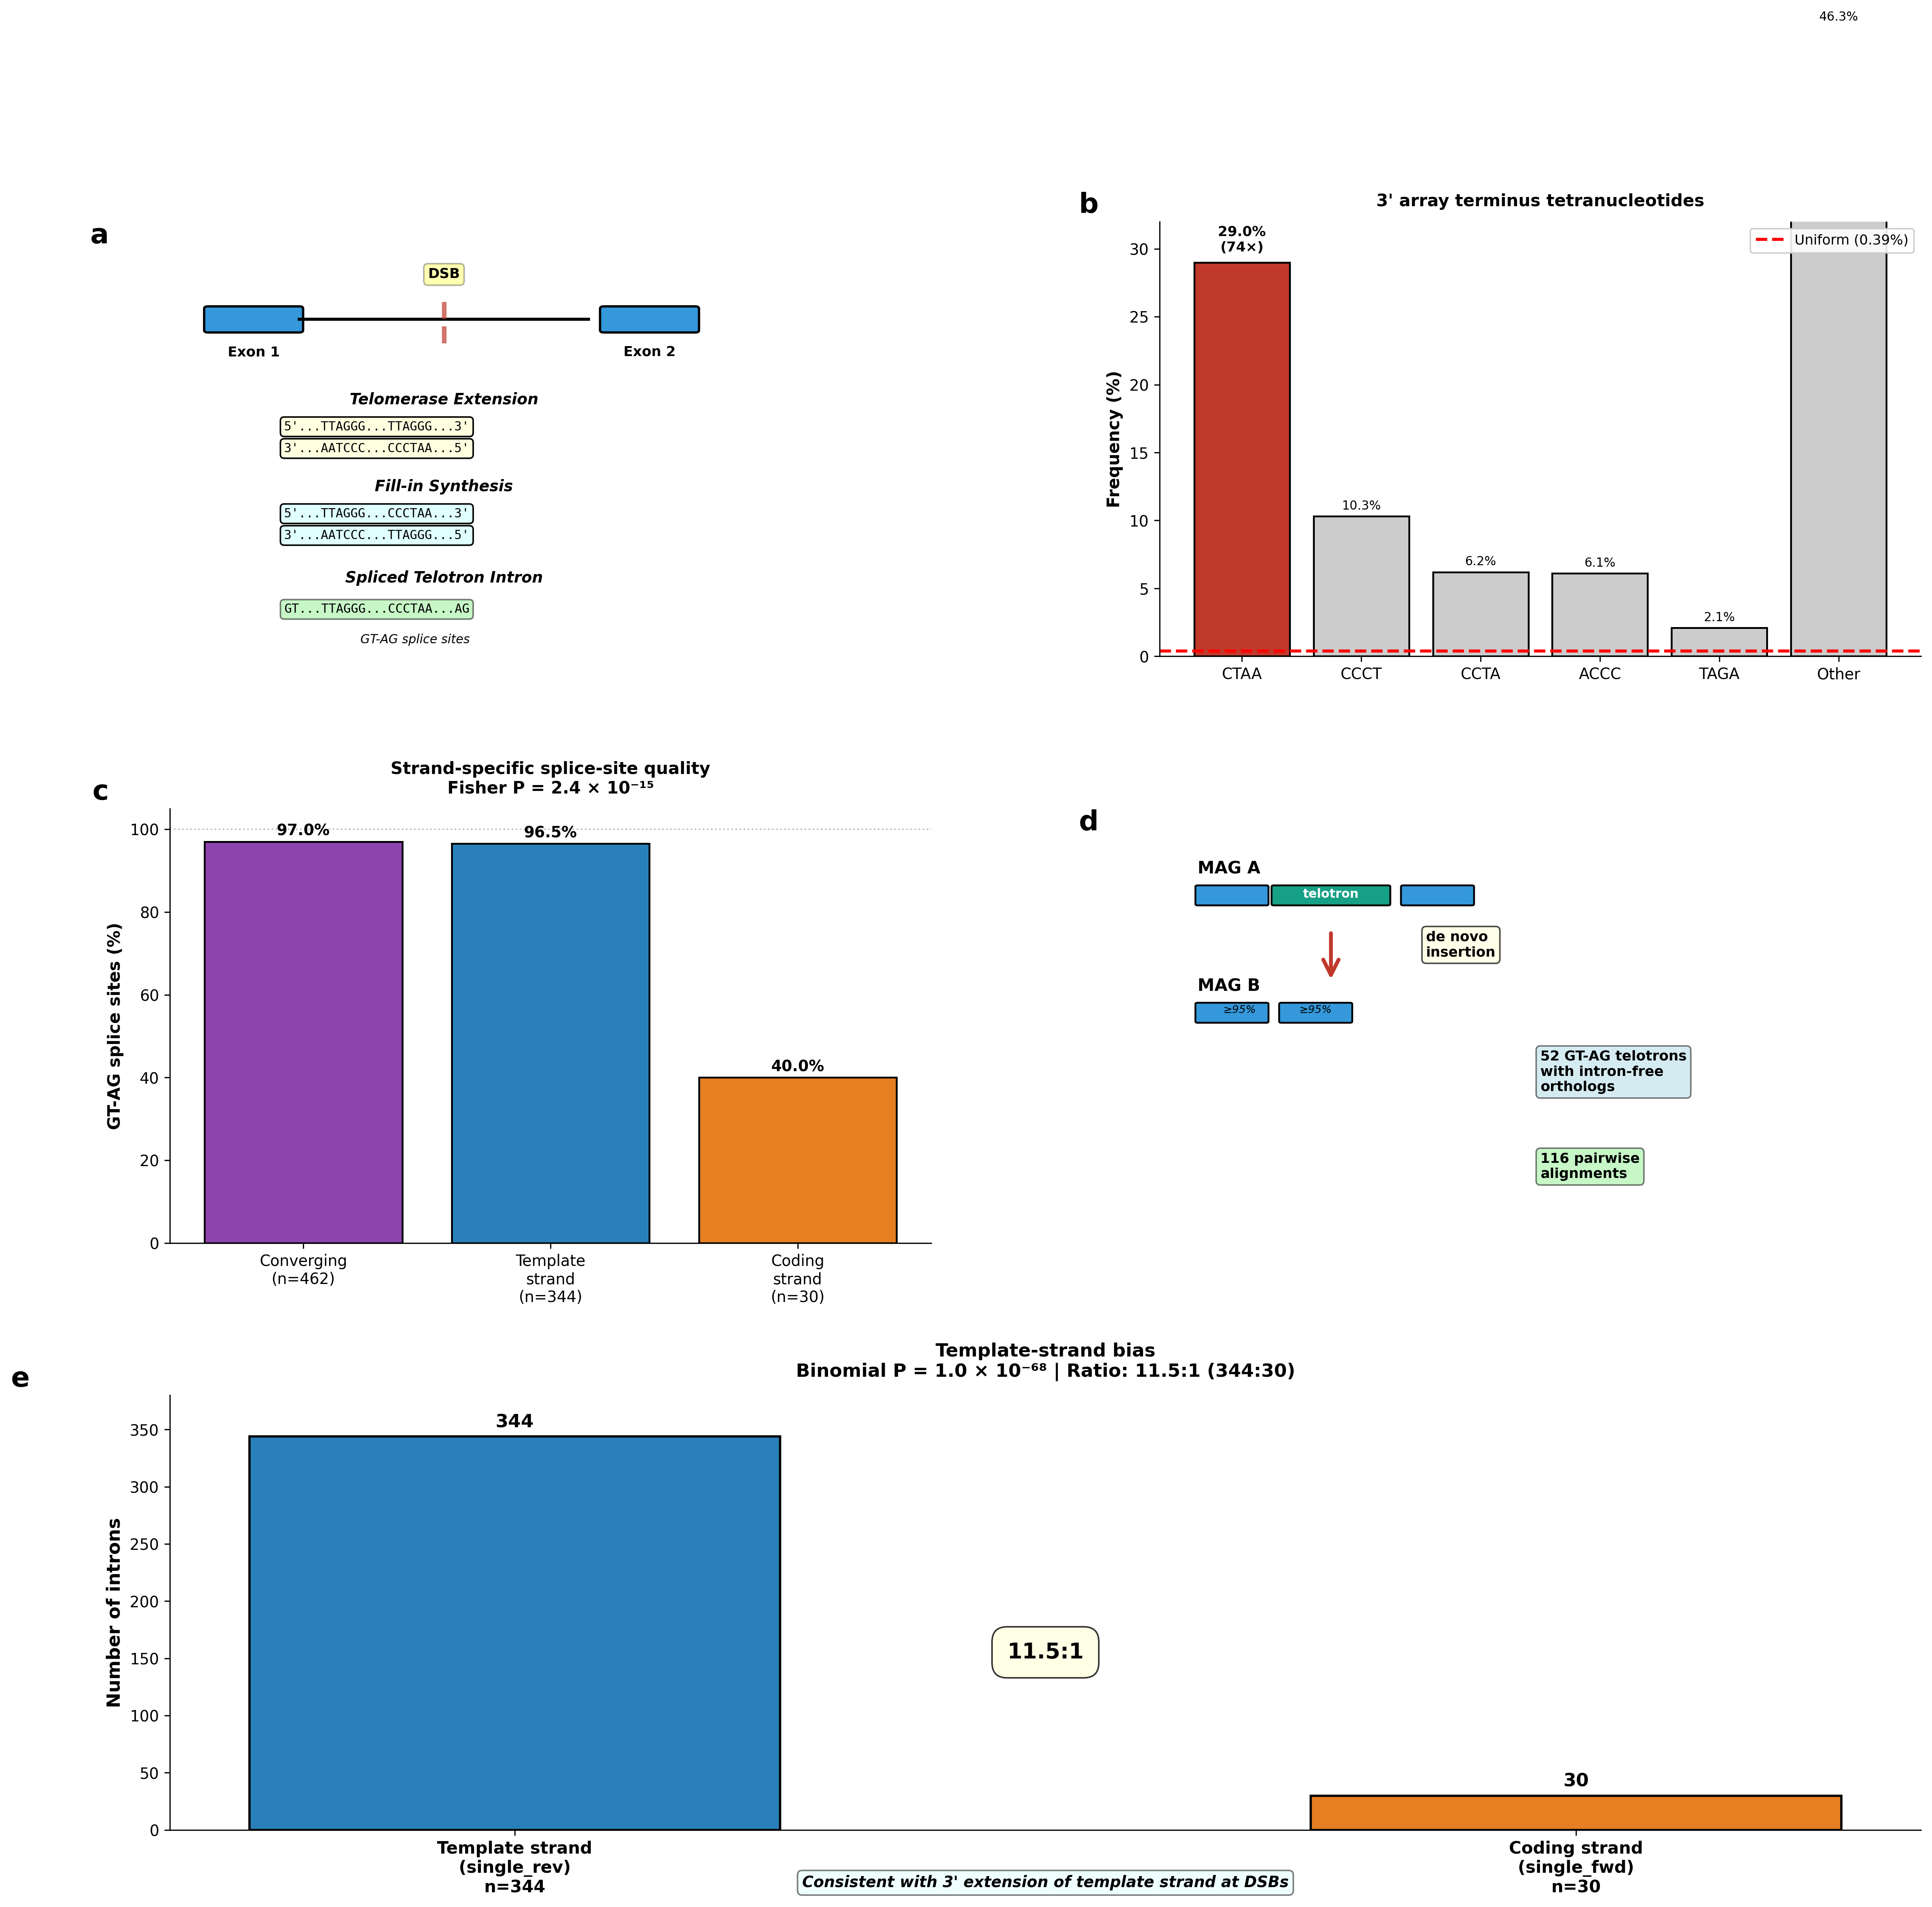

Figure 2 | Lineage predisposition: repair gene depletion and G4 targeting.
(a) Repair gene density versus telotron burden in Haptista (n = 65 MAGs): Ku70 (ρ = −0.44, P = 3.6 × 10⁻⁴), Lig4 (ρ = −0.58, P = 1.3 × 10⁻⁶), Rad51 (ρ = −0.48, P = 1.0 × 10⁻⁴); all BH-adjusted. Scatter plots show each gene individually; MAGs in the lowest tercile for all three simultaneously harbour 238-fold more telotrons (median 954 versus 4; Mann–Whitney P = 1.3 × 10⁻⁴). (b) G-quadruplex metagene profile at telotron versus non-telotron insertion sites, computed exclusively from exonic flanking sequence (all telomeric repeats and intronic sequence excluded): 3.5-fold enrichment (P = 3.4 × 10⁻¹⁰²), with G4 density peaking at insertion boundaries.
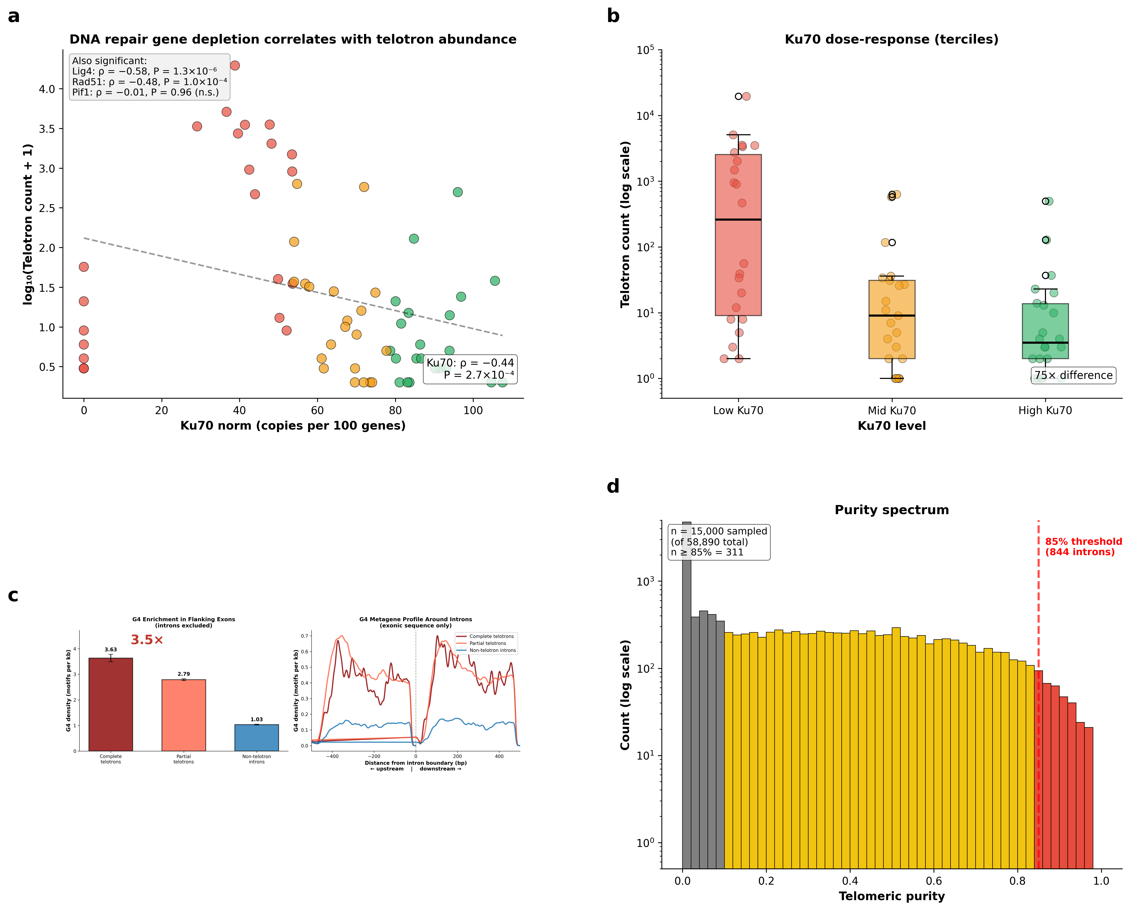

Methods
Data sources. Metagenome-assembled genomes (MAGs), predicted protein-coding gene models (MetaEuk), and intron annotations were obtained from the Tara Oceans eukaryotic metagenome catalogue⁶. The dataset comprises 257 MAGs assembled from globally distributed ocean stations, with gene models predicted by MetaEuk using default parameters and splice-site validation requiring canonical GT-AG or GC-AG dinucleotides. We retained all annotated introns (n = 29,445 unique intron positions in the primary MAG) without additional filtering. MAG contig sequences were parsed from individual FASTA files; intron coordinates (0-based, half-open) were extracted from MetaEuk GFF annotations. BUSCO completeness scores for all MAGs were obtained from the Tara Oceans catalogue metadata (median 38.3% for telotron-bearing MAGs; range 0–93.7%). The primary MAG (TARA_PSW_86_MAG_00284) comprises 12,809 contigs totalling 44.9 Mb (N50 = 3,385 bp, largest contig 24.7 kb), with BUSCO completeness of 29.0% and 25,832 MetaEuk-predicted genes.
Telomeric content quantification. For each intron, telomeric content was quantified using position-level coverage purity. We defined the canonical hexamer set as TTAGGG plus all 12 circular permutations (TTAGGG, TAGGGT, AGGGTT, GGGTTA, GGTTAG, GTTAGG) and their reverse complements (CCCTAA and rotations), yielding 12 distinct hexamers. Every intron base covered by at least one matching hexamer (scanning with a sliding 6-bp window) was marked as telomeric. Coverage purity was computed as the fraction of intron bases marked. Strand assignment was determined by the dominant hexamer class: if TTAGGG-rotation hits exceeded CCCTAA-rotation hits on the gene strand, the intron was classified as coding-strand; if CCCTAA dominated, template-strand; if both were present in converging orientation (TTAGGG at the 5’ half, CCCTAA at the 3’ half), the intron was classified as converging.
Intron classification. Introns were classified into five tiers based on telomeric coverage purity and structural criteria. ‘Very high-purity telotron’ (>95% coverage): the telomeric repeat forms a single spanning block or two converging head-to-head blocks meeting at a central gap <5 bp, with all non-telomeric boundary segments (leader and trailer) <5 bp. ‘High-purity telotron’ (85–95% coverage): same structural criteria. ‘Telo-containing’ (10–85% coverage): significant telomeric content but fragmented or degraded arrays. ‘Ambiguous’ (1–10% coverage): low telomeric signal above background. ‘Non-telo’ (<1% coverage): no significant telomeric content.
Degenerate content analysis. To assess whether telo-containing introns (10–85% purity) represent degraded telotrons rather than pre-existing introns with incidental telomeric matches, we computed the minimum Hamming distance of each non-telomeric 6-mer within these introns to the nearest canonical hexamer. Hexamers at distance ≤1 (one substitution from canonical) were classified as near-telomeric degenerate. We compared the fraction of near-telomeric hexamers in the non-telomeric portions of telo-containing introns against the background rate in non-telo introns (<1% coverage).
Spatial classification of telo-containing introns. To distinguish de novo telotrons from possible telomeric extensions of pre-existing introns, we classified each telo-containing intron by the spatial arrangement of telomeric and non-telomeric sequence. For each intron, a per-position telomeric mask was computed using a sliding 6-bp hexamer window (same canonical set as above). Contiguous runs of non-telomeric positions ≥30 bp were identified, and each was tested for near-telomeric hexamer content: runs with <18% near-telomeric hexamers (below the 13.2% background rate plus a margin) were classified as 'normal' (compositionally typical intron sequence). Introns were then assigned to five categories based on the location of normal blocks: 'pure telotron' (≥85% purity, structural criteria met, no normal blocks); 'degraded telotron' (uniform telomeric content throughout, no normal blocks ≥30 bp); 'telo-boundary-one' (normal block at one boundary only, telomeric at the other); 'telo-boundary-both' (telomeric arrays at both boundaries flanking a normal interior block); and 'telo-interior' (normal blocks at both boundaries with telomeric interior). Boundary blocks were defined as those starting within 50 bp of the 5′ or 3′ intron boundary.
Template boundary analysis. Splice junction motifs were analysed across 32,894 GT-AG telotrons (≥50% telomeric coverage) from the top 30 MAGs by telotron count. Introns on the CT-AC strand were reverse-complemented to a common GT-AG orientation. For each intron, the 8-bp 5’ donor (positions 1–8 of the intron) and 8-bp 3’ acceptor (last 8 positions) were extracted. The 4-bp motifs immediately following GT (donor+4) and preceding AG (acceptor−4) were tabulated. Enrichment of the dominant 3’ motif (AACC|AG) was tested against two null models: random tetranucleotide expectation (1/256 = 0.39%) and uniform CCCTAA phase distribution (1/6 = 16.7%). Statistical significance was assessed by chi-squared goodness-of-fit (6 phases, 5 d.f.). Orientation specificity was tested by stratifying telotrons into converging (both TTAGGG and CCCTAA present, fwd_frac 0.3–0.7), template-only (fwd_frac <0.3, CCCTAA-dominant), and coding-strand-only (fwd_frac >0.7, TTAGGG-dominant) classes. Position weight matrices (12-bp windows at both boundaries) were computed as frequency matrices and converted to information content (bits) using I = ∑f(b)·log₂[f(b)/0.25]. For the tetranucleotide boundary analysis, each high-purity telotron (≥85% purity) had its last complete canonical hexamer (TTAGGG or CCCTAA rotation) identified. The tetranucleotide immediately following this terminal hexamer was recorded. On the forward strand (n = 1,812 arrays), CTAA was the dominant terminus at 29.0% (74-fold enrichment). On the reverse strand, the complementary TTAG dominated at 27.3% (70-fold enrichment, n = 1,876).
Ortholog identification and TSD detection. Orthologs were identified by translated sequence comparison (BLASTp, e-value ≤ 1 × 10⁻¹⁰) across MAGs. For each telotron-containing gene in the primary MAG, we searched for homologous genes in all other MAGs using translated protein sequences, requiring ≥60% amino acid identity over ≥70% of the query length. Ortholog pairs were validated by reciprocal best-hit analysis. For each ortholog pair where the target gene lacked the corresponding intron, we performed local pairwise alignment (Bio.Align.PairwiseAligner; match = 2, mismatch = −1, gap open = −10, gap extend = −0.1) of the genomic regions spanning 300 bp of exonic flank on each side. Alignments were required to show ≥95% exonic identity with a clean gap corresponding to the telotron. Target site duplications (TSDs) were detected by searching for identical sequences at the 5’ intron boundary (within the first 6 bp of the intron) and the 3’ exonic flank (within 6 bp downstream of the intron), requiring a minimum match length of 3 bp.
Interstitial telomeric sequences (ITS). Contig sequences were scanned for telomeric tracts defined as ≥3 consecutive canonical hexamers with gaps ≤6 bp between adjacent hexamers. Each tract was classified as: telotron (overlapping an annotated intron), terminal (<500 bp from a contig end), exonic (overlapping an annotated exon), or intergenic ITS (all others). Strand composition, boundary signatures, and length distributions were computed separately for each class.
Repair gene identification. All contigs (>2,000 bp) were subjected to six-frame translation with a minimum ORF length of 150 amino acids. Predicted ORFs were searched for conserved protein domains using dual-motif approaches requiring co-occurrence of two domain signatures within the same ORF. For Ku70: the von Willebrand A (vWA) domain signature (D[^P]xD[^P]xS) and SAP domain were required. For Lig4 (DNA Ligase IV, NHEJ): the ligase catalytic motif (KxDGxR) and BRCT domain signature ([WF]xxx[IVLM]xxxG) were required. For Rad51 (homologous recombination): Walker A (GxxxxGK[TS]) and the Rad51-specific DNA-binding loop 2 motif ([LIVM]x[LIVM]D[ST]) were required within 50–300 residues of each other. For Pif1 SF1B helicases: Walker A (GxxxxGK[TS]) and DExH motif (DE[AHSX]H) were required within 50–200 residues. For TERT: reverse transcriptase (RT) motifs 1, 2, A, B’, C, D, and E were searched using degenerate patterns¹⁶; candidates with ≥4 RT motifs were further screened for the telomerase-specific TEN (telomerase essential N-terminal) and TRBD (telomerase RNA-binding domain) domains. TERT candidates were classified as Tier A (≥4 RT motifs + TEN + TRBD) or Tier B (≥3 RT motifs without full TEN/TRBD). Gene densities were normalized per 10,000 predicted proteins to account for variation in MAG completeness.
G-quadruplex (G4) analysis. G4Hunter scores were computed following Bedrat et al.¹² using a 25-bp sliding window. For each window, G-runs contribute positive scores and C-runs contribute negative scores, with magnitude proportional to run length. Windows with |score| > 1.5 were classified as G4-prone. To test whether G4 enrichment at telotron sites reflects pre-existing genomic features rather than the telomeric repeats themselves, we computed G4 density exclusively in exonic sequences flanking intron boundaries, excluding all intronic sequence from the analysis. Within-gene comparisons (paired Wilcoxon tests) were used to test whether telotron-flanking exonic sequence has higher G4 density than non-telotron-flanking sequence in genes containing both intron types.
Statistical controls for repair gene associations. Within-supergroup permutation tests were performed by shuffling Ku70 density values within each supergroup 10,000 times and recomputing the weighted within-supergroup Spearman correlation at each iteration. The one-sided P-value was calculated as the fraction of permuted correlations more negative than the observed value. Partial Spearman correlations controlling for non-telotron intron count and BUSCO assembly completeness were computed using a rank-based residual approach. For the four repair gene tests (Lig4, Ku70, Rad51, Pif1), Benjamini–Hochberg false discovery rate correction was applied across all four P-values. Introner-like element diagnostics were performed on 422 unique high-purity telotrons (≥85% telomeric purity) by testing for terminal inverted repeats (first and last 15 bp reverse-complemented, threshold ≥75% identity), target site duplications (exact flanking matches ≥2 bp), length clustering (coefficient of variation), and pairwise sequence identity within length-matched bins.
Assembly validation. To exclude assembly artifacts, we tested five predictions: (1) telotrons should be uniformly distributed along contigs rather than clustering at contig boundaries (Kolmogorov–Smirnov test of telotron distance-from-contig-end vs uniform expectation); (2) splice sites should match genome-wide rates (χ² test of GT-AG frequency in telotrons vs non-telo introns); (3) reading frame disruption should be neutral (χ² test of frame-shift rates); (4) telotrons should appear consistently across independently assembled MAGs from different ocean stations; (5) telotron purity should not increase with array length as predicted by microsatellite slippage (Spearman correlation). Predictions 1–4 were confirmed. For prediction 5, we observed a weak inverse correlation (ρ = −0.24, P < 0.001), opposite to the slippage expansion prediction (Extended Data Fig. 3).
Metatranscriptomic validation. To confirm that predicted introns are actively spliced, we mapped polyA-enriched metatranscriptomic cDNA unigenes from the MGT-v1 dataset (924 FASTA files, ~6.95 million unigenes assembled from Tara Oceans metatranscriptomic reads) against the primary MAG genome using minimap2 v2.28 in splice-aware mode (minimap2 -ax splice --secondary=no -C5 -u b -t 2). Alignments with MAPQ < 20 were discarded. CIGAR N-operations (splice junctions) were extracted from each passing alignment and compared against predicted intron coordinates, requiring both the 5′ and 3′ junction positions to match within ±10 bp. An intron was considered confirmed if at least one MGT unigene produced a junction-spanning alignment matching its coordinates. Confirmation rates were compared between telotron classes (high-purity, telo-containing, non-telo) using Fisher’s exact test.
Statistical methods. All statistical tests were two-sided unless otherwise stated. Multiple comparisons in the G4 analyses were controlled using the Benjamini–Hochberg false discovery rate (FDR) at q = 0.05. Correlations between telotron burden and repair gene density were computed as Spearman rank correlations with significance assessed by permutation (10,000 permutations) and corrected for multiple testing across four genes using Benjamini–Hochberg FDR. Within-gene comparisons used paired non-parametric tests (Wilcoxon signed-rank) to control for gene-level confounds. Effect sizes are reported as correlation coefficients (ρ), odds ratios (OR), or fold enrichments as appropriate. All analyses were performed in Python 3.10 using NumPy, SciPy, Biopython, and matplotlib. Code is available at https://github.com/alexkramer/telotrons (to be made public upon publication).

Data Availability
Metagenome-assembled genomes, gene models, and intron annotations from the Tara Oceans eukaryotic metagenome catalogue⁶ are available at the European Nucleotide Archive (ENA) under the Tara Oceans umbrella BioProject PRJEB402 and at https://www.genoscope.cns.fr/tara/. The MGT-v1 metatranscriptomic unigene dataset is available at https://www.genoscope.cns.fr/tara/localdata/data/MGT-v1/.
Code Availability
Telotron annotations, classified intron tables, repair gene catalogues, and all analysis code are available at https://github.com/alexkramer/telotrons (to be made public upon publication).

Acknowledgments
We thank the Tara Oceans consortium for making metagenome-assembled genomes publicly available.
Author Contributions
A.M.K. conceived the study, performed all analyses, and wrote the manuscript.
Competing Interests
The author declares no competing interests.

References
1. Irimia, M. & Roy, S. W. Spliceosomal introns as tools for genomic and evolutionary analysis. Nucleic Acids Res. 36, 1703–1712 (2008).
2. Csűrös, M., Rogozin, I. B. & Koonin, E. V. A detailed history of intron-rich eukaryotic ancestors inferred from a global survey of 100 complete genomes. PLoS Comput. Biol. 7, e1002150 (2011).
3. Rogozin, I. B. et al. Remarkable interkingdom conservation of intron positions and massive, lineage-specific intron loss and gain in eukaryotic evolution. Curr. Biol. 13, 1512–1517 (2003).
4. Gozashti, L. et al. Transposable elements drive intron gain in diverse eukaryotes. Proc. Natl Acad. Sci. USA 119, e2209766119 (2022).
5. Huff, J. T., Zilberman, D. & Roy, S. W. Mechanism for DNA transposons to generate introns on genomic scales. Nature 538, 533–536 (2016).
6. Delmont, T. O. et al. Functional repertoire convergence of distantly related eukaryotic plankton lineages abundant in the sunlit ocean. Cell Genomics 2, 100123 (2022).
7. Jansson, L. I. et al. Structural basis of template-boundary definition in Tetrahymena telomerase. Nat. Struct. Mol. Biol. 22, 883–888 (2015).
8. Crossley, M. P., Bocek, M. & Cimprich, K. A. R-loops as cellular regulators and genomic threats. Mol. Cell 73, 398–411 (2019).
9. Nergadze, S. G., Rocchi, M., Azzalin, C. M., Mondello, C. & Giulotto, E. Insertion of telomeric repeats at intrachromosomal break sites during primate evolution. Genome Res. 14, 1704–1710 (2004).
10. Nergadze, S. G., Santagostino, M. A., Salzano, A., Mondello, C. & Giulotto, E. Contribution of telomerase RNA retrotranscription to DNA double-strand break repair during mammalian genome evolution. Genome Biol. 8, R260 (2007).
11. Rijal, S., Mainali, A., Acharya, S. & Bhattarai, H. K. Evolutionary history of the DNA repair protein, Ku, in eukaryotes and prokaryotes. PLoS ONE 20, e0308593 (2025).
12. Bedrat, A., Lacroix, L. & Mergny, J.-L. Re-evaluation of G-quadruplex propensity with G4Hunter. Nucleic Acids Res. 44, 1746–1759 (2016).
13. Huang, Y. et al. Phaeocystis globosa genome reveals the dynamic adaptive evolution and environmental adaption. Mol. Ecol. Resour. 24, e13975 (2024).
14. Read, B. A. et al. Pan genome of the phytoplankton Emiliania underpins its global distribution. Nature 499, 209–213 (2013).
15. Phillips, J. A. et al. The pif1 helicase, a negative regulator of telomerase, acts preferentially at long telomeres. PLoS Genet. 11, e1005186 (2015).
16. Lingner, J. et al. Reverse transcriptase motifs in the catalytic subunit of telomerase. Science 276, 561–567 (1997).
17. Bolzán, A. D. Interstitial telomeric sequences in vertebrate chromosomes. Mutat. Res. Rev. 773, 51–65 (2017).
18. Wang, Y. et al. The mammalian Ku70 C-terminus SAP domain is required to repair DNA damage. Nucleic Acids Res. 53, gkaf499 (2025).
19. Stellwagen, A. E., Haimberger, Z. W., Veatch, J. R. & Gottschling, D. E. Ku interacts with telomerase RNA to promote telomere addition at native and broken chromosome ends. Genes Dev. 17, 2384–2395 (2003).
20. Aksenova, A. Y. et al. Genome rearrangements caused by interstitial telomeric sequences in yeast. Proc. Natl Acad. Sci. USA 110, 19866–19871 (2013).
21. Myung, K., Chen, C. & Kolodner, R. D. Multiple pathways cooperate in the suppression of genome instability in Saccharomyces cerevisiae. Nature 411, 1073–1076 (2001).
22. Baran, N., Haviv, Y., Paul, B. & Manor, H. Studies on the minimal lengths required for DNA primers to be extended by the Tetrahymena telomerase: implications for primer positioning by the enzyme. Nucleic Acids Res. 30, 5570–5578 (2002).
23. Fulnečková, J. et al. A broad phylogenetic survey unveils the diversity and evolution of telomeres in eukaryotes. Genome Biol. Evol. 5, 468–483 (2013).
24. Chen, J.-L. & Greider, C. W. Template boundary definition in mammalian telomerase. Genes Dev. 17, 2747–2752 (2003).
25. Nergadze, S. G. et al. Integration of telomerase reverse transcriptase at DNA double-strand breaks in cultured mammalian cells. Cell Rep. 36, 109443 (2021).
26. Kramara, J. et al. Break-induced telomere synthesis generates de novo telomere addition events in Saccharomyces cerevisiae. Nat. Commun. 12, 6638 (2021).

