**Success** :

Before calling the RestAPI :

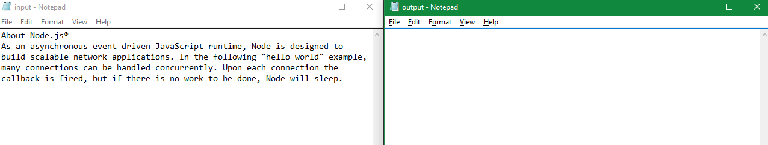

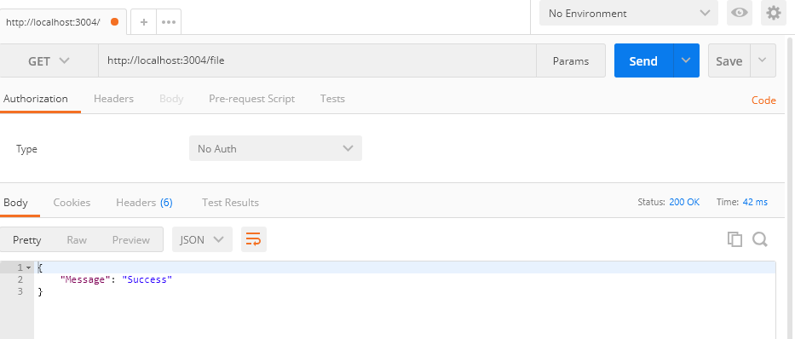

After calling the RestAPI :

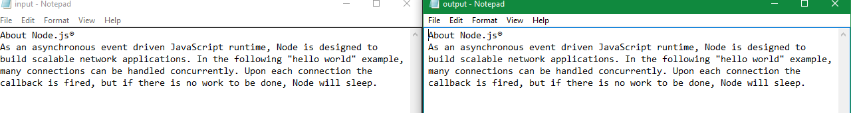

Failure :

