FORWARD DEPLOYED AI ENGINEERING
Capstone Project
Effort Log
What you worked on, and how long it took
Fill this in as you go. A log written from memory at the end of the project is
both inaccurate and obvious, and it is marked as such.
FILL IN EVERY SECOND DAY

Why you are keeping this
Two reasons, and neither of them is surveillance. The first is that estimating your own work is a professional skill you will be asked to exercise constantly, and the only way to get better at it is to compare what you predicted against what actually happened. The second is that the reflection section of your report needs material, and a log that shows discovery took half the time you expected while evaluation took twice as long gives you something genuinely worth writing about.
Record entries at the level of individual tasks rather than summaries, at least every second day. Record the hours you actually worked, including the ones that produced nothing useful. A task that took four hours and ended in a dead end is a real cost and belongs here.
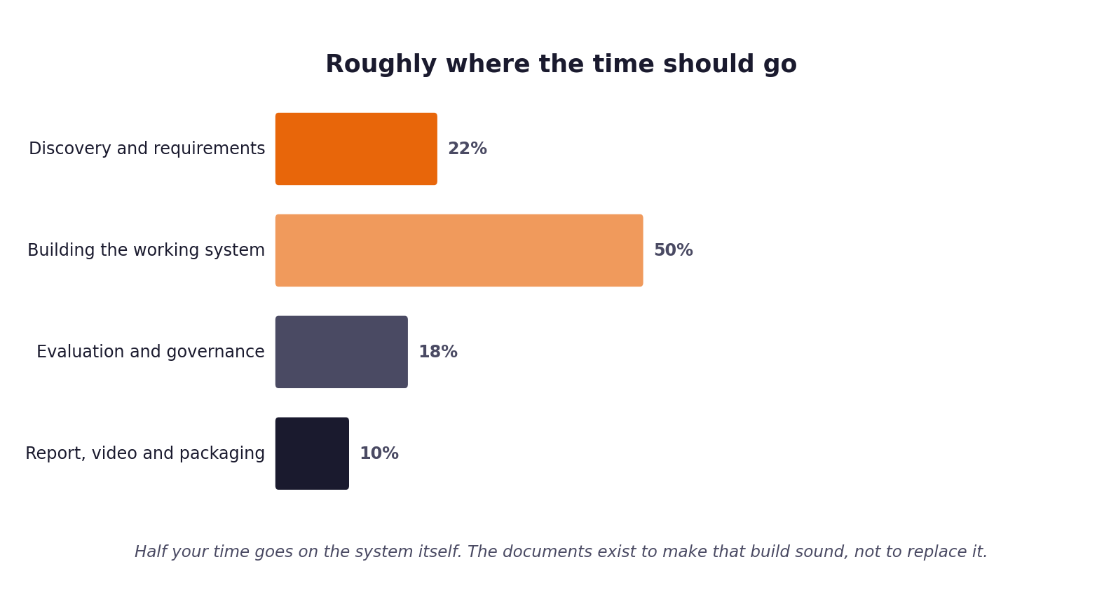
Figure 1. Roughly how the hours are expected to distribute. Compare yours against this at the end of each week.
1 Your details
Field | Value
Full name | Amlan Acharya
Project start date | 22 October 2026 (first commit in the v1 repository)
Target submission date | 18 November 2026 (confirmed deadline)
Hours available per week

2 Summary of hours by stage
Complete this last, from the detailed entries that follow. The totals must reconcile with your daily records.
Stage | Planned hours | Actual hours | Difference | Why the difference
1. Discovery & Analysis | 10 | 0.5 | -9.5 | Estimated share of the 22 Oct documents session; reading and analysis time not visible in git
2. Requirements (PRD v1) | 8 | 0.5 | -7.5 | PRD v2.0 written 22 Oct; v1 time not separately recorded
3. Prompt Engineering | 10 | 0.5 | -9.5 | Prompt library written 22 Oct; two prompts shipped in prompts/
4. Sprint & Capacity Plan | 6 | 0.5 | -5.5 | Not separately recorded
5. Implementation & Tests | 25 | 17.0 | -8.0 | Two implementations (v1 on 22-23 Oct, v2 on 31 Oct) plus tuning on 8 Nov; git-visible time only
6. Evaluation, Report, Video | 20 | 5.0 | -15.0 | Two film versions, one report rewrite, validation re-measurement and tuning on 8 Nov
Total | 79 | 24.0 | -55.0 | Hours are estimated from commit and run timestamps (session span plus lead-in). Lower bound: reading, planning and conversation time is not visible in git. Confirm before signing.

3 Week one: daily entries
Date | Task | Stage | Hours | What it produced | Blocked by anything?
Thu 22 Oct | v1 repository: service skeleton, channel normalisation, evidence retrieval, routing, cited answers, escalation and audit, evaluation harness (11 commits, 02:44-03:18) | 5 | 1.5 | First end-to-end pipeline; capstone specs and Hyperframes workflow documented | Later found it assumed channel-specific field names
Thu 22 Oct | v1: resilience and operational controls, governance evaluation reporting, evidence package (10:26-10:31) | 5 | 1.0 | Controls and reporting scaffolding | None recorded
Thu 22 Oct | Baseline on the real 500 development tickets answered 0 and failed 288; rebuilt the pipeline on the real dataset: semantic retrieval, trained classifier, router, harness, API, kill switch, CI, monitoring (19:16-19:47) | 5 | 3.0 | Rebuilt pipeline; baseline-v0 result kept as evidence | The first build did not fit the real data and was replaced
Thu 22 Oct | Prompt library, discovery figures, fill-in guides, PRD v2.0, fairness audit, urgency finding, run register, final validation run on 80 tickets (19:50-20:30) | 1-4, 6 | 2.0 | Documents and a recorded validation run (55 answered, 25 escalated, 0 blocked) | Hidden-set status recorded as 0 runs
Fri 23 Oct | Live provider path moved to available Groq models; reasoning-model handling (11:35) | 5 | 1.0 | Working live provider path | Earlier Groq key returned HTTP 401 (see pending.md)

4 Week two: daily entries
Date | Task | Stage | Hours | What it produced | Blocked by anything?
Sat 31 Oct | Second implementation in this repository (LangGraph state graph): ingestion and PII redaction, 87-chunk retrieval, classifier, dual gates, 3-tier cascade, guardrails, append-only audit, harness (phases 1-6, A1-A12; commits from 04:19) | 5 | 6.5 | Working orchestrator and unit tests | Pydantic v2 / ChromaDB 0.3.21 conflict resolved with a compatibility shim
Sat 31 Oct | Code-review follow-ups #16-#23: per-sentence guardrail, crash attribution, 21-label vocabulary, retrieval depth and failed-node logging, test hermeticity (to 13:01) | 5 | 2.5 | 132 tests in the suite; fixes recorded in git history | None recorded
Mon 2 Nov | Dashboard control-plane upgrade (six scenarios, tamper test) and first HyperFrames film (commit 09:06) | 6 | 3.0 | Live dashboard; film and demo video v1 | Estimated from a single commit; confirm

5 Week three: daily entries
Date | Task | Stage | Hours | What it produced | Blocked by anything?
Sun 8 Nov | Re-ran the 80-ticket validation set in this repository: FCR 7.5%, ECE 0.070, P95 7.7 s; diagnosed the causes; found that earlier report, film and script figures had no backing run | 6 | 0.5 | validation_report.json; diagnosis of the similarity floor and the guardrail | Earlier figures (68.3% FCR) were unsupported
Sun 8 Nov | Tuned on development data: captured 113 development drafts, judged groundedness with a second model, rewrote the generation prompt (v2), added stemming to the guardrail, added intent-based veto (incl. data residency), lowered similarity floor to 0.40; three more validation runs; 4 new tests | 5 | 1.5 | FCR 23.8% in final configuration; evaluation/experiments/ and run register | Groq daily token cap (200k) exhausted mid-evening; last run unusable
Sun 8 Nov | Re-recorded the in-app demo, replaced Act VI, rewrote film acts and narration, rewrote the 23-page report around the final runs, added CI, prompts, requirements, packaging scripts; committed and pushed | 6 | 1.5 | Corrected film and PDF report; submission package | Free-tier rate limits slowed the demo; each 18-minute render takes 25 min

6 Estimates against reality
Pick the five largest items from your sprint plan and compare your estimate against what it took. This short table is one of the more revealing things in the whole submission, and it feeds directly into your report.
Item | Estimated hours | Actual hours | Why the difference

7 Where the time went unexpectedly
Answer these in full sentences. They are short, and they will save you writing the reflection section from a blank page in your final week.
Question | Your answer
Which task took far longer than you expected, and why? | The second implementation and then its evaluation. I rebuilt the system on 31 Oct and wrote a report with performance figures before I had run the harness on it; re-measuring on 8 Nov showed 7.5% FCR rather than the figure I had quoted, which meant correcting the report, film and scripts.
Which task was easier than you expected, and why? | The evaluation harness and audit log: the unattended run and the decision log worked on the first full run, because they were built early and tested in isolation.
What would you allocate differently if you started again on Monday? | Run the harness on the validation set and fit the retrieval and confidence thresholds on the development set before writing any report text, and commit and log every second day rather than in two bursts.
What did you spend time on that turned out not to matter? | The first build (replaced after it answered 0 of 500 development tickets) and the hand-built dashboard mock in the first film, which was replaced with a real screen recording.

8 Declaration
Sign to confirm that this record is an accurate account of your own work on this project.
Full name | Signature | Date | Total hours recorded
Amlan Acharya |  |  | 24.0

