FORWARD DEPLOYED AI ENGINEERING
Capstone Project
Stage Two: Requirements
The product requirements document you write from your findings
Everything here must trace back to your discovery workbook. A requirement that
cannot be traced is a preference, and preferences do not belong in a PRD.
WEEK ONE · DAYS FOUR AND FIVE

What this document is and why it matters
A product requirements document states what is being built, for whom, and how anyone will know when it is finished. It is not a design document and it is not a plan. It should be specific enough that two different engineers reading it would build broadly the same thing, and general enough that it does not dictate how they do it.
You will write version one at the end of week one and you will revise it during week two. That revision is compulsory. Write this version with the expectation that parts of it will turn out to be wrong, and record your assumptions clearly so that you can tell which ones failed when they do.
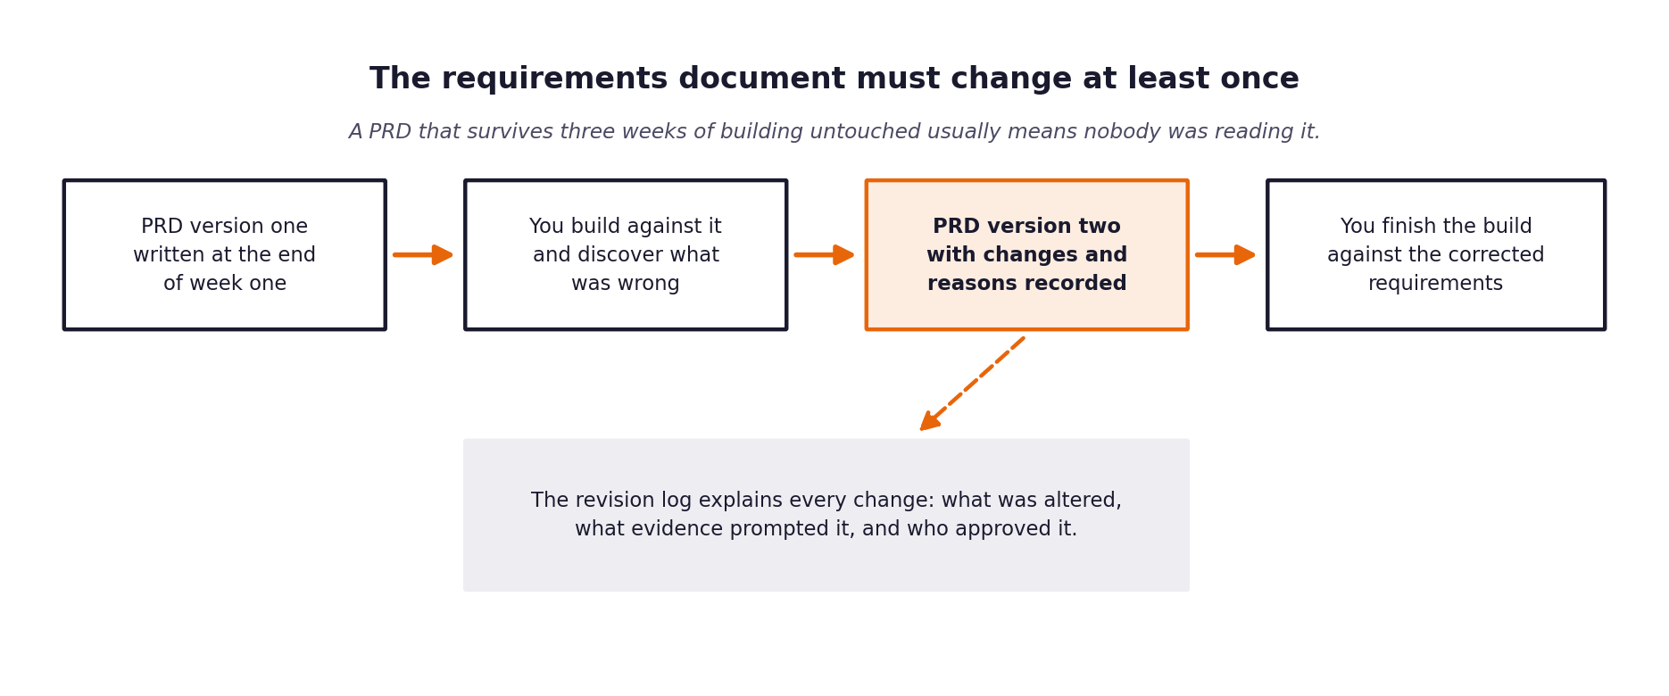
Figure 1. The requirements document is expected to change once building starts.

1 Document control
Field | Value
Version | 2.0 (revised after the build and again after evaluation; see the Stage 5 revision log)
Written by | Amlan Acharya
Date | October 31, 2026
Status | Final for submission
Approved by | Not formally approved: individual project, reviewed by the author only

2 The problem in one paragraph
Copy across the paragraph you wrote at the end of your discovery workbook. If you find yourself wanting to improve it as you copy, go back and improve it in the workbook first, so that the two do not drift apart.
Problem statement
CloudServe customer support operations suffer from an artificially depressed First-Contact Resolution rate of 42% (target 65%) and an mean resolution time of about 7.0 hours, driven not by lack of documentation but by vocabulary mismatch that blinds keyword search, and an unstructured escalation pipeline that forces senior engineers to repeat basic discovery on routine tickets. The solution requires a decoupled modular monolith combining multi-channel ingestion, dense semantic retrieval over 29 curated articles, independent dual-gate routing (confidence >= 0.75, similarity >= 0.65), citation-grounded answer generation, active guardrail blocking, and enriched escalation packaging.

3 Who this is for
Describe each group of users separately. A requirement that serves everybody usually serves nobody particularly well.
User group | What they need from this system | What they currently do instead | How you will know it worked for them
Customers raising tickets | Instant, accurate, citation-backed answers for routine operational questions; rapid human handoff for critical downtime. | Wait in generic queues for 4 to 18 hours or repeatedly re-submit tickets. | FCR uplift to >= 65%, P95 latency <= 3s on auto-responses, and CSAT >= 4.2.
Tier one support agents | Automated deflection of routine repeat tickets (API keys, lockouts, rollbacks) so they can focus on complex customer inquiries. | Manually search fragmented wikis while racing 10-minute queue SLA clocks. | Ticket volume deflected by 65%+ and handle time reduced by 50%.
Tier two and specialist engineers | Enriched escalation packets containing inferred intent, confidence, failed gate reasons, and top candidate documentation links. | Receive blank 'needs help' tickets and repeat basic discovery questions. | Zero repeat discovery required; preventable escalations reduced by 50%.
Head of Support (Marcus) | Measurable FCR uplift, compliant append-only decision logging, and zero-tolerance brand safety protection. | Manually spot-checks tickets and defends poor SLA numbers to executive leadership. | Automated daily metrics reports (FCR, latency, ECE) and 100% audit reconciliation.
Security and compliance reviewers | Evidence that nothing sensitive is answered automatically and that every decision can be reconstructed. | Review a sample of tickets by hand. | Zero must-not tickets answered automatically; every ticket has an audit record.

4 Functional requirements
Each requirement gets an identifier, a statement, a priority and a link back to the discovery evidence that produced it. The identifiers matter because your specifications, your prompts and your test cases will all refer to them.
Use the priority scale consistently. Must means the system is not acceptable without it. Should means it is expected but could be deferred with a stated consequence. Could means it would add value if time allows. Will not means it has been considered and deliberately excluded, and recording those is as useful as recording the rest.
ID | Requirement | Priority | Discovery evidence | Acceptance criteria
FR-01 | The system shall normalise tickets from email, chat, forum and docs-comment channels into one record and redact card numbers, API keys, emails, phone numbers and tokens before any model sees them. | Must | Channels differ in field names (data); a wrong or leaked value is the main fear (Marcus). | A2: all four channels parse; redaction tests pass for each pattern.
FR-02 | The system shall classify each ticket's intent (the dataset's labels; the build lists 21 of the 22, see the Stage 5 log) and urgency with a confidence between 0 and 1, and flag must-not-automate tickets by rule. | Must | Interviews on routing; labels.must_not_auto_respond (17.4%). | A3: output has intent, alternatives, urgency, confidence; veto tests pass.
FR-03 | The system shall retrieve passages from the 29-article knowledge base by semantic similarity. | Must | 71.4% of tickets are answerable; keyword search fails on vocabulary (Sofia, Ines). | A4: indexed passages within 70 to 90; top-3 retrieval precision measured.
FR-04 | The system shall answer automatically only if confidence is at least 0.75, similarity is at least the floor, urgency is not critical and the safety veto is not set; the scores are never blended. | Must | Composite score masked misclassification (revision log). | A5: routing unit tests; floor and thresholds are configurable.
FR-05 | The system shall draft answers only from retrieved passages, with ticket text sandboxed and a [DOC-ID] citation on every claim. | Must | Customers need cited, grounded answers (Marcus, Daniel). | A6: every released answer cites a retrieved document.
FR-06 | The system shall suppress a draft and escalate if it contains personal data, cites a document that was not retrieved, or has a sentence unsupported by the retrieved text. | Must | Wrong answers cost trust; Marcus would rather say nothing. | A7: guardrail tests for each failure type.
FR-07 | The system shall attach to every escalation the intent, confidence, urgency, the failed gate and the top two candidate articles. | Must | Tier two receives blank tickets (Daniel). | Escalation packet present on every escalated record.
FR-08 | The system shall write every decision to an append-only SQLite log that rejects UPDATE and DELETE. | Must | Compliance review needs explainability. | A8: a tamper attempt is aborted; the log reconciles with the processed tickets.

5 Non-functional requirements
These describe how well the system must do the things it does. They are frequently what distinguishes a demonstration from something that could actually be deployed.
ID | Category | Requirement | How it will be verified
NFR-01 | Latency | The 95th percentile latency shall be at most 3 s for automatic answers and 500 ms for escalations. | Measured by the evaluation harness (latency percentiles). Not met: P95 6.5 to 6.7 s (report Section 7.10).
NFR-02 | Availability | Every graph node shall be wrapped so a failure becomes a logged escalation, and provider failure shall fall through a three-tier cascade. | A11: failure-injection tests; zero unhandled crashes in every run.
NFR-03 | Accuracy | Intent confidence shall be calibrated: expected calibration error at most 0.15. | Computed with 10 bins in evaluation/metrics.py (0.093 to 0.108 on validation).
NFR-04 | Privacy | No personal data shall reach a model or a reply. | Redaction tests, an output scan, and a demo ticket with a card and a key.
NFR-05 | Auditability | The decision log shall be append-only and every processed ticket shall have a record. | Trigger test; reconciliation of processed tickets with log rows.
NFR-06 | Fairness | Outcomes shall be reported by language fluency and customer tier. | Planned fairness measure; not completed on the development set (stated in the report).
NFR-07 | Cost | A run shall stay within a configurable spend cap. | MAX_SPEND_USD aborts a run; the 500-ticket benchmark cost about 13 cents.

6 What is deliberately out of scope
Recording what you are not building is one of the most valuable things a requirements document does, because it is the section that prevents an argument in week three.
Not building | Why not | What would have to change for this to be reconsidered
Sending replies to customers without a person deciding on sensitive tickets | Wrong answers are the main fear, and the label ceiling shows many tickets need a person. | A human-review step and evidence that must-not answers stay at zero.
A trained intent classifier | The v1 build used one and benefited from near-duplicate bodies in the development data. | A hidden set that is independent of the training data.
Live queue management | There is no queue to integrate with, so the priority score has no queue position. | Access to the ticketing system.
Languages other than English | The knowledge base and tickets are English. | A multilingual knowledge base and labelled tickets.
A new definition of first-contact resolution | The target was set on the client's definition; changing it would hide the gap. | The client agreeing to a different definition.

7 Assumptions and their consequences
Every assumption you are making is a place where this document could turn out to be wrong. Listing them now is what makes the revision in stage five a considered update rather than a scramble.
Assumption | Why you believe it | What happens if it is false | How you will find out
The documentation already answers most tickets. | Interview with Ines; 71.4% answerable (data). | The case for retrieval falls apart. | Held: labels.answerable_from_docs.
The specified thresholds (0.75 and 0.65) will release enough tickets. | They came with the specification. | FCR stays far below target. | Did not hold: first run gave 7.5% FCR; similarity floor lowered to 0.40.
Free-tier providers are enough for evaluation. | Zero cost. | Runs are slowed or lose tickets to the offline tier. | Did not hold: a daily token cap sent 50 of 80 tickets offline.
The labels are a fair measure of correct behaviour. | They were supplied with the data. | Results measure the labels, not customers. | Partly checked: spot checks only; released answers were not graded against reference responses.
Validation results generalise to unseen tickets. | Separate file. | Reported figures are optimistic. | Did not hold: I tuned after seeing validation results; the hidden set has not been run.
Calibrated confidence separates easy from hard tickets. | Interviews suggested hard tickets are rare. | The confidence gate adds nothing. | Held: ECE 0.093 to 0.108.

8 Success measures
State the measures this system will be judged on, with the baseline and the target for each, and say who is accountable for reporting them.
Measure | Baseline | Target | Measured how | Reported by
First contact resolution | 42% (data: 43.8%) | 65% | Share of tickets with final disposition AUTO_RESOLVED (evaluation/metrics.py) | The evaluation harness
Time to first reply | 8 to 12 hours | P95 at most 3 s for automatic answers; 500 ms for escalations | Latency percentiles from the decision log | The evaluation harness
Customer satisfaction | 3.2 / 5 (data: 2.97) | At least 4.2 | Not measurable offline; needs live CSAT | Support leadership after launch
Escalation rate | 56.2% | No higher than the share labelled escalate (37.8%) | Share of tickets escalated by router, guardrail or error | The evaluation harness
Expected calibration error | Not measured | At most 0.15 | 10-bin ECE on intent confidence | The evaluation harness
Must-not tickets answered automatically | Not measured | 0 | Count of must_not_auto_respond tickets with disposition AUTO_RESOLVED | The evaluation harness
Wrong answers among those sent | Not measured | As low as possible | Answered tickets whose label says escalate | The evaluation harness

9 Open questions
The things you do not yet know. Each one needs an owner and a date by which it will be resolved, otherwise it will still be open in week three.
Question | Why it matters | Owner | Resolve by
Does the system hold up on the hidden evaluation set? | All tuning used development and validation data. | Author | Before the final submission
Who reviews replies in assisted mode? | That mode answers more tickets but also some that need a person (5 of 87 must-not tickets on development). | Head of Support | Before any deployment
Can a dedicated or self-hosted model meet the 3-second budget? | Measured P95 is 6.5 to 6.7 s on a shared provider. | Author | Before any deployment
Who owns keeping the 29 articles current? | Stale articles become cited wrong answers. | Technical writer | Before any deployment
Should FCR be reported as automatic resolution only, or with assisted replies counted? | The figure depends on the definition. | Head of Support | Before reporting to leadership

The review before you move on
Read your finished PRD and ask, for each requirement in turn, whether an engineer who had not attended any of your interviews could build it from what is written. Where the answer is no, the requirement is not finished. This check takes twenty minutes and it is the single highest-value thing you can do at the end of week one.

