FORWARD DEPLOYED AI ENGINEERING
Capstone Project
Stage Four: Sprint Plan
Deciding who does what, in what order, and what finished means
A plan is not a list of tasks. It is a statement of sequence, ownership and
completion that the team has actually agreed to.
WEEK TWO · DAY ONE

How to plan three weeks of work
You have already lost a third of the project to discovery and requirements, which is as it should be. What remains has to be sequenced carefully, because several parts of the build depend on others and the dependencies are not always obvious until you hit them.
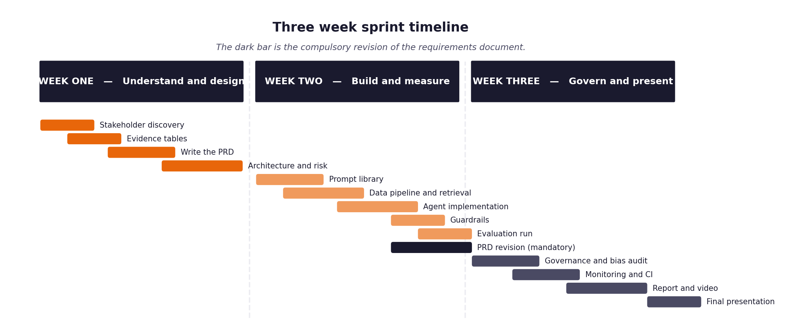
Figure 1. The shape of the three weeks, including the compulsory requirements revision.
Three rules that make the difference
- Every item has an estimate in hours and a priority. When you run short of time, and you will, the priority column is what decides for you rather than whatever felt urgent that morning.
- Every item has a definition of done written before work starts. Written afterwards, it describes whatever happened to be produced.
- The retrieval layer and the evaluation harness come early, not late. Almost everything else depends on one or the other, and leaving the harness until the end means discovering your results too late to act on them.
- The full unattended run over the hidden evaluation set happens in week two, not week three. It is the gate the project turns on, and it always exposes problems that never appear when you are testing one ticket at a time.

1 Section one: your capacity
Before you plan anything, work out honestly how much time you actually have. Plans built on optimistic capacity fail in week two rather than week three, which is worse, because by then you have committed to an architecture that assumed the time existed.
Week | Hours realistically available | Other commitments that week | Days you cannot work
Week One | Not planned in advance; 8.5 hours actually worked (22 and 23 October) | Discovery, requirements, prompts and a first build (v1 repository) | Not recorded
Week Two | Not planned in advance; 12 hours actually worked (31 October and 2 November) | Second implementation, test suite (132 tests by 31 October), dashboard | Not recorded
Week Three | Not planned in advance; 26.5 hours actually worked (8 to 14 November) | Evaluation runs, tuning, report, videos, final package (150 tests at the end) | Not recorded

On working alone
Working individually removes the coordination overhead and replaces it with a different problem: nobody will notice when you have been stuck for six hours. Set yourself a rule that anything blocking you for more than an hour gets written down and either escalated or worked around, and check that list at the end of each day.

2 Section two: the backlog
List every item of work. Estimate in hours rather than in vague sizes, because hours can be compared against the capacity you recorded above. Mark dependencies explicitly, because the order matters more when there is only one of you.
ID | Item | Est. hours | Priority | Depends on | Definition of done
B-01 | Environment and dependency setup | Not itemised | Must | None | Clean checkout installs and runs (A1).
B-02 | Data loading and normalisation | Not itemised | Must | B-01 | Four channels normalise; redaction tests pass (A2).
B-03 | Document chunking and embedding | Not itemised | Must | B-02 | 29 articles chunked into 87 passages (A4).
B-04 | Vector store and retrieval | Not itemised | Must | B-03 | Top passages returned with similarity scores (A4).
B-05 | Evaluation harness | Not itemised | Must | B-02 | Batch CLI runs unattended and writes a metrics report (A9, A10).
B-06 | Intent and urgency classifier | Not itemised | Must | B-02 | Intent, alternatives, urgency and confidence returned (A3).
B-07 | Routing logic and thresholds | Not itemised | Must | B-06 | Dual-gate router and escalation packet pass unit tests (A5).
B-08 | Answer generation with citations | Not itemised | Must | B-04 | Every claim cites a retrieved document (A6).
B-09 | Guardrails and validation | Not itemised | Must | B-08 | Unsupported drafts are suppressed and escalated (A7).
B-10 | Decision logging | Not itemised | Must | B-07 | Append-only log reconciles with processed tickets (A8).
B-11 | First full unattended run over the hidden evaluation set (THE GATE) | Not itemised | Must | B-05, B-09 | Run over the validation set with metrics. The hidden set has not been run.
B-12 | Monitoring and dashboards | Not itemised | Should | B-10 | Dashboard shows scenarios, decision log and a tamper test.
B-13 | Continuous integration pipeline | Not itemised | Should | B-11 | Tests run on every push (A12).
B-14 | Fairness audit | Not itemised | Should | B-11 | Not completed on the development set; stated in the report.
B-15 | Report, video and submission package | Not itemised | Must | all | PDF report, two videos, workbooks, source.

3 Section three: the week two plan in detail
Day | What will be finished by the end of the day | Hours | Risk to this
Sat 31 Oct | Second implementation and unit tests (6.5 h), code-review follow-ups to 132 tests (2.5 h) | 9.0 | Pydantic and ChromaDB conflict, resolved with a shim
Mon 2 Nov | Dashboard control plane with six scenarios and a tamper test | 3.0 | Estimated from one commit

4 Section four: the week three plan in detail
Day | What will be finished by the end of the day | Hours | Risk to this
Sun 8 Nov | Validation re-run (7.5% FCR), tuning, corrected report | 3.5 | Daily token cap on the provider
Mon 9 to Thu 12 Nov | Economy cascade, 500-ticket benchmark, floor and retry ablations | 10.0 | Provider rate limits; retry raised must-not answers
Fri 13 Nov | Customer envelope, key-length fix, OpenRouter re-run, voiced videos | 12.5 | A background run that called the wrong provider
Sat 14 Nov | Cleanup and final package | 1.5 | None recorded

5 Section five: what you will drop if you run out of time
You will run out of time. Every student does. Deciding now what gets cut is far better than deciding in a panic on the final Wednesday, and it protects the parts that carry the most marks.
Item | Cut order | Consequence of cutting it | What you will say about it in the report
Fairness audit (B-14) | 1st to go | Outcomes by fluency and tier are not tested on the system's decisions. | The audit was not completed on the development set and the report says so.
Grading released answers against reference responses | 2nd to go | Answer content is checked only by the guardrail, not by a person or reference text. | Stated as a limit in the report.
Hidden-set run (B-11 final gate) | 3rd to go | Reported figures are from tuned data and are optimistic. | Stated as the single most important caveat.

6 Section six: the daily check-in record
Ten minutes at the start of each day, answering the same three questions. Keeping this record is what makes your effort log accurate rather than reconstructed, and it is where you will notice a blocker that has quietly consumed two days.
Date | Finished since yesterday | Doing today | Blocked by
Fri 23 Oct | v1 repository, baseline on the real tickets | Live provider path | Provider key returned HTTP 401
Sat 31 Oct | Second implementation and code-review follow-ups | Dashboard | Dependency conflict
Mon 2 Nov | Dashboard control plane | Validation re-run | None recorded
Sun 8 Nov | Re-measured validation, tuned, corrected report | 500-ticket benchmark | Daily token cap
Mon 9 Nov | Economy cascade and 500-ticket benchmark | Floor ablation | Free-tier rate limits
Wed 11 Nov | Floor ablation and report figures | Regenerate-on-failure | Run-to-run variation
Thu 12 Nov | Regenerate-on-failure runs | Colleague spec and videos | Must-not answers rose with retry
Fri 13 Nov | Features, key fix, OpenRouter re-run, voiced videos | Cleanup | Background run on the wrong provider
Sat 14 Nov | Cleanup, effort log and workbooks | Submission | None recorded

