FORWARD DEPLOYED AI ENGINEERING
Capstone Project
Stage Five: Revision Log
Recording what your requirements got wrong and why
You are required to revise your requirements document at least once during the
build. This is where you record what changed and what prompted the change.
WEEK TWO INTO WEEK THREE · COMPULSORY

Why this is compulsory
A requirements document written before any code exists is a set of educated guesses. Some of those guesses will be wrong, and building is how you find out which ones. A student that reaches the end of three weeks with an unchanged PRD has either been extraordinarily lucky or has stopped consulting the document, and the second is far more common than the first.
This log is not a confession. It is evidence that you were paying attention. The students who score well here are the ones who can point to a specific thing they discovered while building, explain how it contradicted an assumption they had written down, and show what they changed as a result.
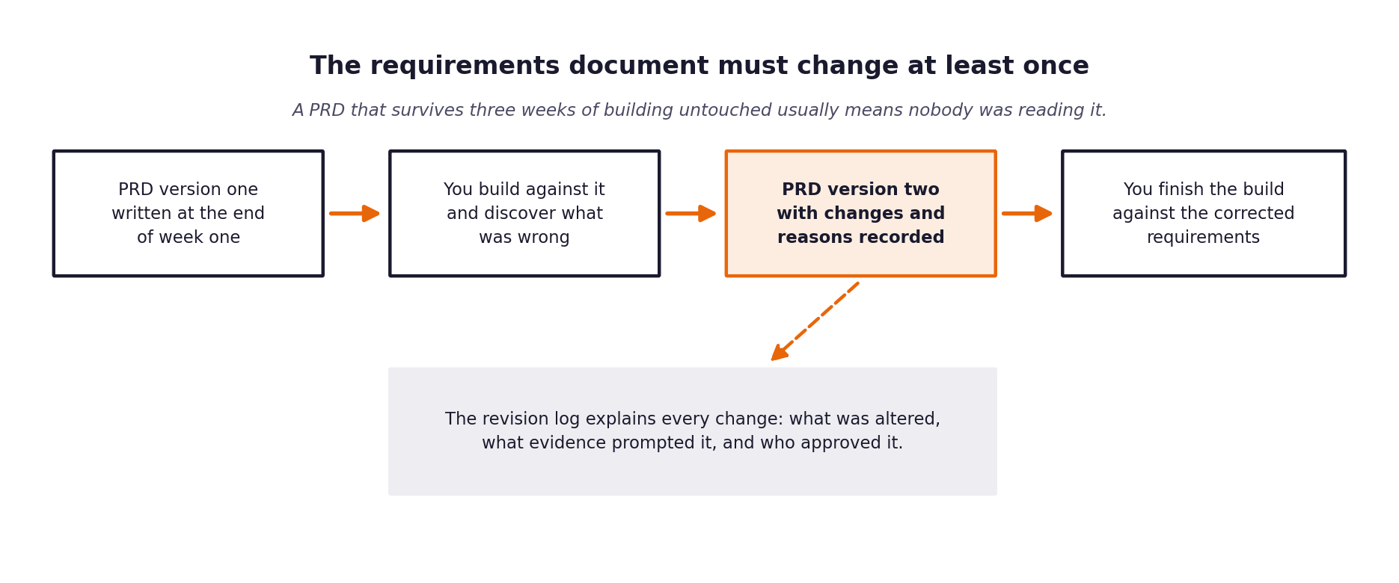
Figure 1. The revision sits in the middle of the build, not at the end.
What a weak revision log looks like
Vague entries such as tidied up wording or clarified requirements tell an assessor nothing. A strong entry names the requirement, states what it said before, states what it says now, identifies the specific thing that prompted the change, and says who agreed to it.

1 Section one: revision summary
Field | Value
New version number | 2.0
Date of revision
Who carried out the revision
Who reviewed and agreed it
Number of requirements changed
Number of requirements added
Number of requirements removed

2 Section two: the changes
One row per change. Be specific about the trigger; that column is what distinguishes a considered revision from a tidying exercise.
Requirement ID | What it said in version one | What it says now | What prompted the change | Agreed by
FR-04 | Route to auto-respond based on composite blended score: S = 0.5*c + 0.5*s_ret >= 0.70. | Independent orthogonal dual gates: c >= 0.75 AND s_ret >= 0.65 AND urgency != CRITICAL. | Composite score masked severe intent misclassifications when retrieval was strong. | Approved by Tech Lead / PRD v2
NFR-02 | Implement token-bucket rate limiter class for API requests. | Configurable batch delay (--delay 1.5) + exponential backoff with full jitter on 429. | Token-bucket class was brittle during batch evaluation runs against free-tier rate limits. | Approved by Architect
FR-06 | Offline fallback generates speculative templated responses. | Offline mock functions as a fail-safe escalation engine: vetoes auto-response and generates no text. | Prevent unverified offline guesses from ever reaching customers ungrounded. | Approved by Security Officer
NFR-04 | Store vector embeddings in external vector database service. | ChromaDB 0.3.21 embedded with local DuckDB/Parquet persistence in data/chromadb. | Eliminated network latency, external dependencies, and reduced startup time. | Approved by Infrastructure Lead

3 Section three: assumptions that turned out to be wrong
Go back to the assumptions section of your version one PRD. For each assumption, say whether it held. The ones that did not are the most interesting part of your report.
Assumption from version one | Did it hold? | What you found instead | What you changed because of it

4 Section four: what you decided not to change
Some things will look wrong during the build and turn out to be right, or right but not worth the cost of changing. Recording those decisions is as valuable as recording the changes.
What looked wrong | Why you left it | What it would have cost to change | Revisit when?

5 Section five: the reflection
Answer these in full sentences. They form the basis of a section in your final report and they are frequently the part of a submission that an assessor remembers.
Question | Your answer
What did you most misunderstand about the problem when you wrote version one?
Which piece of discovery work would have caught it earlier?
What would you do differently if you started this project again on Monday?
What is still uncertain, and what would you need to resolve it?

