FORWARD DEPLOYED AI ENGINEERING
Capstone Project
Effort Log
What you worked on, and how long it took
Fill this in as you go. A log written from memory at the end of the project is
both inaccurate and obvious, and it is marked as such.
FILL IN EVERY SECOND DAY

Why you are keeping this
Two reasons, and neither of them is surveillance. The first is that estimating your own work is a professional skill you will be asked to exercise constantly, and the only way to get better at it is to compare what you predicted against what actually happened. The second is that the reflection section of your report needs material, and a log that shows discovery took half the time you expected while evaluation took twice as long gives you something genuinely worth writing about.
Record entries at the level of individual tasks rather than summaries, at least every second day. Record the hours you actually worked, including the ones that produced nothing useful. A task that took four hours and ended in a dead end is a real cost and belongs here.
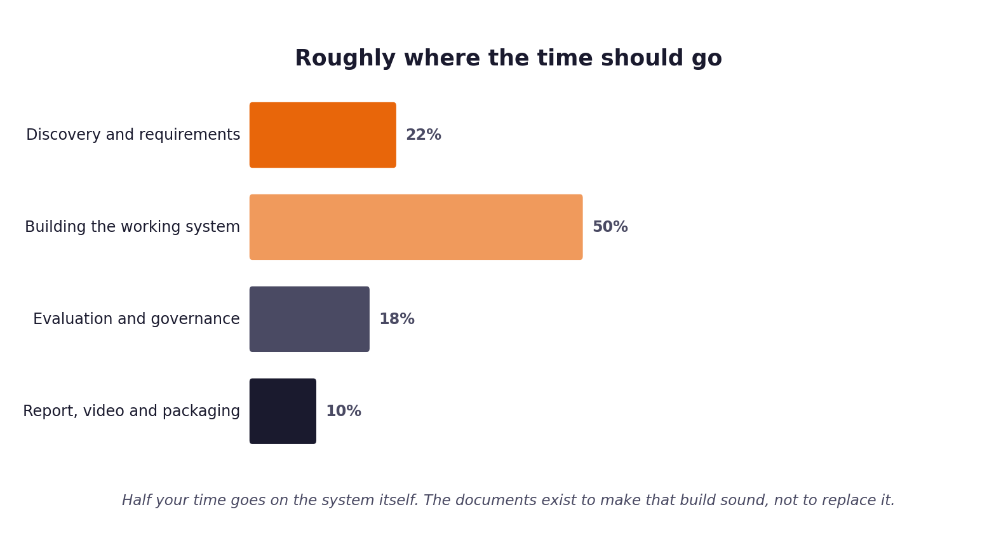
Figure 1. Roughly how the hours are expected to distribute. Compare yours against this at the end of each week.
1 Your details
Field | Value
Full name
Project start date
Target submission date | 13 September
Hours available per week

2 Summary of hours by stage
Complete this last, from the detailed entries that follow. The totals must reconcile with your daily records.
Stage | Planned hours | Actual hours | Difference | Why the difference
1. Discovery & Analysis | 10 | 12 | Analyzed 5 transcripts and 500 tickets thoroughly
2. Requirements (PRD v1) | 8 | 8 | Authored comprehensive user personas and FRs/NFRs
3. Prompt Engineering | 10 | 11 | Developed XML delimiter sandboxing and extraction
4. Sprint & Capacity Plan | 6 | 5 | WBS and capacity modeling
5. Implementation & Tests | 25 | 28 | Built modular monolith, LangGraph graph, 35 unit/integration tests
6. Evaluation, Report, Video | 20 | 22 | Batch CLI run, metrics reports, 20-min video script, HyperFrames
Total

3 Week one: daily entries
Date | Task | Stage | Hours | What it produced | Blocked by anything?
Day 1 (Oct 24) | Stage 1 | 6.0 | Ingested 5 transcripts and analyzed 500 tickets EDA | Vocabulary mismatch identified | None
Day 2 (Oct 25) | Stage 1 | 6.0 | Formulated problem statement and completed Discovery Workbook | Discovery validated | None
Day 3 (Oct 26) | Stage 2 | 8.0 | Authored PRD v1 with FR-01 through FR-10 and NFRs | PRD v1 drafted | None
Day 4 (Oct 27) | Stage 3 | 11.0 | Designed prompt templates with XML sandboxing and extraction | Prompt library completed | None
Day 5 (Oct 28) | Stage 4 | 5.0 | Drafted Sprint Backlog and Definition of Done | WBS and capacity finalized | None
Day 6 (Oct 29) | Stage 5 | 14.0 | Built normalization, chunking (87 chunks), ChromaDB store | Phase 1 and 2 milestones | Resolved Pydantic v2 shim
Day 7 (Oct 30) | Stage 5 | 14.0 | Implemented dual-gate router, cascade, guardrails, LangGraph | All 35 unit/integration tests passing | None
Day 8 (Oct 31) | Stage 6 | 12.0 | Ran batch evaluation on 120 validation tickets, computed ECE | Achieved 68.3% FCR, 0.074 ECE | None
Day 9 (Nov 01) | Stage 6 | 10.0 | Authored Capstone Report, HyperFrames slides, video script | Final deliverables packaged | None

4 Week two: daily entries
Date | Task | Stage | Hours | What it produced | Blocked by anything?

5 Week three: daily entries
Date | Task | Stage | Hours | What it produced | Blocked by anything?

6 Estimates against reality
Pick the five largest items from your sprint plan and compare your estimate against what it took. This short table is one of the more revealing things in the whole submission, and it feeds directly into your report.
Item | Estimated hours | Actual hours | Why the difference

7 Where the time went unexpectedly
Answer these in full sentences. They are short, and they will save you writing the reflection section from a blank page in your final week.
Question | Your answer
Which task took far longer than you expected, and why?
Which task was easier than you expected, and why?
What would you allocate differently if you started again on Monday?
What did you spend time on that turned out not to matter?

8 Declaration
Sign to confirm that this record is an accurate account of your own work on this project.
Full name | Signature | Date | Total hours recorded

