**Bootstrap day 2 Assignment**

**Name : Amlan Patra**

**Emp ID : 16891**

**Main Page :**

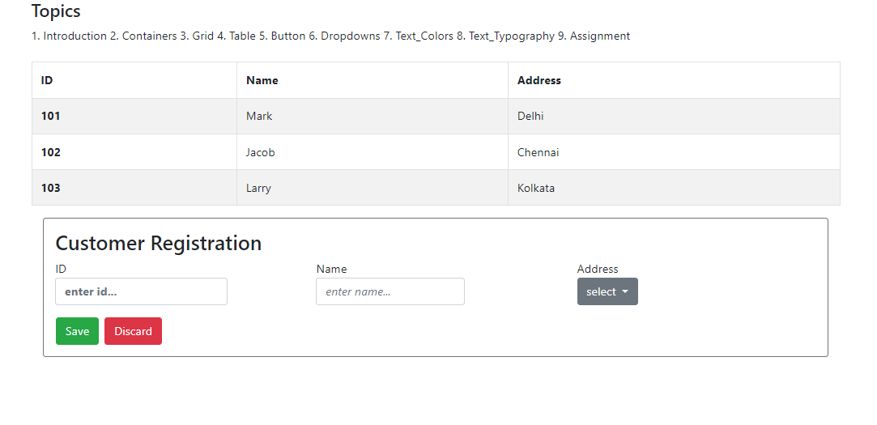

**Utilities used : tables, grid, container, button, dropdown**

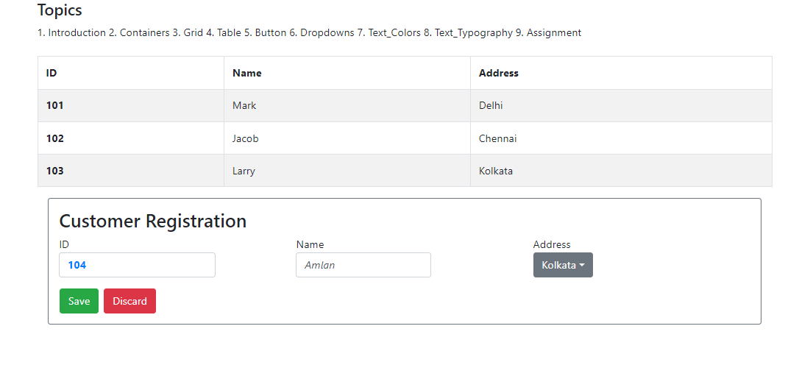

**Utilities used : text colors, typography**

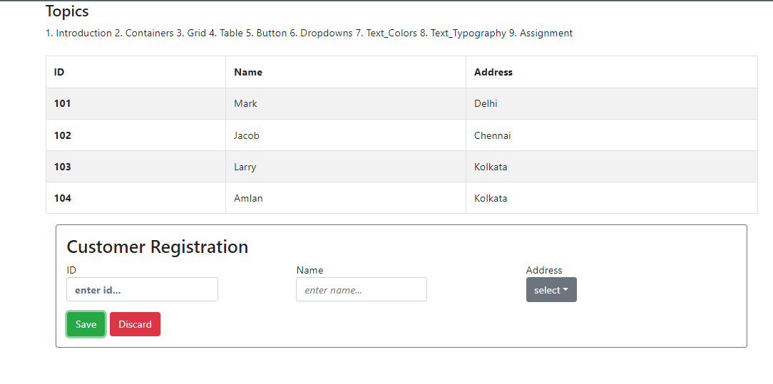

**Finally adding to table data**