**STOCK MARKET POSITION SIZING APP**

A Project Report

Submitted By

AMLAN PATRA (17700119020)

MONIDEEPA BHUNIA (17700119009)

TANIMA GARAI (17700119022)

In partial fulfilment for the award of the degree

of

BACHELOR OF TECHNOLOGY

IN

COMPUTER SCIENCE AND ENGINEERING

from

**MAULANA ABUL KALAM AZAD UNIVERSITY OF TECHNOLOGY**

Project carried out under the guidance of

**MR. ARIJIT CHATTARAJ**

Assistant Professor, CSE Department



CALCUTTA INSTITUTE OF TECHNOLOGY

ULUBERIA, HOWRAH

Affiliated to MAKAUT

ACKNOWLEDGEMENT

It is a great privilege for us to express our profound and sincere gratitude to our revered teacher **Mr. Arijit Chattaraj** , Assistant Professor , Computer Science and Engineering , Calcutta Institute of Technology for his valuable suggestions, constant supervision and inspiration throughout the course of our work, without which it would have been difficult to pursue this project report. We would also like to express our cordial thanks to our Teacher In Charge , **Dr. Satrughna Singha**. We also take the opportunity to extend our gratitude to all our Professors whose knowledge and untiring efforts during our B.Tech course have immensely helped us to complete the project successful. Lastly, we would like to express a word of apology to the readers who may come across some errors that may have crept in unconsciously due to rush of work.

AMLAN PATRA (17700119020)

MONIDEEPA BHUNIA (17700119009)

TANIMA GARAI (17700119022)

**RECOMMENDATION**

I hereby recommend that the project report entitled ‘Stock market position Sizing App’ be accepted in partially fulfilment Requirements for the Degree of B.Tech from the department Computer Science And Engineering , Calcutta Institute of Technology .

Date :

Place :

__________________________

Asst. Prof. Mr. Arijit Chattaraj

(Project Guide)

Department of CSE

Calcutta Institute of Technology

CERTIFICATE OF APPROVAL

The project report entitled ‘STOCK MARKET POSITION SIZING APP’ is hereby approved and certified as a creditable study of technological subject carried out and presented in a manner satisfactory to warrant its acceptance as a requisite to the Degree of B.Tech in Computer Science And Engineering for which it has been submitted. It is understood by the approval that the undersigned does not necessarily endorse or approve any statement made, opinion expressed or conclusion drawn therein, but approve the report only for the purpose for which it has been submitted.

_________________________ _______________________

Prof. Dr. Krishnendu Pramanik Dr. Satrughna Singha

(Principal-In-Charge) (TIC and Asst. Professor)

Calcutta Institute of Technology Department of CSE Calcutta Institute of Technology

________________________

Asst. Prof. Mr. Arijit Chattaraj

(Project Guide)

Department of CSE

Calcutta Institute of Technology

INDEX

|  |  |  |
| --- | --- | --- |
| SL No. | TOPIC | PAGE NO. |
| 1. | Introduction | 6 |
| 2. | Abstract | 7 |
| 3. | Advantages and disadvantages | 7 |
| 3.1. | Advantages | 7 |
| 3.2. | Disadvantages | 9 |
| 4. | Successful and unsuccessful investors | 11 |
| 5. | Project key terms | 14 |
| 6. | Project Description | 25 |
| 7. | Installation and Usage | 26 |
| 8. | Getting started | 27 |
| 9. | Project Analysis | 28 |
| 10. | Data handling and flow | 30 |
| 11. | Data flow and UI | 30 |
| 12. | Conclusion and future reference | 31 |
| 13. | Reference and bibliography | 35 |

(PROJECT CODE LINK : <https://github.com/amlanpatra/stock-quantity-calculator>)

1. **INTRODUCTION:**
   1. What is stock market?

The term stock market refers to several exchanges in which shares of publicly held companies are bought and sold. Such financial activities are conducted through formal exchanges and via over-the-counter(OTC) marketplaces that operate under a defined set of regulations.

Both “stock market” and “stock exchange” are often used interchangeably. Traders in the stock market buy or sell shares on one or more of the stock

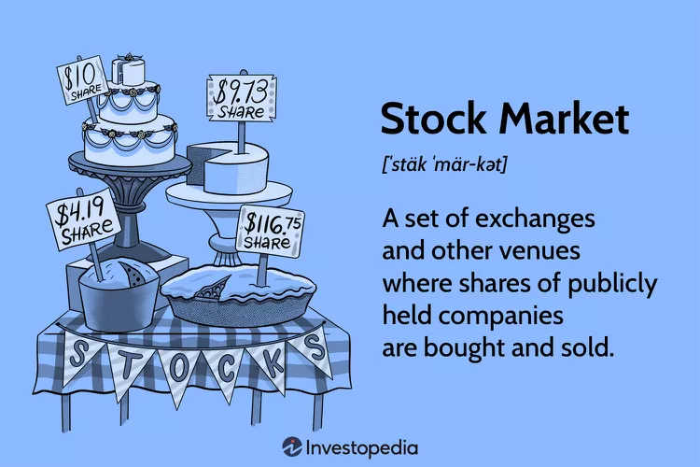

1. **ABSTRACT :**

The advent of WWW has enabled people to get connected with each other effectively. As a result, everyone can find opportunities if increase their wealth through online trading or investing platforms and can take decisions with the click of a button. As a result, huge number of people take trades in a hope to gain profit, but the market is always supreme and people loses their financial edge. This project aims to minimise the risk involved in any trade by taking in account the current brokerage amount, the current break even point, the margin required and the maximum loss that the individual can take. This approach helps in minimising the loss in great extent and extending the longevity of investing career.

1. ADVANTAGES AND DISADVANTAGES
   1. DOMAIN ADVANTAGES :

1. Gain received : The ability of the market to generate the kinds of gains it does is the most essential component of investing directly in markets.

Stock markets have always stood the test of time, rising in value over time, even though individual stock values fluctuate daily, according to historical data.

2. Safety against Inflation : The fundamental goal of investments is to guarantee our future, but we must keep track of inflation regularly. The gains will be nil if inflation and the rate of return on investments are comparable. In an ideal world, the rate of return on investments would be higher than inflation

1. Liquidity or Ease of Conversion: Stocks are considered liquid assets since they can be easily converted to cash and have a large number of purchasers at any given time. The same cannot be said for all assets; some, such as real estate, are difficult to sell. It could take months to see a return on your home investment. It is, however, much simpler in the case of stocks.

4. Potential for Higher Returns: Historically, the stock market has generated higher returns compared to other investment options such as bonds or savings accounts. Investing in well-performing stocks can lead to significant capital appreciation over the long term.

5. Diversification: The stock market allows investors to diversify their portfolios by investing in a wide range of companies across various industries and sectors. This diversification helps reduce the risk associated with investing in a single company or industry.

6. Liquidity: The stock market is highly liquid, meaning investors can easily buy and sell stocks at market prices. This provides flexibility and allows investors to convert their investments into cash relatively quickly, providing access to funds when needed.

7. Ownership and Voting Rights: When you invest in stocks, you become a partial owner of the company. This ownership comes with certain rights, such as voting on company matters and receiving dividends when the company distributes profits.

8. Income Generation: Some stocks pay dividends to their shareholders. Dividends are a portion of the company's earnings distributed to shareholders as a return on their investment. This can provide a steady stream of income, especially for long-term investors.

9. Hedge Against Inflation: Investing in the stock market can be a hedge against inflation. Over time, as the prices of goods and services rise due to inflation, the value of stocks may also increase, helping to preserve purchasing power.

10. Accessibility: The stock market is accessible to a wide range of investors. With the advent of online trading platforms and brokerage accounts, anyone with an internet connection can start investing in stocks with relatively low capital requirements.

11. Long-Term Growth Potential: Investing in the stock market is often considered a long-term strategy. Over extended periods, the stock market has shown a general upward trend, despite shorter-term fluctuations. Patient investors who hold their investments over time may benefit from this long-term growth potential.

* 1. DOMAIN DISADVANTAGES:

1. Market fluctuations : your business may become vulnerable to market fluctuations beyond your control - including market sentiment, economic conditions or developments in your sector.
2. Cost : The costs of flotation can be substantial and there are also ongoing costs of being a public company, such as higher professional fees.
3. Responsibilities to shareholders : In return for their capital, you will have to consider shareholders' interests when running the company - which may differ from your own objectives. Public companies must comply with a wide range of additional regulatory requirements and meet accepted standards of corporate governance including transparency, and needing to make announcements about new developments. While stock market investing can offer various benefits, it also comes with certain disadvantages. Here are some common disadvantages to consider:
4. Volatility: The stock market can be highly volatile, with prices fluctuating rapidly. This volatility can lead to significant short-term losses or gains. Sudden market downturns can result in substantial portfolio declines, which may be unsettling for some investors.
5. Risk of Loss: Investing in stocks involves a risk of losing money. Companies can fail, economic conditions can worsen, or unforeseen events can negatively impact stock prices. Investors can potentially lose some or all of their invested capital.
6. Emotional Stress: The stock market can be emotionally challenging, particularly for individual investors. Market fluctuations and financial losses can lead to stress, anxiety, and emotional decision-making, which can harm investment performance.

. Time and Effort: Successful stock market investing requires time, research, and effort. Investors need to thoroughly analyze companies, review financial statements, follow market trends, and stay informed about relevant news. This can be time-consuming and may not be suitable for individuals with limited availability.

. Lack of Control: As a shareholder, you have limited control over the decisions made by the company's management. Even if you believe in a company's long-term potential, its management may make choices that are detrimental to the stock's performance.

. Transaction Costs: Buying and selling stocks can involve transaction costs, such as brokerage fees and taxes. These costs can eat into your returns, especially if you frequently trade or have a small investment portfolio.

. Information Overload: The stock market is flooded with information, news, and analysis from various sources. It can be challenging to filter through the noise and make informed investment decisions. The abundance of conflicting opinions and data can confuse investors and lead to poor choices.

. Short-Term Focus: Stock market investing often encourages a short-term mindset, where investors focus on daily or monthly fluctuations. This emphasis on short-term gains can lead to impulsive decision-making and neglecting long-term investment strategies.

. Limited Diversification: While the stock market offers diversification opportunities, investing solely in stocks can limit diversification. Relying heavily on one asset class exposes investors to the risks associated with individual companies or sectors, increasing vulnerability to market downturns.

. Regulatory and Political Risks: Regulatory changes or political events can significantly impact stock markets. New laws, regulations, or government policies can influence the performance of specific sectors or entire markets, adding an element of uncertainty for investors.

It's important to note that these disadvantages should not discourage you from investing in the stock market. While risks exist, investing in a diversified portfolio, staying informed, and maintaining a long-term perspective can help mitigate these downsides and potentially achieve favorable investment outcomes.

**4. SUCCESSFUL & UNSUCCESSFUL INVESTORS:**

**4.1 Successful investors**

According to a survey of unauthorized investors we have come to see that many investors/traders doing stock marketing have not succeeded, they have a huge loss and more than 80% of them have quitted. Though they are unauthorized investors but still large numbers of them have stated.

1. Profitable trading is difficult and successful traders share specific rare characteristics.

2. It is estimated that more that 80% of traders fail and quit.

3. One key to success is to identify strategies that win more money than they lose.

4. Many traders fail because strategies fail to adapt to changing market conditions.

1. Warren Buffett: Warren Buffett is one of the most successful investors of all time. He is the chairman and CEO of Berkshire Hathaway and has achieved remarkable returns for his investors over several decades. Buffett is known for his long-term investment approach and value investing principles.

2. Peter Lynch: Peter Lynch is a legendary investor who managed the Fidelity Magellan Fund from 1977 to 1990. Under his leadership, the fund delivered annualized returns of around 29%. Lynch is known for his "invest in what you know" philosophy, focusing on companies with strong growth prospects and a competitive advantage.

3. Benjamin Graham: Benjamin Graham is considered the father of value investing. His book "The Intelligent Investor" has been a guiding principle for many successful investors, including Warren Buffett. Graham advocated for a disciplined approach to investing, emphasizing the importance of analyzing a company's fundamentals and buying stocks at a discount to their intrinsic value.

**4.2. Unsuccessful Investor:**

1. Long-Term Capital Management (LTCM): LTCM was a hedge fund founded by Nobel laureates and renowned finance experts. However, in 1998, the fund faced significant losses and had to be bailed out to prevent a broader financial crisis. LTCM's failure was primarily due to excessive leverage and an incorrect assessment of market risks.

2. Bill Ackman's Herbalife Bet: Bill Ackman, a prominent hedge fund manager, made a highly publicized and ultimately unsuccessful bet against the nutritional supplement company Herbalife. Ackman claimed that the company was operating as a pyramid scheme and took a massive short position. However, his bet backfired as Herbalife's stock price rebounded, resulting in significant losses for Ackman's fund.

3. Dot-com Bubble Investors: During the late 1990s, the dot-com bubble witnessed a frenzy of speculative investments in internet-related companies. Many investors piled into these companies without proper analysis of their business models or profitability. When the bubble burst in 2000, numerous investors suffered substantial losses as the stock prices of these companies collapsed.

It's important to note that investing in the stock market carries inherent risks, and even successful investors have experienced failures or periods of underperformance. The examples provided highlight some notable cases but do not represent an exhaustive list of all successful or unsuccessful investors in the stock market.

**5**. PROJECT KEY TERMS

1. ENTRY PRICE :

The term "entry price" in the stock market refers to the price at which an investor or trader enters a position in a particular stock or security. It represents the price at which the investor buys or initiates a trade.

When buying a stock, the entry price is the price at which an investor purchases the shares. For example, if an investor buys 100 shares of Company XYZ at $50 per share, the entry price would be $50.

The entry price is significant because it affects the investor's potential returns and risk. If the stock price increases after the entry, the investor may realize a profit when selling the shares. Conversely, if the stock price decreases, the investor may face a loss if they decide to sell at that lower price.

It's important to note that entry price alone does not determine the success or failure of an investment. Other factors such as the company's fundamentals, market conditions, and the investor's investment strategy also play crucial roles in determining the outcome of an investment.

Importance of Entry Price:

The entry price in the stock market is crucial for investors and traders due to the following reasons:

Profit Potential: The entry price determines the starting point for an investment or trade. If the entry price is favourable, it can potentially lead to higher profits when the stock price increases. A lower entry price allows investors to buy more shares for a given investment amount, magnifying their gains if the stock performs well.

1. Risk Management: Entry price plays a significant role in managing risk. By carefully selecting an entry price, investors can set appropriate stop-loss levels and determine their risk-reward ratio. A well-planned entry price helps limit potential losses and provides a clear point at which to exit a trade if the stock price moves against expectations.
2. Investment Valuation: The entry price affects the valuation of an investment. When assessing the attractiveness of a stock, investors consider factors like the price-to-earnings ratio (P/E ratio), price-to-book ratio (P/B ratio), and other valuation metrics. A lower entry price relative to a company's fundamentals may indicate a better valuation and potential for future growth.
3. Opportunity Cost: Entry price also relates to opportunity cost. If an investor enters a stock at a high price, they may miss out on other investment opportunities with potentially better risk-reward profiles.
4. Long-term Returns: The entry price can influence long-term investment returns. Buying quality stocks at lower entry prices provides investors with a margin of safety and the potential for capital appreciation over time. Lower entry prices can also enhance dividend yields, leading to higher income from dividend-paying stocks.

2. STOP LOSS

In the stock market, a stop-loss order is an instruction given by an investor to their broker to sell a security if its price reaches a specific predetermined level. It is a risk management tool used to limit potential losses on a trade.

Let's say an investor buys shares of Company ABC at $100 per share and wants to limit their potential losses. They may set a stop-loss order with a stop price of $90. If the stock's price drops to or below $90, the stop-loss order is triggered, and the shares are sold. This helps the investor limit their potential loss to $10 per share.

Stop-loss orders are commonly used by investors and traders to manage risk and protect their capital. By having a predetermined exit point, investors can control their downside risk and prevent substantial losses in the event of an adverse price movement.

It's important to note that while stop-loss orders can help limit losses, they are not fool proof. In certain situations, such as during periods of high volatility or market gaps, the execution price of the stop-loss order may differ from the expected price due to market conditions. Additionally, stop-loss orders do not protect against all types of risks, such as systematic risks that can affect the entire market. Therefore, it's essential for investors to carefully consider their risk tolerance and use stop-loss orders in conjunction with other risk management strategies.

**FACTORS INFLUENCING STOP-LOSS :**

Several factors can influence the placement of a stop-loss order in the stock market. Here are some key considerations:

1. Risk Tolerance: Each investor has a different level of risk tolerance. Stop-loss orders can be adjusted based on an individual's risk appetite and comfort level with potential losses. Conservative investors may set tighter stop-loss levels, while more aggressive investors may allow for greater price fluctuations before triggering a stop loss.
2. Volatility: Volatility measures the degree of price fluctuations in a stock or the overall market. Highly volatile stocks may require wider stop-loss levels to accommodate the normal price swings. Less volatile stocks, on the other hand, might require tighter stop-loss levels.
3. Market Conditions: The overall market conditions and sentiment can impact the placement of stop-loss orders. During periods of heightened uncertainty, economic instability, or major news events, investors may opt for tighter stop-loss levels to mitigate potential risks.
4. Position Sizing: The size of the investment or position in a particular stock can influence the placement of stop-loss orders. A larger position may warrant tighter stop-loss levels to protect a significant amount of capital, while a smaller position may allow for wider stop-loss levels.
5. Investment Strategy: Different investment strategies have varying approaches to stop-loss placement. For example, trend-following strategies may use trailing stop-loss orders that adjust based on the stock's price movement. Contrarian strategies may set stop-loss levels based on specific signals or indicators.

3. BREAKEVEN

In the stock market, the term "breakeven" refers to the point at which an investor's position neither generates a profit nor incurs a loss. It is the price at which the investor's total cost is equal to the current market value of the investment.

To calculate the breakeven point for a stock investment, you need to consider the purchase price of the stock, any transaction fees or commissions, and any other costs associated with the investment (such as taxes). The formula to calculate the breakeven price per share is as follows:

Breakeven Price per Share = (Total Investment) / (Number of Shares)

Let's say you bought 100 shares of a stock at $50 per share, and you incurred $100 in transaction fees. The total cost of your investment would be:

Total Cost of Investment = (Purchase Price per Share * Number of Shares) + Transaction Fees Total Cost of Investment = ($50 * 100) + $100 Total Cost of Investment = $5,000 + $100 Total Cost of Investment = $5,100

In this example, your breakeven price per share would be $5,100 divided by 100 shares, which equals $51 per share. This means that for you to breakeven on your investment, the stock's price would need to reach $51 per share.

It's important to note that breakeven price doesn't account for other factors like opportunity cost, inflation, dividends, and fluctuations in market conditions. It's a simple calculation to determine the point at which you recover your initial investment without making a profit or loss.

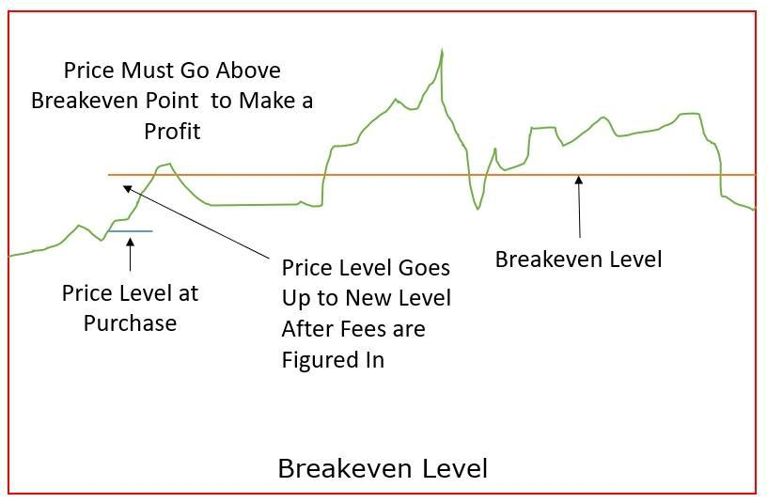

4. MARGIN

In the stock market, margin refers to borrowing funds from a brokerage firm to purchase securities. When an investor uses margin, they are essentially using borrowed money to increase their buying power and potentially amplify their investment returns. The amount of money an investor can borrow is based on the margin requirements set by the brokerage firm.

Margin trading involves the use of a margin account, which is different from a regular cash account. With a margin account, investors can borrow funds against the securities they already own or plan to purchase. The borrowed money acts as collateral for the loan, and the securities purchased with borrowed funds are held as collateral by the brokerage firm.

The margin requirements vary depending on factors such as the brokerage firm's policies, the type of securities being traded, and regulatory guidelines. Typically, brokerage firms set initial margin requirements, which determine the percentage of the total purchase price that the investor must fund with their own money. The remaining amount is borrowed from the broker.

It's important to note that while margin trading can potentially amplify gains, it also magnifies losses. If the value of the securities purchased on margin declines, the investor may be required to deposit additional funds into their margin account to meet margin calls. Failure to meet a margin call can result in the brokerage firm selling off the securities to repay the loan.

Margin trading carries additional risks, and it is typically recommended for experienced investors who understand the risks involved. It's crucial to carefully consider the potential risks and rewards of margin trading and to have a solid understanding of the rules and regulations set by the brokerage firm and relevant regulatory authorities.

Factors depending for Margin:

Several factors determine the margin requirements set by brokerage firms. These factors can vary among different firms and are subject to regulatory guidelines. Here are some common factors that can influence margin requirements:

1. Securities being traded: Different types of securities have varying levels of volatility and liquidity. Margin requirements may be higher for stocks with higher volatility or lower liquidity, as they carry more risk.
2. Price of the security: The price of the security being traded can affect margin requirements. Higher-priced securities may require larger initial margin deposits compared to lower-priced securities.
3. Market conditions: Margin requirements can be influenced by overall market conditions. During periods of high market volatility or economic uncertainty, brokerage firms may increase margin requirements to mitigate potential risks.

•**POSITION SIZING**

**Introduction**:

Position sizing points to the total number of units held by a trader or investor in certain security. An investor’s risk-taking abilities and account size have to be necessarily considered by a financial planner or advisor when deciding on the position sizing.

**Breaking Down Position Sizing:**

Position sizing is referred to as the size of the position held by an investor with respect to a particular security or portfolio. It is also referred to as the amount of money being traded in a given asset.

Carefully analysing position sizing will provide means for investors to arrive at the number of units that they can purchase within the level of risk that they are ready to assume. This will help them earn maximum returns and at minimal risk.

The term position sizing is a critical concept in almost all investment types, and it is generally linked with intra-day trading in the forex [market](https://cleartax.in/g/terms/market) (currency).



Account Risk:

The investors or traders have to determine their account risk in order to best utilise position sizing for a particular trade. This is generally represented as a percentage of their capital being invested. Generally, Most traders or investors would not like to assume a risk of more than 2% of their capital in a particular trade, and the risk assumed by fund managers would be much lower than this.

Trade Risk:

The investors should then fund out as to where they should place their stop-loss order pertaining to trading

1. Particular asset or security. If a trade is trading shares, then the trade risk is the difference between the stop-loss price and intended entry price.

For instance, if a trade is willing to purchase a share at Rs 180, and likes to place the stop-loss order at Rs 150, then the trade of that trader is Rs 30 per share.

**DETERMINING POSITION SIZING :**

The goal of position sizing is to strike a balance between maximizing potential returns and managing risk. Here are some key considerations when determining position size:

1. Risk tolerance: Assess your risk tolerance, which is your willingness and ability to handle potential losses. It varies from person to person and depends on factors such as financial situation, investment goals, and personal preferences.
2. Stop-loss level: Set a predetermined exit point or stop-loss level for your trade or investment. This is the price at which you will exit the position to limit potential losses. The distance between your entry

Point and stop-loss level helps determine the potential risk for the trade.

1. Risk per trade: Determine the maximum amount of capital you are willing to risk on each trade or investment. This is typically expressed as a percentage of your total trading capital. For example, if your risk per trade is 2% and your total trading capital is $10,000, the maximum amount you would risk on a single trade is $200.
2. Volatility: Consider the volatility of the instrument you are trading. More volatile instruments may require smaller position sizes to manage risk, while less volatile ones may allow for larger positions.
3. Reward-to-risk ratio: Evaluate the potential reward-to-risk ratio of the trade. This ratio compares the potential profit (reward) to the potential loss (risk) of a trade. A higher reward-to-risk ratio suggests a potentially more favourable trade setup.
4. Portfolio diversification: Take into account your overall portfolio and avoid overexposure to a single asset or trade. Diversifying your positions across different assets or sectors can help spread risk.

**EFFECT OF POSITION SIZING :**

The effect of position sizing on trading or investing can be significant and directly impacts your overall risk and this is the most important part of any kind of trade.

Potential returns. Here are some key effects of position sizing:

1. Risk management: Proper position sizing is crucial for effective risk management. By determining the appropriate amount of capital to allocate to each trade, you can limit potential losses and protect your overall portfolio. Smaller position sizes reduce the impact of individual trade losses on your capital, allowing you to withstand adverse market movements and avoid significant drawdowns.
2. Capital preservation: Position sizing helps protect your trading capital from excessive risk exposure. By limiting the amount of capital at risk per trade, you can preserve your trading capital for future opportunities. This approach helps maintain consistency and longevity in your trading or investing journey.
3. Consistency in returns: Implementing consistent position sizing enables you to manage risk in a disciplined manner. By allocating a consistent percentage of your trading capital to each trade, you create a systematic approach that reduces the impact of emotional or impulsive decision-making. This consistency helps you maintain a balanced risk-reward ratio over time.
4. Potential returns: Position sizing can also influence your potential returns. Larger position sizes can amplify both profits and losses. While larger positions may offer the potential for higher returns, they also carry a higher level of risk. Smaller

Position sizes may result in more modest returns, but they also provide a cushion against significant losses.

5. Portfolio diversification: Considerations contribute to portfolio diversification. By allocating capital across multiple trades or investments, you can spread risk and reduce the impact of individual positions on your portfolio. This diversification can help mitigate the impact of adverse market movements in specific assets or sectors.

6. Psychological impact: Position sizing has psychological implications for traders and investors. Properly sizing positions based on risk tolerance and capital allocation can help reduce anxiety and emotional decision-making. Knowing that you have defined your risk parameters and position sizes can enhance discipline and promote a more rational approach to trading or investing.

* **PROJECT DESCRIPTION:**

This app aims to provide the best "position size" for a trade with a predefined "stop loss”.

Suppose in a trade, an investor/trader can take loss upto Rs.1500. So, for a given Risk Amount(1500) and the desired "Buy Price" of the stock and the "SL difference" between the desired buy price and desired SL price, it calculates the optimal position size, breakeven point and required margin for that specific tradeincluding the brokerage charges and all hidden charges.

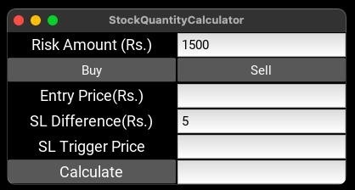

**INSTALLATION AND USAGE:**

1. Prerequisites : [python](https://www.python.org/downloads/) must be installed
2. In a folder clone this repository and install the required files - pip install -r requirements.txt
3. run the main.py file by running python main.py in

Terminal or in case of any virtual environment run source {virtualenv_name}/bin/activate && python main.py

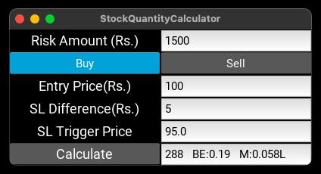

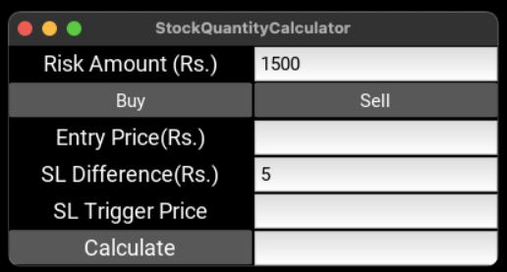

**GETTING STARTED :**

1. Enter desired maximum risk amount per trade in the "Risk Amount" tab.
2. Select BUY/SELL which type of trade it is
3. Enter the desired buy/sell entry price
4. Enter the absolute difference in Rs. between the desired Stop Loss and Entry Price
5. Click calculate
6. It will show you the probable Trigger Price which you had in your mind, and it is for CROSS VERIFICATION
7. The best position size will be shown followed by the “Breakeven” and “Margin” amount required for that trade :

**REPORT ANALYSIS:**

1. Understand the Terminology:

Breakeven: The price at which the profit or loss of a trade becomes zero. Above this price, you make a profit, and below it, you incur a loss.

Margin Amount: The initial deposit required by your broker to open a leveraged position. It allows you to control a larger position with a smaller capital investment.

Position Size: The number of units or contracts you trade in a particular asset.

1. Define Your Risk Tolerance:

Assess your risk tolerance to determine the maximum amount you are willing to lose on a trade. This will help you establish an appropriate risk-reward ratio.

1. Calculate Position Size:

Determine the total amount you are willing to risk on a trade, typically as a percentage of your overall capital.

Decide on a suitable stop loss level, which represents the price level at which you would exit the trade to limit your losses.

Calculate the potential loss per unit by subtracting the stop loss price from the entry price.

Divide the total risk amount by the potential loss per unit to determine the position size. For example, if you are willing to risk $200 and the potential loss per unit is $20, your position size would be 10 units ($200 / $20 = 10).

1. Consider Margin Requirements:

Understand the margin requirements set by your broker for the specific asset you want to trade. Margin requirements represent the percentage of the total position value that you must provide as collateral.

1. Calculate Margin Amount:

Multiply the position size by the current price to determine the total value of the position.

Multiply the total value of the position by the margin requirement percentage to obtain the margin amount required. For instance, if your position size is 10 units and the current price is $50, with a margin requirement of 5%, the margin amount required would be $250 ($50 * 10 * 0.05 = $250).

1. Set Breakeven Point:

Once your trade is in a profitable position, you may consider setting a breakeven point. This is the price level at which you adjust your stop loss to your entry price, ensuring that you don't incur any losses even if the market reverses.

1. Regularly Review and Adjust:

Continuously monitor the market and your trade. Adjust your stop loss level if necessary to lock in profits or protect your capital as the market moves. Regularly reviewing and adjusting your trades is crucial for successful risk management.

**DATA HANDLING AND FLOW :**

Request to get current rates from broker

Gives SL, current price and max loss capacity

Broker api

User

**FLOW ANALYSIS AND UI :**

The software is presented as a simple cross platform desktop app where the current user gives the stock price and the stop loss and gets the best position size to trade in that current moment for that given stop loss value.

Any user with minimal computer experience will be able to use the software as the instructions are self explanatory. Also there is a feature of sending the notifications to telegram app if the user uses limit for

Trading/investing.

Gets rates

Gets BE, margin and position size

Software

**CONCLUSION AND FUTURE PROSPECTS:**

This app minimizes the loss of an investor/trader and thus protecting capital if used correctly. It can be further modified to add a brokerage ape functionality and take trades from the app itself. Also it can be extended to add the telegram API and add telegram notification to the user with trade details during trade execution. Furthermore, we can also add feature to track progress of stocks from telegram itself without the use of a desktop.

A stock market sizing app can have various future prospects depending on its features, functionality, and target audience. Here are a few potential areas of growth and development for such an app :

1. Enhanced Analytics: Improving the app's analytical capabilities can provide users with deeper insights into the stock market. This can include features such as advanced charting, technical analysis indicators, trend predictions, and sentiment analysis. The app can also incorporate machine learning algorithms to provide personalized investment recommendations.

2. Real-Time Data and Notifications: Providing real-time stock market data and timely notifications can be a valuable feature for traders and investors. Users can receive updates on market news, price movements, and other relevant information to make informed decisions quickly. Integration with stock market APIs and news sources can ensure the app delivers up-to-date information.

3. Portfolio Management: Expanding the app to include portfolio management tools can help users track their investments, monitor performance, and analyze their portfolio's risk and return metrics. Adding features like tax calculations, automated dividend tracking, and customizable performance reports can enhance the app's value for investors.

4. Social Integration: Incorporating social features into the app can enable users to connect with other investors, share insights, and discuss investment strategies. Features like forums, chat rooms, or even a social media-like feed can foster a community-driven environment and encourage collaboration among users.

5. Education and Learning Resources: Many investors, especially beginners, seek educational resources to learn about the stock market. Including educational materials, tutorials, and investment guides within the app can attract users and establish the app as a comprehensive platform for both information and execution.

6. Integration with Brokerage Platforms: Partnering with brokerage firms to integrate the app with their trading platforms can allow users to execute trades directly from the app. Seamless integration can enhance user experience and streamline the investment process.

7. Personalization and Customization: Offering personalized recommendations and customization options based on users' preferences, risk appetite, and investment goals can make the app more appealing. Tailored content, alerts, and investment strategies can enhance user engagement and satisfaction.

1. Regulatory Compliance: Staying updated with regulatory requirements, especially in the financial industry, is crucial. Ensuring compliance with security standards, privacy regulations, and data protection measures will help build trust with users and maintain the app's credibility:

1. Expanded Market Coverage: Increasing the app's coverage to include global stock markets and exchanges can attract a broader user base. Providing real-time data, analysis, and news for international markets can cater to the needs of investors looking for opportunities beyond their domestic markets.

2. Options and Derivatives Analysis: Incorporating features specifically designed for options and derivatives trading can attract advanced traders and investors. Including options pricing models, options strategy analyzers, and volatility analysis tools can provide users with comprehensive support for trading these complex financial instruments.

3. Algorithmic Trading Support: Offering support for algorithmic trading can attract active traders and institutions. Providing features such as back testing frameworks, order execution algorithms, and integration with popular trading platforms and APIs can cater to users looking to automate their trading strategies.

4. Integration with Alternative Data Sources: Incorporating alternative data sources, such as satellite imagery, social media sentiment, or supply chain data, can provide users with additional insights and unique trading opportunities. Integration with data providers specializing in alternative data can help users make more informed decisions.

5. Mobile Trading and Notifications: Enhancing the app's mobile trading capabilities and push notifications can provide users with real-time updates and enable them to execute trades on the go. Offering a seamless and user-friendly mobile experience can attract a broader user base and improve user engagement.

6. Artificial Intelligence and Natural Language Processing: Leveraging artificial intelligence and natural language processing technologies can enable the app to extract insights from vast amounts of textual data. Sentiment analysis, news sentiment scoring, and automated news aggregation can provide users with relevant information to support their investment decisions.

7. Social Trading and Investment Communities: Building social trading features and investment communities within the app can facilitate knowledge sharing, collaboration, and idea generation among users. Allowing users to follow and replicate trades of successful investors can create a sense of community and attract users seeking a social aspect in their investment journey.

8. Integration with Robo-Advisory Services: Partnering with robo-advisory platforms can provide users with automated investment recommendations based on their risk profile, financial goals, and preferences. Integrating robo-advisory features within the app can offer users personalized investment strategies and portfolio management guidance.

Remember, the success of a stock market sizing app depends on various factors, including user adoption, competitive landscape, and the app's ability to provide value and differentiate itself in the market. Conducting market research, understanding user needs, and iterating based on user feedback will be essential for future growth and success.

•REFERENCES AND BIBLIOGRAPLY:

1. Shen J, Shafiq MO. Learning desktop application usage, 2018;112:258–73.
2. Lin X, Yang Z, Song Y. Expert systems with applications short-term stock price prediction based on echo state net-   
   works. Expert Syst Appl. 2009;36(3):7313–7.
3. “TheIntelligentInvestor”by Benjamin Graham
4. Davidsson, Marcus, The Science and Art of Position Sizing (2011). Journal of Financial Decision Making, Vol. 7, Issue 2, pp. 20-35, December 2011.
5. “Position-sizing Effects on Trader Performance: An experimental analysis” By Johan Gilyard.