Final Project Presentation
C-PCIT7 - Part 2: Packet Tracer Skills
Group Members:
Garcia, Aian Jae
Laxamana, Aaron
Sunga, Justin Vince
Henson, Patricia Alizah
Musngi, Bern Ricel

*If DHCP fails to load, just exit and open PT file again

Topics Included:
FHRP - HSRP
Wireless - WLAN with WPA2 Security
Routing - OSPF
VLans and InterVLan Routing
EtherChannel & STP

- Building the Topology
Minimum Requirements:
- 3 Routers
- 5 Switches
- Several End Devices

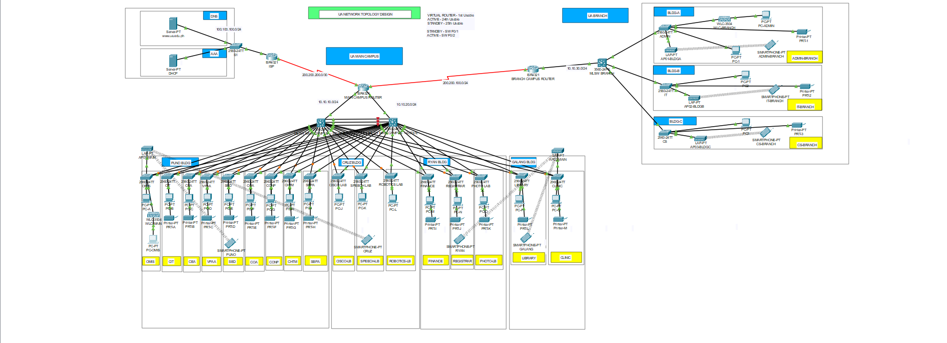

- VLSM
Documentation Link: Group 2 Networking Documentation - Part 2
- Key Configurations
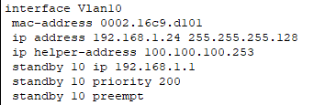
- HSRP
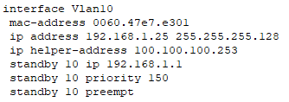

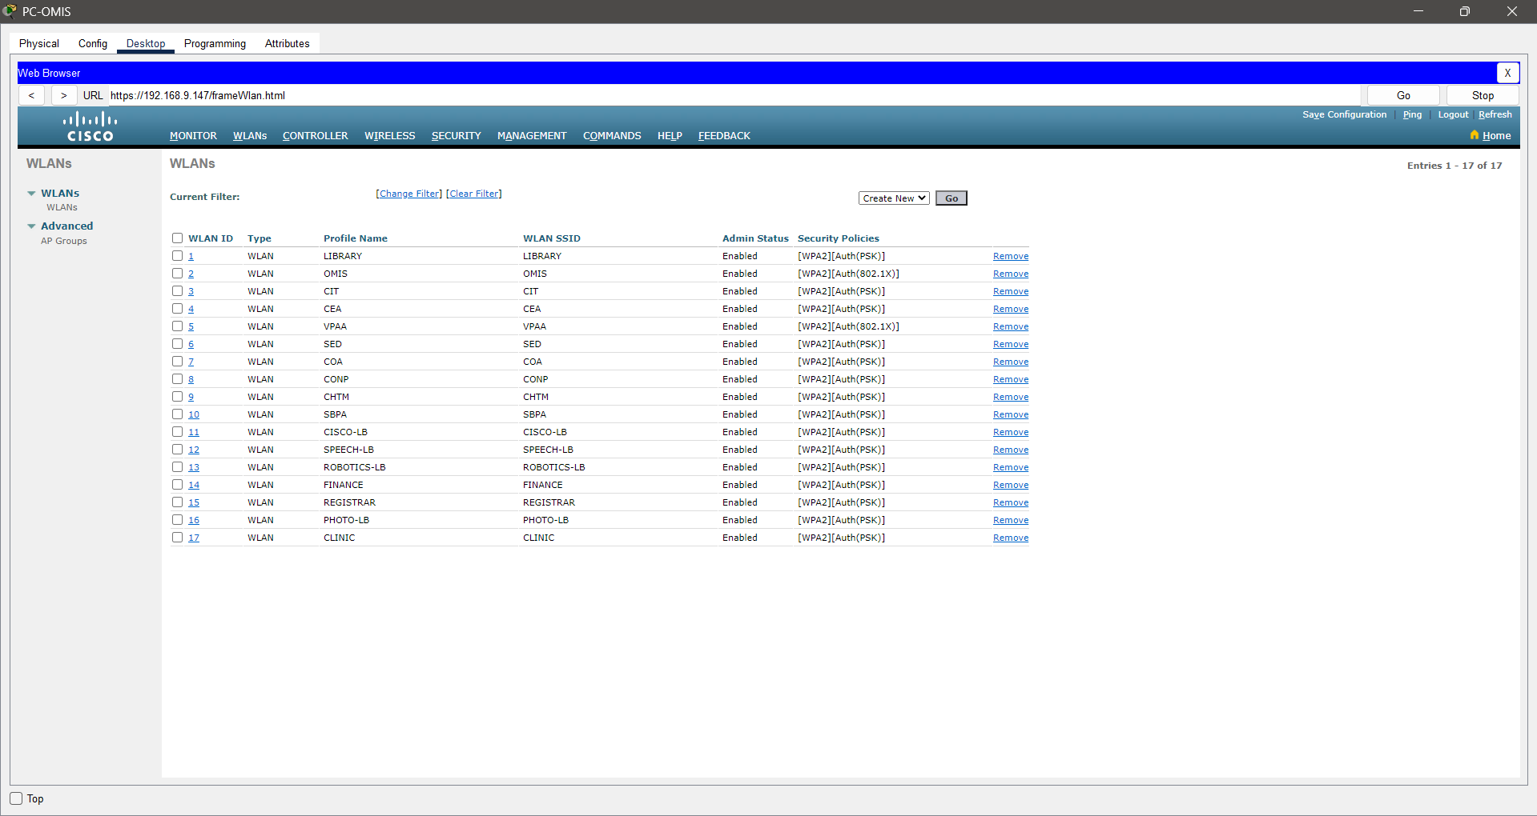
- WLAN with WPA2 Security

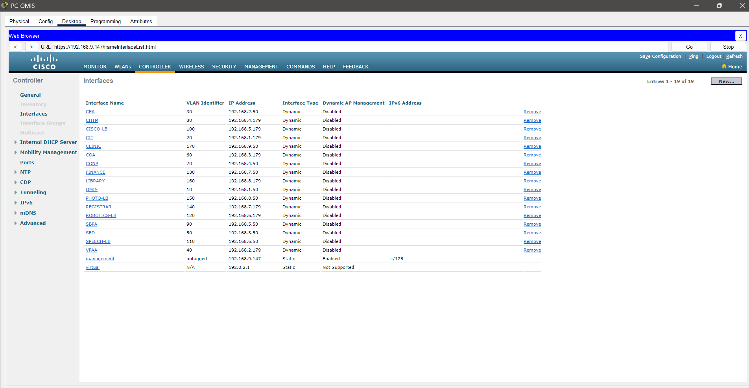

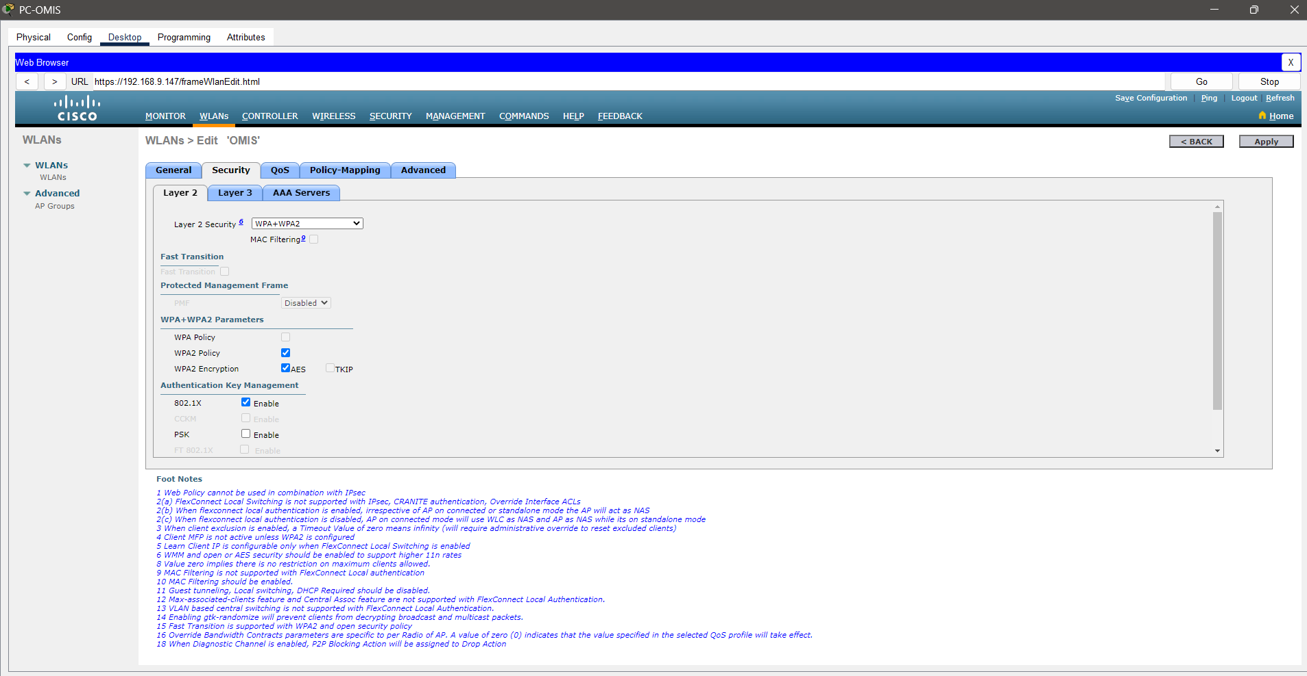

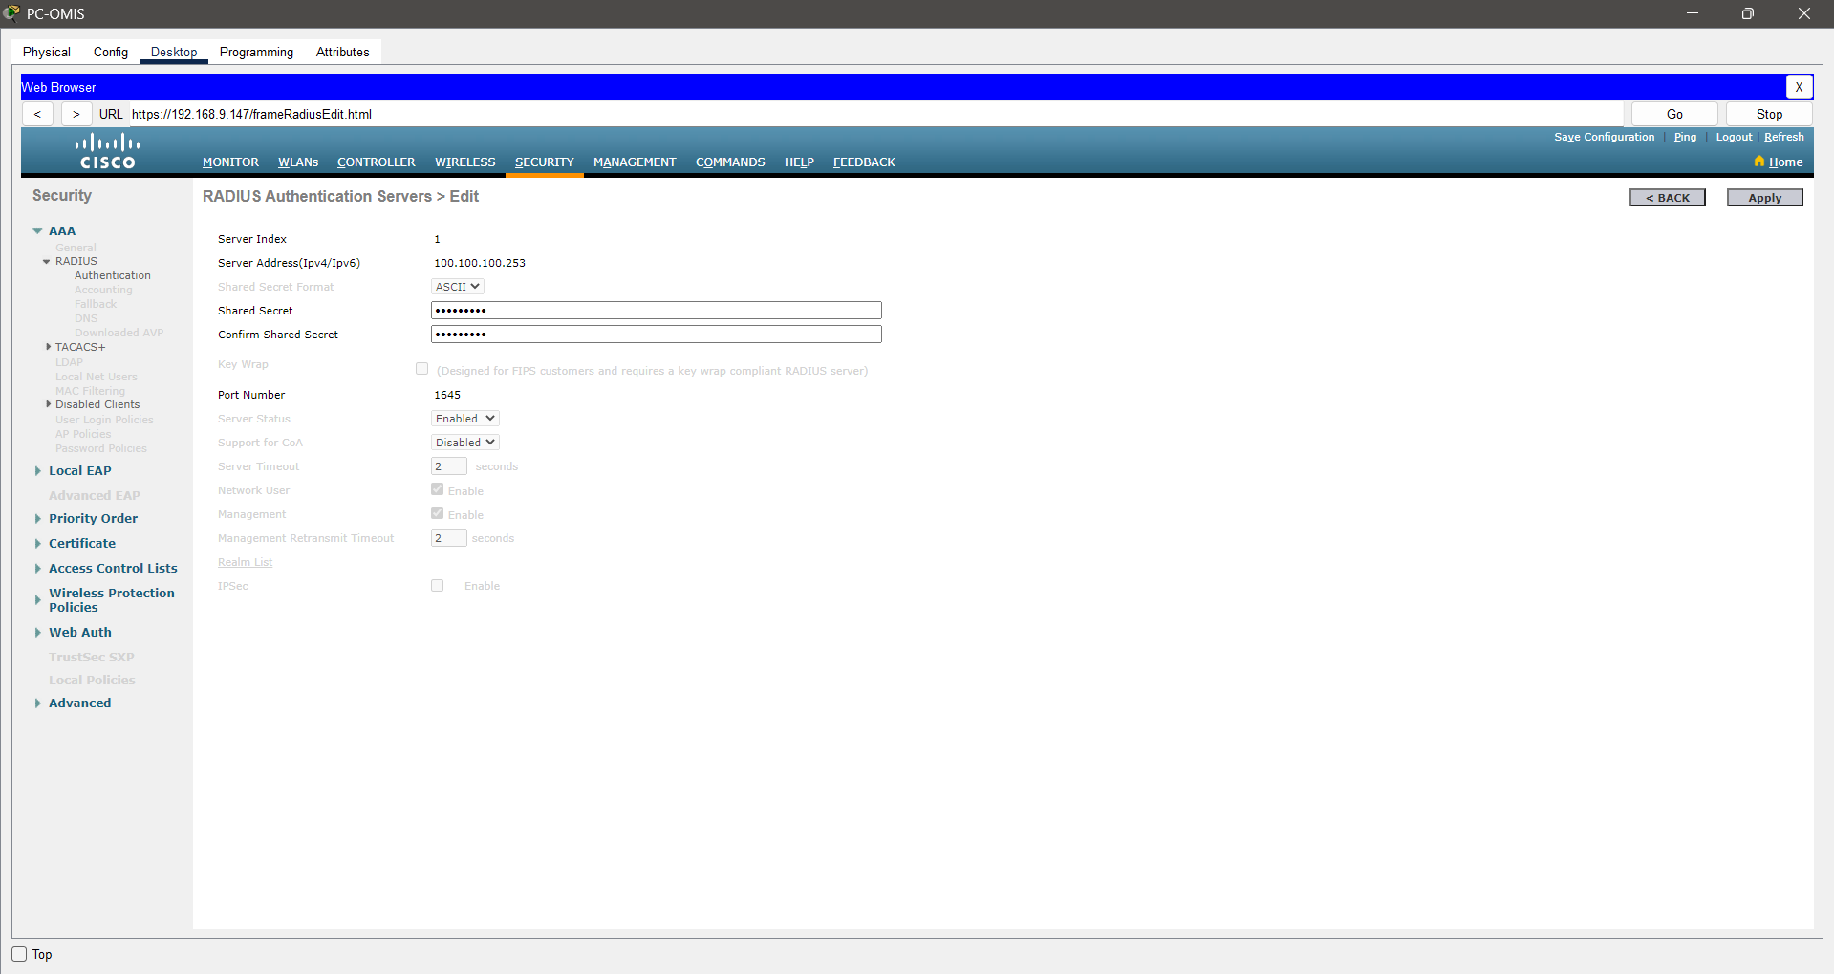

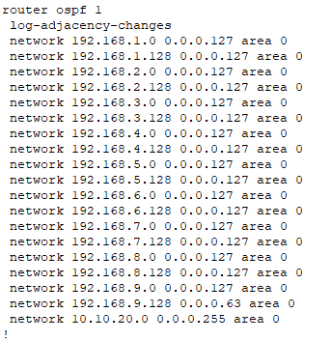
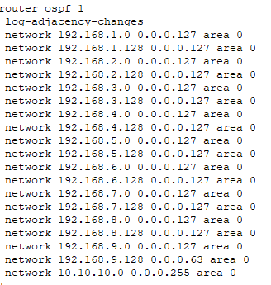
- OSPF

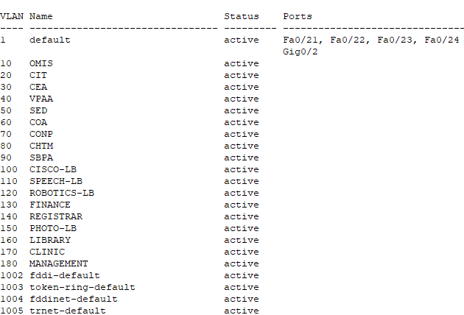
- VLANS and InterVLAN Routing

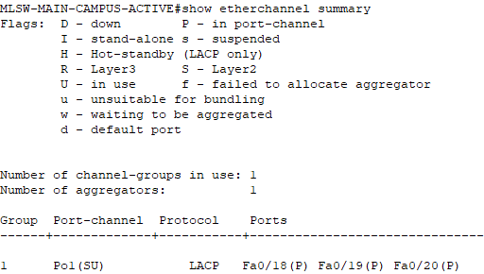
- EtherChannel & STP

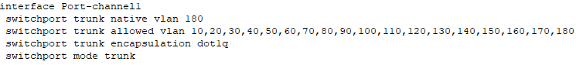

- Verification and Troubleshooting
- End to End Connectivity
- HSRP Failover
- WLAN Connection and Access

