o

|  |  |
| --- | --- |
|  | 🞂[User Documentation: The Great Audio Race]  [Created by: That1Group] |
|  |  |
|  | Description: Mac OS X:Users:brandonscott:Downloads:Game Logo.png |
|  |  |

That1Group of Engineers in Training:

Brandon Scott, Taran Pennebacker, Andrew Rauh, Andrew Lees

Engineering 100.650

The Great Audio Race

Table of Contents

Page 3: System Requirements

Page 4: Main Menu

Page 6: About

Page 7: Play

Page 9: Settings

Page 11: High Scores

## System Requirements

Not available at this time.

[Main Menu]

Summary:

This is the screen that will be seen originally at the start up of the game. It has four buttons on it that include: Play, Exit, High Scores, and Settings. Each tab leads to a new screen within the game. If the Play button is clicked, the player is brought directly to the screen in-order to begin playing *The Great Audio Race.* If the High Score button is clicked, the player will be directed to the screen to see all of the top scores of that player on the local machine they are playing on. If the Settings button is clicked, the user will be brought to a screen that allows them to customize the game thoroughly. Finally, if the Exit button is clicked the user will exit from the game.

Detailed Information:

The Main Menu is a file of it’s own that is called upon by the MainGame.py file. When the screen is brought up there are five working and visible options for the user to choose from. They can choose between Settings, Play, High Score, About, and Exit.

As a player clicks the High Scores button they will be brought to a screen with a list of players that have successfully finished the game along with their score within the game. As the user finishes songs and earns points a top ten list will be provided on the screen. This will include the users initials as well as the score that they received in game.

As the player clicks the Play button then would be brought to a screen that will generate a map based on the song they have selected. They will then begin to the play the game until they have successfully finished the song.

As the player clicks the About button they will be brought to a screen that gives the information about the game. They will be taught about the reasons for the games creation as well as its help in the battle against ASD.

As the player clicks the Settings button they will be brought to a screen with a list of customizable options for them to select from. They can select the difficulty of their game, this being the speed of the game, the amount of obstacles, as well as life total. They can also change the menu colors from the original green color that we have provided for them, and they can also change the color of the rocket ship, changed from the color that is provided at the current time. This will allow for full customization to make the user feel much more comfortable while playing *The Great Audio Race*.

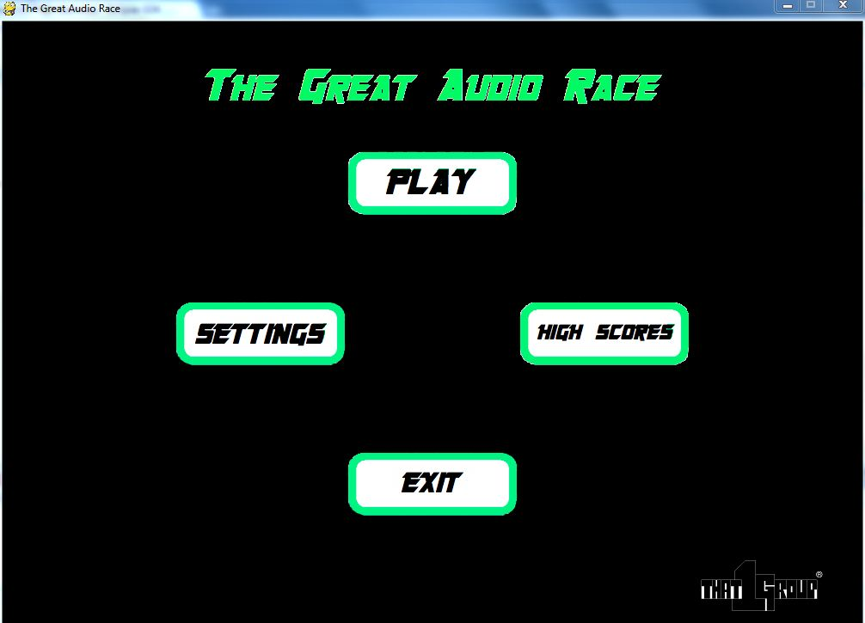

[About]

Summary:

This module describes the About Menu, which is accessed by clicking “The Great Audio Race” icon on the main menu. It describes the therapeutic values as well as the goals of our game. The therapeutic values are that the user, usually a patient with ASD, will be able to react and develop the skills needed to react to multiple stimuli simultaneously. Patients that play this game will usually have problems reacting to multiple things that are going on at simultaneous events. With *The Great Audio Race* they will be able to adhere to attempting to fix this problem by completing the ultimate goal of our game, which is for the patient to receive maximum score on our hardest difficulty with their favorite song.

Detailed Information:

The therapeutic values of this game are to help the user adhere to multiple stimuli at simultaneous times. The game idea sprung from project founder Brandon Scott’s sister. He sat down with his sister and his parents and asked them what they thought was the hardest thing for Regina, his autistic sister, to deal with. They said that she had difficulty reacting to multiple things at one time, especially while she listened to music. Therefore, Brandon thought that a game that incorporated both reaction and music would be very helpful for patients with ASD.

The idea behind the game is that users will have to dodge obstacles and follow a path based on the frequency behind their favorite songs. This will allow them to focus on two things at once both music and collision. The user will react simultaneously to obstacles that generate as well as the map that generates that they can’t see. We as the creators are confident this will help people with ASD attain a much better ability to be able to adapt to situations that they would usually not be able to handle the pressure of overwhelming situations.

The goal of the team is that patients with ASD will walk away after using this therapeutic item with a better grasp on adhering to multiple stimuli at one time. With this game the ASD patient should have a better understanding of decision making as well. Since people with ASD have a very difficult time with making their own decisions, this game has an underlying theme of making sure that the user will be able to make quick time decisions. Usually people with ASD have problems with driving cars, living by themselves, and even simple things like choosing what they want to get when they go out to eat. With this game, we hope that the user will be taking one step closer to being able to make their own decisions. We don’t except them to be drastic changes, but steps in the right directions.

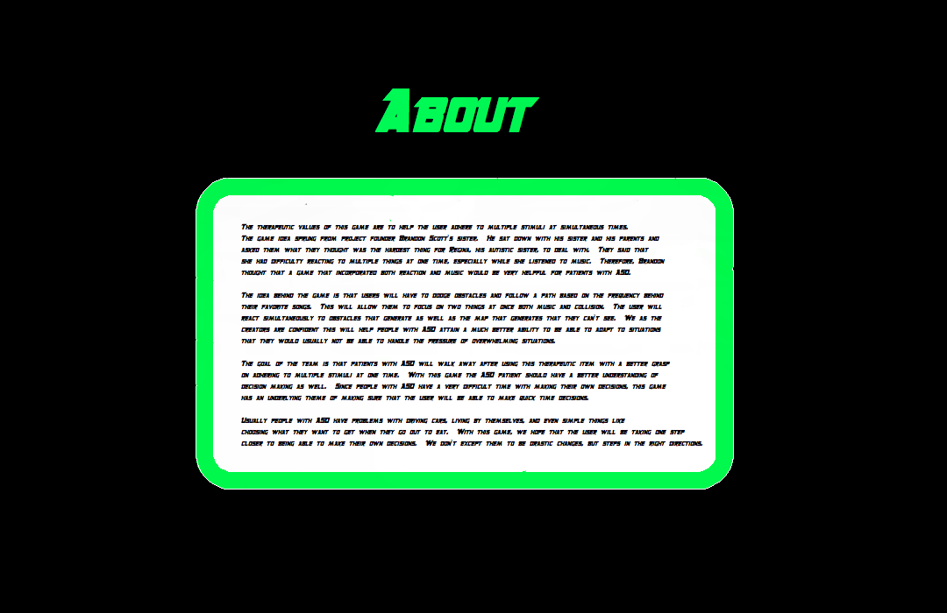

[Play]

Summary:

Pressing the play button starts the main game loop. After being pressed, the person playing the game will select an audio file from their computer that will generate the level they are about to play. Once a track is selected, the main player object (a rocketship) will appear at the bottom of the screen. Obstacles, such as asteroids and other space objects, will appear based on the difficulty of the song selected. The person playing the game has the responsibility to avoid the falling and appearing obstacles on the screen. Obstacles will scroll down the screen, and the person playing the game will have the ability to move the spaceship left or right with the arrow keys.

Detailed Information:

This module describes the Play button and what happens when it is clicked. When the play button is clicked on the main menu, the main game loop method is called from the Main.py file. The previous main menu interface will disappear and will be replaced by a menu that allows the user to select a music file from their music directory folder on their computer. After a song is selected, the menu will disappear and the main game interface will show. The song will be analyzed and a level will be created to correspond to the frequency, tone, and pace of the song.

The main objective of the game is for the player to move the rocket ship left or right to avoid the falling and randomly appearing asteroids and other obstacles on the screen. If the song selected has a faster pace, or higher frequency, more asteroids and obstacles will appear on screen for the player to avoid. The more obstacles the player avoids, the more points they will be rewarded. After so many points have been collected, more health will be added to the player’s health bar.

If the rocket collides with any of the asteroids or other obstacles, the rocketship will be returned to the center of the screen. If gameplay is in “easy” mode, then no health will be subtracted from the player. However, if gameplay is in “medium” or “hard” mode then health will be lost each time a collision occurs.

When the end of a level (song) has been reached successfully, the screen will transition to a congratulations screen where an animation of the rocket ship and the number of points awarded will be shown. After a few seconds, the view will transition to the high score screen. If the player looses all health, they will be prompted to either select a different song or try the same song again, perhaps at an easier level of difficulty.

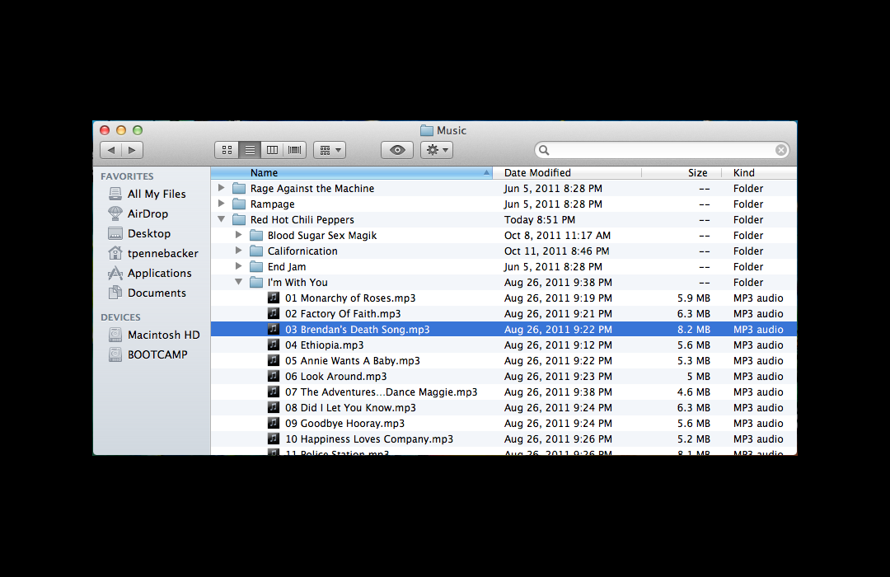

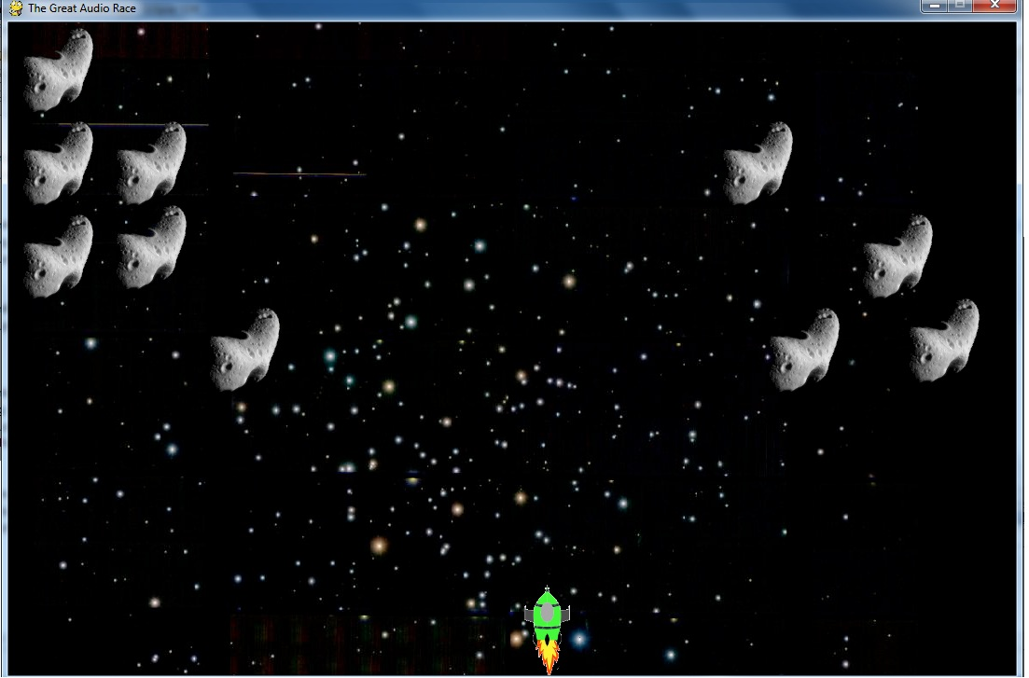

[Settings]

Summary:

The Settings Menu is the menu that customizes the game. It contains various buttons that can be toggled by the user to have a more customizable and personal experience when playing the *Great Audio Race.* The options that can be edited are Difficulty, Menu Colors, and Rocketship Colors. The user has the ability to toggle what difficulty setting and what game colors that the individual will enjoy.

Detailed Information:

This module describes the Settings Menu, which is one of the five choices that the user can choose from in the Main Menu. When this screen loads there will be three different options to choose from with multiple buttons to toggle. The player has the options of: Difficulty, Menu Colors, and Rocketship Colors. Whether it is the user, a therapist, a doctor, or the user’s parents, the options can be customized to have the best experience possible.

As the player clicks the Settings button they will be brought to a screen with a list of options for them to customize. They can select the difficulty of their game, this being the speed of the game, the amount of obstacles, as well as life total. The buttons that can be toggled for difficulty are Easy, Medium, and Hard. When the level of difficulty is selected, the button will have a white font, while the other difficulty buttons will appear as the preselected menu colors.

The player also has the option to select the Menu Colors. This allows the player to choose a favorite color for the menu layouts out of the six colors that have been provided to be selected from. There are at total of six colors to choose from, and the default color is green. When a color is changed, all of the titles and words will change to the preferred color.

The final option to edit is the rocketship’s color. The player can make the rocketship a color of their choice. These choices are the same color choices that the user can select for their menu colors. This is so the user can have a more uniform game if they so choose.

This menu is vital for *The Great Audio Race.* It gives the game versatility and helps aid the user by not overwhelming them at one time. If gives them the ability to have some customization, but not so much that the game doesn’t do what it is entitled to do. The game is trying to make the user react to multiple stimuli at once, however it is understand that too much at once can be negative, and the Settings Menu allows for a smooth transition.

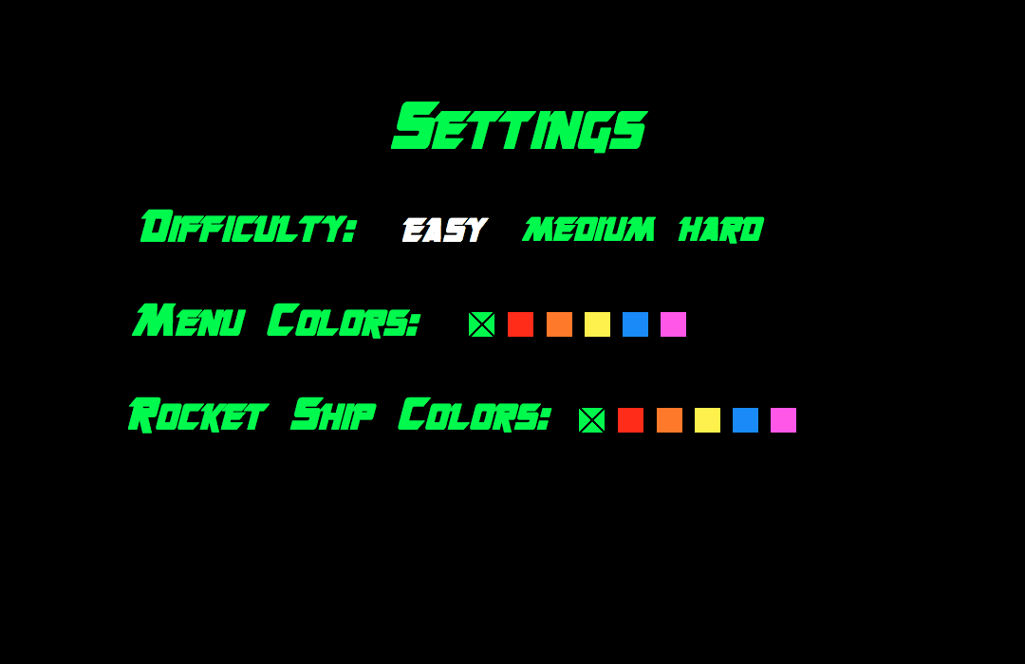

[High Scores]

Summary:

This module describes the function of the High Scores menu as well as the ability to track a user’s progress based on the difference in scores. The High Scores menu is a basic menu that is used to track the greatest scores achieved by the users while playing the game. These scores can in turn be compared to determine if a specific user is progressing.

Detailed Information:

The High Scores menu will be used to display the highest scores achieved by all users. Each entry will have the user’s initials aligned along the left side of the screen and the corresponding score aligned on the right side of the screen. The scores will be listed in descending order with the highest score at the top of the screen. The ranking of the stored scores will create a competitive nature in the game. The user will always be trying to achieve a greater score and to secure a spot higher in the menu.

The scores that are assigned won’t be specific to each song or difficulty but rather a generalization of both factors. If a song is quick, and the difficulty is set to hard, the user will have more opportunities to gain points. However, if the user selects a harder difficulty, it will be harder to earn the points. This generalization allows for the tracking of progress for a user without the need to repeatedly use the same song or the same difficulty.

The high scores can be used to track the progress of a certain user. By comparing each score that the user receives with the old scores they have obtained, a trend is created on whether the user is adapting to the gaming and progressing. Positive trends suggest that the user is doing well and is able to understand the task at hand while negative trends can signal a lack of understanding. A negative trend doesn’t necessarily mean the user isn’t progressing, a lower difficulty or slower song may be recommended to set a base score.

Each High Scores menu will be localized meaning that the high scores stored in one users’ computer won’t reflect the high scores of another users’ computer. This allows for the tracking of each users progress to be clear and coherent because other scores won’t fill up the spaces on the high scores menu.

