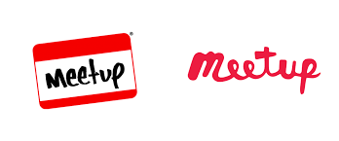

*Managing Microservices using terraform and Docker*

6 July, 2019

Thane

|  |  |
| --- | --- |
| Time | Topic |
| 10.30 – 10.45 | Key Note by Amlendu Choudhary and Team |
| 10.45 – 11.00 | Agenda and Pre-requisite |
| 11.00 – 11.30 | Terraform Concept |
| 11.30 – 11.45 | Tea Break |
| 11.45 – 12.00 | Create Container Registry |
| 12.00 – 12.30 | Create Kubernetes Cluster |
| 12.30 – 1.00 | Running Test Application inside Cluster |

Address - Opp. Vedant Hospital, R K AVENUE, between & HAWARE RESIDENTIAL BUILDING, WEST,, Ghodbunder Rd, Kasarvadavali, Thane West, Thane, Maharashtra 400615

Location Map - <https://goo.gl/maps/TWwR49zuHtGTu9a56>