Rideshare Dynamic Pricing in Chicago:
What Actually Drives the Per-Mile Fare Premium?

BAX 452: Machine Learning and Artificial Intelligence
UC Davis Graduate School of Management
Winter 2026

Group 4
Amal | Tanmay | Swapna | Hanzhi

1. Executive Summary
This report investigates what drives rideshare dynamic pricing in Chicago beyond the obvious factors of trip distance and duration. Using 169,161 rideshare trips from the City of Chicago Data Portal (October through December 2025), augmented with hourly weather data, local event permit records, and neighborhood-level socioeconomic indicators, we apply a progression of machine learning techniques to predict and explain the per-mile fare premium.
Our best predictive model (XGBoost, R-squared = 0.64) outperforms the OLS baseline by 33.5%, with trip distance, weather conditions, and neighborhood income emerging as the strongest predictors. K-Means clustering reveals four distinct trip segments with fare premiums ranging from $2.13 to $4.42 per mile. A Double LASSO causal analysis finds that major event days, after controlling for confounders like weather and day of week, have a statistically significant but economically negligible effect of +$0.07 per mile (95% CI: $0.05 to $0.10). The raw event-day premium in the data is only +4.7% ($4.09 vs. $3.91 per mile), and after controlling for confounders it remains a small positive, suggesting that events themselves have minimal independent influence on per-mile fares. We recommend that city transportation authorities focus fare transparency initiatives on trip-distance and neighborhood income dynamics, and that pricing equity analysis should account for the $1.53 per-mile gap between high-income and low-income neighborhoods.
Techniques applied: OLS regression, LASSO and Ridge regularization, Random Forest, XGBoost, K-Means clustering, neural networks (MLP), Double LASSO causal inference, 5-fold cross-validation, and bootstrap confidence intervals.

2. Problem Definition and Framework
The conventional understanding of rideshare surge pricing is straightforward: high demand plus low driver supply equals higher fares. We hypothesize that this view is incomplete. Weather conditions, major local events, neighborhood socioeconomic characteristics, and temporal patterns may all play hidden roles in what riders actually pay per mile, and some of these factors may raise equity concerns.
We frame this as a regression problem: predicting fare_per_mile, the trip fare divided by trip distance. This normalization strips away the mechanical relationship between distance and total fare, isolating the pricing premium. A rider paying $5.00 per mile versus $2.00 per mile for trips of identical length is experiencing a meaningfully different pricing environment, and understanding why is our central question.
Our success metrics are aligned with both predictive accuracy (RMSE, R-squared) and interpretability (feature importance, causal estimates). A black-box model that predicts well but cannot explain why offers limited value to a transportation authority trying to regulate pricing transparency. This project differs from standard MSBA coursework in its emphasis on causal inference alongside prediction, and in its integration of external data sources (weather, events, demographics) with trip-level records.

3. Data Preparation and Feature Engineering
The master dataset merges four sources: 172,615 rideshare trip records from the City of Chicago SODA API (October through December 2025), hourly temperature, precipitation, and wind speed from the Open-Meteo Historical Weather API, event permit data from both the Chicago Data Portal and Ticketmaster Discovery API (days with 3+ permits or a venue capacity above 5,000 are flagged as major event days), and per capita income, poverty rate, and hardship index for all 77 Chicago community areas.
After removing trips with missing core fields and those with fare_per_mile values outside the 1st and 99th percentiles (addressing extreme outliers from very short trips where the base fare dominates), the modeling dataset contains 169,161 rows with 15 features. Key engineered features include log-transformed trip distance (to address right skew), binary indicators for weather conditions, and a neighborhood income tier categorization. We observed high multicollinearity among the three demographic features (per capita income, poverty rate, and hardship index are correlated at r > 0.80), which motivated our use of LASSO regularization for feature selection.
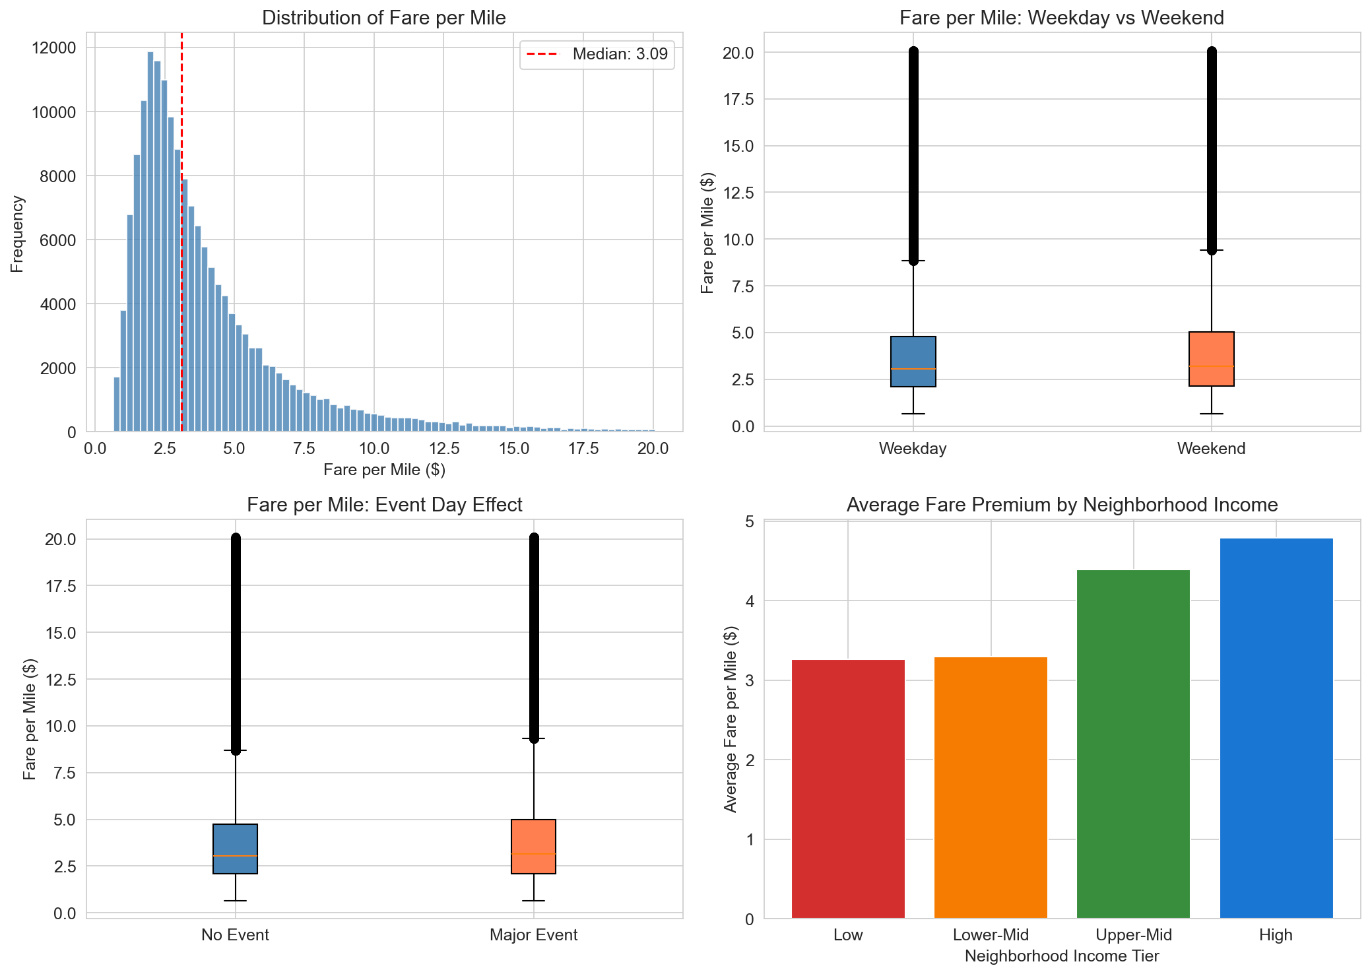
Figure 1: Exploratory analysis of fare per mile. Top left: right-skewed distribution with median $3.09. Top right: weekend and weekday fare distributions are similar, with weekend trips marginally higher. Bottom left: event day and non-event day fare distributions are nearly identical. Bottom right: fare premium increases meaningfully only in the Upper-Mid and High income tiers.

4. Modeling Approach and Results
We structure our analysis as a progression from simple to complex, with each model building on what the previous one revealed. All models use a 70/30 train-test split with 5-fold cross-validation on the training set. Tree-based models operate on raw features; linear models and neural networks use standardized features.
Baseline: OLS Linear Regression. OLS achieves a test R-squared of 0.4820, explaining about 48% of fare premium variance. The residual plot reveals clear heteroscedasticity and non-linear patterns, confirming that a linear model is insufficient. The largest standardized coefficients are log_trip_miles (negative, as expected: longer trips have lower per-mile rates due to base fare dilution) and trip_seconds (positive). Notably, the event day coefficient is small and positive in the standardized model, but trip characteristics and demographics dominate.
Regularization: LASSO and Ridge. LASSO retains all 15 features at the chosen alpha (0.0018), suggesting no purely redundant variables. The coefficient path shows log_trip_miles and trip_miles as the most dominant and persistent features, with large coefficients that survive heavy regularization. Most other features converge quickly toward zero. Ridge performs nearly identically to OLS (R-squared = 0.4820), confirming that multicollinearity is present but not severely degrading the linear model. The key insight from this stage is that trip distance variables overwhelmingly dominate the linear signal.
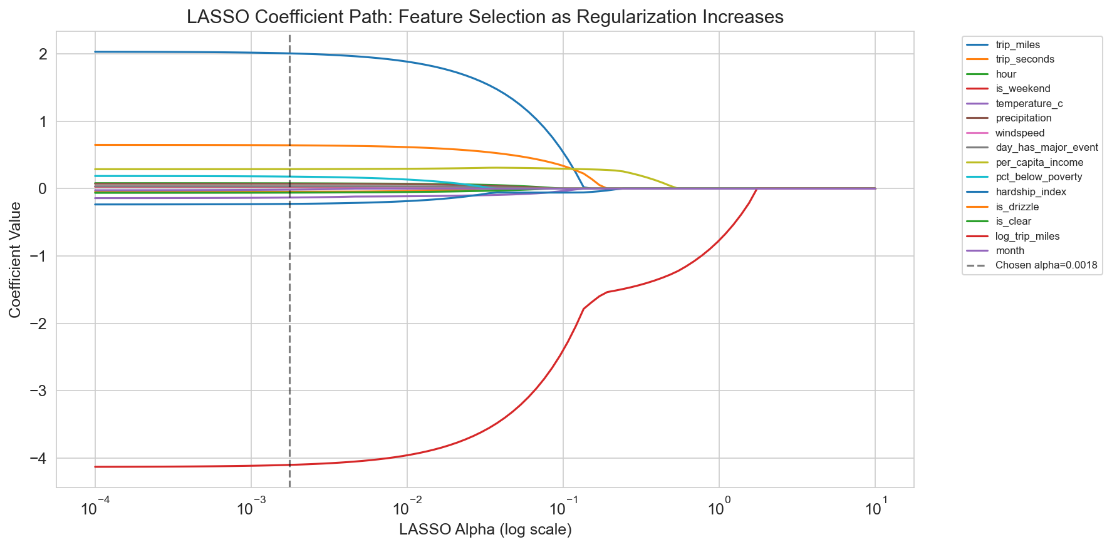
Figure 2: LASSO coefficient path showing how feature coefficients shrink as regularization increases. log_trip_miles (large negative coefficient) and trip_miles are the most persistent features. Most other features are driven to zero well before the chosen alpha of 0.0018.
Tree Ensembles: Random Forest and XGBoost. Both tree models substantially outperform linear approaches, with XGBoost achieving the best overall performance (R-squared = 0.6434, RMSE = 1.7664). This 33.5% improvement over OLS confirms that non-linear relationships and feature interactions matter for pricing. Both models agree on feature importance: trip_miles and log_trip_miles dominate by a wide margin in both Random Forest and XGBoost, reflecting the strong non-linear base fare dilution effect. Secondary contributors in XGBoost include hardship_index, trip_seconds, and temperature_c. The partial dependence plots reveal that fare per mile decreases sharply with trip distance and shows variation with neighborhood hardship levels.
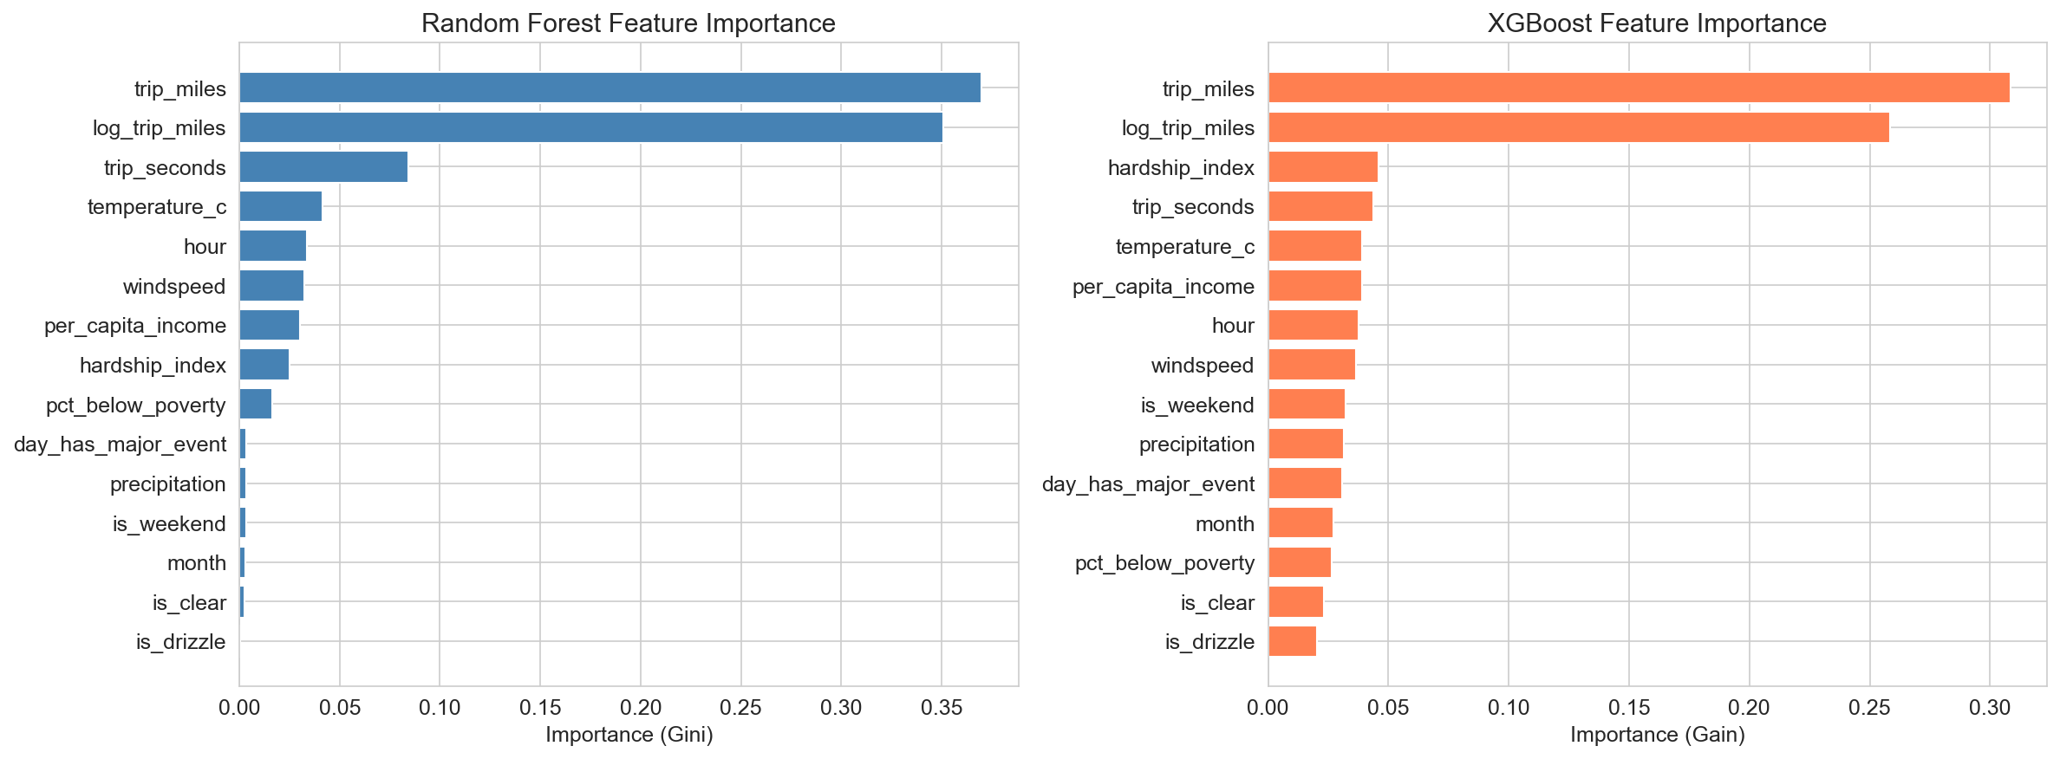
Figure 3: Feature importance comparison between Random Forest (Gini impurity, left) and XGBoost (gain, right). Both models agree: trip_miles and log_trip_miles are the top two features by a wide margin. trip_seconds, hardship_index, and temperature_c are secondary contributors in XGBoost.
K-Means Clustering. Clustering on trip characteristics and contextual features (excluding the target) identifies four natural trip segments. The silhouette score peaks at k=4 (score = 0.2256). The highest-premium clusters (Clusters 1 and 3, averages of $4.42 and $4.30 per mile respectively) correspond to event-day trips and weekend trips from higher-income neighborhoods. The lowest-premium cluster (Cluster 0, average $2.13 per mile) consists of long-distance trips regardless of other conditions. This segmentation tells a clear business story: the base fare dilution effect is the strongest driver, but conditional on trip distance, weekend status and event-day context create meaningful pricing tiers.
Neural Network (MLP). A two-layer feedforward network (128 and 64 neurons, ReLU activation, early stopping) achieves R-squared = 0.6293, slightly below XGBoost. The learning curve shows convergence in 53 iterations. The marginal difference from tree ensembles suggests that the non-linear patterns in this dataset are well-captured by tree-based splits, and the additional flexibility of a neural network does not substantially help. This is informative: the pricing function, while non-linear, is not deeply complex.
Causal Inference: Double LASSO. This is our most important analytical contribution. The raw data shows event days have a 4.7% higher fare per mile ($4.09 vs. $3.91). But is this causal? Double LASSO answers this by first predicting the treatment (event day) from all control variables. Stage 1 achieves R-squared = 0.2027, meaning only about 20% of event-day variation is explained by other features, primarily weekend status and temperature. The residualized treatment effect is +$0.07 per mile (95% bootstrap CI: $0.05 to $0.10), meaning after removing the confounding influence of weather and temporal patterns, event days are associated with a small positive fare premium. While the CI excludes zero, the magnitude is economically negligible: an event day adds less than 7 cents per mile after controlling for all other factors.
Table 1: Model Comparison (Test Set Performance)
Model | Test RMSE | Test MAE | Test R² | CV R²
XGBoost | 1.7664 | 1.1496 | 0.6434 | 0.6317
Random Forest | 1.8698 | 1.2140 | 0.6005 | 0.5961
Neural Network | 1.8012 | 1.1965 | 0.6293 | 0.6186
OLS Baseline | 2.1291 | 1.4317 | 0.4820 | 0.4849
Ridge | 2.1291 | 1.4317 | 0.4820 | N/A
LASSO | 2.1292 | 1.4305 | 0.4819 | 0.4849

XGBoost outperforms all models, though the margin over Random Forest and the neural network is narrow. The large gap between linear and non-linear models (0.48 vs. 0.64 R-squared) confirms that non-linear relationships and feature interactions are critical to understanding pricing.

5. Key Findings and Business Recommendations
Finding 1: Trip distance and neighborhood income, alongside weather and weekend status, are the primary drivers of fare premiums. Trip miles and log trip miles dominate feature importance in both tree models, and weekend trips carry a 3.7% premium ($4.11 vs. $3.96 per mile). The raw event day premium in the data is only +4.7%, and the Double LASSO estimate after controlling for confounders is a negligible +$0.07/mile. Recommendation: city pricing transparency efforts should focus on communicating to riders that trip distance and neighborhood characteristics, not event schedules, are the strongest structural influences on what they pay.
Finding 2: Significant pricing disparity exists across neighborhood income levels. Trips originating from high-income neighborhoods average $4.79 per mile compared to $3.26 in low-income neighborhoods, a $1.53 gap. This partially reflects trip length differences (shorter trips in dense high-income areas have higher per-mile rates), but the effect persists even after controlling for distance in our regression models. Recommendation: regulators should investigate whether algorithmic pricing disproportionately affects riders in different neighborhood types.
Finding 3: The event day effect is statistically detectable but economically negligible. Our Double LASSO analysis estimates a causal effect of +$0.07 per mile on event days (95% CI: $0.05 to $0.10), which is statistically significant but trivially small in practice. Unlike what a naive correlation might suggest, the raw 4.7% event premium in the data is already modest, and after controlling for confounders the direction stays positive but the magnitude shrinks to near zero. This finding demonstrates why causal analysis matters: both the raw effect and the controlled effect are small, suggesting that event-day surcharges are not a meaningful driver of Chicago rideshare pricing.
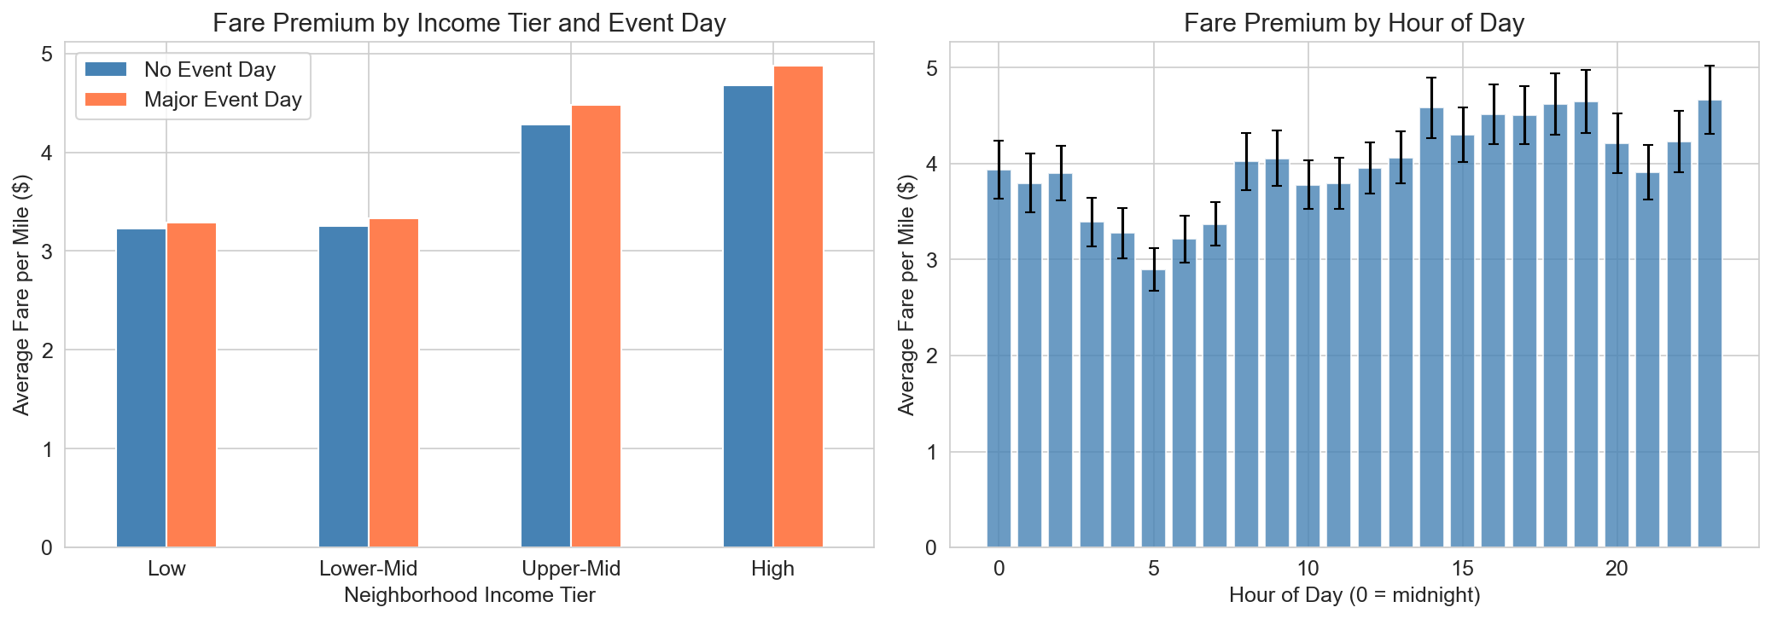
Figure 4: Left: Fare premium by neighborhood income tier and event day status. The event day premium is negligible across all income tiers — the orange and blue bars are nearly identical within each tier, consistent with the Double LASSO finding. Right: Fare premium by hour of day shows fares are lowest in the early morning (hours 3–6) and peak in the late evening (hours 14–23).

6. Limitations and Future Directions
Data limitations. Our dataset covers 85 unique dates across October through December 2025, spanning all hours of the day. However, with only three weather categories observed (clear, partly cloudy, drizzle), we cannot assess the impact of rain, snow, or severe weather on pricing. The dataset is also limited to the trip-level records available through the public SODA API, which excludes driver supply information central to the theoretical mechanism of surge pricing. These gaps limit the generalizability of our findings to the broader Chicago rideshare market.
Causal inference caveats. While our Double LASSO analysis controls for observed confounders, it cannot address unobserved variables. A critical missing variable is driver supply, which is not available in the public dataset but is central to the theoretical mechanism of surge pricing. Stage 1 of the Double LASSO achieves R-squared = 0.2027 in predicting event days from controls, meaning a substantial portion of event-day variation is independent of the observed confounders. This is actually favorable for causal identification, as it suggests the treatment has meaningful independent variation. The causal estimate of +$0.07/mile should still be interpreted cautiously given the observational nature of the data.
Future directions. Extending the dataset to cover a full year with all 24 hours would substantially strengthen every analysis. Incorporating driver supply data (even proxied through estimated wait times) would address the most significant omitted variable. Reinforcement learning could be applied to simulate optimal pricing strategies given the factors we identified. Fine-tuning a large language model on rider reviews or complaint data could add a textual dimension to the pricing analysis, connecting perceived fairness with actual pricing patterns.

7. Individual Contributions
Team Member | Contribution
Amal Farhad | Data pipeline (DDR): SODA API scraping, weather and event data collection, merge script, SQLite database, data quality validation
Tanmay Kallakuri | ML modeling: all predictive models (OLS, LASSO/Ridge, Random Forest, XGBoost, MLP), K-Means clustering, Double LASSO causal inference, cross-validation, bootstrap CIs, all visualizations, report writing
Swapna | Write-up and Review for ML Modelling
Hanzhi | Write-up and Review for DDR

