 

MINISTRY OF COMMUNICATIONS AND INFORMATION

DIGITAL EGYPT PIONEERS INITIATIVE (DEPI).

SOFTWARE DEVELOPMENT TRACK

Mobile Application Track

PROJECT: METRO GO APPLICATION

Using Flutter .

SUPERVISED BY

Eng. Hany Nemr

2024-2025

Abstract

The Metro Go App is a smart mobile application designed

to improve daily transportation for Cairo’s metro users. The

app allows users to input their starting and destination

stations to receive the shortest and all routes, number of

stations, ticket price, estimated travel time, and real-time

station alerts. Developed using Flutter (Dart), the application highlights how technology can

transform public transportation into a more efficient and

user-friendly experience.

Acknowledgment

We extend our sincere gratitude to the Ministry of Communications and Information Technology for launching the "Digital Egypt Builders Initiative," which provided us with this outstanding opportunity to develop our skills bring this project to life. We also express our deep appreciation to CLS Company for its dedication and for providing us with a highly experienced professional in mobile application development — Eng. Hany Nemr — whose guidance played a vital role in enhancing our learning journey. His broad expertise, practical insights, and valuable feedback greatly contributed to the successful execution of this project with high quality. At the conclusion of this journey, we offer our heartfelt thanks and respect to Eng. Hany Nemr for his continuous support and commitment, and we are truly honored to have learned from him during this inspiring educational experience.

CHAPTER 1:

GENERAL INTRODUCTION

**What is the Cairo Metro App?**

The Cairo Metro App is an innovative mobile application developed as part of a graduation project to address a real-world challenge faced by millions of daily metro users in Cairo. The application is designed to simplify commuting within Egypt’s largest and busiest metro system by offering a smart and interactive platform. Through this app, users can input their current metro station and their intended destination, and the app will instantly calculate all possible travel routes between the two points. It then selects the most optimal route, usually the shortest one in terms of the number of stations. In addition, the application displays valuable travel information such as the estimated time of arrival, total distance to be covered, ticket pricing, and even provides alerts as the user approaches each station. This tool enhances not only navigation but also planning, especially for newcomers, tourists, or anyone unfamiliar with the intricacies of Cairo’s metro lines. The app serves as a daily companion to help users avoid confusion and delays, making urban transportation smoother and more accessible.

* 1. **Importance of Using Technology in the Cairo Metro**

The use of digital technologies in public transportation is no longer a luxury—it has become a necessity in major cities around the world. Cairo, being one of the most populous cities globally, experiences intense pressure on its public transportation systems. By integrating technology into the Cairo Metro system, we can enhance efficiency, reduce congestion, and offer passengers a more seamless and reliable commuting experience. Digital applications help solve daily commuting problems such as lack of information, missed stops, inefficient route planning, and long travel times. Our mobile application directly addresses these issues by offering real-time routing, optimized path selection, and clear travel data. Furthermore, the app promotes sustainability by encouraging the use of public transportation through convenience, which may help reduce traffic congestion and pollution in the city.

Flow chart:

1. 3 Technologies We Used



The link include all codes about our project:

CHAPTER 2:

FLUTTER APPLICATION

**2.1 What is Flutter?**

Flutter is an open-source UI software development kit created by Google. It allows developers to build natively compiled applications for mobile, web, and desktop using a single codebase. Flutter’s layered architecture helps developers control every pixel on the screen, enabling beautiful and customized designs.

**2.2 What is Dart?**

Dart is the programming language used by Flutter. It is optimized for UI development and offers features like asynchronous programming, strong typing, and object-oriented capabilities. Dart compiles to native code for optimal performance on mobile platforms. 3.3 Packages We Used in This Application To enhance functionality and simplify development,

**we used the following packages:**

cupertino_icons: ^1.0.8

get: ^4.7.2

dartx: ^1.2.0

geolocator: ^14.0.0

video_player: ^2.9.5

curved_labeled_navigation_bar: ^2.0.6

timelines_plus: ^1.0.6

flutter_native_splash: ^2.4.6

**2.1 About our Application**

Screens Implementation:

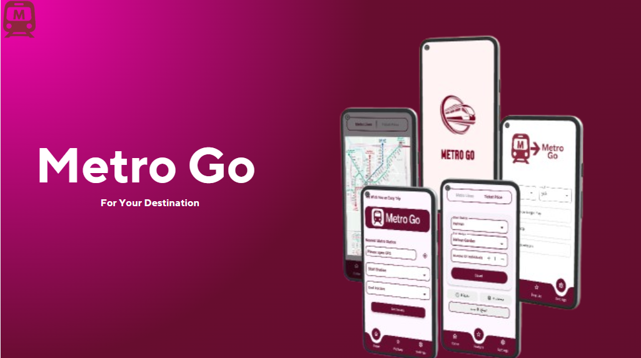

**Splash & Home Screen :**

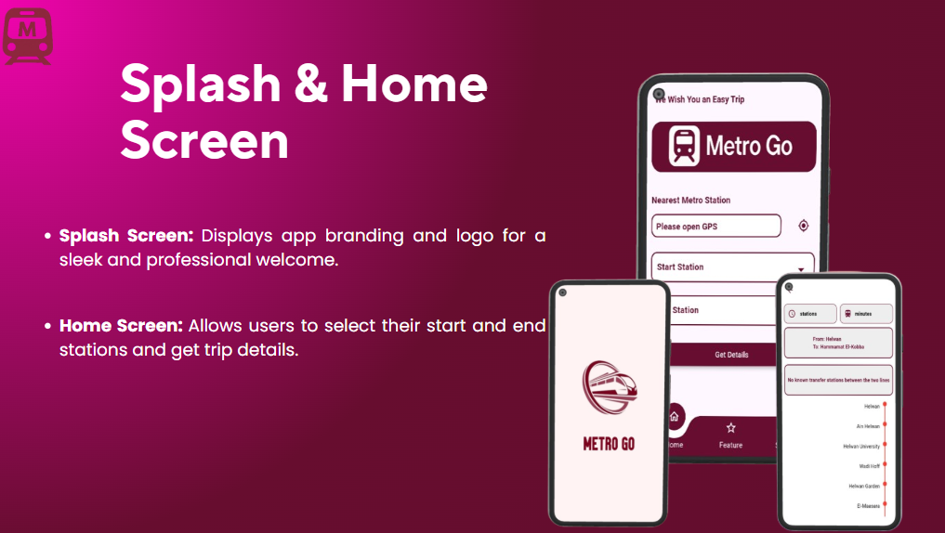

**Station Search UI :**

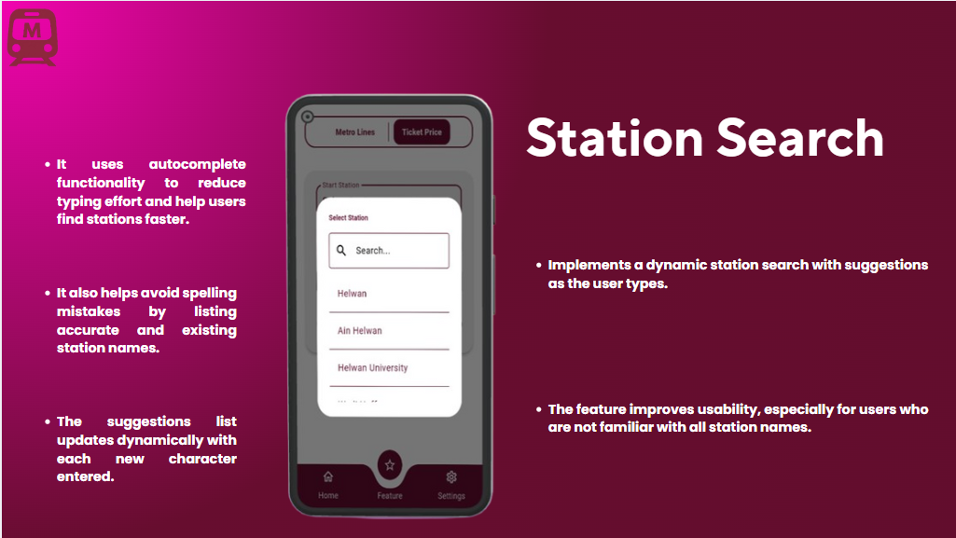

**Ticket Price Feature :**

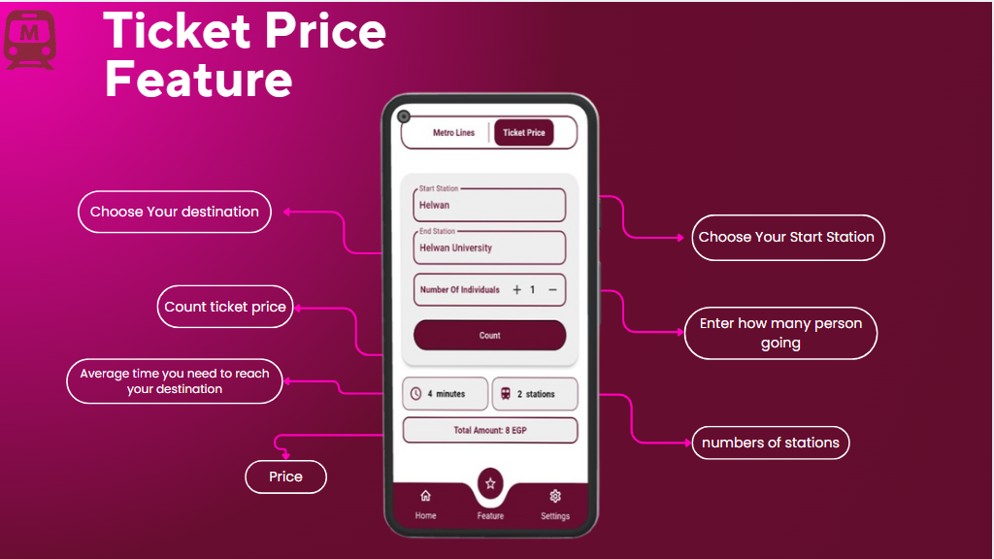

Metro Map Viewer

**Metro Map Viewer :**

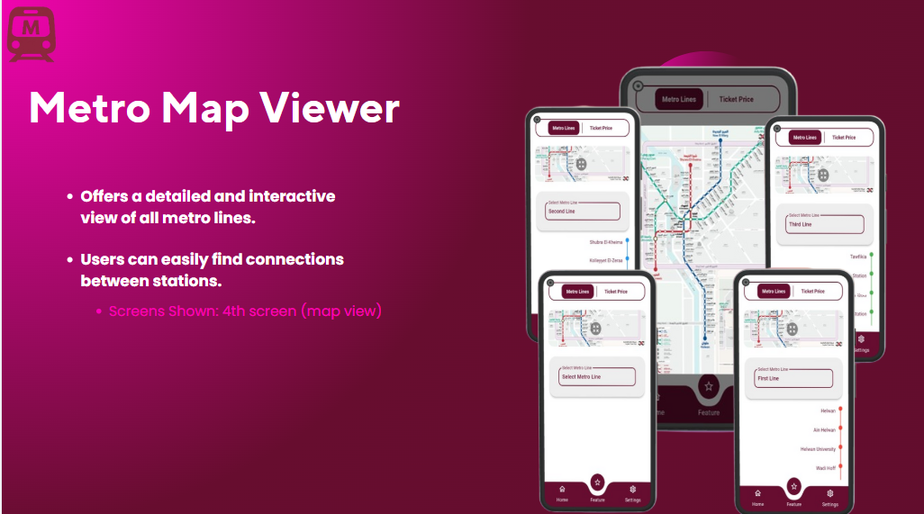

**Settings Screen:**

