How to play an MSO Mission
Version 0.4 by (AEF)Wolffy, (AEF)Swedge, (AEF)Capt Cranky. 6 December 2010.

How to play an MSO Mission
Welcome to Multi-Session Operations
What is an MSO?
What is my side’s goal in this mission?
Situation
Mission
Execution
Health & Welfare
What if I get injured or killed?
How do I change my View Distance?
Admin & Logistics
Artillery Support
Transport
How do I upright a vehicle that has rolled?
How do I change a tyre?
Construction
What resupply is available?
What are the Logistics options and how do I use them?
Communications
What is a JIP Marker and how do I make one?
What is an After Action Report and how do I make one?
How do I create, join, or leave a group?
How do I recruit AI?
What is a JIP Task and how do I make one?
How do I use a Logbook?
Did someone say ‘wild dogs’?
For Troops Returning to this Mission
Frequently Asked Questions

Welcome to Multi-Session Operations
You have just landed at one of our FOB’s. Take a moment to familiarise yourself with the layout of your FOB and the resources available to you. When you find the infantry ammunition crates, carefully select your equipment to ensure you can remain combat effective for several days on patrol. Do not count on resupply in the field.

What is an MSO?
A Multi-Session Operation! Unlike hour-long single-session missions that restart when the players disconnects, an MSO mission can persist for days. When you disconnect, your location, health, weapons and ammunition are saved for when you reconnect. The type of unit you first choose cannot be changed later or taken by other players. Up to 1,500 enemy units can be out there waiting for you 24 hours a day.

What is my side’s goal in this mission?
Just like in real life, this is really up to the imagination of your Commanding Officer.
Typically this will involve recon, patrols, assaulting static positions, clearing areas and settings up Checkpoints and Firebases, or recon and ambush of enemy convoys.
If you’re by yourself, go do some recon or covert ops. Place JIP Markers for what you see and add Tasks to the mission. When the next bunch of guys come in, they can take over where you left off.

Situation
BLUFOR has just established an FOB (or two) in the AO. We have no f**king idea what's actually going on out there, but sh*t's getting real beyond the wire.

Mission
The mission is to secure the entire AO, eliminating all OPFOR strongholds and weapons caches.
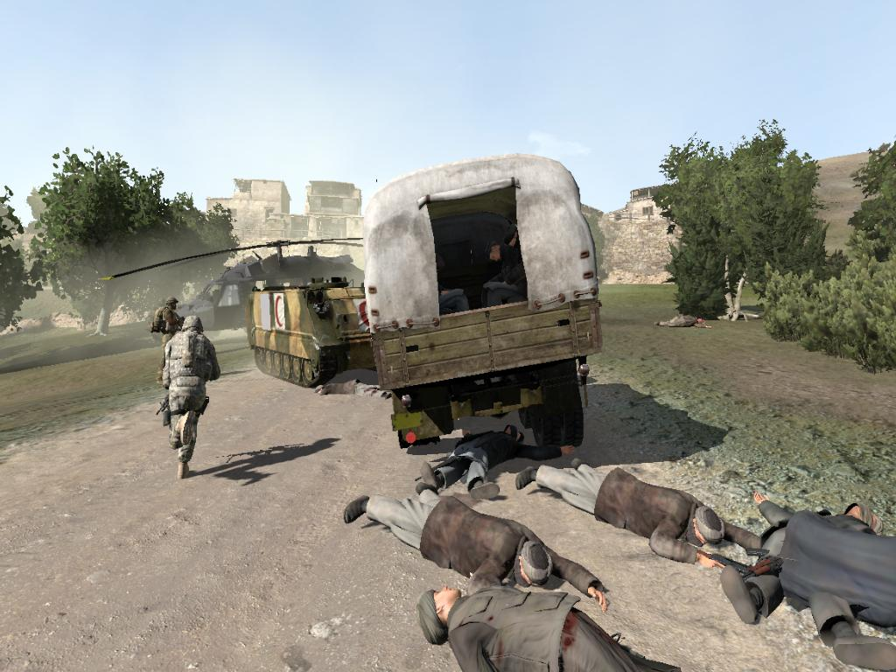

Execution
You will achieve this by ambushing and destroying enemy camps and supply convoys, and systematically securing all villages radiating outwards from the FOB positions.
The group marker system is up and running, so you will see BLUFOR positions marked on your map. OPFOR positions will also appear when in contact. HQ has intel on several enemy convoys operating within the AO. The start and end points for each convoy are marked on the map with numbers to identify each unique convoy. Known intermediate waypoints for convoys are also marked.
As additional intel on OPFOR movement comes to light the map will be updated accordingly.
Be prepared for unexpected enemy contact, and always have a plan to break contact and evade enemy, especially when OPFOR strength approaches or exceeds your own.

Health & Welfare
You will find an aid post within the FOB. Look for a building with a * on the sign out front. Here you can have your wounds dressed and get those much needed transfusions to replace all the blood you left in the field.
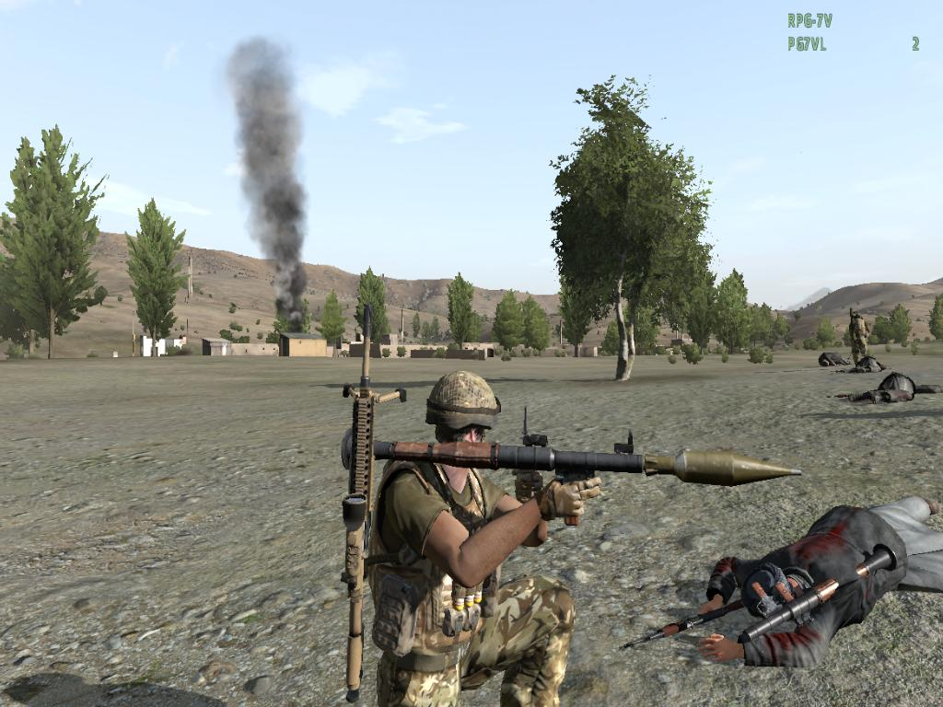

What if I get injured or killed?
If you’re lucky, you can be revived. If you’re injured, there are portable MASH tents or make it back to the FOB for access to the Field Hospital. Worst case is, you’ll respawn back at base with your weapons, but you can only do that a limited number of times (2 - 7).
Remember to always pack the MASH with you if you plan on getting into the thick of it well beyond the FOB.

How do I change my View Distance?
Use the Communications Menu (0-8) and select Settings. Change your view distance and terrain detail, and then press ESC to escape.

Admin & Logistics

Artillery Support
Near the vehicle supply depot you should find some mortars, search lights, and field guns. You can load (or hitch) these into vehicles for field deployment. Each piece includes a small supply of ordinance and artillery computer.

Transport
Offroad vehicles and Jackals are available for transport. Look after them and be sure to bring them back in one piece. Check to see if there is a Vehicle Service Point at your FOB.
Each FOB has one helo which is suitable for transporting personnel, shipping containers and equipment.
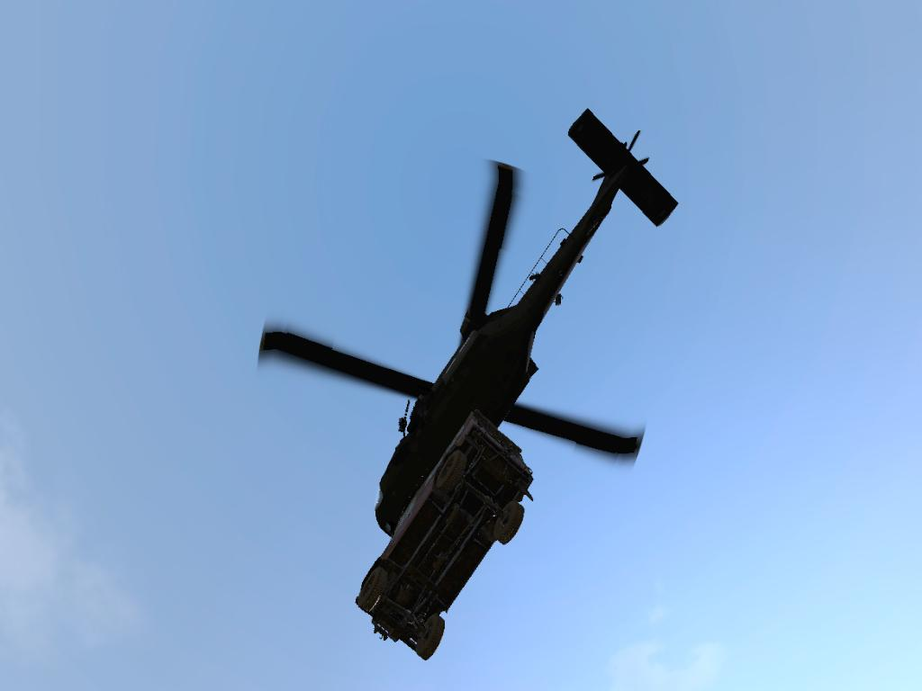

How do I upright a vehicle that has rolled?
All motorcycles or ATV have a Flip Vehicle action so they can be up-righted when rolled. For larger vehicles, use the towing facility.

How do I change a tyre?
All wheeled vehicles have a change tyre option. You need to have brought a spare tyre with you to utilise it though.

Construction
Various ready made construction kits are a available at the FOB. These can be redeployed within the AO by loading them into the appropriate vehicles. Kits include:
- bunkers
- MASH
- razor wire
- steel tank traps / dragon's teeth
- walls
- MG emplacements

What resupply is available?
- When backpacks are taken from the base and moved from the area, they are replaced in 60 seconds.
- Ammunition crates are replaced every 4 hours.
- Most building materials are replaced every 8 hours.
- Transport vehicles will respawn at the base in 12 hours if they are destroyed.
- Support and Attack vehicles will respawn at the base in 24 hours if they are destroyed.
Remember, it is better to pack the entire ammo crate in the back of the vehicle as it will resupply in a few hours.

What are the Logistics options and how do I use them?
The Logistics system enables you to carry, tow, air lift, store and view contents of vehicles and aircraft. You can transport and position building materials to build Forward Operating Bases (FOBs) and transport damaged vehicles back to base. Approach a vehicle and a selection of actions in yellow should activate, allowing you to carry, tow, lift, store and view contents per vehicle.
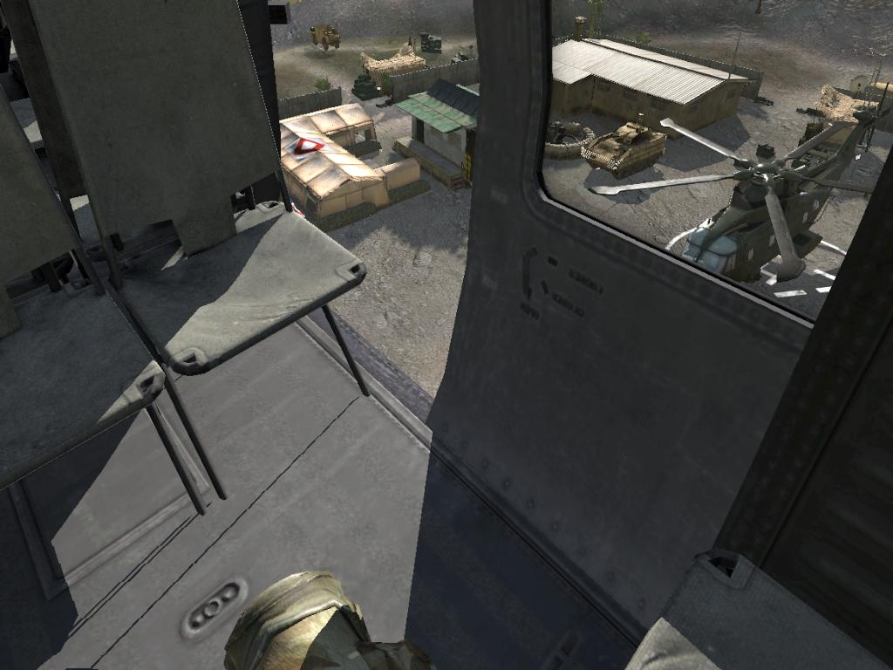

Communications
We will have several squads operating both jointly and independently within the AO. To ensure effective sharing of intel, please observe the following:
- When marking up the map, use the JIP Markers described below
- After contact with OPFOR, submit an After Action Report described below.
- When writing AAR, include the grid reference or town(s) where the action occurred.
- Before writing AAR, tally KIA and WIA of all sides to include in report.

What is a JIP Marker and how do I make one?
Join In Progress Marker that can be seen by players who Join the mission while it is In Progress. Any enemy contacts should be marked with a JIP Marker ASAP to help keep every other player up to date on what’s happening in the battlefield. All players are able to add JIP Markers, which are displayed in the Map screen. To create a JIP Marker, ALT+Click the map, where you can enter the marker type and text description. To delete a JIP Marker, ALT+Click near the marker, and select Delete Nearest from the dialog.
Remember, this is the best way to keep the rest of your team informed on what you saw while they were away.

What is an After Action Report and how do I make one?
After every incursion or event, you should add an After Action Report. This is a summary of an incident, including the event, date/time, location, observation, and lessons learned. Its best to submit them ASAP, so you don’t forget and it helps keep every other player up to date on what’s happening. All players are able to add AARs, which are displayed in the Map screen under Notes. To submit an AAR, use the Communications Menu (0-8) and select AAR. Fill in the details and click Submit to post.
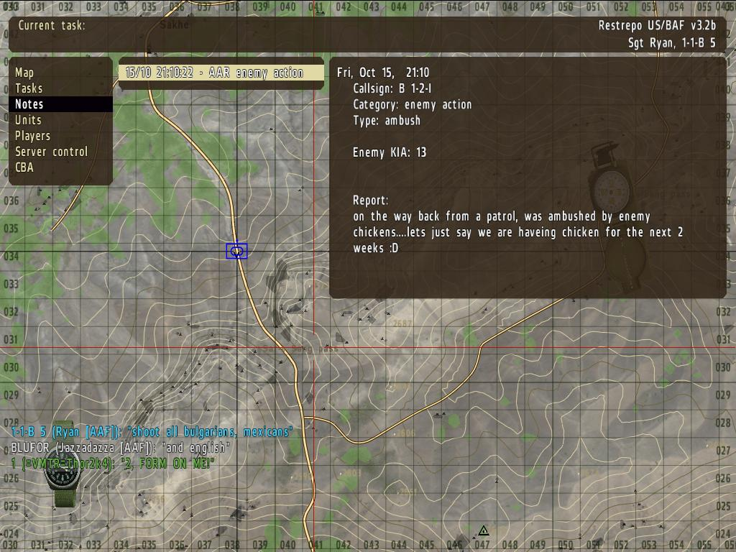

How do I create, join, or leave a group?
The Team Status dialog allows you to create, join and leave groups. This action is typically available from a HQ or Barracks object.

How do I recruit AI?
Using the AI recruitment dialog, AI can be recruited to man static defences or created into a new group to make them autonomous. Team Leaders can recruit up to 6 AI units to join their group. This is handy when defending bases while players are disconnected. This action is typically available from a HQ or Barracks object.

What is a JIP Task and how do I make one?
If a CO would like all players to focus on specific tasks, these should be created here. Only Team Leaders can add JIP Tasks, which are displayed in the Map screen. To create a JIP Task, SHIFT+ALT+Click the map, where you can enter the task title and text description. To delete a JIP Tasks, SHIFT+ALT+Click near the marker, and select Delete Nearest from the dialog.

How do I use a Logbook?
These are typically available on Notice boards, Notebooks, Laptops, or Satellite Phones. To use the Logbook, simply select the action on the object, add your text and press submit.
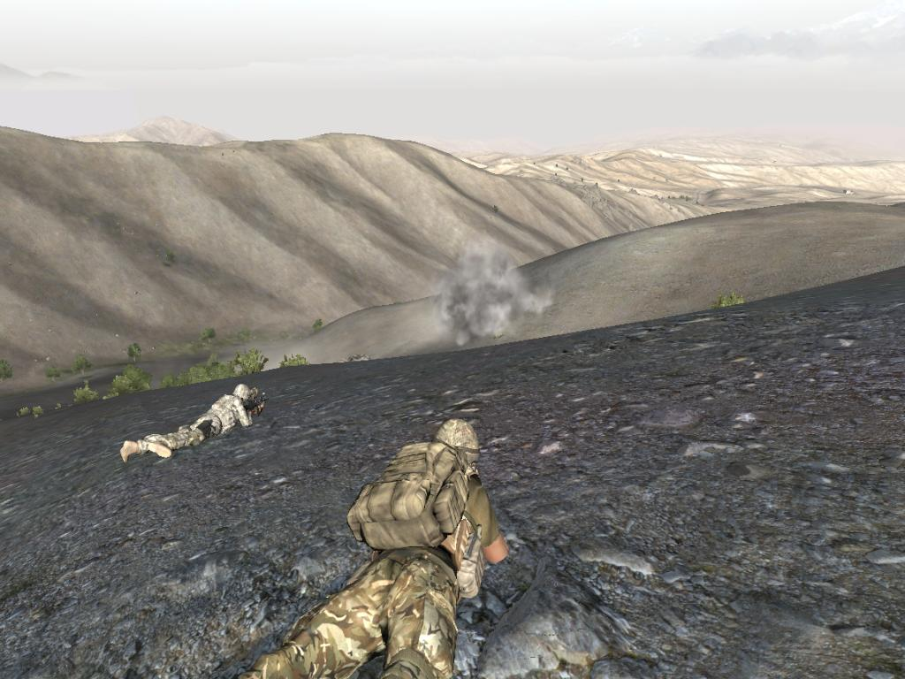

Did someone say ‘wild dogs’?
Players may be attacked by packs of wild dogs.

For Troops Returning to this Mission
You will initially be reinserted as a new recruit at the FOB. Be patient and wait a while and you will find yourself miraculously repositioned to wherever you left off complete with all the gear you were carrying when you left the mission.

Frequently Asked Questions
- Why can’t I connect anymore?
Most likely, you’re trying to connect as a different class than you did the first time. Just choose the class you previously used and it should be fine.
The only other reason is that you’ve run out of lives. You’ll have to wait until the mission is restarted to join again.
- What am I supposed to do again?
Go on a patrol or recon an MSR. Make sure you mark what you engage and see using JIP Markers and fill out your AAR’s ASAP for the rest of the team to benefit.
- Will the vehicles respawn?
They’ll only respawn if completely destroyed. If they are repairable, mark them on the map using JIP Markers and treat it as an objective to recover them.
- What should I take with me on patrol?
MASH tent, ammunition, a mortar is handy, some spare tyres and anything else you think would be great to have in a squeeze.
- Why is there so much mess at the base?
Its all building materials for you to go forth and reproduce. Pack what you need in a shipping container (transport by heli) or in a truck, and go setup a Fire Base on a hill top somewhere. Your team will really appreciate the Artillery if you need to take down something big.

