Alarm Correlator Tool
ACT System Design

Version <1.0>

Revision History
Date | Version | Description | Author
7 May 03 | 1.0 |  | Shih-Yang Chou

Table of Contents
1. Introduction 1
2. System Design Overview 1
3. ACT System Class 1
4. Class Descriptions 4
4.1 Manager Class 4
4.1.1 AlarmManager 4
4.1.2 NTManager 4
4.1.3 RDManager 4
4.1.4 AOManager 4
4.1.5 RCManager 5
4.1.6 GUIManager 5
4.1.7 Logger 5
4.2 Alarm 5
4.2.1 Attributes 5
4.2.2 Description and Operation 5
4.3 Network Element 6
4.3.1 Attributes 6
4.3.2 Description and Operation 6
4.4 Network Topology 6
4.4.1 Attributes 6
4.4.2 Description and Operation 6
4.5 Alarm Group 6
4.5.1 Attributes 6
4.5.2 Description and Operation 7
4.6 Rules Definition 7
4.6.1 Attributes 7
4.6.2 Description and Operation 7
4.7 Alarm Occur 7
4.7.1 Attributes 7
4.7.2 Description and Operation 7
4.8 Correlator 7
4.8.1 Attributes 7
4.8.2 Description and Operation 7
4.9 KnReplication 8
4.9.1 Attributes 8
4.9.2 Description and Operation 8
4.10 ACT Station 8
4.10.1 Attributes 8
4.10.2 Description and Operation 9
4.11 ACT_GUI 9
4.11.1 Attributes 9
4.11.2 Description and Operation 9
4.12 LogMessage 9
4.12.1 Attributes 9
4.12.2 Description and Operation 9
4.13 PeerACTClient 9
4.13.1 Attributes 9
4.13.2 Description and Operation 9
4.14 PeerACTServer 9
4.14.1 Attributes 9
4.14.2 Description and Operation 9
5. User Interface Design 9
5.1 Component Layout 9
5.2 Reservation Tables 13

Design

Introduction
The purpose of the Alarm Correlator Tool (ACT) is to assist NMS with alarm diagnosis and tracking. The ACT is a DSS that uses a rules-based approach to identify the root cause of a fault scenario and report the best corrective action if one exists. The roles of ACT in a distributed NMS architecture will now be considered as it pertains in both distinct levels of functionality. The first role is at the local cable stations where it will be used to assist the operator engineers and/or technicians in diagnosing local equipment problems. The rules, topology configurations, and alarm definitions are confined to the immediate jurisdiction of the cable station (including “end of a fiber” locations) in this function that all share the same rules and alarm definitions. This requirement facilitates replication between neighboring stations nodes, such that “learned” scenarios can be disseminated to other actors.
The second role for the ACT addresses the top-level NMC. Since alarms across the network are aggregated for use at the upper level NMS, the raw data the ACT would require already exists at a central server at the NMC. Rules and alarm definition are already required for the network level correlation. The initial phase would require simple replication of the cable station level rules, topology and alarm definitions. Having done this, it is now necessary to “tie” these together with NMC rules that represent the topology of the entire network. That is, cable station rules and alarm definitions represent connections within each cable station.
The NMC is solely responsible for this second function. The proposed ACT knowledge exchange pattern achieves a number of previously unattainable features; namely:
- ACT provides a mechanism to leverage local field personnel’s intimate knowledge of the cable station layout and equipment. This knowledge can then be used to diagnose higher-level problems at the network level.
- ACT facilitates distributed knowledge acquisition and sharing through a single tool interface.
- Learned scenarios become shared knowledge by dynamically distributing them to all cable stations and the NMC.
- Learned scenarios become shared knowledge by dynamically distributing them to all cable stations and the NMC.

System Design Overview
This document will provide with the design of the class in the ACT system. During the introduction of the class, it will be clearer to understand the design of this system. In addition to the class diagram with precise relationship between any two related classes, we also list the attributes, operations, and clearer description for users to comprehend the multifunctional ACT system. Each of these classes is described in the following sections. The purpose of this section is to outline each of the major classes' attributes and operations, to provide the implementation team an easier transition between design and actual code. Note that all attributes and operations for each class will be listed here.
Besides, we will discuss about the graphic user interface that is also an important part in design. To explain this, we place the screen shot here with description about how to design the user interface.

ACT System Class
In following diagram, it includes all of the classes in this system, and also description of it. The attributes, operations, relations, and comparison within classes are listed in following diagram.

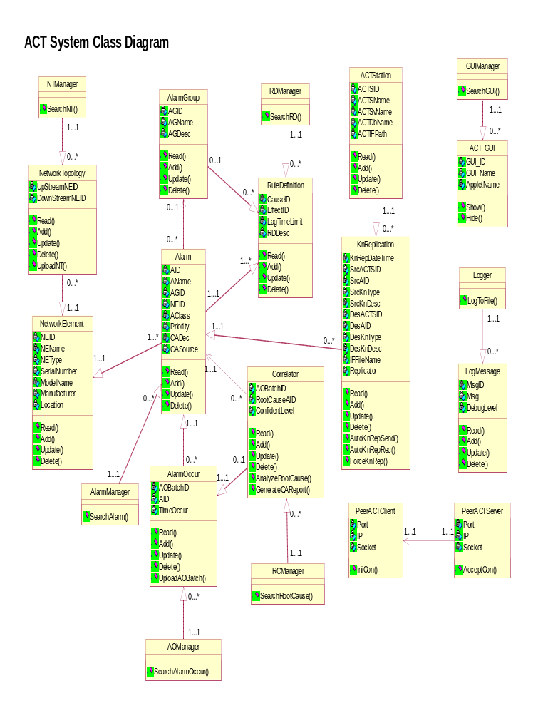
Diagram 1. ACT System Class Diagram

Class | NTManager | RDManager | GUIManager | AlarmManager | AOManager
Attribute
Operation | SearchNT | SearchRD | SearchGUI | SearchAlarm | SearchAlarmOccur

Class | RCManager | NetworkTopology | NetworkElement | Alarm | AlarmGroup
Attribute |  | UpStreamNEID  DownStreamNEID | NEID  NEName  NEType  SerialNumber  ModelName  Manufacturer  Location | AID  AName  AGID  NEID  AClass  Priority  CADec  CASource | AGID  AGName  AGDesc
Operation | SearchRootCause | Read  Add  Update  Delete  UploadNT | Read  Add  Update  Delete | Read  Add  Update  Delete | Read  Add  Update  Delete

Class | AlarmOccur | Correlator | RuleDefinition | KnReplication | ACTStation
Attribute | AOBatchID  AID  TimeOccur | AOBatchID  RootCauseAID  ConfidentLevel | CauseID  EffectID  LagTimeLimit  RDDesc | KnRepDateTime  SrcACTSID  SrcAID  SrcKnType  SrcKnDesc  DesACTSID  DesAID  DesKnType  DesKnDesc  IFFileName  Replicator | ACTSID  ACTSName  ACTSvName  ACTDbName  ACTIFPath
Operation | Read  Add  Update  Delete  UploadAOBatch | Read  Add  Update  Delete  AnalyzeRootCause  GenerateCAReport | Read  Add  Update  Delete | Read  Add  Update  Delete  AutoKnRepSend  AutoKnRepRec  ForceKnRep | Read  Add  Update  Delete

Class | ACT_GUI | Logger | LogMessage | PeerACTServer | PeerACTClient
Attribute | GUI_ID  GUI_Name  AppletName |  | MsgID  Msg  DebugLevel | Port  IP  Socket | Port  IP  Socket
Operation | Show  Hide | LogToFile | Read  Add  Update  Delete | AcceptCon | IniCon

Figure 1. ACT System Class

Class Descriptions
The class diagram describes how classes relate to each other, and the numeral comparison between relatively two classes.

Manager Class
Manager class in the ACT System Design represents basically a container that allows access to and from each specific class. In ACT system design, there are 7 managers class described below in our system design.

AlarmManager

Description
From AlarmManager class, users can call function to manipulate alarm. It includes defining, updating, deleting, and adding alarms in the system. It allows users to iterate through all defined alarms, or to search for a specific one by matching NEID or NAME.

Operations
SearchAlarm is a member function to let the class access the Alarm class. So that users can start to manipulate alarm.

NTManager

Description
NTManager class might match what users want with LinkID in NetworkElement Class through Network Topology class to search for specific Network Element.

Operations
SearchNT helps users to access the Network Topology class, so that users can search for a specific Network Element by matching the LindID.

RDManager

Description
RDManager class allows users to enter Rule Definition class to search for specific rule definition. At the meantime, users also can manipulate the rule definition by updating, adding, reading, or deleting it.

Operations
By using ResearchRD order, users can access the Rule Definition class to manipulate rules that they want.

AOManager

Description
AOManager class allows users to access AlarmOccur class so as to read, add, update, delete, or upload alarm list from NMS's interface file

Operations
SearchAlarmOccur means a function used to search for the alarm that has occurred in the network.

RCManager

Description
It is a manager for users to access the Correlator class, so that the correlator can be used to iterate through all current alarms and analyze the root cause.

Operations
By using ResearchRootCause function, users can access Correlator class to find the root cause through corrleator’s analysis

GUIManager

Description
GUIManager class allows users to access the ACT_GUI class to decide how the user interface is deployed.

Operations
SearchGUI operation can be used to access the ACT_GUI class.

Logger

Description
A Logger class carries out generic logging to a file.

Operations
LogToFile operation allows users to access the LogMessage class so that they can find specific log message.

Alarm

Attributes
For each Alarm, there are 8 attributes include AID (alarm ID), AName (alarm name), AGID (alarm group ID), NEID (network element ID), Aclass(such as primary or secondary described below), priority (1,2,3…) , CADesc (corrective action description), and CADSource (corrective action source).
Alarm | Primary | Secondary
Description | Primary Alarms on a specific element (with a numbered precedence) | Secondary Alarms on a specific element, caused by a primary alarm

Description and Operation
Users can read, add, update, or delete the specific alarm in the system. Alarm class offers users to inquire, create, update, or delete alarms. Every alarm may belong to at most one alarm group, or may not belong any alarm group. If an alarm is not in a group (set AGID to NULL), users can decide which alarm group that the alarm can be put in. A single corrective action may be used for many alarms, and then to save typing/memory users can do it the way they have it.
There is relationship between Alarm Class and many classes such as AlarmGroup, RuleDefinition, NetworkElement, AlarmOccur, Correlator, and KnReplication classes (see the class diagram).

Network Element

Attributes
NEID (network element ID), NEName (network element name), NEType (described in the figure below), Serial number (of each element), ModelName (ports such as Amp 1, Amp 2…), Manufacture, and Location (ex. Encoder).
NE Group | Transceivers | Receiver | Amplifiers | Combiners & Splitters | Telemetry
Function | Transmit signal (Decode/Encode). | Receive Signal (Decode/Encode). | Amplify incoming/outgoing signal. | Perform Multiplexing/ De-multiplexing. | Provide network time synchronization and misc. functions

Transceivers encode data for transmission (i.e. Tx). Multiple transmitted wavelengths are combined via a combiner. The aggregate signal can then be amplified and transmitted across fiber to its destination (this is a much simplified picture, but it will suffice to drive a generic design that can then be used to model more complicated network architectures). At the destination, the signal is again amplified, then it is split (via a splitter) into it’s separate wavelengths via a splitter and finally, it is delivered to the Receive (Rx) side of a transceiver. As the number of transmission channels in a fiber increases (as well as the number of fibers in a cable) so does the amount of equipment.

Description and Operation
From the figure above, this class offers users the information about specific network element to read, add, update, or delete from the system. There is relationship between itself and other two classes such as NetworkToplogy and Alarm class (see the class diagram).

Network Topology

Attributes
LinkID, UpstreamNEID, and DownStreamNEID of the network topology.

Description and Operation
When users access NetworkTopology class through NTManager class, they can
get the information such as UpstreamNEID, and DownStreamNEID of the specific network topology by matching the LinkID. Users can also read, add, update, delete, and upload network topology from NMS’s interface file. Besides, there is relationship built to NetworkElement class that users also can find.

Alarm Group

Attributes
Alarm Group class has AGID (alarm group ID), AGName (see figure below), and AGDsec (alarm group description) as its attributes..
Alarm Group | Transmission (Trail) Alarm | Equipment Alarm | Causal Alarm | Caused Alarm | Primary Alarm | Secondary Alarm
Description | Alarm that is due to signal or link degradation | Alarm that is due to a NE fault | Alarms that cause alarms in downstream elements | Alarms that are caused by upstream elements | Primary Alarms on a specific element (with a numbered precedence). | Secondary Alarms on a specific element, caused by a primary alarm

Description and Operation
Alarm group has its rule definition, and consists of alarms, so there is relationship with the two classes. The users also can read, add, update, and delete the information of alarm group in this class.

Rules Definition

Attributes
Users can check CauseID, EffectID, LagTimeLimit, and RDDec (Rule definition description) of the rule definition.

Description and Operation
To correctly perform complete root cause analysis at the network level, rules and alarm definitions that define failures at the links connecting all the nodes must also be defined. After users enter the class through RDManager class, this class is called. Rule Definition class can be based on both alarm groups and individual alarms. For alarm groups, it means that if all primary alarms occur, it will cause all Secondary Alarm to occur. In the class, Boolean-based rules can be used to define how the tool will treat a scenario. The rules module allows for all relational Boolean statements (e.g. “NOT”, “AND”, “OR”, etc.). In this way, users can read, add, update, and delete the rule definition in the system.

Alarm Occur

Attributes
The attributes of this class include AOBatchID (Alarm Occur BatchID which is primary key), AID (alarm ID), and TimeOccur (the time at which the alarms occur).

Description and Operation
AlarmOccur class means that the system produces alarm occur list from NMS’s interface file, so that the correlator class mentioned below can do the correlation work. Through the AOManager class, the operations allow users to read, add, update, delete the alarm occur information, and also upload the alarm occur list from the NMS’s interface file. So that when the alarms occur, NMS can directly transfer the list to ACT systems. After receiving the alarm list, it can contact the Correlator class to do the analysis and evaluation to find the root cause.

Correlator

Attributes
Correlator attributes includes AOBatchID (primary key to find the specific alarm occur list), RootCauseAID, and ConfidenceLevel.

Description and Operation
Correlator class stands for the class that actually assists NMS with alarm diagnosis and tracking. When alarms occur, through AlarmOccur class, this class can get the list of alarms that have occurred. In addition to adding, updating, reading, and deleting the data, the Correlator class can analyze the alarms in the alarm list to find the root cause. Section Scenario below will discuss clearly how the Correlator class analyzes the alarms to find the root cause by calculating the lag time, and matching it with the lag time limit from the Rule definition class.

KnReplication

Attributes
There are many attributes recorded for the knowledge replication process such as:

KnRepDateTime
To record time of replication.

SrcACTSID
Source of ACT station ID.

SrcAID
Source alarm ID.

SrcKnType
Source knowledge type (corrective action/ rule definition).

SrcKnDesc
Source knowledge description (of corrective action or of rule definition).

DesACTSID
Destination ACT Station ID. It means the station to which the knowledge would be replicated.

DesAID
Destination Alarm ID. It means the alarm to which the knowledge would be replicated.

DesKnType
Destination knowledge type (corrective action/ rule definition).

DesKnDesc
Destination knowledge description (of corrective action or of rule definition).

IFFileName
Interface file name of sender and receiver in auto replication process, or the name is null in forced one.

Replicator
Auto (in auto replication) or the user’s name (in forced replication)

Description and Operation
The replicate knowledge class is for logging purposes. For the class, system can read, add, update, and delete the logging file. Besides, it produces the logging file when executing automatic replication or forced replication, which are the functions in this class.

ACT Station

Attributes
The class includes attributes such as ACT station ID, ACT station name, ACT server name, ACT database name, and ACT interface path.

Description and Operation
There are operations such as adding, updating, changing, and deleting the information of the ACT station.

ACT_GUI

Attributes
The class includes attributes such as graphic user Interface ID, graphic user Interface name, and Applet name.

Description and Operation
This class shows how information of alarms, rules, network, and all messages would be displayed in the ACT system. They consist of some generic table row class that inherits and customizes the Java tables. The operations of this class include showing or hiding the GUI.

LogMessage

Attributes
There are three attributes (Message ID, Message, and Debug Level) in this class.

Description and Operation
A generic logMessage class contains a debugLevel and string of what to print to file. After logger class logs to file, it will produce a log message. Besides, the log message can be read, added, updated, or deleted from the system.

PeerACTClient

Attributes
Port, IP address, and socket of the ACT client.

Description and Operation
The class is used to initiate connection to peer act.

PeerACTServer

Attributes
Port, IP address, and socket of the ACT server.

Description and Operation
The class is used to accept connection from peer act

User Interface Design

Component Layout
ACT system interface is based on friendly function for users to easily use. The ACT system is opened with a main menu, which offers users to select what they want to execute. In addition to the buttons of function that users can directly click, the interface also offers selective menu on the top of the interface for users to select. For example, in the main menu shown below, users can either directly select “Force Replication” button or select the “Action” in the menu, and then choose the same order. In short, the ACT system interface offers two methods for users to execute their works.

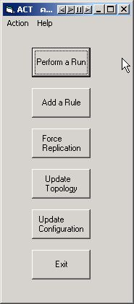

Diagram 2. Main Menu

We design to create an interface easy to use for the users. Once users select the button with certain function, the system will do the specific work by matching the specific button or selection (e.g. “NMS-SERVER_1” in the pull menu). Besides, we also offer users to select “Cancel” if they regret it.

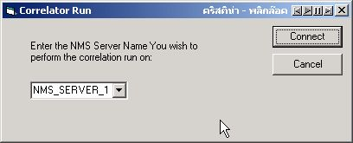

Diagram 3. Automatic Knowledge Replication

In our interface, it will react to the process or searching result for users to know how is the work going. There are explanations anywhere for users to know what is the meaning of any changes.

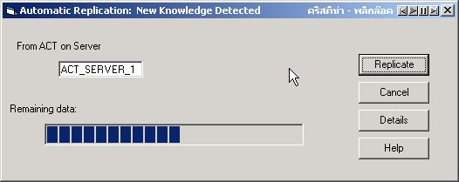

Diagram 4. Replication Processing

The user interface is a kind of connection to printer, internal database, and so on. It is free and easy for users to transmit their orders to them.

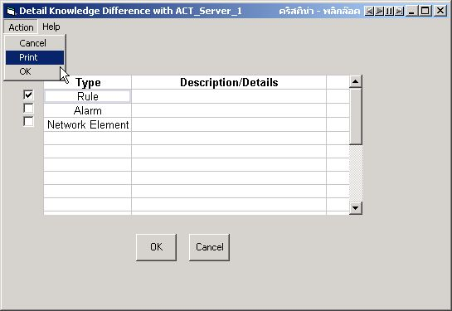

Diagram 5. Print

In order to show the Boolean algorithm, ACT system uses the text box for users to create new rules. At the meantime, the result will show in another text box to be confirmed.
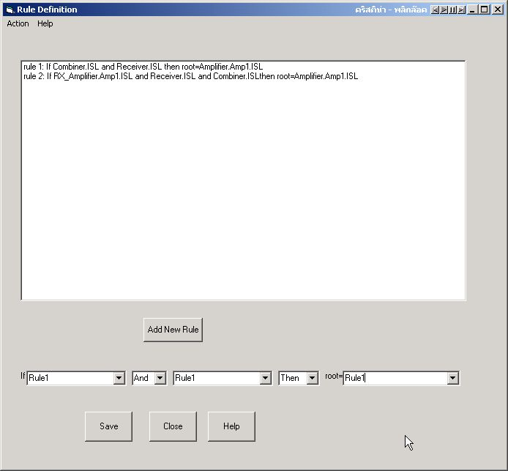
Diagram 6. Boolean Algorithm

In our system, the existing data in database can show up if users select other entities related to it. The system also can update the data if users overwrite or update it.
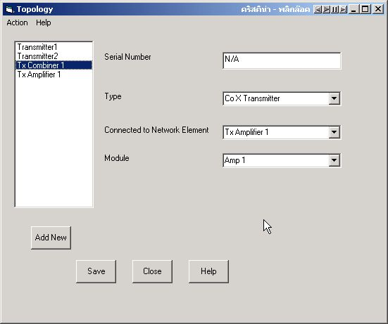
Diagram 7. Data Entry

Reservation Tables
If there are lots of data to be compared, we design to create a table loading it. From the database, the system can grab the data users want to know on the screen. Then the users can manipulate the data directly.
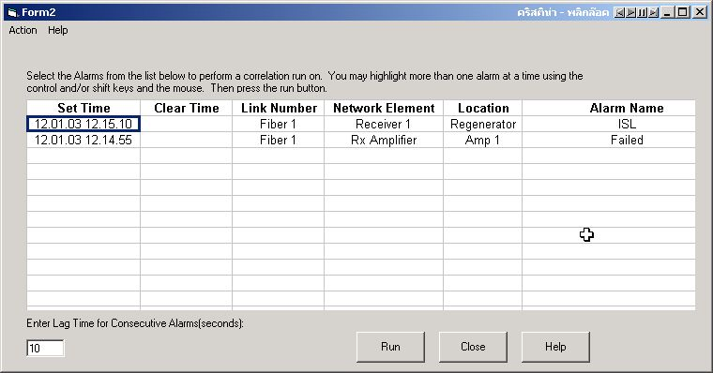
Diagram 8. Reservation Tables - 1

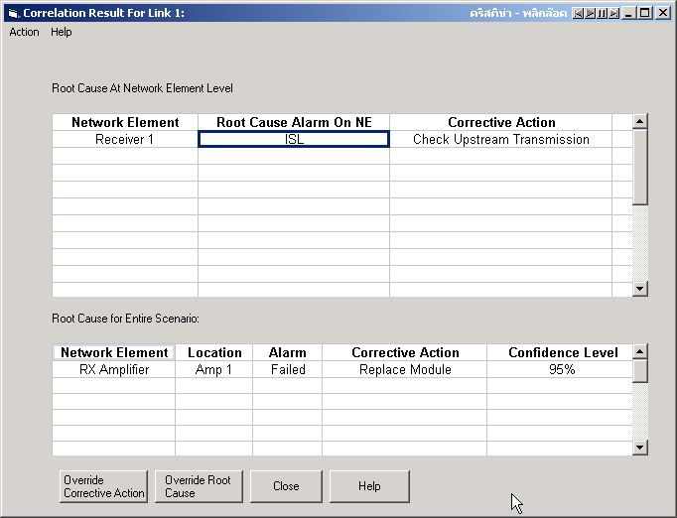
Diagram 9. Reservation Tables - 2

