https://github.com/amm9093/e-portfolio/tree/main/capstone-project

Introduction
The purpose of this submission is to put forward a cloud strategy for Meridian Health Group, a private hospital network in the UK (hypothetical). A hybrid AWS platform is put on the table, one that is constructed with Terraform and makes use of AI, automation and hybrid connectivity; the risks and regulatory side of patient data are also appraised. The document has two sections. In the first I offer some reflective commentary on what was learned in the course of the project. An appendix contains the remainder of the assessment report in the form of an executive summary, solution design, risk and compliance and advanced technologies as well as any recommendations for the future and their supporting appendices. One will find all of this, along with the Terraform code and evidence of its validation and testing, in my ePortfolio at the above link.

Reflective Commentary
I have drawn on nursing and management education, where one is accustomed to structured reflection, and set about weighing up four models before putting pen to paper. There is Kolb’s (1984) experiential learning cycle which can account for the way active experimentation follows on from concrete experience, but it is too broad to be of much use in writing a reflection. Then there is the Johari Window (Luft and Ingham, 1955) which, while good at uncovering blind spots via the feedback of others, is more applicable to interpersonal development than to the dissection of a project. Driscoll (2007) has his “What? So what? Now what?” approach that is in vogue in clinical supervision for its brevity, yet it does not allow for the emotions to be probed.
Gibbs’ Reflective Cycle (1988) was the one I settled on. With its six steps from description through to an action plan it is able to encompass the analytical as well as the emotional aspects of the undertaking. In the analysis I made the Johari Window a secondary tool to distinguish between weaknesses of my own making and those brought to light by feedback. To ensure I was doing more than describing, and actually evaluating and creating, I applied Bloom’s revised taxonomy (Anderson and Krathwohl, 2001) at every turn.

Description
My brief was to come up with a cloud strategy for a hypothetical hospital network in the UK. I opted for the healthcare sector on the basis that the sensitivity of patient data and the degree of regulation make it a stern test for any cloud strategy. It was a matter of bringing together Infrastructure as Code, AI, the hybrid cloud and what is to come in a single plan, while minding the regulations. Six weeks were spent on the research, in putting together a risk register and in writing Terraform modules and comparing designs; I put my case in the module seminars and on the discussion forum as well.

Feelings
Technically I was in no doubt as to the soundness of the design, but the regulation was something of an imposition. With so many layers to healthcare compliance I found myself frustrated by the apparent obligation each source would bring. But once I could see the requirements being met by a technical control like the service control policy for data residency, there was a sense of satisfaction. As for the Terraform code, I was not without my anxieties; up until now my use of it had been confined to the odd lab exercise, not a multi-account design.

Evaluation
For the most part the decision-making was sound. I did not simply go with whatever was in fashion, but took the time to weigh up ECS and EKS or Terraform and CloudFormation and OpenTofu for every major point of choice. There is a certain defensibility to my reasoning when I put the rationale down in a table. The risk registers were effective for much the same reason, in that I had to account for my priorities by scoring every risk.
Time management was not so good. I put in nearly two weeks on regulatory research before I got around to writing code and as a result did not have as much time for testing. At one point I was of the view that all patient data could be housed in a single region; it was only later I found out AWS has but one UK region. That discovery obliged me to put in a cross-border transfer in the risk analysis and do some rethinking of the disaster recovery plan.

Analysis
If I am critical about what transpired, there is a pattern to be seen: I have no trouble with the technical side of things but have a way of leaving governance to the end. One learns from this project that in any regulated sector, compliance will dictate the architecture. The matter of data residency was not so much a technical error as a gap in the requirements. It is an example of “shift-left” security, where one designs in the controls at the outset instead of testing for them afterwards.
The AI portion presented its own difficulties. I was inclined to put together an AI scribe of my own making, purely on the strength of the technical challenge. Then I read the NHS England guidance and saw the light; to build it would be to make the hospital into a medical device manufacturer. I have come to see the difference between what can be done and what is responsible for the organization. A classmate in a seminar made me think of something I had overlooked entirely by posing the question of who would be left with the clinical liability should an AI summary prove incorrect.
Using the Johari Window, my time management is an open book, a weakness I was aware of. My habit of regarding governance as an afterthought was a blind spot, brought to my attention by my tutor’s comments on an early draft. I was also influenced by some collaborative learning. When a peer in the module forum took issue with my use of public cloud and asked why I did not just leave the patient data on premises, I was defensive. But once I gave his perspective some thought it prompted me to decide which workloads really needed to be moved, hence the hybrid placement table in 3.3. As a cloud architect dealing with finance, clinicians and security as well as engineers, I have been shown that being able to explain oneself and put up with contrary views is as important as any technical know-how.
I also saw a lack of evidence in my work. Code does not prove itself, and validation has to be given as much planning as the design.

Conclusion
I am better placed now to put forward design decisions based on evidence and to produce Infrastructure as Code that will see to policy enforcement, having honed my skill in assessing cloud architectures for cost, regulation and business needs. I am equally clear on my failings: I must be more rigorous with my research, allow for testing from the off and involve myself with governance sooner.

Action plan
Appendix D contains my professional development plan and the actions I have put in place, all of which are measured to the standards of SFIA 9 (the BCS/Chartered Institute for IT skills framework). To give an overview:
- By March 2027 I will have obtained the HashiCorp Certified: Terraform Associate credential and executed the report’s code in full on my AWS account.
- With a view to making governance an integral part of how I design, I shall be studying the NCSC Cyber Assessment Framework and finishing the AWS Certified Security – Specialty course before June 2027.
- On my next project a time-boxed approach will be adopted, with a minimum of 25% of the time put aside for validation and testing.
- I intend to secure a mentor in either cloud architecture or healthcare IT no later than March 2027, making use of LinkedIn and the specialist groups at BCS.

References for the reflective commentary
Anderson, L.W. and Krathwohl, D.R. (eds.) (2001) A Taxonomy for Learning, Teaching, and Assessing: A Revision of Bloom's Taxonomy of Educational Objectives. New York: Longman.
Driscoll, J. (2007) Practising Clinical Supervision: A Reflective Approach for Healthcare Professionals. 2nd edn. Edinburgh: Baillière Tindall Elsevier.
Gibbs, G. (1988) Learning by Doing: A Guide to Teaching and Learning Methods. Oxford: Further Education Unit, Oxford Polytechnic.
Kolb, D.A. (1984) Experiential Learning: Experience as the Source of Learning and Development. Englewood Cliffs, NJ: Prentice Hall.
Luft, J. and Ingham, H. (1955) 'The Johari window, a graphic model of interpersonal awareness', Proceedings of the Western Training Laboratory in Group Development. Los Angeles: University of California, Los Angeles.
SFIA Foundation (2024) SFIA 9: skills directory A–Z. Available at: https://sfia-online.org/en/sfia-9/all-skills-a-z (Accessed: 11 October 2026).

Appendix: Cloud Strategy Assessment Report
The sections below answer the five assessment tasks. The same content is published in the ePortfolio.

Executive Summary
A 30-month programme is put forward to transition Meridian Health Group onto a hybrid AWS platform, one that is constructed as code with Terraform. This will have the dual effect of rendering AI-assisted care fit for purpose and reducing the time it takes to recover from ransomware to an hour or less, instead of days. (Meridian is a made-up private hospital network in the UK; any numbers given here are for illustration only.)

Business context and needs
Some 4,200 employees work at the six acute hospitals, and 14 outpatient and diagnostic clinics Meridian has in England. In all, e-Referral Service funding from the NHS accounts for a third of what the organization does, so it must adhere to UK GDPR and NHS information governance rules, not least the Data Security and Protection Toolkit. The on-premises estate is centered on two data centers whose core hardware will be without vendor support by 2027.
There are four imperatives behind the strategy:
- Resilience: Clinical systems can no longer make do with a nightly backup as the recovery point. One has only to look at the Synnovis ransomware incident of 2024 to see why: in the space of a week two London trusts were put out of action for over 800 operations and 700 appointments, with the provider putting the bill at £32.7m (Security Affairs, 2024; Digital Health News, 2025).
- Interoperability: To honor its NHS contracts Meridian has to be able to pass FHIR-standard records to its partners. The NHS 10 Year Health Plan is moving from analogue to digital and towards a Single Patient Record common to all settings (DHSC, 2025; NHS England, 2025a).
- Cost and elasticity: With imaging set to put up 25% annually, there is the matter of procuring and building new capacity by hand, which is a three-week process and requires hardware to be put in place for peak load.
- Workforce demands: A good part of a clinician’s consultation is taken up with documentation. Ambient scribing and other forms of AI under safe governance would put that time back where it belongs, with the patient (NHS England, 2025b).

Proposed solution
The report is divided into sections corresponding to the three tiers of our solution:
- A landing zone in the eu-west-2 (London) Region of AWS, secure and defined by Terraform modules. A gated CI/CD pipeline will handle deployment of every account, key, guardrail and network, all of them version-controlled and peer-reviewed (see Cloud Solution Design).
- Hybrid integration. Private links of a resilient nature will tie in site-based clinical systems like theatre and imaging where latency is an issue. Cloud is where disaster recovery, AI and analytics will go (see Advanced Cloud Technologies).
- Automation and AI with proper oversight. Policy-as-code to pre-empt non-compliant changes, generative and clinical-language AI services requiring human approval and a FHIR data store (see Advanced Cloud Technologies and Risk and Compliance Considerations).
The migration follows lift-and-shift approach but will work to the “6 Rs” of AWS. Databases get replatformed to managed services, commodity workloads rehosted, legacy reporting done away with and modality-attached systems left on site.

Expected outcomes
Outcome | Baseline (assumed) | Target by month 30
Recovery time for tier-1 clinical systems | 2–5 days | Under 1 hour
Recovery point for tier-1 data | 24 hours | 15 minutes or less
Time to provision a new environment | About 3 weeks | Under 1 day
Infrastructure defined as code | Under 10% | 100% of cloud resources
DSPT status | Standards met with improvement plan | Standards met, CAF-aligned outcomes evidenced
Five-year infrastructure total cost of ownership | 100 (index) | 80–85 (index)
What the business is putting out in the short term, by way of dual running costs for the migration and to put in place new cloud and FinOps capabilities, is the price of admission. The payoff is a platform with security and cost controls that are self-enforcing, something one does not get from a hardware estate.

Cloud Solution Design
Built in its entirety with Terraform to leave no resource created manually in the console, the design is an AWS landing zone of multiple accounts in the London Region. Two private links tie it to the Meridian hospitals. The result is infrastructure that is auditable, reviewable and repeatable; Morris (2020) would call these the principal advantages of IaC.

Design principles
In keeping with the six pillars of the AWS Well-Architected Framework (operational excellence, reliability, performance efficiency, cost optimization, sustainability and security), the design is suited to healthcare (AWS, 2024a). There are four tenets:
- Zero trust: In accordance with NIST SP 800-207 (Rose et al., 2020) hospital networks can not be taken on trust; every request must be authenticated and authorized where ever it comes from.
- Default to least privilege: Standing access to production is not given to engineers, any changes have to go through the pipeline’s role.
- Infrastructure that is disposable and immutable: One does not patch servers or containers in situ but replaces them. Should a workload be compromised it is rebuilt from code in a matter of minutes.
- Data residency by design: As Risk and Compliance Considerations will detail, patient-identifiable data is confined to the UK region with the exception of encrypted backups that make their way to the EU (Ireland) Region.

Target architecture
There are four layers to the platform. At the organization level, AWS Organizations and Control Tower are employed to put accounts into OUs such as Security for the log archive and audit, Infrastructure for the network hub and shared services, Workloads for production and non-production and a Sandbox. This separation keeps cost attribution straightforward and contains the blast radius in the event of a compromise.
A hub-and-spoke model is used for the network layer. A Transit Gateway in the network account is the point of connection for every workload VPC, while two Direct Connect links, sourced from the respective data centers, provide connectivity that is both private and predictable, with an encrypted Site-to-Site VPN as a fail-over. Public subnets are off limits to traffic for the patient portal which has to come via Amazon CloudFront, an Application Load Balancer and AWS WAF. All VPCs are over three AZs, application and database tiers included and in private subnets.
For workloads, stateless web and integration services are on Amazon ECS with Fargate. Relational data is on Amazon Aurora PostgreSQL in three AZs and medical images are put to rest in Amazon S3, tiered according to age. The data and AI layer is home to the AI services described in Advanced Cloud Technologies and a FHIR R4 store in AWS HealthLake, now in the London Region (AWS, 2025a).

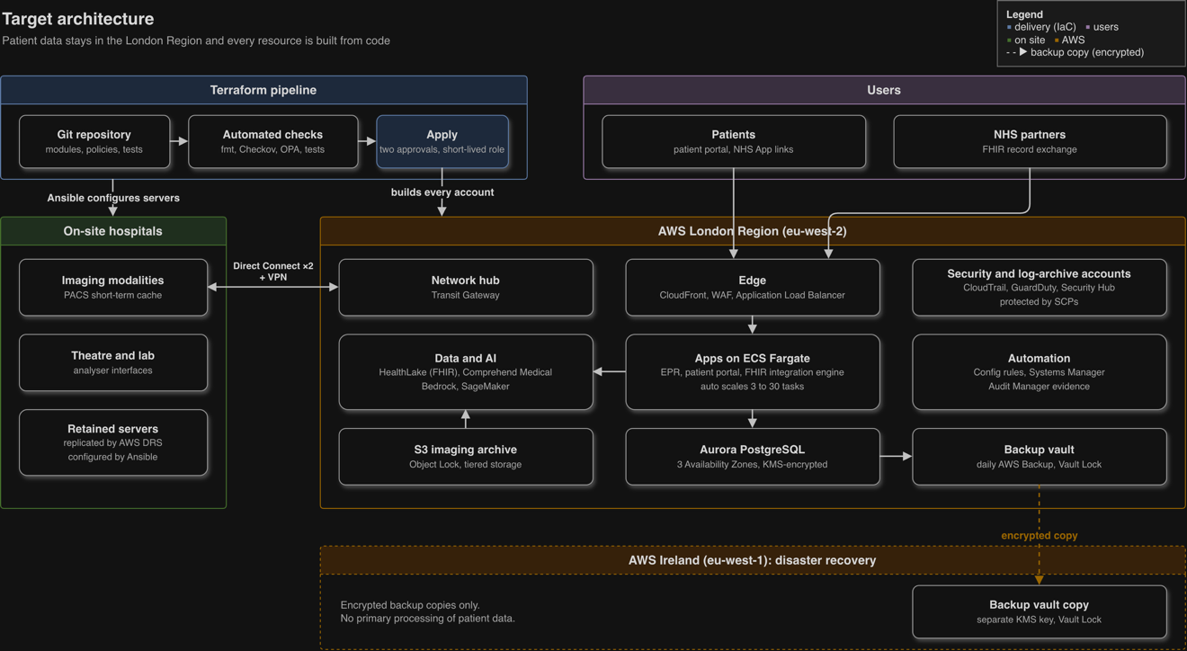
Figure 1: Target architecture: on-site systems, London Region accounts and the Terraform pipeline
As can be seen in Figure 1, the Terraform pipeline is the source for all of the London Region and the on-site servers that have been put in place. The UK is not exited by anything but an encrypted backup.

Key design decisions
In making any number of major choices, one must weigh what is realistic in the way of alternatives to see if they fit with Meridian’s requirements. To allow for a re-evaluation should the circumstances warrant it, the table has the rationale for these decisions set down.
Decision | Options considered | Choice | Rationale
IaC tool | Terraform, AWS CloudFormation, Pulumi, OpenTofu | Terraform, with OpenTofu as a tested fall-back | There is no better module ecosystem or depth of skills with which to handle non-AWS resources like monitoring and DNS. Given that IBM’s purchase of HashiCorp was finalised in February 2025 and the switch to a Business Source Licence by Terraform in 2023 (Spacelift, n.d.), we have made sure the code will work with the open-source OpenTofu fork as a safeguard against lock-in.
Configuration management | Ansible, AWS Systems Manager | Systems Manager for cloud; Ansible for retained on-site servers | To avoid drift one would not want to conflate the two roles in a single tool. Terraform does the provisioning while Ansible is used to configure the hospital servers remaining on site.
Application compute | Amazon EKS, ECS on Fargate, EC2 | ECS on Fargate | It is billed per second and there are no servers requiring patching. The team is too small to operate Kubernetes safely and the workloads do not call for that kind of flexibility.
Disaster recovery | Backup and restore, pilot light, warm standby, multi-site | Multi-AZ for high availability, plus warm standby for tier-1 systems | It is billed per second and there are no servers requiring patching. The team is too small to operate Kubernetes safely and the workloads do not call for that kind of flexibility..
Migration approach | Big-bang lift-and-shift, phased "6 Rs" | Phased "6 Rs" | Clinical risk is minimised and any refactoring is done only where the return justifies it.

Design for scalability, security and cost
Quality | Design features | The metrics
Scalability | Auto scaling on ECS with target tracking; read replicas from Aurora; S3 to hold an unlimited number of images; modules used to stamp out new environments | In stress tests the portal p95 latency is kept below 500 ms even at 10 times the usual load. A new environment can be put in place in a day or less.
Security | WAF, private subnets and customer-managed KMS keys from AWS are in play as well as separate accounts and SCPs. GuardDuty, CloudTrail and Security Hub reside in a log-archive account that is locked down; backups are immutable. | We look for a Security Hub score in excess of 90% and no critical findings when the pipeline is scanned. Quarterly restore tests have been passed.
Cost-effectiveness | Pay-per-use on Fargate and S3; Savings Plans where the load is steady; storage tiering; cost tags are de rigueur and every pull request has an estimate; non-production is shut down after hours. | Un-tagged spend is less than 2% and waste is under the 29% industry figure put forward by Flexera (2026). Cost is also measured per patient episode.

There is an inherent tension between cost and scalability. While one would want to auto scale hard in the face of a demand spike for the sake of the patients, there is the risk of an unexpected bill. To avoid this the design puts in place scaling ceilings, say 30 tasks for the portal at most, and has AWS Budgets to sound the alarm. A pull request must be reviewed before any ceiling is altered.

Terraform implementation
What is tested is what makes it to production since both are constructed from the same modules, only with different inputs. The code takes the form of reusable modules invoked by lean configurations for each environment.
meridian-infrastructure/
├── modules/
│ ├── org-guardrails/ # OUs, SCPs, delegated security
│ ├── network-hub/ # VPN, Direct Connect, Transit Gateway
│ ├── workload-vpc/ # VPC across 3 AZs, endpoints, flow logs
│ ├── ecs-service/ # Fargate, ALB and its auto scaling
│ ├── aurora-postgres/ # KMS, backups, multi-AZ cluster
│ └── imaging-archive/ # Object Lock, lifecycle tiers on S3
├── live/
│ ├── prod/ # just the inputs
│ └── nonprod/
├── policies/ # for the OPA/Rego rules in the pipeline
└── tests/ # terraform test files

Snippet 1: state, provider and the like. An encrypted S3 bucket with versioning is where the state is kept. With use_lockfile we have native S3 locking so two pipelines cannot be making changes to the infrastructure simultaneously. There is also allowed_account_ids to preclude a production configuration being put in the wrong account. And default_tags will put an owner and cost centre on every resource for the FinOps reporting detailed in 2.4.
terraform {
required_version = ">= 1.10"
required_providers {
aws = {
source = "hashicorp/aws"
version = "~> 5.0"
}
}
backend "s3" {
bucket = "meridian-tfstate-prod"
key = "workloads/clinical/terraform.tfstate"
region = "eu-west-2"
encrypt = true
use_lockfile = true
}
}

provider "aws" {
region = "eu-west-2"
allowed_account_ids = [var.prod_account_id]

default_tags {
tags = {
owner = "platform-team"
environment = var.environment
cost_centre = var.cost_centre
data_class = var.data_classification # e.g. "patient-identifiable"
managed_by = "terraform"
}
}
}

The clinical network in Snippet 2 is of the three-AZ variety. To forestall any untested or haphazard upgrades, the code has been written to major versions of the AWS provider and community VPC module which are accordingly pinned. There is a premium to be paid for a NAT gateway in each AZ over a shared option, yet it is worth it to eliminate a single point of failure when it comes to clinical traffic. And should DSPT assessors want an evidence trail, the flow logs will provide it.
module "clinical_vpc" {
source = "terraform-aws-modules/vpc/aws"
version = "~> 5.0" # pinned major version; upgrades are deliberate
name = "${var.environment}-clinical"
cidr = "10.20.0.0/16"
azs = ["eu-west-2a", "eu-west-2b", "eu-west-2c"]
private_subnets = ["10.20.0.0/20", "10.20.16.0/20", "10.20.32.0/20"]
database_subnets = ["10.20.48.0/24", "10.20.49.0/24", "10.20.50.0/24"]
public_subnets = ["10.20.64.0/24", "10.20.65.0/24", "10.20.66.0/24"]
enable_nat_gateway = true
one_nat_gateway_per_az = true
enable_flow_log = true
create_flow_log_cloudwatch_log_group = true
create_flow_log_cloudwatch_iam_role = true
}

The imaging archive in Snippet 3 is built to withstand ransomware. We use a key under the customer’s control to encrypt images and have it rotate of its own accord. Then there is Object Lock, set to compliance mode; for the duration of an object’s retention window that precludes any deletion or overwriting, be it by an attacker in possession of administrator credentials or otherwise. As images get on in age, lifecycle rules will relegate them to more economical tiers, yet one can still call up an old image from Glacier Instant Retrieval in a matter of milliseconds for clinical purposes. A lifecycle rule is not employed to let records lapse. Deletion is the province of the records-management system since NHS retention is a function of the patient; take children whose files are held until they are 25.
resource "aws_kms_key" "phi" {
description = "CMK for patient-identifiable data"
enable_key_rotation = true
deletion_window_in_days = 30
}
resource "aws_s3_bucket" "imaging_archive" {
bucket = "meridian-${var.environment}-imaging-archive"
object_lock_enabled = true
}
resource "aws_s3_bucket_public_access_block" "imaging_archive" {
bucket = aws_s3_bucket.imaging_archive.id
block_public_acls = true
block_public_policy = true
ignore_public_acls = true
restrict_public_buckets = true
}
resource "aws_s3_bucket_server_side_encryption_configuration" "imaging_archive" {
bucket = aws_s3_bucket.imaging_archive.id
rule {
apply_server_side_encryption_by_default {
sse_algorithm = "aws:kms"
kms_master_key_id = aws_kms_key.phi.arn
}
bucket_key_enabled = true # cuts KMS request costs
}
}
resource "aws_s3_bucket_object_lock_configuration" "imaging_archive" {
bucket = aws_s3_bucket.imaging_archive.id
rule {
default_retention {
mode = "COMPLIANCE"
days = 35
}
}
}
resource "aws_s3_bucket_lifecycle_configuration" "imaging_archive" {
bucket = aws_s3_bucket.imaging_archive.id
rule {
id = "tier-by-age"
status = "Enabled"
filter {}
transition {
days = 90
storage_class = "GLACIER_IR"
}
transition {
days = 1095
storage_class = "DEEP_ARCHIVE"
}
}
}

With the organization guardrails put in as code (Snippet 4), service control policies are in place to impose limits beyond what an account administrator can override. Technically, not just on paper, the initial statement will bar any regional service not in one of the two sanctioned regions and so ensure data residency. As for the second, it precludes anyone from disabling threat detection or audit logging; such a move is often the opening play in a ransomware attack. We have abridged the global services that are exempt from this list.
data "aws_iam_policy_document" "guardrails" {
statement {
sid = "DenyOutsideApprovedRegions"
effect = "Deny"
not_actions = ["iam:*", "organizations:*", "sts:*", "support:*",
"cloudfront:*", "route53:*", "wafv2:*", "budgets:*"]
resources = ["*"]
condition {
test = "StringNotEquals"
variable = "aws:RequestedRegion"
values = ["eu-west-2", "eu-west-1"]
}
}
statement {
sid = "ProtectAuditAndDetection"
effect = "Deny"
actions = [
"cloudtrail:StopLogging",
"cloudtrail:DeleteTrail",
"guardduty:DeleteDetector",
"config:StopConfigurationRecorder",
]
resources = ["*"]
}
}
resource "aws_organizations_policy" "guardrails" {
name = "meridian-baseline-guardrails"
type = "SERVICE_CONTROL_POLICY"
content = data.aws_iam_policy_document.guardrails.json
}
resource "aws_organizations_policy_attachment" "workloads" {
policy_id = aws_organizations_policy.guardrails.id
target_id = var.workloads_ou_id
}

With elastic scaling and a cost ceiling in place (snippet 5), the patient portal is configured to have no fewer than three tasks running, one in each AZ; should an AZ go down the portal will not be put offline. Once average CPU gets above 60% target tracking will put more tasks on. But there is a hard limit of 30 to contain any expenditure from a spike in load due to a bot attack or some other fault.
resource "aws_appautoscaling_target" "patient_portal" {
service_namespace = "ecs"
resource_id = "service/${aws_ecs_cluster.apps.name}/${aws_ecs_service.patient_portal.name}"
scalable_dimension = "ecs:service:DesiredCount"
min_capacity = 3
max_capacity = 30
}
resource "aws_appautoscaling_policy" "patient_portal_cpu" {
name = "cpu-target-60"
policy_type = "TargetTrackingScaling"
service_namespace = aws_appautoscaling_target.patient_portal.service_namespace
resource_id = aws_appautoscaling_target.patient_portal.resource_id
scalable_dimension = aws_appautoscaling_target.patient_portal.scalable_dimension
target_tracking_scaling_policy_configuration {
target_value = 60
predefined_metric_specification {
predefined_metric_type = "ECSServiceAverageCPUUtilization"
}
}
}

The delivery pipeline and its validation
There is a single gated procedure for all changes, one that will pick up any error prior to it getting to the patient. In their 2019 work Rahman, Parnin and Williams identified security smells of a recurring nature in IaC scripts, be it over-permissive rules or hard-coded secrets. For this reason, an automated scan is mandatory.
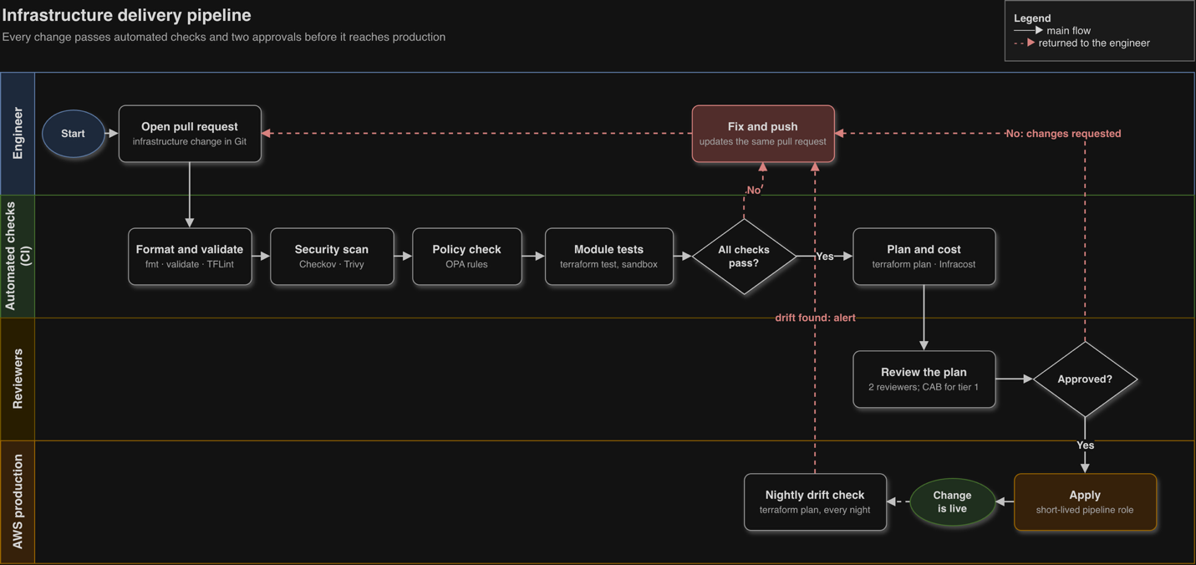
Figure 2 - Infrastructure delivery pipeline: nine stages, one failure path
The course of a change is depicted in Figure 2. Should the format, scan, policy or test check not be met, the change is returned to the author. Application is reserved for those changes that have withstood all such checks and been approved on two occasions; a short-lived pipeline role is employed for this. A nightly plan will pick up any change made outside code. The build is certain to fail on high-severity scan findings, while production credentials are not in the hands of engineers.
For the validation tests, their expected results and the observed results, see Appendix B.

Advanced Cloud Technologies
We have made of AI, automation and hybrid cloud a single system. The hybrid layer provides the cloud with standardised data of a high quality, which AI converts into decisions, leaving automation to ensure the estate is compliant unassisted by hand. None are put in place unless they answer to a business requirement set out in the Executive Summary.

Artificial intelligence
Clinical risk dictates how we go about adopting AI. We start with operational and administrative applications since their failure is something that can be put up with. Anything bearing on a treatment or diagnosis is left to the end and done via suppliers with the regulatory approvals in order. In medicine the near-term worth of AI is to put time back in the clinician’s day, not to supplant judgement, according to Topol (2019); the portfolio here is in keeping with that view.
Use case | AWS services | Business value | Risk tier and control
Bed and theatre demand forecasting | Amazon SageMaker on de-identified data from the HealthLake analytics store | Fewer cancelled operations; better use of theatre time | Low: operational, not a medical device. Models are monitored for drift monthly.
Referral letter triage | Amazon Comprehend Medical to extract conditions and medications into FHIR resources | Faster booking; less manual keying | Medium: an administrator confirms every extracted field before it is saved.
Staff knowledge assistant for policies and procedures | Amazon Bedrock with a retrieval knowledge base and Bedrock Guardrails | Quicker answers for staff; fewer policy breaches | Medium: non-clinical content only; guardrails block patient data and clinical advice.
Ambient clinical scribing | Procured from a supplier on the NHS England ambient voice technology registry; integrated through FHIR | Clinicians spend more of each consultation with the patient | High: products that summarise consultations are likely to be medical devices (NHS England, 2025b). Meridian buys rather than builds, and completes a DCB0160 safety case and DPIA before go-live. Clinicians sign off every note.
Security and cost anomaly detection | Amazon GuardDuty, AWS Cost Anomaly Detection | Earlier detection of attacks and runaway spend | Low: alerts route to the security operations team and FinOps lead.

The decision to buy rather than build the ambient scribe is deliberate. Building one on Bedrock would be technically simple, but it would make Meridian a medical-device manufacturer, with the clinical-safety and regulatory obligations that brings. That is outside the organisation's core competence. The cloud platform's role is to provide the secure integration, identity and audit trail that any approved product needs.
All models sit in a model register that records owner, purpose, training data, validation results and review date. Generative AI calls are restricted by SCP to the approved regions. Prompts and outputs are logged to the locked log-archive account so that any AI-assisted decision can be reconstructed.

Automation
IaC automates how infrastructure is built. Three further layers automate how it is run:
- Self-healing compliance. AWS Config rules check resources continuously. When a rule fails, for example a storage bucket losing its encryption setting, AWS Systems Manager Automation restores the correct setting within minutes and logs the event. This turns compliance from an annual audit into a continuous control.
- Automated recovery. AWS Elastic Disaster Recovery replicates the retained on-site servers into AWS continuously. Recovery runbooks are scripted and rehearsed every quarter. Aurora and ECS workloads fail over between AZs without human action.
- Automated evidence. AWS Audit Manager collects evidence mapped to control frameworks. This reduces the effort of preparing the annual DSPT submission and gives the board current, not year-old, assurance.
Non-production environments are switched off outside working hours on a schedule, removing roughly 65% of their running hours.

Hybrid cloud
Not every workload belongs in the cloud. Systems wired directly to clinical equipment need very low latency and must keep working if the internet link fails. The placement of each workload follows from its latency, safety and data needs, as below.
Workload | Placement | Reason
Imaging modalities and PACS short-term cache | On site | Scanners need local, low-latency storage; studies must be viewable during a network outage
Theatre and laboratory analyser interfaces | On site | Safety-critical; must keep running if connectivity is lost
Electronic patient record (EPR) application | AWS, replatformed | Benefits most from multi-AZ resilience and elastic capacity
Imaging long-term archive | AWS (S3 tiers) | Fastest-growing data set; cloud storage removes capacity planning
Integration engine (HL7 v2 to FHIR) | AWS | Central hub for NHS data exchange and the AI services
Analytics, AI and disaster recovery | AWS | Elastic compute; pay only when used

A single management plane is in place across both. On-site servers are put in hand of Systems Manager and Ansible in the same way as cloud resources. Staff have one identity to use throughout, courtesy of AWS IAM Identity Center federating with the current directory. And the CloudWatch agent will be relaying on-site metrics and logs over to the dashboards. An HSCN provider of repute provides the link to national NHS services.
As for AWS Outposts, it was considered and put aside. While it would bring a uniform operating model to the hospital by putting AWS infrastructure there, management of it requires a connection back to the parent region and it would mean doing away with hardware that has another two years of support. A review of this and the edge options set out in Future Recommendations will be part of the 2027 hardware refresh.

Risk and Compliance Considerations
Careless migration to the cloud is the greater risk, not the move itself; a resource poorly configured can put thousands of patient records at risk. The approach taken is to make compliance a matter of code so the pipeline and platform enforce the following controls, not just some policy document.

Shared responsibility
The physical data centres and the infrastructure underpinning the services are secured by AWS as per its shared responsibility model (AWS, n.d.). Meridian has to see to what it configures, from the applications and data classification down to encryption and network rules. Since the preponderance of cloud breaches happen on the customer side of the equation, the Terraform implementation and the delivery pipeline are devoted to averting misconfiguration.

Regulatory landscape
Obligation | What it requires | How the design meets it
UK GDPR and Data Protection Act 2018 | Health data is special category data. It needs a lawful basis, security appropriate to risk (Article 32), a Data Protection Impact Assessment (DPIA) for high-risk processing and breach reporting to the ICO within 72 hours. | Encryption with customer-managed keys; DPIA for the migration and each AI use case; GuardDuty and Security Hub alerts feed the incident process.
Data (Use and Access) Act 2025 | Amends UK GDPR, including rules on automated decision-making and international transfers. It received Royal Assent on 19 June 2025 and is being commenced in stages (DSIT, 2025). | Human review of every AI output that affects a patient; transfer assessments kept under review as provisions commence.
Data Security and Protection Toolkit (DSPT) | Annual self-assessment for organisations handling NHS patient data. The CAF-aligned version, mandatory for NHS trusts and designated operators of essential services, is aligned to version 4.0 of the NCSC Cyber Assessment Framework (CAF) for 2026-27, with a deadline of 30 June 2027 (NHS England, 2026). | As an independent provider Meridian may complete the standard version, but it adopts the CAF outcomes voluntarily (see Mapping controls to the Cyber Assessment Framework) to match its NHS partners. Audit Manager collects evidence continuously.
DCB0129 and DCB0160 clinical risk management | Manufacturers (DCB0129) and deploying organisations (DCB0160) must manage clinical safety, with a named Clinical Safety Officer and hazard log. | Clinical safety case for the EPR migration and every clinical AI tool; supplier DCB0129 evidence required at procurement.
Medical device regulation (MHRA) | Software that informs diagnosis or treatment, including ambient scribes that summarise, is likely to be a medical device. | Buy-not-build policy for clinical AI (see Artificial intelligence); registration checked at procurement.
Cyber Security and Resilience Bill | Extends the NIS Regulations 2018 to managed service providers and data centres and tightens incident reporting. Introduced on 12 November 2025, it completed its Commons stages on 25 June 2026 and was in the Lords at the time of writing (TLT, 2026; Cloudswitched, 2026). | Meridian's managed service partners are likely to fall in scope. Contracts require 24-hour incident notification and evidence of CAF-aligned controls.
Care Quality Commission (CQC) | Safe, well-led services, including continuity of care during IT failure. | Tested downtime procedures; quarterly recovery rehearsals reported to the board.
Records Management Code of Practice | Minimum retention periods that vary by record type and patient. | Object Lock prevents early deletion; retention is driven by the records system, not lifecycle rules.
There is a matter of residency that calls for some clarification. Given that AWS operates but one region in the UK, any regional disaster copy has to be located beyond its borders. For this purpose we have our encrypted backups in the EU (Ireland) Region. Such a transfer is allowed since the UK deems EEA states to offer sufficient protection, though it is put on record in the DPIA and confined to the encrypted backups; primary processing of data does not go outside the UK.

Mapping controls to the Cyber Assessment Framework
CAF objective | Key controls in this design
A. Managing security risk | Risk register (see Risk register); board-level ownership; supplier assurance clauses; IaC peer review as change control
B. Protecting against cyber attack | Phishing-resistant multi-factor authentication; least privilege; SCP guardrails; encryption; private networking; patching by automation
C. Detecting cyber security events | GuardDuty, Security Hub, VPC flow logs and CloudTrail in an isolated log-archive account; 24/7 managed security operations
D. Minimising the impact of incidents | Immutable backups; warm standby for tier-1 systems; Elastic Disaster Recovery for on-site servers; rehearsed recovery runbooks

Risk register
Likelihood (L) and impact (I) are scored from 1 (low) to 5 (high); the score is L × I before mitigation. Residual ratings assume the mitigations are fully in place.
ID | Risk | L | I | Score | Mitigation | Owner | Residual
R1 | Ransomware via stolen credentials encrypts clinical systems | 4 | 5 | 20 | Phishing-resistant MFA for all staff; no standing admin access; Object Lock backups; quarterly restore tests; SCP blocks disabling of logging. Reports found the Synnovis attack might have been stopped by two-factor authentication (Digital Health News, 2025). | CISO | Medium
R2 | Misconfiguration exposes patient data publicly | 3 | 5 | 15 | Pipeline scanning (Checkov, Trivy); OPA policies; S3 public access blocked at account level; Config auto-remediation | Platform lead | Low
R3 | Terraform state file leaks secrets | 3 | 4 | 12 | Encrypted, versioned state bucket with narrow access; secrets held in AWS Secrets Manager and referenced, never written in code | Platform lead | Low
R4 | Compromised or changed third-party module, provider or licence | 2 | 4 | 8 | Versions pinned; private module mirror; dependency scanning; code kept compatible with OpenTofu | Platform lead | Low
R5 | Patient data processed outside approved regions | 2 | 5 | 10 | Region-deny SCP; data-classification tags checked in pipeline; DPIA for every new data flow | DPO | Low
R6 | Clinical AI produces an unsafe output | 3 | 5 | 15 | Buy-not-build for clinical AI; DCB0160 safety case; clinician sign-off on every output; incident reporting and model monitoring | Chief Clinical Information Officer | Medium
R7 | Forecasting model is biased against some patient groups | 3 | 3 | 9 | Equality impact assessment; performance tested across age, sex and ethnicity groups; human review of scheduling decisions | Data science lead | Low
R8 | Loss of hospital-to-cloud connectivity | 2 | 4 | 8 | Dual Direct Connect plus VPN fail-over; safety-critical systems retained on site; paper downtime procedures | Network lead | Low
R9 | Vendor lock-in and concentration risk | 3 | 3 | 9 | Open standards (FHIR, PostgreSQL, containers); documented exit plan tested annually; IaC portable to OpenTofu | CIO | Medium
R10 | Cloud costs exceed budget | 4 | 3 | 12 | Mandatory tagging; budgets and anomaly alerts; Infracost on every change; Savings Plans; monthly FinOps review | FinOps lead | Low
R11 | Skills gap slows delivery or causes errors | 4 | 3 | 12 | Cloud Centre of Excellence; certification plan; delivery partner with knowledge-transfer clauses | CIO | Medium
R12 | Regulatory change (CSRB, DUAA commencement) alters obligations | 3 | 3 | 9 | Quarterly horizon scan by legal and DPO; policies held as code so updates deploy everywhere at once | DPO | Low

Mitigation has left three risks at a medium level. One can only so much with ransomware (R1) and clinical AI (R6), rendering them survivable but not something to be done away with. As for lock-in (R9), it is the cost of doing business with managed services, an exposure the exit plan puts in check. The board will want to make a quarterly review of these.
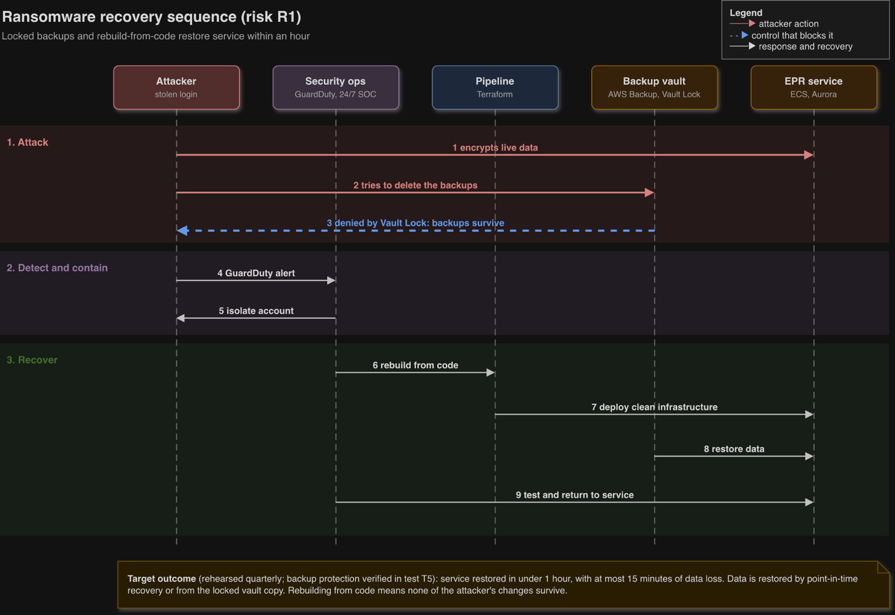
Figure 3 - Ransomware recovery sequence for risk R1: five participants, nine steps
An attack on risk R1 and the interplay of its controls are illustrated in Figure 3. While an attacker is in a position to encrypt live data, the locked backups are beyond his reach (steps 1-3). The security team will have quarantined the account by then; the pipeline has put in place new infrastructure from code and the data has been put back via Aurora point-in-time recovery or a copy from the locked vault (steps 4-9). Since one rebuilds the infrastructure as opposed to mending it, nothing of the attacker’s handiwork remains. Test T5 in Appendix B confirms the step the whole sequence depends on: a locked image version cannot be deleted.

Future Recommendations
It is advisable for Meridian to make provision for new technologies according to how mature they are. Post-quantum cryptography planning should be underway, edge computing piloted with the hardware refresh of 2027, and quantum computing left to the research sphere. A modular approach to IaC underpins this, allowing each capability to be introduced as a module, not a project.

Edge computing
By handling data at the source, edge computing reduces both bandwidth and latency (Shi et al., 2016; Satyanarayanan, 2017). There are two applications in the hospital setting that are of particular interest. AI inference next to the scanner will, for instance, identify something like a possible head CT bleed before the study is done uploading. Then there are virtual wards and remote monitoring; the NHS 10 Year Health Plan foresees these expanding as care moves out of the hospital and into the community (DHSC, 2025), and the steady flow of information from wearables is more effectively filtered on site.
We recommend a 2027 pilot at the principal hospital, with AWS IoT Greengrass on local servers under the control of the existing Terraform code base. An assessment of AWS Outposts can be made concurrently when the pilot has revealed what the actual latency requirements are. Any AI applied to imaging must be an approved medical device.

Quantum computing and post-quantum security
There are two distinct ways in which quantum computing will impinge on Meridian.
From a planning perspective the threat is imminent. Public-key cryptography used to secure data in transit will be vulnerable to large fault-tolerant quantum machines (Bernstein and Lange, 2017). Given the lifelong sensitivity of health records, what is captured today may be decrypted in time, the so called “harvest now, decrypt later” approach. NIST put its first three post-quantum standards in place last August (NIST, 2024) and the NCSC would have organisations have their migration goals set and discovery done by 2028, with high-priority work completed by 2031 and all concluded by 2035 (NCSC, 2025).
The opportunities are of a longer duration. Amazon has put forward Ocelot, a prototype chip that could see the cost of quantum error correction fall 90% (Amazon, 2025), and with Amazon Braket cloud access to quantum computers is already there. One might consider optimisation of theatre scheduling but at the scale of Meridian no advantage over the classical way has been demonstrated as yet.
To address this: have a cryptographic inventory in place by 2027, a tagged data set from the IaC and AWS Config resource inventory. Make use of managed services such as KMS or load balancers for the sake of crypto-agility, since the provider can effect any algorithm change centrally. Put hybrid post-quantum TLS on external interfaces where AWS offers it. As for quantum computing, confine it to a modest research endeavour via Braket.

Agentic AI operations
One sees AI agents making suggestions for infrastructure changes and diagnosing incidents. IaC is the proper vehicle for this; an agent can file a pull request but is subject to the same policy checks and human sign off as an engineer and is without production credentials. From 2028 Meridian ought to put this to the test on low-risk tasks like the rightsizing of non-production resources.

Sovereignty and portability
Sovereign cloud is in demand. In January 2026 AWS opened up its European Sovereign Cloud in Brandenburg, Germany, as a region apart from the rest (AWS, 2026). It is for the EU and not the UK so it is not of consequence to Meridian at present, but it is an indication of what sovereign demands on health data may look down the line. To keep the option open without excessive expense, workloads should be portable, using containers, OpenTofu-compatible code and open data standards.

FinOps and sustainability
AI workloads are to blame for a 29% rise in estimated cloud waste, the first in half a decade, according to Flexera (2026). A FinOps function needs to be established from the outset along the lines of Storment and Fuller (2023) and the board should be given cost per patient episode figures. The Well-Architected Framework’s sustainability pillar is a good guide for storage tiering or the use of Graviton processors. For the purposes of NHS supplier reporting, carbon data can be drawn from the AWS Customer Carbon Footprint Tool.

Recommendations summary
Recommendation | When to act | Success measure
Cryptographic inventory and crypto-agility | Start 2026; complete by 2027 | 100% of external interfaces inventoried; NCSC 2028 milestone met early
Edge pilot and Outposts decision | 2027 hardware refresh | Urgent imaging findings flagged at least 10 minutes sooner in the pilot
FinOps and GreenOps function | From month 0 | Waste below 15%; cost per episode falling year on year
Agentic AI for operations | From 2028, low-risk changes only | No agent change bypasses the pipeline; hours saved per month
Sovereignty and portability review | Annually | Exit plan tested; no new proprietary dependency without a recorded decision
Quantum computing research | Opportunistic, through Braket | Documented findings; no production dependency

Conclusion
A hybrid AWS platform built entirely in Terraform gives Meridian Health Group what its current estate cannot: recovery from ransomware in under an hour, capacity in a day instead of weeks, and security and cost controls that are enforced automatically on every change.
The strategy's strength is that its parts reinforce each other. IaC makes the landing zone repeatable and auditable. The hybrid layer keeps safety-critical systems on site while feeding standardised FHIR data to the cloud. AI is introduced in order of clinical risk, with a buy-not-build rule for anything that could be a medical device. Compliance with UK GDPR, the DSPT and clinical safety standards is built into the pipeline rather than checked once a year.
The approach has real costs and limits. Dual running, new skills and a FinOps discipline must be funded before savings appear. Ransomware and clinical AI risks can be reduced but not removed, and dependence on one hyperscaler is accepted in exchange for managed services. These trade-offs are made explicit, owned and reviewed. Finally, the roadmap prepares Meridian for post-quantum cryptography, edge computing and agentic operations in proportion to each technology's maturity, so that the organisation is ready to adopt them without betting on them too early.

References for the assessment report
Amazon (2025) Amazon announces Ocelot quantum chip. Available at: https://www.aboutamazon.com/news/aws/quantum-computing-aws-ocelot-chip (Accessed: 11 October 2026).
AWS (2024a) AWS Well-Architected Framework. Available at: https://docs.aws.amazon.com/wellarchitected/latest/framework/welcome.html (Accessed: 11 October 2026).
AWS (2025a) AWS HealthLake FAQs. Available at: https://aws.amazon.com/healthlake/faqs (Accessed: 11 October 2026).
AWS (2026) AWS launches AWS European Sovereign Cloud and announces expansion across Europe, press release, 15 January. Available at: https://press.aboutamazon.com/aws/2026/1/aws-launches-aws-european-sovereign-cloud-and-announces-expansion-across-europe (Accessed: 11 October 2026).
AWS (n.d.) Shared responsibility model. Available at: https://aws.amazon.com/compliance/shared-responsibility-model/ (Accessed: 11 October 2026).
Bernstein, D.J. and Lange, T. (2017) 'Post-quantum cryptography', Nature, 549(7671), pp. 188–194.
Cloudswitched (2026) UK Cyber Security & Resilience Bill clears Commons, enters Lords 25 June 2026. Available at: https://www.cloudswitched.com/news/cyber-security-resilience-bill-lords-july-2026-uk-sme-msp-10-step-compliance-plan (Accessed: 11 October 2026).
Department for Science, Innovation and Technology (DSIT) (2025) Data (Use and Access) Act 2025: plans for commencement. Available at: https://www.gov.uk/guidance/data-use-and-access-act-2025-plans-for-commencement (Accessed: 11 October 2026).
Department of Health and Social Care (DHSC) (2025) Fit for the Future: 10 Year Health Plan for England. London: DHSC.
Digital Health News (2025) Cyber attack cost Synnovis estimated £32.7m in 2024. Available at: https://www.digitalhealth.net/?p=216081 (Accessed: 11 October 2026).
Flexera (2026) Flexera finds cloud value is rising while AI waste grows, press release, 18 March. Available at: https://www.flexera.com/about-us/press-center/flexera-finds-cloud-value-is-rising-while-ai-waste-grows (Accessed: 11 October 2026).
Morris, K. (2020) Infrastructure as Code: Dynamic Systems for the Cloud Age. 2nd edn. Sebastopol, CA: O'Reilly Media.
National Cyber Security Centre (NCSC) (2025) Timelines for migration to post-quantum cryptography. Available at: https://www.ncsc.gov.uk/guidance/pqc-migration-timelines (Accessed: 11 October 2026).
NHS England (2025a) The Single Patient Record. Available at: https://www.england.nhs.uk/digitaltechnology/the-single-patient-record (Accessed: 11 October 2026).
NHS England (2025b) Guidance on the use of AI-enabled ambient scribing products in health and care settings. Available at: https://www.england.nhs.uk/long-read/guidance-on-the-use-of-ai-enabled-ambient-scribing-products-in-health-and-care-settings (Accessed: 11 October 2026).
NHS England (2026) Data Security and Protection Toolkit 2026-27 version 9. Available at: https://www.dsptoolkit.nhs.uk/News/169 (Accessed: 11 October 2026).
NIST (2024) NIST releases first 3 finalized post-quantum encryption standards, 13 August. Available at: https://www.nist.gov/news-events/news/2024/08/nist-releases-first-3-finalized-post-quantum-encryption-standards (Accessed: 11 October 2026).
Rahman, A., Parnin, C. and Williams, L. (2019) 'The seven sins: security smells in infrastructure as code scripts', Proceedings of the 41st International Conference on Software Engineering (ICSE). Montreal: IEEE, pp. 164–175.
Rose, S., Borchert, O., Mitchell, S. and Connelly, S. (2020) Zero Trust Architecture. NIST Special Publication 800-207. Gaithersburg, MD: National Institute of Standards and Technology.
Satyanarayanan, M. (2017) 'The emergence of edge computing', Computer, 50(1), pp. 30–39.
Security Affairs (2024) London hospitals canceled over 800 operations in the week after Synnovis ransomware attack, 15 June. Available at: https://securityaffairs.com/?p=164541 (Accessed: 11 October 2026).
Shi, W., Cao, J., Zhang, Q., Li, Y. and Xu, L. (2016) 'Edge computing: vision and challenges', IEEE Internet of Things Journal, 3(5), pp. 637–646.
SFIA Foundation (2024) SFIA 9: skills directory A–Z. Available at: https://sfia-online.org/en/sfia-9/all-skills-a-z (Accessed: 11 October 2026).
Spacelift (n.d.) Terraform license change (BUSL/BSL): impact on users and providers. Available at: https://spacelift.io/blog/hashicorps-license-change (Accessed: 11 October 2026).
Storment, J.R. and Fuller, M. (2023) Cloud FinOps: Collaborative, Real-Time Cloud Value Decision Making. 2nd edn. Sebastopol, CA: O'Reilly Media.
TLT (2026) The Cyber Security and Resilience Bill: understanding the UK's legislative response to digital threats. Available at: https://www.tlt.com/insights-and-events/insight/the-cyber-security-and-resilience-bill-understanding-the-uks-legislative-response-to-digital-threats (Accessed: 11 October 2026).
Topol, E.J. (2019) 'High-performance medicine: the convergence of human and artificial intelligence', Nature Medicine, 25(1), pp. 44–56.

Report appendices

Appendix A: Terraform module inventory
Module | Creates | Key inputs | Key outputs
org-guardrails | Organisational units, SCPs (Snippet 4), delegated admin for GuardDuty, Security Hub and Config | Approved regions, OU IDs | Policy IDs
network-hub | Transit Gateway, Direct Connect gateway, Site-to-Site VPN, Route 53 Resolver endpoints | On-site CIDR ranges, BGP ASNs | Transit Gateway ID, route table IDs
workload-vpc | Three-AZ VPC (Snippet 2), flow logs, VPC endpoints for S3, KMS and ECR | CIDR, environment | Subnet IDs, VPC ID
ecs-service | ECS cluster and Fargate service, ALB, auto scaling (Snippet 5) | Container image, min and max tasks, CPU target | Service name, ALB DNS name
aurora-postgres | Aurora PostgreSQL cluster across three AZs, KMS key, automated backups, AWS Backup plan | Instance class, retention days | Cluster endpoints
imaging-archive | S3 bucket with Object Lock, KMS encryption and lifecycle tiers (Snippet 3) | Retention days, tier ages | Bucket ARN

Appendix B: IaC validation test plan
The tests run in the pipeline described in The delivery pipeline and its validation and cover positive, negative, exception, recovery and portability cases. They were run on 12 Oct 2026; the terminal output of each executed test is reproduced in Figures B1 to B10 below. Where a test fails, the remediation is applied and the test is re-run.
ID | Type | Test | Tool | Expected result | Remediation if it fails | Observed result (Pass/Fail, date) | Evidence
T1 | Positive | Code is formatted and syntactically valid | fmt -check, validate, TFLint | Pass, no changes needed | Run terraform fmt; fix reported syntax errors | Pass, 12 Oct 2026: formatting clean; all 8 modules and stacks valid; TFLint 0 issues | Figure B1
T2 | Positive | Plan creates the expected resources and nothing else | plan against the AWS API emulator | Plan lists only the resources defined in the modules | Review module inputs; correct the variable values | Pass, 12 Oct 2026: 98 to add, 0 to change, 0 to destroy; only module resources planned | Figure B2
T3 | Negative | Imaging bucket rejects unencrypted or public configuration | Checkov | Build fails if encryption or the public access block is removed | Restore the setting; add a test so it cannot regress | Pass, 12 Oct 2026: build failed as intended (CKV2_AWS_6) when the public access block was removed | Figure B3
T4 | Negative | Patient-identifiable resources use a customer-managed key | OPA policy (conftest) on the T2 plan | Plan rejected if a database or bucket lacks a CMK or data_class tag | Add the KMS key reference and tag | Pass, 12 Oct 2026: 5 rules evaluated, 0 failures; rejection of non-compliant plans shown in T11 | Figure B4
T5 | Negative | Object Lock prevents deletion | Test script against the AWS API emulator | Deleting a locked object version is denied during the retention window | Confirm compliance mode and retention days | Pass, 12 Oct 2026: deletion of the locked version denied, including with governance bypass; version retained | Figure B5
T6 | Exception | Two pipelines cannot change the same state at once | Two parallel runs, S3 backend with use_lockfile | Second run fails with a state lock error; state is not corrupted | Confirm use_lockfile = true; release stale locks only after checking | Pass, 12 Oct 2026: second run refused with "Error acquiring the state lock"; state intact afterwards | Figure B6
T7 | Recovery | Drift is detected | plan -detailed-exitcode | A manual console change raises an alert within 24 hours | Revert the change through code; review access | Pass, 12 Oct 2026: bucket policy deleted outside code; plan returned exit code 2 and showed the missing resource | Figure B7
T8 | Portability | Code runs unchanged on OpenTofu | tofu init and tofu validate | Same result as Terraform | Replace any Terraform-only feature | Pass, 12 Oct 2026: every executed test in this table ran on OpenTofu 1.10.6 with no code changes | Figures B1, B2, B8
T9 | Positive and negative | Imaging archive module unit tests (4 runs, mock provider) | tofu test (mock provider) | 4 of 4 pass: secure defaults applied; invalid retention and early Deep Archive rejected | Fix the module or the failing assertion | Pass, 12 Oct 2026: 4 passed, 0 failed | Figure B8
T10 | Positive | Static security scan of all infrastructure code | Checkov 3.3.27 | No failed checks; every skip has a written reason | Fix the resource or record a justified skip | Pass, 12 Oct 2026: 220 passed, 0 failed, 14 skips each with a written reason | Figure B9
T11 | Negative | Policy rules catch non-compliant plans | OPA unit tests (conftest verify) and sample plans | Compliant plan: no denials. Non-compliant plan: every violation caught | Correct the policy rule | Pass, 12 Oct 2026: 7 of 7 policy unit tests passed, including 5 negative tests that reject non-compliant plans | Figure B10

Test evidence
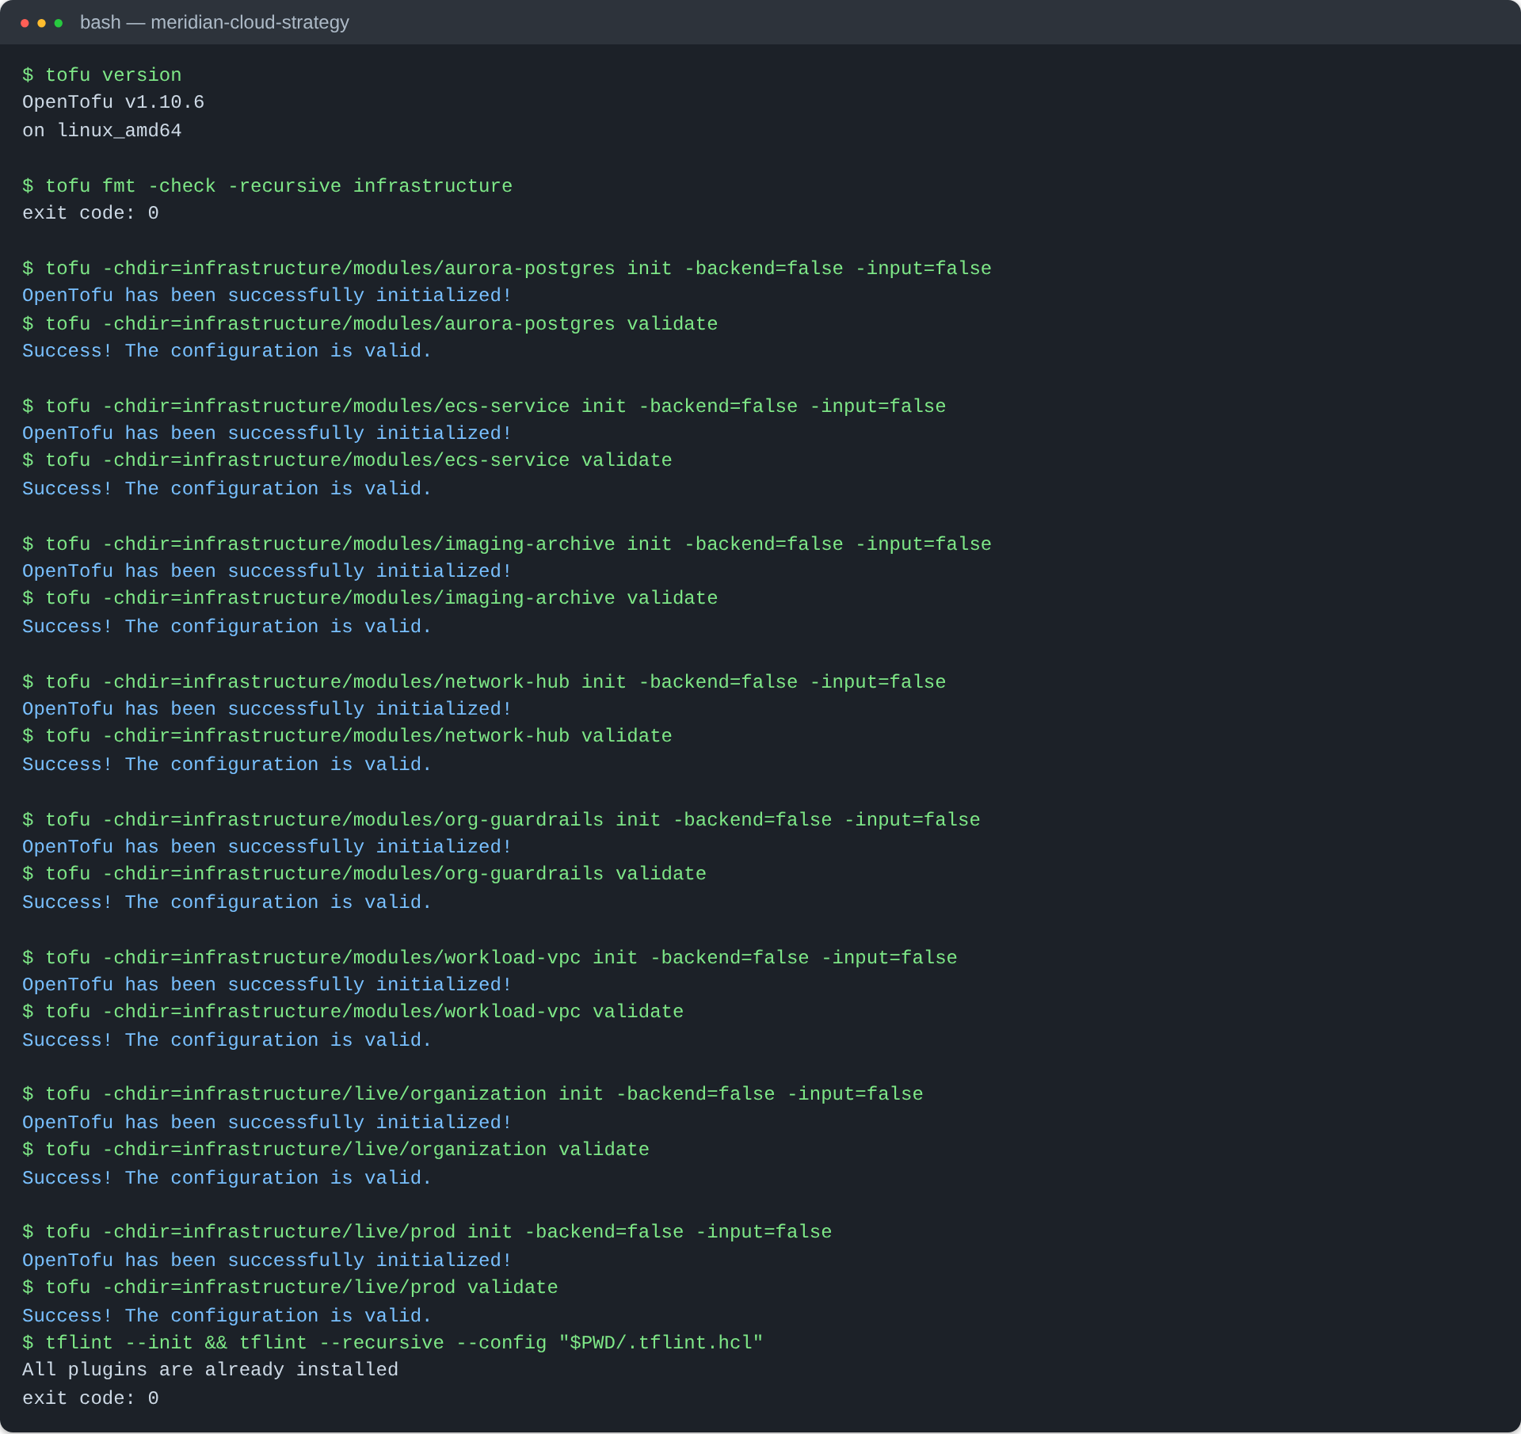
Figure B1 · T1 and T8: format check, validation of all eight modules and stacks, and TFLint
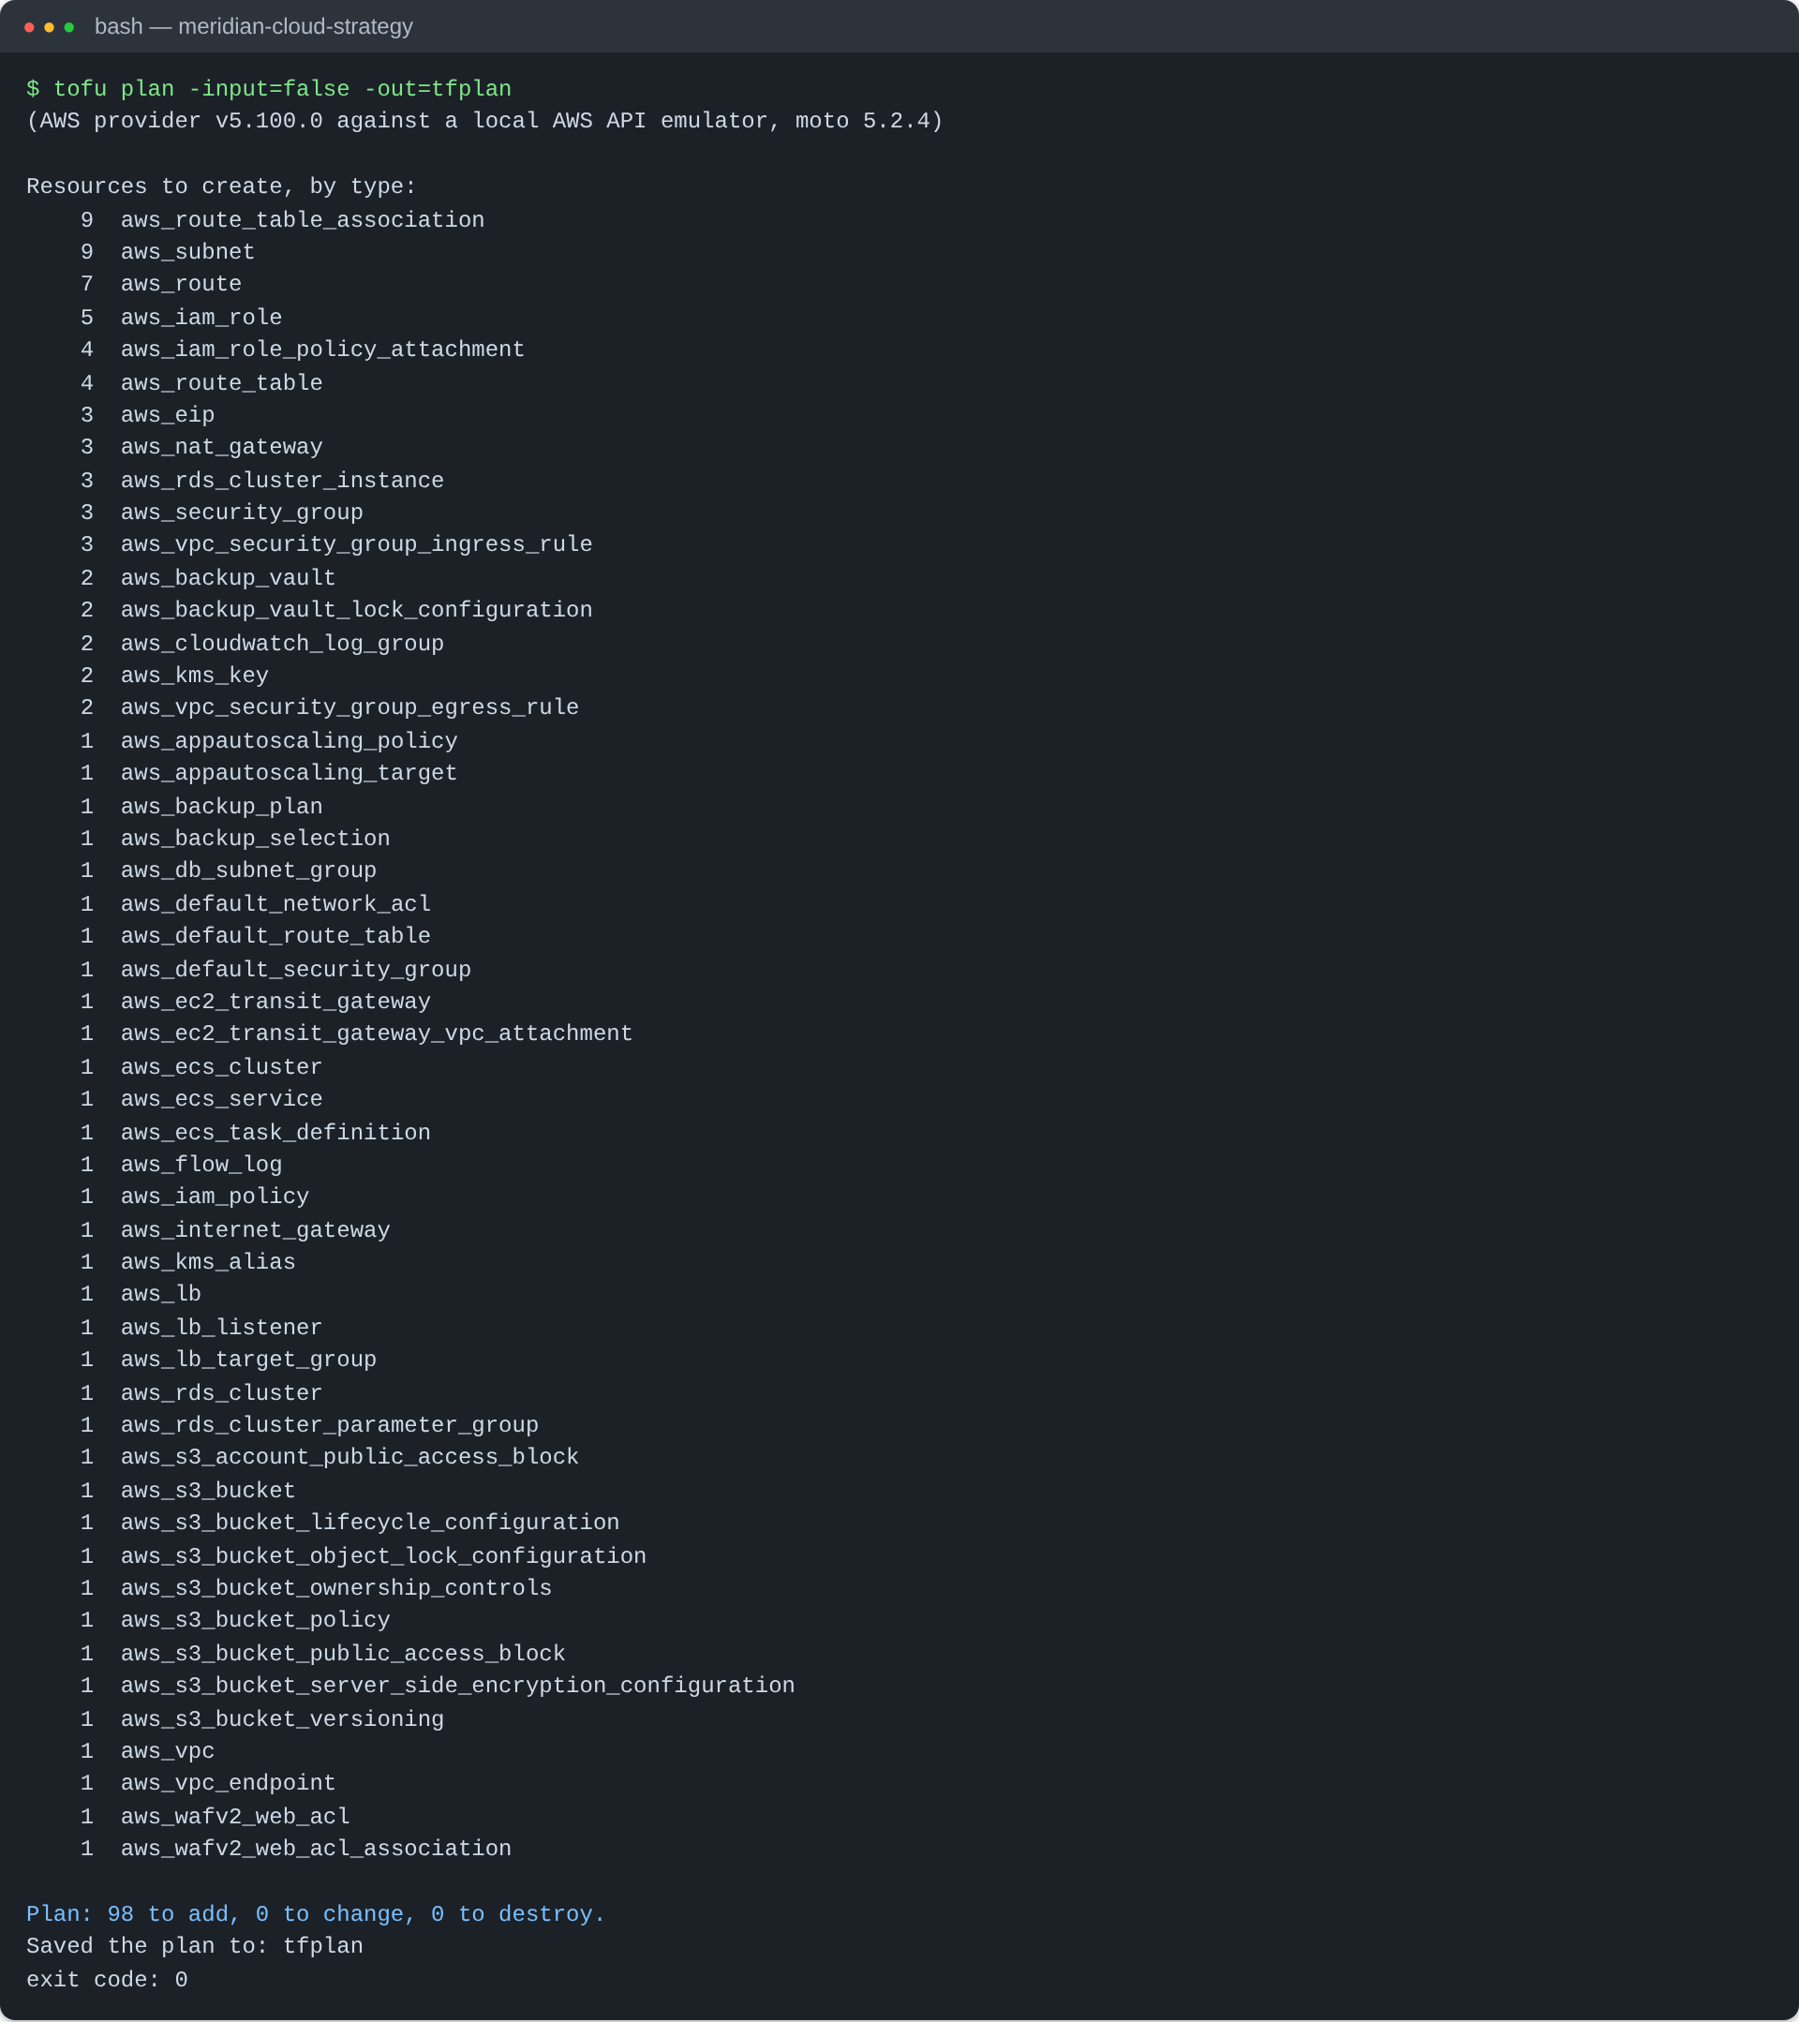
Figure B2 · T2: production plan, 98 resources to add, run against the AWS API emulator
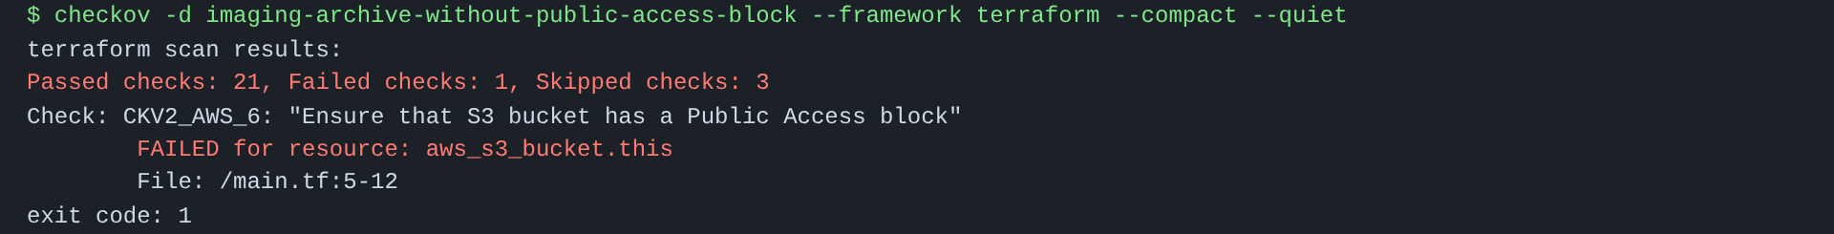
Figure B3 · T3: Checkov fails the build when the public access block is removed
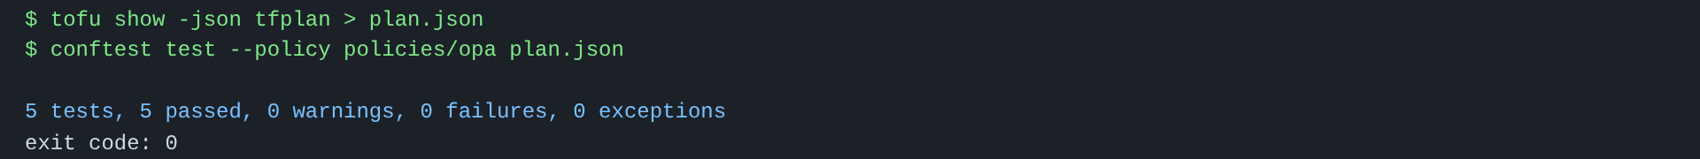
Figure B4 · T4: OPA policy check on the production plan
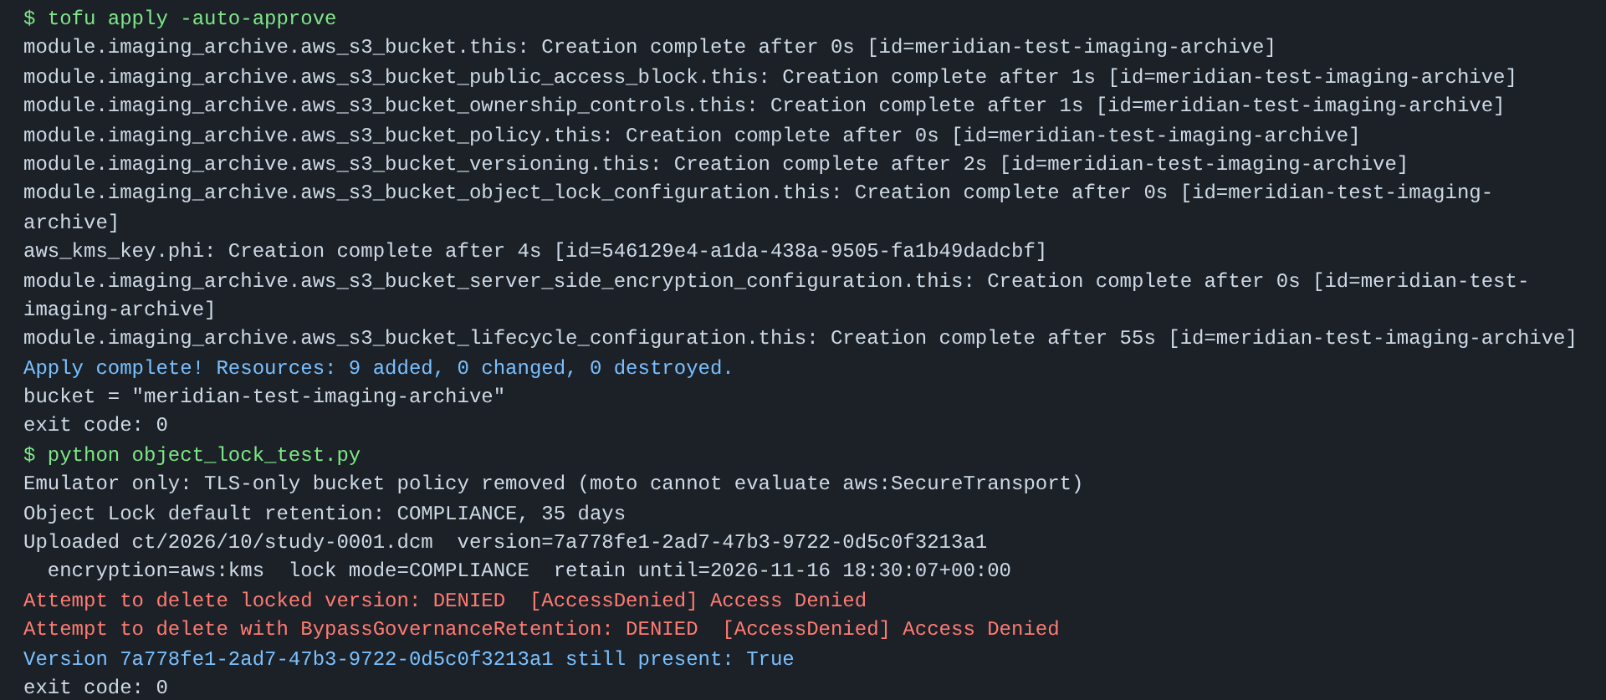
Figure B5 · T5: Object Lock denies deletion of a locked image version
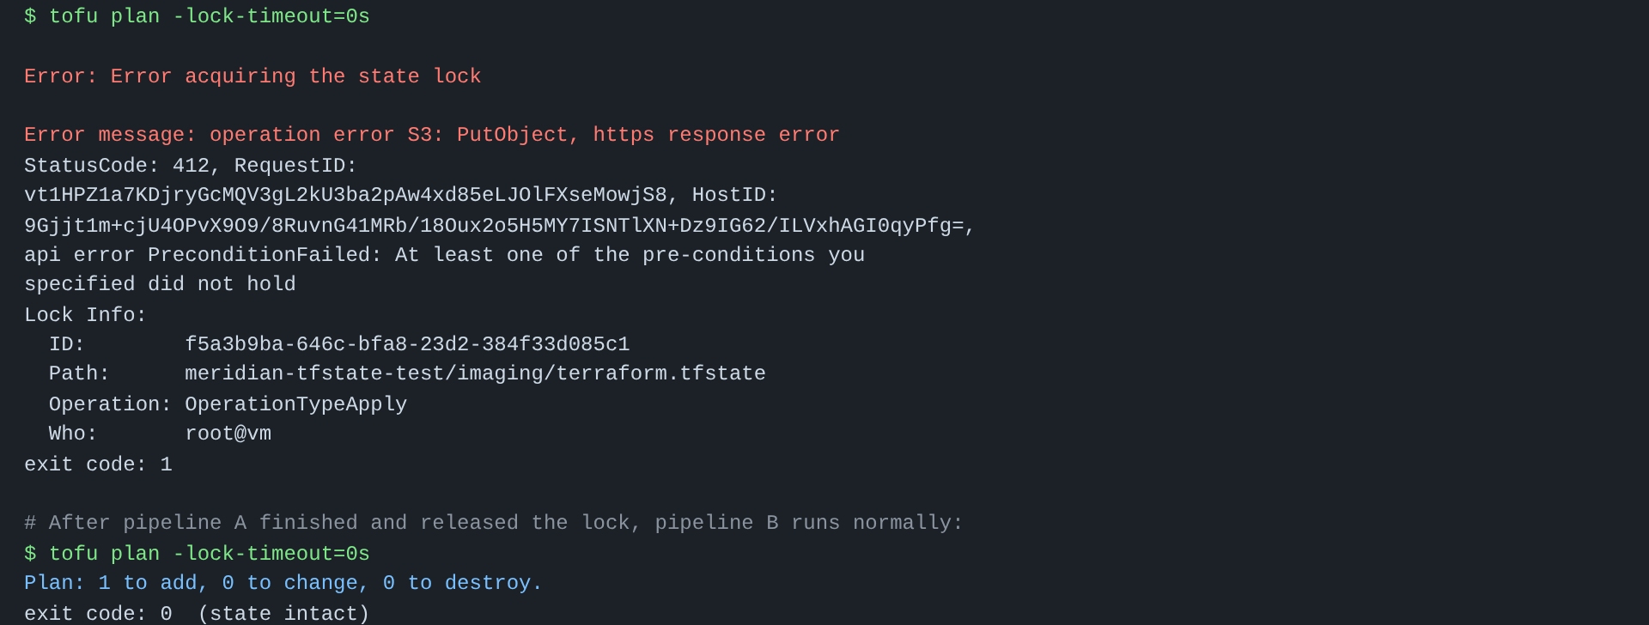
Figure B6 · T6: a second pipeline cannot acquire the state lock
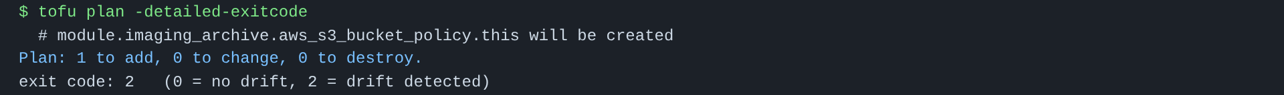
Figure B7 · T7: the nightly plan detects a change made outside code
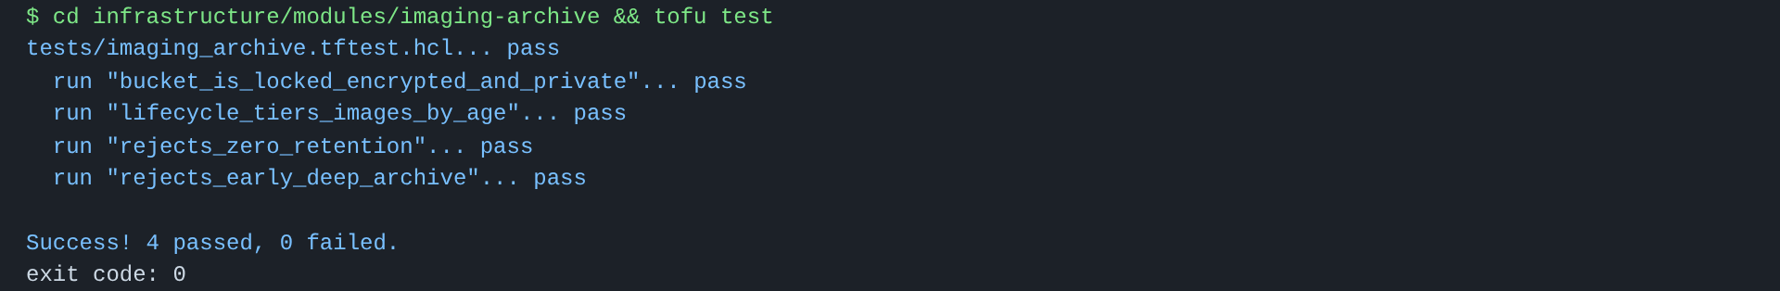
Figure B8 · T9: imaging-archive module unit tests
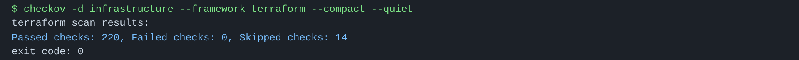
Figure B9 · T10: Checkov scan of all infrastructure code
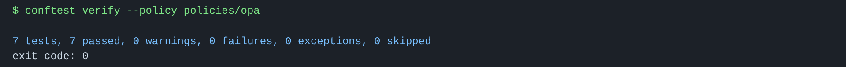
Figure B10 · T11: OPA policy unit tests

Appendix C Assumptions for the cost model
What is set out in Expected outcomes is an index for the five-year cost comparison, not a quote. It would be prudent to substitute it with numbers from Meridian’s finance data and the AWS Pricing Calculator prior to making any decision. The following are the assumptions underpinning the model:
- For on-premises we have factored in support contracts, the hardware refresh due in 2027, staff time on hardware and data-centre power/cooling.
- Cloud side there are costs for a FinOps tool, managed security operations, Direct Connect and 12 months of dual running in the course of migration.
- Three-year Savings Plans cover the steady state workloads (some 60% of compute), with the balance being on demand.
- Non-production is at 50 hours per week as opposed to 168.
- We allow for 25% annual growth in imaging data, with a minimum of 70% going into Glacier Instant Retrieval or Deep Archive after year one.
- Platform team training and certification is part of years 1 and 2.

Appendix D Professional development plan
In order to gauge professional competence BCS makes use of SFIA 9, the Skills Framework for the Information Age (SFIA Foundation, 2024); skills are measured against this. The competency ratings have been self-assessed and can be found in my ePortfolio in tabular form.
Skill | Benchmark | Current competency | Target | Action plan | Target date | Status
Infrastructure as Code | SFIA 9: Infrastructure design (IFDN) | Developing | Achieved | Run this report's Terraform end to end in a personal AWS account; pass the Terraform Associate exam | Mar 2027 | In progress
Cloud security | SFIA 9: Information security (SCTY) | Developing | Achieved | Study the NCSC Cyber Assessment Framework; complete a cloud security course such as AWS Security Specialty | Jun 2027 | Not started
Risk and compliance | SFIA 9: Risk management (BURM) | Developing | Achieved | Shadow a DPIA or risk review at work; maintain a regulatory horizon-scan log | Jun 2027 | Not started
Release automation | SFIA 9: Release management (RELM) | Developing | Achieved | Build a GitHub Actions pipeline with Checkov, OPA and Infracost for a sample project | Feb 2027 | Not started
Applied AI | SFIA 9: Machine learning (MLNG) | Aware | Developing | Complete a SageMaker or Bedrock hands-on course; build one small forecasting model | Sep 2027 | Not started
Cloud cost management | SFIA 9: Financial management (FMIT) | Aware | Developing | Complete the FinOps Foundation's Certified Practitioner course | Dec 2027 | Not started
Emerging technology | SFIA 9: Emerging technology monitoring (EMRG) | Developing | Achieved | Follow NCSC post-quantum and edge computing guidance; write one short briefing each quarter | Ongoing | In progress
Communication and presentation | SFIA 9 behavioural factor: Communication | Developing | Achieved | Present this design to my study group; practise public speaking monthly | Jan 2027 | Not started
Collaboration and mentoring | SFIA 9 behavioural factor: Collaboration | Developing | Achieved | Identify a mentor in cloud architecture; join a BCS specialist group | Mar 2027 | Not started
Time management | SFIA 9 behavioural factor: Planning | Developing | Achieved | Time-box research; reserve 25% of each project for testing | Next project | In progress

