Q1: In a university degree program, students are required to successfully complete five courses from three different pools A, B and C as given below.
A = {Programming Fundamental, Discrete Structure, Digital Logic Design}
B = {Object Oriented Programming, Computer Organization, Computer Networks}
C = {Information Security, Enterprise System}
The following restrictions are imposed by the authority or by students themselves.
- Same course cannot be passed twice
- None of the student is willing to pass more that 5 courses to complete his/her degree.
- Students must pass at least two courses from pool A to takes courses from pool B and pool C
- Students must pass at least two courses from pool B to takes courses from pool C.
Construct the DFA to show all the possible ways in which a students can successfully complete his or her degree.
Programming Fundamental = f,
Discrete Structure = s,
Digital Logic Design = l
Object Oriented Programming = p
Computer Organization = o
Computer Networks = n
Information Security = i
Enterprise System = e
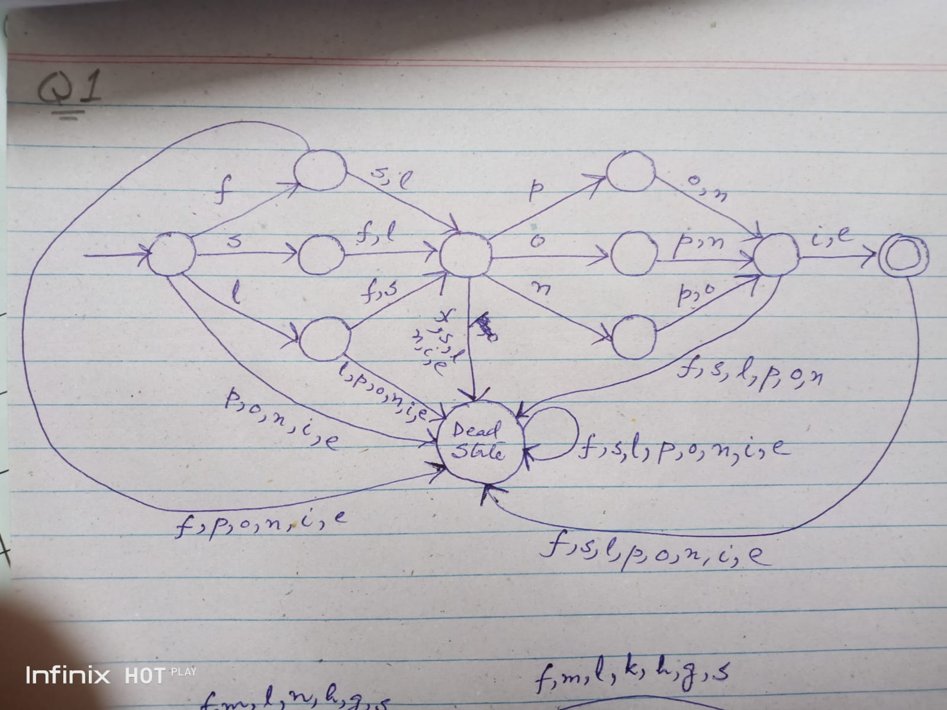
Note: All unshown must be assumed to dead state.
Q2: An elementary school divided his periods into early morning pre-noon and post noon sessions. The following courses are taught during these sessions:
Early Morning= {Mathematic, Science, English}
Pre Noon= {Urdu, Islamic studies, Pakistan studies}
Post Noon = {Sindhi, Drawing, Physical Training}
Teacher will select courses of their choice with following restrictions:
- Each teacher has to select a course from every session in an academic year.
- Each teacher must not conduct more than 4 courses in an academic year.
- A teacher can select two different courses only from pre noon session.
Construct the DFA to show all the possible ways in which a teacher can their course.
Mathematic = m
Science = s
English=e
Urdu = u
Islamic studies = i
Pakistan studies = p
Sindhi = n
Drawing = d
Physical Training = h
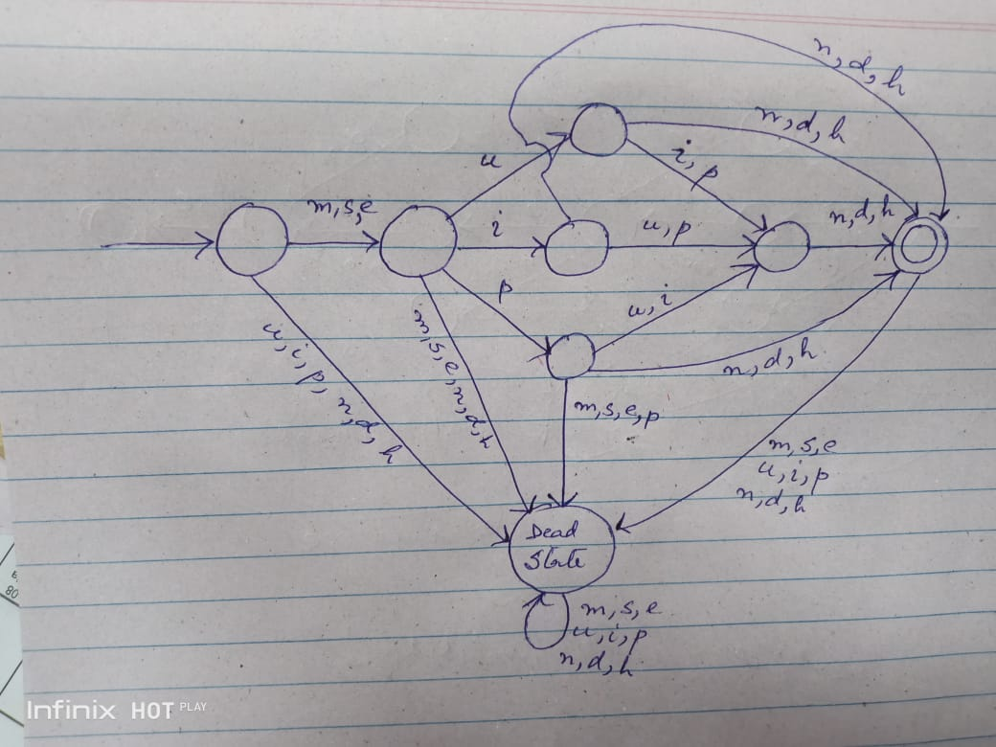
Note: All unshown must be assumed to dead state.
Q3: A travel agent provides customized traveling plans for his valuable clients. He designs three pools of worth seeing places in Northern area and capital of Pakistan.
A = {Shah Faisal Mosque, Pakistan monument, Lok Virsa Heritage museum}
B = {Kashmir point, Sangrela Natural water park, Patriata}
C = {Hunza valley, Kaghan valley, Shogran valley}
The following restrictions are imposed on the clients:
- The clients must select exactly one point from pool A.
- The clients must select exactly two different points from pool B.
- The clients must select exactly one point from pool C.
A travel guide has the following restrictions while visiting his clients to their chosen places:
- Pool A places must be visited first.
- Pool B places must be visited after visiting pool A.
- Pool C places must be visited in the last.
Construct the DFA to show all the possible ways in which a travel guide visit the above places along with his clients.
Shah Faisal Mosque = f
Pakistan monument = m
Lok Virsa Heritage museum = l
Kashmir point = k
Sangrela Natural water park = n
Patriata = p
Hunza valley = h
Kaghan valley = g
Shogran valley = s

