

School of Electrical Engineering and Computer Science

COS5019-B Enterprise Pro

**Planning Document**

Project: My Supermarket Shop

Team 22

# Team Information

Team Number: 22.

Team 22 has been allocated with the project “MySupermarketShop”.

## Team Members

The following table displays all the members of the team.

**Team Leader:** Muhammad Ammaar Rehman.

|  |  |  |
| --- | --- | --- |
| **Member Name** | **Member UB Number** | **Member UB Email** |
| Muhammad Ammaar Rehman | 19006176 | m.rehman16@bradford.ac.uk |
| Abul Foyez | 19005230 | a.foyez@bradford.ac.uk |
| Muhammad Mubeen Mazher | 19005553 | m.mazher@bradford.ac.uk |
| Hassan Ahmed | 19006181 | hahmed69@bradford.ac.uk |

# Link to GitHub

The project’s source code, documentation (Planning & Requirements Documents) and meeting meetings can be found at:

<https://github.com/ammaar1/EnterpriseProT22>

Table of Contents

Team Information 2

Team Members 2

Link to GitHub 2

Team Introduction: 4

Team Member Introduction: 4

Rationale of Topic Choice 4

Literature Review 5

Competitors 5

CompareTheMarket.com 5

LatestDeals.co.uk 5

Work Plan 5

Allocation of Development Work 6

Gantt Chart 6

Meetings Minutes 7

Meeting week 2 7

Meeting week 3 8

Meeting week 4 8

Meeting week 5 9

Meeting week 6 9

Meeting week 7 10

Bibliography 11

# Team Introduction:

We are a team of 4 passionate software engineers that are looking forward to working together and delivering a product that has the potential to re-shape the way we imagine shopping and supermarkets.

## Team Member Introduction:

**Muhammad Ammaar Rehman**

I am a hard-working individual with a heavy interest in the PHP programming language for handling data in the backend. My other strengths involve writing HTML code to integrate PHP forms.

**Abul Foyez**

I am a passionate programmer with experience in web programs using the JavaScript programming language as well as some PHP components that can handle data manipulation/submission/retrieval.

**Muhammad Mubeen Mazher**

A creative individual that specializes in front-end developing such as HTML, CSS, and JavaScript to produce powerful portals and pages that provide the best user experience possible while using the product.

**Hassan Ahmed**

A back-end specialist programmer who loves dealing with big datasets using NoSQL databases. My main environment for playing with non-sequential databases is the Google’s Firebase Database which has a great amount of documentation.

# Rationale of Topic Choice

Since the dawn of civilization people have always had the need to acquire good essential to their living. Our economy has transformed a lot since the earlier ages as now people can look for items in more than one places. This has brought a new challenge to the people looking to manage their finances better.

Supermarkets have been the main source of acquiring products that we need as they are the main place to buy all the goods needed. Food such as bread and meat or items such as tools, these just a few of the products available.

With the introduction of the internet people have now gained a new ability, to pick the goods they like from their favourite places, but also compare the same item’s price to another store. This has transformed they way our economy works as now supermarkets and other merchants fight over the customer by adjusting their prices accordingly.

A tool that can gather all the information on a specific product and give a clear overview of where this product is most economically advisable to be acquired could save hundreds of pounds each year for families. This tool could help people make better choices and adjust their shopping habits accordingly.

No more spending money on overpriced stores where the same product can be bought cheaper!

# Literature Review

Portals such as this one has always existed but not many have had the potential to change society as this one way to do.

It has been researched that virtual portals that offer the look and feel of supermarkets can increase the shopping ability of consumers (van Herpen, van den Broek, van Trijp and Yu, 2016).

One research has found that almost 30% of Americans use the help of online shopbot assistants to find they are looking for to shop. Users have been dependant on these tools to make their purchasing choices. (Passyn, Diriker and Settle, 2013)

## Competitors

### CompareTheMarket.com

One of the key platforms that have implemented the same idea is comparethemarket.com. While CompareTheMarket.com is aimed at services such as gas bill and insurance they have had great success in comparing different service providers. They offer advanced services like looking into the price range tour neighbourhood is in or even test your internet speed and see if you are eligible for a better connection.



Figure CompareTheMarket.com

### LatestDeals.co.uk

One other key competitor is latestdeals.co.uk where users can navigate the best deals on various products. Here the major drawback is that the best price is displayed from the recommended store while not other options are shown. It verry limiting. Our applications aim to provide all the options on the products so that the user can place multiple orders from different supermarkets.



Figure latestdeals.co.uk

# Work Plan

Being a team of 4 people, and each being a specialist in a different field, helps us shape a dynamic team that can implement various aspects of the project utilizing each person’s unique skillset.

There various technologies implemented at the project such as:

* HTML
* CSS
* JavaScript
* PHP
* Google Firebase Database (NoSQL)

## Allocation of Development Work

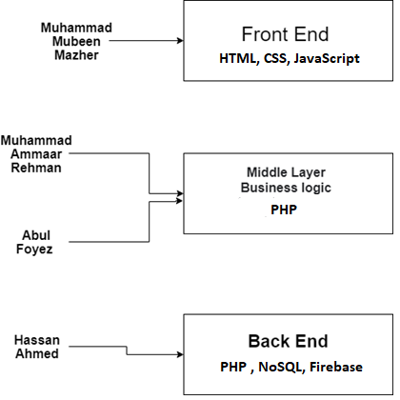

Figure Allocation of Work

## Gantt Chart

The following chart will explain the progress of work during the development process.

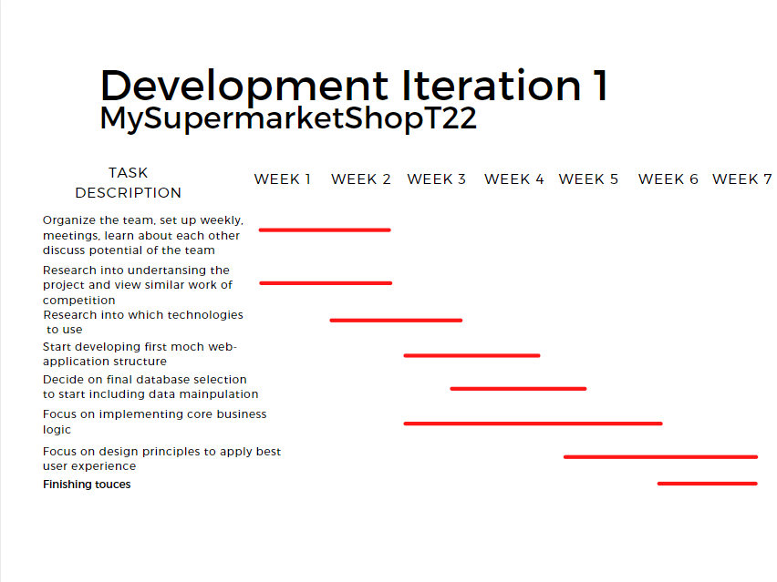

Figure Gantt Chart

## Meetings Minutes

Below all the meeting minutes will be listed to show the progress of the project, the allocation of tasks and the collaboration between the team members.

Format: Date, Time and Members present at the meeting. Discussing the goals achieved based on the previous meeting and plan on the next steps.

Muhammad Ammaar Rehman

Abul Foyez

Muhammad Mubeen Mazher

Hassan Ahmed

### Meeting week 2

|  |  |  |  |
| --- | --- | --- | --- |
| **Date** | | 03/02/2021 | |
| **Time** | | 14:00 | |
| **Team Members Present** | | All | |
| **Objectives Completed** | | | |
| **Objective** | **Description** | | **Completed By:** |
| FIRST MEETING NO PREVIOUS OBJECTIVES | | | |
| **Next Objectives** | | | |
| **Objective** | **Description** | | **Allocated to:** |
| First Meeting General Introduction | Meet each other, learn about our strengths and weaknesses, discuss potential topics, and find information | | All |
| Discuss Potential Topics | Wait for Topic Approval | | All |

### Meeting week 3

|  |  |  |  |
| --- | --- | --- | --- |
| **Date** | | 10/02/2021 | |
| **Time** | | 14:00 | |
| **Team Members Present** | | All | |
| **Objectives Completed** | | | |
| **Objective** | **Description** | | **Completed By:** |
| Acquired Topic | We have been given a topic and now we can focus on reviewing it and organizing the implementation | | All |
| **Next Objectives** | | | |
| **Objective** | **Description** | | **Allocated to:** |
| Research into literature review | Learn about what other platforms that utilise supermarkets have done and how consumers behave when using these systems | | Abul Foyez  Muhammad Mubeen Mazher |
| Research into competition | Look into what other websites have done | | Hassan Ahmed |
| Organize working plan | Plan next steps in terms of organization (similar to Gantt chart) | | Muhammad Ammaar Rehman |

### Meeting week 4

|  |  |  |  |
| --- | --- | --- | --- |
| **Date** | | 17/02/2021 | |
| **Time** | | 13:00 | |
| **Team Members Present** | | All | |
| **Objectives Completed** | | | |
| **Objective** | **Description** | | **Completed By:** |
| Research into literature review | Gathered Successfully information about the topic at hand | | Abul Foyez  Muhammad Mubeen Mazher |
| Research into competition | Successfully found main competitors to draw ideas from and improve | | Hassan Ahmed |
| Organize working plan | Developed a Gannt Chart that will be consulted when implementing the project to check if we are on track | | Muhammad Ammaar Rehman |
| **Next Objectives** | | | |
| **Objective** | **Description** | | **Allocated to:** |
| Discuss team’s knowledge | See what knowledge everyone has and see how we can create a good mix | | All |
| Research into which technologies are suitable for the project | Find our which programming languages/databases/techniques to use that will be used by everyone | | Muhammad Ammaar Rehman  Abul Foyez  Hassan Ahmed |
| Have a rough idea of the look and feel of the project from a design perspective | Draw a small design mockup taking into consideration client feedback | | Muhammad Mubeen Mazher |

### Meeting week 5

|  |  |  |  |
| --- | --- | --- | --- |
| **Date** | | 24/02/2021 | |
| **Time** | | 14:00 | |
| **Team Members Present** | | All | |
| **Objectives Completed** | | | |
| **Objective** | **Description** | | **Completed By:** |
| Discuss team’s knowledge | Decided that key strengths include Front-End HTML, CSS, JavaScript, Middle Layers using PHP and Backend Databases using NoSQL Firebase | | All |
| Research into which technologies are suitable for the project | Muhammad Ammaar Rehman  Abul Foyez  Hassan Ahmed |
| Have a rough idea of the look and feel of the project from a design perspective | Successfully gave a nice sketch about the actual presentation of the project in terms of designs | | Muhammad Mubeen Mazher |
| **Next Objectives** | | | |
| **Objective** | **Description** | | **Allocated to:** |
| Start implementing first pages such as Login, Register, Home (Search) | Design and implement first pages using Front end technologies | | Muhammad Mubeen Mazher |
| Start implementing the PHP code along with the front – end development to handle the data manipulation | Write the PHP code and see how it works when manipulating data from the forms on the HTML code and submitting it to the backend | | Muhammad Ammaar Rehman  Abul Foyez |
| Create Google Firebase Instance and learn how to setup the Realtime NOSQL Database to upload data | Learn and utilize Google Platform to use Firebase to save all the data from the website using PHP, find suitable library | | Hassan Ahmed |

### Meeting week 6

|  |  |  |  |
| --- | --- | --- | --- |
| **Date** | | 03/03/2021 | |
| **Time** | | 15:00 | |
| **Team Members Present** | | All | |
| **Objectives Completed** | | | |
| **Objective** | **Description** | | **Completed By:** |
| Start implementing first pages such as Login, Register, Home (Search) | Completed first part of the project by creating the Login, Register and Home Search pages. | | Muhammad Mubeen Mazher |
| Start implementing the PHP code along with the front – end development to handle the data manipulation | Implemented the middle layer using PHP to draw data from the front end and send back to the back-end using PHP | | Muhammad Ammaar Rehman  Abul Foyez |
| Create Google Firebase Instance and learn how to setup the Realtime NOSQL Database to upload data | Create a Google Firebase instance where all the data will be saved about products/users/orders | | Hassan Ahmed |
|  |  | |  |
| **Next Objectives** | | | |
| **Objective** | **Description** | | **Allocated to:** |
| Start developing the pages Basket, Profile, and the look of the Search result once the user has selected a product | Further crate pages so user can see the products from all the available supermarkets and place orders to view in the Basket | | Muhammad Mubeen Mazher |
| Create logic where users can select the product available and view all the prices and supermarkets that have them | Middle layer business logic where the products will be displayed in a way that show the supermarket that offers the products and how much they offer it for | | Muhammad Ammaar Rehman  Abul Foyez |
| Assist both in middle layer and backed to populate the dataset to simulate the project better for the presentation | Assist in developing the logic that will be used to retrieved the data from the Firebase database created and also populate the database with fake data | | Hassan Ahmed |

### Meeting week 7

|  |  |  |  |
| --- | --- | --- | --- |
| **Date** | | 10/03/2021 | |
| **Time** | | 15:00 | |
| **Team Members Present** | | All | |
| **Objectives Completed** | | | |
| **Objective** | **Description** | | **Completed By:** |
| Start developing the pages Basket, Profile, and the look of the Search result once the user has selected a product | All the pages have been developed and are available for the user to navigate having all functionality such as login, register and search and place order | | Muhammad Mubeen Mazher |
| Create logic where users can select the product available and view all the prices and supermarkets that have them | Middle layer perfected to retrieve data about users and products where necessary | | Muhammad Ammaar Rehman  Abul Foyez |
| Assist both in middle layer and backed to populate the dataset to simulate the project better for the presentation | Database populated with fake data to simulate project for demo video and also database schema is refined | | Hassan Ahmed |
|  |  | |  |
| **Next Objectives** | | | |
| **Objective** | **Description** | | **Allocated to:** |
| Finishing Touches | Check all functionalities that work, change some design options such as colour, sizes, and structure. | | Muhammad Mubeen Mazher  Abul Foyez |
| Documentation | Focus on finishing the requirements documentation and add any info that we way have missed | | Muhammad Ammaar Rehman  Hassan Ahmed |

# Bibliography

Briesch, R., Krishnamurthi, L., Mazumdar, T. and Raj, S., 1997. A Comparative Analysis of Reference Price Models. Journal of Consumer Research, 24(2), pp.202-214.

Passyn, K., Diriker, M. and Settle, R., 2013. Price Comparison, Price Competition, And The Effects Of ShopBots. Journal of Business & Economics Research (JBER), 11(9), p.401.

van Herpen, E., van den Broek, E., van Trijp, H. and Yu, T., 2016. Can a virtual supermarket bring realism into the lab? Comparing shopping behavior using virtual and pictorial store representations to behavior in a physical store. Appetite, 107, pp.196-207.