

School of Electrical Engineering and Computer Science

COS5019-B Enterprise Pro

**Requirements Document**

Project: My Supermarket Shop

Team 22

# Team Information

Team Number: 22.

Team 22 has been allocated with the project “MySupermarketShop”.

## Team Members

The following table displays all the members of the team.

**Team Leader:** Muhammad Ammaar Rehman.

|  |  |  |
| --- | --- | --- |
| **Member Name** | **Member UB Number** | **Member UB Email** |
| Muhammad Ammaar Rehman | 19006176 | m.rehman16@bradford.ac.uk |
| Abul Foyez | 19005230 | a.foyez@bradford.ac.uk |
| Muhammad Mubeen Mazher | 19005553 | m.mazher@bradford.ac.uk |
| Hassan Ahmed | 19006181 | hahmed69@bradford.ac.uk |

# Link to GitHub

The project’s source code, documentation (Planning & Requirements Documents) and meeting meetings can be found at:

<https://github.com/ammaar1/EnterpriseProT22>

Table of Contents

Team Information 2

Team Members 2

Link to GitHub 2

Introduction 4

Key functions of the system 4

Type of Actors 4

Users (Consumers/Customers) 4

Admin (Administrators) 4

Functions 4

Registration (User) 4

Log in (User, Admin) 4

Home – Search (User) 5

Basket (User) 5

Profile (User) 5

Use Case Diagram 5

Data 6

Input 6

Output 6

Data Stored 7

User 7

Product 7

Order 7

Interface 8

User 8

Main Menu 8

Home Page – Search Products 8

Technical and professional issues 9

Code of Ethics 9

Intellectual property 9

Privacy 9

Confidentiality 9

Professional quality 9

Software Risks 9

# Introduction

The following document will showcase the implementation of the “MySupermarketshop” web-application. It involves a website where people can come and compare prices of different products available in all the supermarkets. This way, users can multi-purchase products from different supermarkets, picking the best price from each. After selecting which products, they want from which supermarket and the quantity, orders are placed in the basket where users can proceed with their orders.

# Key functions of the system

The following section will address the types of actors that will use the system, the functions for each actor and the use case diagrams explaining the processes.

## Type of Actors

The type of actors are the actual people that are meant to use the systems, categorising them according to their purpose of using the system.

### Users (Consumers/Customers)

The main actors of the system are the users. There are the ones that will register with the system by providing their personal information to create a profile. This way they can look through a wide range of products and select their most favourite to put in the basket and order afterwards. Users cannot see other users; they can just see all the available products in different supermarkets and compare prices. They can put items in the basket and make the orders from that basket. When placing orders, users can adjust the desired quantity of an item.

### Admin (Administrators)

Admins are the owners of the system. Here they can have a full overview of all the users registered with the website as well as see their orders and purchasing history. Admins can also edit or remove users from the system. New products are placed by admins by inputting the supermarket it is available in and the price it is sold for. **Note: Not implemented in this iteration**

## Functions

The following section will address the main functions of the system.

### Registration (User)

User will navigate to this page to create an account with the system by providing their personal information such as:

* Username
* Email
* Password
* Date of Birth

After registering with the service, user can log in the system to view their profile.

### Log in (User, Admin)

Users can navigate to this page and input their username and password to access the system and view their profile.

### Home – Search (User)

This is the main page of the website. Here users will be greeted by a welcoming message and maybe view current offers on products.

Here there will be a search box where all the available products will be listed, and the users can select the one they are looking for in the list. After selecting one, the user will be redirected to the page showing the supermarkets that have the product available, each showing the price it is sold for.

The users can then select their desired quantity of the item and click ‘Add to Basket’ to put the item in the basket. The product, the supermarket, the quantity, and the price are then saved as an order.

### Basket (User)

Users can navigate to this page to view their current orders of items placed and decide whether to proceed to purchase or remove items or empty the basket.

A detailed table is shown containing information on every order and its information such as:

* Product
* Supermarket
* Quantity
* Price
* **Calculated**: Total (Quantity X Price)

### Profile (User)

Here Users can view their complete profile and the personal information they have inputted at registration. Users can edit the information. In addition, users can track the status of their current orders or view past purchases made on the system. **Note: Not implemented in this iteration**

## Use Case Diagram

The following diagrams will demonstrate the use of the system by the actors demonstrating the flow of use.

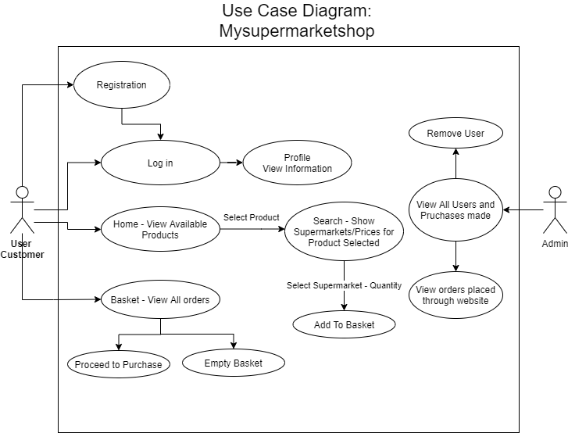

Figure Use Case Diagram.

# Data

The following section will include the data handled by the system such a user information or orders placed. Data are stored in a remote Google Firebase Database.

## Input

The data inputted in the system are:

* User
  + Username
  + Email
  + Password
  + Date of Birth
* Order
  + Product
  + Supermarket
  + Quantity Desired

## Output

The data outputted by the system are:

* Product
  + Product name
  + Supermarkets available
  + Price in each supermarket

## Data Stored

Here all the data saved in the database will be explained. This data is available to the system and system owners.

### User

Data stored for a user.

|  |  |
| --- | --- |
| **Data** | **Type** |
| username | Text |
| email | Text (email format) |
| password | Text |
| Date of Birth | Date |
| Orders Placed | List of Orders |

### Product

Data stored for a product available on the website.

|  |  |
| --- | --- |
| **Data** | **Type** |
| Product Name | Text |
| Supermarkets offering the product | List of Supermarkets |
| Price | Number |

### Order

Data stored for an order placed.

|  |  |
| --- | --- |
| **Data** | **Type** |
| Product Name | Text |
| Supermarket Name | Text |
| Quantity | Number |
| Price | Number |

# Interface

The interfaces will be described in this scope to illustrate the possible path for a user using the system.

## User

Users are able different views depending on their desired task.

### Main Menu

The following display will show possible paths for a user when viewing the main menu interface of the website.

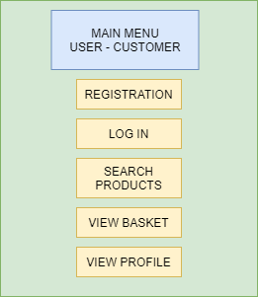

Figure User Interface Display

### Home Page – Search Products

The following display will show possible paths for a user when viewing the home page interface of the website.

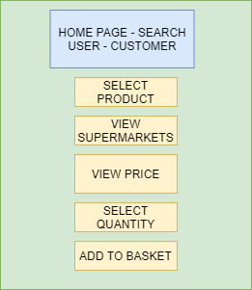

Figure Home page - Search Interface Display

# Technical and professional issues

This section will briefly mention the issues related to the project undertaken by Team 22.

## Code of Ethics

Team 22 has agreed and set in place mechanisms that will ensure that ethics are a top priority for the team.

### Intellectual property

While Team 22 is designing and implementing the project, all deliverables are property of the respected client.

### Privacy

Privacy is a top concern for Team 22 therefore all communications between team members have been done using software that adhered to all privacy rules therefore eliminating any potential leak of data or knowledge.

### Confidentiality

While NDAs have been signed and sent back to the respected client, all team members have agreed to not disclose any information relating the project undertaken.

### Professional quality

Team 22 has set as a goal to ensure the maximum possible quality to be achieved utilizing all our strengths and optimizing our time.

### Software Risks

While some parts of the software have been secured and tested, the system should be delivered to an external partner for further security verification.