**Online Second-Hand Furniture Marketplace**

**Final Project Report**

Laura Onajite and Amma A. Boa-Amponsem

College of Professional Studies, Northeastern University

ITC 6000: Database Management Systems

Dr. Anjum Biswas

October 28, 2023

**Online Second-Hand Furniture Marketplace**

**Final Project Report**

**Overview**

Welcome to the in-depth business analysis report of our second-hand Furniture Marketplace online platform presented by Group 7.This website initiates the solution to the challenges of online shoppers or individual users who struggle to make the right decisions on where to purchase high quality yet affordable furniture products. We are Laura Onajite and Amma A. Boa-Amponsem.

**Introduction**

In this detailed report, we will include the Problem Statement, Solution, Business analysis, and solution Architecture using diverse visualizations for clarity and comprehension.

Furniture shopping, influenced by various factors such as budget considerations, standard type, material, quality, and sizes can be complex and overwhelming at times. Users find it challenging to get the perfect furniture for their homes, event decors and offices to name a few. To deliver a community-friendly solution, our team has developed an online marketing platform which offers users to: buy and sell their second-hand furniture; review or share their good and bad experiences on furniture products they purchase; assist in making well-informed decisions on furniture choices and provide insights on the supply and demand of certain furniture products for manufacturers and interior designers.

With this user-friendly website, a wide range of database on user profiles, furniture listings, categories, and images as well as a vigorous rating and review mechanism will be obtained. We simply aim to improve the furniture shopping process and provide adequate resources for furniture enthusiasts.

**Problem Statement**

As team members and newly enrolled postgraduate students who just moved into new apartments in a new city and country, we find it hard to choose sofas, lamp lights, tables, etc for our individual budget-friendly choices. Being in a new environment where landmarks and places are hard to identify, there are several online furniture-selling platforms that also create obstacles in the purchasing journey.

**Solution**

We propose a business concept, to build a community for fellow furniture enthusiasts and regular users to purchase second-hand furniture pieces or sets for their ideal uses.

The target users for our website would include people who would like to buy furniture products, people who want to review purchased furniture products, individuals and manufacturers who want to sell, and people generally interested in furniture.

Real-life examples of such user types to name a few could be; a student looking to find budget-friendly second-hand furniture for their newfound apartment, a newlywed couple in need of house furniture and fixtures for their love nest, a regular user who wants to share their positive or negative experiences with certain furniture pieces to help others in the community, and a distributor wanting feedback on reviews to improve his products and stay competitive in the industry.

***Figure 1.0. Website Logo Concept***

**Business Analysis**

**Features and Functionality**

Here are some of the features that will be provided on our website:

***Profiles***: User profiles will be created with information on their names, emails, phone numbers and other details for easier tracking of their activities on the website.

***Furniture Database***: Data will be collected on the furniture pieces based on their categories, names, makes, listings, imagery, and their distributor’s information.

***Furniture Rating***: On a scale of 0 to 5, users can expressively rate the products under five (5) main categories: accessibility, price, durability, quality, and style.

***Comments****:* Users can also provide their detailed reviews in writings on their experiences with certain furniture pieces.

***Shopping lists****:* Users can buy furniture, share, or save links to access the distributor’s website on certain furniture pieces.

***Data Analysis***: The website will recommend the products with the highest number of sales, best ratings and reviews based on its users’ database and activities on the website.

**Monetization**

The website is also completely free to use, although there might be some sponsored furniture listings and other third-party ads, showing on both sides of the web page from which we plan to generate revenue. The user might also choose to personalize their sponsored furniture based on their previous purchases, reviews, or search history. The website would only profit from promoting sponsored furniture and the sponsorship ads would not interfere with the activities of the users. This would help the core functionality of the website, marketplace, rating, and commenting, to stay neutral.

**User Types**

Our second-hand furniture website is truly useful for anyone interested in budget-friendly furniture. There are some user personas:

***User A (Budget Shopper)***: A university student who just moved out of the dorm and rented an apartment. User A is looking to purchase some budget-friendly furniture but as a new user didn’t know where to start. Fortunately, user A found our website with people sharing via social media and viewing all kinds of different furniture. After carefully reviewing each furniture’s ratings and comments, user A created a shopping list of every furniture they would like to buy on our website.

***User B (Unsatisfied Customer)***: User B just bought a sofa 3 months ago, and now they found out the sofa is completely broken with very light use. User B visited our website and found out many purchasers of the same couch have a similar problem. User B left a bad durability rating on the sofa they bought and chose a good-rating sofa on our website instead. Since then, more and more people who visited our website have avoided the bad couch and bought a good one.

***User C (Furniture Producer)***: User C is a furniture producer, and they produce ergonomic chairs. They found out that their sales are decreasing on the website but don’t know why. They visited our website and found out that although many people gave their chair a high rating on durability and style, few people think the chair’s build quality isn’t good. So, User C later used a better material and their sales drastically improved.

***User D (Interior Designer)***: User D is an Interior Designer looking for stylish and durable second-hand furniture pieces as an inspiration for designing home and office concepts for their clients who are budget minded. User D discovers the website on the web search bar results and decides to click on the link. After being satisfied with the insights they gained on the listings and reviews of certain furniture pieces from our website, User D now has the necessary information on which furniture types to recommend to their clients.

**Business rules**

Our business rules will regulate the core operations of our website:

***Registration***: Users can only be able to access the website by creating individual accounts for them to be identified by the user IDs, email addresses, phone numbers, genders, ages and any history of purchases or reviews.

***Data Security***: Our users information details and data on furniture will be securely stored on a server which will follow the guidelines and policies of data security. Higher security and access control on certain vital and confidential data will only be accessed by the main Administrators and authorized personnels approved solely by them.

***Administrators Responsibility***: An administrator can have access to edit or remove a user’s comments if they are not adhering to the rules and regulations. They can also add more distributors and furniture pieces to the website.

***Users Responsibility***: A user can have access to the furniture categories, view the ratings and reviews or even leave their own ratings and reviews on specific furniture pieces they have used or in use.

In Summary:

a USER could ORDER one or many FURNITURE pieces

USER could REPORT or ISSUE a complaint to an ADMINISTRATOR about comments or other USERS

a USER could RATE many FURNITURE pieces

a USER could perform zero or many RATINGS, but a RATING must have one USER

a USER could leave many COMMENTS on a FURNITURE piece, but a COMMENT cannot have many USERS only one,

a USER could SEARCH for a DISTRIBUTOR to identify FURNITURE

a DISTRIBUTOR can SELL his/her FURNITURE pieces

a FURNITURE can have many RATINGS, but a USER can only RATE a FURNITURE once

a FURNITURE can have many RATINGS, but a USER can RATE a FURNITURE once

a DEPARTMENT could have many FURNITURE pieces, but a specified FURNITURE piece could belong to one DEPARTMENT

ADMINISTRATOR could EDIT DISTRIBUTOR and FURNITURE

ADMINISTRATOR could disable USER comments or ban USER for misbehavior

Below is an illustration of business rules for easier identification and explanation:

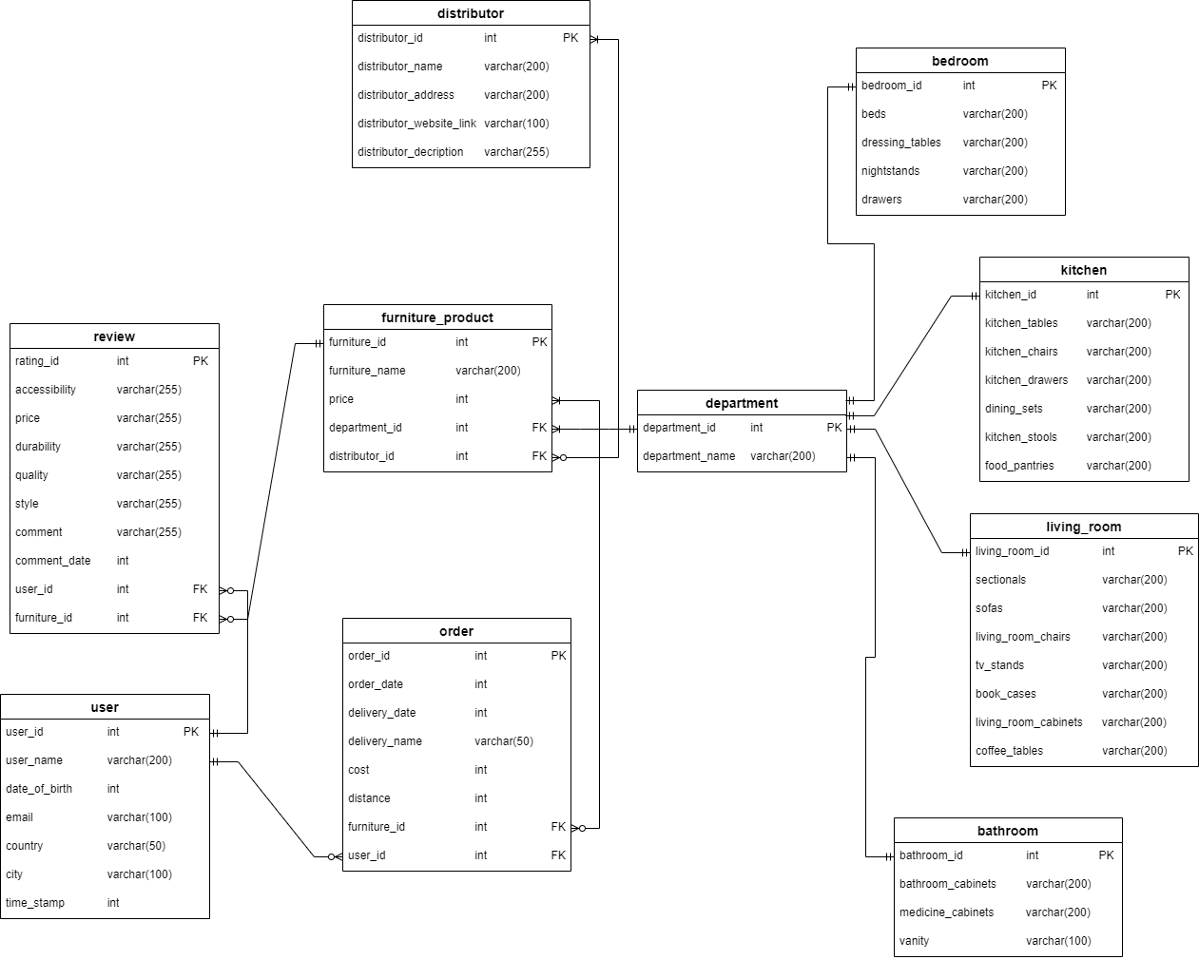

***Figure 1.1: An illustrated ER Diagram***

**Table Design and Analysis**

Reflecting on our ER diagram depicted on *Figure 1.1*, we have ten (10) different but significant tables or entities namely, “user”, “review”, “order”, “furniture_product”, “distributor”, “department”, “bathroom”, “living_room”, “bedroom” and “kitchen”.

***“user” Table:*** The “user ” table will keep records on data obtained from the users. Such data will be on the following attributes depicted on our ERD. They are the “user_id”, “user_name”, “date_of_birth”, “email”, “country”, “city” and “time_stamp”. The “user” table has a relationship with both the “order” and “review” tables where a user can have zero to many orders or reviews depending on their activities on the website.

***“review” Table:*** The “review ” table will track records on data obtained from the reviews from users. The attributes are the “rating_id”, “accessibilty”, “price”, “durabilty”, “quality”, “style” and “comment”, “comment_date”, “user_id” and “furniture_id”. The “review” table has a relationship with both the “user” and “furniture_product” tables where zero to many reviews can done but one furniture can be reviewed once by a user.

***“order” Table:*** The “order ” table will track purchases and sales record on data obtained from both users and distributors. The attributes are the “order_id”, “order_date”, “delivery_date”, “delivery_name”, “cost”, “distance”, “furniture_id” and “user_id”. The “order” table has a relationship with both the “user” and “furniture_product” tables where a user can place zero or many orders and an order can have at least one to many furniture products.

***“******furniture_product” Table:*** The “furniture_product” table will record all the furniture listings uploaded by the distributors. The attributes are the “furniture_product”, “furniture_name”, “price”, “department_id”, and “distributor_id”. The “furniture_product” table has a relationship with the “review”, “distributor”, “department” and “order” tables where a furniture type belongs to one department and distributor respectively. It can also have zero to many reviews and at least one order.

“**distributor**” Table: The “distributor” table will record all the information and details on the distributors. The attributes are the “distributor_id”, “distributor_name”, “distributor_address”, “distributor_website_link”, and “distributor_description”. The “distributor” table has a relationship with the “furniture_product table where a distributor can upload at least one furniture product.

“**department**” Table: The “department” table will record all the furniture products assigned to each department or category. The attributes are the “department_id” and “department_name”. The “department” table has a relationship with the “furniture_product” , “bedroom”, “bathroom”, “kitchen” and “living_room” tables where a deparment can have only one furniture type (e.g., a living room chair can only belong to the living room).

“**bedroom**” Table: The “bedroom” table will record all the furniture products assigned to the bedroom department. The attributes are the “bedroom_id”, “beds”, “dressing_tables”, “nightstands” and “drawers”. The “bedroom” table has a relationship with the “department” table where a bedroom furniture type can be found in only one department.

“**kitchen**” Table: The “kitchen” table will record all the furniture products assigned to the kitchen department. The attributes are the “kitchen_id”, “kitchen_tables”, “kitchen_chairs”, “kitchen_drawers”, “dining_sets”, “kitchen_stools” and “food_pantries”. The “kitchen” table has a relationship with the “department” table where a kitchen furniture type can be found in only one department.

“**living_room**” Table: The “living_room” table will record all the furniture products assigned to the living room department. The attributes are the “living_room_id” and “sectionals”, “sofas”, “living_room_chairs”, “tv_stands”, “book_cases”, “living_room_cabinets” and “coffee_tables”. The “living_room” table has a relationship with the “department” table where a living room furniture type can be found in only one department.

“**bathroom**” Table: The “bathroom” table will record all the furniture products assigned to the bathroom department. The attributes are the “bathroom_id” and “bathroom_cabinets”, “medicine_cabinets” and “vanity”. The “bathroom” table has a relationship with the “department” table where a bathroom furniture type can be found in only one department.

Our overall tables contain 50 or more rows of data created.

**Database Implementation**

With our well-detailed and clear ERD and database, we can show graphical examples of SQL commands that can be used to obtain an information from our database.

***SQL Command 1***: Find the furniture product of a distributor that has ratings above 4 stars on durability.

“SELECT” and “JOIN” key tables as demonstrated in ***Figure 1.2.1*** to derive the result in ***Figure 1.2.2.***

***Figure 1.2.1: An illustrated SQL Command 1***

***Figure 1.2.2: Result from SQL Command 1***

***SQL Command 2:*** Find a living room furniture that was sold between 20 and 50 USD and has 3-star ratings and below in accessibility.

“SELECT” and “JOIN” key tables as demonstrated in ***Figure 1.3.1*** to derive the result in ***Figure 1.3.2.***

***Figure 1.3.1: An illustrated SQL Command 2***

 ***Figure 1.3.2: Result from SQL Command 2***

***SQL Command 3:*** Find the name of the person who made a comment with the word "good" in it on a product and the date he/she commented.

“SELECT” and “JOIN” key tables as demonstrated in ***Figure 1.4.1*** to derive the result in ***Figure 1.4.2.***

***Figure 1.4.1: An illustrated SQL Command 3***

***Figure 1.4.2: Result from SQL Command 3***

***SQL Command 4:*** Find the furniture product, its cost of delivery and the name of the person who received his/her product in Boston.

“SELECT” and “JOIN” key tables as demonstrated in ***Figure 1.5.1*** to derive the result in ***Figure 1.5.2.***

***Figure 1.5.1: An illustrated SQL Command 4***

***Figure 1.5.2: Result from SQL Command 4***

**Analytics, Reports, and Metrics**

***Users***

Analytics on user interface will be obtained as:

* + Number of favourites on a furniture product
  + Number of shares
  + Number of comments
  + Number of ratings
* Distributors
  + Number of Views by users
  + Percentage number of Clicks on a product
  + Percentage number of Clicks on website link
  + Number of Furniture Listings
* Administrators
  + Total number of users
  + Total number of distributors
  + Percentage number of Users with activity in the past 7 days
  + Most active distributors uploading Furniture pieces

**Security Concerns**

The following Security concerns will be met and thoroughly supervised:

* Our user's information details and data on furniture will be securely stored on a server
* Follow the guidelines and policies of data security
* Higher security and access control on certain vital and confidential data will only be accessed by the two Administrators and authorized personnels approved by the Administrators

***Disclaimer***: We will put a disclaimer that no payment should be made online prior to a physical inspection of the product to prevent users from being scammed.

**Architecture**

The system will be divided into two key components:

**Client**: Our platform’s user interface will include web browsers and mobile apps used by the users. Users will be able to send and request for data, like furniture information, reviews, and transactions, to the server.

**Server**: The main server will handle several functions including:

***Database Management*** – It will operate the core database. Data on user profiles, furniture information, reviews and marketplace listings will be managed.

***Application Logic*** – Application logic will be executed by the main server. This will include the user authentication, recommendation algorithms and data analytics.

***Application Programming Interfaces (APIs)***: For communication between the user and server to be enabled, we will develop APIs for seamless data exchange.

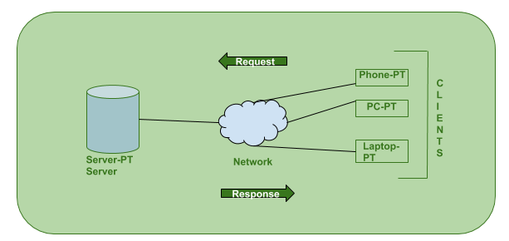

***Figure 1.1. Client/Server Architecture Concept***

**Hosting Model**

Hosting it in the cloud is the preferred choice given the accessibility and flexibility required for our platform. We will use cloud providers like IBM Cloud, Microsoft Azure, Oracle Cloud, Google Cloud Platform (GCP) or Amazon Web Services (AWS) that provide the resources required to guarantee high accessibility and manage increased demand.

Cloud hosting provides benefits such as easier backup and recovery, automatic scalability, and reduced infrastructure management overhead. It will enable us to focus on developing and managing the website without hardware concerns.

**Storage Requirements**

There are a lot of factors to consider when it comes to the amount of storage required. Factors such as the size and number of images and product data, the volume of user generated content, and historical data for analytics. We will initially plan for a few terabytes of storage to contain user reviews, furniture listings and their associated images. To manage costs on the actual usage, we intend to implement automated storage scaling for our website.

**Project Wrap-Up and Future Considerations**

**Project Wrap-Up**

**Future Considerations**

**References**

Wayfair LLC. (2023). Furniture Category. <https://www.wayfair.com/>

Inter IKEA Systems B.V. (2023). Rooms Category.

<https://www.ikea.com/us/en/rooms/bedroom/>

Baldazzi, G. (2012, Jan 29). *Entity Relationship Diagram (ERD) Training* [Video]

YouTube. <https://www.youtube.com/watch?v=-fQ-bRllhXc&t=15s>

Geeks for Geeks. (n.d.). Client-Server Model

<https://www.geeksforgeeks.org/client-server-model/>