Infrastructure setup:

I have setup this infra on AWS, to deploy my script I have to configure my creds on server then created a project directory. Inside that project directory place all the files & run: terraform init & terraform apply to deploy.

Deployed from terraform.

Terraform will deploy following resources:

1. Create VPC.
2. Create Subnets.
3. Create EC2.
4. Create security groups that will allow traffic from port 80, could be any port on which application is running.
5. Create Internet Gateway & Route table.
6. Create S3 Bucket
7. Create RDS postgresql.

Flow:

1. ROR will be deployed on ec2.
2. React Frontend would be deployed on S3 bucket.
3. Db on rds.

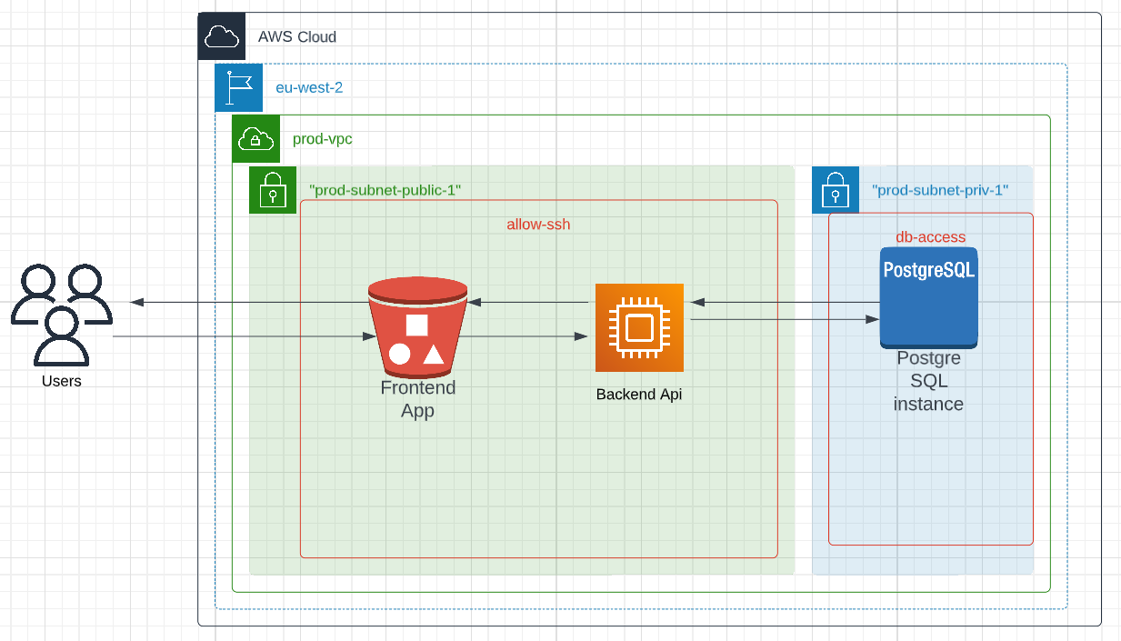

For deployment purposes we can use AWS code pipeline.