
Federal Urdu University of Arts, Sciences and Technology
Department of Computer Science
SkillKart
An AI-Powered Freelance Marketplace Platform
Final Year Project Report
Submitted in partial fulfilment of the requirements for the degree of
Bachelor of Science in Computer Science (BSCS)
Submitted by
Name | Registration No.
Muhammad Hassan Siddiq | 19252020
Syed Sheeryar Uddin | 19252082
Alisha Binte Ovais | 19252052
Project Supervisor
Sir Siddiq
Session: 2022 – 2026 Submission date: [Month, Year]
Certificate of Approval
This is to certify that the project titled "SkillKart — An AI-Powered Freelance Marketplace Platform" has been carried out by the group members listed above under the supervision of Sir Siddiq, in partial fulfilment of the requirements for the degree of Bachelor of Science in Computer Science at Federal Urdu University of Arts, Sciences and Technology.
The project has been examined and is approved for submission.

_______________________ | _______________________
Project Supervisor | Head of Department
Sir Siddiq | Sir Siddiq

_______________________ | _______________________
Internal Examiner | External Examiner

Declaration
We hereby declare that this project report titled "SkillKart — An AI-Powered Freelance Marketplace Platform" and the software system it documents are the result of our own work, carried out under the supervision of Sir Siddiq. All external libraries, services, and reference material used in this project have been duly acknowledged and cited. No portion of this work has been submitted in support of an application for any other degree or qualification at this or any other institution.
We further declare that the system described in this report is a functioning software implementation, and that the statistics, architecture, and behaviour reported herein reflect the actual state of the delivered codebase.

_______________________ | _______________________ | _______________________
Muhammad Hassan Siddiq | Syed Sheeryar Uddin | Alisha Binte Ovais
19252020 | 19252082 | 19252052

Dedication
To our parents and families, whose patience and support carried us through the long months of design, development, and testing; and to the freelancers — students, graduates, and self-taught professionals — whose determination to build a career on their own skills inspired this project, in the hope that a fairer and more trustworthy marketplace can give them a better start.
Table of Contents
1. Abstract 1
2. Acknowledgements 3
3. Introduction 4
3.1 Overview 4
3.2 Purpose 4
3.3 Motivation 5
3.4 Development Approach 5
3.5 Report Structure 6
4. Problem Statement 7
4.1 Freelancer Discovery 7
4.2 Lack of AI Assistance 7
4.3 Payment Workflow and Trust 7
4.4 User and Skill Verification 7
4.5 Contract and Dispute Management 8
4.6 Summary 8
5. Objectives 9
6. Scope and Requirements 10
6.1 In Scope 10
6.2 User Roles 10
6.3 Functional Requirements 11
6.4 Non-Functional Requirements 14
6.5 Assumptions and Constraints 14
6.6 Out of Scope (Current Phase) 15
7. Literature Review 16
7.1 The Online Freelance Economy 16
7.2 Fiverr 16
7.3 Upwork 17
7.4 Freelancer.com 17
7.5 Comparative Analysis 17
7.6 How SkillKart Differs 17
8. Proposed Solution 19
8.1 A Unified Dual-Model Marketplace 19
8.2 An Integrated AI Layer 19
8.3 Secure Escrow Payments 19
8.4 Trust, Verification, and Oversight 20
8.5 Native Mobile Access 21
8.6 Design Principles 21
9. System Architecture 22
9.1 Architectural Overview 22
9.2 The React Frontend 23
9.3 The Express Backend 24
9.4 The MongoDB Database 26
9.5 The Authentication Subsystem 26
9.6 The Admin Panel Subsystem 27
9.7 Integration Subsystems 27
9.8 The Escrow Services 28
9.9 Scheduled Jobs 28
9.10 Deployment Architecture 29
9.11 Architectural Trade-offs 31
10. Database Design 32
10.1 Overview 32
10.2 Collections by Domain 32
10.3 Key Design Decisions 36
10.4 Key Relationships 37
10.5 Status Vocabularies and State Machines 43
11. Technologies Used 45
11.1 Frontend 45
11.2 Backend 45
11.3 Database 46
11.4 Authentication and Security 46
11.5 Email Delivery 46
11.6 Payments 47
11.7 Artificial Intelligence 47
11.8 File Storage and Media 47
11.9 Push Notifications 47
11.10 Mobile 47
11.11 Discoverability 47
11.12 Tooling and Operations 48
11.13 Why This Stack 48
12. Features 50
12.1 Authentication and Account Security 50
12.2 Freelancer Onboarding and Profile 52
12.3 Client Onboarding and Profile 54
12.4 Skill Verification 54
12.5 Skill Gating and the Apply Gate 57
12.6 Skill Taxonomy and Discovery 58
12.7 Jobs 59
12.8 Gigs 60
12.9 Gig Orders and Custom Offers 61
12.10 Proposals 62
12.11 Contracts and Lifecycle 64
12.12 Fixed-Price Milestone Escrow 67
12.13 Hourly Wallet-Lock Escrow 70
12.14 Deliveries and Revisions 71
12.15 Wallet, Payments and Withdrawals 72
12.16 Reviews and Ratings 73
12.17 Disputes 74
12.18 Messaging 75
12.19 Notifications 76
12.20 Transactional Email 76
12.21 Public Website and Discoverability 77
12.22 Dashboards and Navigation 77
12.23 Reporting Content 79
13. AI Features 81
13.1 AI Capabilities 81
13.2 Matchmaking: A Deterministic Engine 82
13.3 The Provider Router 83
13.4 Resilience: AI Failure Never Crashes the Application 85
13.5 Abuse Controls 85
13.6 What the Skill Test Asks of the AI 85
13.7 What Is Not an LLM 86
13.8 Future AI Expansion 86
14. Admin Panel 87
14.1 Design Rationale 87
14.2 Authentication and Sessions 89
14.3 Modules 90
14.4 Accountability and the Audit Log 91
14.5 Platform Settings 92
14.6 Administrative Surfaces Outside the Panel 92
14.7 Exports 93
15. Mobile Applications 94
15.1 Overview 94
15.2 One Codebase, Three Build Targets 94
15.3 Platform Integration 96
15.4 Native-Specific Engineering 96
15.5 Photos and Files 101
15.6 Build and Distribution 101
15.7 Verification and Limitations 102
16. Security 103
16.1 Authentication 103
16.2 Authorisation (RBAC) 103
16.3 Input Validation and Injection Protection 104
16.4 Transport and Headers 104
16.5 Abuse Prevention 105
16.6 Data Protection 106
16.7 Financial Integrity 106
16.8 Accountability and Monitoring 107
16.9 Resilience as a Security Property 107
16.10 Limitations and Hardening Roadmap 107
17. Workflow 109
17.1 Registration and Onboarding 109
17.2 Login and Session 109
17.3 Skill Verification 111
17.4 Hiring on a Fixed-Price Job 111
17.5 Working on an Hourly Contract 112
17.6 Buying a Gig or Accepting a Custom Offer 114
17.7 Delivery, Revision, and Release 116
17.8 Disputes 116
17.9 Withdrawing Earnings 116
17.10 Reviews 117
17.11 Administrative Moderation 117
17.12 Where the Money Goes: Worked Examples 118
18. Testing 119
18.1 Approach 119
18.2 Manual and Exploratory Testing 119
18.3 Real-Browser End-to-End Verification 119
18.4 Scripted Backend Checks 120
18.5 Test Data: the Demo Seeder 121
18.6 Resilience Testing 122
18.7 Interface and Responsiveness Testing 122
18.8 Performance Considerations 122
18.9 Test Gaps 123
19. Results 124
19.1 Achievement of Objectives 124
19.2 System Statistics 124
19.3 Requirements Coverage 125
19.4 Outcome 125
19.5 System Screenshots 126
19.6 Known Limitations 130
20. Challenges Faced 132
20.1 Unreliable Free-Tier AI Providers 132
20.2 Money Correctness Without Transactions 132
20.3 Stale Authentication After a Role Change 133
20.4 A Refresh-Token Bug Found Only in a Real Browser 133
20.5 Proctoring That Detected Nothing on Android 133
20.6 An Infinite Redirect Loop in the Mobile App 134
20.7 Email Delivery Blocked by the Hosting Platform 134
20.8 Cross-Site Cookies Between Separately Hosted Apps 135
20.9 An Empty Value That Was Truthy 135
20.10 Push Notifications That Silently Never Worked 136
20.11 A Toast Library Incompatible with React 19, and a Silent Method-Name Bug 136
20.12 Keeping Test Data Honest as the Model Changes 137
20.13 A Modal Overlay Trapped by a CSS Transform 137
20.14 Writing the Report as a Test of the Code 137
21. Future Enhancements 138
21.1 Quality and Operations 138
21.2 Product Features 138
21.3 AI 139
21.4 Trust and Security 139
22. Conclusion 140
23. References 141
24. Appendix 143
Appendix A — API Summary 143
Appendix B — Folder Structure 144
Appendix C — Environment Variables (without secrets) 145
Appendix D — Major Screens 146
D.1 Public Site and Sign-In 146
D.2 Freelancer 150
D.3 Client 156
D.4 Admin Panel 160
D.5 Mobile Applications 168
Appendix E — Database Collections 169
Appendix F — Running the Project 169

List of Figures
Figure 6.1 — Use-case overview: roles and the capabilities they use 11
Figure 9.1 — System architecture 22
Figure 9.2 — Request lifecycle through the middleware pipeline and the layered backend 25
Figure 9.3 — Deployment architecture 30
Figure 10.1a — Entity relationships: identity and profiles 39
Figure 10.1b — Entity relationships: marketplace 40
Figure 10.1c — Entity relationships: contracts, escrow and payments 41
Figure 10.1d — Entity relationships: communication, reviews and withdrawals 42
Figure 10.1e — Entity relationships: skills, verification and reports 43
Figure 12.1 — Login, two-factor authentication and token lifecycle 52
Figure 12.2 — Skill-test flow: level choice, proctored test, grading and verification 56
Figure 12.3 — The apply gate: eligibility is checked before the proposal form opens 58
Figure 12.4 — Life cycle of a gig order, from requirements to completion 62
Figure 12.5 — Life cycle of a proposal and the effect of accepting it 64
Figure 12.6a — Contract state machine 66
Figure 12.6b — Milestone state machine (fixed-price contracts) 67
Figure 12.7 — Fixed-price milestone funding, delivery and release 69
Figure 12.8 — Hourly escrow: lock, draw-down, top-up and refund 71
Figure 12.9 — Dispute handling for a fixed-price milestone 75
Figure 12.10 — Interaction map of the client and freelancer areas 79
Figure 13.1 — The AI provider router: fallback, validation and the 503 path 84
Figure 14.1 — Admin login: credentials, emailed one-time code, session cookie 88
Figure 15.1 — One codebase, three build targets 95
Figure 15.2 — Mobile social sign-in through the system browser and a deep link 98
Figure 15.3 — Push notification path from an event to the phone 100
Figure 15.4 — Native Android application: sign-in, dashboard, job details and navigation drawer 102
Figure 17.1 — Registration, onboarding and first sign-in 110
Figure 17.2 — End-to-end workflow of a fixed-price engagement 112
Figure 17.3 — Hourly engagement: lock, bill, top up, end 113
Figure 17.4 — Gig order and custom-offer workflow 115
Figure 17.5 — Withdrawal by Stripe Connect payout 117
Figure 19.1 — Public home page 126
Figure 19.2 — Browse Gigs 126
Figure 19.3 — Gig detail with tiered pricing and ordering 127
Figure 19.4 — Job detail and proposal form with the AI cover-letter draft 127
Figure 19.5 — Post-a-job wizard 128
Figure 19.6 — Accepting a proposal with a milestone split 128
Figure 19.7 — Client's My Projects with milestone escrow status 128
Figure 19.8 — Freelancer dashboard with the Skill Verification Center 129
Figure 19.9 — Skill test level picker and rules screen 129
Figure 19.10 — Freelancer's My Work: delivery, timer, and time logs 130
Figure 19.11 — Client wallet: balance, escrow, and transaction history 130
Figure 19.12 — Admin panel dashboard 130
Figure D.1 — Sign-in page 146
Figure D.2 — Registration with role choice 146
Figure D.3 — One-time-password verification 147
Figure D.4 — Browse Projects with filters 147
Figure D.5 — Browse Freelancers 148
Figure D.6 — Public freelancer profile with verified skills 148
Figure D.7 — Categories 148
Figure D.8 — Buddy AI assistant 149
Figure D.9 — AI Cost Estimator 149
Figure D.10 — AI Matchmaking 150
Figure D.11 — Onboarding: résumé upload and AI analysis 150
Figure D.12 — Onboarding: skills step with AI validation 150
Figure D.13 — Onboarding success: take the skill test now or later 151
Figure D.14 — Skill test in progress with the camera guard 151
Figure D.15 — Skill test result and earned rank 152
Figure D.16 — Profile editor 152
Figure D.17 — Portfolio 152
Figure D.18 — My gigs 153
Figure D.19 — Create a gig 153
Figure D.20 — My proposals 154
Figure D.21 — Earnings and wallet 154
Figure D.22 — Messages with a custom-offer card 154
Figure D.23 — Send a custom offer 155
Figure D.24 — Notifications 155
Figure D.25 — Security settings 156
Figure D.26 — Client onboarding 156
Figure D.27 — Client dashboard 156
Figure D.28 — Review proposals 157
Figure D.29 — Order a gig: requirements form 157
Figure D.30 — Unpaid gig order with pay and cancel actions 158
Figure D.31 — Hourly contract panel: escrow, timer and top-up 158
Figure D.32 — Reviewing a delivery 158
Figure D.33 — Raising a dispute 159
Figure D.34 — Messages 159
Figure D.35 — Saved freelancers 160
Figure D.36 — Client profile 160
Figure D.37 — Admin login: credentials 160
Figure D.38 — Admin login: one-time code 161
Figure D.39 — Analytics 161
Figure D.40 — Users 162
Figure D.41 — User detail with verification controls 162
Figure D.42 — Contracts 162
Figure D.43 — Contract detail 163
Figure D.44 — Disputes queue 163
Figure D.45 — Dispute resolution 164
Figure D.46 — Payments 164
Figure D.47 — Wallets 164
Figure D.48 — Withdrawals 165
Figure D.49 — Chat oversight and Support replies 165
Figure D.50 — Reviews moderation 166
Figure D.51 — Notification broadcast 166
Figure D.52 — Monitoring 166
Figure D.53 — Audit logs 167
Figure D.54 — Settings 167
Figure D.55 — Swagger API documentation 168
Figure D.56 — Client and freelancer app: sign-in, dashboard, My Projects, and wallet 168
Figure D.57 — Client and freelancer app: photo chooser, skill test camera check, and notifications 168
Figure D.58 — Admin app: sign-in, dashboard, disputes, and users 169

List of Tables
Table 4.1 — Problems identified and the SkillKart response 8
Table 6.1 — User roles 10
Table 6.2 — Functional requirements: accounts and verification 11
Table 6.3 — Functional requirements: marketplace 12
Table 6.4 — Functional requirements: engagement and payments 12
Table 6.5 — Functional requirements: communication 13
Table 6.6 — Functional requirements: administration and platform 13
Table 6.7 — Non-functional requirements and how they are met 14
Table 7.1 — Comparison of SkillKart with existing freelance marketplaces 17
Table 9.1 — Size of the code base 23
Table 9.2 — Services that move money 28
Table 9.3 — Scheduled jobs 28
Table 10.1 — Identity and access collections 33
Table 10.2 — Profile and file collections 33
Table 10.3 — Marketplace collections 34
Table 10.4 — Engagement and payment collections 34
Table 10.5 — Communication and feedback collections 35
Table 10.6 — Skill, verification and taxonomy collections 35
Table 10.7 — Administration and operations collections 36
Table 10.8 — Content and public-form collections 36
Table 10.9 — Principal relationships between collections 37
Table 10.10 — Status vocabularies and the transitions that occur 44
Table 12.1 — Authentication parameters 51
Table 12.2 — Skill-test levels 54
Table 12.3 — Fixed-price and hourly escrow compared 70
Table 12.4 — Platform settings that govern money 73
Table 12.5 — Dispute resolution outcomes 74
Table 12.6 — Notification events 76
Table 13.1 — LLM-backed AI capabilities 81
Table 13.2 — Matchmaking score components 82
Table 13.3 — AI providers 83
Table 14.1 — Admin panel modules and their capabilities 90
Table 14.2 — System settings 92
Table 15.1 — Capacitor plugins and their use 96
Table 16.1 — Rate limits 105
Table 17.1 — Worked examples of the three escrow models 118
Table 18.1 — Defects found through real-browser testing 120
Table 18.2 — Fixed demo accounts 121
Table 19.1 — Achievement of the project objectives 124
Table 19.2 — System statistics 124
Table A.1 — API route groups 143
Table C.1 — Environment variable groups 145

List of Abbreviations
Abbreviation | Meaning
AES | Advanced Encryption Standard
AI | Artificial Intelligence
API | Application Programming Interface
APK | Android Package (installable Android application file)
BSCS | Bachelor of Science in Computer Science
CMS | Content Management System
CORS | Cross-Origin Resource Sharing
CPU | Central Processing Unit
CSS | Cascading Style Sheets
CSV | Comma-Separated Values
CV | Curriculum Vitae (résumé)
FCM | Firebase Cloud Messaging
GPU | Graphics Processing Unit
HTML | HyperText Markup Language
HTTP | HyperText Transfer Protocol
HTTPS | HyperText Transfer Protocol Secure
IP | Internet Protocol
JSON | JavaScript Object Notation
JWT | JSON Web Token
LLM | Large Language Model
MERN | MongoDB, Express, React, Node.js
OAuth | Open Authorization (delegated sign-in)
OTP | One-Time Password
OWASP | Open Worldwide Application Security Project
PDF | Portable Document Format
PKR | Pakistani Rupee
RBAC | Role-Based Access Control
REST | Representational State Transfer
SDK | Software Development Kit
SEO | Search Engine Optimisation
SHA | Secure Hash Algorithm
SME | Small and Medium-sized Enterprise
SMTP | Simple Mail Transfer Protocol
SPA | Single-Page Application
TLS | Transport Layer Security
TTL | Time To Live (automatic expiry of a record)
UI | User Interface
URL | Uniform Resource Locator

1. Abstract
The freelance economy has become a significant part of the global digital workforce, particularly for students and recent graduates seeking flexible, skill-based income. Existing freelance platforms, however, present recurring challenges: freelancer discovery is inefficient, intelligent assistance is minimal, payment security is a persistent concern, and the verification of skills is weak. These barriers are especially acute for newcomers, who lack the experience to write competitive proposals, price their work correctly, and prove their skills to a stranger.
SkillKart is an AI-powered, dual-sided freelance marketplace built to address these problems in a single, coherent platform. It combines the two dominant freelancing models — pre-packaged Gigs (Fiverr-style) and custom Jobs with Proposals (Upwork-style) — and adds custom offers made inside a chat conversation. It augments them with an integrated artificial-intelligence layer, a wallet-native escrow payment system, layered verification built around a proctored skill test, and a comprehensive administrative panel, and it is delivered both as a responsive web application and as two native Android applications built from the same codebase through Capacitor.
The system is implemented on the MERN stack (MongoDB, Express.js, React, Node.js). The frontend is a React 19 single-page application built with Vite; the backend is a layered Express REST API backed by MongoDB through Mongoose, comprising 40 data models, 26 route modules, and 317 endpoints in about 118,000 lines of code. Fourteen AI capabilities — a conversational assistant, cost estimation, proposal drafting, brief suggestion, skill validation, skill-test generation and grading, CV analysis, and others — are delivered through a provider router that fails over automatically across Gemini, DeepSeek, Qwen, Groq, Claude, and a local Ollama model, so that an AI outage never crashes the platform. Freelancer matchmaking is handled separately by a deterministic, rules-based scoring engine. Payments use a per-milestone escrow for fixed-price work, a balance-lock escrow with automatic billing for hourly work, and a Stripe-backed deposit flow for gig orders, with Stripe also handling wallet top-ups and freelancer payouts. Skill verification is offered at three levels (Easy, Intermediate, and Expert) and is proctored by an on-device face-presence check and a browser guard; verified skills gate which jobs a freelancer may apply for and which gigs they may publish. Security rests on rotating JSON Web Tokens, role-based access control, one-time-password verification, input validation, rate limiting, bot detection, and an audit log.
The completed system delivers the full engagement lifecycle — from registration and verification, through job posting, proposals, and gig orders, to escrow-secured delivery, reviews, disputes, and withdrawals — under the supervision of a dedicated, isolated 17-module admin panel. All project objectives were achieved and demonstrated on realistic, seeded data. This report documents the motivation, design, implementation, testing, results, and limitations of the SkillKart project.
Keywords: Freelance Marketplace, MERN Stack, Artificial Intelligence, Escrow Payments, Skill Verification, Role-Based Access Control, Capacitor, MongoDB, React.

2. Acknowledgements
We would like to express our sincere gratitude to our project supervisor, Sir Siddiq, whose guidance, feedback, and encouragement were invaluable throughout the development of SkillKart. Their insights helped us refine both our technical decisions and our understanding of what it takes to build a production-quality software system.
We are thankful to the Department of Computer Science, Federal Urdu University of Arts, Sciences and Technology for providing the academic environment, resources, and structured evaluation that shaped this project.
We also thank the developers and maintainers of the open-source technologies on which SkillKart is built — including React, Node.js, Express, MongoDB, Capacitor, MediaPipe, and the many supporting libraries — as well as the providers of the AI, payment, email, and notification services integrated into the platform.
Finally, we thank our families and peers for their continuous support and patience during the many months of design, development, and testing.
Muhammad Hassan Siddiq, Syed Sheeryar Uddin, Alisha Binte Ovais

3. Introduction

3.1 Overview
SkillKart is a web-based and mobile-ready, AI-powered freelance marketplace that connects clients who need work completed with freelancers who offer their skills and services. Unlike a simple job board, SkillKart manages the entire engagement lifecycle: discovery, negotiation, contracting, secure payment, delivery, feedback, and dispute resolution. Artificial intelligence assists users at each stage, and a dedicated administrative layer oversees the platform.
The platform deliberately unifies the two most successful freelancing paradigms:
- Gigs — freelancers publish pre-packaged service offerings with tiered pricing (Basic / Standard / Premium), which clients can purchase directly. This is the model popularised by Fiverr.
- Jobs and Proposals — clients post custom job requirements and freelancers submit competitive proposals. This is the model popularised by Upwork.
By supporting both, SkillKart accommodates a wide range of work, from quick, standardised tasks to large, custom engagements that are split into milestones or billed by the hour. A third path joins the two: a freelancer can send a custom offer inside a chat conversation, which the client can accept to start paid work immediately.
The system is built on the MERN stack (MongoDB, Express.js, React, Node.js). A single React codebase is delivered three ways: as a responsive web application, as a native Android application for clients and freelancers, and as a separate native Android application dedicated to platform administrators.

3.2 Purpose
The purpose of SkillKart is to lower the barriers that make freelancing difficult, particularly for students and new entrants, while raising the level of trust and security for every participant. Specifically, the platform aims to:
- Simplify discovery — helping clients find suitable talent and freelancers find relevant work through structured categories, search, and rules-based matchmaking.
- Provide intelligent assistance — using AI to help freelancers write proposals, price their work, validate their skills, and build their profiles from a CV.
- Guarantee payment security — holding funds in escrow so that freelancers are assured of payment and clients are assured of delivery.
- Establish trust — through layered verification (email one-time passwords, proctored AI-generated skill tests, and identity checks) and a transparent two-way review system.
- Enable oversight — giving administrators the tools to moderate content, resolve disputes, monitor the system, and analyse platform activity, with every sensitive action recorded in an audit trail.

3.3 Motivation
The freelance economy has become a significant part of the global digital workforce. For students and recent graduates in particular, it offers flexible, skill-based income without the need for a traditional employer. Yet the same students are the people least equipped to succeed on the large international platforms. They lack a review history, they are unsure how to price their work, they struggle to write a proposal that stands out among hundreds, and they have no way to prove their skills to a stranger. On the client side, small businesses and individuals worry about paying in advance for work that may never arrive.
Three observations motivated this project:
- The trust problem is structural, not cosmetic. A marketplace in which money can be lost, or skills misrepresented, will not retain either side. Escrow, verification, and dispute handling therefore had to be designed into the core of the system rather than added afterwards.
- AI is most useful where users are least experienced. Drafting a proposal, estimating a budget, or parsing a CV are tasks where an assistant gives a newcomer a real advantage — but only if the assistant is dependable. Free-tier AI services are rate-limited and intermittently unavailable, so the platform had to treat AI as an enhancement that can fail without taking the application down with it.
- A final-year project should be a real system. The team set out to build something that behaves like a production service: real payment flows, real security controls, real administrative tooling, and real mobile applications — and to test it as such.

3.4 Development Approach
SkillKart was developed iteratively between January and October 2026, in a Git repository that records more than 300 commits. Work proceeded in feature increments — authentication and onboarding first, then the marketplace and contract lifecycle, then payments and escrow, then the AI layer, the admin panel, and finally the mobile applications — followed by repeated hardening passes that audited the system for money-correctness, validation gaps, and usability defects.
A distinguishing practice was verification in the running application: each significant change was exercised end to end in a real browser (and, for the mobile build, on an Android emulator) rather than being judged only by reading code. Several of the most instructive defects described in Chapter 20 were found this way, because they were invisible to static inspection.

3.5 Report Structure
This report is organised as follows. Chapters 4–6 define the problem, the objectives, and the scope and requirements. Chapter 7 reviews existing platforms, and Chapter 8 presents the proposed solution. Chapters 9–11 describe the system architecture, database design, and technologies. Chapters 12–16 describe the platform's features, AI capabilities, administrative panel, mobile applications, and security model. Chapter 17 walks through the complete workflows. Chapters 18–20 cover testing, results, and the challenges encountered, and Chapters 21–22 discuss future work and conclusions. References and appendices follow.

4. Problem Statement
Freelance marketplaces have matured over the past decade, yet several structural problems persist — problems that disproportionately affect new freelancers and small clients. SkillKart is designed directly against the following five challenges.

4.1 Freelancer Discovery
On large platforms, quality talent is often buried beneath thousands of profiles. Search and categorisation are frequently keyword-based and shallow, making it hard for clients to find the right person and for capable-but-new freelancers to be seen. Without intelligent matching, discovery is inefficient for both sides: clients spend time sifting, and newcomers never surface.

4.2 Lack of AI Assistance
New freelancers face a steep learning curve. Writing a compelling proposal, pricing a project competitively, and presenting skills professionally are non-trivial tasks that existing platforms largely leave to the user. There is little built-in, intelligent guidance to help a newcomer succeed, and what AI tooling exists tends to be bolted on rather than woven into the workflow.

4.3 Payment Workflow and Trust
Payment is the single biggest source of anxiety in freelancing. Freelancers fear completing work and not being paid; clients fear paying and receiving poor or no work. A robust escrow mechanism — where funds are held securely until both parties are satisfied — is essential, but it must be implemented correctly and transparently. It must also handle the awkward cases: a client who goes silent after receiving work, a long project that cannot sensibly be paid for in a single lump, an hourly engagement with no fixed price, and a dispute that needs a fair resolution path.

4.4 User and Skill Verification
Trust depends on verification. Fake profiles, exaggerated skills, and unverified identities erode confidence in a marketplace. Many platforms offer only basic verification, and rigorous skill testing is often paid or absent. A self-declared skill list tells a client very little; a test that is taken without supervision tells them little more, because it can be taken by someone else or with the answers open in another window. A trustworthy platform needs layered verification of email, skills, and identity, and it needs the skill verification itself to be hard to cheat.

4.5 Contract and Dispute Management
A freelance engagement is a contract with a defined lifecycle — start, delivery, revision, completion — and occasionally disputes. When this lifecycle is not modelled explicitly, engagements become ambiguous and conflicts are hard to resolve fairly. Comprehensive contract tracking and a structured, administrator-mediated dispute process are necessary but frequently underdeveloped.

4.6 Summary
In short, existing solutions leave gaps in discovery, assistance, payment trust, verification, and lifecycle management. SkillKart addresses all five within one integrated, AI-augmented, admin-supervised platform. Table 4.1 maps each problem to the part of the system that answers it.
Table 4.1 — Problems identified and the SkillKart response
Problem | SkillKart response | Chapter
Poor freelancer discovery | Structured taxonomy, public search and filters, rules-based matchmaking engine | 12, 13
Little intelligent assistance | Buddy assistant, AI proposal drafting, cost estimator, brief auto-fill, CV analysis | 13
Payment anxiety on both sides | Wallet-native escrow: per-milestone for fixed-price work, balance-lock for hourly work, auto-release | 12, 17
Weak verification | Email OTP, proctored AI skill tests at three levels, skill-gated applying and publishing | 12, 13
Ambiguous contracts and disputes | Explicit contract and milestone state machines, per-milestone disputes, admin resolution with audit log | 10, 14

5. Objectives
The aim of the project is to design and implement a complete, secure, and intelligent freelance marketplace that supports both gig-based and proposal-based engagements and that is accessible from the web and from native mobile devices. The specific objectives are as follows.
- Build a complete dual-sided marketplace supporting both Gigs (packaged services) and Jobs with Proposals (custom engagements), together with custom offers made in chat, with full freelancer and client experiences.
- Integrate artificial intelligence to assist users — including a conversational assistant, AI cost estimation, AI proposal drafting, brief auto-fill, AI skill validation and test generation, and AI CV analysis — together with a rules-based freelancer matchmaking engine.
- Implement a secure escrow payment system — a wallet-native escrow (per-milestone for fixed-price work, balance-lock for hourly work) plus a Stripe-backed flow for gig orders, with Stripe also handling wallet top-ups and freelancer payouts — including wallets, deposits, escrow release, platform-fee calculation, and withdrawals.
- Provide multi-factor verification to establish trust — email OTP verification, proctored AI-generated skill tests at three levels (Easy, Intermediate, Expert), and skill-based gating of who may apply for or publish what.
- Develop a comprehensive administrative panel with isolated authentication for moderating users, jobs, contracts, payments, disputes, and reviews, and for monitoring and analytics.
- Enforce strong security throughout — JWT authentication with refresh-token rotation, role-based access control, password hashing, OTP, rate limiting, input validation and sanitisation, bot mitigation, and audit logging.
- Model the complete contract lifecycle explicitly — as state machines — so that engagements are unambiguous, auditable, and safe.
- Ensure resilience and reliability, particularly for third-party services (AI, payments, email, push), so that failures degrade gracefully rather than crashing the application.
- Deliver native mobile access — package the same web codebase as native Android applications via Capacitor (a client/freelancer app and a separate, standalone admin app), with platform-level integration (camera, push notifications, offline detection, native back-button navigation, file sharing) rather than a bare web wrapper.

6. Scope and Requirements

6.1 In Scope
The following capabilities are within the scope of the project and are implemented.
- User management: registration, login with optional two-factor authentication, social sign-in, role-based onboarding, and profile management for freelancers and clients.
- Verification: email one-time-password verification, AI-generated and proctored skill tests at three levels, and skill-based gating of who may apply for work and publish gigs.
- Marketplace: job posting, gig publishing with tiered pricing, gig ordering, custom offers in chat, proposals, and search and browsing by category and skill.
- Engagement lifecycle: contract creation, milestone and hourly escrow, delivery and revision, time tracking, completion, and administrator intervention.
- Payments: a wallet for each user, Stripe top-ups and payouts, escrow, release, platform-fee handling, auto-release, and withdrawals.
- Communication and feedback: in-app chat with contact-information masking, notifications (in-app and push), transactional email, and a two-way review system.
- Dispute resolution: raising, tracking, and administrator resolution of disputes.
- AI tools: assistant, cost estimator, proposal drafting, brief suggestion, skill validation and tests, CV analysis, and rules-based matchmaking.
- Administration: a dedicated, isolated admin panel with moderation, finance, monitoring, audit logs, and analytics.
- Mobile: two native Android applications built from the same codebase.
- Security and operations: authentication, authorisation, input hardening, abuse prevention, and a demo data seeder.

6.2 User Roles
The platform defines six roles, of which four are used through a user interface.
Table 6.1 — User roles
Role | Who | Principal capabilities
Visitor / public viewer | An unauthenticated visitor, or a social-login user who has not yet chosen a role | Browse jobs, gigs, and freelancers; use the AI cost estimator and matchmaking; chat with Buddy (limited); register
Freelancer | A person offering skills | Build a profile; verify skills; publish gigs; apply to jobs; send custom offers; deliver work; log time; chat; withdraw earnings; review clients
Client | A person or business hiring | Post jobs; order gigs; review proposals and hire; fund milestones; approve work; top up the wallet; chat; review freelancers
Administrator | A platform operator (admin panel) | Moderate users, jobs, contracts, and reviews; resolve disputes; manage wallets and withdrawals; broadcast notifications; monitor and audit
Content editor | A CMS author (back-end role) | Create, update, and publish CMS pages through the API; no user interface exists yet
SuperAdmin | The bootstrap operator (marketplace credential) | Bypasses marketplace role checks; no user interface

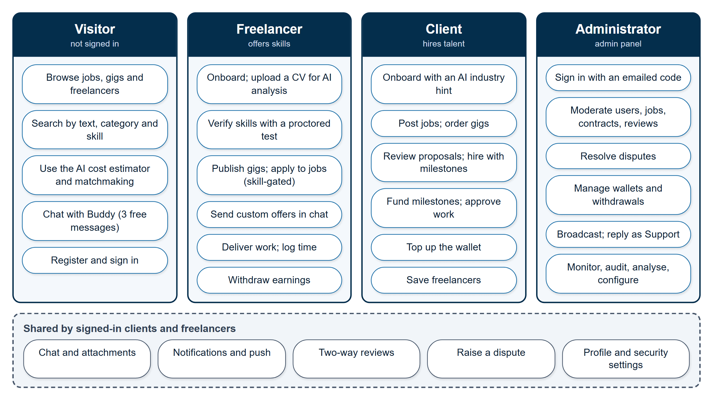
Figure 6.1 — Use-case overview: roles and the capabilities they use
Visitors, freelancers, clients, and administrators each have a distinct set of capabilities (Section 6.2).

6.3 Functional Requirements
The functional requirements are grouped by area. The last column names the section in which each is implemented.
Table 6.2 — Functional requirements: accounts and verification
ID | Requirement | Section
FR-A1 | A visitor shall be able to register as a client or a freelancer with an email address and password | 12.1
FR-A2 | The system shall verify an email address with a one-time password | 12.1
FR-A3 | A user shall be able to enable two-factor login, sign in with a social provider, and reset a forgotten password | 12.1
FR-A4 | The system shall lock an account after repeated wrong passwords and shall revoke all sessions on password change | 12.1, 16.1
FR-A5 | A freelancer shall complete a guided onboarding, optionally with AI-assisted CV analysis | 12.2
FR-A6 | A client shall complete a guided onboarding, with an AI industry recommendation | 12.3
FR-A7 | A freelancer shall be able to verify a skill by taking a proctored AI-generated test at the Easy, Intermediate, or Expert level | 12.4
FR-A8 | The system shall restrict applying to jobs and publishing gigs to freelancers with a matching verified skill | 12.5

Table 6.3 — Functional requirements: marketplace
ID | Requirement | Section
FR-M1 | A client shall be able to post a job, save it as a draft, and publish it without a wallet balance | 12.7
FR-M2 | A freelancer shall be able to publish a gig with up to three pricing tiers | 12.8
FR-M3 | A client shall be able to order a gig by supplying written requirements and paying a deposit | 12.9
FR-M4 | A freelancer shall be able to send a priced custom offer in a conversation, which a client may accept | 12.9
FR-M5 | A freelancer shall be able to submit a proposal, including an AI-drafted cover letter | 12.10
FR-M6 | A client shall be able to accept a proposal, splitting a fixed price into milestones, or reject it with or without allowing resubmission | 12.10
FR-M7 | Users shall be able to browse and search jobs, gigs, and freelancers by text, category, and skill | 12.6, 12.21
FR-M8 | The system shall rank freelancers for a project brief | 13.2

Table 6.4 — Functional requirements: engagement and payments
ID | Requirement | Section
FR-P1 | The system shall lock the first milestone's amount from the client's wallet when a proposal is accepted | 12.12
FR-P2 | The system shall prevent work submission on an unfunded milestone | 12.12
FR-P3 | The system shall release a milestone on client approval, and automatically after a review window | 12.12
FR-P4 | The system shall lock a week's estimate for an hourly contract and bill logged time against it automatically | 12.13
FR-P5 | The system shall refund unused hourly escrow when a contract ends | 12.13
FR-P6 | A client shall be able to add money to their wallet through Stripe | 12.15
FR-P7 | A freelancer shall be able to withdraw earnings, automatically through Stripe Connect or by an administrator-approved request | 12.15
FR-P8 | The system shall deduct a configurable platform fee on release | 12.12, 14.5
FR-P9 | Either party shall be able to raise a dispute, which an administrator resolves | 12.17
FR-P10 | Both parties shall be able to review each other after completion | 12.16

Table 6.5 — Functional requirements: communication
ID | Requirement | Section
FR-C1 | Users shall be able to chat one-to-one, with attachments | 12.18
FR-C2 | The system shall mask off-platform contact details and block repeat offenders | 12.18
FR-C3 | The system shall notify users of significant events in-app and, on Android, by push | 12.19, 15.4
FR-C4 | The system shall send security-related and verification email | 12.20
FR-C5 | A signed-in user shall be able to report a profile, job, gig, or review to the moderation team | 12.23

Table 6.6 — Functional requirements: administration and platform
ID | Requirement | Section
FR-D1 | An administrator shall sign in through an isolated, two-step login | 14.2
FR-D2 | An administrator shall be able to moderate users, jobs, contracts, reviews, and chat | 14.3
FR-D3 | An administrator shall be able to inspect and adjust financial records, with every action audit-logged | 14.3, 14.4
FR-D4 | An administrator shall be able to monitor errors, API traffic, and email delivery | 14.3
FR-D5 | An administrator shall be able to review AI-suggested taxonomy entries | 12.6
FR-D6 | The platform shall be usable on Android through two native applications | Ch. 15

6.4 Non-Functional Requirements
Table 6.7 — Non-functional requirements and how they are met
ID | Quality | Requirement | How it is met
NFR-1 | Security | Protect accounts, money, and data from common web attacks | Chapter 16: hashed credentials, rotating tokens, validation, sanitisation, rate limits, bot detection, audit trail
NFR-2 | Financial integrity | Money shall never be created, lost, or applied twice | Atomic conditional updates, claim-before-pay, idempotent confirmations, check-before-write ordering (Section 16.7)
NFR-3 | Reliability | A failing third-party service shall not take the platform down | Fail-open optional integrations, AI fallback chain, controlled 503, operational-error guard (Sections 13.4, 16.9)
NFR-4 | Isolation | Administrative access shall be separate from marketplace access | Separate secret, cookie, middleware, and session store (Section 14.1)
NFR-5 | Usability | New freelancers shall be able to onboard and succeed without outside help | Guided wizards, AI assistance, optional verification, in-place error messages
NFR-6 | Portability | One codebase shall serve web and Android | Capacitor, with a single platform check (Chapter 15)
NFR-7 | Maintainability | Business rules shall be defined in one place | Layered architecture and single choke points for money, notifications, and email (Section 8.6)
NFR-8 | Configurability | Operators shall be able to tune behaviour without code changes | Environment-driven AI order, email provider, proctoring strictness, and administrator-editable fee, release window, and withdrawal minimum
NFR-9 | Deployability | The system shall run with minimal configuration and degrade gracefully | Only a database URI, two JWT secrets, and the API address are mandatory (Section 9.10)
NFR-10 | Discoverability | Public content shall be crawlable | Live sitemap and robots.txt (Section 12.21)

6.5 Assumptions and Constraints
- Free-tier AI services are rate-limited and unreliable; the design assumes that any provider can fail at any time.
- A single currency, Pakistani Rupees, is used throughout, and Stripe processes card payments in it.
- A single language (English) is supported.
- The deployment host blocks outbound SMTP, which constrains how email can be sent.
- The project was built by a small team within one academic year, which favoured simple, well-understood solutions (polling, Context state, rules-based matching) over more elaborate ones.

6.6 Out of Scope (Current Phase)
The following are deliberately deferred and documented in Chapter 21.
- Real-time WebSocket chat and video calls — messaging currently uses efficient polling.
- Embedding-based semantic search — matchmaking is deterministic and rules-based.
- Internationalisation — multi-language support and multiple currencies.
- An iOS application — the codebase is portable, but a build was out of scope.
- A multi-administrator role model and an automated test suite.

7. Literature Review
To position SkillKart, we studied the three most prominent freelance marketplaces, reviewed published research on trust in online marketplaces, and identified where our platform differs.

7.1 The Online Freelance Economy
Online labour platforms have grown into a measurable part of the global labour market. Kässi and Lehdonvirta [21] developed the Online Labour Index to track the number of projects and tasks posted across the major English-language platforms over time, making the size and composition of the online gig economy — which spans software development, creative work, writing, and clerical tasks — observable for the first time. For a student or recent graduate, this is an attractive entry point to paid work. It is also a hard one to enter: work is found through a handful of large platforms, and on each of them success depends heavily on a reputation that a newcomer does not yet have.
A second strand of research explains why reputation and institutional safeguards matter so much. Resnick and Zeckhauser [36], studying eBay's feedback system, show that buyers and sellers who do not know each other rely on reputation signals to decide whether to transact. Pavlou and Gefen [22] extend this to the question of what makes strangers trust an online marketplace, finding that institutional mechanisms — feedback systems, escrow services, and guarantees — increase a buyer's trust in the community of sellers as a whole. Both findings bear directly on freelance marketplaces, where the buyer pays for something that does not yet exist. They motivated the two design commitments that run through SkillKart: money is held in escrow until work is accepted, and credibility is built from evidence (tested skills, completed work, two-way reviews) rather than self-description.

7.2 Fiverr
Fiverr [11] popularised the Gig model, in which freelancers publish fixed, packaged service offerings that buyers purchase directly. Its strengths are simplicity and speed of transaction: a buyer can choose a package, pay, and receive work without negotiating. Its limitations include relatively high service fees, a heavy dependence on a seller's own marketing and search ranking for visibility, and minimal intelligent assistance for sellers who are new to the platform. A new seller with no reviews competes against established sellers on the same search page.

7.3 Upwork
Upwork [12] is built around the Job and Proposal model, in which clients post projects and freelancers bid. It supports hourly and fixed-price contracts, time tracking, and escrow-style payment protection. Its strengths are contract flexibility and a mature payment system. Its limitations include a complex bidding process that disadvantages newcomers, a paid, credit-based mechanism for submitting proposals, and limited built-in guidance for writing a competitive proposal or pricing a project.

7.4 Freelancer.com
Freelancer.com [13] supports both models and a wide range of project types through a bidding and contest system. It is broad, but it is often criticised for a crowded, highly competitive bidding environment in which price dominates, and for inconsistent quality control and verification.

7.5 Comparative Analysis
Table 7.1 — Comparison of SkillKart with existing freelance marketplaces
Aspect | Fiverr | Upwork | Freelancer.com | SkillKart
Marketplace model | Gigs | Jobs and proposals | Both | Gigs, jobs and proposals, and custom offers in chat
Built-in AI assistance | Limited | Limited | Minimal | Integrated: assistant, proposal drafting, cost estimation, brief auto-fill, CV analysis
Skill verification | Basic | Tests (varies) | Basic | Proctored AI-generated tests at three levels; verified skills gate applying and publishing
Escrow payments | Yes | Yes | Yes | Yes: wallet-native, per-milestone for fixed price, balance-lock for hourly, auto-release
Dispute resolution | Yes | Yes | Yes | Per-milestone disputes, admin-mediated, fully audit-logged
Mobile applications | Yes | Yes | Yes | Native Android client/freelancer app plus a separate admin app, from one codebase
Target focus | General | General | General | Student- and graduate-friendly, low-friction onboarding

The comparison reflects the public positioning of each platform at the time of writing and is intended to show where SkillKart's design choices differ, not to claim that SkillKart replaces mature commercial services.

7.6 How SkillKart Differs
SkillKart's differentiation is not a single feature but an integration philosophy. AI assistance is woven through onboarding, discovery, bidding, and pricing rather than bolted on. Verification is layered and partly AI-driven, and the test that underpins it is proctored, so a verified skill carries real meaning. Payments, contracts, and disputes are unified in one state-machine model and supervised by a purpose-built admin panel with full audit logging. And every optional external dependency — AI providers, payment processor, email transport, push service, bot-detection — is isolated behind a service layer that degrades gracefully, so that the failure of a free-tier service never stops a freelancer from working or a client from paying. The result is a platform explicitly designed to lower the barrier for new freelancers while maintaining trust for clients.

8. Proposed Solution
SkillKart is proposed as a single, integrated platform that resolves the problems identified in Chapter 4 through five pillars, each described below, and that is built according to a small set of design principles that recur throughout the system.

8.1 A Unified Dual-Model Marketplace
By supporting both Gigs and Jobs with Proposals — and by letting a freelancer send a custom offer inside a conversation — SkillKart serves the full spectrum of freelance work. A freelancer can both publish standardised services and bid on custom projects; a client can both buy a ready-made service and post a bespoke requirement. All three routes end in the same place: a paid, tracked engagement whose state, money, and messages are managed uniformly (Chapters 10 and 12).

8.2 An Integrated AI Layer
AI is used to reduce friction rather than to decorate the interface:
- The Buddy assistant answers platform and freelancing questions conversationally.
- AI proposal drafting helps freelancers respond to jobs competitively.
- The AI cost estimator helps price projects using market context.
- Brief auto-fill infers a job's category, skills, and budget from a free-text description.
- AI skill validation and test generation verify capabilities objectively.
- AI CV analysis parses a résumé, scores it, and auto-fills the profile.
- Matchmaking ranks freelancers for a given project brief. Unlike the AI features above, this is a deterministic, rules-based scoring engine — it does not call an LLM provider, and so it cannot fail when AI is unavailable.
Crucially, the AI subsystem is engineered for resilience (Chapter 13): a prioritised chain of providers with automatic fallback, ending in a controlled 503 and a graceful interface message if every provider is down.

8.3 Secure Escrow Payments
The platform operates in Pakistani Rupees (PKR) and keeps client and freelancer money in internal wallets. Escrow works differently for each kind of engagement, so that each is protected in the way that suits it.
- Fixed-price work is paid by milestone. The moment a proposal is accepted, the first milestone's amount is debited from the client's wallet and locked — never left as an unfunded promise. A large project can be split into any number of sequential milestones (provided the amounts add up to the agreed price); each later milestone is funded only when the client is ready to start that phase, so capital is not locked for work that has not begun.
- Hourly work has no fixed price to lock, so a week's estimated cost (hourly rate multiplied by the freelancer's estimated weekly hours) is locked at hire. Each logged hour is then billed automatically against that lock, and whatever is left is refunded to the client when the contract ends.
- Gig orders use a deposit-then-release flow processed through Stripe.
- Auto-release. If a client goes silent after a freelancer submits work, the milestone's escrow is released automatically after a configurable review window (default seven days) instead of leaving the freelancer unpaid indefinitely.
- No gate at posting. Posting a job carries no wallet-balance check: a client may publish with any balance, including zero, so the job is visible and can collect proposals. The wallet is checked, and funds locked, only when a proposal is accepted — the earliest moment at which real money must be committed.
When escrow is released, the platform fee (a default of 0.5% of the amount, adjustable by an administrator) is deducted and the remainder is credited to the freelancer's wallet, from which they can withdraw — automatically through Stripe Connect, or through a manually approved request. This protects both parties and gives disputes a clear financial basis.

8.4 Trust, Verification, and Oversight
Trust is built through layered verification, a transparent two-way review system, and a structured dispute process.
- Identity is anchored by email one-time-password verification and optional two-factor login.
- Skills are verified by AI-generated tests that the freelancer takes at one of three levels — Easy, Intermediate, or Expert — under proctoring: a camera check that cancels the attempt if no face is in view, and a guard against switching tabs or leaving full screen. The level taken is the rank earned, and verified skills gate which jobs a freelancer may apply for and which gigs they may publish.
- Behaviour is recorded in two-way reviews that feed profile ratings, and in an append-only contract history.
- Oversight is provided by an isolated admin panel with its own authentication, a seventeen-module management surface, and an immutable audit log of every sensitive action.

8.5 Native Mobile Access
The same React codebase is packaged, through Capacitor, as two Android applications: one for clients and freelancers, and a separate one for administrators. They are not wrapped websites: they integrate the camera, push notifications, the hardware back button, offline detection, and native file sharing (Chapter 15).

8.6 Design Principles
Five principles, applied consistently, explain many of the decisions described in later chapters.
- Server-side enforcement. A rule that protects money or trust is enforced on the server, not merely implied by the interface. A freelancer cannot submit work to an unfunded milestone, and a skill gate is checked by the API, not only by a disabled button.
- Single choke points. Each sensitive operation passes through exactly one function: all milestone money movement goes through the milestone service, every notification goes through one notify() function, and every outgoing email goes through one email service. This makes behaviour consistent and makes each operation auditable and testable in one place.
- Order of operations in place of transactions. Because the system does not use multi-document database transactions, every money-moving flow validates before it writes, performs its guarded atomic update, and only then creates dependent records.
- Fail open for optional integrations. Every third-party integration that is not essential — reCAPTCHA, push notifications, AI, an email provider — degrades quietly when it is unconfigured or unreachable, so that an outage can never lock all users out of the platform.
- Isolation of privilege. The administrative system shares no tokens, cookies, secrets, or middleware with the marketplace, so a marketplace credential can never grant administrative access.

9. System Architecture

9.1 Architectural Overview
SkillKart follows a decoupled client–server architecture. A React single-page application (SPA) communicates with a stateless Express REST API over HTTPS, exchanging JSON, in the architectural style described by Fielding [23]. MongoDB is the single source of truth for all marketplace data. Every external integration — payments, AI, social login, email, file storage, push notifications, and bot detection — is isolated behind a dedicated service module, so that the core application is never tightly coupled to any one vendor and any optional service can be absent without stopping the system.
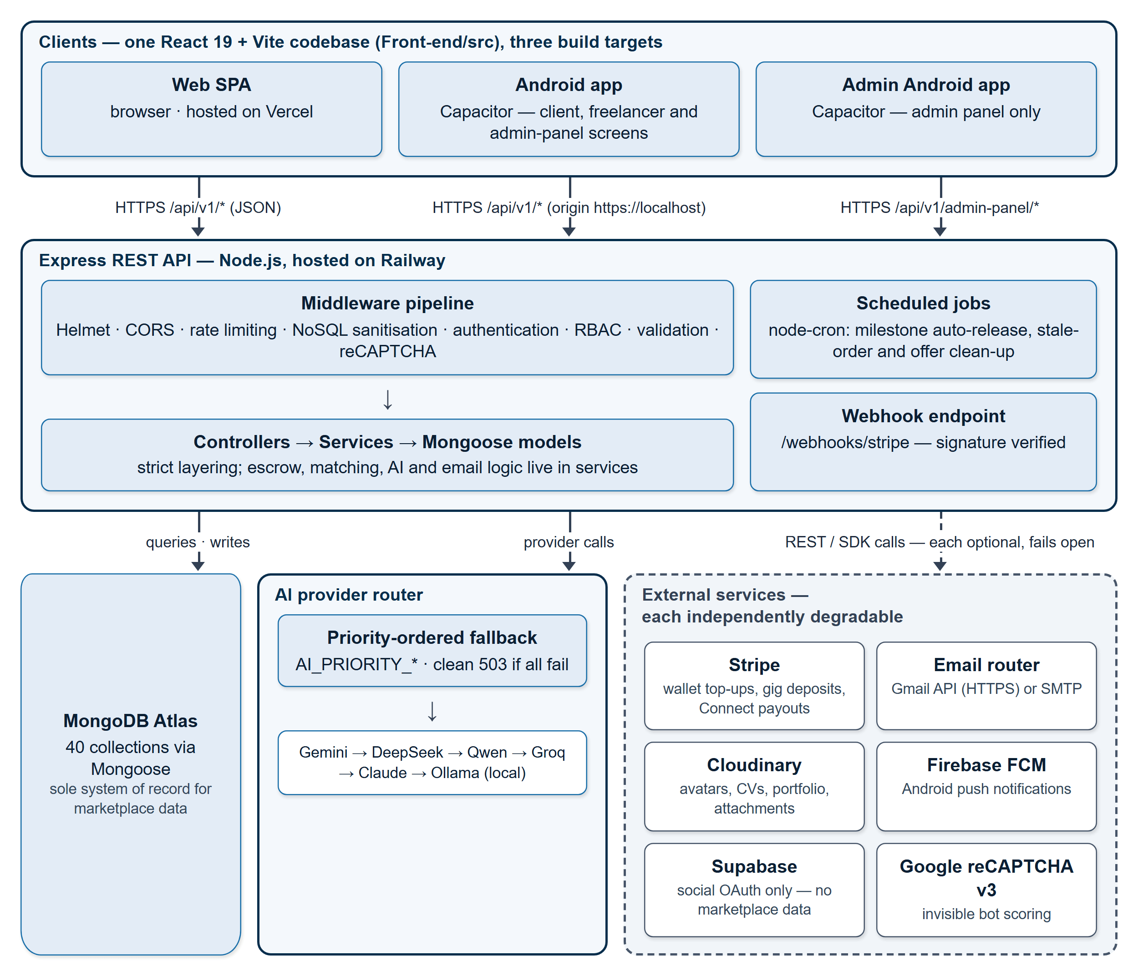
Figure 9.1 — System architecture
One React codebase is delivered as a web application and two Android applications; all of them talk to one Express API, which uses MongoDB as the only required service (Section 9.1).
The project is organised as a single repository with two independently run applications: Backend/ (the Express API) and Front-end/ (the React application, including the two Capacitor Android projects), together with docs/. Table 9.1 gives its size.
Table 9.1 — Size of the code base
Part | Files | Lines
Backend (Backend/src, JavaScript) | 197 | 36,475
Frontend (JavaScript and JSX) | 202 | 50,378
Frontend stylesheets (CSS) | 76 | 31,086
Application source in total | 475 | 117,939

9.2 The React Frontend
The frontend is a React 19 SPA [4] built with Vite 7 [5] and routed by React Router 7. Its source is organised by audience: pages/public (38 files), pages/freelancer (22), pages/client (11), pages/adminPanel (5), pages/common (2), and one legacy admin page, together with 57 reusable components and nine custom hooks.
State management uses the React Context API, with five providers — authentication, administrator authentication, client data, freelancer data, and notifications — combined with local component state. A heavier state library was judged unnecessary for an application whose server data is fetched per page.
One HTTP client. All server communication passes through a single Axios module that is wrapped with interceptors. The request interceptor attaches the access token and, for the four reCAPTCHA-protected endpoints, mints and attaches a reCAPTCHA token. It also de-duplicates identical in-flight GET requests so that components requesting the same data share one network call. The response interceptor, on a 401, refreshes the session through the rotating refresh token and replays the request once, or signs the user out; it recognises a blocked-account response, suppresses duplicate toasts, and shows the single "AI is temporarily out of service" notice for any failed request to an AI endpoint (Section 13.4). Each API resource has its own small module (24 in total) built on this client. The admin panel uses its own client, so no admin request can carry a marketplace token.
Role-based routing. ProtectedRoute guards every authenticated route tree: an unauthenticated visitor is redirected to the login page and returned to the page they wanted afterwards, and a user with the wrong role is redirected to an unauthorised page. Unknown paths go to a 404 page.
Performance and robustness. Twenty-two lower-traffic pages are loaded lazily, so that their code is fetched only when visited; the choice between the marketplace and admin route trees is itself lazy. Error boundaries wrap both route trees, and each section of the home page has its own boundary, so that one failing section cannot blank the page. Toasts use a small, dependency-free utility, and all console output goes through a logger that is silent in production builds, both conventions that arose from defects described in Chapter 20.

9.3 The Express Backend
The backend is a Node.js [2] and Express 4 [3] application with a strict layered structure:
Request → Route → Middleware (limits, authentication, role checks, validation)
→ Controller (thin: validate and delegate)
→ Service (business logic)
→ Model (Mongoose) → MongoDB

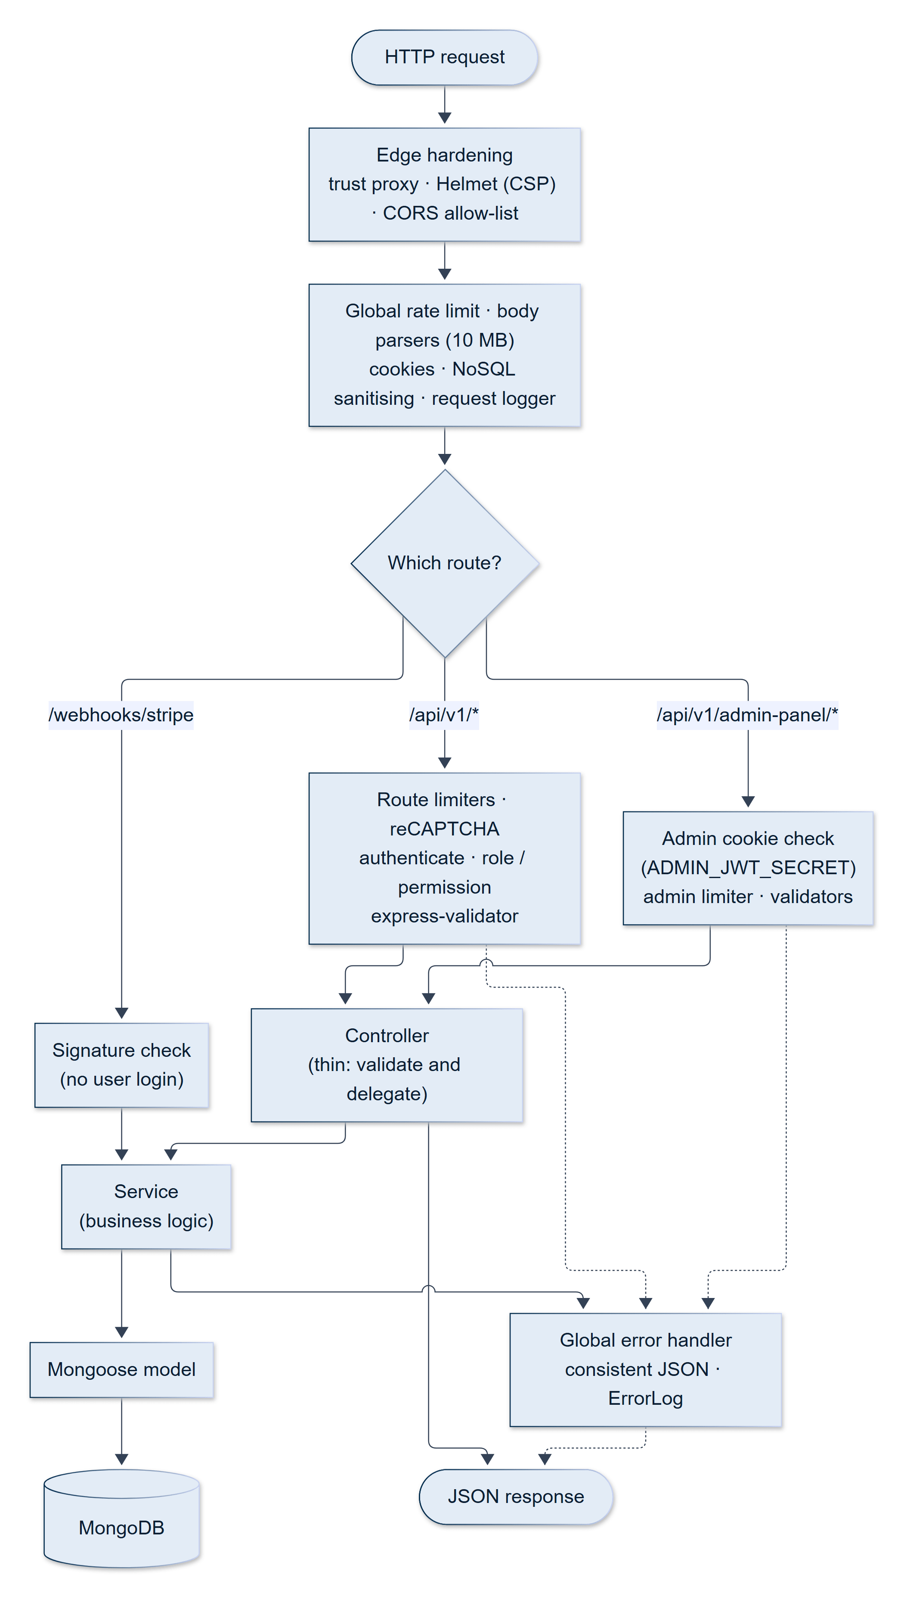
Figure 9.2 — Request lifecycle through the middleware pipeline and the layered backend
Authentication, validation and permission failures are routed to the centralised error handler, which returns a controlled response (Section 9.3).
It comprises 26 route modules (25 under /api/v1/* plus the isolated admin panel) exposing 317 endpoints, 35 controllers (26 marketplace and nine admin-panel), 49 service files (26 core modules, nine for the AI router, and fourteen for the email subsystem), 40 Mongoose models, ten middleware modules, eleven validator modules, and fifteen utility modules. Controllers stay thin and delegate business logic to services; for example, stripe.service, milestone.service, hourlyEscrow.service, gigOrder.service, matchmaking.service, taxonomy.service, notification.service, and email.service.
Request pipeline. The order of the middleware matters, and is deliberate: trust proxy → Helmet → CORS → global rate limit → body parsers (which keep the raw body for webhook signature verification) → cookie parsing → NoSQL sanitisation → request logging → compression → routes → the admin-panel routes → the webhooks → a 404 handler → a single global error handler. That handler maps Mongoose validation errors, duplicate-key errors, JSON Web Token errors, cast errors, and CORS rejections to consistent JSON responses, forwards structured error data (for instance, the required and available amounts of an insufficient-balance error) so that the interface can react to it, hides stack traces outside development, and persists every error for the monitoring page.
Start-up. The server verifies its safety guards (Section 16.7), connects to MongoDB (and exits if it cannot), then initialises each optional subsystem in turn — Redis, Supabase, the AI router (with a real one-token call to the first working provider), and the email provider — logging and continuing past any that fail, and finally starts the scheduler and begins listening on all interfaces at the port named in the environment. Redis is connected at start-up for future caching, but no feature uses it yet.
API documentation. Interactive Swagger (OpenAPI [26]) documentation is served at /api/v1/docs. It currently documents 38 operations across eleven route files (authentication, freelancer, client, public, job, proposal, custom offer, user, CMS, and the legacy administration routes); the 93 admin-panel endpoints are not yet annotated.

9.4 The MongoDB Database
MongoDB [1], accessed through Mongoose [6] and hosted on MongoDB Atlas [33], stores all persistent data in 40 collections (Chapter 10). Relationships are modelled with ObjectId references and enforced in the application layer. Collections carry indexes for the common query patterns, TTL indexes remove expired one-time codes, refresh tokens, and admin sessions on their own, and list endpoints are paginated on the server.

9.5 The Authentication Subsystem
Authentication is JWT-based, with rotating refresh tokens that are tracked server-side, per-request user verification, optional two-factor login, and optional social sign-in through Supabase (Sections 12.1 and 16.1). The admin panel has a completely isolated authentication flow, so that a marketplace token can never grant administrative access (Section 14.1).

9.6 The Admin Panel Subsystem
The admin panel is served under an isolated route namespace with its own provider, protected routes, HTTP client, and scoped stylesheet (ap- class prefix). It provides 17 management modules and is architecturally separated from the marketplace, so that no administrative capability can leak into the public application (Chapter 14).

9.7 Integration Subsystems
Every external service is reached through one service module, which hides the vendor and degrades gracefully when the service is absent.
AI provider router. A router presents a uniform interface and tries a prioritised chain of providers — Gemini, DeepSeek, Qwen, Groq, Claude, and a local Ollama model — with the order set by environment variables (Chapter 13).
Email provider router. Controllers and services call only email.service, never a provider. Underneath, a registry maps a provider name to a class and a factory selects one at start-up from the EMAIL_PROVIDER setting. Two providers exist: SMTP through Nodemailer, and the Gmail API, which sends over HTTPS using OAuth credentials for a dedicated platform mailbox [25]. If the Gmail credentials are missing or fail verification at start-up, the factory falls back to SMTP. To add a provider such as SES or Mailgun, one new class and one registry line suffice, with no change to any controller. The Gmail provider exists because the deployment host blocks outbound SMTP ports (Section 20.7).
Payments. stripe.service wraps Stripe [7] for Checkout sessions, Connect accounts, transfers, and payouts. With no key configured, or with STRIPE_DUMMY=true, every call is simulated so that the full payment flow can be demonstrated without real money. Simulated checkout-session identifiers are signed and tied to the user and the amount, so a client cannot fabricate one to credit a wallet.
File storage. Uploads pass through upload.service to Cloudinary [18]; no request handler touches the Cloudinary SDK directly, and old assets are cleaned up on a best-effort basis when they are replaced.
Push notifications. push.service wraps Firebase Cloud Messaging [17] and is called from the single notify() function (Section 15.4).
Social login and bot detection. Supabase [20] is used only to authenticate users through Google, LinkedIn, and GitHub; it holds no marketplace data. Google reCAPTCHA v3 [19] is verified by recaptcha.service and fails open (Section 16.5).

9.8 The Escrow Services
Money movement is concentrated in a few services, each of which is the only place its kind of operation happens.
Table 9.2 — Services that move money
Service | Responsibility
milestone.service | Fund a milestone from the client's wallet; release a milestone to the freelancer's wallet; approve a milestone and advance or complete the contract. Both manual approval and automatic release call the same approval function
hourlyEscrow.service | Lock a week's estimate; draw an amount down for a time log; re-lock on top-up; refund, release, or split what remains
gigOrder.service | Create a gig-order job; the single activation function that every deposit-confirmation path calls
jobCompletion.service | Roll up completion statistics exactly once per job
stripe.service | Checkout, Connect, transfers, payouts, and the simulated mode

9.9 Scheduled Jobs
A small scheduler (node-cron) starts with the server and runs five jobs in the server's local time.
Table 9.3 — Scheduled jobs
Schedule | Job | Purpose
Every hour, on the hour | Milestone auto-release | Release submitted milestones whose review deadline has passed
Every hour, at :30 | Stale order and offer clean-up | Cancel gig orders left unpaid for seven days; expire custom offers past their expiry
Sunday, 23:59 | Hourly retry | Retry pending time logs on active hourly contracts
Every day, 02:15 | Skill verification expiry | Revert skill verifications older than six months to unverified, and notify the freelancer
Every hour, at :45 | Scheduled CMS publication | Publish CMS pages whose scheduled time has passed

An open job's deadline expiry is deliberately not a scheduled job: it is applied lazily, the next time the job is read.

9.10 Deployment Architecture
The three tiers are deployed independently.
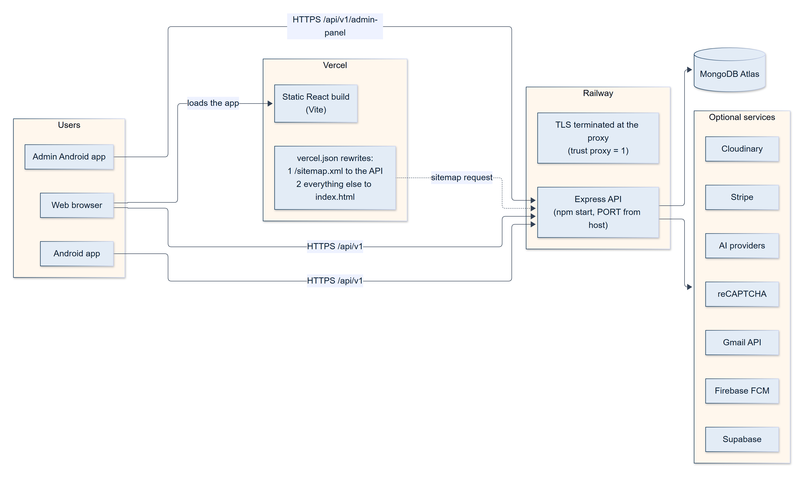
Figure 9.3 — Deployment architecture
The frontend and the API are deployed independently and live on different domains; every third-party service other than MongoDB is optional (Section 9.10).
- The frontend is a static Vite build hosted on Vercel [32]. Its vercel.json contains two rewrites whose order is load-bearing: /sitemap.xml is proxied to the backend, and every other path is rewritten to index.html for client-side routing. Reversing them would let the catch-all swallow the sitemap request.
- The backend runs on Railway [31] with npm start, bound to the platform-supplied port. Railway terminates TLS and forwards plain HTTP, which is why trust proxy is enabled, and Railway blocks outbound SMTP ports, which is why the Gmail API provider is mandatory there.
- The database is MongoDB Atlas [33].
- Mobile builds are produced locally and distributed as signed APK files (Chapter 15).
The minimum configuration to run the backend is a MongoDB connection string and two JWT secrets; the frontend needs the API address. Everything else — Stripe, Supabase, the AI providers, email, reCAPTCHA, Cloudinary, and Firebase — degrades gracefully when unset.

9.11 Architectural Trade-offs
Several decisions trade capability for simplicity, and are stated openly.
- REST and polling in place of GraphQL and WebSockets. Chat and the project pages poll every few seconds. This works through any proxy and needs no connection state, at the cost of latency and of extra requests.
- Context API in place of a state library, which keeps the dependency count low and suits per-page data.
- No multi-document transactions. Operation ordering and atomic conditional updates provide the needed guarantees, at the price of careful discipline in each money flow (Section 16.7).
- Sequential AI fallback with no circuit breaker, which is simple and predictable, but slow when several providers are down (Section 13.3).

10. Database Design

10.1 Overview
SkillKart's data layer consists of 40 MongoDB collections managed through Mongoose schemas. MongoDB is the sole system of record for marketplace data: users, jobs, gigs, proposals, contracts, payments, messages, and everything else described below. (Supabase, where it is configured, handles optional social sign-in only and holds no marketplace data.)
The design is reference-based. Related documents point to each other with ObjectId references, which keeps each collection small and lets the same record — a user, a job — be shared by many others without duplication. Embedded sub-documents are used only where the child has no life of its own: a skill inside a freelancer profile, a dispute inside a contract or milestone, a FAQ inside a gig. Enumerated fields (enum) constrain every status and type to a fixed vocabulary, so a state cannot be set to a value the code does not understand.
Three further characteristics shape the rest of the system.
- No multi-document transactions. The codebase does not use MongoDB transactions. Correctness instead comes from strict operation ordering — validate first, write after — and from atomic single-document updates (findOneAndUpdate with a guard condition) wherever money or a state transition is involved. Section 12.12 describes how this is applied to escrow.
- Referential integrity at the application layer. MongoDB does not enforce foreign keys, so the service layer is responsible for keeping references valid. The demo-data seeder builds every reference from a record that already exists, so the seeded dataset is consistent by construction (Section 18.5).
- Self-cleaning collections. Time-limited records expire by themselves through TTL indexes: one-time passwords (OTP), refresh tokens (RefreshToken), and admin sessions (AdminSession) are removed by MongoDB once their expiresAt passes.

10.2 Collections by Domain
The 40 collections fall into nine groups. Each table lists the collection, its purpose, and the fields that matter most to the rest of the system.
Table 10.1 — Identity and access collections
Collection | Purpose | Key fields
User | The core identity for every marketplace account | email (unique), hashed password, role (superadmin, admin, contenteditor, freelancer, client, publicviewer), authProvider, isEmailVerified, isActive, isBlocked, tokenVersion, loginAttempts/lockUntil, pushTokens, contactViolations
RefreshToken | Server-side record of every issued refresh token, enabling rotation and theft detection | jti (unique), familyId, userId, revokedAt, replacedByJti, TTL on expiresAt
OTP | One-time passwords for verification and sensitive operations | otpHash (never the plain code), purpose (11 values, e.g. email_verification, login, password_reset), attempts/maxAttempts (5), isBlocked, TTL on expiresAt
AdminUser | The isolated identity of database-backed administrators | email, passwordHash, role (super_admin, finance_admin, support_admin, moderator, analytics_viewer), isActive
AdminSession | A login session of an administrator | tokenHash (unique), ipAddress, lastActivityAt, logoutReason (manual, expired, inactivity, forced), TTL on expiresAt
ClientOnboardingDraft | Saved progress of the client onboarding wizard | userId (unique), formData, step
OnboardingProgress | Step-by-step onboarding tracker (email, profile, CV, portfolio, payment method) | userType, steps.*, overallProgress, isOnboardingComplete

Table 10.2 — Profile and file collections
Collection | Purpose | Key fields
FreelancerProfile | Everything specific to a freelancer | title, bio, hourlyRate, skills[] (name, level, isVerified, verificationScore, lastTestedAt, expiresAt), portfolio[], education[], certifications[], languages[], availability, experienceLevel, rating, completedProjects, totalEarnings, walletBalance, stripeAccountId, verificationDetails, aiClassification
ClientProfile | Everything specific to a client | companyName, companyType (Individual, Startup, SME, Enterprise), industry, budgetRange, totalProjectsPosted, totalSpent, walletBalance, verificationStatus, savedFreelancers, fundingFlags[]
FileUpload | Metadata of every uploaded asset | url, cloudinaryId, fileType (cv, portfolio, document, image, other), mimeType, size, owning userId

Table 10.3 — Marketplace collections
Collection | Purpose | Key fields
Job | A client's requirement — and, for a gig order, the order itself | title, description, budget (min, max, type: fixed/hourly), skills, category, experienceLevel, status (draft, open, pending_payment, in-progress, completed, cancelled, expired, closed), source (project/gig), gigId, gigTier, customOfferId, requirements, delivery, revisions[]
Gig | A freelancer's packaged service | title, category, skills, three-tier pricing (basic, standard, premium: price, delivery time, revisions, features), media, faqs[], status (draft, active, paused), stats (views, orders, rating, reviews)
Proposal | A freelancer's bid on a job | coverLetter, fixedPrice or hourlyRate, estimatedDeliveryTime, estimatedWeeklyHours, status (pending, accepted, rejected, withdrawn), canResubmit
CustomOffer | A bespoke offer sent inside a chat | title, description, price, deliveryDays, revisions, status (pending, accepted, declined, withdrawn, expired), expiresAt, link to the resulting jobId

Table 10.4 — Engagement and payment collections
Collection | Purpose | Key fields
Contract | The lifecycle engine, created when a proposal is accepted | type (fixed/hourly), fixedPrice or hourlyRate, weeklyLimit, milestoneMode, currentMilestoneOrder, status (active, paused, in_revision, delivered, completed, pending_cancellation, under_review, cancelled), paymentStatus, timer, hourlyEscrow (lockedBalance, weeklyLockAmount, totalLocked, totalDrawn), endRequest, embedded dispute (hourly only)
Milestone | One funded phase of a fixed-price contract | order, title, amount, status (pending_funding, funded, submitted, in_revision, approved, disputed, released, refunded, cancelled), reviewDeadline, embedded dispute
ContractHistory | Append-only log of significant contract events | action, previousValue, newValue, performedBy or performedByAdmin, notes
Delivery | A submitted deliverable | version, message, files, links, status (pending_review, accepted, revision_requested), milestoneId
TimeLog | A time entry on an hourly contract | duration, startTime, endTime, source (timer/manual), status (pending, approved, rejected, billed)
Payment | An escrow or wallet transaction | type (job_escrow, wallet_deposit, hourly_escrow, hourly_invoice), milestoneId, totalAmount, feeRate (default 0.005), platformFee, freelancerPayout, currency (default PKR), status (deposit_pending, deposit_paid, released, refunded), Stripe identifiers
Withdrawal | A freelancer cash-out request | amount, method (bank_transfer, paypal, stripe), status (pending, processing, completed, failed, cancelled)

Table 10.5 — Communication and feedback collections
Collection | Purpose | Key fields
Conversation | A chat between participants | participants, lastMessage, per-user unreadCount map
Message | One message in a conversation | content, attachments, type (text/custom_offer), customOfferId, readBy
Notification | An in-app notification | type, title, message, link, read, references to the related job, gig or proposal
Review | A two-way rating | rating, comment, type (client_to_freelancer/freelancer_to_client), isHidden with moderator details; unique per job and reviewer
Testimonial | A user's public success story | text, rating, status; one per user

Table 10.6 — Skill, verification and taxonomy collections
Collection | Purpose | Key fields
SkillNode | A vertex of the skill graph | name, slug, type (industry, category, profession, skill, technology, tool, concept), aliases, synonyms, weight, status (active, deprecated, merged), canonicalParent
SkillRelationship | A typed edge between two nodes | from, to, type (15 relationship types such as BELONGS_TO, RELATED_TO, PREREQUISITE), weight; the from/to/type triple is unique
TaxonomyProposal | An AI-suggested node awaiting admin approval | name, type, relationships[], sourceType (gig_creation, job_posting, profile_update, periodic_analysis), status (draft, pending_review, approved, rejected), aiReasoning
SkillTestAttempt | One attempt at a skill test | skillsTested, level (easy, intermediate, expert), questions[], totalScore, passed, status, violations[], proctoring summary

Table 10.7 — Administration and operations collections
Collection | Purpose | Key fields
AdminAuditLog | Immutable record of sensitive administrative actions | adminEmail, action, category (16 categories), resource, resourceId, previousValue, newValue, severity (info, warning, critical), ipAddress
Report | A user or content report | category (spam, abuse, fraud, harassment, inappropriate, other), priority (low…critical), status (pending, investigating, resolved, dismissed), reportedItem
PlatformSettings | Category-popularity weights used for ordering categories | weights (gigs 0.40, jobs 0.25, freelancers 0.20, search volume 0.10, views 0.05)
SystemSettings | Key–value platform configuration | key, value, category (fees, security, email, features, general, maintenance), valueType
ApiLog | One row per API request | method, path, statusCode, duration, userId, ip
ErrorLog | Captured server errors | message, type (unhandledRejection, uncaughtException, requestError, validationError, other), route, resolved
EmailLog | One row per email send attempt | to, subject, template, provider (smtp/gmail), status, attempts, errorMessage

Table 10.8 — Content and public-form collections
Collection | Purpose | Key fields
CMSContent | A versioned content page (backend infrastructure; see Section 14.6) | pageId, status (draft, published, archived, scheduled), version, previousVersions[], modificationHistory[], SEO block
NewsletterSubscriber | A newsletter sign-up from the public site | email (unique), status
ContactMessage | A message sent through the public contact form | name, email, subject, message, status (new, read, resolved)

10.3 Key Design Decisions
One entity for projects and gig orders. Ordering a gig does not create a separate "order" collection. It creates a Job with source: 'gig', linked back to the Gig and the chosen pricing tier (or to the CustomOffer it came from). The order then reuses the same escrow, delivery, completion, and statistics lifecycle as any other job instead of a parallel one. Only source: 'project' jobs — a client's own posted requirement, matched through proposals — go on to spawn a Contract.
Milestones are a top-level collection. A Milestone is not embedded in its Contract. Each funded phase has its own state machine, its own Payment row, its own review deadline, and its own dispute, and it must be addressable by ID from the payment and delivery endpoints. A fixed-price hire with no explicit split still receives one implicit "Full Project" milestone, so there is no separate no-milestone code path.
Disputes live where the money is. For a fixed-price contract the dispute is embedded in the specific Milestone in question; for an hourly contract, which has no milestones, it is embedded in the Contract. A fixed-price contract therefore never has a contract-level dispute, and any code that reads a dispute must branch on contract.type.
Wallet balances live on the profiles. The freelancer's and the client's wallet balances are fields on FreelancerProfile and ClientProfile, adjusted only through atomic, guarded updates. Frozen wallets are represented by isFrozenWallet and its audit fields.
A single Payment status vocabulary. Every payment type shares one status enum. Locking funds is recorded as deposit_paid and releasing them moves the same row to released; there is no separate "locked" status. A fixed-price contract has several Payment rows (one per milestone), so a payment is always resolved through its milestone rather than through the contract alone.
Verification data lives with the skill. A freelancer's verified status is not a single flag. Each entry in FreelancerProfile.skills[] carries its own level, isVerified, verificationScore, lastTestedAt, and expiresAt (verification expires after six months), which is what allows applying and publishing to be gated per skill and per experience level.
Uniqueness is enforced by indexes. Duplicate reviews are prevented by a unique index on (jobId, reviewerId); duplicate skill-graph edges by a unique index on (from, to, type); one testimonial per user by a unique index on userId; and one profile per user on both profile collections.

10.4 Key Relationships
Table 10.9 — Principal relationships between collections
Relationship | Cardinality | Notes
User — FreelancerProfile / ClientProfile | 1 : 1 | A user has the profile matching their role
Client (User) — Job | 1 : N
Job — Proposal | 1 : N | A freelancer may have one proposal per job
Accepted Proposal — Contract | 1 : 1 | Acceptance creates the contract
Contract — Milestone | 1 : N | Fixed-price only
Milestone — Payment | 1 : 1 | One escrow payment per milestone
Contract — Payment | 1 : N | Hourly lock and invoice payments
Contract — Delivery, TimeLog, ContractHistory | 1 : N
Conversation — Message | 1 : N | A message may carry a CustomOffer
CustomOffer — Job | 1 : 1 | Created when the client accepts
Gig — Job | 1 : N | Each order is a job linked to the gig
Job — Review | 1 : N | At most one review per reviewer
SkillNode — SkillRelationship — SkillNode | N : N | The taxonomy graph

The Contract is the central hub of the engagement lifecycle: an accepted proposal creates a contract, which then drives milestones, payments, deliveries, messaging, reviews, and — when necessary — disputes. Figures 10.1a to 10.1e show the core entities and their relationships.
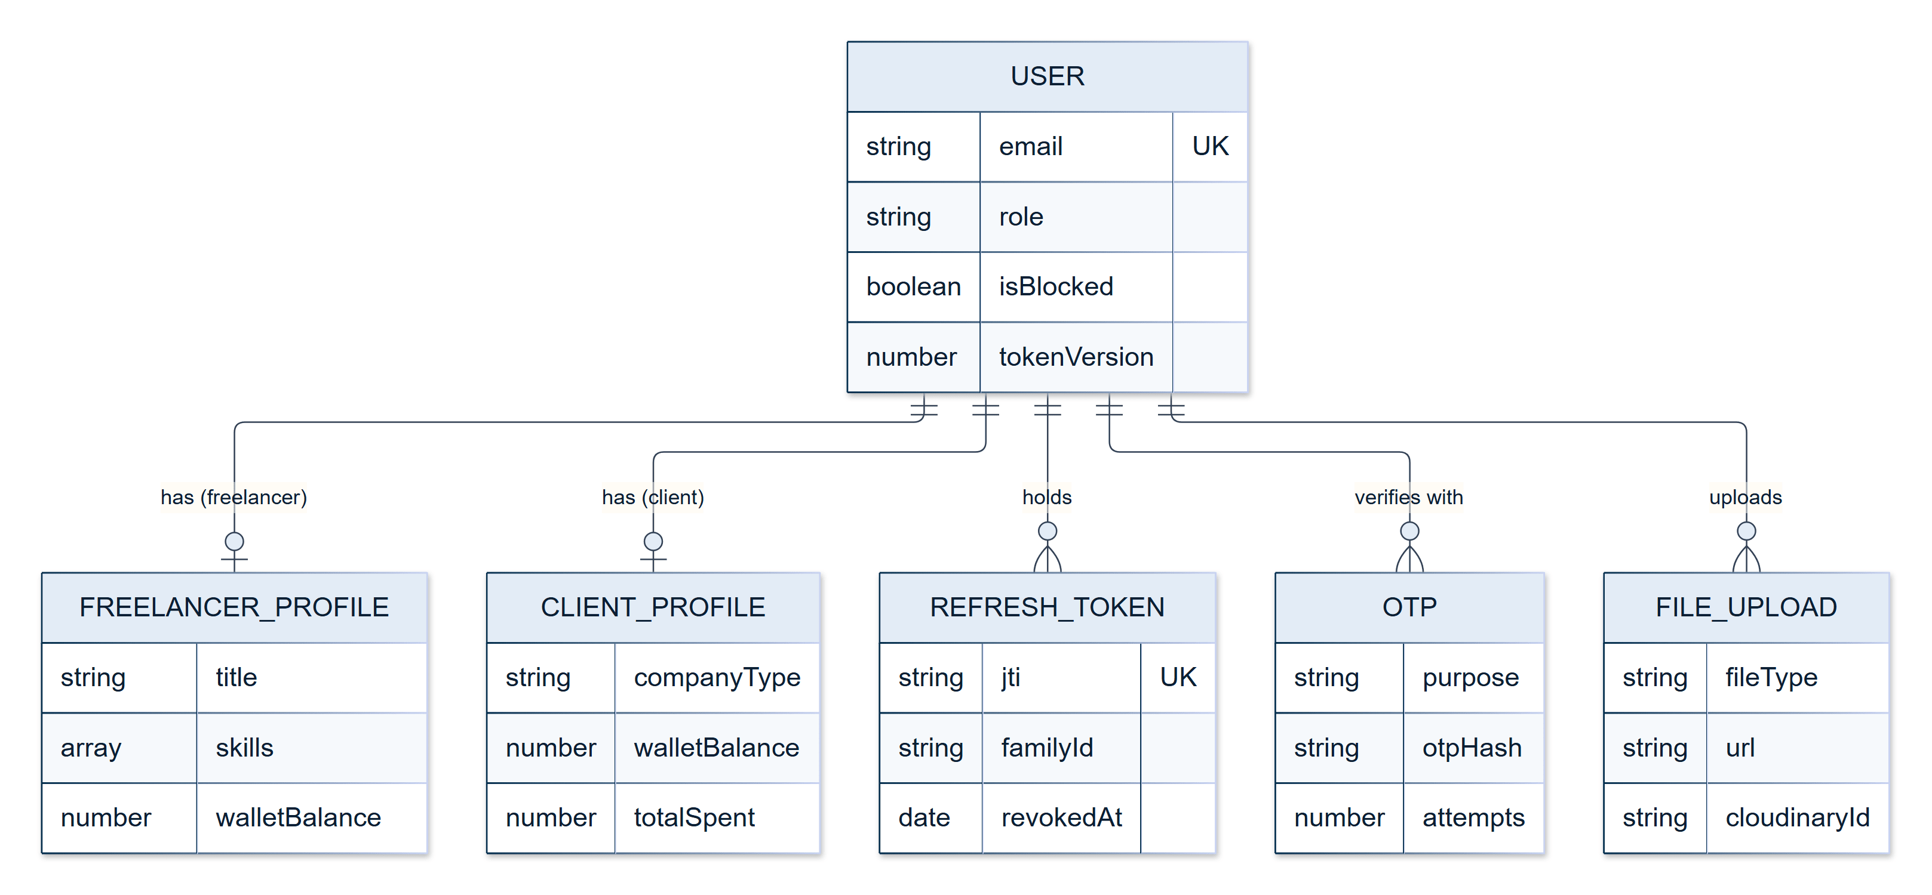
Figure 10.1a — Entity relationships: identity and profiles
The entity relationships are shown as five diagrams, (a) to (e), so that every entity name stays legible when printed.
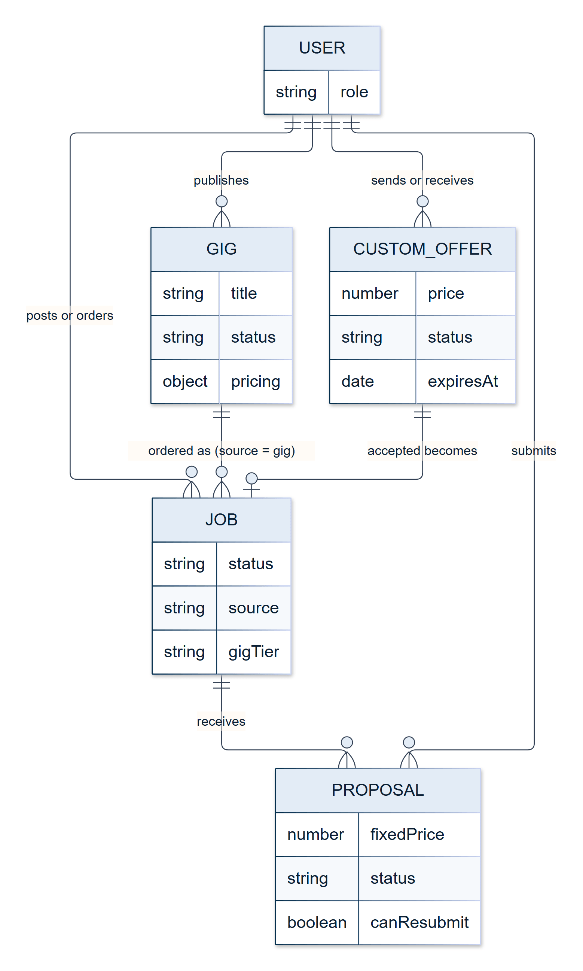
Figure 10.1b — Entity relationships: marketplace
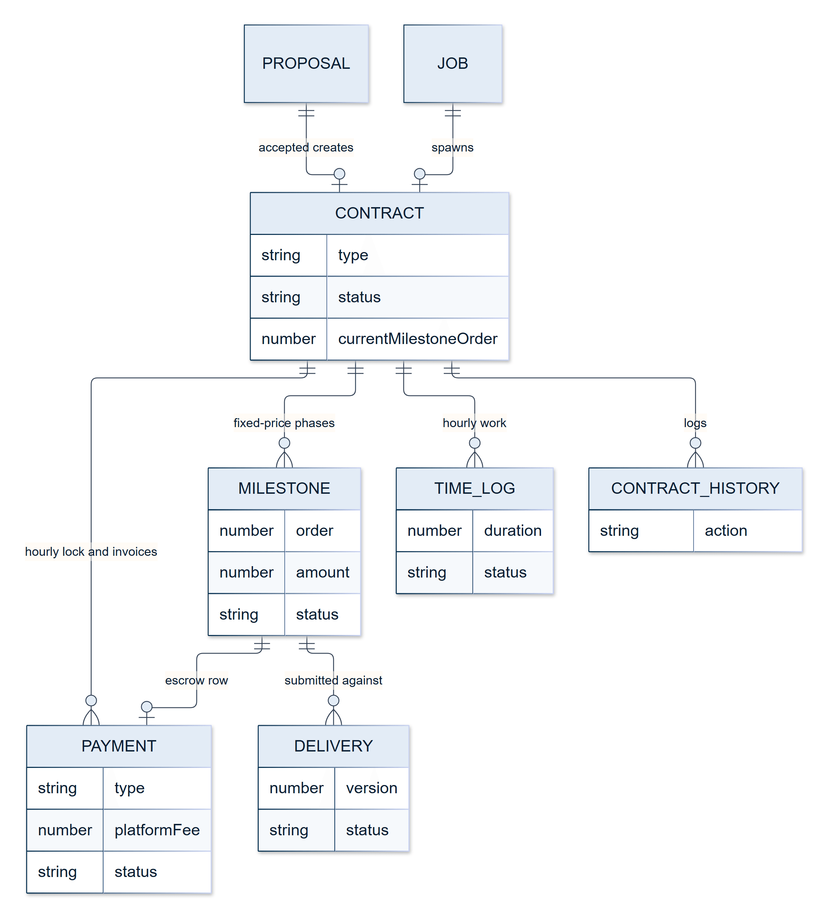
Figure 10.1c — Entity relationships: contracts, escrow and payments
A gig order is a Job with no Contract; its payments link to the Job directly (Section 12.9).
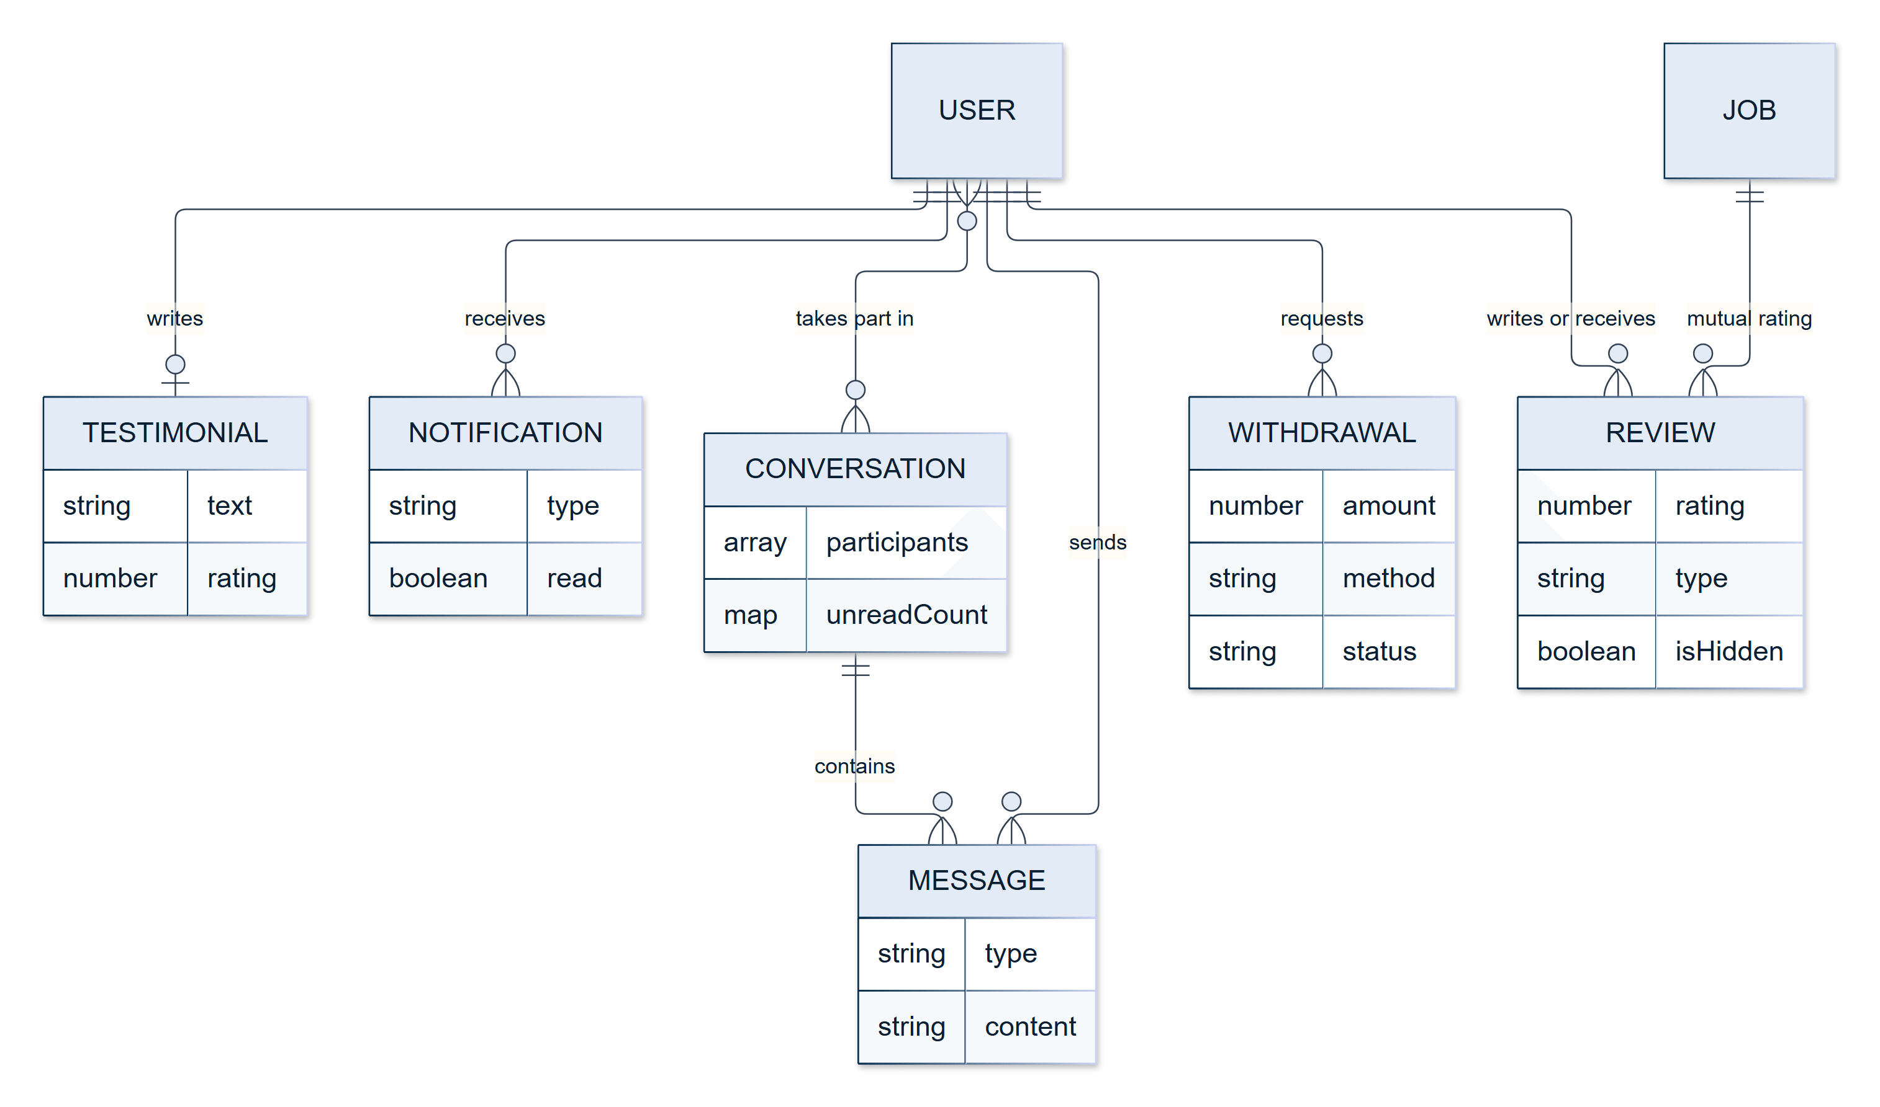
Figure 10.1d — Entity relationships: communication, reviews and withdrawals
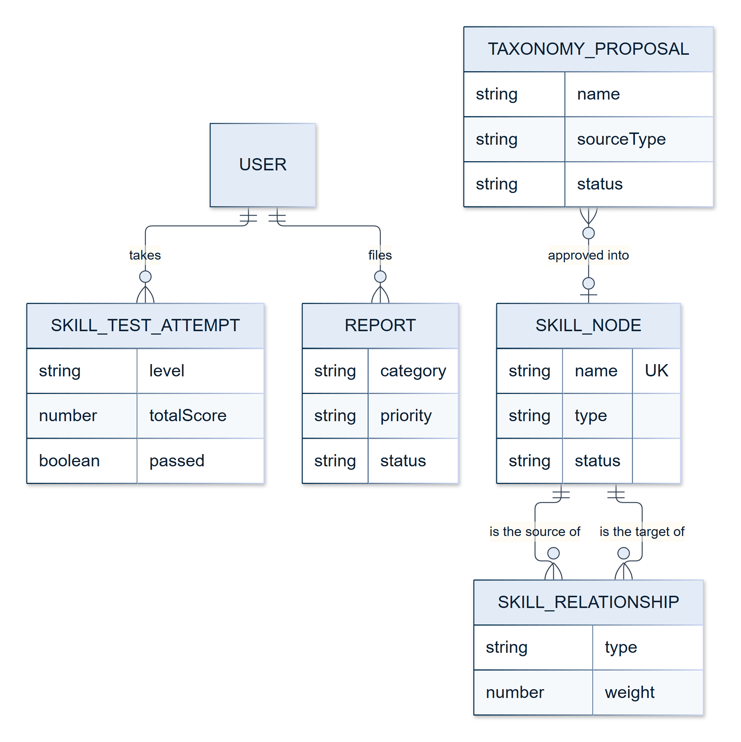
Figure 10.1e — Entity relationships: skills, verification and reports

10.5 Status Vocabularies and State Machines
Every entity with a life cycle has a fixed enum of statuses, and the code moves it between them only along defined transitions. Table 10.10 lists each vocabulary and the transitions that occur. A few values are reserved: they are part of the schema so that a future feature can use them, but no current code path sets them.
Table 10.10 — Status vocabularies and the transitions that occur
Entity | Statuses | Transitions in practice
Job | draft, open, pending_payment, in-progress, completed, cancelled, expired, closed | draft → open (publish); open → in-progress (proposal accepted); in-progress → completed or cancelled; open → expired (deadline passed, applied when read) or closed (client or administrator). A gig order is created as pending_payment and becomes in-progress when the first deposit lands
Proposal | pending, accepted, rejected, withdrawn | pending → accepted or rejected; a rejection with canResubmit allows rejected → pending again
Contract | active, delivered, in_revision, completed, under_review, cancelled, paused, pending_cancellation | active → delivered → in_revision ⇄ delivered → active (next milestone) or completed; a dispute moves the contract to under_review; paused is set only by an administrator; pending_cancellation is reserved
Milestone | pending_funding, funded, submitted, in_revision, approved, disputed, released, refunded, cancelled | pending_funding → funded → submitted → released, with in_revision ⇄ submitted for revisions and disputed as a side branch; refunded and cancelled result from administrator action. approved is reserved: release follows submission directly
Payment | deposit_pending, deposit_paid, released, refunded | deposit_pending → deposit_paid → released or refunded. An hourly_escrow lock row stays deposit_paid; each billed log is its own hourly_invoice row, created already released
TimeLog | pending, approved, rejected, billed | pending → billed, automatically. approved and rejected are reserved: no client approval step exists
Withdrawal | pending, processing, completed, failed, cancelled | A Stripe withdrawal is created processing or completed; a manual one is created pending and an administrator moves it to completed or cancelled (with an automatic refund). failed is reserved
CustomOffer | pending, accepted, declined, withdrawn, expired | pending → any of the other four; expiry is applied by the hourly clean-up job

The contract and milestone machines, which are the most consequential, are drawn in Figures 12.6a and 12.6b (Section 12.11).

11. Technologies Used
This chapter explains each major technology and the reason it was chosen. Versions are those installed in the project at the time of writing.

11.1 Frontend
- React 19.2 [4] — a component-based UI library chosen for its ecosystem, performance, and suitability for a complex, stateful single-page application.
- Vite 7 [5] — the build tool and development server, chosen for fast hot-module replacement and optimised, code-split production builds.
- React Router 7 — declarative client-side routing with nested routes and route guards.
- React Hook Form 7 — performant form management with validation and minimal re-rendering.
- Axios 1.13 — the HTTP client, wrapped in a module with interceptors for authentication, token refresh, request de-duplication, and error handling.
- Tailwind CSS 4 [35] with hand-authored component CSS (76 stylesheets) — utility styling combined with scoped component styles.
- Framer Motion 12 and GSAP 3 — animation libraries for transitions and interactive effects.
- lucide-react — a consistent icon set; react-select and react-easy-crop — searchable selects and in-browser image cropping.
- MediaPipe Tasks Vision 1.0.1 [16] — on-device face detection for skill-test proctoring.
- Supabase JS 2 [20] — the client for optional social sign-in.

11.2 Backend
- Node.js 22.3 or later [2] — the JavaScript runtime, enabling one language across the stack.
- Express 4 [3] — a minimal, flexible web framework for the layered REST API.
- Mongoose 8 [6] — an object–document mapper adding schemas, validation, hooks, and relationship modelling to MongoDB.
- Multer — multipart upload handling; node-cron 4 — the scheduler for the five background jobs.
- Swagger (swagger-jsdoc and swagger-ui-express) [26] — interactive API documentation at /api/v1/docs.
- ExcelJS and PDFKit — generation of the administrators' Excel and PDF exports; pdf-parse and mammoth — text extraction from PDF and Word résumés; ua-parser-js — browser and device details for login-alert emails.

11.3 Database
- MongoDB [1] on MongoDB Atlas [33] — a document database chosen for its flexible schema, scalability, and natural fit for the varied, evolving data of a marketplace: nested gig tiers, embedded disputes, skill arrays with per-skill verification.

11.4 Authentication and Security
- JSON Web Tokens [9] (jsonwebtoken) — access and refresh tokens, with refresh rotation backed by a collection.
- bcrypt [24] (bcryptjs, cost factor 12) — one-way password hashing.
- One-time passwords — six-digit, hashed, emailed codes for verification and two-factor login.
- Supabase Auth [20] — optional Google, LinkedIn, and GitHub sign-in. Supabase authenticates end users only; it is deliberately decoupled from the platform's outbound email.
- Google reCAPTCHA v3 [19] — invisible, score-based bot mitigation on login, registration, and the contact and newsletter forms.
- Helmet [37], express-rate-limit, express-validator, express-mongo-sanitize, sanitize-html — header hardening, abuse prevention, input validation, NoSQL-injection sanitisation, and HTML stripping.
- crypto-js — AES encryption of the SuperAdmin credential file.

11.5 Email Delivery
Transactional email is sent through a pluggable provider architecture, selected at runtime by a single EMAIL_PROVIDER variable (Section 9.7):
- Gmail API (googleapis) [25] — the provider used in deployment. It sends over HTTPS using OAuth credentials for a dedicated platform mailbox, with a long-lived refresh token; the application performs no OAuth authorisation flow at runtime.
- SMTP (nodemailer) — the default for local development, and the automatic start-up fallback when the Gmail credentials are absent or fail verification.
Two constraints drove this design. First, cloud hosts commonly block outbound SMTP ports (465 and 587), and the deployment target is one of them, so an HTTPS-based transport is a functional requirement in production, not a preference. Second, the Gmail send permission cannot be satisfied by the existing Supabase Google sign-in: Supabase authenticates end users, whereas a transactional message is sent as the platform, often to someone who has never used Google sign-in and at moments when no user session exists, such as a password-reset code. The two concerns are therefore kept entirely separate.

11.6 Payments
- Stripe 22 [7] — Checkout for wallet top-ups and gig deposits, Connect Express accounts and payouts for freelancer withdrawals, and webhooks with signature verification. A simulated mode (STRIPE_DUMMY) allows the entire payment flow to be demonstrated without real transactions.

11.7 Artificial Intelligence
- An in-house provider router over Google Gemini [8] (@google/genai), DeepSeek [14], Alibaba Qwen [29], Groq [28] (groq-sdk), Anthropic Claude [27] (@anthropic-ai/sdk), and Ollama [30] (local). Each provider is wrapped in a common interface (Chapter 13).

11.8 File Storage and Media
- Cloudinary [18] — hosted storage and delivery for avatars, logos, covers, portfolio images, gig banners, job attachments, and chat attachments. Résumés are parsed in memory and are not stored.

11.9 Push Notifications
- Firebase Cloud Messaging [17] through firebase-admin 14 on the server and @capacitor/push-notifications on the device, hooked into the single notify() function and designed to fail open.

11.10 Mobile
- Capacitor 8 [15] with nine plugins (app, browser, camera, filesystem, network, push notifications, share, splash screen, status bar), building two Android applications from the web codebase (Chapter 15).

11.11 Discoverability
- A live-generated XML sitemap, a robots.txt that excludes authenticated and transactional routes, a web-app manifest (brand colours, icons, and shortcuts), and Open Graph and Twitter Card metadata for link previews (Section 12.21).

11.12 Tooling and Operations
- ESLint 9 and Prettier 3 — linting and formatting; Nodemon — automatic restart during development; Concurrently — runs the backend and frontend together with one command.
- Playwright [34] — browser automation, used throughout development for end-to-end verification in a real browser (Chapter 18).
- Git and GitHub — version control, with more than 300 commits across the project.
- Hosting — Vercel [32] (frontend), Railway [31] (backend), MongoDB Atlas [33] (database).
- Winston and Chart.js appear in the dependency manifests, but the application does not currently use them: logging is done through the console, request logging, and database log collections, and the administrator analytics are drawn with plain CSS bars. They are noted here for completeness and are candidates for removal or adoption (Chapter 21).

11.13 Why This Stack
Choosing a stack is a set of engineering trade-offs under real constraints. Equally capable alternatives exist — Django with PostgreSQL, Laravel with MySQL, Spring Boot, ASP.NET Core — and none is inferior on capability grounds. The reasoning below explains why MERN suits this system.
One language removes a class of integration cost. Every layer — Express handlers, Mongoose schemas, validators, the React frontend, even the AI prompts that request JSON — describes JSON-shaped data in JavaScript. There is no mapping between a data-transfer object and an entity and no second type system to keep in step at the API boundary, which narrows the surface for "the backend and frontend disagree about a field" defects and lets any team member work on any part of the code.
The workload is I/O-bound, which suits Node. Most of this application's time is spent waiting: for MongoDB, and for HTTP responses from AI providers, Stripe, Cloudinary, and the email transport. Node's non-blocking event loop handles many concurrent slow operations cheaply. The AI router's sequential fallback, for example, issues several awaited calls in turn without blocking any other request in the meantime.
A document database fits the data. A gig has up to three pricing tiers with their own features; a contract embeds a dispute; a freelancer profile carries arrays of skills each with its own verification record. These are natural documents, and reading one is a single query. The cost is that referential integrity must be maintained in the application layer (Section 10.1).
The ecosystem covers every integration. npm provides maintained clients for Stripe, Firebase, the AI providers, Cloudinary, and Capacitor. This is not a claim that only Node could integrate them; it is that no capability gap arose that would have forced another stack.
A real trade-off is designed around, not hidden. A single-threaded event loop can be blocked by CPU-heavy work. In this system the main candidate is password hashing, which uses the asynchronous implementation of bcrypt so that it does not stall other requests.

12. Features
This chapter describes the platform's functional modules in the order in which a user meets them: identity and verification first, then the marketplace, the engagement and payment lifecycle, communication, and the public site. Administrative features are covered in Chapter 14, AI features in Chapter 13, and the mobile applications in Chapter 15.

12.1 Authentication and Account Security
Registration. A visitor registers with an email address and password. Registration is a two-step form: the visitor first chooses to join as a Client or a Freelancer, then enters a first name, last name, email, and password. The role is sent with the registration request and the server re-validates it against a whitelist, so a privileged role can never be self-assigned. Passwords must be at least eight characters and contain an upper-case letter, a lower-case letter, and a digit. They are hashed with bcrypt at cost factor 12 before storage [24].
Email verification and one-time passwords. After registration the system emails a six-digit one-time password (OTP). The code expires after ten minutes, is stored only as a SHA-256 hash, is deleted automatically by a database expiry index, and allows five attempts before the code is blocked. A new code may be requested after a one-minute cooldown; a sign-in code can be re-sent only while a live one exists, which shows that the password step was completed moments earlier. The same OTP mechanism, with eleven distinct purposes, also confirms password resets, password changes, email changes, recovery-email changes, account deactivation, and account deletion.
Login and two-factor authentication. On login the server checks the credentials and the account state. An account that is inactive or blocked is refused, and an account is locked for two hours after five consecutive wrong passwords. Two-factor authentication is enabled by default for every client and freelancer: after the password is accepted, a login OTP is emailed and must be entered before tokens are issued. The user can switch two-factor authentication, login-alert emails, and password-change alert emails on or off in the Security settings page. Social-login users skip the OTP step because their identity has already been established by the provider.
Social login. Google, LinkedIn, and GitHub sign-in are offered through Supabase Auth [20], which implements the OAuth 2.0 authorisation framework [38] (Google only on the registration page). The backend does not trust any identity claim decoded in the browser: it sends the access token to Supabase for server-side verification, then finds the existing account by provider identity or by email address, or creates one. New social users start with a neutral publicviewer role and choose Client or Freelancer on a role-selection screen before onboarding. In the Android app the provider's consent screen opens in the system browser (a Chrome Custom Tab) and returns to the app through a registered deep link (skillkart://auth-callback), because Google does not allow OAuth inside an embedded WebView.
Sessions and tokens. Authentication uses a pair of JSON Web Tokens [9]. The access token (lifetime seven days by default) is held in memory and in per-tab session storage; the refresh token (thirty days) is kept in local storage in obfuscated form so that all browser tabs share one session. The client refreshes the access token proactively every 55 minutes and, as a safety net, retries once through the refresh endpoint whenever a request returns 401. Refresh tokens rotate: every use of the refresh endpoint revokes the old token and issues a new one, and the server stores only each token's identifier (jti) and its family. If a token that has already been rotated is presented again after a ten-second grace period — the signature of a stolen token — the whole token family is revoked and the account's tokenVersion is incremented, logging the user out on every device. A change or reset of the password, or "sign out of all devices", increments tokenVersion in the same way, which invalidates every token issued earlier. The browser also logs the user out after 30 minutes of inactivity, and a logout in one tab logs out the others.
Per-request checks. The authentication middleware does not rely on the claims inside the token. On every request it reloads the user record and rejects the request if the account is missing, inactive, or temporarily locked, or if the token's version does not match the account's current tokenVersion. A user who has been blocked by an administrator may still read data, but every write request is refused with a 403 response, and the interface shows a "suspended" overlay.
Account maintenance. Users can change their email address (the confirmation code is sent to the new address, and security alerts go to the old, new, and recovery addresses), set a recovery email, change their password (current password plus OTP), deactivate the account, or delete it. Deactivation and deletion are refused while the user has active work: a freelancer with a hired job in progress, or a client with an open or in-progress job.
Table 12.1 — Authentication parameters
Parameter | Value
Password hashing | bcrypt, cost factor 12
Password policy | at least 8 characters; upper case, lower case and digit
OTP | 6 digits, 10-minute expiry, SHA-256 hashed, 5 attempts, 1-minute resend cooldown
Account lock | 5 wrong passwords, locked for 2 hours
Access token | JWT, 7 days; refreshed proactively every 55 minutes
Refresh token | JWT, 30 days; rotating with reuse detection (10-second grace)
Inactivity logout | 30 minutes (browser)
Rate limits (per IP) | global 1,000 requests per 15 minutes; login/register/reset-request 5 per 15 minutes; OTP endpoints 20 per 15 minutes; public AI tools, contact and newsletter 10 per minute
Bot protection | reCAPTCHA v3 on register, login, contact and newsletter; score threshold 0.5

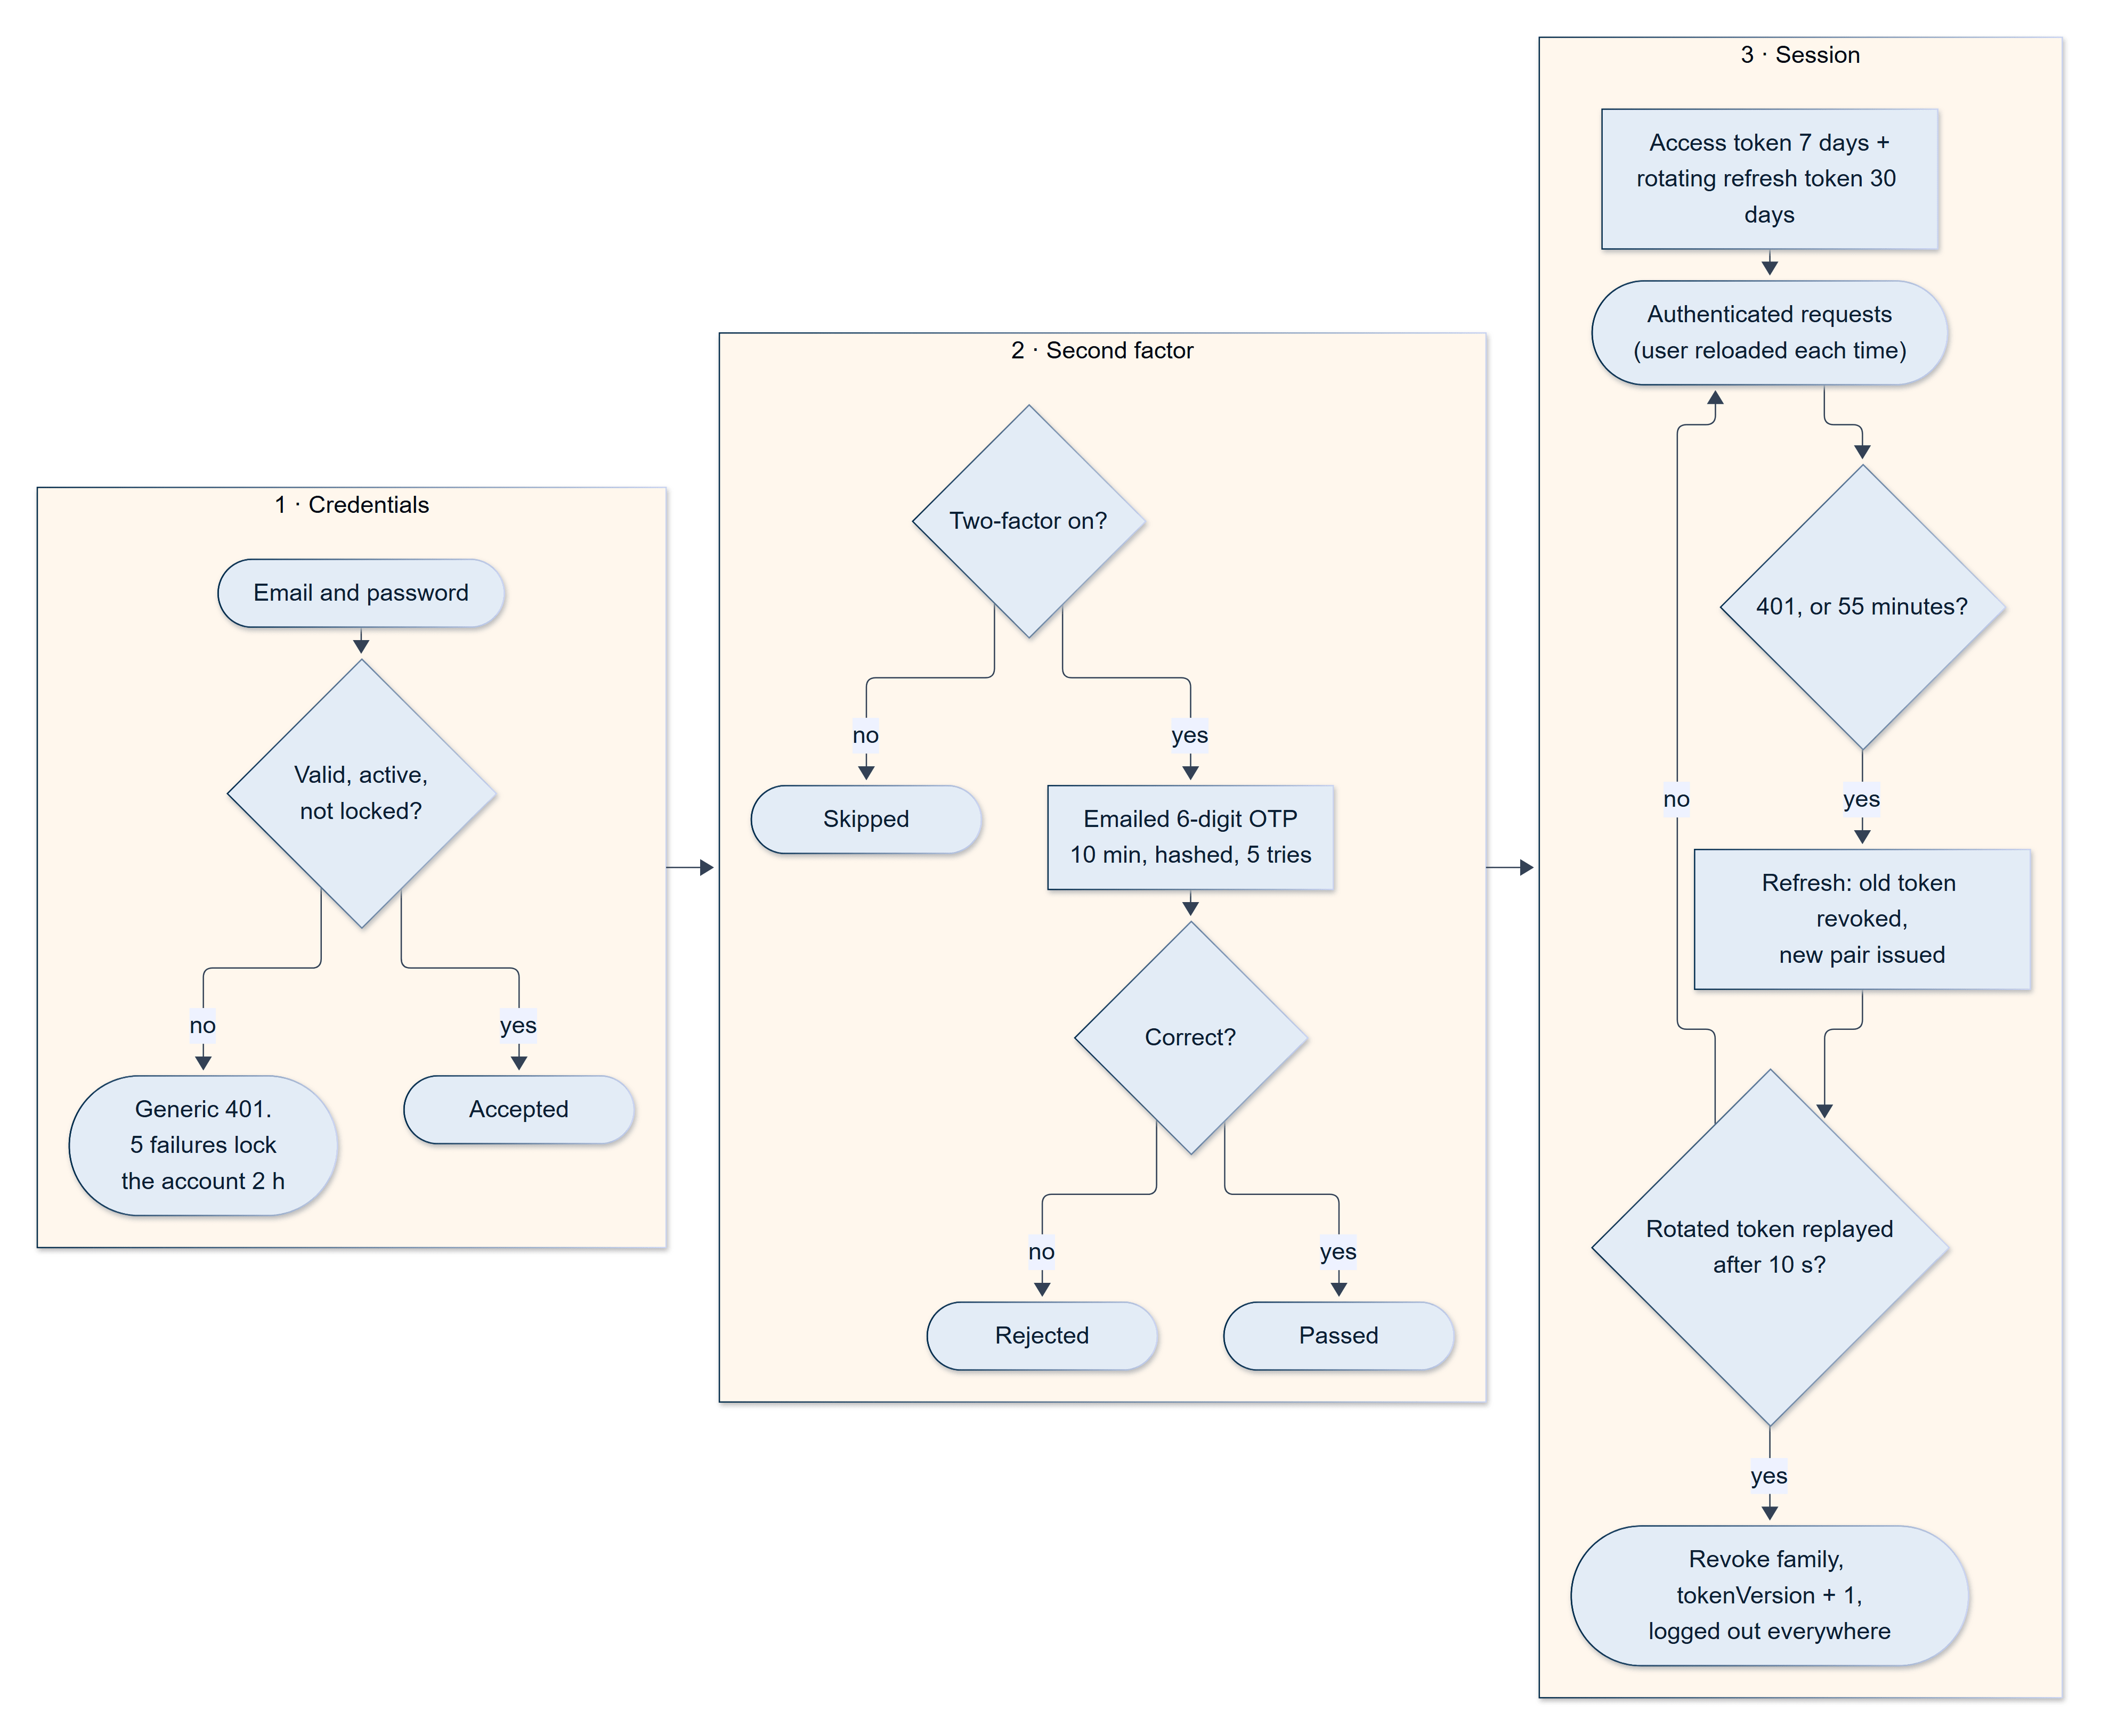
Figure 12.1 — Login, two-factor authentication and token lifecycle
Access tokens are renewed through a rotating refresh token; reuse of an already-rotated token revokes the whole token family and logs the user out everywhere (Section 12.1).

12.2 Freelancer Onboarding and Profile
After verifying their email, a new freelancer completes an eight-step onboarding wizard:
- Résumé (optional). The freelancer can upload a PDF, DOC, or DOCX file of up to 5 MB. The text is extracted on the server and analysed by AI, which proposes a title, a biography, a skill list, and education entries, and gives the résumé a score and a classification (Strong, Average, or Weak). The freelancer reviews the suggestions and accepts or discards them; the file itself is not stored.
- Basic information. Name, professional title, biography, hourly rate, availability (full-time, part-time, contract, or not available), time zone, experience level (Entry, Intermediate, or Expert), and a cropped profile photo.
- Skills. Skills are entered as tags. Typing offers suggestions drawn from the skill graph (Section 12.6); adding a tag asks the AI to validate and normalise it (for example "reactjs" becomes "React.js") and rejects entries that are not professional digital skills. If the AI service is unavailable, the tag is accepted unverified rather than blocking the user. An "AI suggest" helper can infer skills and an experience level from the title and biography.
- Languages, each with a proficiency (basic, conversational, fluent, native).
- Portfolio, with images uploaded to cloud storage.
- Education.
- Certifications.
- Review and submit.
The wizard autosaves a draft in the browser so that an interrupted onboarding can be resumed. On submission the server accepts only a whitelist of profile fields, strips HTML from the biography, marks onboarding complete, computes a profile-completion score, and queues any skill it does not recognise for administrator review (Section 12.6). Editing a profile never changes a skill's earned level, score, or verification: only passing the skill test, or an administrator, can do that. Onboarding never depends on a skill test: on the success screen the freelancer chooses either "Take the skill test now" or "I'll do it later". Choosing later leaves every skill at 0% and unverified, which is the default for any new skill; verification is needed only later, when the freelancer wants to apply for work or publish a gig that requires it.
The freelancer's dashboard shows a verification checklist (email, profile, onboarding, and skill verification are required; a payment method is optional) and a Skill Verification Center listing every skill with its level and score and a "Verify Skill" or "Retake Test" button. The profile editor covers personal information, education, certifications, skills and languages, portfolio projects, and social links, and the public profile shows the verified badge, tested skills, portfolio, languages, ratings, and reviews. The public view deliberately omits private data: phone number, security settings, wallet balance, earnings, and payment identifiers.
A freelancer's verified status is computed, not self-declared: it requires a verified email, completed onboarding, a complete profile (a biography, a title, at least one skill, and at least one portfolio item), and every listed skill to be verified.

12.3 Client Onboarding and Profile
A client completes a five-step wizard: (1) identity and organisation — name, work email, phone, organisation type (Individual, Startup, SME, or Enterprise), company details, and logo; (2) company background — whether the client is new to hiring, industry, role, and a description (with an AI industry recommendation that suggests the three most suitable industries from a fixed list of 30); (3) project requirements — technology stack, budget range, and hiring frequency; (4) strategy and timeline — technical understanding, communication preferences, and urgency; and (5) a final security check covering time zone, social links, and acceptance of the terms. Company name and industry are optional for an individual client. The wizard saves a server-side draft on every step and, on submission, stores a normalised budget range and marks the profile pending verification.
The public client profile shows the company, location, industry, projects posted, total spent, and reviews written by freelancers; budget range, phone number, and wallet balance remain private.

12.4 Skill Verification
Skill verification is SkillKart's answer to the problem of self-declared skills (Section 4.4). It is an AI-generated, proctored test that the freelancer takes for a chosen skill.
Three levels. Before starting, the freelancer picks a level on the rules screen. The level determines the number of questions and how hard the AI writes them.
Table 12.2 — Skill-test levels
Level | Questions | Multiple choice / written | Rank earned if passed
Easy | 5 | 4 / 1 | Beginner
Intermediate | 10 | 8 / 2 | Intermediate
Expert | 15 | 12 / 3 | Expert

About 80% of each test is multiple choice with four options and the remainder is short written answers. Each multiple-choice question allows 20 seconds and each written answer 30 seconds; the test advances automatically, cannot be revisited, and runs in a locked full-screen view.
Grading and results. The AI grades each answer and returns a score between 0 and 1, with partial credit for written answers; a skill's percentage is the mean of its question scores. The option that the question writer marked as correct is kept on the server with the attempt and is never sent to the browser, so a candidate cannot read it from the page; the grader itself does not use it (Section 13.6). A skill scoring 25% or more is verified, and it is marked with the rank of the level the freelancer chose — not a rank derived from the score. Below 25% the skill earns nothing, and a failed attempt never removes an existing verification, rank, or score. A verification is valid for six months; when it lapses, the skill reverts to unverified — on the profile and public badge as well as at the gate — and the freelancer is notified. A daily job applies this, and it is also applied whenever the profile's verification status is recalculated. The last score and rank stay visible beside the Retake Test button. There is no cooldown or attempt limit: a freelancer can retake a test, and a passed retake re-marks the skill at the retaken level.
Proctoring. To make a verified skill mean something, the test is proctored in the freelancer's browser or phone, using two independent guards.
- Camera guard. Google's MediaPipe Face Landmarker [16] runs entirely on the device, analysing a camera frame every 700 milliseconds. The only camera rule is face presence: if no face has been in view for three seconds, the attempt is cancelled immediately. Head turns, eye direction, movement, and extra faces are deliberately not checked. A device with no camera at all may still take the test (a warning is shown and only the browser guard applies), whereas a denied or busy camera blocks the start, so that declining the permission prompt cannot bypass the check. On Android the detector runs on the CPU, because WebView GPU inference fails silently, and the three-second countdown pauses while the WebView's camera feed is frozen.
- Browser guard. Switching tabs, blurring the window, or leaving full-screen mode counts as a strike; at the default setting the third strike cancels the test, with a warning at the second. Right-click, copy, cut, developer-tool shortcuts, and paste into the answer box are blocked on a best-effort basis.
The strictness of proctoring is controlled by one backend setting, SKILL_TEST_PROCTOR_STRICTNESS, between 0 (proctoring off) and 1: it switches the guards on or off and sets the strike limit (between two and six, three at the default of 0.5). A blank or invalid value falls back to the default rather than to "off", so a typing mistake can never disable proctoring silently. The server records the violations a test reported, together with the strictness in force, on the attempt for later review.
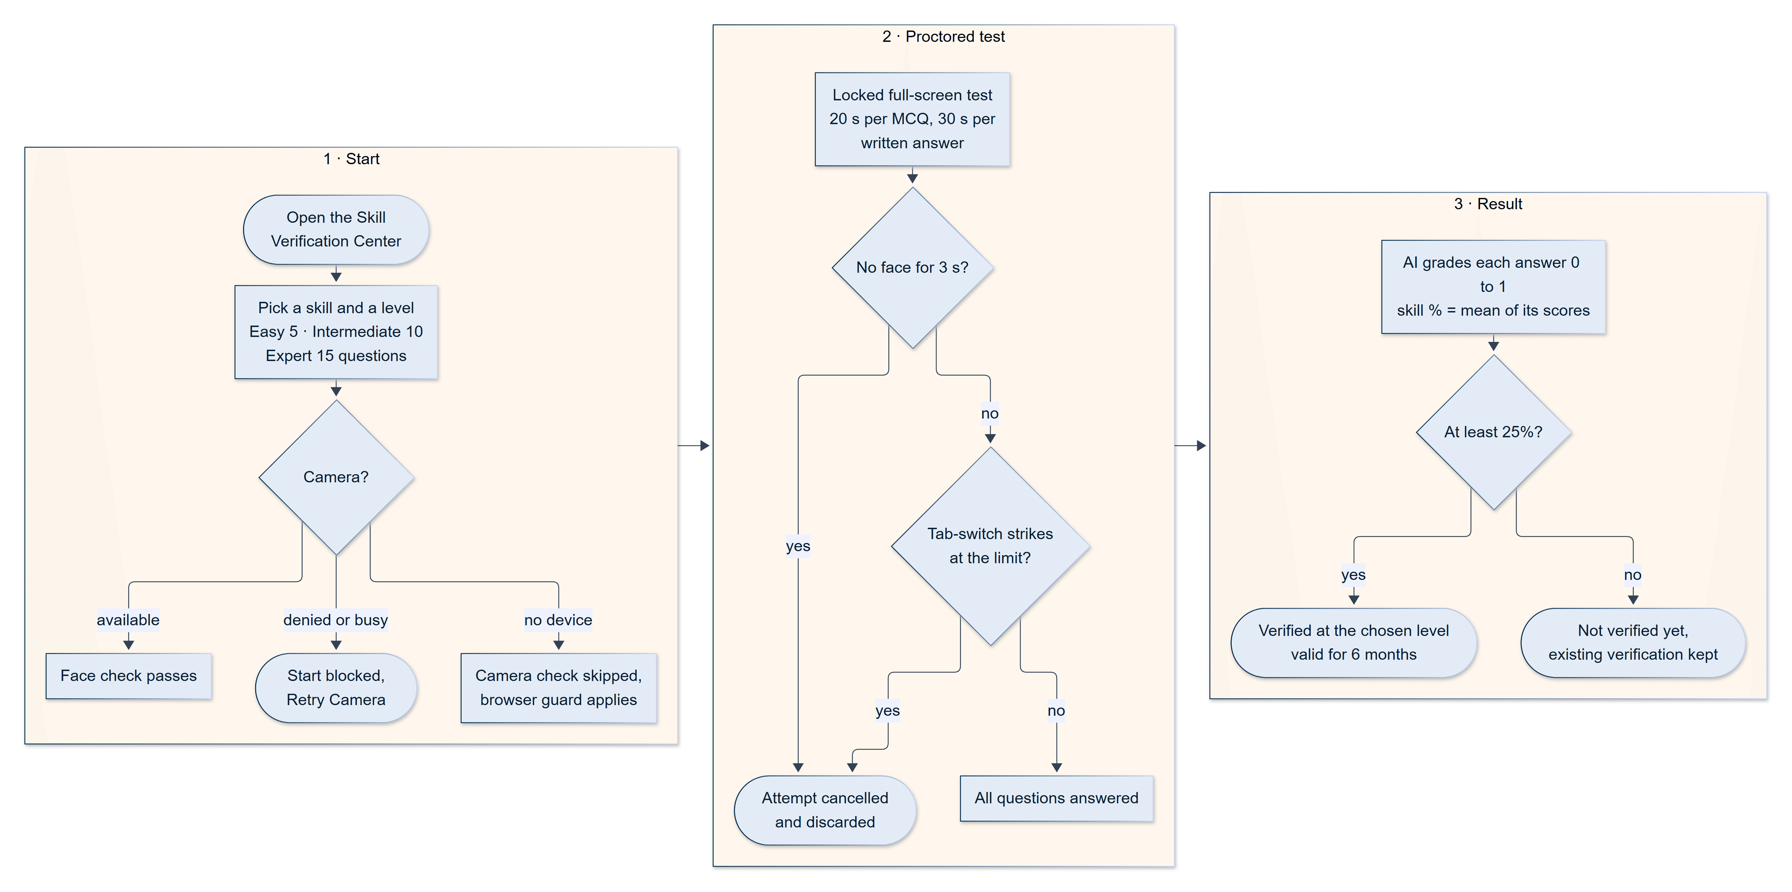
Figure 12.2 — Skill-test flow: level choice, proctored test, grading and verification
The camera and browser guards can cancel an attempt at any point; a cancelled attempt is discarded and never affects an existing verification (Section 12.4).

12.5 Skill Gating and the Apply Gate
Verified skills carry weight because they control what a freelancer may do. A freelancer may apply for a job, resubmit a rejected proposal, or create or edit a gig only if they hold at least one non-expired verified skill that covers a skill (or the category) the work requires. When a job also states a required experience level — entry, intermediate, or expert — only verified skills whose rank is at least that level count: a skill verified at Beginner cannot unlock an Expert job. Whether one skill covers another is decided by the skill graph (Section 12.6), so a verified "React" can satisfy a requirement for "Frontend Development".
The check is enforced by the server. To spare the freelancer the frustration of writing a proposal that will be refused, the job-details page calls a read-only eligibility endpoint before opening the proposal form. If the freelancer is not eligible, a dialog explains why and offers to take the relevant skill test, returning them to the same job afterwards with the proposal form open. If that eligibility request itself fails, the form opens anyway and the server remains the final authority.
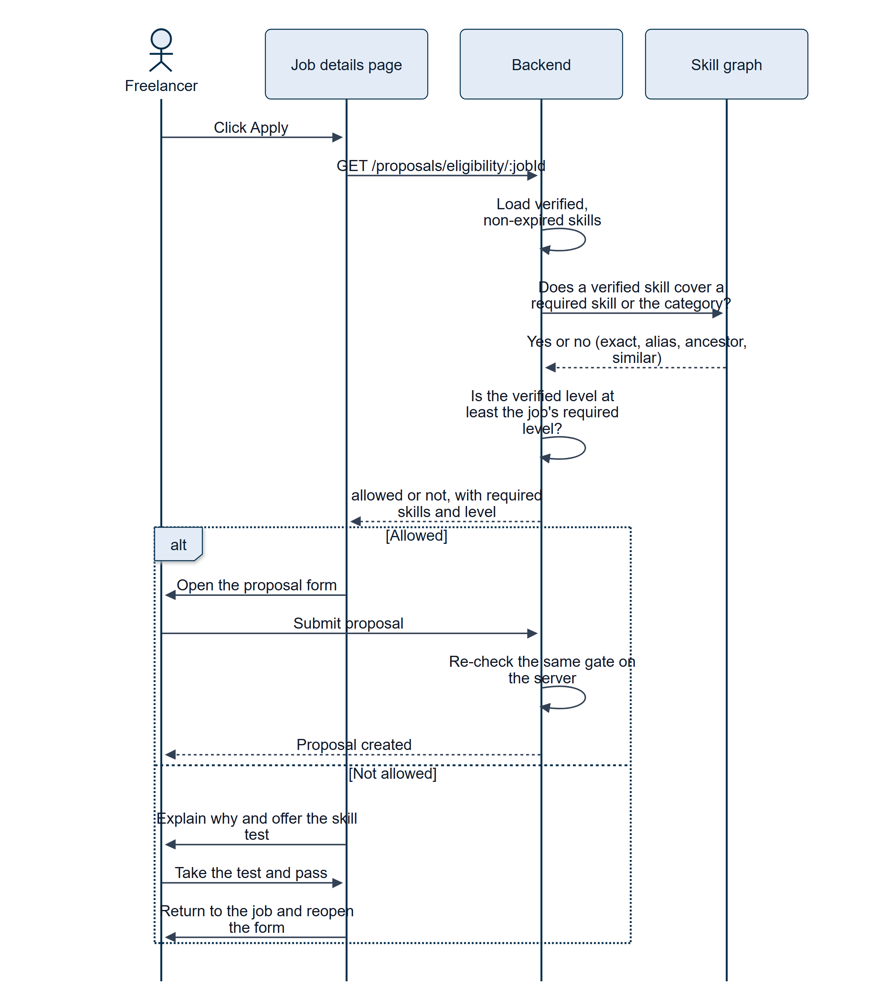
Figure 12.3 — The apply gate: eligibility is checked before the proposal form opens
The server re-checks eligibility when the proposal is submitted, so the pre-check is a convenience and not the security boundary (Section 12.5).

12.6 Skill Taxonomy and Discovery
Behind categories, search, and gating sits a skill graph. SkillNode documents are typed vertices — industry, category, profession, skill, technology, tool, or concept — each with aliases, synonyms, a relevance weight, and an active, deprecated, or merged status. SkillRelationship documents are typed edges (fifteen types, including belongs to, related to, prerequisite, specialises in, and similar to), which lets the graph express relationships that a flat category tree cannot. The initial graph, of roughly 180 nodes, is created by a seed script, and 68 job categories in ten groups are defined as constants.
The graph is used in four ways:
- Resolution maps what a user types ("reactjs", "ML") onto a canonical node through its aliases and synonyms.
- Search expansion widens a search for a skill to include its ancestors, descendants, and related skills, so that a search for "Frontend" finds freelancers who list "React".
- Matching. A match score compares the skills a job requires against those a freelancer holds: an exact match scores 1.0, a more specific skill the candidate holds 0.85, a more general one 0.70, and a directly related skill 0.55 weighted by the edge's strength.
- Navigation. The site's category menu and the category and skill pages are built from the graph.
The graph grows under supervision. When a freelancer, gig, or job introduces a skill the graph does not recognise, the system asks an AI provider to suggest where the skill belongs and records the suggestion as a TaxonomyProposal with the AI's reasoning. A proposal changes nothing until an administrator reviews it in the taxonomy admin page (/admin/taxonomy), where nodes and relationships can also be created, edited, and merged. That page authenticates with the ordinary marketplace token and is limited to the admin and superadmin roles; it is one of two older administrative surfaces that sit outside the isolated admin panel (Section 14.6).
Freelancers can be discovered through a public search (/browse-freelancers) that filters by text, skills, hourly rate, availability, verified status, minimum rating, and location, and orders results by verification and test score by default.

12.7 Jobs
A job is a client's requirement, and the starting point of the proposal-based route. Jobs are created from the client's My Projects area through a five-step wizard: basic information (title, category, subcategory, required skills, experience level), budget and timeline (fixed price or hourly, a minimum and maximum budget in rupees, a duration, and a proposed deadline), description, media (up to five images and five documents, uploaded to cloud storage), and a final review. A client can save a draft at any time or publish; publishing requires a future deadline. The category must be one of 68 fixed categories arranged in ten groups (for example Software & Technology, Design, Writing & Content, Marketing), and the subcategory is free text.
The wizard includes AI helpers: a "suggest category" and a "suggest subcategory" button that return up to three suggestions, a Generate with AI button on the free-text fields that drafts or expands a description, and a link to the AI cost estimator. If the category-suggestion service is unavailable, a keyword fallback answers instead, so the form never dead-ends. A brief started on the public Post a Project page — which offers a "suggest category and skills" helper — is carried into this wizard once the visitor signs in.
No wallet check at posting. A client may publish a job with any wallet balance, including zero. The job is then visible to freelancers and can collect proposals; the balance is checked, and funds locked, only when the client accepts a proposal (Section 12.10).
Job lifecycle. A job moves through the statuses draft, open, in-progress, completed, cancelled, expired, and closed, and a gig order adds a further status, pending_payment (Section 12.9). A draft becomes open when published; accepting a proposal moves it to in-progress; the final release of escrow, the end of an hourly contract, or an administrator's force-completion moves it to completed. An open job whose deadline passes becomes expired the next time it is read, and a client can close an open job, which rejects its pending proposals with the note "Job closed". A job that is in progress cannot be closed or deleted by the client: it must run through the delivery, payment, or dispute lifecycle.
Browsing and search. The public browse page (/browse-projects) lists open jobs ten at a time and filters them by category, budget type, and experience level; a text search matches the title and description and also expands the query through the skill graph (Section 12.6). The job detail page (/jobs/:id) shows the brief, the client's profile summary and statistics, the number of proposals, and the actions the visitor may take — apply, edit a proposal, or resubmit a rejected one. Freelancers can save jobs to revisit later (/freelancer/saved), and clients can likewise save freelancers (/client/saved).

12.8 Gigs
A gig is a freelancer's packaged service, and the starting point of the Fiverr-style route. A gig has a title, short and full descriptions, a category and subcategory, skill tags, a banner and up to five images, a list of frequently asked questions, and up to three pricing tiers — Basic, Standard, and Premium. Only the Basic tier is mandatory; each tier carries a title, a description, a price, a delivery time, a number of revisions, and a feature list. Gigs are created in a five-step wizard (basic information, pricing, description, media, publish) and can be saved as drafts, published, or paused and re-activated later. Each gig keeps its own statistics: views, orders, rating, and review count.
Publishing and editing a gig is skill-gated (Section 12.5): a freelancer can offer a gig only in an area in which they hold a verified skill, and the skill chips offered in the wizard are restricted to the freelancer's verified skills. A gig cannot be deleted while any order for it is in progress; deleting a gig cancels its unpaid orders.
Gigs are discovered on the public browse page (/browse-gigs), which offers search, category, price, and rating filters and several sort orders, and on the gig detail page (/gigs/:id), which shows the tiers side by side, the frequently asked questions, the freelancer's profile, and the ordering controls.

12.9 Gig Orders and Custom Offers
Ordering a gig. A client orders a gig by choosing a tier and filling in a requirements form. The requirements are mandatory: a description of at least 30 characters, and up to five reference links. Ordering does not create a separate order record; it creates a Job with source: 'gig', linked to the gig and tier and assigned to the gig's owner. The order starts in the status pending_payment: it is hidden from the freelancer, and the freelancer is not notified, until the first deposit has been paid.
Gig orders use a deposit-then-release payment in two equal halves, 50% at the start and 50% on delivery. For each half, the client's wallet is used first if it covers the amount; otherwise the client is sent to a Stripe Checkout page. When the deposit is confirmed — whichever route it arrives by — a single activation function moves the order to in-progress, increments the gig's order count, and notifies the freelancer; because every confirmation path calls that one function, an order can never be activated twice or counted twice. While an order is unpaid, the client can pay it or cancel it from My Projects, and an unpaid order that is left for seven days is cancelled automatically by a scheduled job.
The freelancer delivers through a message and up to ten links. The client can request a revision (there is no limit on the number of revisions) or pay the second half, at which point the platform fee is deducted, the freelancer's wallet is credited, and the order is completed. A gig order has no Contract, so — unlike a proposal-based engagement — it has no milestone, no dispute path, and no automatic release; this simplicity is the trade-off for a one-step purchase.
Custom offers. A freelancer can turn a conversation into a priced order by sending a custom offer from inside the chat. An offer has a title, a description, a price, a delivery time in days, and a number of revisions, and it can be tied to one of the freelancer's gigs. To limit abuse, an offer must be addressed to a client in an existing conversation; its price must lie between Rs. 5 and Rs. 10,000,000, its delivery time between 1 and 365 days; its text must not contain an email address or phone number; it expires after seven days; and a freelancer may have at most five open offers in one conversation. The offer appears in the chat as a card, and the client can accept, decline, or let it lapse; the freelancer can withdraw it while it is pending. Accepting an offer is a single atomic action that creates the same pending_payment gig order described above, after which payment, delivery, and completion proceed identically.
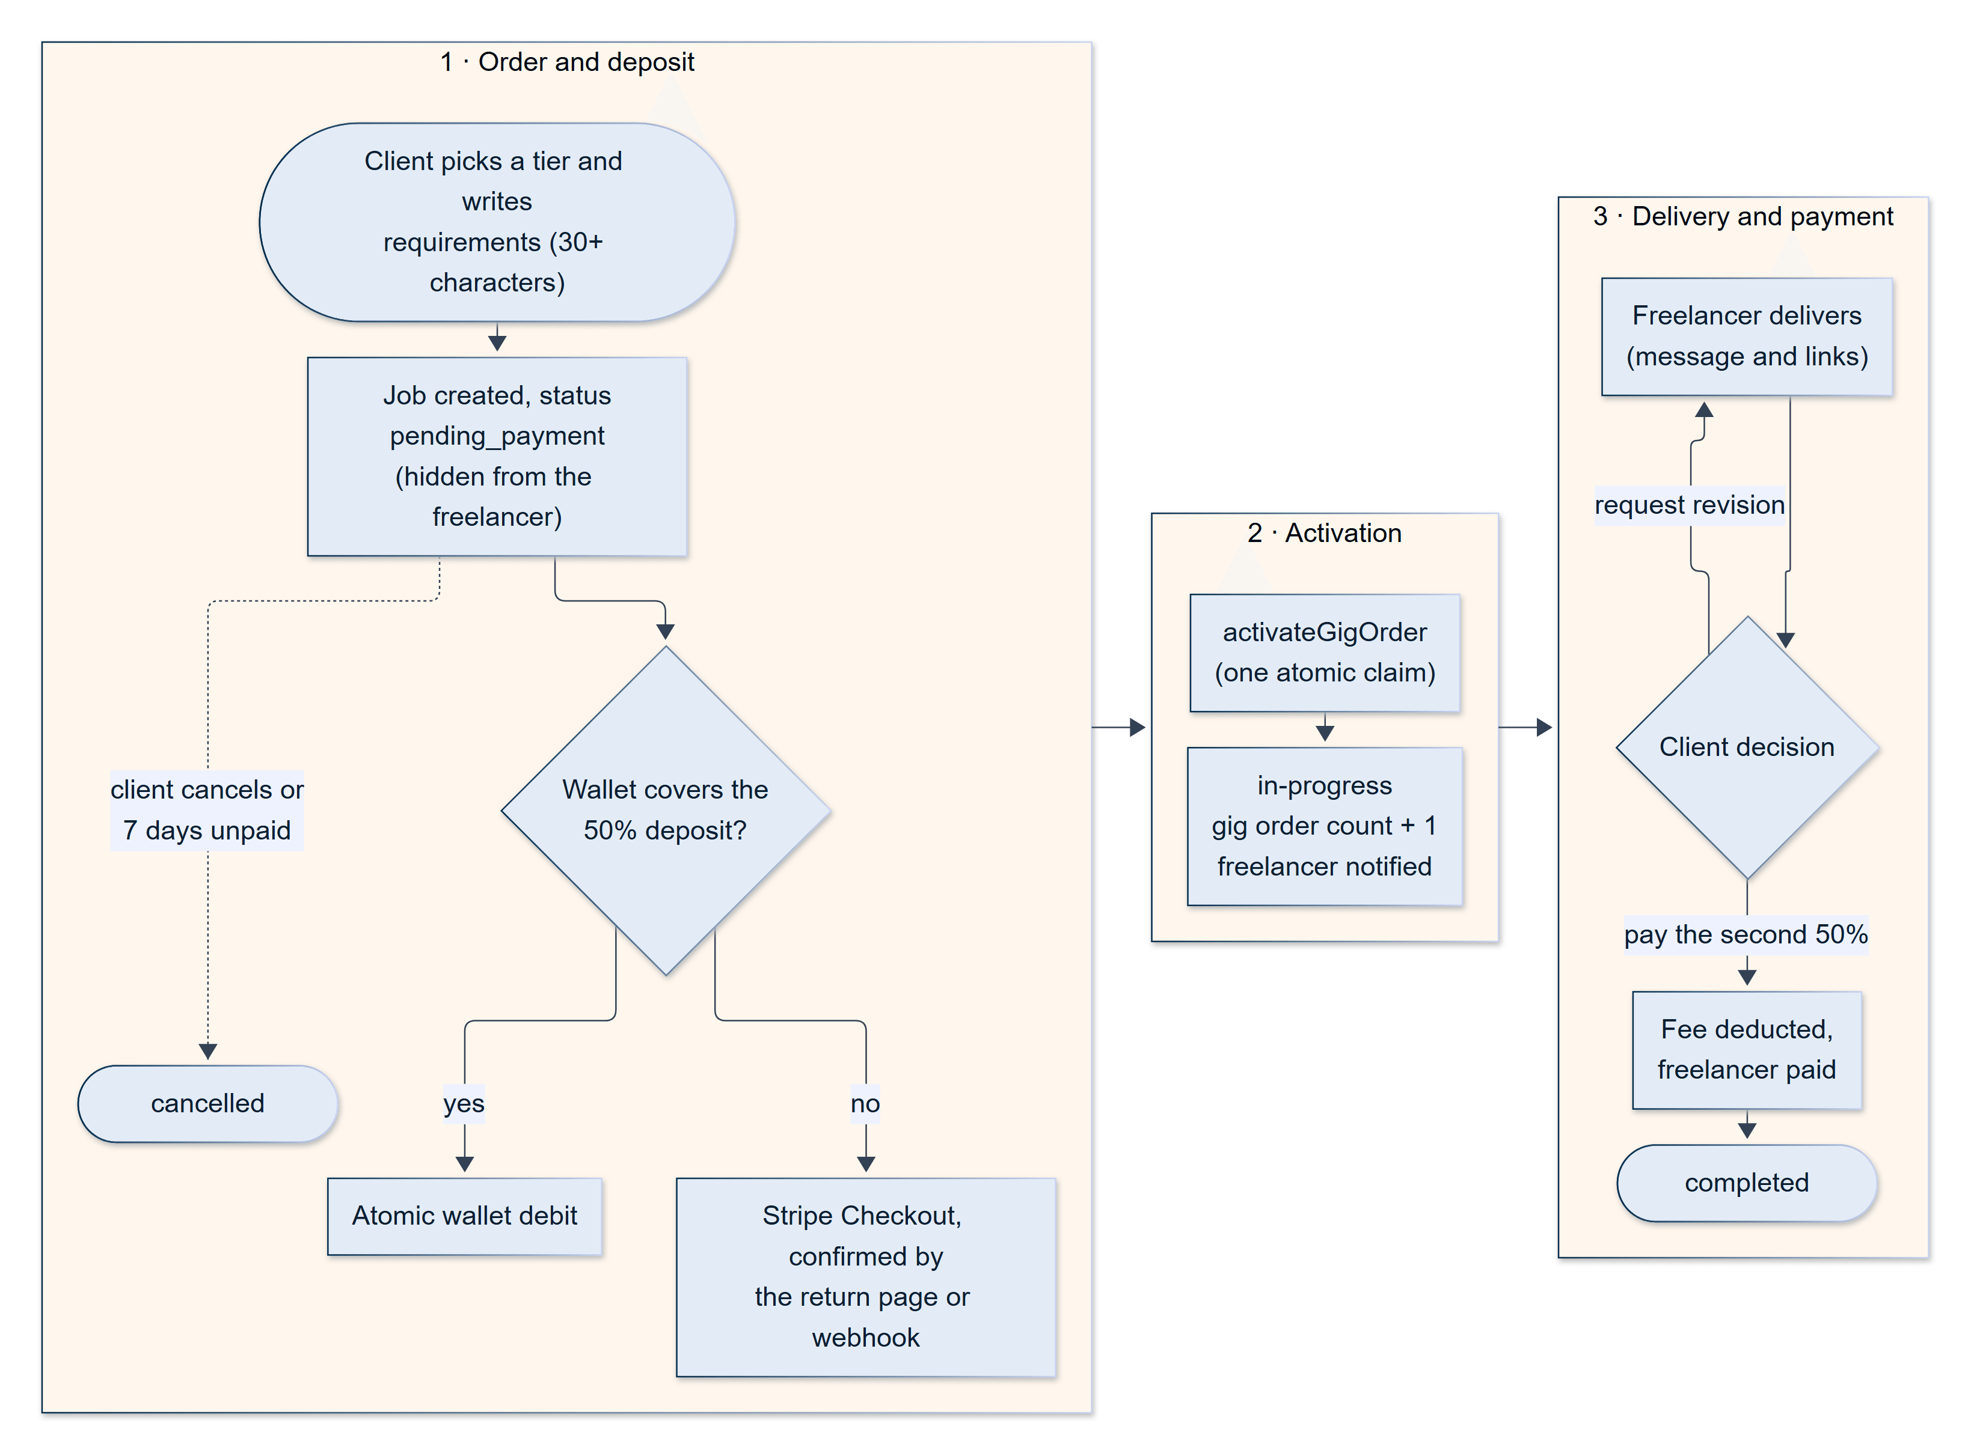
Figure 12.4 — Life cycle of a gig order, from requirements to completion
A gig order starts as pending_payment and becomes in-progress only when a deposit lands, through a single activation function (Section 12.9).

12.10 Proposals
A freelancer applies for an open job by submitting a proposal: a cover letter of 100 to 2,000 characters, a price, and an estimate of delivery. For a fixed-price job the proposal states a fixed price and a delivery estimate; for an hourly job it states an hourly rate and the number of hours the freelancer expects to work each week. A freelancer may submit one proposal per job, and cannot bid on a job that already has a contract. The cover letter can be drafted by the AI from the job and the freelancer's own profile (Section 13.1) and is then edited freely.
Before the proposal form opens, the apply gate checks that the freelancer is eligible (Section 12.5). A pending proposal can be edited or withdrawn while the job is open.
Reviewing proposals. The client reviews proposals on a dedicated page (/client/projects/:jobId/proposals), where each proposal can be inspected, discussed in chat, accepted, or rejected. A rejection carries a reason and an "allow resubmission" option. If resubmission is allowed, the freelancer can revise the same proposal and send it back into pending; this second submission is subject to the same skill gate as the first, so a verification that has lapsed cannot be sidestepped by resubmitting instead of applying afresh.
Accepting a proposal is the most consequential action on the platform, because it is the moment at which money is committed. It follows a strict order, designed to be safe without database transactions:
- The server checks that the job is still open and has no contract, and that the price the client saw is still the live price.
- For a fixed-price job, the client may split the price into any number of sequential milestones; each amount must be positive and the amounts must add up exactly to the agreed price. If no split is given, a single implicit milestone, "Full Project", carries the whole price. The server checks that the client's wallet covers the first milestone. For an hourly job, the server computes one week's estimated cost (hourly rate multiplied by estimated weekly hours) and checks that the wallet covers it. If the wallet is short, nothing is written and the interface offers a top-up.
- Only after the check does the server write: it atomically claims the job (moving it to in-progress), marks the proposal accepted, creates the contract and the milestones, auto-rejects every other pending proposal with the note "Position filled", and finally debits the wallet and locks the funds (Sections 12.12 and 12.13).
- If locking the funds fails — for example, because a concurrent action drained the wallet — every earlier write is reversed and the error is returned, leaving the job open as it was.
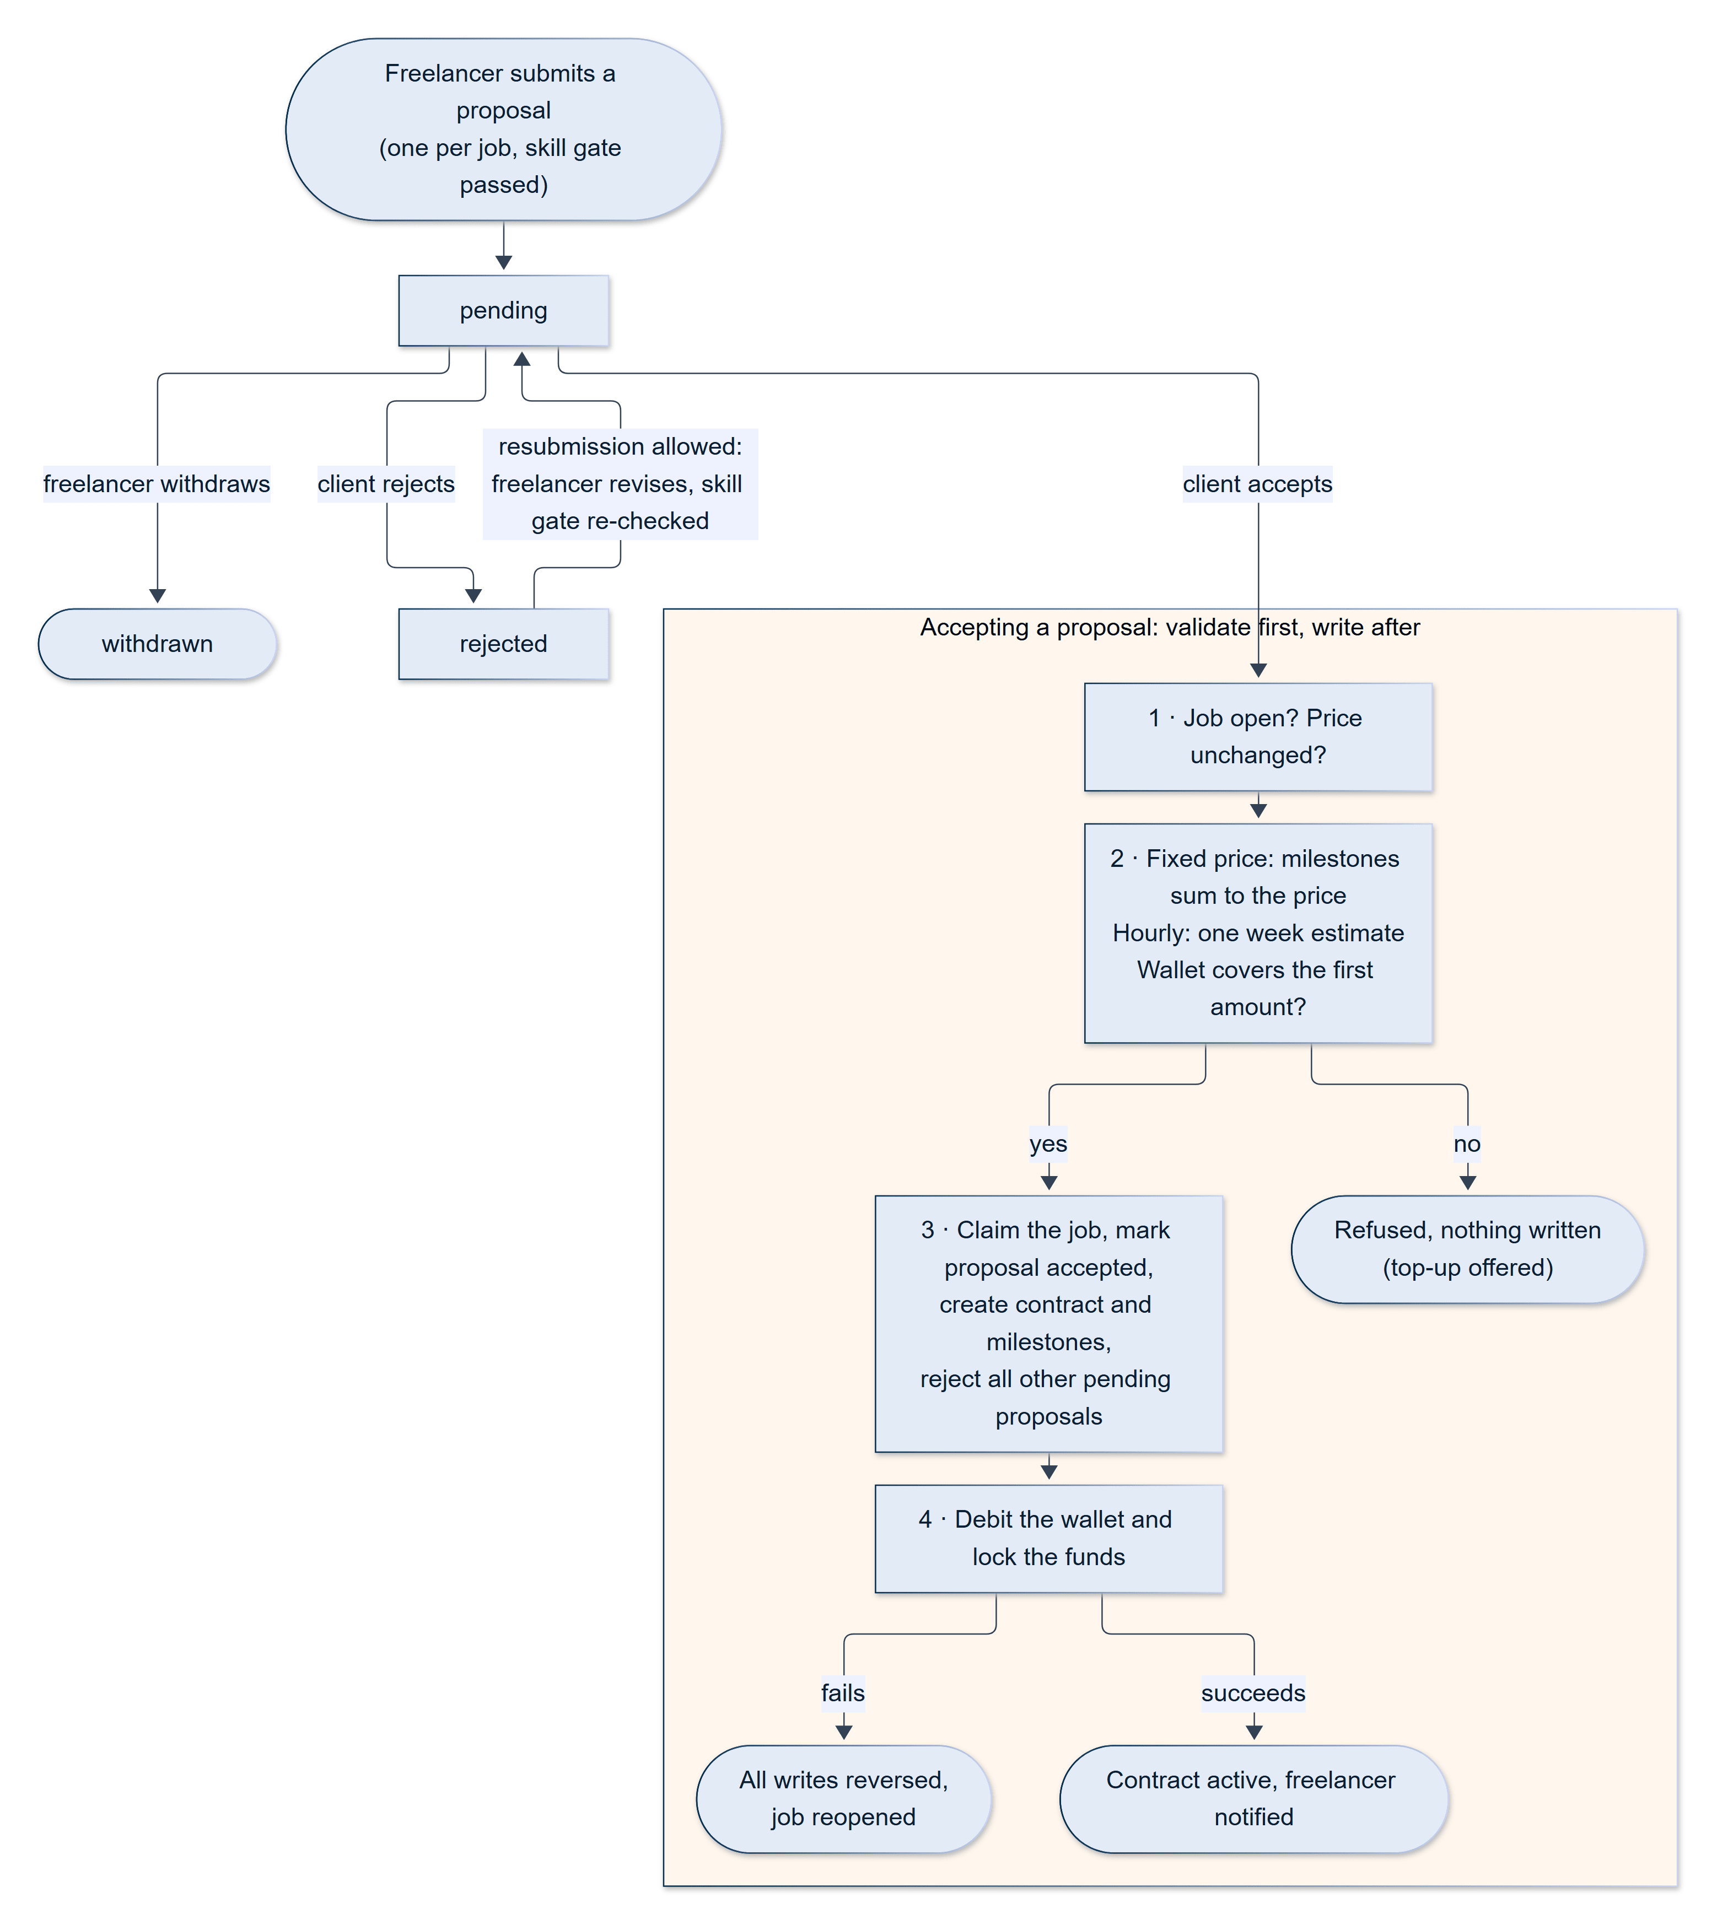
Figure 12.5 — Life cycle of a proposal and the effect of accepting it
Acceptance validates before it writes and reverses its writes if funding fails (Section 12.10).

12.11 Contracts and Lifecycle
When a proposal is accepted, a contract links the job, the proposal, the client, and the freelancer, and drives everything that follows. The contract's type — fixed or hourly — decides which payment model applies. Its status is a state machine: it starts as active; when the freelancer submits work it becomes delivered; if the client asks for changes it becomes in_revision and returns to delivered on resubmission; approval returns it to active (to start the next milestone) or finishes it as completed. A dispute or cancellation request moves it to under_review, and an administrator can pause, resume, or cancel it. Every significant event is appended to the contract history, which records what changed, who changed it, and — for administrators — their email address.
Only hourly contracts can be ended by agreement. Either party may submit an end request with a reason (work completed, mutual agreement, client no longer requires work, freelancer unavailable, communication issues, or other), and the other party approves or rejects it. A fixed-price contract has no such flow: it ends when its last milestone is approved, when a dispute is resolved, or by administrator action.
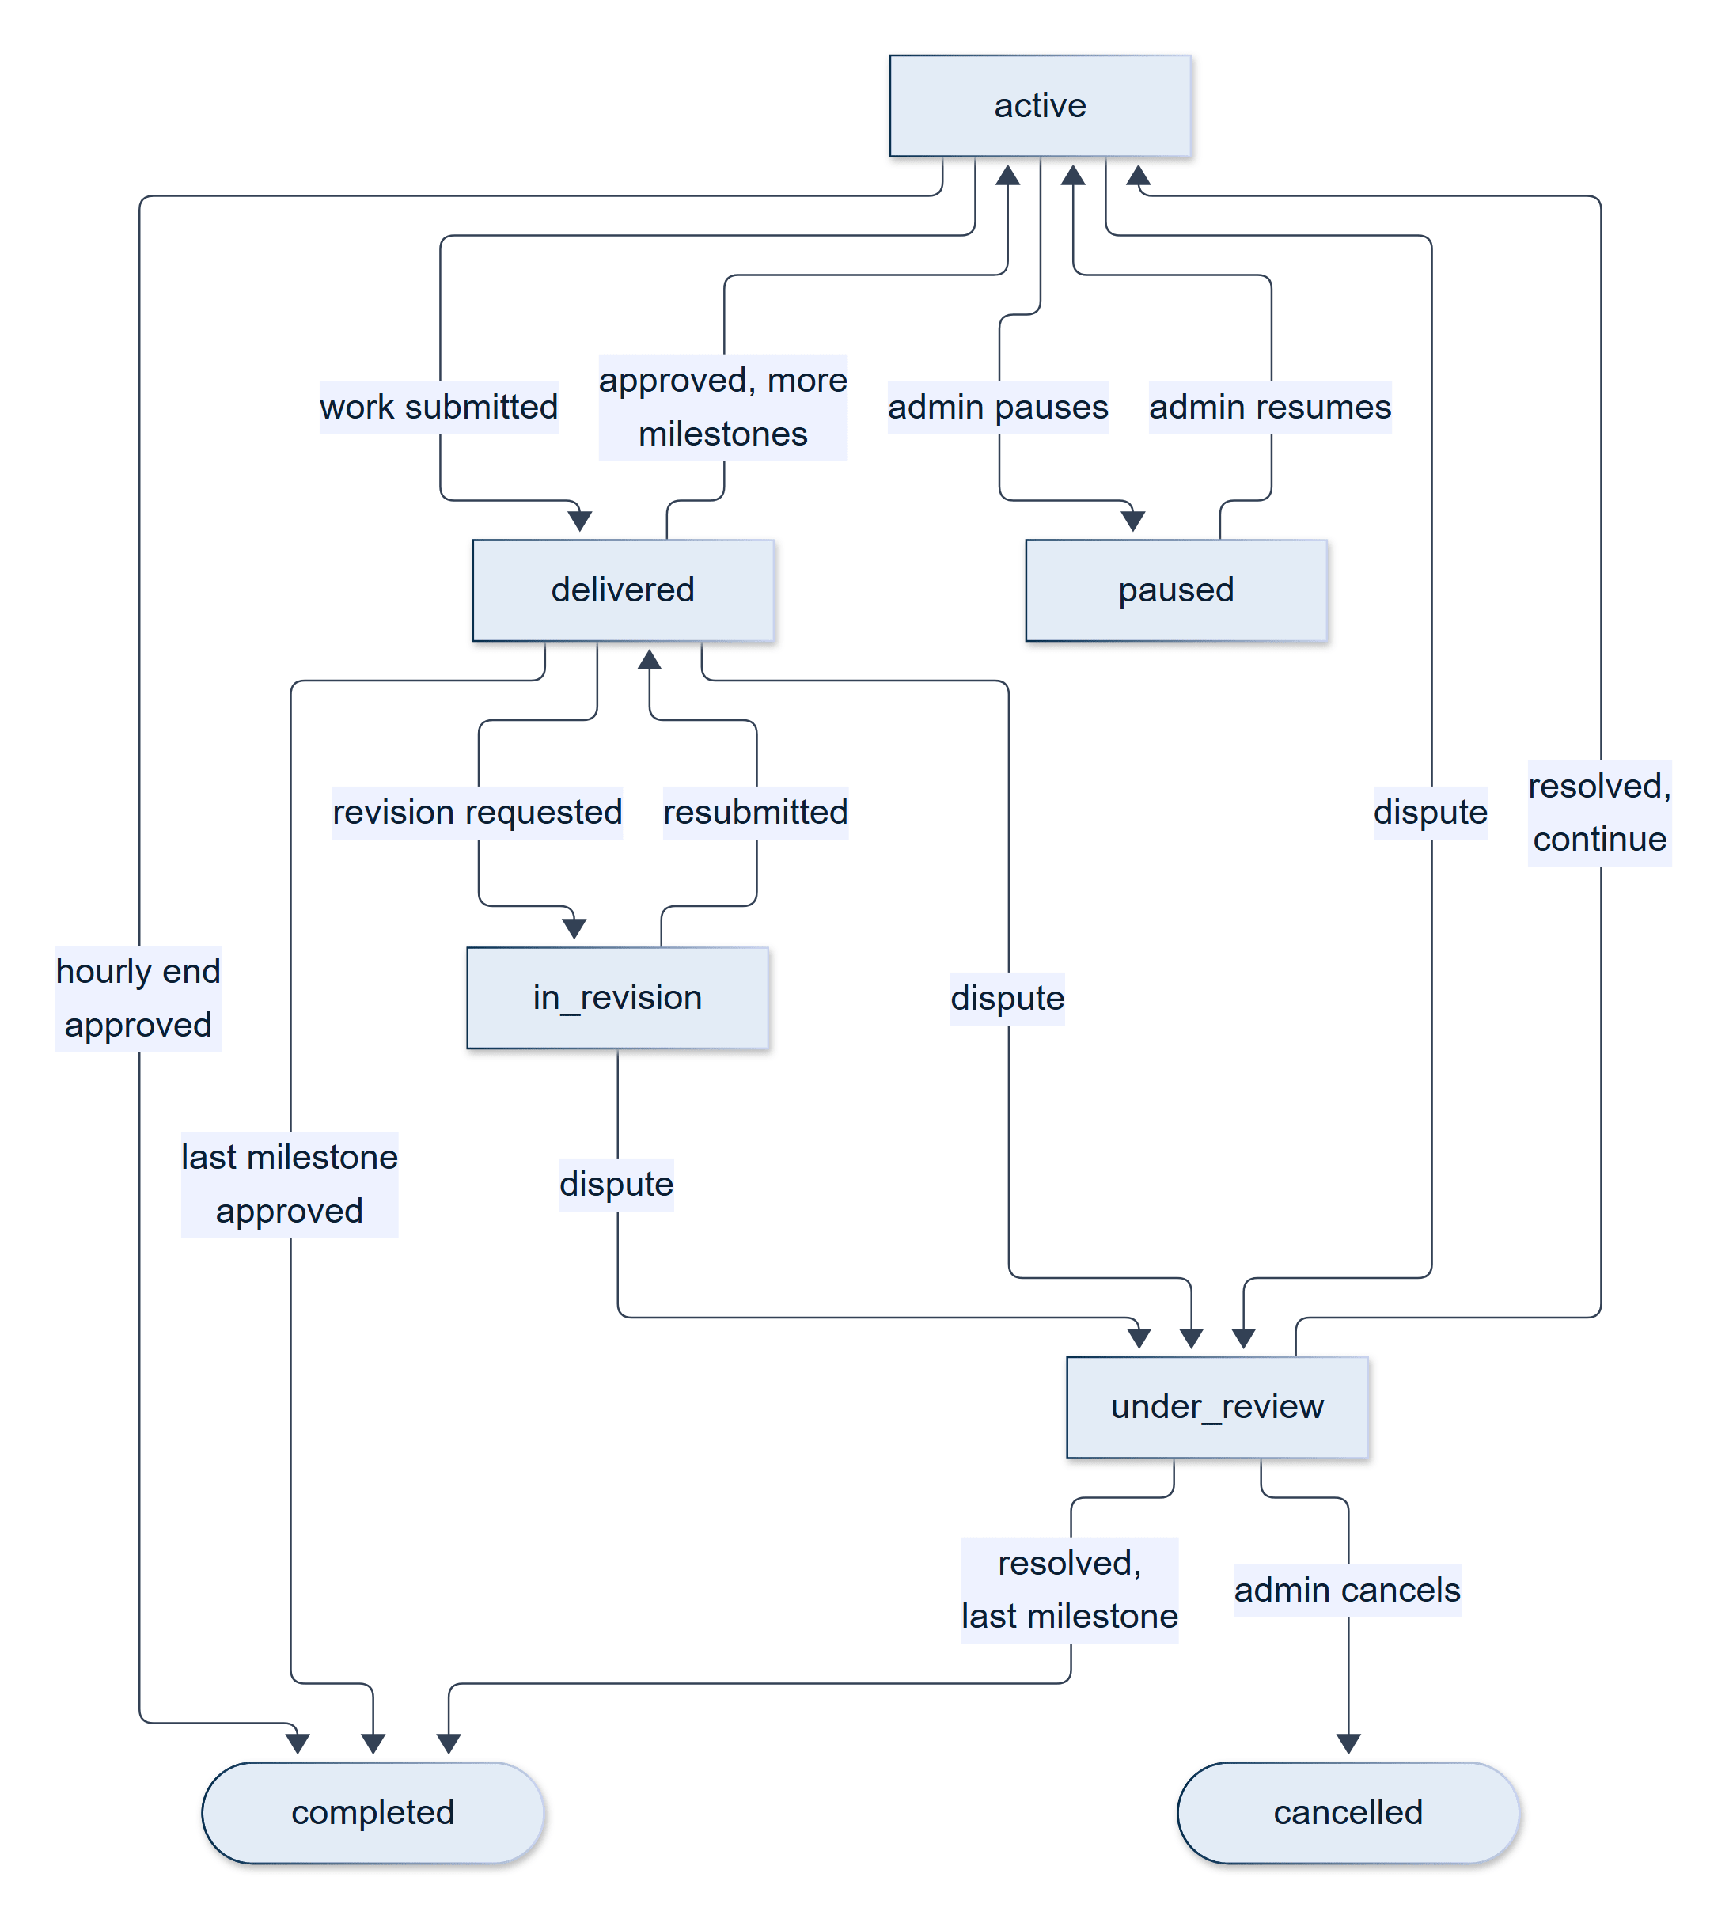
Figure 12.6a — Contract state machine
A contract and its current milestone move together; disputes attach to the milestone for fixed-price work and to the contract for hourly work (Sections 12.11 and 12.17).
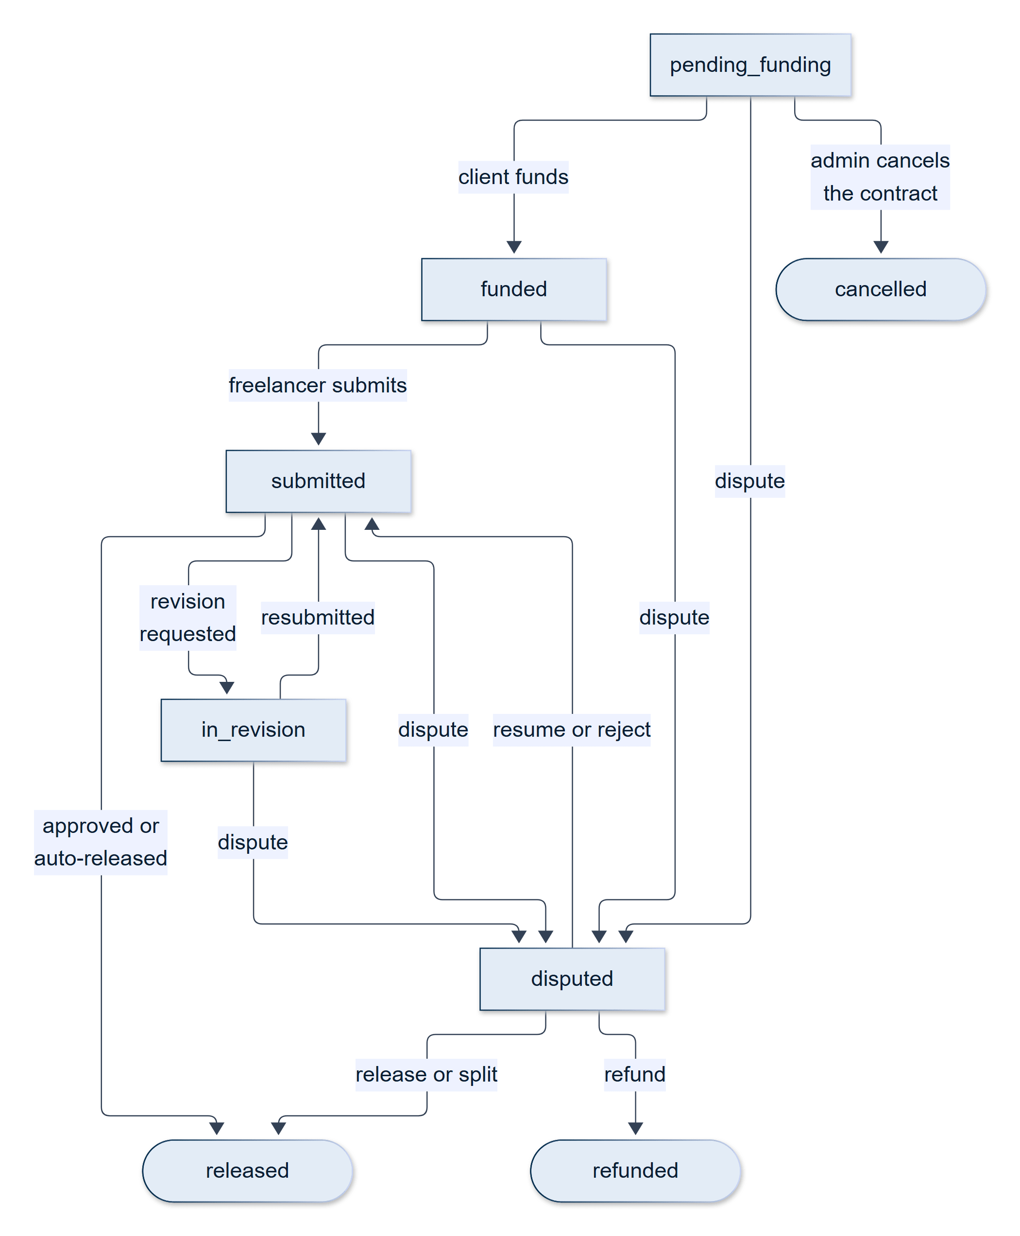
Figure 12.6b — Milestone state machine (fixed-price contracts)

12.12 Fixed-Price Milestone Escrow
Fixed-price work is protected by a wallet-native, milestone-based escrow. The money for a phase is debited from the client's wallet and held by the platform until the client approves the work or the review window lapses; the freelancer can see that the money is there before starting.
Funding. The first milestone is funded as part of accepting the proposal. Each later milestone is funded only when the client is ready for that phase, by an explicit request that is accepted only if the previous milestone has been released and no milestone of the contract is under dispute. Capital is therefore never locked for work that has not begun. Funding performs an atomic, conditional debit of the client's wallet (the debit succeeds only if the balance covers the amount), creates a Payment row for the milestone, marks the milestone funded, and notifies the freelancer.
The submit gate. A freelancer may submit a delivery only when the current milestone is funded or in_revision. This turns the promise "escrow is funded, so it is safe to work" into a rule enforced by the server, not a claim made by the interface.
Review and release. A submission starts a review window (by default seven days, set by the administrator). The client then approves the work, which releases the milestone, or asks for a revision. On release the platform fee is deducted from the milestone amount — 0.5% by default, an administrator-set value that is captured on each payment when it is funded, so that changing the rate affects only future payments — and the remainder is credited to the freelancer's wallet. If that was the last milestone, the contract and the job are completed; otherwise the contract advances to the next milestone, which the client then funds.
Auto-release. To stop a client from going silent after receiving work, a scheduled job runs every hour, finds submitted milestones whose review deadline has passed, and releases them through the same approval function a client's click uses, notifying both parties. A milestone that is under dispute can never be auto-released.
One path for money. All movement of milestone money goes through a single service (milestone.service): the manual approval and the automatic release both call the same function, so the rules can never diverge. Every debit and credit is an atomic, conditional database update, and a double release is prevented because the release first claims the payment row (moving it from deposit_paid to released) and only the caller that wins the claim credits the wallet.
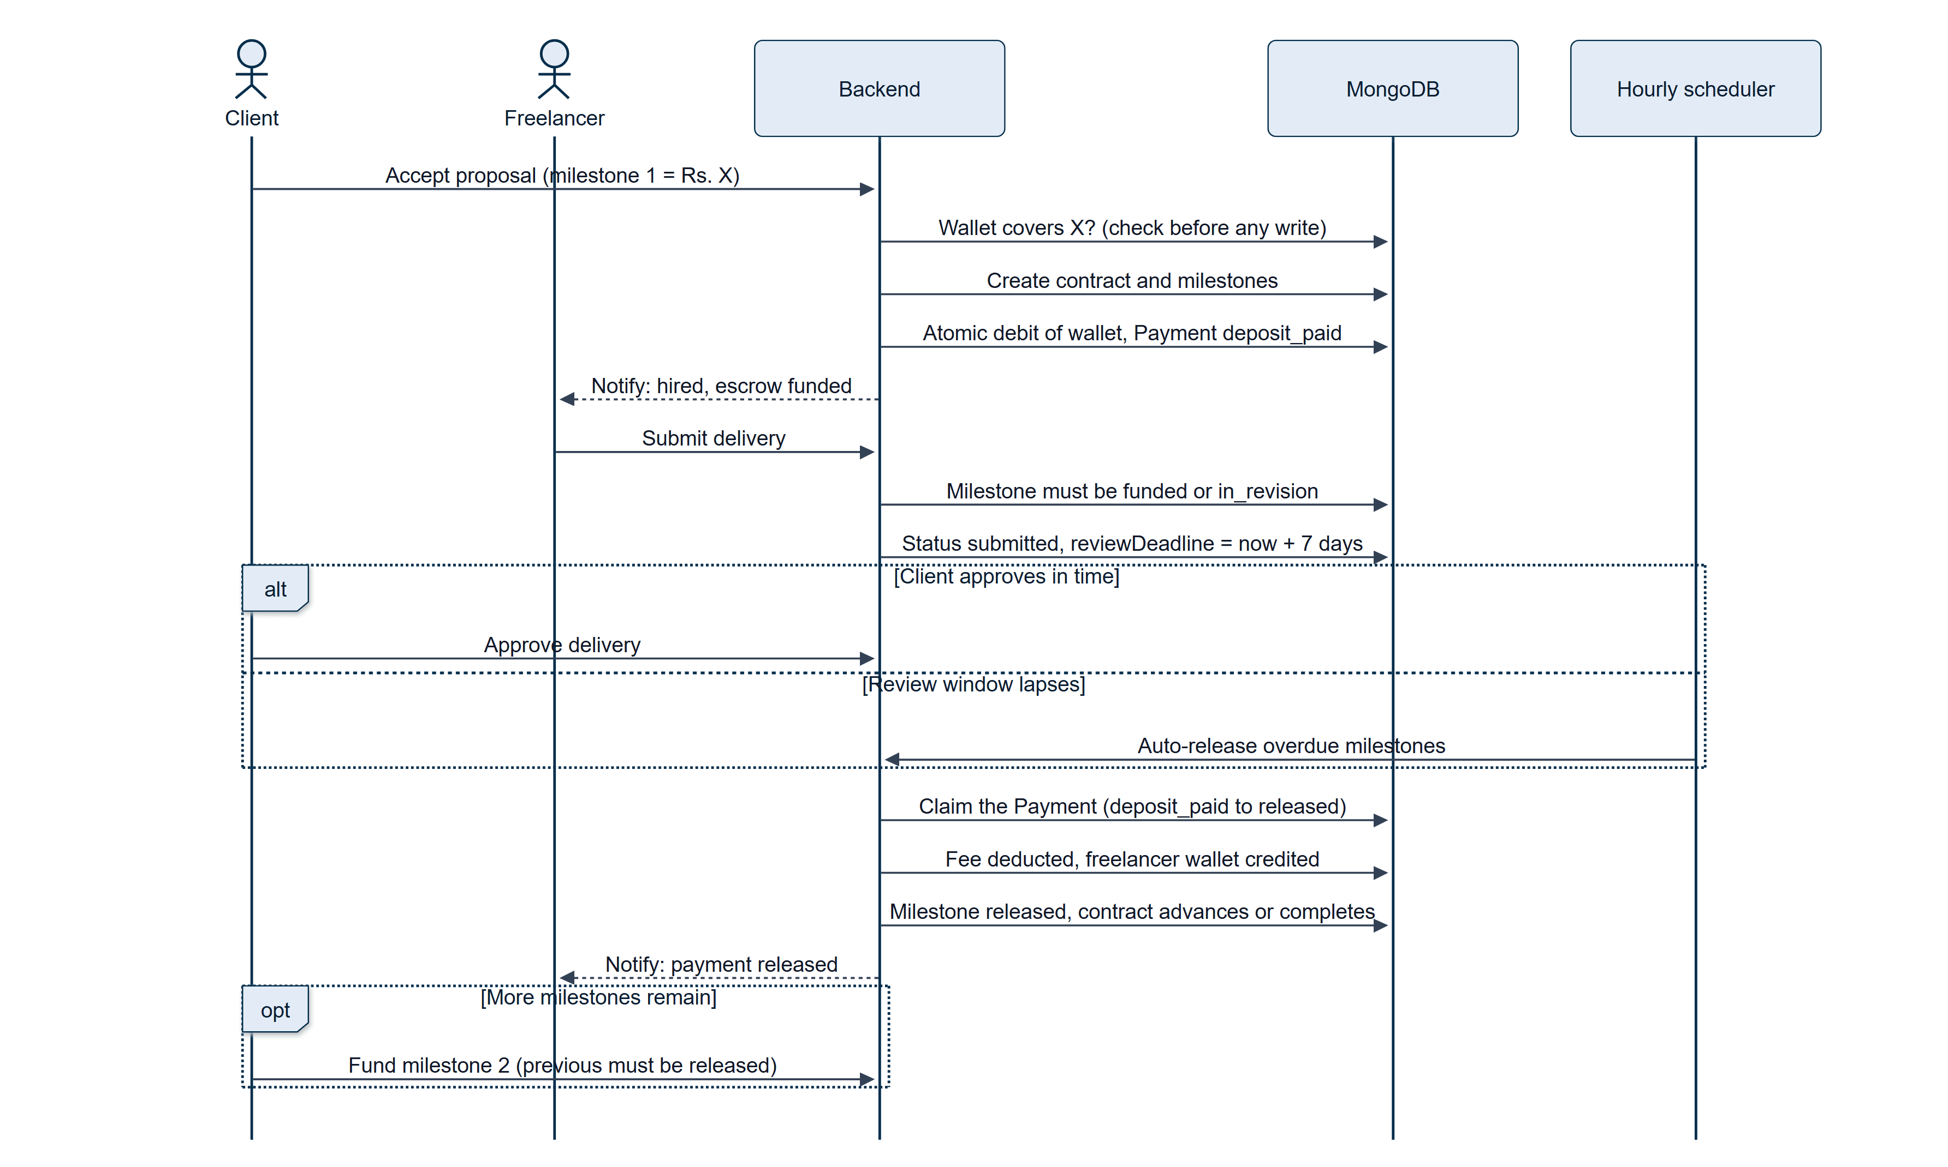
Figure 12.7 — Fixed-price milestone funding, delivery and release
Funding, submission and release are separate steps, each guarded by a state check (Section 12.12).

12.13 Hourly Wallet-Lock Escrow
An hourly contract has no fixed price to lock, so it uses a balance-lock model. At hire, one week's estimated cost (hourly rate multiplied by the estimated weekly hours) is debited from the client's wallet and held in the contract's locked balance; if the wallet cannot cover it, the hire is refused up front.
Time tracking. The freelancer logs time either with a timer (start and stop) or with a manual entry (start time, end time, notes). A timer session shorter than 60 seconds is discarded as too short, and manual entries may not overlap an existing entry. Before any time is logged, the server checks that the unbilled work does not exceed the locked balance; if it would, logging is blocked with a message asking the client to top up.
Automatic billing. Billing is automatic and incremental, not approved hour by hour. As soon as a log is created, its amount (the logged hours multiplied by the contract's hourly rate) is drawn down from the locked balance and credited to the freelancer's wallet, net of the platform fee, and the log is marked billed. If the lock cannot cover a log — for instance, because the freelancer's last timer session ran past it — the log stays pending and the freelancer is told that a top-up is needed.
Top-up. The client re-locks more funds (by default one more weekly amount), and the system immediately retries every pending log, oldest first, until the lock is exhausted. A scheduled job on Sunday evening performs the same retry for every active hourly contract, as a safety net.
Ending the contract. When an end request is approved, any remaining pending logs are settled first and whatever is left in the lock is refunded to the client's wallet; a lock is a hold, not a spend. Ending is refused while unbilled time exceeds the lock, so the client must top up before an engagement can close with money owed.
Table 12.3 — Fixed-price and hourly escrow compared
Aspect | Fixed-price (milestones) | Hourly (wallet lock)
Locked at hire | The first milestone's amount | One week's estimate (rate × weekly hours)
Further funding | Client funds each next milestone | Client tops up the lock
Release trigger | Client approval, or auto-release after the review window | Each logged hour, automatically
Unused funds | None: each milestone is released or refunded | Remaining lock refunded when the contract ends
Dispute scope | The specific milestone | The whole contract
Payment records | One job_escrow row per milestone | One hourly_escrow lock row and one hourly_invoice row per billed log

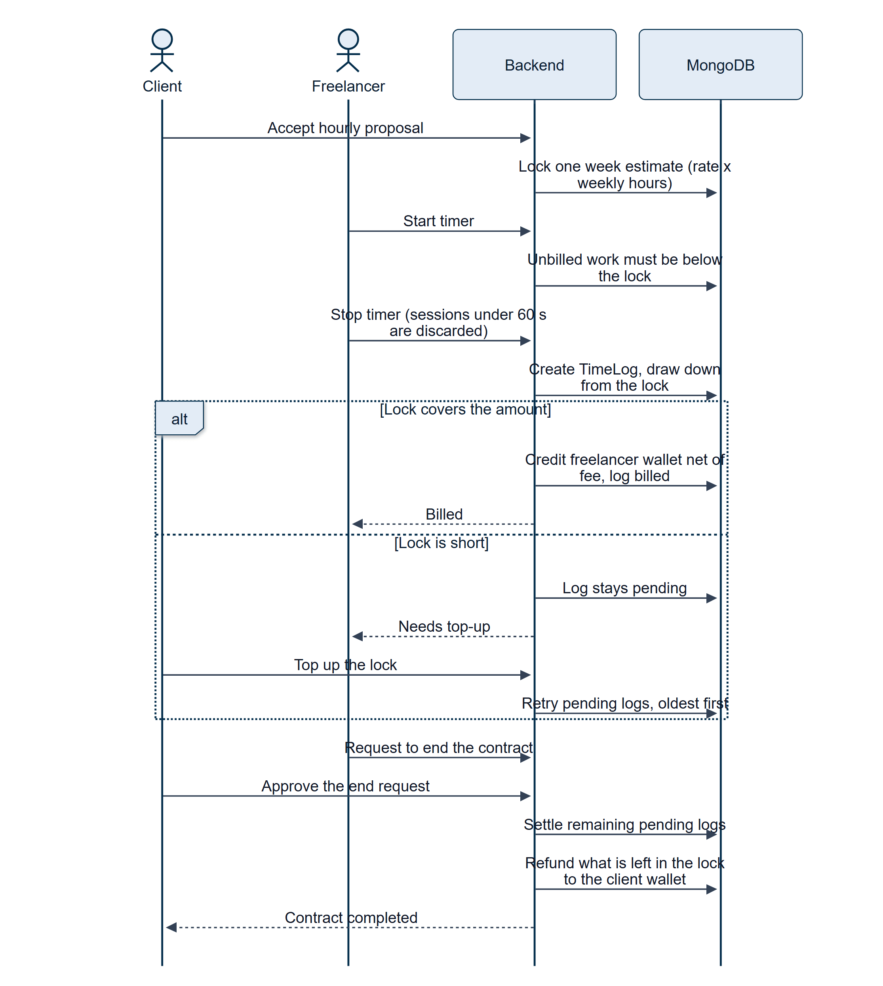
Figure 12.8 — Hourly escrow: lock, draw-down, top-up and refund
Logged time is billed immediately against the lock; whatever remains is refunded when the contract ends (Section 12.13).

12.14 Deliveries and Revisions
A freelancer submits work through the delivery mechanism: a message and any number of links, recorded as a numbered version. A delivery is accepted only while the contract is active or in_revision, so at most one delivery is awaiting review at a time. For fixed-price work, each delivery is linked to the milestone it was submitted against, and releasing money is resolved from that link rather than from a counter. The client reviews a delivery in one of two ways: accept it (which releases the milestone, or, on an hourly contract, completes the engagement) or request a revision with written feedback, which returns the milestone to in_revision and clears its review deadline until the freelancer resubmits. There is no limit on the number of revision rounds. Deliveries are exchanged as links to files hosted elsewhere rather than as uploads.

12.15 Wallet, Payments and Withdrawals
Each client and each freelancer has a wallet balance, held on their profile and changed only through atomic, guarded database updates. The platform operates in Pakistani Rupees (PKR).
Funding the wallet. Only clients add money: they choose an amount (at least Rs. 5) and complete a Stripe Checkout payment by card. The credit is idempotent — each Stripe session identifier is recorded on the profile, and the update is conditional on the identifier not having been processed — so a page refresh or a webhook arriving first cannot credit the wallet twice.
Paying out. A freelancer earns into their wallet and withdraws from it. The minimum withdrawal is administrator-configurable (Rs. 5 by default). The withdrawal interface offers a Stripe Connect payout: the freelancer connects an Express account through Stripe's hosted onboarding, and a payout request first reserves the amount by debiting the wallet atomically and only then calls Stripe, refunding the reservation if Stripe fails — an ordering that closes a double-payout race in which two simultaneous requests could both pass the balance check. The backend also supports bank_transfer and paypal withdrawals, which create a pending request for manual handling by an administrator (Section 14.3); the freelancer interface currently exposes only the Stripe route.
Payment records. Every movement of escrow leaves a Payment row of one of four types — job_escrow, hourly_escrow, hourly_invoice, and wallet_deposit — each with its total amount, platform fee, freelancer payout, currency, and one of four statuses (deposit_pending, deposit_paid, released, refunded). A fixed-price contract has several payment rows, one per milestone, so a payment is always resolved through its milestone and never through the contract alone.
Frozen wallets. An administrator can freeze a wallet (Section 14.3). A frozen wallet cannot fund a milestone, lock hourly escrow, pay a gig deposit or final payment, accept a proposal, or withdraw: the check runs before anything is written, and each debit repeats it inside its atomic update so that a freeze applied at the last instant still wins. Money coming in — an escrow release, a refund, a top-up — is still credited, so a freeze holds funds in place rather than losing them.
Simulated payments. With no Stripe key configured, or when STRIPE_DUMMY=true, every payment is simulated: checkout sessions, Connect accounts, transfers, and payouts are synthetic, and the full flow can be demonstrated without real money. Simulated session identifiers are signed by the server (they carry a random nonce and a signature over the phase, job, amount, and — for a wallet top-up — the user), so an identifier that the server did not issue is refused. As a safeguard, the server refuses to start in a production environment (NODE_ENV=production or a managed host such as Railway) if STRIPE_DUMMY is set, because a simulated payment would tell a client that money had moved when none had.
Table 12.4 — Platform settings that govern money
Setting (SystemSettings) | Default | Effect
platform_fee_rate | 0.005 (0.5%) | Fee deducted from the freelancer's payout on release; captured on each payment when funded
escrow_release_days | 7 | Review window after a milestone is submitted before auto-release
withdrawal_min_amount | Rs. 5 | Smallest allowed withdrawal

The wallets pages show these balances to the user. The client's Billing and Payments page (/client/wallet) shows the available balance, the funds currently in escrow, an Add Funds action, and a filterable transaction history; the freelancer's Earnings and Wallet page (/freelancer/wallet) shows the balance available for withdrawal, lifetime earnings, the Stripe connection status, and the withdrawal form with the live minimum.

12.16 Reviews and Ratings
Reviews are the platform's record of behaviour. Each review has a rating from 1 to 5 and an optional comment of up to 1,000 characters, and it is directional: either a client-to-freelancer review or a freelancer-to-client review.
There are two ways to write one. After a job is completed, the client and the hired freelancer can each review the other once; the type is derived from who is writing. In addition, a signed-in user can leave a review for another user directly from that user's public profile (/freelancers/:id or /clients/:id), one per direction. Reviewers can edit or delete their own reviews at any time. Each change recalculates the reviewee's rating — the average of the reviewee's visible reviews of that type — and, for reviews of a gig order, the gig's own rating and review count. Administrators can hide, restore, or permanently delete a review for policy reasons (Section 14.3); hidden reviews are excluded from every average and from public display.
A freelancer can also publish a testimonial — a short success story of 20 to 600 characters with a rating — which is shown on the home page.

12.17 Disputes
When an engagement goes wrong, either party can raise a dispute with a reason (5–500 characters) and a description. The scope of a dispute follows the money.
- For a fixed-price contract, a dispute is scoped to the specific milestone under review. The milestone moves to disputed, its review deadline is cleared so that auto-release can never touch it, and the contract moves to under_review. Disputing one phase therefore does not freeze the rest of a multi-phase project's history. A milestone can carry at most one pending dispute.
- For an hourly contract, which has no milestones, the dispute is raised on the contract as a whole; a running timer is folded into the logged time and any pending end request is rejected.
Disputes are handled by administrators in a single merged queue that shows both kinds side by side. For a dispute the administrator sees the milestone breakdown, deliveries, time logs, and the complete chat between the parties, and chooses one of six outcomes, with written notes of 10 to 2,000 characters.
Table 12.5 — Dispute resolution outcomes
Outcome | Fixed-price (per milestone) | Hourly (whole contract)
Release to freelancer | Milestone escrow paid to the freelancer, minus the platform fee | Remaining locked balance paid to the freelancer, contract completed
Refund client | Full milestone amount returned to the client's wallet | Remaining lock refunded, contract cancelled
Split | A chosen percentage (1–99%) goes to the freelancer (fee on that share only); the rest is refunded | The same split, applied to the remaining lock
Cancel contract | Only when the milestone was never funded and so holds no escrow; the contract and job are cancelled | Not available
Resume / reject | Dismiss the dispute: the milestone returns to submitted with a fresh review window | Dismiss the dispute and resume work

A financial resolution of a milestone then advances the contract to its next milestone, or completes the contract and the job if it was the last. Resolution is atomic: the resolution first claims the pending dispute in a single conditional update, so that a double submission is refused with a conflict response instead of paying twice. Every resolution is written to the audit log at critical severity.
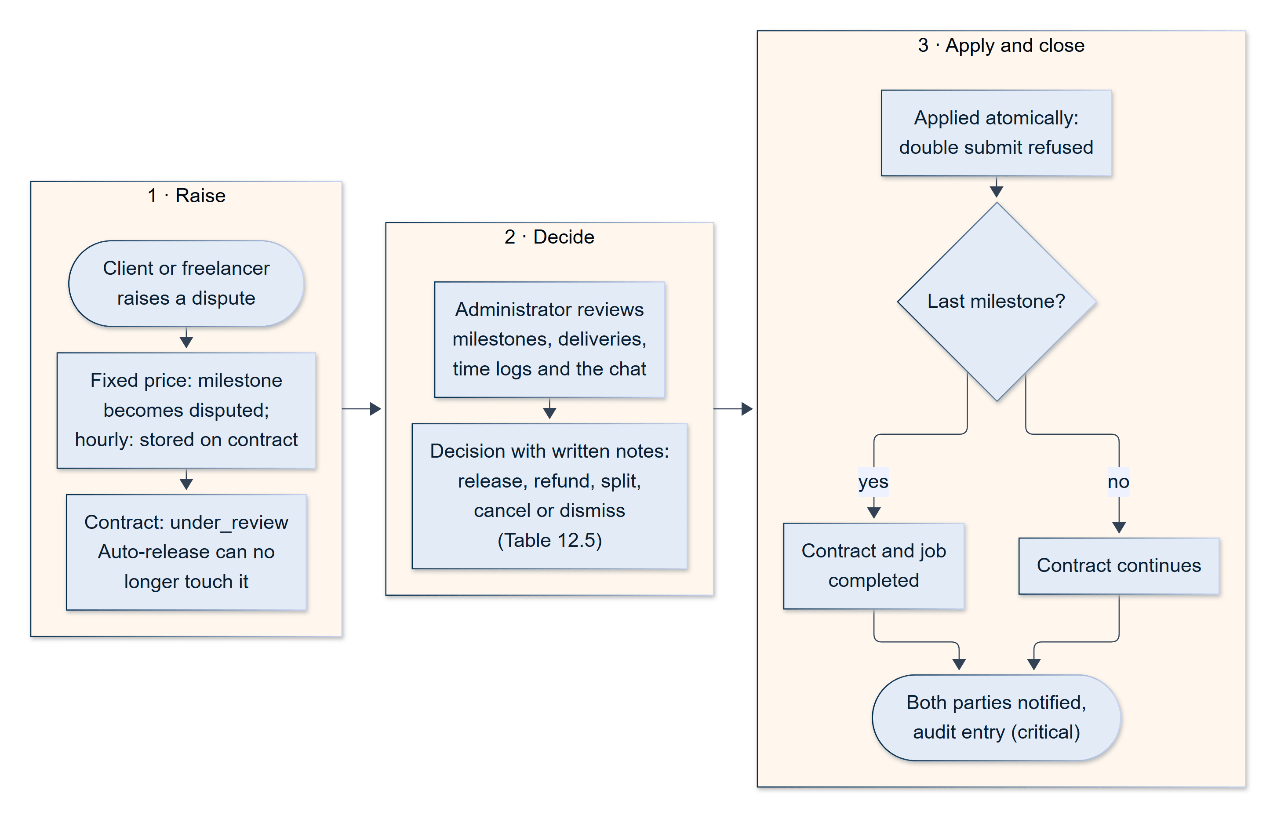
Figure 12.9 — Dispute handling for a fixed-price milestone
The administrator's decision is applied to the disputed milestone only; the contract then continues, completes, or is cancelled (Section 12.17).

12.18 Messaging
SkillKart includes a one-to-one, in-app chat between any two signed-in users. A conversation can be opened from a freelancer's or client's public profile, from a gig page, or from the proposals screen, so that a client can ask a question before hiring. The Messages pages (/client/messages and /freelancer/messages) show a conversation list and a thread; messages can carry up to ten attachments (images, PDFs, or Word documents of up to 10 MB each, uploaded to cloud storage), and each conversation records a per-user unread count and who has read each message. Custom offers appear in a thread as rich cards (Section 12.9).
Anti-leakage protection. Marketplaces depend on payments staying on the platform, so the system masks off-platform contact details. An email address or phone number typed into a message is replaced with a "contact info blocked" notice and counted as a violation: the first violation sends the sender a warning notification, and the second blocks the account, with the reason recorded. Custom offers containing contact details are rejected outright.
Delivery of messages. Chat uses HTTP polling rather than a persistent connection: an open conversation refreshes every three seconds and the conversation list every ten. This is simple and robust behind any proxy, and it is a deliberate trade-off; replacing it with WebSockets is listed among the future enhancements (Chapter 21).
Support conversations. An administrator can message a user, or reply to an existing conversation, as SkillKart Support. Because chat messages need a user as sender, a hidden system account is created on first use for this purpose, and the message reaches the user's ordinary inbox and notification feed (Section 14.3).

12.19 Notifications
Every significant event produces a notification. A single function, notify(), is the only way a notification is created: it stores a Notification record, never throws (a notification failure can never break the action that triggered it), and then attempts a push notification to the user's phone. The platform defines 25 event types, grouped below, plus the administrator broadcast.
Table 12.6 — Notification events
Group | Events
Proposals | received, resubmitted, accepted, rejected (with a hint when resubmission is allowed)
Orders and offers | gig ordered (sent only after the deposit is paid), custom offer received, accepted, declined
Delivery and payment | deposit or milestone funded, work delivered, revision requested, payment released, milestone auto-released, escrow refunded, project completed
Withdrawals | withdrawal requested, withdrawal completed
Contracts and disputes | contract status changed, contract disputed, dispute resolved, dispute dismissed, job cancelled
Social and policy | new message, review submitted, contact-information warning, skill verification expired

A notification bell on the dashboards polls for the unread count every 30 seconds and shows the latest eight notifications; the full page lists them with filters, per-item delete, and clear all. Each notification carries a link, so that opening it takes the user straight to the relevant screen. On the Android app the same events are also delivered as push notifications (Chapter 15).

12.20 Transactional Email
The platform sends email for the events that need an out-of-band channel: one-time passwords, login and password-change alerts, email-change and recovery-email security notices, the administrator login code, the public contact form, and the newsletter sign-up notice. All sending goes through one service and a pluggable provider layer selected by a single EMAIL_PROVIDER setting (Section 9.7): the Gmail API, which sends over HTTPS and is the provider used in deployment, or SMTP, which is the default for local development. A transient failure — a network error, an HTTP 429 or 5xx response, a temporary SMTP reply — is retried up to three times with exponential back-off and random jitter, whereas errors that cannot be fixed by retrying, such as an invalid credential, are not. Every attempt is recorded in EmailLog and can be inspected by administrators on the Monitoring page. Two switches exist for safe testing: EMAIL_ENABLED=false suppresses all sending, and a sandbox mode redirects every message to a single test address with the original recipient noted in the subject line.

12.21 Public Website and Discoverability
The public website is what a visitor sees before signing in. Its pages are:
- Home — a hero section, a skills slider, trending skills (computed from live data), testimonials, and a footer with a newsletter sign-up.
- Browse Projects, Browse Gigs, and Browse Freelancers with filters, and the matching detail pages for a job, a gig, a freelancer, and a client.
- Categories, category pages, and skill pages, which show real aggregates (counts of active gigs, jobs, and freelancers) for each category and skill.
- Post a Project, a short brief form that hands the draft to the signed-in wizard, and AI Matchmaking, which ranks freelancers for a pasted brief (Section 13.2).
- Buddy AI and the AI Cost Estimator (Chapter 13).
- About, Contact, Help Center, and the legal pages (Privacy Policy, Terms of Service, Cookie Policy, Services Agreement).
The Contact and Newsletter forms are protected by reCAPTCHA and a rate limit, store each submission in its own collection, and relay a notice to the platform's inbox.
Search-engine visibility. The sitemap (/sitemap.xml) is generated live by the backend from the database — static pages plus every open job, active gig, and public freelancer and client profile (up to 5,000 of each) and the category pages — and cached for an hour, so new content becomes crawlable without a redeployment. It is built from a dedicated PUBLIC_SITE_URL setting rather than the CORS origin list. The frontend host proxies /sitemap.xml to the backend through a rewrite that must stay above the single-page-app catch-all rule, or the request would be swallowed by index.html. A robots.txt excludes authentication, dashboard, admin, and payment pages from crawling. The site ships a web-app manifest with the brand colours, icons, and shortcuts, and a static Open Graph and Twitter-card block for link previews; page titles and the canonical link are set per page.

12.22 Dashboards and Navigation
Each role has its own area, reached after login according to the user's role.
Client area (/client/*).
- Dashboard — profile summary and statistics (total projects, open jobs, freelancers hired, total spent), quick actions, and recent projects.
- My Projects — every job and gig order with its status; per project the client can edit, publish, or delete a draft, view proposals, fund the next milestone, review a delivery or request a revision, pay or cancel a gig order, top up an hourly escrow, request the end of an hourly contract, raise a dispute, and leave a review. The page refreshes itself every four seconds while it is visible.
- Post a Project, Review Proposals, Wallet, Saved Freelancers, Messages, Notifications, Buddy AI, Profile, Settings, and Security.
Freelancer area (/freelancer/*).
- Dashboard — profile summary, statistics (gigs, active bids, accepted proposals, profile views), the verification checklist and Skill Verification Center, quick actions, and recent gigs.
- Gigs and Create Gig, Proposals, My Work (contracts and gig orders — deliver work, start and stop the timer, add a manual time entry, respond to end requests, raise a dispute, review), Wallet, Portfolio, Saved Jobs, Skill Test, Messages (including Send Custom Offer), Notifications, Buddy AI, and the same profile and security pages.
Shared pieces — the notification bell, the Buddy AI tab, the offline screen on mobile, and the suspended-account overlay — are described in the chapters that cover them.
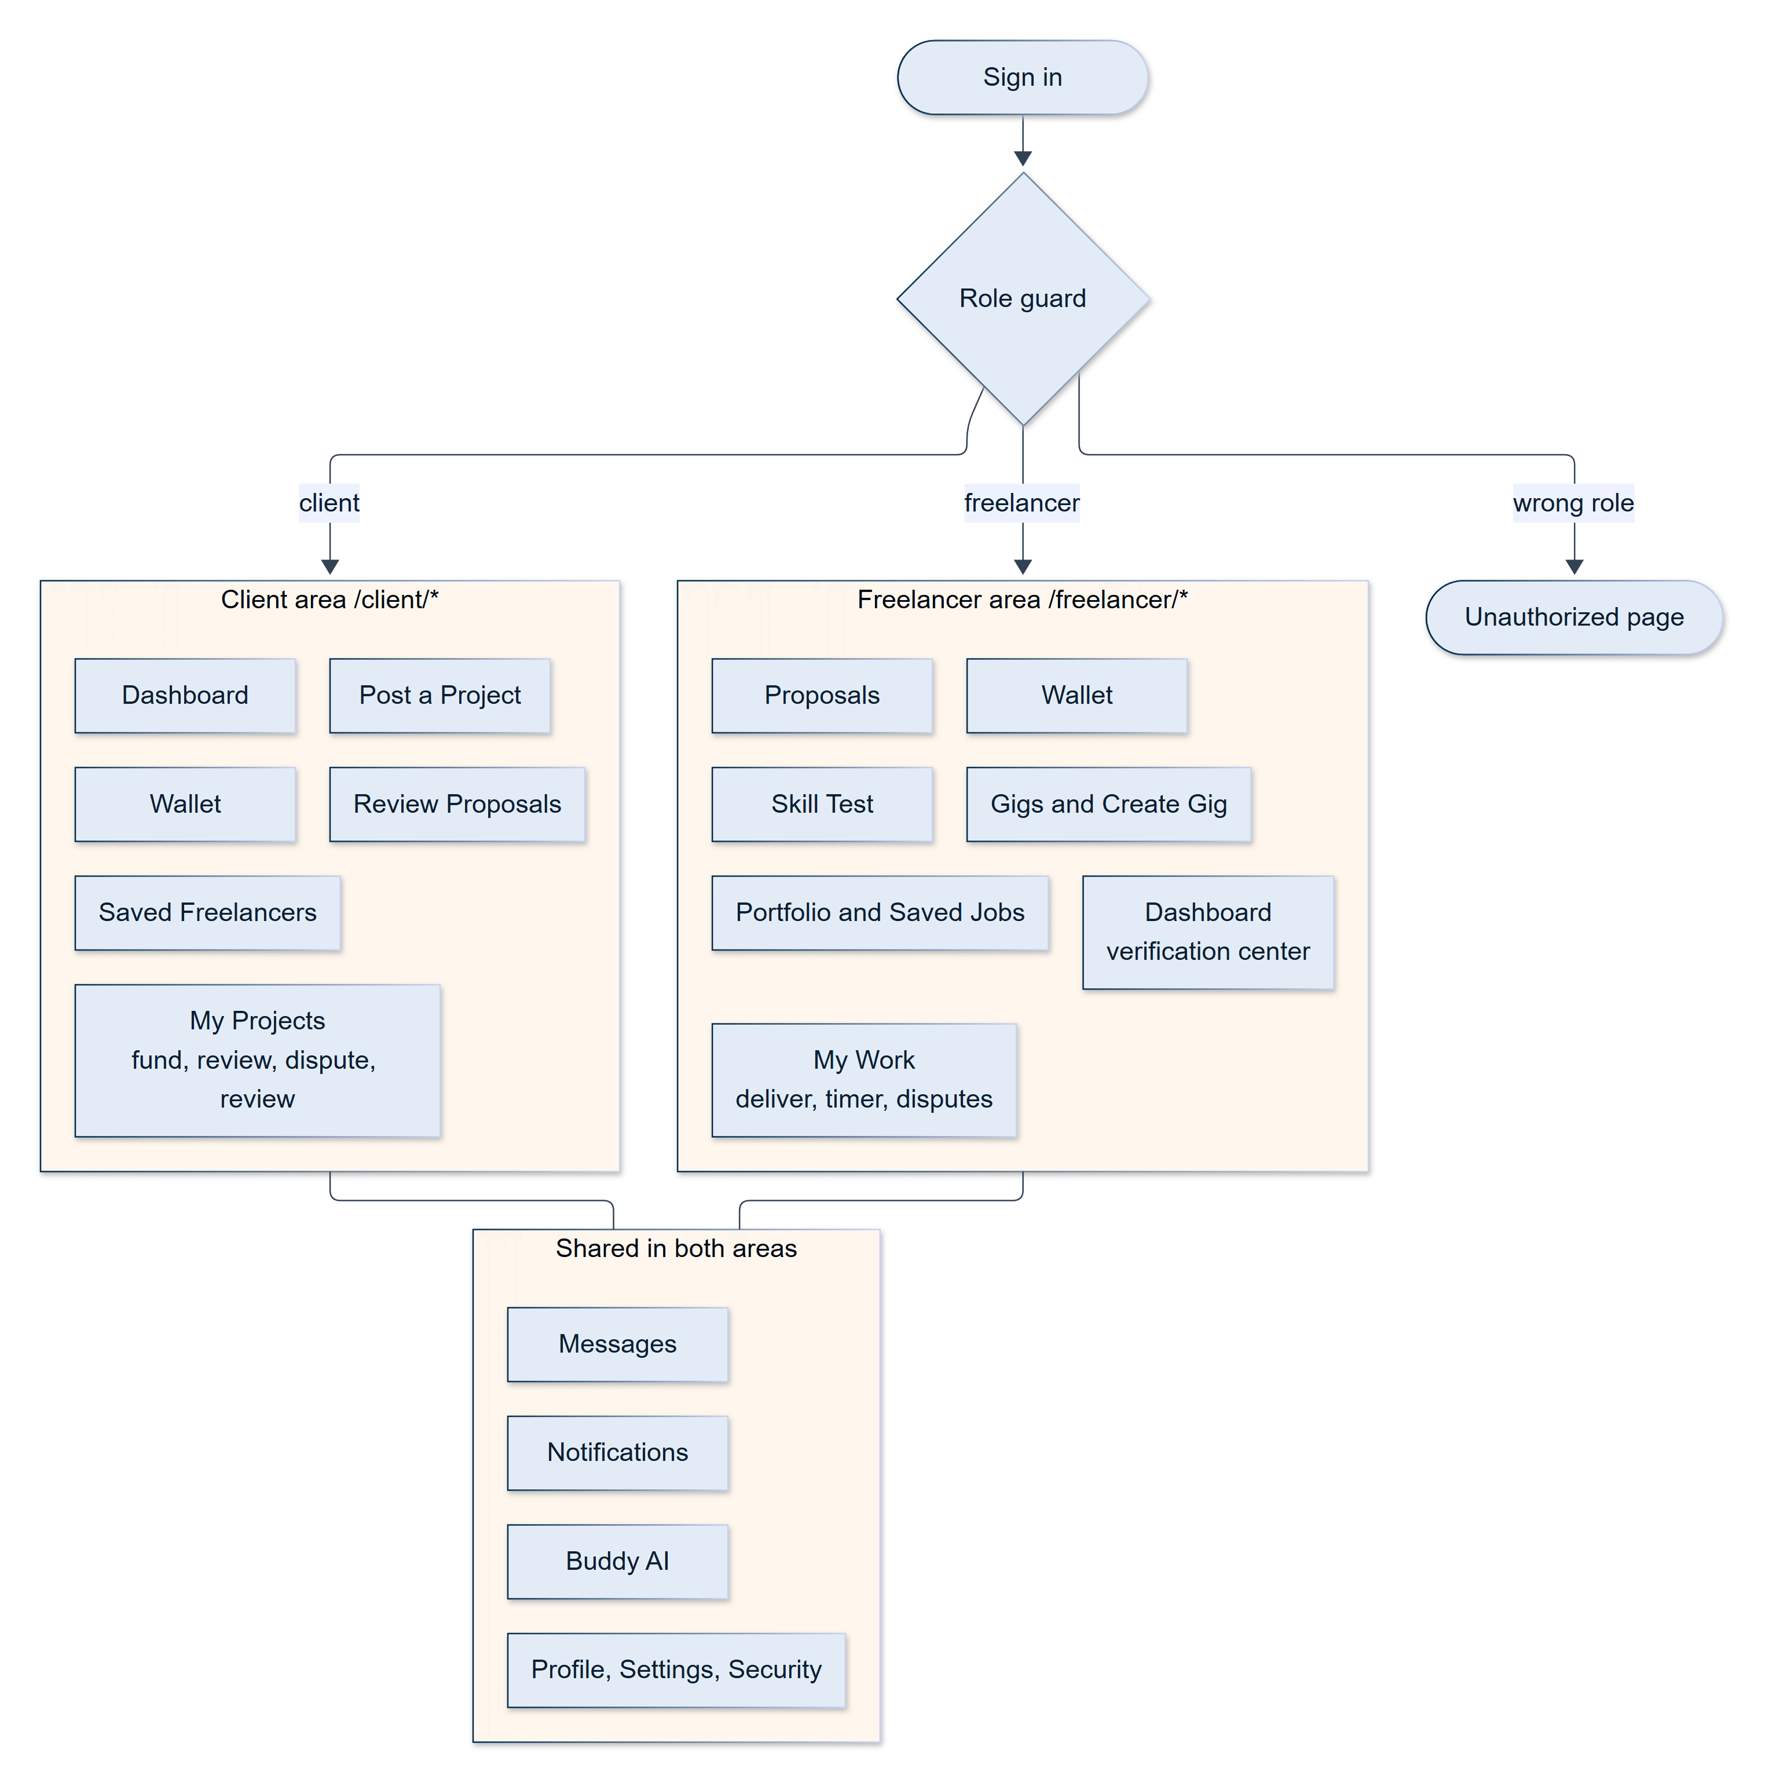
Figure 12.10 — Interaction map of the client and freelancer areas
Each role sees only its own route tree; role guards redirect everything else to an 'unauthorized' page (Section 12.22).

12.23 Reporting Content
Any signed-in user can report a freelancer or client profile, a job, a gig, or a review, using a Report button on the corresponding public page (it is hidden on a user's own content). The dialog asks for a reason — spam or misleading, scam or fraud, harassment or threats, abusive or hateful content, inappropriate content, or something else — and a description of 10 to 1,000 characters, and sends it to the moderation team.
Three rules keep the channel trustworthy. The person being reported is worked out by the server from the item itself, never from anything the browser sends, so a report cannot be aimed at an arbitrary account; you cannot report your own content; and there is one open report per user per item, so a second click is answered kindly rather than queued again. Reports about fraud or harassment are queued at high priority, and the rest at medium; the reporter chooses the reason, not the priority. To stop one account flooding the queue, each user may file ten reports an hour. A report appears in the admin panel's Reports module (Section 14.3), where a moderator assigns it, resolves it with notes, or dismisses it. Filing a report does not notify the reported person; the queue is where moderators find it.

13. AI Features
Artificial intelligence is a first-class part of SkillKart, woven into onboarding, discovery, bidding, pricing, and verification. This chapter describes what the AI layer does, how the requests are routed across providers, how the system behaves when providers fail, and — equally important — which intelligent-looking features are not powered by a language model.

13.1 AI Capabilities
The platform provides fourteen LLM-backed capabilities. Table 13.1 lists them with the screen that uses each. Thirteen are reachable through an API endpoint; the fourteenth (taxonomy suggestion) runs only in the background.
Table 13.1 — LLM-backed AI capabilities
# | Capability | What it does | Used in
1 | Buddy assistant | Conversational help on freelancing, hiring, pricing, and using the platform; short replies (about 120 words) using the last eight turns of conversation | Floating widget on public pages, /ai/buddy, and a Buddy AI tab in both dashboards
2 | Cost estimator | From a brief (title, description, category, skills, complexity, timeline) returns a budget range in PKR, a rationale, and a breakdown | /ai/cost-estimator
3 | Brief suggestion | From a free-text description infers a title, a category, up to eight skills, a budget, and an experience level | "Suggest" buttons in job, gig, onboarding, and matchmaking forms
4 | Skill validation | Normalises a typed skill ("reactjs" becomes "React.js"), rejects non-professional or offline inputs, and suggests alternatives | Skill tag inputs throughout the site
5 | Semantic skill expansion | Returns five to eight specific skills related to a query | API only; the user-facing search uses the non-LLM skill graph instead
6 | Generate with AI | Drafts a field from scratch or expands the user's own draft, aware of whether the writer is a client or a freelancer | About twenty text fields: job and gig descriptions, biography, portfolio, FAQs, success stories
7 | Skill-test generation | Writes a test of 5, 10, or 15 questions at the chosen level | Skill test
8 | Skill-test evaluation | Scores each answer between 0 and 1 | Skill test
9 | CV parsing and analysis | Extracts title, biography, skills, education, experience, and portfolio from a CV, scores it, and classifies it | Freelancer onboarding
10 | Industry recommendation | Suggests the three most suitable industries from a fixed list of 30 | Client onboarding and profile
11 | Job category suggestion | Suggests up to three of the 68 categories | Post-a-job wizard
12 | Job subcategory suggestion | Suggests a subcategory | Post-a-job wizard
13 | Proposal drafting | Writes a first-person cover letter of 120–200 words from the job and the freelancer's profile, without inventing facts | Job details page
14 | Taxonomy suggestion | Proposes where an unrecognised skill belongs in the skill graph, with reasoning, for administrator review | Background; reviewed in the taxonomy admin page

Each capability follows the same pattern: a provider method builds a task-specific prompt, requests a structured JSON response, and parses it defensively (tolerating code-fenced or slightly malformed output), so that AI output is machine-usable and predictable. The router then checks that the result has the expected shape — for example, a proposal draft must contain a cover letter and a cost estimate must have a minimum or a maximum — and treats a malformed result like a failed call.

13.2 Matchmaking: A Deterministic Engine
Matchmaking is deliberately not an LLM feature. Given a project brief — pasted into /ai-matchmaking or taken from a saved job — a scoring engine ranks up to 100 candidate freelancers and returns the best eight, each with a score from 0 to 100 and a list of plain-language reasons. Because it uses no external service, it is fast, free, reproducible, and unaffected by AI outages.
Table 13.2 — Matchmaking score components
Component | Maximum points | How it is computed
Skill match | 50 | Graph-aware overlap between required and held skills (Section 12.6); if the brief lists no skills, 5 points per candidate skill up to 35
Verified skills | 10 | 3 points per verified skill
Rating | 15 | Rating out of 5, scaled to 15
Experience | 10 | Completed projects divided by two, up to 10
Budget fit | 15 | 15 if the freelancer's rate is within the budget, 9 if within 30% above, otherwise 3; 8 if unknown
Availability | 5 | 5 for full-time, 3 for part-time

The components add up to 105 and the total is capped at 100. The engine also produces an estimated cost range, from roughly one day to one week of the freelancer's hourly rate. The scoring weights are plain constants in code, which makes them easy to explain, audit, and tune; Chapter 21 discusses replacing the skill-overlap component with embeddings.

13.3 The Provider Router
All LLM calls go through a provider router, a single object that presents one interface to the rest of the application and, internally, tries a prioritised list of providers.
Table 13.3 — AI providers
Provider | Access | Default model | Methods implemented
Google Gemini [8] | @google/genai SDK | gemini-3.1-flash-lite | All 14
DeepSeek [14] | OpenAI-style HTTP API, JSON mode, 60-second timeout | deepseek-flash | All 14
Alibaba Qwen [29] | OpenAI-compatible HTTP API, 60-second timeout | qwen-plus | 5: CV parsing, test generation and evaluation, skill validation, industry recommendation
Groq [28] | groq-sdk | llama-3.3-70b-versatile | The same 5
Anthropic Claude [27] | @anthropic-ai/sdk | claude-3-haiku-20240307 | The same 5
Ollama [30] (local) | HTTP to a local server, 120-second timeout | llama3 | 7 light, interactive ones (Buddy, cost estimate, brief suggestion, skill validation, industry and category recommendation, proposal drafting)

Models for Gemini, DeepSeek, Qwen, and Ollama can be changed through environment variables.
Fallback algorithm. For each request the router takes its providers in priority order and calls the same method on each in turn. A provider that lacks the method, has no API key configured, or throws is skipped with a warning, and the first provider to return a well-formed result wins. The order is set by numbered environment variables, AI_PRIORITY_<PROVIDER>: 0 is tried first, higher numbers later, and a negative value such as -1 disables the provider. The default order is Gemini → DeepSeek → Qwen → Groq → Claude → Ollama. This design answers the reality that free-tier AI services are rate-limited and unreliable: when one provider exhausts its quota or is unavailable, the next takes over, and the local Ollama model — which has no quota — is the last resort for the capabilities it supports. The effective order is logged at startup, and a real one-token call verifies that at least one provider works.
The router is intentionally simple: calls are sequential and there is no circuit breaker, so a provider that is down is retried on every request and the worst-case latency is the sum of the providers' timeouts. A circuit breaker is listed among the future enhancements.
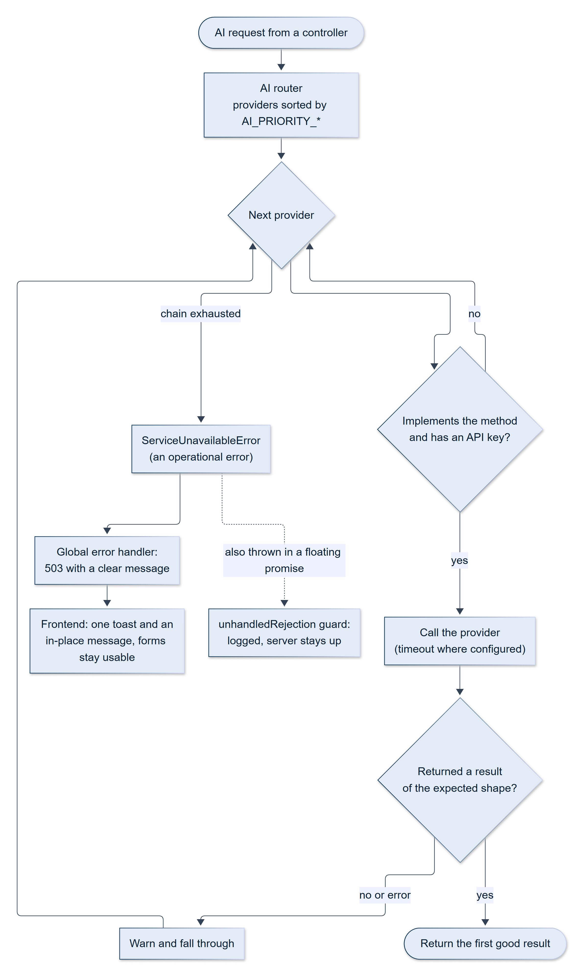
Figure 13.1 — The AI provider router: fallback, validation and the 503 path
Each provider is tried in priority order; if every provider fails, the API returns a controlled 503 and the interface shows a single notice (Section 13.4).

13.4 Resilience: AI Failure Never Crashes the Application
The AI subsystem is engineered so that AI failures never take the application down.
- If every provider fails, the router throws a dedicated ServiceUnavailableError — marked as an operational error — which the global error handler turns into a clean 503 response with a recognisable message: "AI is temporarily out of service."
- The process-level unhandledRejection handler distinguishes operational errors (expected, recoverable failures such as this one), which it logs and survives, from genuinely unexpected rejections, which it logs and then shuts down on. A provider outage therefore cannot terminate the server.
- The frontend client treats any failed request to an AI endpoint the same way and shows a single, consistent toast; each AI screen also renders its own in-place message, so that forms remain usable by hand.
- Four capabilities never return a 503 at all, because a sensible default exists: industry recommendation falls back to a static list of three industries, category suggestion falls back to a keyword matcher, subcategory suggestion returns an empty suggestion, and the background taxonomy suggestion simply logs and stops.
- Optional configuration follows the same philosophy: a provider without an API key is skipped, and the server starts even if no AI provider works ("proceeding without AI features").

13.5 Abuse Controls
The public AI tools do not require a login, so they are rate-limited: all of them share a limit of ten requests per minute per IP address. Buddy has an additional guest quota — a visitor who is not signed in may send three messages per IP address in a rolling 24-hour window, after which the interface asks them to sign in; signed-in users are not capped beyond the per-minute limit. Inputs are length-limited (for example, a Buddy message at 1,000 characters and a skill at 60) before they reach a provider.

13.6 What the Skill Test Asks of the AI
Skill verification (Section 12.4) uses two LLM capabilities. Generation asks the provider for the right number of questions for the chosen level, about 80% multiple choice, and retries once if the multiple-choice share falls below 65%. Evaluation sends only the question, the skill, and the candidate's answer to the grader; the grader scores each answer from 0 to 1, with partial credit. Because the grading prompt contains no answer key, a multiple-choice answer is judged on the grader's own knowledge of the subject. Only the Gemini, DeepSeek, Qwen, Groq, and Claude providers can serve these capabilities; Ollama cannot, and so a test requested while all five are down returns the controlled 503.

13.7 What Is Not an LLM
Three features that a visitor may reasonably think of as "AI" are deliberately not LLM calls, and keeping them separate is a design decision (Section 8.6).
- Matchmaking is the rules-based engine described in Section 13.2.
- Skill search and gating use the skill graph (Section 12.6): graph traversal and a match-score formula, not a model.
- Face-presence proctoring uses MediaPipe's Face Landmarker [16], a small computer-vision model that runs on the user's own device, so no camera frame ever leaves it.

13.8 Future AI Expansion
The provider abstraction makes it straightforward to add providers or models: a new provider implements the base interface and is registered in the router. Planned directions include a circuit breaker for failing providers, embedding-based semantic matching to complement the rules-based engine, grading multiple-choice answers against the stored answer key, AI-assisted dispute summaries, and automated profile-improvement coaching (Chapter 21).

14. Admin Panel

14.1 Design Rationale
The admin panel is a separate, isolated application inside the frontend, served under /admin-panel/*. Its isolation is a security decision: a marketplace user's token can never grant administrative access, and administrative code and credentials can never leak into the marketplace. The isolation is complete along every axis.
- A separate secret (ADMIN_JWT_SECRET), with its own token issuer and audience, so a marketplace token fails admin verification and the reverse.
- A separate cookie (admin_token), httpOnly, rather than the marketplace's bearer token.
- Separate middleware (adminAuth), separate rate limiters, and separate request validators.
- A separate frontend context and HTTP client, so the admin interface never reads or writes marketplace session state.
- A separate route tree, which is served both inside the web application and as the entire content of the standalone SkillKart Admin Android app (Chapter 15).
The panel is organised as 17 management modules (Section 14.3), seven detail screens, and a global search.
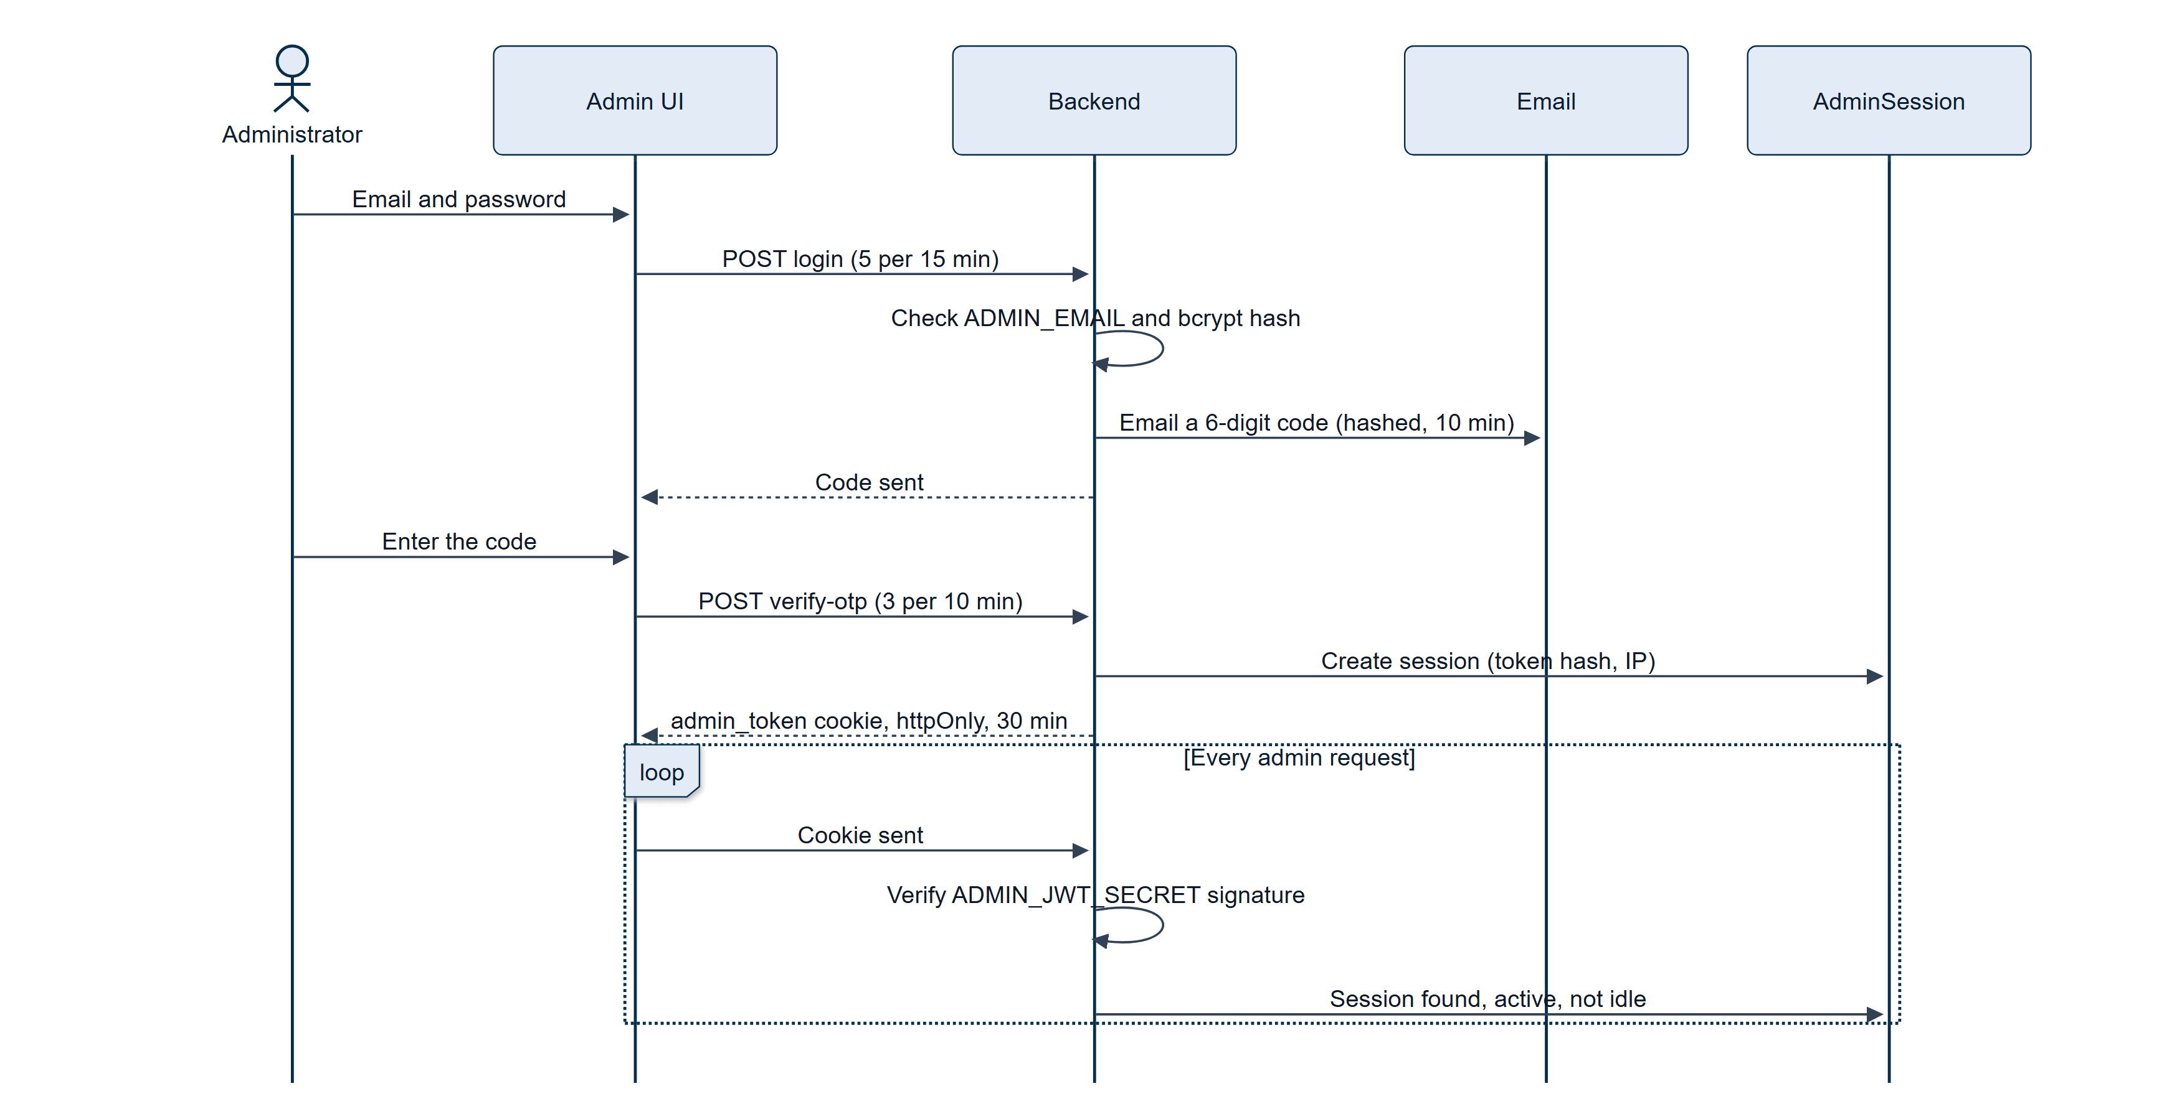
Figure 14.1 — Admin login: credentials, emailed one-time code, session cookie
The administrator's credentials are verified, a one-time code is emailed, and a successful verification creates a server-side session and sets an httpOnly cookie (Section 14.2).

14.2 Authentication and Sessions
The panel has one administrative identity, defined in the server's environment rather than in the database: the operator's email address (ADMIN_EMAIL) and a bcrypt hash of their password (ADMIN_PASSWORD_HASH). Keeping the credential in configuration means that no marketplace account — and no database record that a marketplace user could influence — can ever become an administrator.
Login is two-step.
- The operator submits an email and a password. Both are checked, and a failure of either returns the same generic "invalid credentials" response (and is audit-logged), so the response never reveals which was wrong.
- A six-digit one-time code is emailed to the administrator address. The code is stored only as a SHA-256 hash, is single-use, expires after ten minutes, and allows five attempts. Route-level limits are tighter still: five login attempts per fifteen minutes and three code verifications per ten minutes per IP address.
A successful verification creates an AdminSession record that stores a SHA-256 hash of the session token, the IP address, and the user agent, signs a JWT with the admin secret, and returns it in the admin_token cookie. On every request the middleware verifies the signature and looks the session up by its hash, so a valid signature without an active session is refused; sessions also expire after 30 minutes of inactivity, and the cookie lifetime is a fixed 30 minutes from login. Session records are deleted automatically by a database expiry index. The cookie is Secure and SameSite=None when the connection is HTTPS (the frontend and the API are hosted on different domains) and SameSite=Lax otherwise; the choice is made from the request protocol, not from an environment label (Section 20.8). The API also offers a session-history endpoint and a force logout endpoint for an individual session.
Cross-site request protection. Because the cookie must be SameSite=None for a cross-domain deployment, a browser attaches it to cross-site requests, so every state-changing admin request must show that it came from the admin client: it must carry a custom header that the admin client sends, an Origin on the CORS allow-list (which also keeps already-installed admin apps, which present the fixed origin https://localhost, working), or a Bearer token. A cross-site HTML form cannot set a custom header, and a request from any other origin is already refused by the CORS layer before it reaches the panel; the guard is the defence in depth for requests that carry no Origin at all. Read-only requests are unaffected.
Encrypted SuperAdmin credential. Separately from the panel, the marketplace API supports a legacy SuperAdmin login (POST /auth/superadmin/login). Its username and a bcrypt-hashed password are stored in a file encrypted with AES under a key held in the environment (ENCRYPTION_KEY), created by npm run setup:superadmin; the file is kept outside the database. This login produces a marketplace token with the superadmin role, which bypasses the marketplace's role checks. It has no user interface, and it is distinct from the admin panel's login.
Role model. The panel is single-operator by design: every session carries the super_admin role. The data model reserves a database-backed administrator (AdminUser, with finance, support, moderator, and analytics roles) and the route definitions already name the permission each action would require, so that multi-administrator access control can be enabled without changing the routes (Chapter 21).

14.3 Modules
Table 14.1 — Admin panel modules and their capabilities
Module | Capabilities
1. Dashboard | Live platform overview refreshed every 30 seconds: users (total, freelancers, clients, active now, new today), jobs, contracts, open disputes, platform revenue, escrow balance, fees today, wallet totals, pending withdrawals, open reports, message count, recent admin activity, and a health card (database state, uptime, memory, Node version, environment)
2. Analytics | Range selector (7 days, 30 days, 90 days, 1 year); KPI cards with period-over-period change (gross volume, platform fees, accounts, job completion rate); charts of revenue by month, users by role, jobs by status, and top categories; a top-earners table with CSV export
3. Users | Search and filter; suspend and unsuspend with a reason; soft-delete; edit an account or a full profile; change role (never to superadmin); set an avatar; verify an email without a code; pass or reset a skill test; set the identity, phone, portfolio, and payment verification flags and the overall status; message the user as SkillKart Support; adjust the wallet; tabs for contracts, jobs, payments, wallet, reports, and activity
4. Jobs | Filter and search; edit any field; close (which rejects pending proposals), reopen, soft-delete. Gig orders appear here too, since they are jobs
5. Contracts | Inspect history, time logs, payments, and deliveries; edit terms; pause, resume, cancel (refunds funded escrow to the client), force-complete (pays outstanding escrow to the freelancer), reassign to another freelancer, add internal notes. Every change is written to the contract history with the administrator's email
6. Disputes | One queue of hourly and per-milestone disputes; full context (milestones, deliveries, time logs, the complete chat); six resolution outcomes (Table 12.5)
7. Payments | List and detail; refund and release a payment with a recorded reason (milestone payments are routed through the same approval function as a client's click; refunding a disputed milestone is refused)
8. Wallets | List wallets with a balance; adjust a balance (signed amount up to ±1,000,000, with a reason, never below zero); freeze and unfreeze a wallet with a recorded reason (a frozen wallet cannot fund, lock, or withdraw money; Section 12.15)
9. Withdrawals | Queue of manual (bank_transfer and paypal) withdrawal requests; complete with a payout reference, or reject with a reason, which refunds the wallet automatically. Stripe withdrawals are automated and never need this queue
10. Transactions | A unified, date-ordered view of payments and withdrawals, with export
11. Chat | Search and read any conversation; reply as SkillKart Support; message any user; download a transcript
12. Reviews | Hide (with a reason), restore, or permanently delete a review; the reviewee's rating is recalculated each time
13. Notifications | Broadcast an announcement (title and message) to all users, all freelancers, or all clients, shown in each user's notification feed
14. Reports | Triage queue for user and content reports: assign to oneself, resolve with notes, or dismiss with a reason; categories and priorities as in Table 10.7
15. Monitoring | Three tabs: server errors (with a resolved toggle), API request logs, and email delivery logs
16. Audit Logs | Read-only, paginated record of administrative actions (Section 14.4)
17. Settings | View and edit platform settings grouped by category (Section 14.5)

Beyond the modules, a Global Search (Ctrl+K) in the header searches users, jobs, contracts, payments, withdrawals, reports, and reviews at once, and seven detail screens open from the lists (user, job, contract, dispute, payment, conversation, and report).

14.4 Accountability and the Audit Log
Every sensitive administrative action is written to the AdminAuditLog, which records the administrator, the action, a category (one of 16), the resource and its identifier, the previous and new values, the IP address and user agent, free-text notes, and a severity of info, warning, or critical. Roughly 45 distinct actions are logged, from sign-in attempts to user suspension, wallet adjustments, dispute resolutions, and settings changes. The actions with direct financial or account consequences — refunds, releases, wallet adjustments, dispute resolutions, contract cancellation, force-completion and reassignment, user deletion, and changes to verification status — are recorded at critical severity.
Two design points deserve to be stated plainly. First, the audit trail is append-only by construction: there is no route that updates or deletes a log entry. Second, writing an entry is best-effort: a failure to write is reported to the server console but never blocks the action, trading a guarantee of completeness for availability. Reads — for example, an administrator opening a private conversation — are not currently logged. Both are noted among the future enhancements (Chapter 21).

14.5 Platform Settings
Platform parameters are stored as key–value documents (SystemSettings), seeded with defaults the first time an administrator signs in, and edited on the Settings page; changes to the maintenance toggle are audited at critical severity.
Table 14.2 — System settings
Key | Default | Status
platform_fee_rate | 0.005 (0.5%) | Live — fee on every release; captured on each payment when funded
withdrawal_min_amount | Rs. 5 | Live — minimum withdrawal
escrow_release_days | 7 | Live — milestone review window
maintenance_mode | false | Stored and audited; reserved for a maintenance banner
enable_ai_features | true | Stored; reserved for a global AI switch
enable_email_notifications | true | Stored; reserved
max_login_attempts | 5 | Stored; the lockout currently uses a fixed rule (Table 12.1)
otp_expiry_minutes | 10 | Stored; the OTP expiry is set by an environment variable

A one-time correction in the seeding code brings legacy fee and withdrawal values in line with the current defaults for rows that no administrator has edited, so a deliberate administrator change is never silently reverted.

14.6 Administrative Surfaces Outside the Panel
Three older administrative capabilities predate the isolated panel and were intentionally left outside its isolation boundary. They authenticate with the ordinary marketplace token and role checks instead.
- Taxonomy administration (/admin/taxonomy, eight endpoints under /admin) lets admin and superadmin users review the AI's skill suggestions and create, edit, connect, and merge skill-graph nodes (Section 12.6). It is the only part of this group with a user interface.
- Legacy user and administrator management (/users and /admin, ten and three endpoints) provides list, create, update, block, role-change, and password-reset operations, protected by a higher-role rule — an administrator can neither act on nor assign a role equal to or above their own. The admin panel has its own, richer user module and does not use these endpoints.
- Content management (CMS). A complete, versioned content-management back end exists — thirteen endpoints for creating, updating, publishing, unpublishing, scheduling, restoring, and exporting pages, with a modification history, the last twenty versions of each page, and permissions granted to a dedicated contenteditor role. It has no frontend consumer: there is no editor screen, and no public page renders CMS content, so it is documented as back-end infrastructure built ahead of the interface that would use it. Scheduled publication is applied by an hourly job, which publishes every page whose scheduled time has passed.

14.7 Exports
Six lists — users, jobs, contracts, payments, withdrawals, and transactions — can be exported as CSV, Excel (formatted with a header row and filters), or PDF (landscape tables). Exports are produced on the server and named with the date; on the Android apps, files that the app generates itself (conversation transcripts, the top-earners CSV) are saved to the app's cache and handed to the system share sheet, because a browser-style download has nowhere to go inside a WebView (Section 15.5). Each export is recorded in the audit log.

15. Mobile Applications

15.1 Overview
Objective 9 of the project was to deliver native mobile access without maintaining a second codebase. SkillKart therefore ships two Android applications built from the same React source using Capacitor [15], a runtime that embeds a web application in a native Android shell and exposes native capabilities to it through plugins.
- SkillKart (com.skillkart.app) — the client and freelancer application. It contains the authentication and onboarding screens, the six public marketplace pages (browse projects, browse gigs, browse freelancers, and the job, gig, and freelancer detail pages), and both dashboards.
- SkillKart Admin (com.skillkart.admin) — a separate, standalone application that contains only the admin panel (Chapter 14), for administrators who need moderation access on the move without installing the marketplace application.
These are not a bare web page in a frame; each runs the web application inside the Android WebView component [40], with native capabilities added around it. Each integrates the platform: the camera, push notifications, the hardware back button, offline detection, the splash screen and status bar, an in-app system browser, and the native share sheet. The web build is unaffected by any of this: the same components run in all three targets, and a single check decides where behaviour differs.

15.2 One Codebase, Three Build Targets
A single environment value, VITE_APP_TARGET, selects the target at build time, and two helper functions derived from it — isMobileApp() and isAdminApp() — are the only places where the shared code branches between web and native.
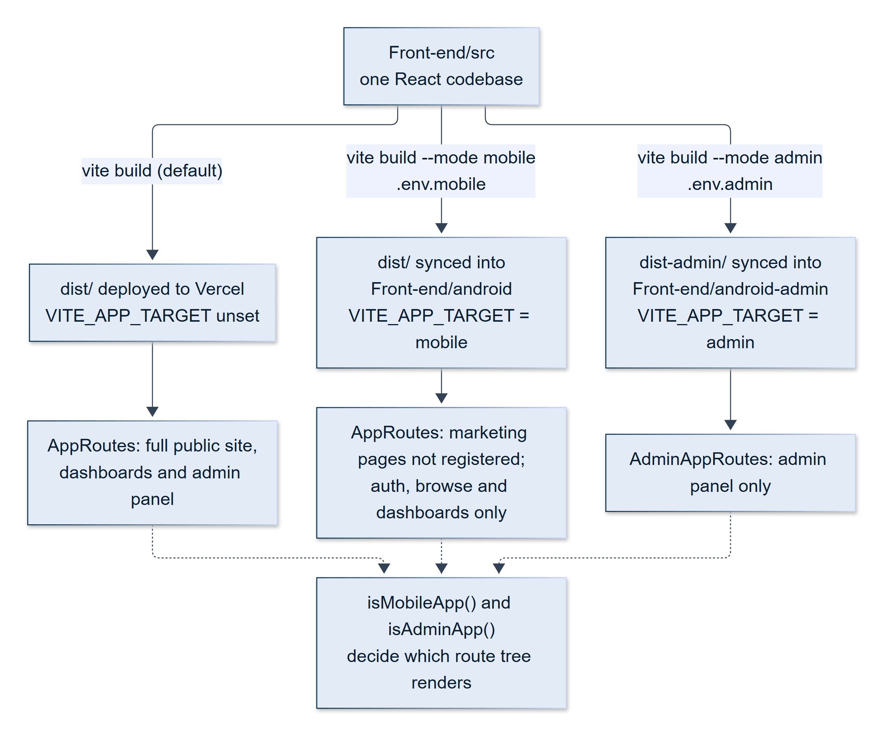
Figure 15.1 — One codebase, three build targets
The same Front-end/src is built three ways; isMobileApp() and isAdminApp() decide which route tree renders (Section 15.2).
Target | Build | Route tree
Web | vite build (default) | The full public site and both dashboards, plus the admin panel
Android app | vite build --mode mobile, then Capacitor sync | AppRoutes, with the public marketing, legal, AI-tool, skill, and category pages not registered
Admin Android app | vite build --mode admin, then Capacitor sync | AdminAppRoutes: only /admin-panel/*; every other path redirects to the admin login

In the Android build, the marketing and legal pages are neither registered nor loaded: they are React.lazy imports, so their code and assets are never fetched on a phone. The browse, detail, and authentication pages are kept, because a freelancer on a phone needs to find work and a client needs to find talent. The application's WebView has a fixed origin of https://localhost; this origin is included in the backend's CORS allow-list, and it is exempted from reCAPTCHA, because Google's reCAPTCHA v3 is unreliable inside an embedded WebView. The mobile build also omits the reCAPTCHA site key, so nothing even attempts to load.

15.3 Platform Integration
Table 15.1 — Capacitor plugins and their use
Plugin | Used for
@capacitor/app | The Android hardware back button (navigates back, or minimises the app on a root screen); receives the OAuth return deep link
@capacitor/browser | Opens external links and the OAuth consent screen in a Chrome Custom Tab, with a way back into the app
@capacitor/camera | Take Photo in every image upload (Section 15.5)
@capacitor/filesystem, @capacitor/share | Saving and sharing files that the app generates (Section 15.5)
@capacitor/network | The offline screen: shown after three consecutive offline readings, with a Retry button
@capacitor/push-notifications | Receiving push notifications (Section 15.4)
@capacitor/splash-screen | A branded splash, hidden only once the sign-in state has been restored
@capacitor/status-bar | Brand-coloured status bar

Other behaviours specific to the native build:
- External links never navigate the app away. On a native WebView, window.open or target="_blank" replaces the application with no way back, so all external links go through a helper that opens the Chrome Custom Tab. This also covers server-generated downloads such as the admin exports.
- Smooth rendering. A stylesheet that applies only inside the native app disables backdrop-filter and hides scrollbars. These are the main sources of visual jank on Android WebViews and have no effect on the web build.
- Navigation. The root route resolves the signed-in user's role and sends them to the right dashboard instead of blindly redirecting to the login page (Section 20.6).
- Reduced chrome. The floating Buddy widget and the cookie banner are not shown; Buddy is reached through a tab in the dashboard sidebar.

15.4 Native-Specific Engineering
Social sign-in. Google does not allow OAuth sign-in inside an embedded WebView, so on Android the consent screen opens in the system browser. After the user approves, the provider redirects to a registered custom URL (skillkart://auth-callback), which Android hands back to the app; the app closes the browser tab, takes the token from the URL fragment, and continues through the same handler as the web.
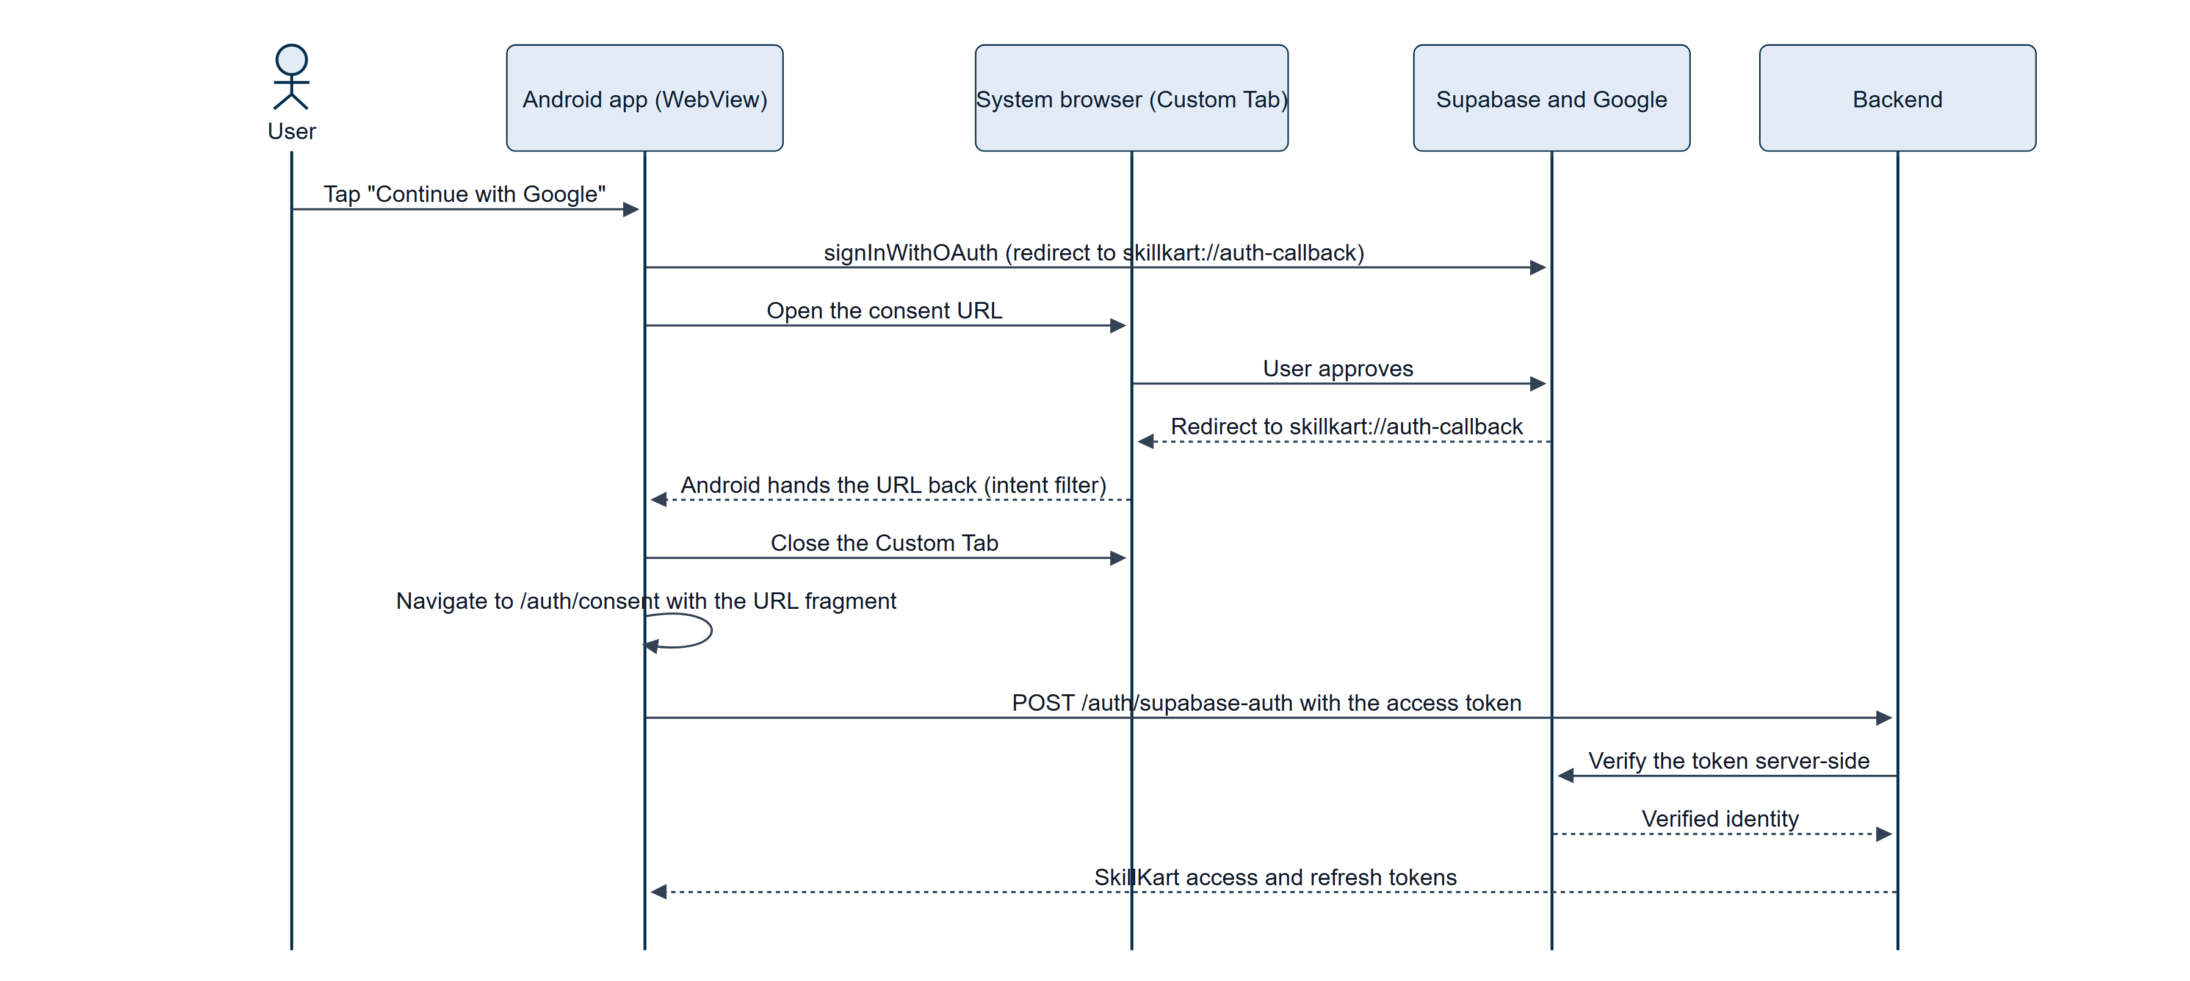
Figure 15.2 — Mobile social sign-in through the system browser and a deep link
Google blocks OAuth in embedded WebViews, so the consent screen opens in the system browser and the code returns through a registered URL scheme (Section 15.4).
Push notifications. Push delivery is hooked into the single notify() function (Section 12.19), so every event that creates a notification can also reach the phone. The server uses Firebase Cloud Messaging [17] through the Firebase Admin SDK; a device registers its token through an authenticated endpoint, tokens are stored on the user, and a token that FCM reports as no longer valid is pruned. Signing out sends the device token with the logout request, so the server unregisters that phone in the same authenticated call; signing out of every device, or changing the password, clears all of a user's tokens. Tapping a notification opens the screen named in the notification's link. Like every optional integration, push fails open: if the Firebase credential is absent, every call is a silent no-op, and on the client the registration is gated by a build flag because registering without a Firebase configuration file would crash the native app.
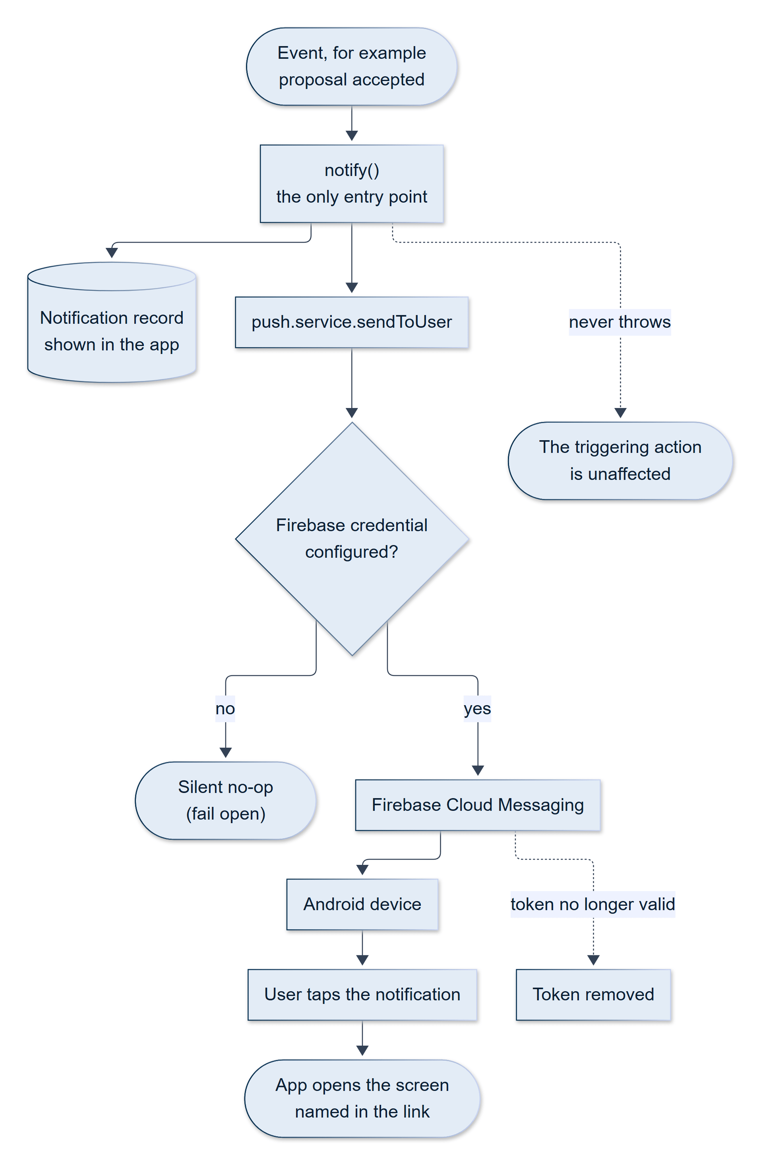
Figure 15.3 — Push notification path from an event to the phone
notify() stores the notification, then asks the push service to deliver it; failures never affect the triggering action (Section 15.4).
Skill-test proctoring in a WebView. The camera guard was rebuilt for Android after the first implementation, which used a face-detection library on the GPU, proved to silently detect nothing on a WebView. The current MediaPipe-based guard runs on the CPU inside the Android app, requests the front camera, and pauses its three-second countdown while the WebView's camera feed is frozen — measured on the emulator, the feed freezes for three to four seconds at a time. The detection model and its runtime are bundled into the application and served from the app's own origin, never from a CDN (Section 20.5).

15.5 Photos and Files
Photo upload. Every image upload uses one reusable component, ImageSourcePicker, which is a drop-in replacement for a hidden file input with the same click() interface. On the web, it opens the device's file picker directly. In the Android app it first shows a chooser, Take Photo or Choose from Device; Take Photo uses the real @capacitor/camera plugin rather than the HTML capture attribute, because the latter relies on WebView file-chooser behaviour that varies too much across Android manufacturers to be dependable. Documents such as résumés keep a plain file input, because a camera cannot produce a PDF.
Downloads and sharing. A file that comes from a server URL (for example, an admin export) is opened through the system browser. A file that the app builds itself from data already on screen — a conversation transcript or a CSV — has only a blob: URL that exists in the WebView's memory and cannot be handed to a separate browser. A small helper, downloadFile(blob, filename), therefore writes the file to the app's private cache (which needs no storage permission) and opens the native share sheet so that the user can save or send it. On the web it is an ordinary browser download.

15.6 Build and Distribution
The Android projects live in Front-end/android and Front-end/android-admin, with their own application identifiers and signing configuration. Both target Android API level 36 and support Android 7.0 (API 24) and later; both are at version 1.0. A build is produced by compiling the web bundle for the chosen mode, synchronising it into the Android project, and running Gradle (cap:sync and cap:android for the main application; cap:admin for the admin application). The Gradle wrapper is pinned to a version that fails with an unrelated-looking "unsupported class file major version" error if a newer Java runtime than expected is used, so the build is run with Java 21.
Signed APK files for both applications are kept in the repository's Apk/ folder; the latest main-application build (10 October 2026, about 25 MB) includes the bundled face-detection model needed for proctoring.
SCREENSHOT TO BE INSERTED
Native Android application: sign-in, dashboard, job details and navigation drawer
thesis-figures/screens/mobile-login.png
thesis-figures/screens/mobile-dashboard.png
thesis-figures/screens/mobile-job.png
thesis-figures/screens/mobile-drawer.png

Figure 15.4 — Native Android application: sign-in, dashboard, job details and navigation drawer
The same React interface rendered inside the Capacitor WebView (Section 15.1).

15.7 Verification and Limitations
The mobile behaviour was verified in two ways: by driving the build for the mobile target in a desktop browser at phone size with browser automation (which found, among others, the redirect loop described in Section 20.6), and by installing the debug build on an Android emulator, connecting to it through the Chrome DevTools protocol, and running the proctoring and navigation flows. Broader testing on a range of physical devices is a recommended next step.
Known limitations of the current mobile build are:
- Admin push is not active. The standalone admin application contains the push plugin and its Firebase configuration, but the push hook activates only for marketplace sign-ins, and the admin panel's isolated authentication never triggers it; administrators also receive no notifications to push. Wiring this up requires deciding which events matter to an administrator.
- Both applications are at version code 1. A store release would require versioning, a release signing certificate under the publisher's control, and a policy review.
- iOS is not built. The same Capacitor project could target it, but it needs a macOS build environment and was out of scope (Chapter 21).

16. Security
Security in SkillKart is layered across transport, authentication, authorisation, input handling, abuse prevention, data protection, financial integrity, and accountability. No single layer is relied on alone: each is designed so that the failure of the layer in front of it does not by itself expose money or data. The structure follows the categories of the OWASP Top Ten [10].

16.1 Authentication
Authentication is described in detail in Section 12.1; its security properties are summarised here.
- Password hashing. Passwords are hashed with bcrypt [24] at cost factor 12 in a Mongoose pre-save hook, so plaintext is never stored, and the password field is excluded from queries by default.
- Password policy. At least eight characters, with an upper-case letter, a lower-case letter, and a digit.
- One-time passwords. Six digits, ten-minute expiry, stored only as a SHA-256 hash, deleted automatically on expiry, five attempts, and a one-minute resend cooldown. Two-factor login is on by default.
- Account lockout. Five consecutive wrong passwords lock the account for two hours.
- Tokens. JSON Web Tokens [9] signed with separate secrets for access and refresh tokens. Refresh tokens rotate on every use and are tracked by identifier and family, so that replay of a rotated token revokes the whole family and increments the account's tokenVersion, which invalidates every token previously issued — the same mechanism that makes "sign out of all devices" and password changes effective immediately.
- Per-request verification. The authentication middleware reloads the user on every request and checks that the account is active, unlocked, and at the token's tokenVersion; the role claim inside the token is never trusted for authorisation, the database role is used. A blocked account becomes read-only and the interface shows a suspended notice.
- Social login is verified server-side with the identity provider, never by trusting a client-decoded token.

16.2 Authorisation (RBAC)
SkillKart defines six roles with a numeric level: superadmin (100), admin (90), contenteditor (50), freelancer and client (30), and publicviewer (10). Role middleware guards every protected route on the server (requireRole), and ProtectedRoute guards the frontend route trees, redirecting a user with the wrong role to an unauthorised page. Permission strings (requirePermission) are used on the CMS routes to separate authoring from publishing and deleting. A higher-role rule protects user management: an administrator can neither act on a user of equal or higher level nor assign such a role. Ownership is checked in the controllers, so that a client can read only their own contracts and a freelancer only their own proposals.
Marketplace roles and the admin panel are strictly separated. The panel uses its own secret, cookie, middleware, and session store (Section 14.1), so possession of a marketplace token of any role — including superadmin — never grants access to the panel.

16.3 Input Validation and Injection Protection
- Schema validation. Request bodies are validated with express-validator: eleven validator files with roughly ninety-five named chains for the marketplace API, and eighteen further schemas for the admin panel. Fields are length-limited, typed, and checked against allow-lists (for example, a job category must be one of the 68 defined categories); writable profile and job fields are whitelisted so that lifecycle and identity fields can never be set from a request body.
- NoSQL injection. express-mongo-sanitize removes query operators from request bodies, queries, and parameters. It is mounted after the body parsers, deliberately: the sanitiser only inspects keys that already exist, so mounting it earlier would sanitise nothing.
- Cross-site scripting. User-supplied rich text is stripped of every HTML tag and attribute before storage, and React escapes output by default.
- Uploads. Files are limited to 10 MB and to an allow-list of image, PDF, Word, and text types, checked first by extension and MIME type and then by their magic bytes, so that a renamed file cannot slip through; files are stored in cloud storage, never on the server's disk.
- Request size. JSON and form bodies are limited to 10 MB.

16.4 Transport and Headers
- Helmet [37] sets secure HTTP headers on the API, including a Content Security Policy that restricts scripts and the default source to the API's own origin.
- A CORS allow-list, built from configuration, restricts which origins may call the API; a request from an origin that is not on the list is refused with a 403.
- trust proxy is enabled, because the hosting platform terminates TLS in front of the application; without it, the application would believe every connection were insecure, would refuse to mark cookies Secure, and would see the proxy's address in place of the client's, which would undermine IP-based rate limiting.
- Cookies. The admin cookie is httpOnly, and Secure with SameSite=None over HTTPS (Section 20.8) [39]. Every state-changing admin request must also show that it came from the admin client — a custom header, an allow-listed Origin, or a Bearer token (Section 14.2) — and a request carrying a foreign Origin is already refused by the CORS layer.
- Webhooks from Stripe and Supabase are authenticated by verifying a signature over the raw request body; the Stripe handler refuses to process an event whose signature does not verify.
- Compression and cookie parsing support efficient transport.

16.5 Abuse Prevention
Table 16.1 — Rate limits
Limiter | Window / maximum (per IP) | Applies to
Global | 15 minutes / 1,000 requests | All /api/ routes
Authentication | 15 minutes / 5 requests | Registration, login, password-reset request
One-time password | 15 minutes / 20 requests | OTP verify and resend, password reset
Public tools | 1 minute / 10 requests | The six public AI tools, contact form, newsletter
Admin login | 15 minutes / 5 requests | Admin login
Admin code | 10 minutes / 3 requests | Admin OTP verification
Admin API | 1 minute / 100 requests | All other admin routes
Reports | 1 hour / 10 requests (per signed-in user) | Filing a report
Mobile-app exemption | 15 minutes / 12 requests | Requests that use the reCAPTCHA exemption for the mobile app (shared by registration, login, contact, and newsletter)

- reCAPTCHA v3 [19] guards registration, login, the contact form, and the newsletter form. It is invisible and score-based: Google returns a score between 0 and 1 and the server rejects a request below a threshold (default 0.5). Each protected endpoint declares a distinct action name and the server checks that the submitted token was minted for that action; without this check, a token obtained from a public form could be replayed against the login endpoint.
- Defence in depth. reCAPTCHA sits alongside rate limiting, not in place of it: rate limiting bounds request volume, whereas reCAPTCHA scores legitimacy, and each covers the other's blind spot — a slow scripted attack and a fast human one.
- Fail-open policy. If reCAPTCHA is unconfigured or Google is unreachable, verification is skipped and the request proceeds. This is a deliberate availability-over-security trade-off at a single, bounded point: an outage at a third-party bot-detection service must never lock every user out of the platform's own login. The residual risk — loss of bot mitigation during such an outage — remains bounded by rate limiting.
- The mobile-app exemption is capped. The Android app's WebView cannot run reCAPTCHA reliably, so requests presenting its fixed origin are exempt from the score check. That origin is a header a script could also claim, so every request that uses the exemption counts against a much tighter per-IP budget (twelve per fifteen minutes) shared by the four protected endpoints: a real app user needs a handful, a bot needs thousands.
- Contact-information masking and a two-strike block discourage taking transactions off the platform (Section 12.18).

16.6 Data Protection
- Passwords and administrator credentials are stored only as bcrypt hashes; OTP codes and admin session tokens are stored only as SHA-256 hashes.
- The encrypted SuperAdmin credential file is protected with AES (through the crypto-js library) under a key from the environment, with owner-only file permissions (Section 14.2).
- On the client, the access token is held in memory and per-tab session storage; the refresh token is kept in local storage in obfuscated form. The obfuscation prevents casual reading, not determined extraction, and is documented as such; the real protection is that refresh tokens rotate and are revocable.
- Public API responses use explicit field whitelists, so that phone numbers, wallet balances, security settings, and payment identifiers never appear on a public profile.
- Request logs store method, path (without the query string), status, duration, user, and IP address — never request bodies, headers, or tokens — so there is nothing sensitive to redact.
- Secrets live only in environment files that are never committed; only .env.example files, containing no values, are tracked.

16.7 Financial Integrity
Because SkillKart moves money, several controls are specific to payments (Chapter 12).
- Check first, write after. Accepting a proposal validates the wallet before any record is written, and reverses its writes if funding then fails.
- Atomic, conditional updates. Every debit, credit, release, refund, and activation is a single conditional database update (for example, "debit only if the balance is at least the amount"), and money-bearing records are claimed before they are paid, so that two simultaneous requests cannot both succeed.
- Reserve before paying out. A Stripe withdrawal debits the wallet before calling Stripe and refunds the debit if Stripe fails, closing a race in which two simultaneous requests could both pass the balance check.
- Idempotency. Each Stripe session is credited at most once; gig activation, offer acceptance, and dispute resolution are single atomic claims, so a double click, a retried webhook, or a racing background job cannot apply an operation twice.
- A price-staleness guard refuses an acceptance if the price changed after the client viewed it.
- Frozen wallets. An administrator-frozen wallet cannot fund, lock, pay out, or withdraw; each debit repeats the check inside its atomic update (Section 12.15).
- Signed simulated payments. A simulated checkout-session identifier carries a nonce and an HMAC over its phase, job, amount, and user, so only an identifier the server issued is accepted (Section 12.15).
- Start-up guards. In a production environment the server refuses to start if STRIPE_DUMMY is set (a simulated payment would tell a client that money had moved when none had) or if SKILL_TEST_EASY_MODE is on (which would reveal test answers and defeat the verification system).

16.8 Accountability and Monitoring
Administrative accountability is provided by the audit log (Section 14.4). Operationally, every API request is recorded in ApiLog, every server error in ErrorLog (with a resolved flag), and every email attempt in EmailLog, all visible on the Monitoring page.

16.9 Resilience as a Security Property
Availability is part of security. The application is hardened against third-party failure: an AI outage returns a controlled 503; an unconfigured integration degrades quietly; and a process-level guard distinguishes operational errors — expected, recoverable failures, which it logs and survives — from genuinely unexpected rejections and exceptions, which it logs and then exits on so that the platform's supervisor can restart a clean process. The server also shuts down gracefully on SIGTERM and SIGINT, closing the HTTP server and the database connection, and forcing an exit after ten seconds if that stalls.

16.10 Limitations and Hardening Roadmap
A candid security review identifies several areas in which the current implementation is adequate for its purpose but would benefit from further hardening before a public launch:
- Token lifetime. The access token's default lifetime is seven days. A shorter lifetime (for example, fifteen minutes) would limit the value of a stolen token; rotation and revocation already make this change straightforward.
- Random-number source. One-time codes are generated with a general-purpose random-number generator; a cryptographically secure generator (crypto.randomInt) should be used.
- Proctoring is client-side. The camera and browser guards, and the per-question timers, run in the user's browser. The server records the violations a client reports but cannot independently enforce them, so a modified client could bypass them. Server-side enforcement of the time limits, and grading multiple-choice answers against the stored key, are listed in Chapter 21.
- Administrator model. The panel is single-operator, and its permission checks are placeholders until the reserved multi-administrator model is enabled.
- Headers on the frontend host. The Content Security Policy applies to the API host; the static frontend host sets no security headers of its own.
- Log retention. Request, error, email, and audit logs have no time-to-live, so they grow without bound.
These are hardening and policy gaps rather than defects in the money and contract state machines described in this report; they are listed so that the system is described as it is.

17. Workflow
This chapter follows the platform's principal workflows from start to finish, tying together the features described in Chapters 12 to 14.

17.1 Registration and Onboarding
A visitor chooses a role — client or freelancer — and registers with a name, email address, and password. The password is hashed, the account is created, and a six-digit code is emailed. After entering the code, the user is signed in and sent to the onboarding wizard for their role (eight steps for a freelancer, five for a client). A user who signs in with a social provider instead is created with a neutral role and picks Client or Freelancer on a short role screen before onboarding. When the wizard is submitted, the profile is complete and the user lands on their dashboard — or, for a freelancer, on a success screen that offers to take a skill test now or later.

17.2 Login and Session
On login, the credentials and the account state are checked. If two-factor login is enabled, a code is emailed and must be entered. Tokens are then issued, the user is sent to the dashboard for their role, and the session survives page reloads and new tabs through the rotating refresh token; it ends after 30 minutes of inactivity or when the user signs out.
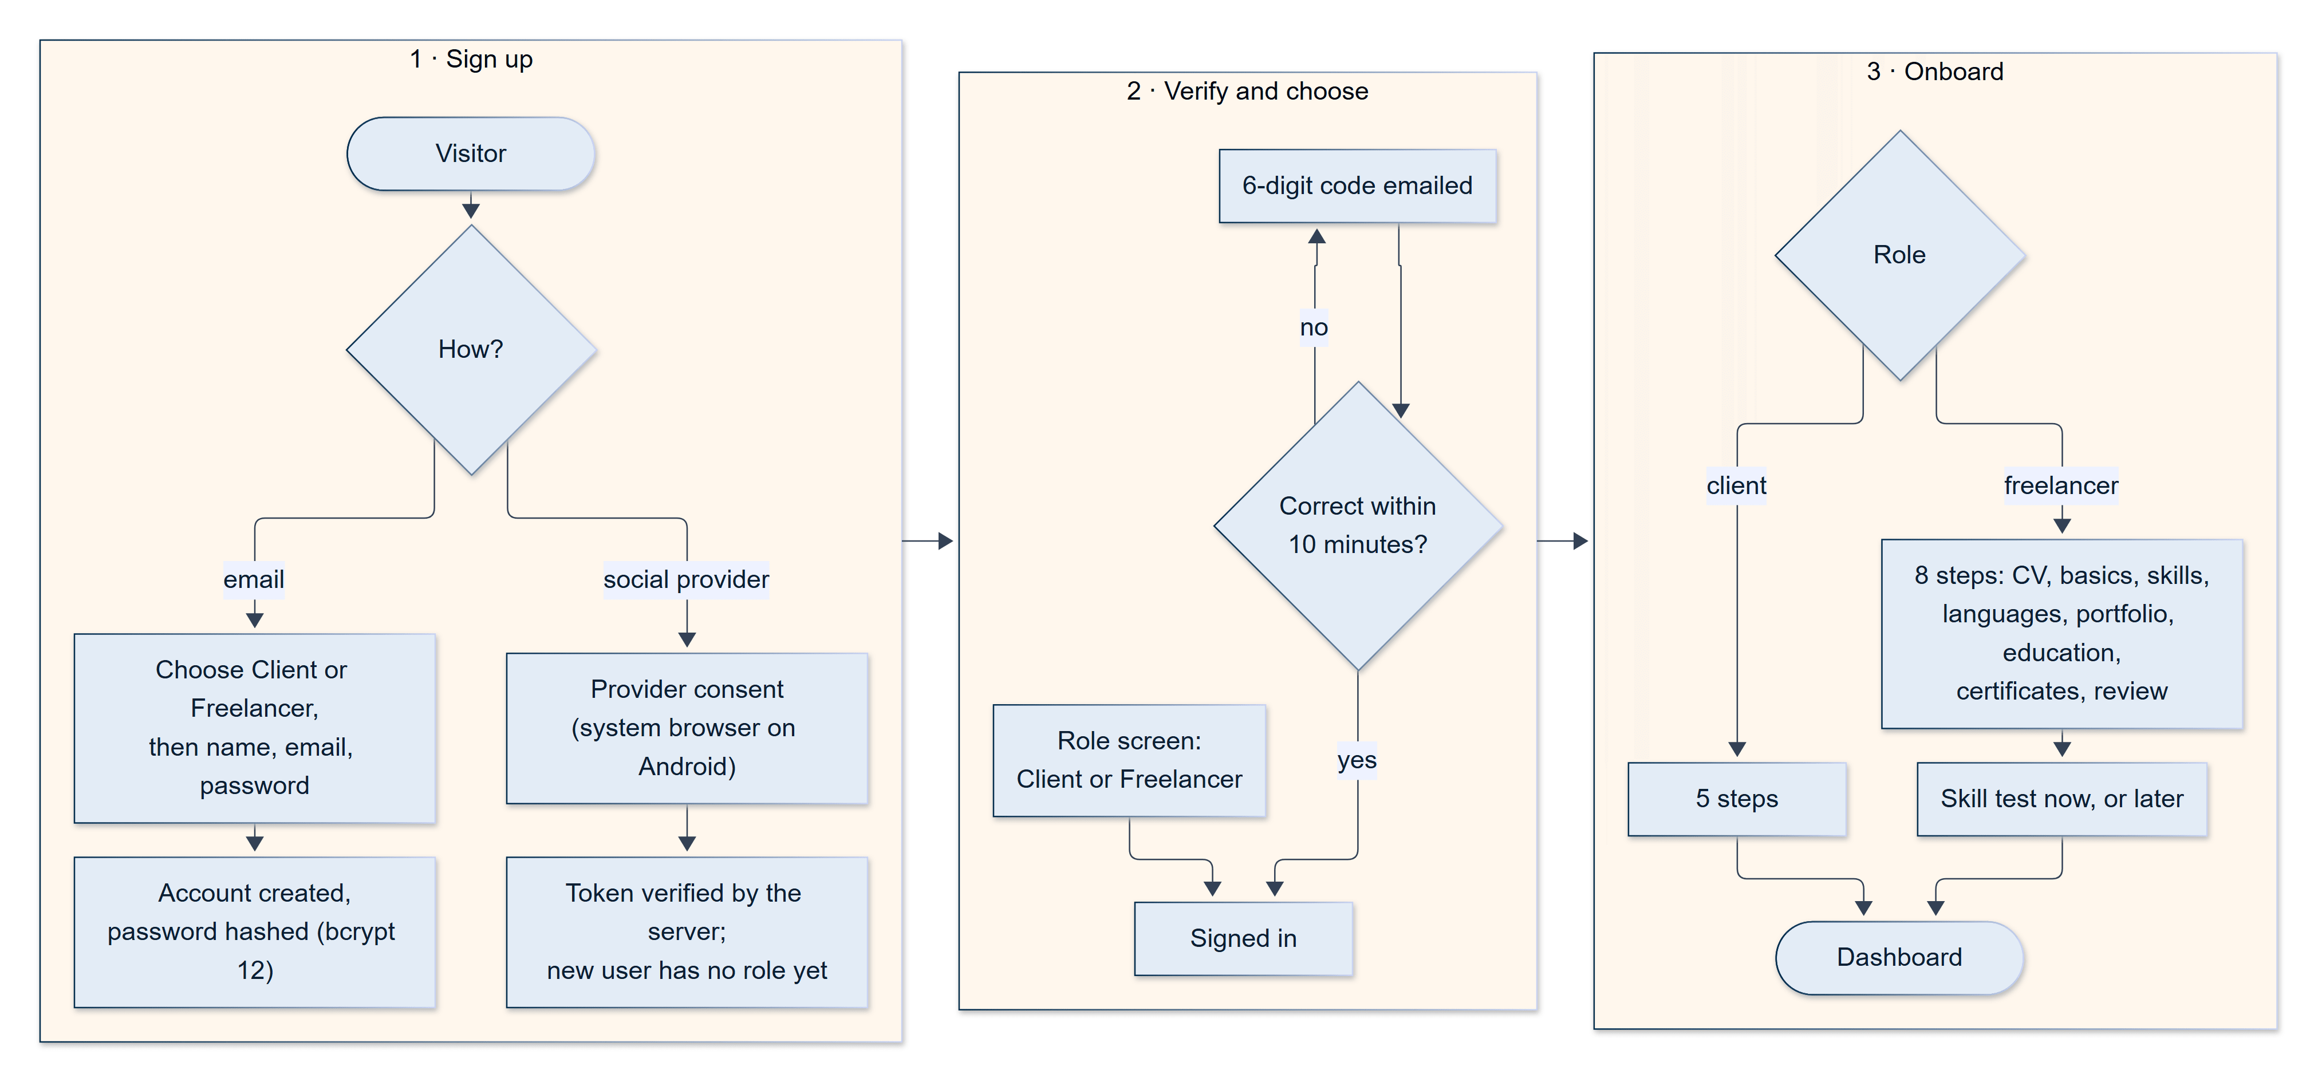
Figure 17.1 — Registration, onboarding and first sign-in
Role is chosen before the account exists for email sign-up; social sign-in users choose it afterwards (Sections 17.1 and 12.1).

17.3 Skill Verification
A freelancer opens the Skill Verification Center, chooses a skill and a level, and starts the test. After the camera check, the test runs in a locked full-screen view with a per-question timer. When it ends, the answers are graded by AI and each skill scoring at least 25% is verified at the chosen level for six months (Section 12.4).

17.4 Hiring on a Fixed-Price Job
- The client posts a job, publishing it with any wallet balance.
- A verified freelancer applies with a proposal, optionally drafted by AI; the apply gate checks eligibility first.
- The client accepts the proposal, optionally splitting the price into milestones. The server checks that the wallet covers the first milestone, creates the contract and milestones, and locks the first milestone's amount. The freelancer is notified.
- The freelancer delivers the first milestone, which starts the review window.
- The client approves — or lets the window lapse — and the milestone is released: the fee is deducted and the payout is credited to the freelancer's wallet.
- For each further milestone, the client funds it when ready, and steps 4 and 5 repeat.
- When the last milestone is released, the contract and the job are completed, and each party can review the other.
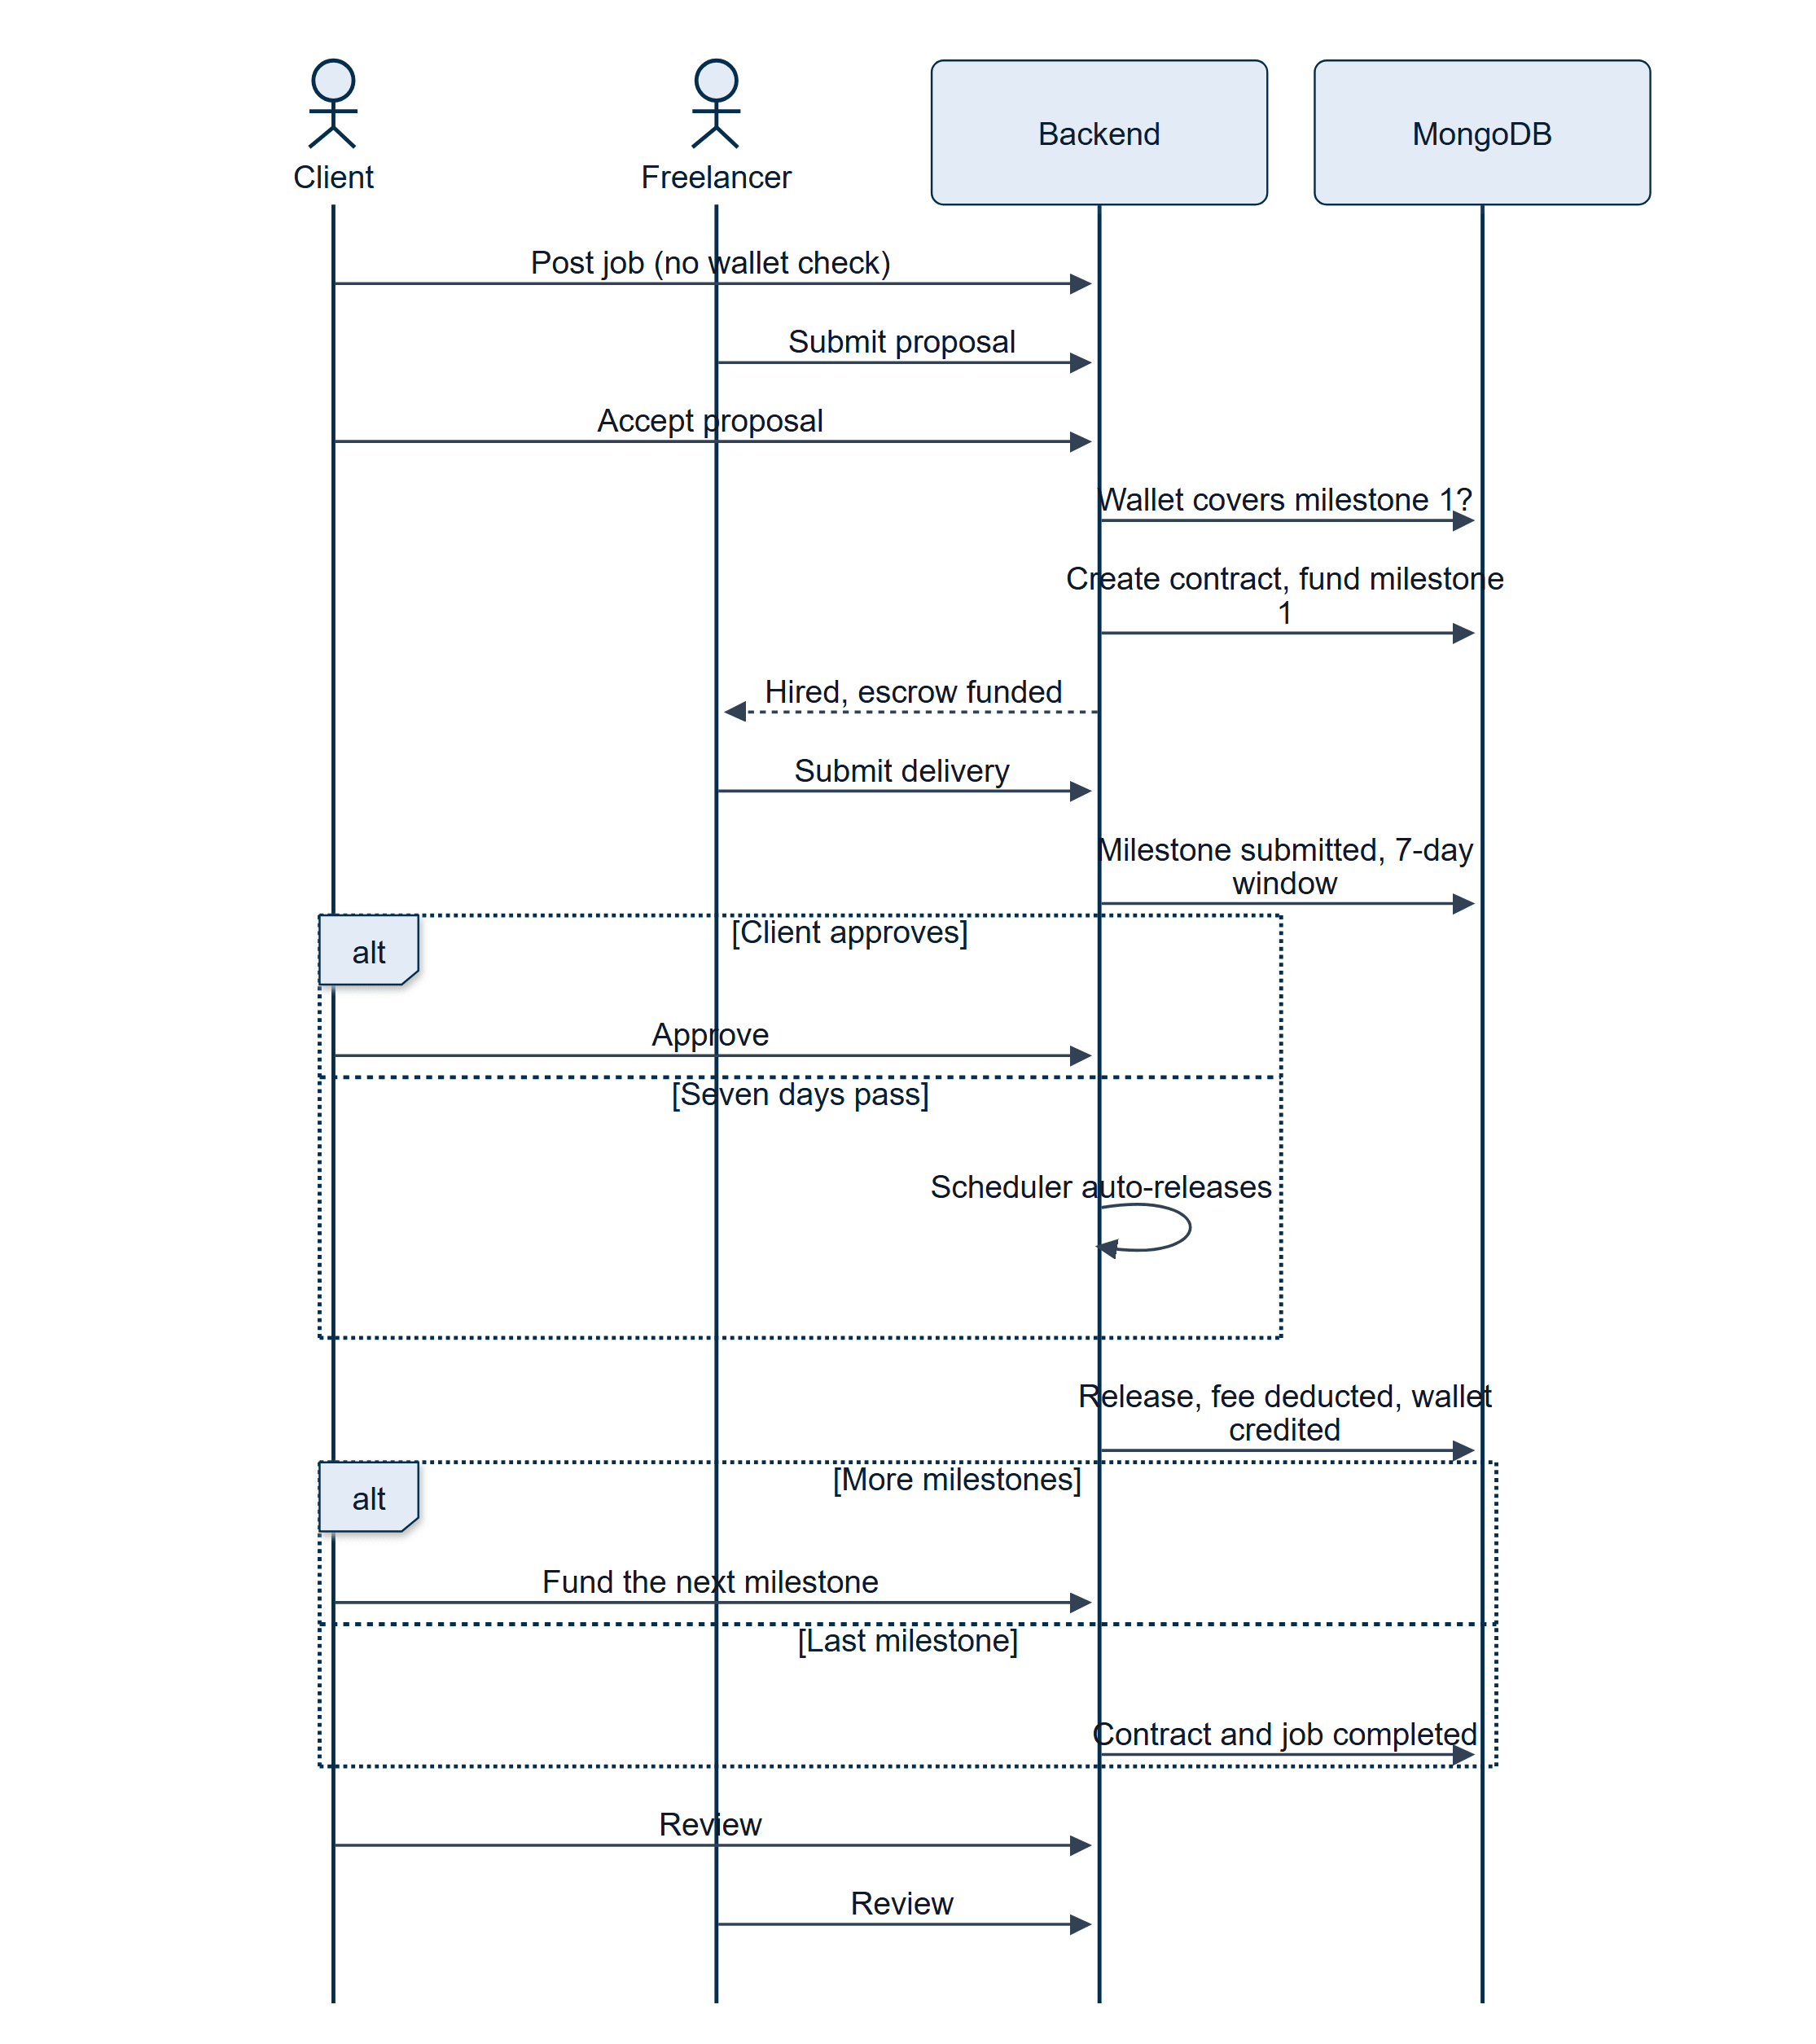
Figure 17.2 — End-to-end workflow of a fixed-price engagement
The funding check precedes every write; release is the same function whether triggered by a click or by the scheduler (Section 17.4).

17.5 Working on an Hourly Contract
When the client accepts an hourly proposal, a week's estimate is locked. The freelancer then starts a timer, works, and stops it; the time is billed against the lock at once, and the freelancer's wallet is credited, net of the fee. If the lock runs out, further logging pauses until the client tops up, at which point any pending time is billed in order. When either party asks to end the contract and the other agrees, the remaining time is settled and what is left in the lock returns to the client's wallet.
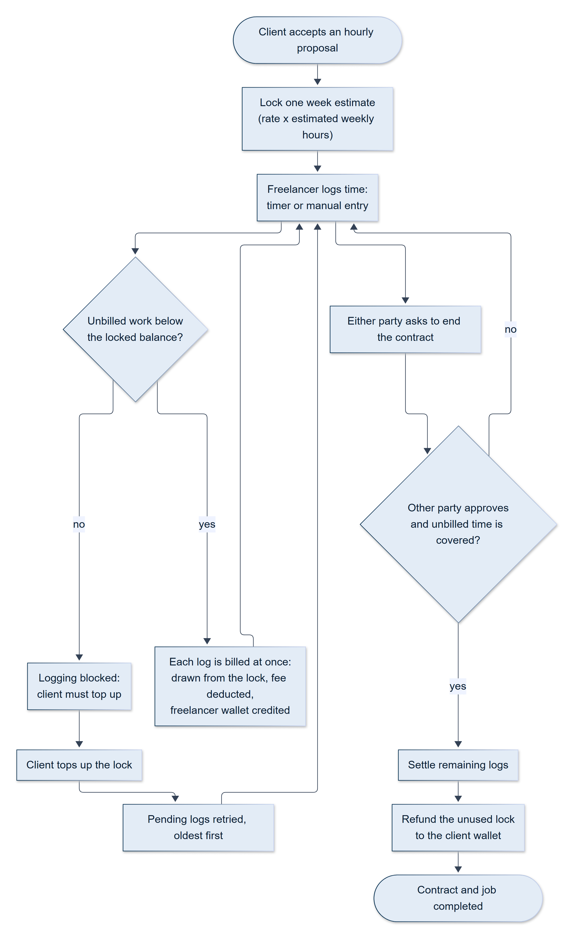
Figure 17.3 — Hourly engagement: lock, bill, top up, end
A lock is a hold, not a spend: whatever is unused returns to the client (Section 17.5).

17.6 Buying a Gig or Accepting a Custom Offer
A client opens a gig, picks a tier, and writes the requirements. The system creates an unpaid order, and the client pays a 50% deposit from the wallet or through Stripe. Only then does the freelancer see the order. After delivery, the client either requests a revision or pays the second half, which completes the order and credits the freelancer. A custom offer reaches the same state through a different door: the freelancer sends it in chat, the client accepts, and the same unpaid order is created.
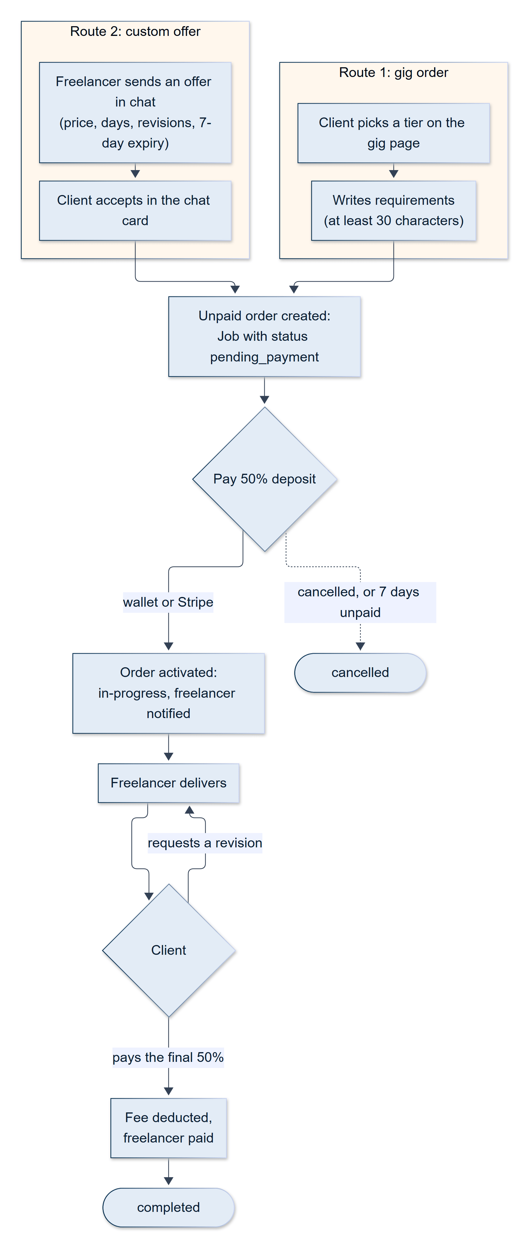
Figure 17.4 — Gig order and custom-offer workflow
A gig order and a custom offer converge on the same pending_payment order (Section 17.6).

17.7 Delivery, Revision, and Release
A delivery is a message with links. For a fixed-price milestone, the client can accept it, which releases the money, or request a revision with written feedback, which returns the milestone to the freelancer; this loop can repeat. If the client does nothing for the length of the review window, the scheduler releases the milestone automatically.

17.8 Disputes
If either party is dissatisfied, they raise a dispute with a reason. For a fixed-price contract the dispute attaches to the milestone under review; for an hourly contract, to the contract. The disputed money is frozen — it can no longer be auto-released — until an administrator reviews the evidence, including the full chat, and chooses to release, refund, split, cancel, or dismiss (Table 12.5). The decision is applied atomically, both parties are notified, and the action is audit-logged.

17.9 Withdrawing Earnings
A freelancer connects a Stripe account once, then requests a withdrawal of at least the minimum amount. The wallet is debited first; Stripe is then asked to pay out; if Stripe fails, the debit is refunded. Withdrawals the backend supports by bank transfer or PayPal are queued for an administrator, who completes or rejects them.
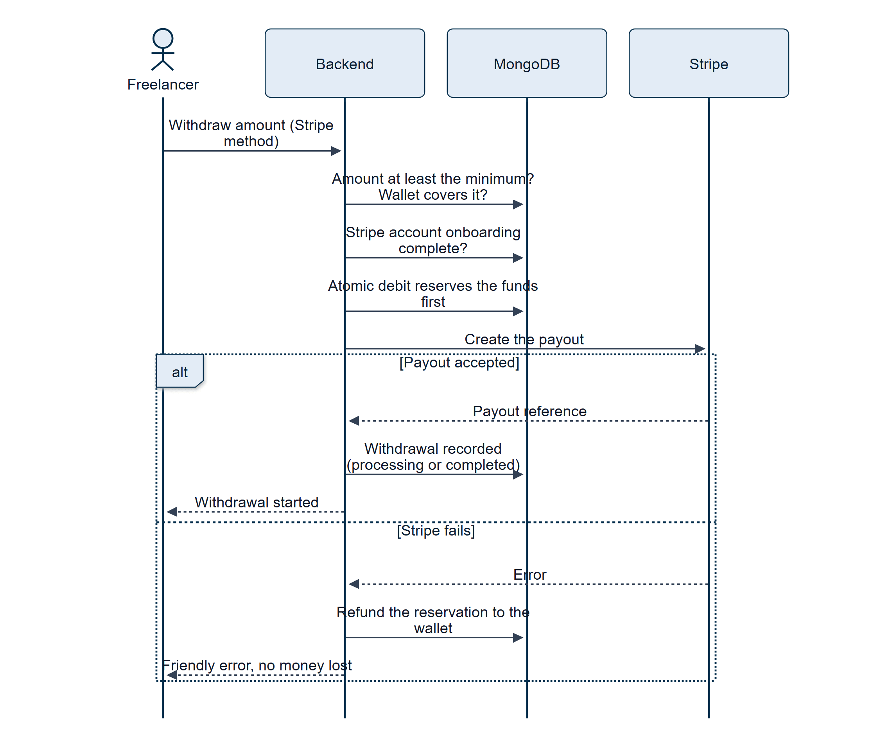
Figure 17.5 — Withdrawal by Stripe Connect payout
The wallet is debited before Stripe is called, which closes the double-payout race (Section 17.9).

17.10 Reviews
After completion, each party can leave a rating and a comment for the other. Reviews update the reviewee's average rating, appear on public profiles, and can be hidden by administrators for policy violations.

17.11 Administrative Moderation
An administrator signs in through the isolated two-step login, monitors the dashboard, and handles the queues: disputes, manual withdrawals, and reports. They may suspend a user, close a job, pause or cancel a contract, adjust a wallet, or reply to a user as SkillKart Support. Every consequential action is recorded in the audit log with the administrator's identity and the previous and new values.

17.12 Where the Money Goes: Worked Examples
The following examples use the default platform fee of 0.5%. All amounts are in rupees.
Table 17.1 — Worked examples of the three escrow models
Scenario | Steps | Result
Fixed price, Rs. 100,000 in two milestones (40,000 and 60,000) | At hire, 40,000 is debited from the client's wallet and locked. On approval, the fee is 40,000 × 0.5% = 200 and the freelancer receives 39,800. The client then funds the second milestone, 60,000; on approval the fee is 300 and the freelancer receives 59,700 | Freelancer total 99,500; platform fee 500; the client was never asked to lock more than one milestone at a time
Hourly, Rs. 1,500 per hour, estimated 20 hours a week | At hire, 1,500 × 20 = 30,000 is locked. The freelancer logs 12 hours: 12 × 1,500 = 18,000 is drawn down, the fee is 90, and the freelancer receives 17,910. The contract then ends | 12,000 remains in the lock and is refunded to the client's wallet
Gig order, Rs. 10,000 | The client pays a deposit of 5,000. After delivery, the client pays the remaining 5,000. The fee is 10,000 × 0.5% = 50 | The freelancer receives 9,950

18. Testing

18.1 Approach
Given the breadth of the system and the sensitivity of its financial and authorisation logic, testing concentrated on four properties: functional correctness of the contract and payment lifecycles, data integrity of the money flows, resilience against the failure of third-party services, and usability across roles and devices.
The project's verification was manual and tool-assisted rather than automated. The repository does not contain an automated unit or integration test suite: the backend's npm test script is a placeholder, and no test runner is configured in either application. Verification instead relied on four complementary practices, described below: structured manual testing by role, end-to-end checks driven through a real browser, scripted checks of individual backend functions against real data, and repeatable demo data. The absence of an automated regression suite is acknowledged as the most significant gap in the testing effort and is the first item in the future-work list (Chapter 21).

18.2 Manual and Exploratory Testing
Every major flow was exercised by hand under each user role: registration and onboarding, job posting, gigs and gig ordering, proposals, the contract lifecycle, milestone and hourly escrow, messaging, reviews, disputes, and every admin module. Both the happy path and the edge cases were covered, including role mismatches, invalid inputs, unauthorised access attempts, insufficient wallet balance at hire, concurrent actions on the same record, and interrupted flows such as a closed browser tab during payment. The backend was also exercised through its interactive Swagger documentation and its /health endpoint.

18.3 Real-Browser End-to-End Verification
The most productive technique was driving the running application through a real browser using Playwright [34], with real AI providers, a real backend, and throwaway test accounts that were removed afterwards. This was chosen deliberately, because a number of defects are invisible to code review and to unit-level checks: they appear only when a real user's clicks, timing, and browser state interact. Table 18.1 lists some of the defects this found.
Table 18.1 — Defects found through real-browser testing
Defect | How it was found | Resolution
A freshly opened second tab, or a browser restart, logged the user out everywhere | An end-to-end run opened successive fresh tabs; the bootstrap re-saved the old refresh token after the server had rotated it, so the next load replayed a rotated token and triggered the theft response | The client now persists the new token returned by the refresh call
The onboarding wizard's Continue button silently did nothing on a validation error | A click-through of onboarding with invalid input: the toast helper had no warn method, so the call threw | Method corrected; every call site of the same bug class was swept
The Connect Stripe button never sent its request | Clicking through the freelancer wallet: a toast helper was called as a function instead of through its methods, before the API call was made | Three call sites fixed; verified by reaching Stripe's hosted onboarding
Every gig order appeared "Delivered" immediately, and a final payment could be released with no delivery | A real gig-order flow: Mongoose saved an empty delivery object on every job, which is truthy | The field no longer defaults to an object, and every check tests delivery.submittedAt
An infinite redirect loop between / and /login in the mobile build | A phone-viewport browser run, with the browser's history calls instrumented to log the code that triggered each navigation | A role-aware root route replaces the unconditional redirect (Section 20.6)
Please fix the errors before saving on an unchanged client profile | The real validator chains were run against every client's would-be payload | Five stacked causes fixed (Section 20.9)
A camera stream that resolved after the user left the test left the camera on | Fault injection into the proctoring hook | A start-sequence guard discards and stops superseded streams (Section 20.5)

Where a flow depends on a camera, the tests used the browser's fake-device options with an image of a face, a blank track to simulate a covered camera, and an injected NotFoundError to simulate a device with no camera. For the native application, the debug build was installed on an Android emulator and driven through the Chrome DevTools protocol.

18.4 Scripted Backend Checks
For logic that is awkward to reach through the interface, small throwaway scripts called backend functions directly against real data and removed their effects afterwards: for example, a script that ran the actual validator chains against every seeded profile; a script that invoked each notification helper and confirmed the resulting records; and a script that sent a push message through the real Firebase service and confirmed the structured response. Tokens for API-level checks were minted directly from the authentication service, which avoids the login rate limit and the two-factor step. Before such a run, a snapshot of the affected collections was taken and restored afterwards, so that the shared development database stayed clean.
A later hardening pass applied the same approach with one important refinement: because the development and production configurations can name the same cloud database, every check was run against an isolated, throw-away local MongoDB that the test harness created and destroyed, never against the shared cluster. A single harness exercised the fixes in-process (about seventy-five assertions covering profile edits, one-time-code resend, the answer key, skill expiry, wallet freezing, signed payment sessions, the admin request guard, the reCAPTCHA exemption limit, the hosted-environment guards, push-token removal, and user reports), and a real-browser run (twenty-two assertions) drove the Report dialog, the corrected public pages, and the job page that no longer shows a client's email.

18.5 Test Data: the Demo Seeder
A demo seeder (npm run seed:demo) populates a realistic, interconnected marketplace across a simulated year of activity: about 200 users (100 freelancers and 100 clients), more than 300 jobs, more than 200 gigs, and over a thousand proposals, together with hundreds of contracts, payments, and reviews and thousands of messages and notifications. It builds every reference from a record that already exists, so the dataset is consistent by construction, and it writes data in the current model: real Milestone documents each linked to its own Payment, disputes on the milestone for fixed-price contracts and on the contract for hourly ones, and wallet-lock payments for hourly work. Two flags adjust a run: --small seeds a compact dataset for quick smoke tests, and --keep appends instead of clearing.
Table 18.2 — Fixed demo accounts
Account | Role | Notes
test.freelancer0@skillkart.com | Freelancer | Top-rated, about 41 completed projects, verified
test.freelancer1@skillkart.com | Freelancer | Mid-level
test.client0@skillkart.com | Client | SME
test.client1@skillkart.com | Client | Startup

These four accounts use the password Pass123!@#, all other seeded accounts use Demo123!@#, and two-factor login is switched off for all of them to make demonstrations quick. The seeder is a destructive tool: by default it drops twenty marketplace collections in whichever database MONGODB_URI names, so it first shows the target database and asks for its name to be typed back (--yes skips the prompt for a throwaway database), refuses a production environment unless --allow-production is given, and only runs when executed directly, so merely loading the file can no longer start a seed. It must still never be pointed at real data. Other scripts support operations: setup:superadmin creates the encrypted SuperAdmin credential, and two idempotent, dry-run-by-default migrations (migrate:hourly-escrow and migrate:skill-verification) bring existing records in line with later design changes. A skill-graph seed script loads the roughly 180-node taxonomy.
Keeping the seeder current is itself part of the work: when escrow moved from one payment per contract to one per milestone, the seeder needed a substantial rewrite, as otherwise the demonstration data would have drifted from the real schema (Section 20.12).

18.6 Resilience Testing
The AI subsystem was exercised by running the application with invalid or missing provider credentials, confirming that the API returned a controlled 503, that the interface displayed a single notice while keeping its forms usable, and that the server stayed up. Email was exercised in sandbox mode and with the provider switch, payments in simulated mode, and optional integrations — push, reCAPTCHA, Supabase, Redis — in an unconfigured state to confirm that dependent features degrade rather than error. Authorisation was exercised through role-mismatch redirects and forbidden-action attempts.

18.7 Interface and Responsiveness Testing
The interface was verified on desktop and phone-sized viewports using browser automation to capture and inspect real rendered screens, and on the Android emulator. This practice surfaced and fixed a series of layout defects, among them a stepper that overflowed small screens, a notification bell that overlapped a header toggle, stacked small buttons, and dead padding at the top of pages, as well as a mobile viewport-height and authentication-layout issue and animated-background jank in the WebView. Because the technique is cheap, it was repeated throughout development rather than done once.

18.8 Performance Considerations
Listing endpoints use server-side pagination (default ten, maximum one hundred) and indexed queries; the production frontend build is code-split, with twenty-two pages loaded lazily; the sitemap is cached for an hour; and identical in-flight requests are de-duplicated on the client. Two known costs are accepted and documented: chat and project pages poll every few seconds, and two list calls on the dashboards return only the most recent ten records. No formal load testing was performed.

18.9 Test Gaps
For completeness, the following gaps are acknowledged: there is no automated regression suite; there was no formal load or penetration testing; and the Android applications were tested on an emulator and in a phone-sized browser, not across a range of physical devices. These are carried into Chapter 21.

19. Results

19.1 Achievement of Objectives
All project objectives (Chapter 5) were achieved and demonstrated on the running system, against realistic seeded data.
Table 19.1 — Achievement of the project objectives
# | Objective | Status | Evidence
1 | Dual-sided marketplace: gigs, jobs and proposals, custom offers | ✔ Achieved | Sections 12.7–12.10; gig orders, proposals, and chat offers all end in a tracked, paid engagement
2 | Integrated AI | ✔ Achieved | 14 LLM-backed capabilities behind a six-provider router, plus a rules-based matchmaking engine (Chapter 13)
3 | Secure escrow payments, wallets, withdrawals | ✔ Achieved | Per-milestone and balance-lock escrow, Stripe top-ups and Connect payouts, configurable fee, auto-release (Sections 12.12–12.15)
4 | Multi-factor verification | ✔ Achieved | Email OTP, optional two-factor login, proctored three-level skill tests, skill-gated applying and publishing (Sections 12.1, 12.4, 12.5). An automated identity check was not built; an administrator can set an identity flag manually
5 | Comprehensive administrative panel | ✔ Achieved | 17 modules with isolated authentication and an audit log (Chapter 14)
6 | Strong security | ✔ Achieved | Rotating tokens, validation, sanitisation, rate limits, bot detection, audit trail (Chapter 16); hardening roadmap in Section 16.10
7 | Explicit contract lifecycle | ✔ Achieved | State machines for jobs, proposals, contracts, milestones, payments, and withdrawals (Sections 10.5 and 12.11)
8 | Resilience and graceful degradation | ✔ Achieved | AI fallback and controlled 503, fail-open optional integrations, operational-error guard (Sections 13.4, 16.9)
9 | Native mobile access | ✔ Achieved | Two Capacitor-based Android applications with camera, push, offline, and back-button integration (Chapter 15)

19.2 System Statistics
Table 19.2 — System statistics
Metric | Value
Application source files | 475 (197 backend, 202 frontend, 76 stylesheets)
Lines of code | 117,939 (36,475 backend; 50,378 frontend JavaScript and JSX; 31,086 CSS)
Data models (collections) | 40
API route modules | 26 (25 under /api/v1/* plus the isolated /api/v1/admin-panel)
API endpoints | 317 under /api/v1 (93 admin panel), plus 6 root and webhook routes
Controllers | 35 (26 marketplace and 9 admin panel)
Service files | 49 (26 core, 9 AI router, 14 email)
Middleware / validator / utility modules | 10 / 11 / 15
Frontend pages / reusable components / API modules | 79 / 57 / 24
Backend runtime dependencies | 42 (and 5 development)
Frontend runtime dependencies | 30 (and 12 development)
AI providers integrated | 6 (Gemini, DeepSeek, Qwen, Groq, Claude, Ollama)
LLM-backed AI capabilities | 14 (plus non-LLM matchmaking and on-device proctoring)
Admin panel modules | 17 sidebar modules, 7 detail screens
Notification event types | 25 (plus the administrator broadcast)
Scheduled jobs | 5
User roles | 6
Native Android applications | 2 (client and freelancer; administrator)
Git commits | more than 300

19.3 Requirements Coverage
All 37 functional requirements in Tables 6.2 to 6.6 are implemented; the non-functional requirements in Table 6.7 are met by the mechanisms named there. Where an implementation is narrower than the requirement's wording suggests, the section cited in the requirement describes the exact behaviour.

19.4 Outcome
The result is a complete, working, production-oriented freelance marketplace rather than a prototype. It delivers the full engagement lifecycle — registration and verification, discovery, proposals and orders, escrow-secured work, delivery and review, disputes, and withdrawals — with AI assistance, layered verification, comprehensive administration, and native mobile access. It also demonstrates sound engineering practice: a layered architecture, explicit state machines, atomic money operations, resilient integration of unreliable third-party services, and defence in depth.

19.5 System Screenshots
The figures below show the running system on the seeded demonstration dataset described in Section 18.5. All names, companies, and amounts are fictitious. Further screens, grouped by role, are collected in Appendix D.
SCREENSHOT TO BE INSERTED
Public home page
thesis-figures/screens/public-home.png

Figure 19.1 — Public home page
SCREENSHOT TO BE INSERTED
Browse Gigs
thesis-figures/screens/public-browse-gigs.png

Figure 19.2 — Browse Gigs
SCREENSHOT TO BE INSERTED
Gig detail with tiered pricing and ordering
thesis-figures/screens/public-gig-detail.png

Figure 19.3 — Gig detail with tiered pricing and ordering
SCREENSHOT TO BE INSERTED
Job detail and proposal form with the AI cover-letter draft
thesis-figures/screens/public-job-detail.png

Figure 19.4 — Job detail and proposal form with the AI cover-letter draft
SCREENSHOT TO BE INSERTED
Post-a-job wizard
thesis-figures/screens/client-post-job.png

Figure 19.5 — Post-a-job wizard
SCREENSHOT TO BE INSERTED
Accepting a proposal with a milestone split
thesis-figures/screens/client-accept-proposal.png

Figure 19.6 — Accepting a proposal with a milestone split
SCREENSHOT TO BE INSERTED
Client's My Projects with milestone escrow status
thesis-figures/screens/client-my-projects.png

Figure 19.7 — Client's My Projects with milestone escrow status
SCREENSHOT TO BE INSERTED
Freelancer dashboard with the Skill Verification Center
thesis-figures/screens/freelancer-dashboard.png

Figure 19.8 — Freelancer dashboard with the Skill Verification Center
SCREENSHOT TO BE INSERTED
Skill test level picker and rules screen
thesis-figures/screens/freelancer-skill-test-rules.png

Figure 19.9 — Skill test level picker and rules screen
SCREENSHOT TO BE INSERTED
Freelancer's My Work: delivery, timer, and time logs
thesis-figures/screens/freelancer-my-work.png

Figure 19.10 — Freelancer's My Work: delivery, timer, and time logs
SCREENSHOT TO BE INSERTED
Client wallet: balance, escrow, and transaction history
thesis-figures/screens/client-wallet.png

Figure 19.11 — Client wallet: balance, escrow, and transaction history
SCREENSHOT TO BE INSERTED
Admin panel dashboard
thesis-figures/screens/admin-dashboard.png

Figure 19.12 — Admin panel dashboard

19.6 Known Limitations
For completeness and honesty, the delivered system has the following known limitations. None changes the correctness of the money and contract flows.
- No automated regression suite (Section 18.9).
- Polling, not push, for chat — latency of a few seconds and extra requests (Section 12.18).
- Gig orders have no contract, so they have no milestone, automatic release, or dispute path (Section 12.9).
- The CMS is back-end only: pages can be authored and scheduled through the API, but there is no editor screen and no public page renders them.
- Admin push notifications and automatic identity verification were not built.
- Several administrator settings are stored but reserved (Table 14.2).
- Redis is connected at start-up but not yet used for caching.

20. Challenges Faced
Several substantive technical challenges were encountered and solved during development. They are described here as challenge, solution, and lesson, because the lessons shaped the conventions that the code now follows.

20.1 Unreliable Free-Tier AI Providers
Challenge. Free-tier AI APIs are heavily rate-limited and intermittently unavailable. Any feature that called a single provider directly was unusable in practice, and a failure could crash dependent flows.
Solution. A multi-provider router with a prioritised, environment-configurable fallback chain (Gemini → DeepSeek → Qwen → Groq → Claude → Ollama), ending in a quota-free local model for the capabilities it supports. Every total failure returns a controlled 503, which the process-level guard recognises as an operational error and survives, and which the interface turns into one consistent notice (Section 13.4).
Lesson. Treat a third-party model as an optional enhancement. A chain of fallbacks gives resilience, but without a circuit breaker it also gives slow failures — a trade-off recorded in Section 13.3.

20.2 Money Correctness Without Transactions
Challenge. Money movement must be exactly correct and auditable, yet the codebase uses no multi-document transactions. A self-directed audit of the payment paths found several races. In the Stripe withdrawal path the real payout was requested before the wallet was debited, so two concurrent requests could both pass the balance check and both receive a real payout. Several release and refund functions were plain read-then-write sequences, so a double click, or a manual approval racing the hourly scheduler, could credit a wallet twice.
Solution. The withdrawal now debits first (reserving the funds), calls Stripe, and refunds the reservation on failure. Release, draw-down, refund, and activation functions were rewritten as atomic claims — a single findOneAndUpdate with a status or balance guard — so that only one caller can win. A subtle point made this harder than it looks: several callers hold the contract in memory and save it again after calling these functions, so each atomic update must also keep the in-memory copy in step, or a later save() silently overwrites the atomic change with a stale value.
Lesson. Without transactions, correctness comes from strict ordering and from making every state change a conditional, single-document update. A related trap was found in the settings code: two administrator-editable settings (the platform fee and the minimum withdrawal) were stored but never read, and the stored fee (5%) was ten times the fee actually applied (0.5%), so an administrator "changing" them did nothing. They were wired up to be read at run time; because defaults are seeded only on insert, fixing the defaults array alone would not have corrected rows that were already seeded, so a guarded one-time correction was added that never overwrites a value an administrator had deliberately set.

20.3 Stale Authentication After a Role Change
Challenge. When a new user selected a role and continued, they were sometimes redirected to an "unauthorised" page. An authentication-state throttle returned a stale role, so the route guards evaluated the old role.
Solution. The explicit "refresh authentication" call now forces a fresh fetch, bypassing the throttle, so that the updated role is available before navigation.

20.4 A Refresh-Token Bug Found Only in a Real Browser
Challenge. Refresh tokens rotate: every refresh revokes the old token and returns a new one. The session-restore code on page load saved the old token again after refreshing. A second fresh tab, or a browser restart more than ten seconds later, then replayed an already-rotated token, which the server correctly treated as theft — revoking the whole token family and logging the user out everywhere. The defect existed since rotation was introduced and was invisible to code review.
Solution. A one-line change persists the new token returned by the refresh call, verified with three successive fresh tabs.
Lesson. A security feature and a client that does not honour its contract can combine to produce an apparent "random logout". Only a test that opened real tabs over real time exposed it.

20.5 Proctoring That Detected Nothing on Android
Challenge. The first camera guard used a face-detection library on the GPU. It worked on a desktop browser but, on Android, the WebView created a graphics context without error and then silently failed every inference, so the guard never detected anything. A further finding, measured on the emulator, was that the WebView freezes the camera feed for three to four seconds at a time; a frozen frame was analysed repeatedly, so one episode of a missing face earned several strikes.
Solution. The guard was rebuilt on MediaPipe's Face Landmarker with a CPU delegate on Android, and frame counting that pauses the countdown while the feed is frozen. After the team decided that the single camera rule should be face presence only — no head-turn, gaze, or movement checks — the detector was simplified accordingly, and the whole camera behaviour was reduced to one backend setting. Fault injection against the finished hook found four more weaknesses (a late ended event from a superseded stream cancelling a healthy test, a camera left running after the user left the page, an error that never cleared, and no way back after a dead camera), each fixed and re-verified with the same injections.
Lesson. Behaviour tested only on a desktop browser cannot be assumed on a WebView. A smaller, simpler rule that works everywhere is preferable to a richer one that fails silently. Another quirk is worth recording: the full-screen test overlay sits above the toast layer, so a toast raised during a test is invisible, and in-test messages must be drawn inside the overlay.

20.6 An Infinite Redirect Loop in the Mobile App
Challenge. Users of the Android build reported flicker, lag, random logouts, and a Find Work page that would not open. A live reproduction found a single cause: on mobile the root path was an unconditional redirect to the login page, while the login page redirected authenticated users to the root path. Any signed-in user who ever rendered the login page entered an endless / ⇄ /login loop at about 150 milliseconds per cycle. A second, related defect then appeared: a delayed post-login redirect raced with the immediate redirect of an effect, and whichever fired last won.
Solution. The root route was replaced by a component that checks the authentication state and sends the user to the right dashboard for their role, which makes navigating to / safe from anywhere, and the effect now yields while a login submission is in flight.
Lesson. The technique mattered as much as the fix: instrumenting the browser's history calls to log the code responsible for each navigation pinpointed the offending line at once, where watching URLs would only have shown the symptom.

20.7 Email Delivery Blocked by the Hosting Platform
Challenge. Registration is gated by an emailed OTP, so email is not auxiliary: if it fails, nobody can create an account. The SMTP implementation worked in development and then silently failed once deployed, because cloud platforms commonly block outbound SMTP ports (465 and 587) to prevent abuse. No amount of debugging the application code could have surfaced this.
Solution. Email was refactored behind a provider abstraction selected by one environment variable, and the Gmail API was implemented as an HTTPS transport unaffected by port blocking. The registry-and-factory design means a new provider needs one file and one registry line. SMTP remains the local default and the start-up fallback.
A subtle point arose: it is tempting to assume that, since the platform already has Google sign-in through Supabase, it holds credentials able to send mail. It does not. Supabase authenticates end users, whereas sending a transactional message requires authority over a mailbox the platform itself owns, often at moments when no user session exists, such as a password-reset code. The two concerns were therefore kept entirely separate.

20.8 Cross-Site Cookies Between Separately Hosted Apps
Challenge. The admin panel authenticated correctly on a developer's machine but, once deployed, looped endlessly: after a successful OTP verification the dashboard redirected straight back to the login screen. The cookie was being issued and accepted but never returned.
Solution. The frontend (on Vercel) and the API (on Railway) are on different domains, so every API call is cross-site, and the SameSite=Strict setting that is correct on a single origin tells the browser to withhold the cookie on exactly those requests. Locally, both apps run on localhost, which is same-site, so the defect was invisible in development. The fix required SameSite=None together with Secure [39] and, on the server, trust proxy: the host terminates TLS at its proxy and forwards plain HTTP, so without it the application believes the connection is insecure and declines to mark the cookie Secure. The decision is made from the request protocol, not an environment label, because tying security behaviour to a label breaks as soon as the deployed environment is not labelled exactly as expected.
Lesson. A locally passing test is not evidence of correctness for behaviour that only manifests across origins.

20.9 An Empty Value That Was Truthy
Challenge. Two defects of the same class appeared in different places. First, every job saved an empty delivery: { links: [] } object, because Mongoose defaults nested arrays to [] and the parent object therefore exists. Code that tested if (job.delivery) always passed, so every gig order looked "delivered" at once, and a client could release the final payment with no delivery. Second, a client profile could not be saved ("Please fix the errors before saving") even when unchanged. Five stacked causes were hiding one another, the first being an expression that combined two array fields with ||: an empty array is truthy and so hid the filled-in field.
Solution. The fields no longer default to an object, and every check tests a real sub-field (delivery.submittedAt); older rows still carry the stub, so checking the object itself is never safe. For the profile, all five causes were found at once by running the real validator chains against every client's would-be payload in a script, which was much faster than clicking and fixing one error at a time.
Lesson. Never combine two Mongoose array fields with ||; test their length. For optional selects in express-validator, use optional({ values: 'falsy' }).

20.10 Push Notifications That Silently Never Worked
Challenge. Push notifications never reached a device even though the Firebase credential was complete and valid. The server logged a single start-up warning and then behaved as if push were simply not configured, which is exactly the designed fail-open behaviour — and therefore indistinguishable from a missing credential.
Solution. The installed firebase-admin v14 had dropped the old monolithic API (admin.apps, admin.credential.cert, admin.messaging) that the service was written against. Switching to the modular subpath imports fixed it, and a throwaway script confirmed that a call reached Google's servers and returned a real structured response. While tracing every notification helper to its real call site, three helpers that were never called were wired in, and one direct write that bypassed notify() was routed through it.
Lesson. Fail-open design protects availability but can hide a defect indefinitely; a start-up warning is not enough to tell "not configured" from "broken". A check that exercises the real service is.

20.11 A Toast Library Incompatible with React 19, and a Silent Method-Name Bug
Challenge. The chosen toast library crashed the component tree under React 19 ("Element type is invalid"), so surfacing an error — including the AI-outage notice — could take down the page.
Solution. A small, dependency-free toast utility renders a plain DOM node directly. During end-to-end testing, a second problem of the same family appeared: several call sites used toast.warn(...) or called the toast object as a function, neither of which exists on the new utility. Because the object does exist and has other methods, neither a linter nor the compiler could notice, and the calls threw only when a user hit the path — breaking onboarding on any validation error. The call sites were fixed and swept.
Lesson. This bug class is visible only by exercising the flow. A targeted search for the wrong method name early in any future review is cheap.

20.12 Keeping Test Data Honest as the Model Changes
Challenge. Meaningful testing and demonstration require large volumes of coherent, interrelated data, and the generator that produces it must keep pace with the model it simulates.
Solution. A seeder builds a fully interconnected dataset in batches. When escrow moved from one payment per contract to the per-milestone design, the seeder was rewritten to create real milestones, each linked to its own payment, and to place each dispute where the current model puts it. Left alone, the demonstration data would have drifted from the schema and kept demonstrating a payment model the platform no longer uses.

20.13 A Modal Overlay Trapped by a CSS Transform
Challenge. A pop-up rendered with visible strips at the sides of the screen. A position: fixed element inside a transformed ancestor is positioned relative to that ancestor, not the viewport.
Solution. The modal is rendered through a React Portal into document.body, so that it escapes the transformed container and covers the full viewport.

20.14 Writing the Report as a Test of the Code
Challenge. A first draft of this very report described several behaviours that the code did not have: an administrator model backed by the database, a skill verification that never expired on the profile, a wallet freeze that nothing enforced, and a fee and an AI vendor on the public pages that differed from what the system did.
Solution. Each chapter was rewritten from a read-only audit of the code rather than from memory, and every discrepancy was then resolved in one of two ways: the report was corrected where the code was right, and the code was fixed where the code was wrong — a profile save that reset every earned rank, a sign-in code that could not be re-sent, a test whose answer key was sent to the browser, a wallet freeze that was never checked, a guessable simulated payment, a client email on a public page, and others. The fixes were verified against an isolated database and in a real browser.
Lesson. Documentation checked line by line against the system is itself a form of testing: writing down exactly what a feature does is the quickest way to find where it does not do it.

21. Future Enhancements
SkillKart is feature-complete for its intended scope, and the limitations in Sections 16.10 and 19.6 define the natural next steps. They are grouped below by theme, roughly in order of recommended priority within each group.

21.1 Quality and Operations
- An automated test suite. Backend unit and integration tests for the escrow, contract, and authentication logic (using a test runner with HTTP-level checks), and a committed set of end-to-end browser tests derived from the verification scripts of Chapter 18, run in continuous integration. This is the single most valuable addition.
- Observability. Structured logging with a log library (one is already a declared dependency), log retention policies, and metrics and alerting for failures and latency.
- Caching and scale. Use the already-connected Redis for caching hot reads and for a shared rate-limit store, so that the application can run as several instances; move the administrator one-time-code store out of process memory for the same reason.
- Load and security testing, including an independent penetration test before a public launch.

21.2 Product Features
- Real-time communication. WebSocket-based chat and WebRTC video calls, replacing polling.
- iOS. The existing Capacitor project can be extended to iOS with comparatively little additional work, given a macOS build environment.
- Disputes and contracts for gig orders, giving the fixed-package route the same milestone, automatic-release, and dispute protections as the proposal-based route.
- Hourly approvals. An optional client approval step for logged time, for clients who want it.
- Notification preferences by event type, and push notifications for administrators.
- A CMS editor in the admin panel, so that the existing back end has a screen to author pages.
- Multi-language and multi-currency support.
- Richer analytics, including dispute analytics and configurable reports for administrators and users.

21.3 AI
- A circuit breaker for failing providers, so that a known-down provider is skipped for a cool-down instead of being retried on every request.
- Embedding-based semantic matching to complement the rules-based engine for deeper freelancer-to-job matching.
- Grading against the stored answer key, so that multiple-choice questions are scored deterministically rather than on the grader's own judgement, and server-side enforcement of test time limits.
- AI-assisted dispute summaries, automated profile-improvement coaching, and fraud detection.

21.4 Trust and Security
- Automatic identity verification through a verification provider, replacing the manual administrator flag.
- A multi-administrator role model — finance, support, moderator, and analytics roles — using the data model and route permissions already in place, with a persisted one-time-code store.
- Shorter-lived access tokens, a cryptographically secure code generator, and security headers on the frontend host (Section 16.10).

22. Conclusion
SkillKart set out to build more than a job board: a secure, intelligent, and trustworthy freelance marketplace that lowers the barrier for new freelancers while protecting everyone who takes part. The completed platform achieves this. It unifies the two dominant freelancing models — gigs and jobs with proposals — and adds a third route, custom offers in chat. It augments them with an integrated AI layer, a wallet-native escrow system that fits the way each kind of work is actually paid for, layered verification centred on a proctored skill test, a two-way review system, structured dispute resolution, and a comprehensive, isolated admin panel. It is delivered not only as a web application but as two native Android applications built from the same codebase.
Technically, the project demonstrates sound engineering across the stack: a decoupled client–server architecture; a strictly layered backend; explicit state machines for the contract, milestone, and payment lifecycles; money operations that are correct under concurrency without the help of database transactions; a resilient multi-provider AI subsystem that degrades gracefully instead of failing; and defence-in-depth security with rotating tokens, validation, rate limiting, bot detection, and an audit trail. Each of the nine objectives was achieved and demonstrated on a realistic, seeded dataset.
The project was also a substantial education in building a production-oriented application. The most instructive lessons were not the features themselves but the defects: a refresh-token bug that appeared only when real tabs were opened over real time; a camera guard that worked on a desktop and silently detected nothing on a phone; a redirect loop that only a live phone-sized run could expose; a push service that was perfectly configured and never worked; and a cookie that behaved correctly everywhere except across two domains. Each reinforced the same point — that a system must be exercised as its users will exercise it, in the environments in which they will use it — and each left a convention in the codebase that prevents its recurrence.
The report has also tried to be candid about what remains: the absence of an automated regression suite, the places where a designed control is not yet enforced, and the hardening that a public launch would warrant. These are recorded in Chapters 16, 19, and 21 not as failures but as an honest account of a system that is complete for its purpose and clear about its next steps. SkillKart stands as a complete, submission-ready Final Year Project that reflects both the breadth of its features and the depth of its engineering.

23. References
References are numbered in the order of the reference list and cited in the text in square brackets. Online documentation was consulted during development in 2026; each entry gives the canonical address of the resource.
[1] MongoDB, Inc., "MongoDB Manual," MongoDB Documentation. [Online]. Available: https://www.mongodb.com/docs/manual/
[2] OpenJS Foundation, "Node.js Documentation." [Online]. Available: https://nodejs.org/en/docs/
[3] OpenJS Foundation, "Express — Node.js web application framework." [Online]. Available: https://expressjs.com/
[4] Meta Open Source, "React Documentation." [Online]. Available: https://react.dev/
[5] Vite contributors, "Vite — Next Generation Frontend Tooling." [Online]. Available: https://vite.dev/
[6] Automattic, Inc., "Mongoose ODM Documentation." [Online]. Available: https://mongoosejs.com/docs/
[7] Stripe, Inc., "Stripe API Reference" and "Stripe Connect Documentation." [Online]. Available: https://docs.stripe.com/api and https://docs.stripe.com/connect
[8] Google, "Gemini API Documentation." [Online]. Available: https://ai.google.dev/gemini-api/docs
[9] M. Jones, J. Bradley, and N. Sakimura, "JSON Web Token (JWT)," Internet Engineering Task Force, RFC 7519, May 2015. [Online]. Available: https://www.rfc-editor.org/rfc/rfc7519
[10] OWASP Foundation, "OWASP Top Ten Web Application Security Risks." [Online]. Available: https://owasp.org/www-project-top-ten/
[11] Fiverr International Ltd., "Fiverr." [Online]. Available: https://www.fiverr.com/
[12] Upwork Global Inc., "Upwork." [Online]. Available: https://www.upwork.com/
[13] Freelancer Technology Pty Ltd., "Freelancer.com." [Online]. Available: https://www.freelancer.com/
[14] DeepSeek, "DeepSeek API Documentation." [Online]. Available: https://api-docs.deepseek.com/
[15] Ionic, "Capacitor Documentation." [Online]. Available: https://capacitorjs.com/docs
[16] Google AI Edge, "MediaPipe Face Landmarker guide." [Online]. Available: https://ai.google.dev/edge/mediapipe/solutions/vision/face_landmarker
[17] Google, "Firebase Cloud Messaging." [Online]. Available: https://firebase.google.com/docs/cloud-messaging
[18] Cloudinary Ltd., "Cloudinary Documentation." [Online]. Available: https://cloudinary.com/documentation
[19] Google, "reCAPTCHA v3." [Online]. Available: https://developers.google.com/recaptcha/docs/v3
[20] Supabase, Inc., "Supabase Auth Documentation." [Online]. Available: https://supabase.com/docs/guides/auth
[21] J. Kässi and V. Lehdonvirta, "Online Labour Index: Measuring the online gig economy for policy and research," Technological Forecasting and Social Change, vol. 137, pp. 241–248, Dec. 2018.
[22] P. A. Pavlou and D. Gefen, "Building effective online marketplaces with institution-based trust," Information Systems Research, vol. 15, no. 1, pp. 37–59, Mar. 2004.
[23] R. T. Fielding, "Architectural styles and the design of network-based software architectures," Ph.D. dissertation, Dept. of Information and Computer Science, Univ. of California, Irvine, CA, USA, 2000.
[24] N. Provos and D. Mazières, "A future-adaptable password scheme," in Proc. USENIX Annual Technical Conf. (FREENIX Track), Monterey, CA, USA, Jun. 1999, pp. 81–91.
[25] Google, "Gmail API." [Online]. Available: https://developers.google.com/gmail/api
[26] OpenAPI Initiative, "OpenAPI Specification." [Online]. Available: https://spec.openapis.org/oas/latest.html
[27] Anthropic, "Claude API Documentation." [Online]. Available: https://docs.anthropic.com/
[28] Groq, Inc., "GroqCloud Documentation." [Online]. Available: https://console.groq.com/docs
[29] Alibaba Cloud, "Qwen — Model Studio Documentation." [Online]. Available: https://www.alibabacloud.com/help/en/model-studio/
[30] Ollama, "Ollama — run large language models locally." [Online]. Available: https://ollama.com/
[31] Railway Corp., "Railway Documentation." [Online]. Available: https://docs.railway.com/
[32] Vercel, Inc., "Vercel Documentation." [Online]. Available: https://vercel.com/docs
[33] MongoDB, Inc., "MongoDB Atlas Documentation." [Online]. Available: https://www.mongodb.com/docs/atlas/
[34] Microsoft, "Playwright Documentation." [Online]. Available: https://playwright.dev/docs/intro
[35] Tailwind Labs, "Tailwind CSS Documentation." [Online]. Available: https://tailwindcss.com/docs
[36] P. Resnick and R. Zeckhauser, "Trust among strangers in Internet transactions: Empirical analysis of eBay's reputation system," in The Economics of the Internet and E-Commerce, ser. Advances in Applied Microeconomics, vol. 11, M. R. Baye, Ed. Amsterdam, The Netherlands: Elsevier Science, 2002, pp. 127–157.
[37] Helmet.js contributors, "Helmet — help secure Express apps with various HTTP headers." [Online]. Available: https://helmetjs.github.io/
[38] D. Hardt, Ed., "The OAuth 2.0 Authorization Framework," Internet Engineering Task Force, RFC 6749, Oct. 2012. [Online]. Available: https://www.rfc-editor.org/rfc/rfc6749
[39] Mozilla, "Set-Cookie: SameSite attribute," MDN Web Docs. [Online]. Available: https://developer.mozilla.org/en-US/docs/Web/HTTP/Reference/Headers/Set-Cookie
[40] Google, "WebView — Android Developers." [Online]. Available: https://developer.android.com/reference/android/webkit/WebView

24. Appendix

Appendix A — API Summary
The backend exposes a versioned REST API under /api/v1. Interactive documentation for the annotated routes is served by Swagger at /api/v1/docs. Table A.1 lists the route groups with their endpoint counts; the counts add up to 317.
Table A.1 — API route groups
Route group | Endpoints | Purpose
/auth | 28 | Registration, login, OTP, token refresh, social sign-in, role change, password and email change, account deactivation and deletion, push-token registration
/users | 10 | Administrator-only user management (list, search, create, update, block, role)
/freelancers | 16 | Freelancer profile, onboarding submission, CV parsing, portfolio, saved jobs, public search
/clients | 17 | Client profile, onboarding draft and submission, uploads, saved freelancers, AI industry recommendation
/jobs | 15 | Job posting and management, search, AI category suggestions, gig-order delivery and revision, job review
/gigs | 10 | Gig creation, management, banner upload, ordering, cancelling an unpaid order
/proposals | 10 | Proposal submission, eligibility pre-check, AI draft, edit, withdraw, accept, reject
/offers | 4 | Custom offers sent in chat: create, accept, decline, withdraw
/contracts | 7 | Contract lifecycle: list, detail, dispute, end request and response, history
/deliveries | 3 | Delivery submission and review
/time-tracking | 4 | Timer start and stop, manual logs, log list for hourly contracts
/payments | 13 | Milestone funding, hourly escrow top-up, gig-order deposit and final payment, wallet checkout and withdrawal, Stripe Connect
/messages | 4 | Conversations, messages, attachment upload
/notifications | 6 | List, unread count, mark read, delete
/reviews | 4 | Create, read, update, delete reviews
/testimonials | 3 | A freelancer's success story
/reports | 1 | File a report about a profile, job, gig, or review
/skills | 13 | Skill taxonomy, graph, resolution, expansion, validation, match score
/skill-tests | 4 | Proctoring configuration, test generation, submission, history
/matchmaking | 2 | Rules-based freelancer matching
/ai | 6 | Public AI tools: Buddy, cost estimate, brief suggestion, skill validation and expansion, text generation
/public | 18 | Public search, profiles, statistics, categories, testimonials, contact, newsletter
/cms | 13 | Content management (back-end only)
/admin | 11 | Legacy administrator routes, including taxonomy administration
/superadmin | 2 | SuperAdmin dashboard and health
/admin-panel | 93 | The isolated admin panel (Chapter 14)

Six further routes exist outside the /api/v1 prefix: GET /health, GET /, GET /sitemap.xml, GET /robots.txt, and the signature-verified webhooks POST /webhooks/stripe and POST /webhooks/supabase.

Appendix B — Folder Structure
Skill-Kart----Micro-Freelance-Platform/
├── Apk/ Signed release APKs (main app builds and admin app)
├── Backend/
│ ├── scripts/ Demo seeder, SuperAdmin setup, one-off migrations
│ └── src/
│ ├── config/ Environment, database, email, Redis, Supabase, Swagger
│ ├── controllers/ HTTP request handlers (35, including 9 in adminPanel/)
│ ├── middleware/ Authentication, RBAC, validation, rate limits, logging (10)
│ ├── models/ Mongoose schemas (40)
│ ├── routes/ API route definitions (26)
│ ├── services/ Business logic: escrow, AI, matching, email, push, ... (49 files)
│ │ ├── ai/ Provider router and the six providers
│ │ └── email/ Email provider registry, factory, providers, templates
│ ├── utils/ Shared helpers (JWT, errors, constants, gating, sanitising, ...)
│ ├── validators/ express-validator schemas (11)
│ ├── webhooks/ Stripe and Supabase webhooks
│ ├── scripts/ seedSkillGraph.js (taxonomy graph seed)
│ ├── app.js Express application assembly
│ └── server.js HTTP bootstrap and start-up checks
├── Front-end/
│ ├── android/ Native Android project (Capacitor): client and freelancer app
│ ├── android-admin/ Native Android project (Capacitor): administrator app
│ ├── assets/, assets-admin/ Source icon and splash images for each native build
│ ├── public/ Static assets: icons, manifest, robots.txt, Open Graph image
│ ├── scripts/ cap-admin.cjs — drives the admin app's Capacitor CLI workaround
│ └── src/
│ ├── pages/ public, client, freelancer, adminPanel, common, admin
│ ├── Components/ Reusable UI components
│ ├── context/ Auth, AdminAuth, Client, Freelancer, Notification providers
│ ├── api/ Axios resource modules (one per resource)
│ ├── layouts/ Route layouts and shells
│ ├── routes/ AppRoutes.jsx, AdminAppRoutes.jsx
│ ├── hooks/ Route guards, back button, push, deep link, polling, ...
│ ├── utils/ Token manager, toast, logger, platform detection, downloads, ...
│ ├── constants/ Shared constants (job categories)
│ └── data/ Static reference data
└── docs/ Report, presentation, guides, and the thesis build tooling

Appendix C — Environment Variables (without secrets)
The backend is configured entirely through environment variables. Secret values are never committed; only .env.example files are tracked. The minimum configuration is a database URI and two JWT secrets for the backend, and the API address for the frontend.
Table C.1 — Environment variable groups
Group | Variables
Core | NODE_ENV, PORT, API_VERSION
Database | MONGODB_URI
Redis (optional) | REDIS_HOST, REDIS_PORT, REDIS_PASSWORD, REDIS_DB
Authentication | JWT_SECRET, JWT_REFRESH_SECRET, JWT_EXPIRE (default 7d), JWT_REFRESH_EXPIRE (default 30d), ENCRYPTION_KEY, SUPERADMIN_CREDENTIALS_PATH
URLs and CORS | CORS_ORIGIN, FRONTEND_URL, CLIENT_URL, PUBLIC_SITE_URL
Email and OTP | EMAIL_PROVIDER (smtp or gmail), EMAIL_ENABLED, EMAIL_SANDBOX, EMAIL_SANDBOX_RECIPIENT, MARKETING_EMAIL; SMTP: SMTP_HOST, SMTP_PORT, SMTP_SECURE, SMTP_USER, SMTP_PASSWORD, SMTP_FROM_EMAIL, SMTP_FROM_NAME; Gmail API: GOOGLE_CLIENT_ID, GOOGLE_CLIENT_SECRET, GOOGLE_REFRESH_TOKEN, GOOGLE_REDIRECT_URI, GOOGLE_EMAIL; OTP_EXPIRY_MINUTES, OTP_LENGTH
Payments | STRIPE_SECRET_KEY, STRIPE_WEBHOOK_SECRET, STRIPE_DUMMY
AI providers | GEMINI_API_KEY, GEMINI_MODEL_LITE, GEMINI_MODEL_HEAVY, DEEPSEEK_API_KEY, DEEPSEEK_BASE_URL, DEEPSEEK_MODEL_LITE, DEEPSEEK_MODEL_HEAVY, DEEPSEEK_TIMEOUT_MS, QWEN_API_KEY, QWEN_BASE_URL, QWEN_MODEL, QWEN_TIMEOUT_MS, GROQ_API_KEY, ANTHROPIC_API_KEY, OLLAMA_BASE_URL, OLLAMA_MODEL, OLLAMA_TIMEOUT_MS, OLLAMA_DISABLED, and AI_PRIORITY_<PROVIDER> for each of the six providers
Skill tests | SKILL_TEST_PROCTOR_STRICTNESS (0–1, default 0.5), SKILL_TEST_EASY_MODE (testing only; refused in production)
Admin panel | ADMIN_JWT_SECRET, ADMIN_EMAIL, ADMIN_PASSWORD_HASH, ADMIN_SESSION_TIMEOUT, ADMIN_OTP_EXPIRY, ADMIN_MAX_OTP_ATTEMPTS
Push notifications | FIREBASE_SERVICE_ACCOUNT_PATH or FIREBASE_SERVICE_ACCOUNT_JSON
reCAPTCHA | RECAPTCHA_SECRET_KEY, RECAPTCHA_MIN_SCORE, RECAPTCHA_TIMEOUT_MS
Rate limiting and uploads | RATE_LIMIT_WINDOW_MS, RATE_LIMIT_MAX_REQUESTS, WEBHOOK_SECRET
Optional services | SUPABASE_URL, SUPABASE_ANON_KEY, SUPABASE_SERVICE_ROLE_KEY, CLOUDINARY_CLOUD_NAME, CLOUDINARY_API_KEY, CLOUDINARY_API_SECRET
Frontend (public, VITE_ prefix) | VITE_API_URL, VITE_SUPABASE_URL, VITE_SUPABASE_ANON_KEY, VITE_RECAPTCHA_SITE_KEY, VITE_ENVIRONMENT; build-time: VITE_APP_TARGET, VITE_PUSH_NOTIFICATIONS_ENABLED

A few variables that appear in the example file — for instance OTP_MAX_ATTEMPTS, MAX_LOGIN_ATTEMPTS, BCRYPT_ROUNDS, and LOG_LEVEL — are placeholders that the current code does not read; the corresponding values are fixed in code (Table 12.1).

Appendix D — Major Screens
The screens below are grouped by role. They are captured from the running application on the seeded demonstration dataset (Section 18.5); every name and amount is fictitious.

D.1 Public Site and Sign-In
SCREENSHOT TO BE INSERTED
Sign-in page
thesis-figures/screens/public-login.png

Figure D.1 — Sign-in page
SCREENSHOT TO BE INSERTED
Registration with role choice
thesis-figures/screens/public-register.png

Figure D.2 — Registration with role choice
SCREENSHOT TO BE INSERTED
One-time-password verification
thesis-figures/screens/public-otp.png

Figure D.3 — One-time-password verification
SCREENSHOT TO BE INSERTED
Browse Projects with filters
thesis-figures/screens/public-browse-projects.png

Figure D.4 — Browse Projects with filters
SCREENSHOT TO BE INSERTED
Browse Freelancers
thesis-figures/screens/public-browse-freelancers.png

Figure D.5 — Browse Freelancers
SCREENSHOT TO BE INSERTED
Public freelancer profile with verified skills
thesis-figures/screens/public-freelancer-profile.png

Figure D.6 — Public freelancer profile with verified skills
SCREENSHOT TO BE INSERTED
Categories
thesis-figures/screens/public-categories.png

Figure D.7 — Categories
SCREENSHOT TO BE INSERTED
Buddy AI assistant
thesis-figures/screens/public-ai-buddy.png

Figure D.8 — Buddy AI assistant
SCREENSHOT TO BE INSERTED
AI Cost Estimator
thesis-figures/screens/public-cost-estimator.png

Figure D.9 — AI Cost Estimator
SCREENSHOT TO BE INSERTED
AI Matchmaking
thesis-figures/screens/public-ai-matchmaking.png

Figure D.10 — AI Matchmaking

D.2 Freelancer
SCREENSHOT TO BE INSERTED
Onboarding: résumé upload and AI analysis
thesis-figures/screens/freelancer-onboarding-resume.png

Figure D.11 — Onboarding: résumé upload and AI analysis
SCREENSHOT TO BE INSERTED
Onboarding: skills step with AI validation
thesis-figures/screens/freelancer-onboarding-skills.png

Figure D.12 — Onboarding: skills step with AI validation
SCREENSHOT TO BE INSERTED
Onboarding success: take the skill test now or later
thesis-figures/screens/freelancer-onboarding-success.png

Figure D.13 — Onboarding success: take the skill test now or later
SCREENSHOT TO BE INSERTED
Skill test in progress with the camera guard
thesis-figures/screens/freelancer-skill-test-running.png

Figure D.14 — Skill test in progress with the camera guard
SCREENSHOT TO BE INSERTED
Skill test result and earned rank
thesis-figures/screens/freelancer-skill-test-result.png

Figure D.15 — Skill test result and earned rank
SCREENSHOT TO BE INSERTED
Profile editor
thesis-figures/screens/freelancer-profile.png

Figure D.16 — Profile editor
SCREENSHOT TO BE INSERTED
Portfolio
thesis-figures/screens/freelancer-portfolio.png

Figure D.17 — Portfolio
SCREENSHOT TO BE INSERTED
My gigs
thesis-figures/screens/freelancer-gigs.png

Figure D.18 — My gigs
SCREENSHOT TO BE INSERTED
Create a gig
thesis-figures/screens/freelancer-create-gig.png

Figure D.19 — Create a gig
SCREENSHOT TO BE INSERTED
My proposals
thesis-figures/screens/freelancer-proposals.png

Figure D.20 — My proposals
SCREENSHOT TO BE INSERTED
Earnings and wallet
thesis-figures/screens/freelancer-wallet.png

Figure D.21 — Earnings and wallet
SCREENSHOT TO BE INSERTED
Messages with a custom-offer card
thesis-figures/screens/freelancer-messages.png

Figure D.22 — Messages with a custom-offer card
SCREENSHOT TO BE INSERTED
Send a custom offer
thesis-figures/screens/freelancer-send-offer.png

Figure D.23 — Send a custom offer
SCREENSHOT TO BE INSERTED
Notifications
thesis-figures/screens/freelancer-notifications.png

Figure D.24 — Notifications
SCREENSHOT TO BE INSERTED
Security settings
thesis-figures/screens/freelancer-security.png

Figure D.25 — Security settings

D.3 Client
SCREENSHOT TO BE INSERTED
Client onboarding
thesis-figures/screens/client-onboarding.png

Figure D.26 — Client onboarding
SCREENSHOT TO BE INSERTED
Client dashboard
thesis-figures/screens/client-dashboard.png

Figure D.27 — Client dashboard
SCREENSHOT TO BE INSERTED
Review proposals
thesis-figures/screens/client-review-proposals.png

Figure D.28 — Review proposals
SCREENSHOT TO BE INSERTED
Order a gig: requirements form
thesis-figures/screens/client-gig-order.png

Figure D.29 — Order a gig: requirements form
SCREENSHOT TO BE INSERTED
Unpaid gig order with pay and cancel actions
thesis-figures/screens/client-unpaid-order.png

Figure D.30 — Unpaid gig order with pay and cancel actions
SCREENSHOT TO BE INSERTED
Hourly contract panel: escrow, timer and top-up
thesis-figures/screens/client-hourly-panel.png

Figure D.31 — Hourly contract panel: escrow, timer and top-up
SCREENSHOT TO BE INSERTED
Reviewing a delivery
thesis-figures/screens/client-review-delivery.png

Figure D.32 — Reviewing a delivery
SCREENSHOT TO BE INSERTED
Raising a dispute
thesis-figures/screens/client-dispute.png

Figure D.33 — Raising a dispute
SCREENSHOT TO BE INSERTED
Messages
thesis-figures/screens/client-messages.png

Figure D.34 — Messages
SCREENSHOT TO BE INSERTED
Saved freelancers
thesis-figures/screens/client-saved.png

Figure D.35 — Saved freelancers
SCREENSHOT TO BE INSERTED
Client profile
thesis-figures/screens/client-profile.png

Figure D.36 — Client profile

D.4 Admin Panel
SCREENSHOT TO BE INSERTED
Admin login: credentials
thesis-figures/screens/admin-login.png

Figure D.37 — Admin login: credentials
SCREENSHOT TO BE INSERTED
Admin login: one-time code
thesis-figures/screens/admin-login-otp.png

Figure D.38 — Admin login: one-time code
SCREENSHOT TO BE INSERTED
Analytics
thesis-figures/screens/admin-analytics.png

Figure D.39 — Analytics
SCREENSHOT TO BE INSERTED
Users
thesis-figures/screens/admin-users.png

Figure D.40 — Users
SCREENSHOT TO BE INSERTED
User detail with verification controls
thesis-figures/screens/admin-user-detail.png

Figure D.41 — User detail with verification controls
SCREENSHOT TO BE INSERTED
Contracts
thesis-figures/screens/admin-contracts.png

Figure D.42 — Contracts
SCREENSHOT TO BE INSERTED
Contract detail
thesis-figures/screens/admin-contract-detail.png

Figure D.43 — Contract detail
SCREENSHOT TO BE INSERTED
Disputes queue
thesis-figures/screens/admin-disputes.png

Figure D.44 — Disputes queue
SCREENSHOT TO BE INSERTED
Dispute resolution
thesis-figures/screens/admin-dispute-detail.png

Figure D.45 — Dispute resolution
SCREENSHOT TO BE INSERTED
Payments
thesis-figures/screens/admin-payments.png

Figure D.46 — Payments
SCREENSHOT TO BE INSERTED
Wallets
thesis-figures/screens/admin-wallets.png

Figure D.47 — Wallets
SCREENSHOT TO BE INSERTED
Withdrawals
thesis-figures/screens/admin-withdrawals.png

Figure D.48 — Withdrawals
SCREENSHOT TO BE INSERTED
Chat oversight and Support replies
thesis-figures/screens/admin-chat.png

Figure D.49 — Chat oversight and Support replies
SCREENSHOT TO BE INSERTED
Reviews moderation
thesis-figures/screens/admin-reviews.png

Figure D.50 — Reviews moderation
SCREENSHOT TO BE INSERTED
Notification broadcast
thesis-figures/screens/admin-notifications.png

Figure D.51 — Notification broadcast
SCREENSHOT TO BE INSERTED
Monitoring
thesis-figures/screens/admin-monitoring.png

Figure D.52 — Monitoring
SCREENSHOT TO BE INSERTED
Audit logs
thesis-figures/screens/admin-audit-logs.png

Figure D.53 — Audit logs
SCREENSHOT TO BE INSERTED
Settings
thesis-figures/screens/admin-settings.png

Figure D.54 — Settings
SCREENSHOT TO BE INSERTED
Swagger API documentation
thesis-figures/screens/swagger-docs.png

Figure D.55 — Swagger API documentation

D.5 Mobile Applications
SCREENSHOT TO BE INSERTED
Client and freelancer app: sign-in, dashboard, My Projects, and wallet
thesis-figures/screens/mobile-app-login.png
thesis-figures/screens/mobile-app-dashboard.png
thesis-figures/screens/mobile-app-projects.png
thesis-figures/screens/mobile-app-wallet.png

Figure D.56 — Client and freelancer app: sign-in, dashboard, My Projects, and wallet
SCREENSHOT TO BE INSERTED
Client and freelancer app: photo chooser, skill test camera check, and notifications
thesis-figures/screens/mobile-app-photo-chooser.png
thesis-figures/screens/mobile-app-skill-test.png
thesis-figures/screens/mobile-app-notifications.png

Figure D.57 — Client and freelancer app: photo chooser, skill test camera check, and notifications
SCREENSHOT TO BE INSERTED
Admin app: sign-in, dashboard, disputes, and users
thesis-figures/screens/mobile-admin-login.png
thesis-figures/screens/mobile-admin-dashboard.png
thesis-figures/screens/mobile-admin-disputes.png
thesis-figures/screens/mobile-admin-users.png

Figure D.58 — Admin app: sign-in, dashboard, disputes, and users

Appendix E — Database Collections
The 40 collections are, by domain:
- Identity and access: User, RefreshToken, OTP, AdminUser, AdminSession, ClientOnboardingDraft, OnboardingProgress
- Profiles and files: FreelancerProfile, ClientProfile, FileUpload
- Marketplace: Job, Gig, Proposal, CustomOffer
- Engagement and payments: Contract, Milestone, ContractHistory, Delivery, TimeLog, Payment, Withdrawal
- Communication and feedback: Conversation, Message, Notification, Review, Testimonial
- Skills and verification: SkillNode, SkillRelationship, TaxonomyProposal, SkillTestAttempt
- Administration and operations: AdminAuditLog, Report, PlatformSettings, SystemSettings, ApiLog, ErrorLog, EmailLog
- Content and public forms: CMSContent, NewsletterSubscriber, ContactMessage
Of these, AdminUser and OnboardingProgress are defined but not currently used by any code path (Sections 14.2 and 12.2).

Appendix F — Running the Project
The project runs locally with the commands below, from the repository root unless noted.
npm run install:all install root, Backend and Front-end dependencies
npm start run Backend and Front-end together
npm --prefix Backend run dev Backend only (nodemon, port 5000)
npm --prefix Front-end run dev Front-end only (Vite, port 3001)
npm --prefix Backend run setup:superadmin create or rotate the encrypted SuperAdmin credential
npm --prefix Backend run seed:demo load the full demo dataset (DESTRUCTIVE: asks you to type the database name first)
npm --prefix Backend run seed:demo:small load a small dataset for quick checks
npm --prefix Front-end run build production web build
npm --prefix Front-end run cap:android build, sync and open the Android project

The backend's health is at /health and its interactive documentation at /api/v1/docs. The demo marketplace accounts are listed in Table 18.2; the admin panel is a separate login at /admin-panel/login, using the credentials configured in the backend's environment (ADMIN_EMAIL and ADMIN_PASSWORD_HASH) and an emailed code. With no Stripe key, the payment flow runs in simulated mode.
End of Report
SkillKart — An AI-Powered Freelance Marketplace Platform

