**Xsys Portal**

**Server:** GoDaddy

**Plesk:** <https://132.148.129.25:8443>

**Domain:** <http://portal.xcell.com.pk>

**Database:** admin_xsys

**Server Side Language:** PHP Laravel Framework version 5.5.39.

**Front End:** VueJs.

**Database:** MySQL.

**1.1 Create New Outlet:**

Create outlet by giving some mandatory details related to the Dealer. Follow the below image.

**Route:** <http://portal.xcell.com.pk/system/public/retailer>

**View:** retailer.blade.php

**Component:** RetailerOutletComponent.vue

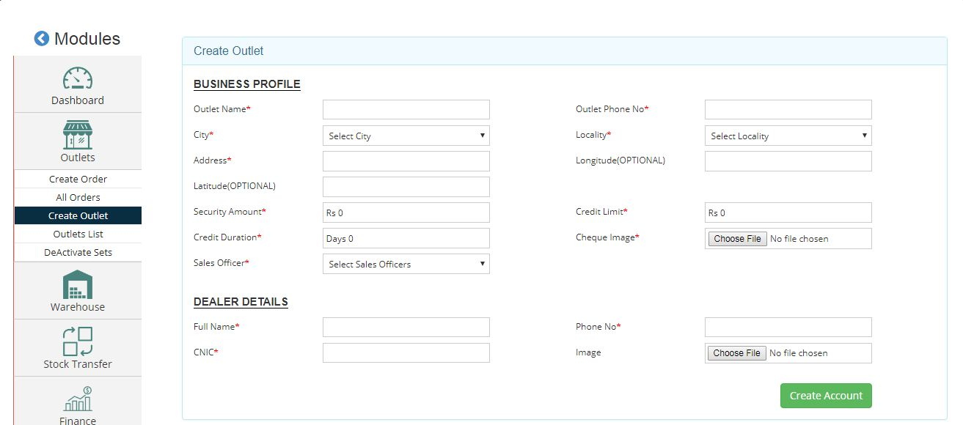

**1.2 Outlet List:**

To View the outlet details, there are 3 filters that can filter the outlets with **Sales Officer**, **State Wise** and **City Wise** and there is also the option for text base searching.

There is the Option of “**Export to Excel**” that can export the list of outlets into the Excel Sheet and download the sheet into the system.

**Route:** <http://portal.xcell.com.pk/system/public/retailer_list>

**View:** retailer_list.blade.php

**Component:** AllRetailersComponent.vue

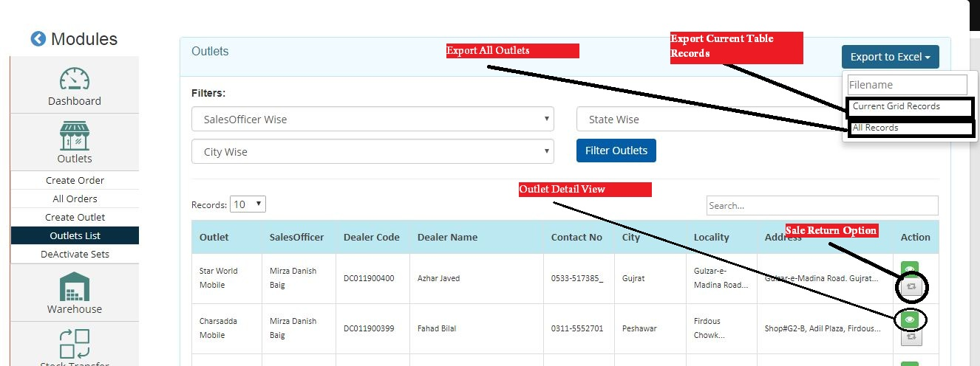

In Action Column there is the “Return Icon”, this is the “Sale Return” Option.

**1.3 Create New Order:**

* **Step1:** Select Outlet for making new Order.
* **Step2:** Select the Models with quantity.
* **Step3:** Submit the Order with Final Summary.

Once the order submitted, it will show to the Finance Office for the Approval, After the Approval from Finance then Order will ready to the dispatch.

**Route:** <http://portal.xcell.com.pk/system/public/retailer/create_order>

**View**: create_retailer_order.blade.php

**Component:** CreateRetailerOrderComponent.vue

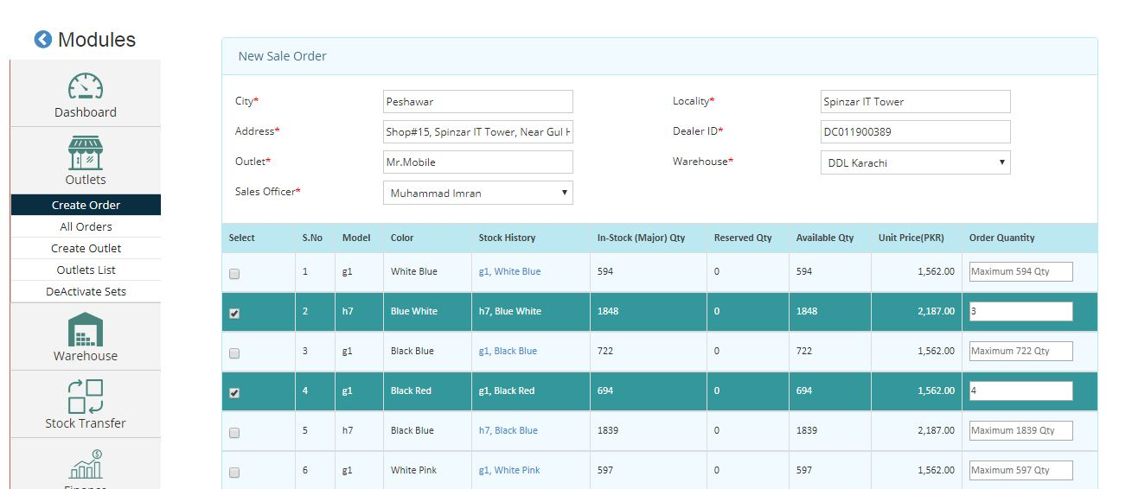

**1.4 All Sales Orders List:**

To View the order details, there are 3 filters **Sales Officer**, **State Wise** and **City Wise** and there is also the option for text base searching.

There is the Option of “**Export to Excel**” that can export the list of order into the Excel Sheet and download the sheet into the system.