|  |
| --- |
| PROAXIVE PORTAL USER GUIDE |
|  |



**LOGIN SCREEN** (<https://portal.proaxive.my>)

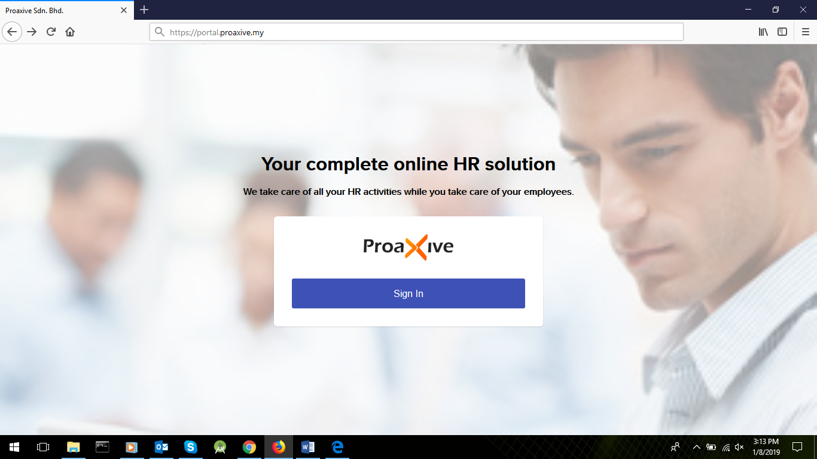

**LOGIN REDIRECTION**

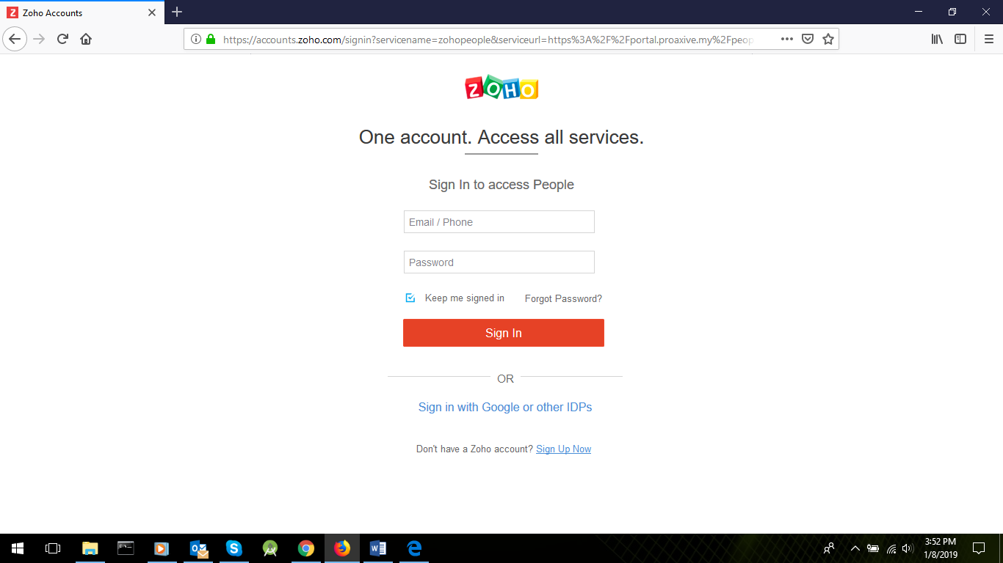

**DASHBOARD**

At Dashboard, from the several options, there’s a **Travel** option present at the left vertical navigation menu.

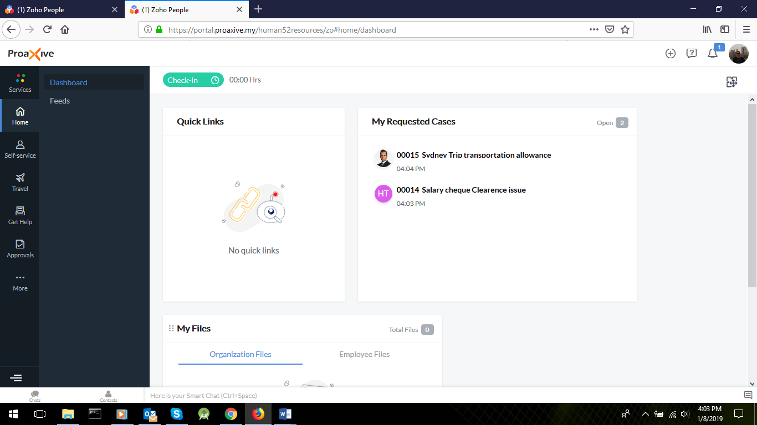

**TRAVEL FEATURE**

A sub-menu opens dedicated to the Travel Features including **Travel Request** and **Travel Expense.** By Default all Travel requests made by the employee only would be shown. The columns shown are completely customizable from the visibility aspect as well.

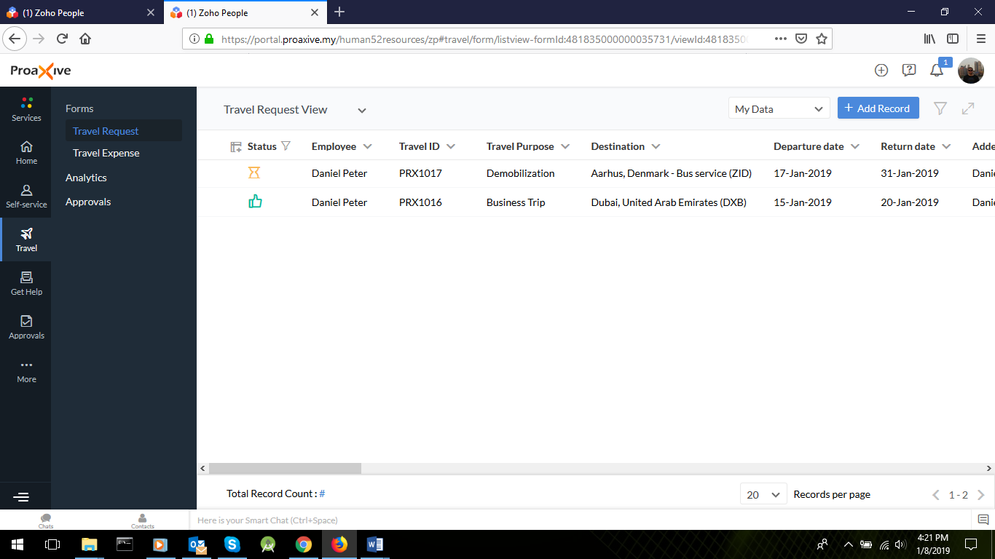

**NEW TRAVEL REQUEST**

At the Travel Requests page, from the top blue button titled *Add Record*, this page opens up. Red marked fields are mandatory.

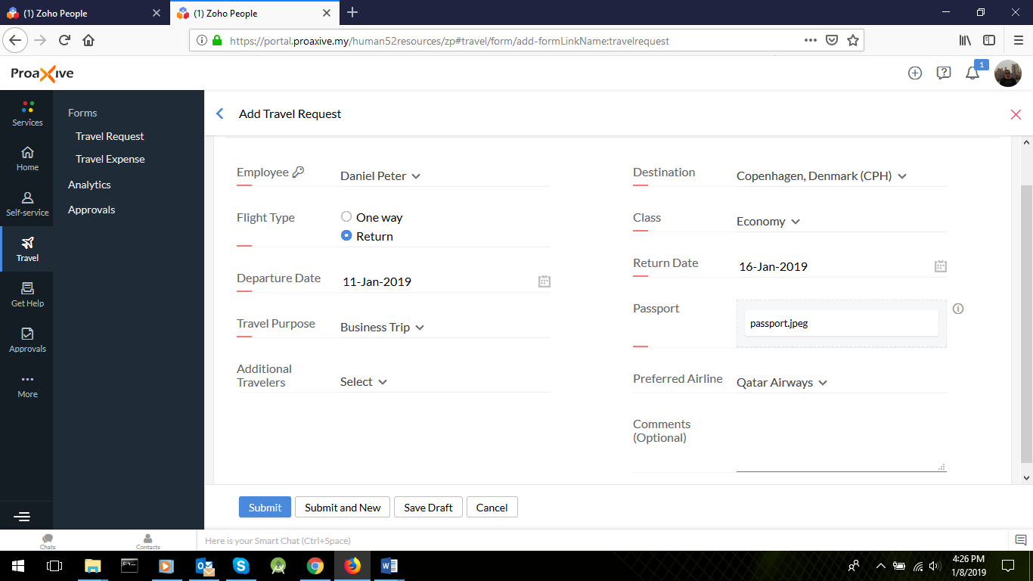

**ADDITIONAL TRAVELERS IN TRAVEL**

If employee needs to take additional members along with his/her trip, he/she must provide their details as well.

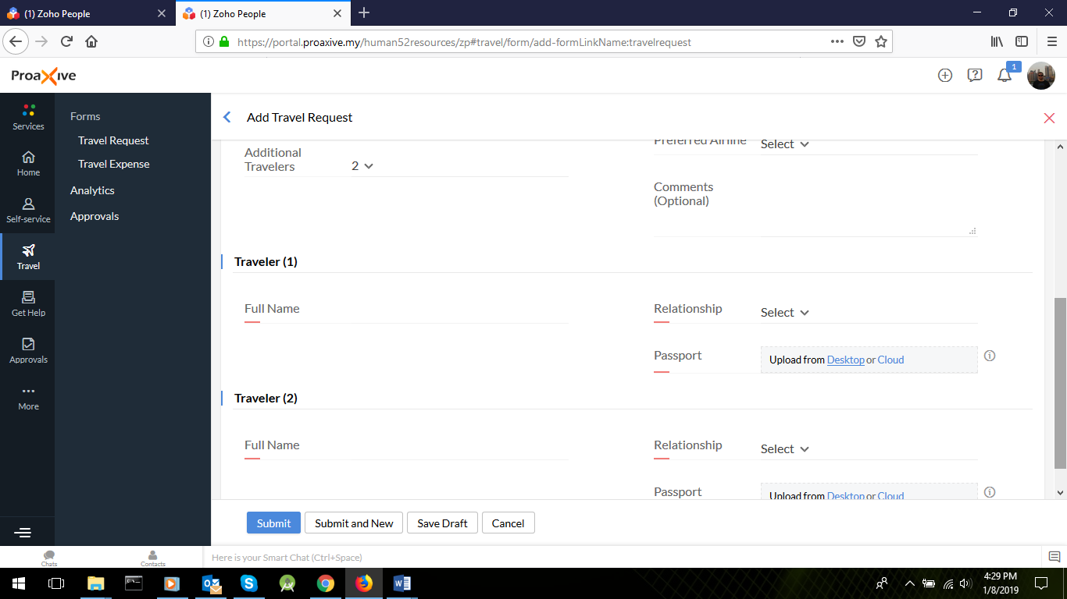

**APPROVAL PROCESS**

As the request is made, approval process gets triggered automatically. Our approval process follows the following hierarchy

**APPROVAL CYCLE STARTS**

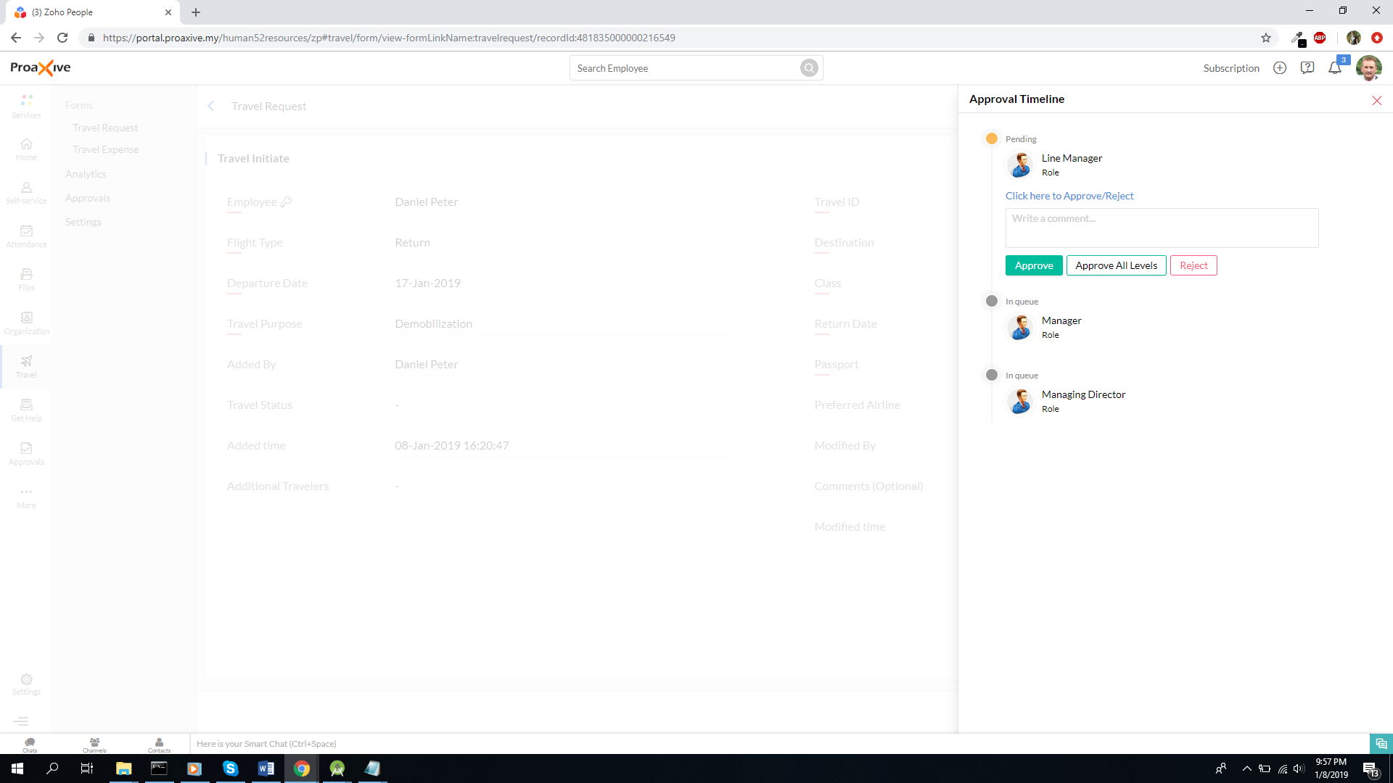

**APPROVAL PROCESS FINISHED AFTER GOING THROUGH EACH STEP**

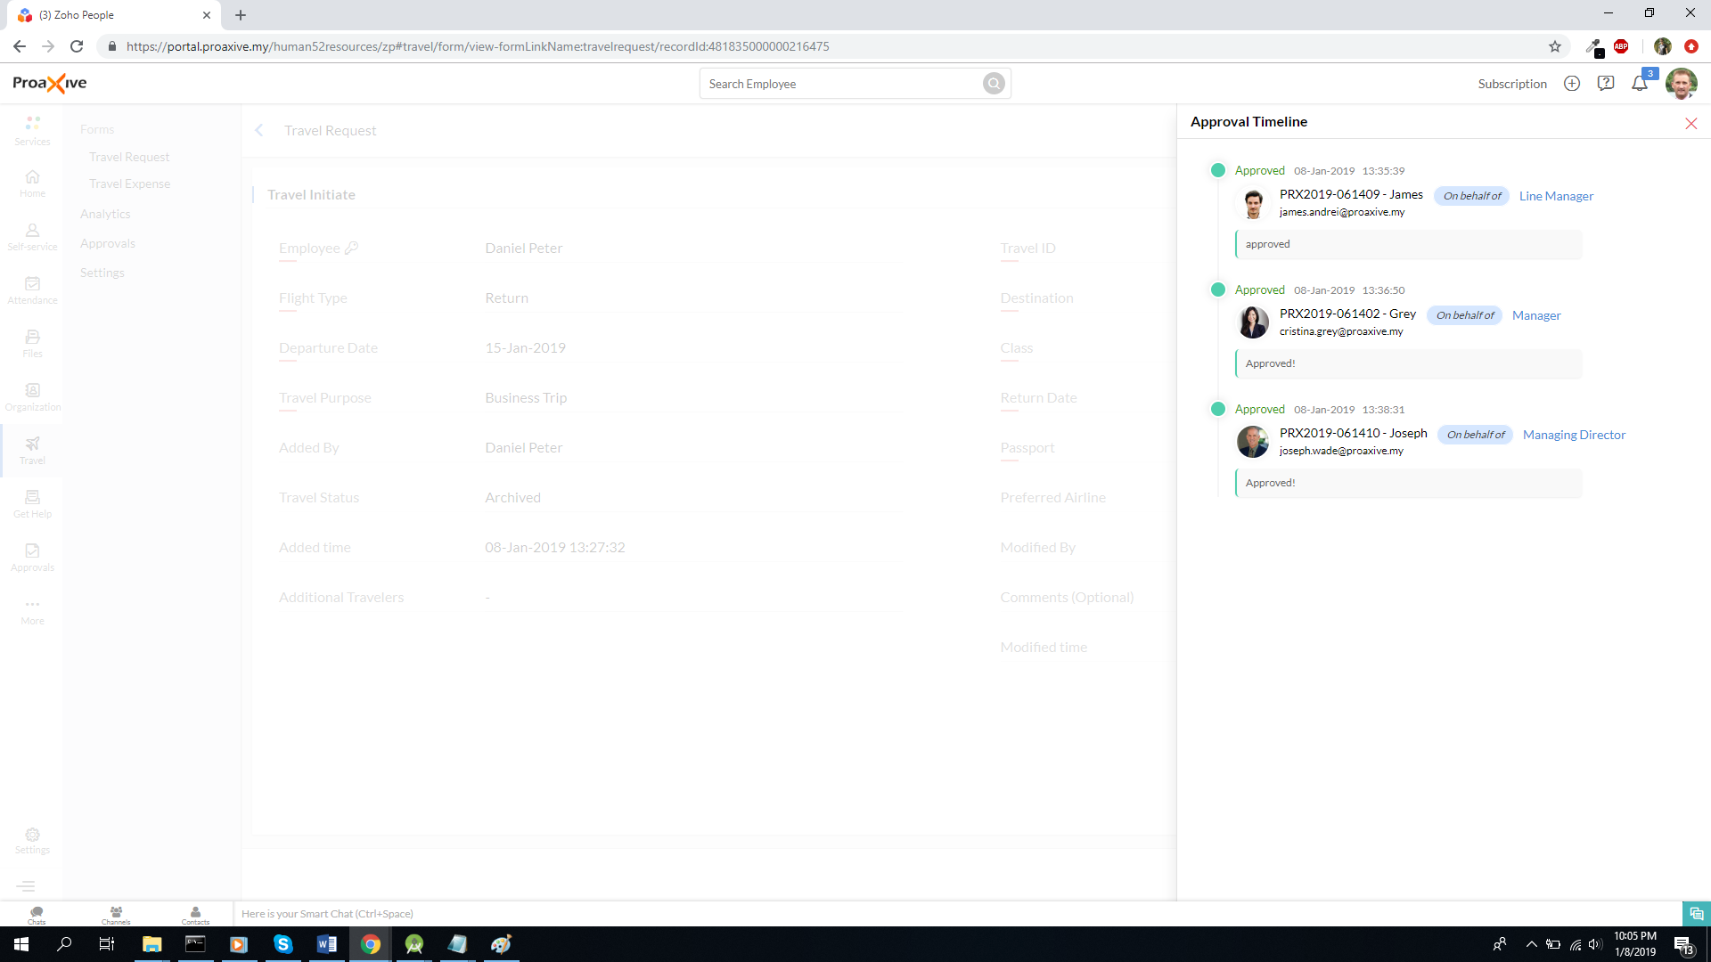

**TRAVEL EXPENSE FEATURE**

Below the Travel Request option is a Travel Expense feature. All the expenses made during trips are shown here

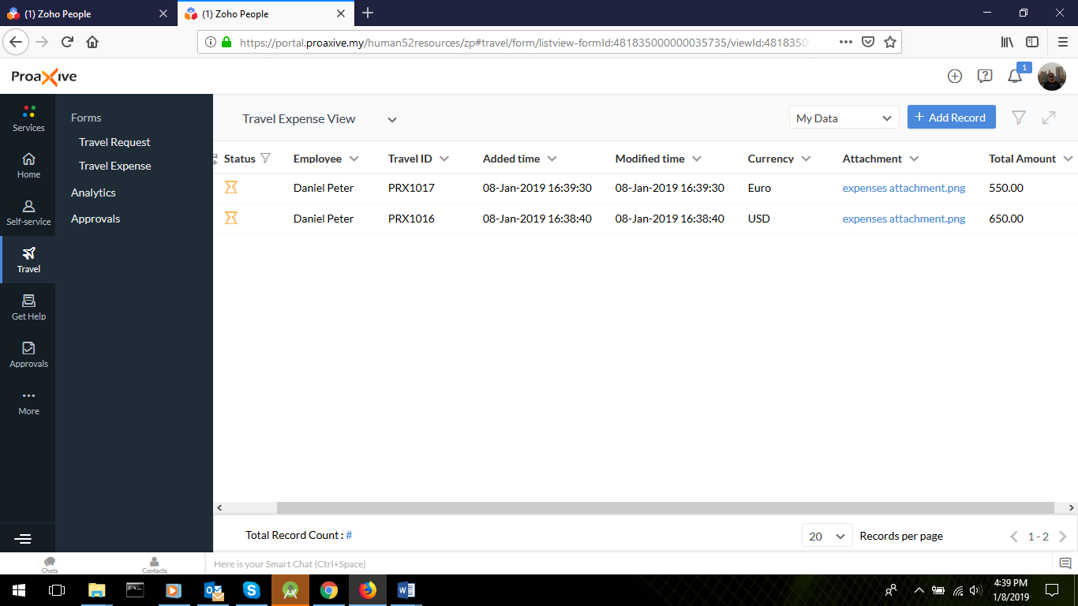

**NEW TRAVEL EXPENSE**

At the Travel Expense page, from the top blue button titled *Add Record*, this page opens up. Red marked fields are mandatory.

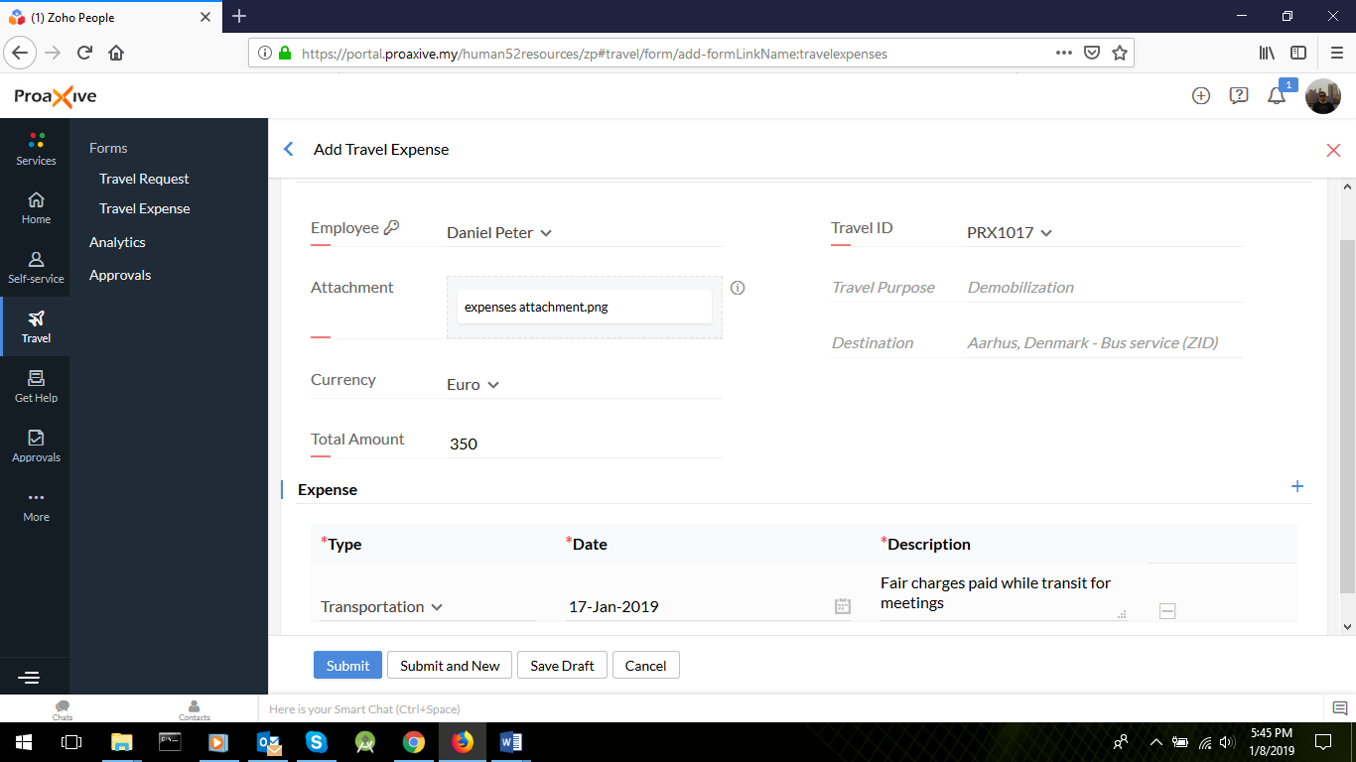

*Note: Same approval process follows here as is explained in Travel Request process at Page # 8*

**GET HELP/SUPPORT**

At the left main menu, there’s a **Get Help** button. Upon clicking on that, following page shows up.

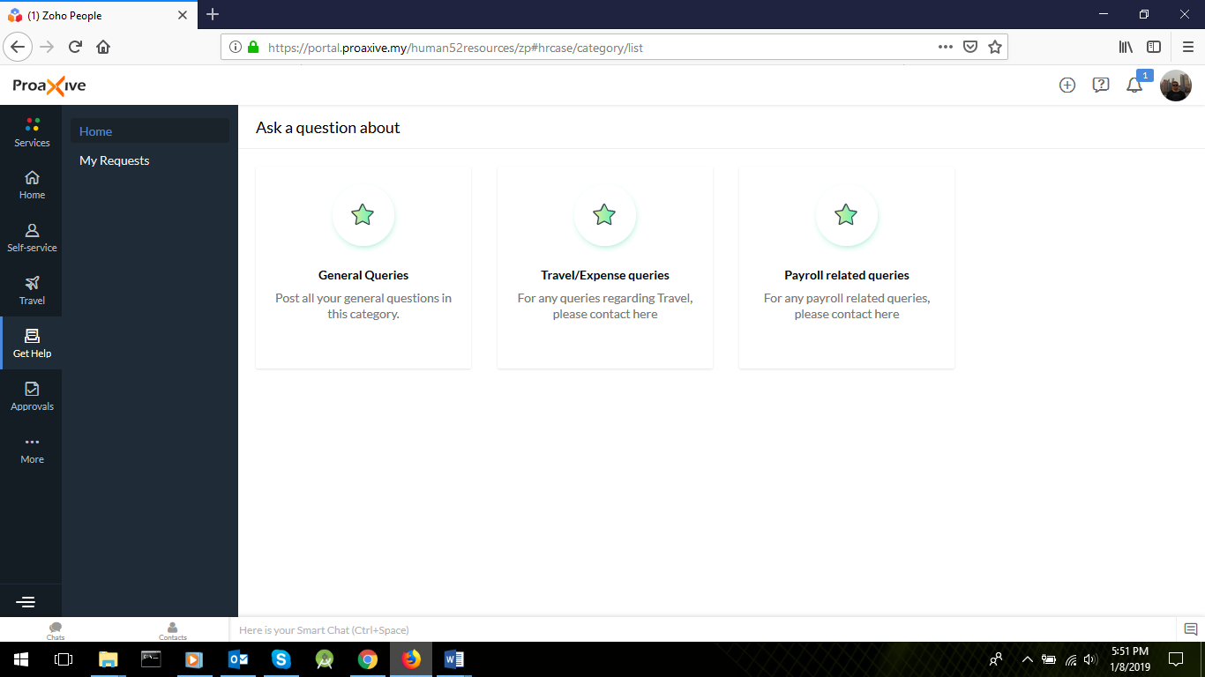

**WRITING SUPPORT QUERY**

Writing a support query for Payroll related purpose. Same format applies for the other queries.

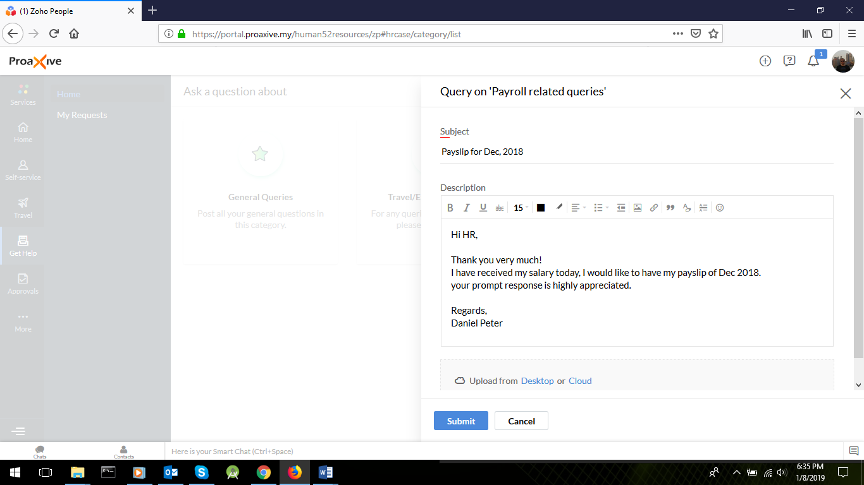

**ALL SUPPOT QUERIES LIST**

At the **Get Help** menu, it shows **My Requests** page. Cases particular to this employee would be shown only.

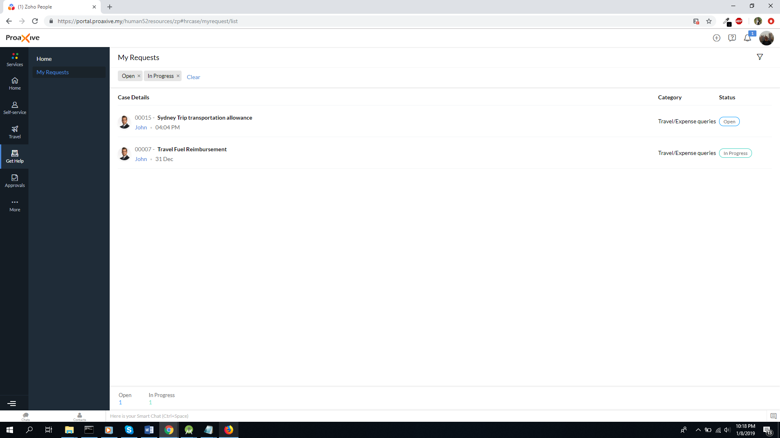

**CASE DETAILS AND ASSOCIATED ACTIONS**

When a particular case is clicked, following details fragment shows up. From here, the employee can write a comment, change status of the case.

